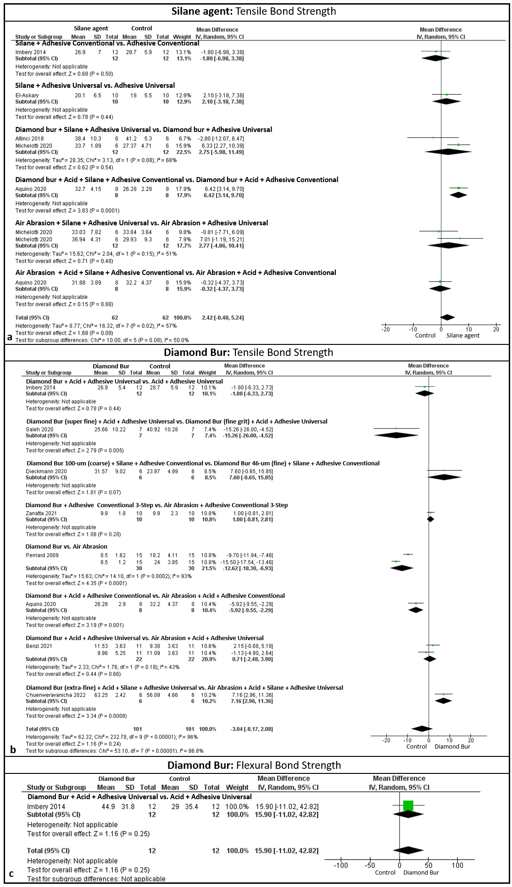
Fig. 2 supplementary In "a" the results of the analysis of the use of the silane agent for the tensile bond strength test resulted in statistical adhesion (P<0.05) when associated with diamond bur + phosphoric acid + conventional adhesive. In "b" and "c" diamond bur was tested, and resulted in statistical adhesion (P<0.05) only when used together with acid + silane + universal adhesive

