Supporting Information

Pickering Emulsions based on Sustainable MIL-101(Fe)/CNC Hybrid Nanoparticles for Effective Photocatalytic Degradation of Aqueous Dyes
Dehai Yu^{a,c, || *}, Zhile Wang^{a, ||}, Dandan Ji^{b,c}, Changshui Jingª, Zhaoping Songª, Huili Wangª, Wenxia Liuª
ª State Key Laboratory of Biobased Material and Green Papermaking, Qilu University of Technology (Shandong Academy of Sciences), Ji’nan, Shandong Province 250353, China
^{b} School of Environmental Science and Engineering, Qilu University of Technology (Shandong Academy of Sciences), Ji’nan, Shandong Province 250353, China
^{c} Huatai Group Corp. Ltd., Dongying, Shandong Province 257335, China
* Corresponding Authors: yudehai@qlu.edu.cn
|| Dehai Yu and Zhile Wang contributed equally to this work.

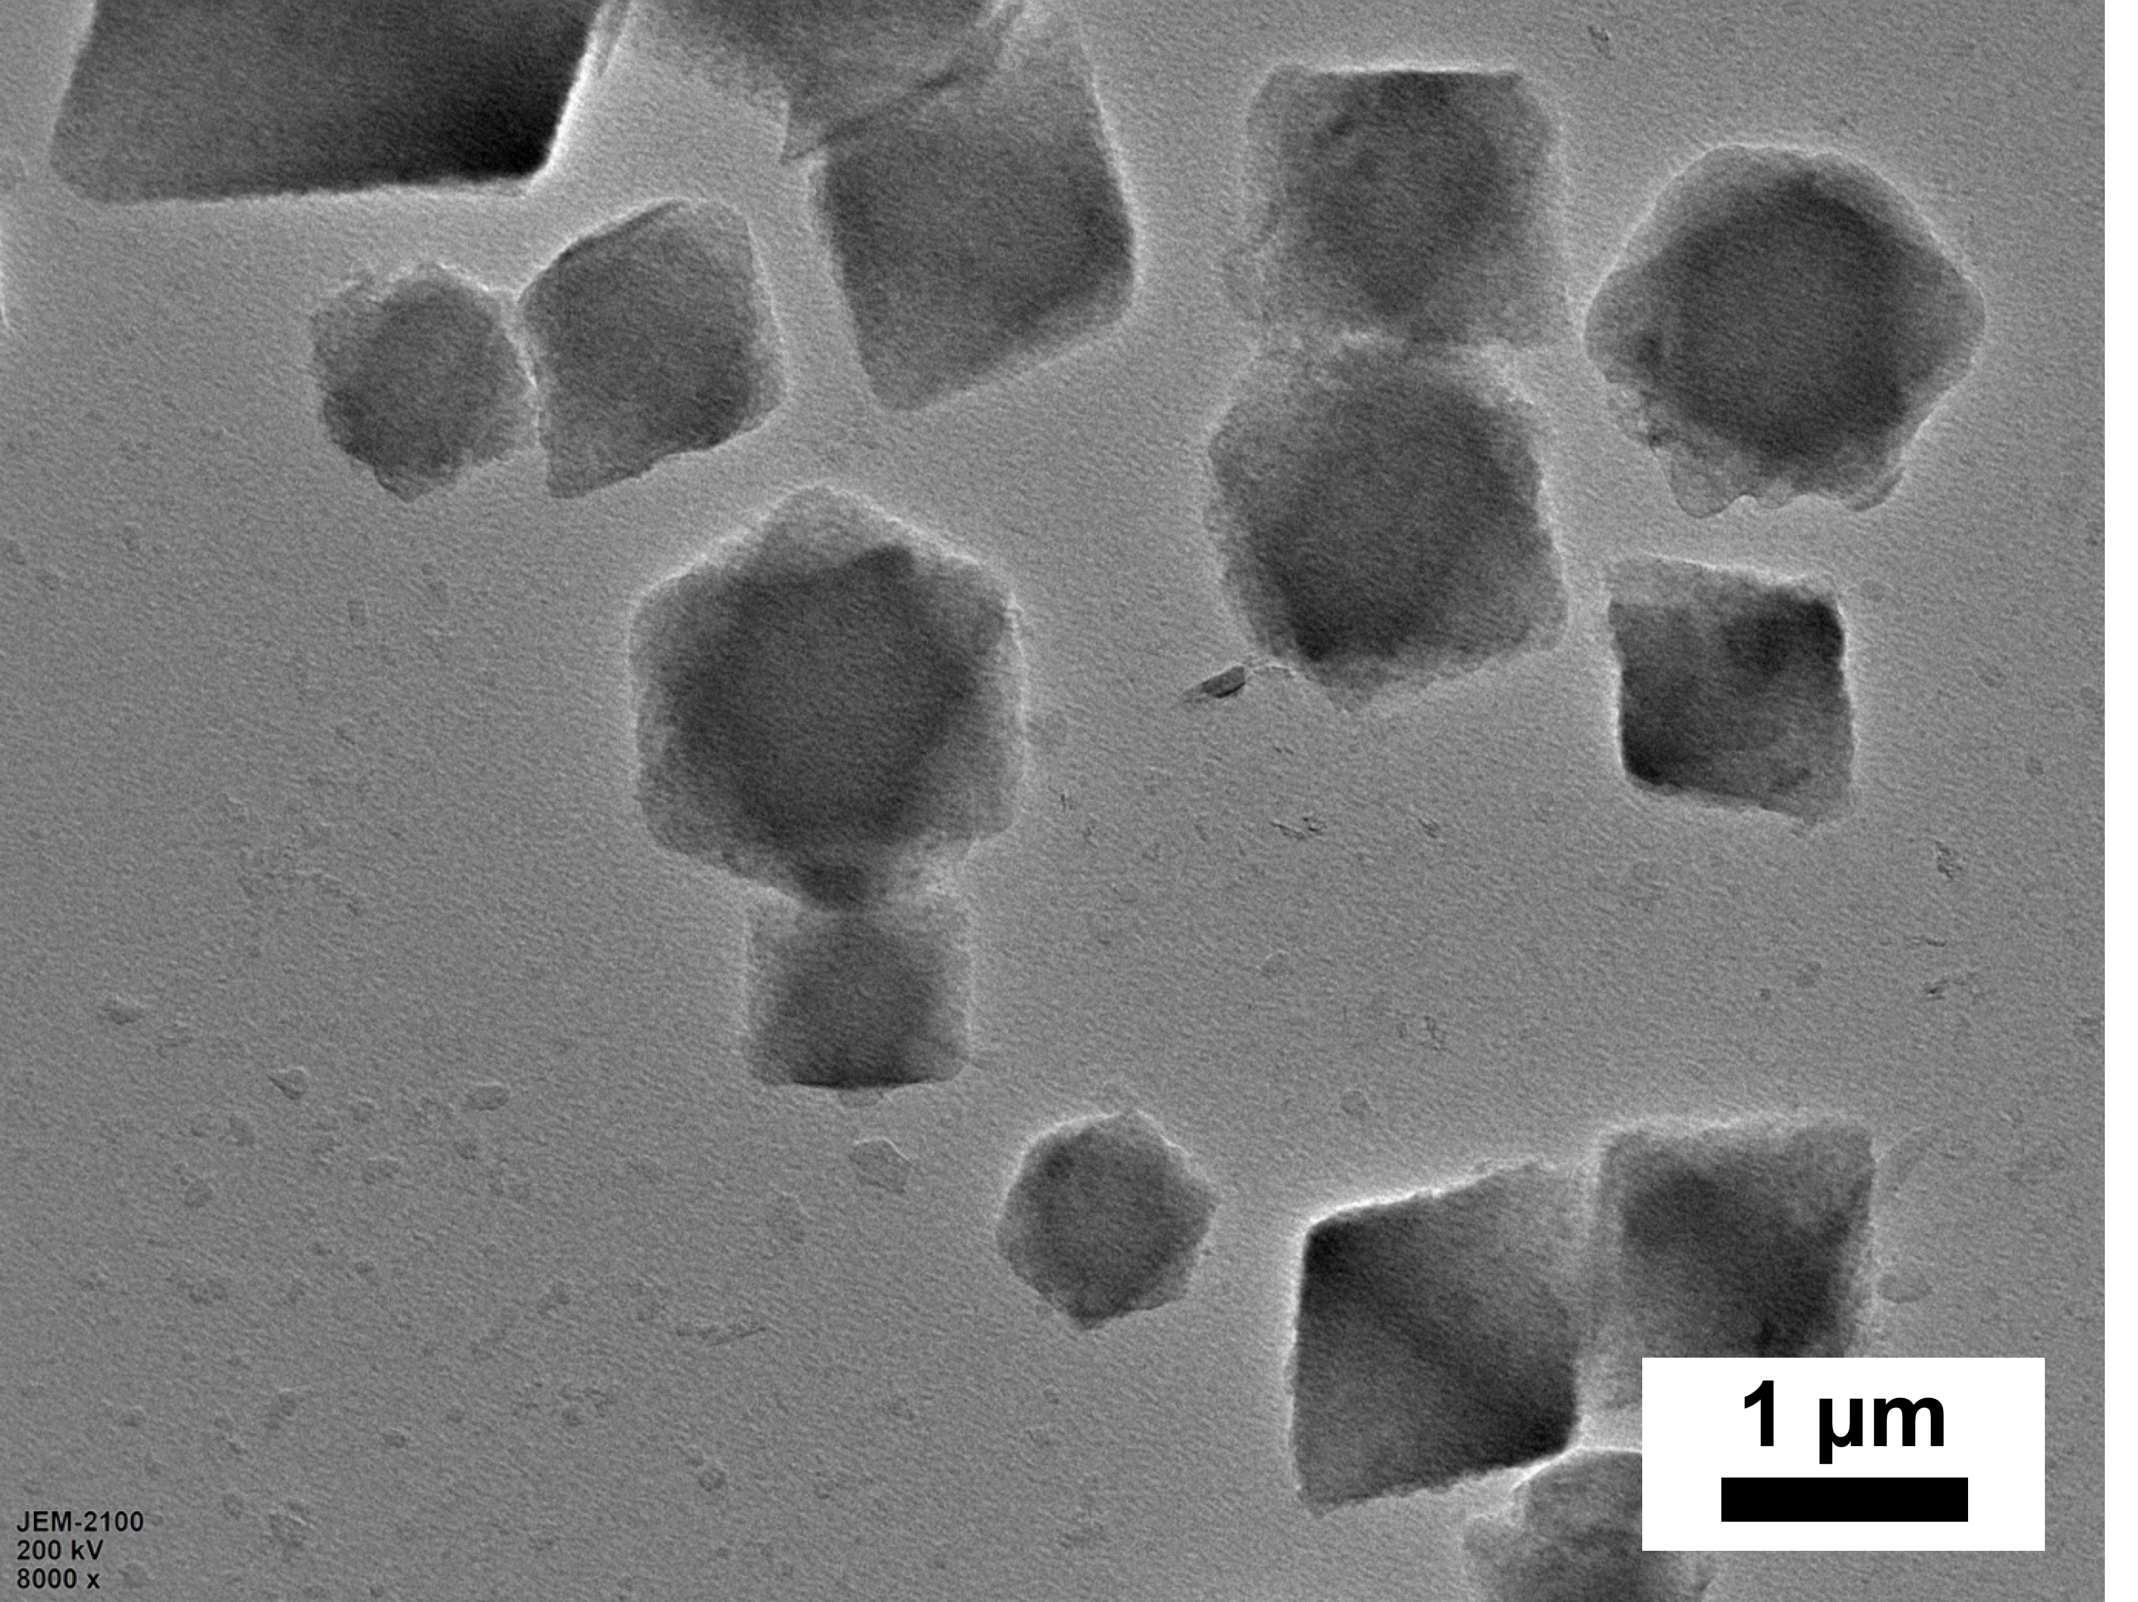
Fig. S1 TEM image of MIL-101(Fe).

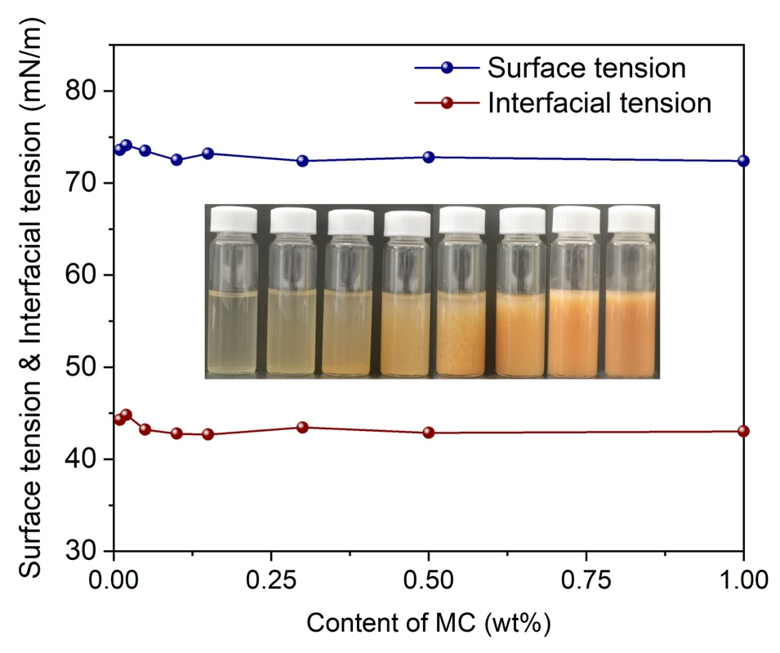
Fig. S2 Surface and interfacial tension of the MC aqueous dispersion with different content of MCs. Inset is the appearance of the MC aqueous dispersion.

Table. S1 Specific surface area and average pore size of MIL-101(Fe) and MIL-101(Fe)/CNC
Samples | BET surface area (m²/g) | Pore volume (cm³/g) | Pore size (nm)
MIL-101(Fe) | 550 | 0.14 | 2.8
MC-0.1 | 554 | 0.15 | 4.9
MC-0.25 | 436 | 0.17 | 6.3
MC-0.5 | 399 | 0.09 | 4.5
MC-1.0 | 390 | 0.08 | 4.1

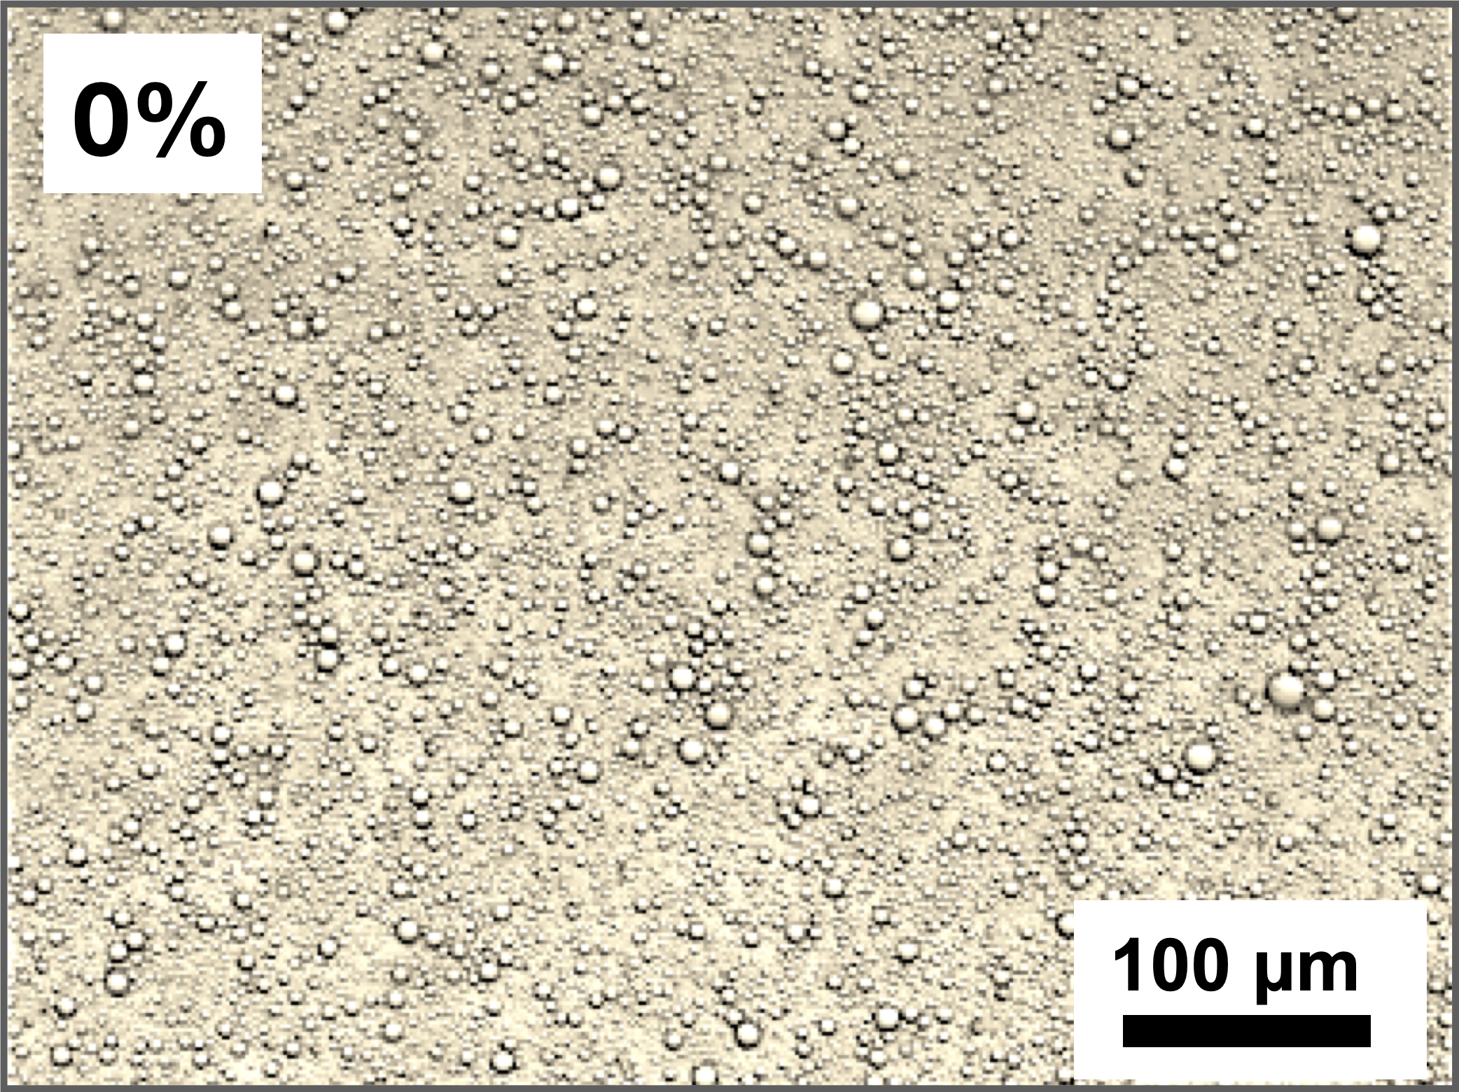
Fig. S3 Microscope image of the Pickering emulsion stabilized by MIL-101(Fe) nanoparticles without CNCs.

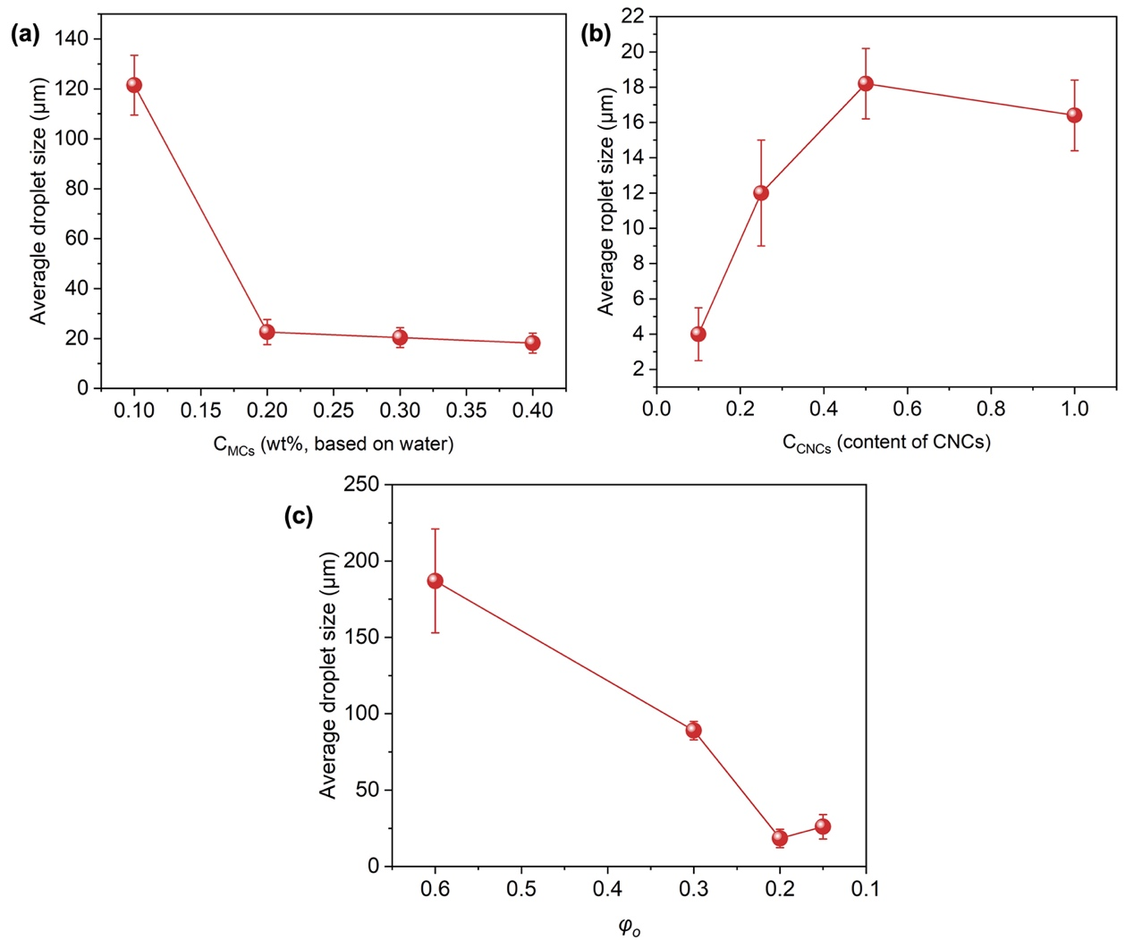
Fig. S4 Average droplet size versus different (a) C_{MCs}, (b) C_{CNCs} and (c) φ_{o}.

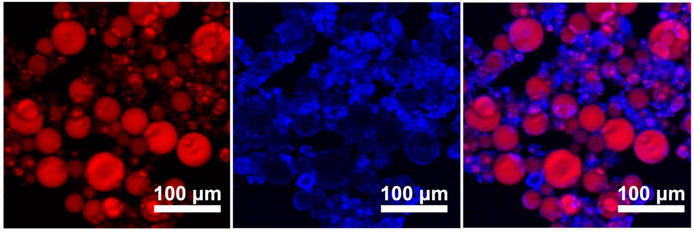
Fig. S5 CLSM of the emulsion stabilized by MCs with 1.0 wt% CNCs.

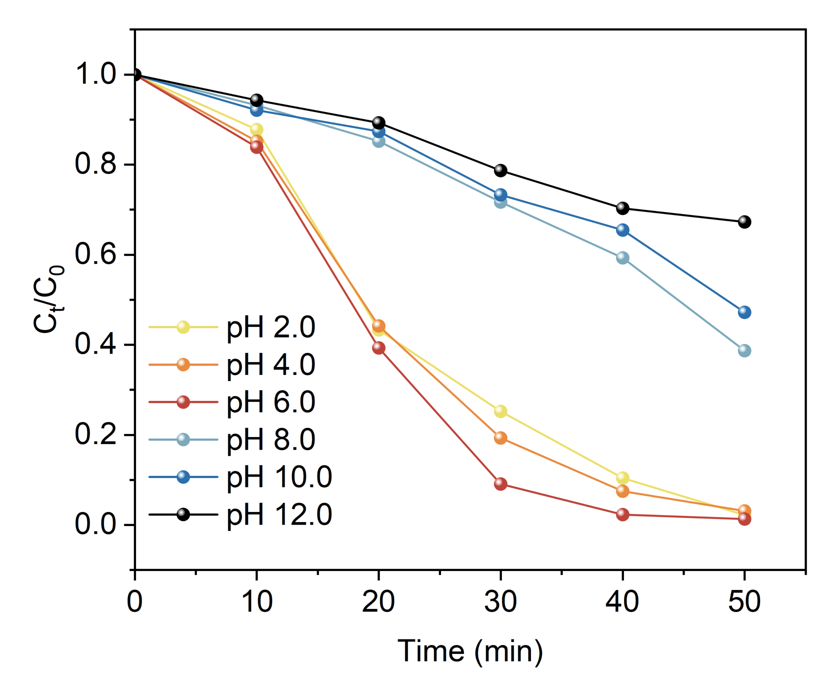
Fig. S6 Degradation rate of the MC-0.5 in the Pickering emulsion system with different pH.

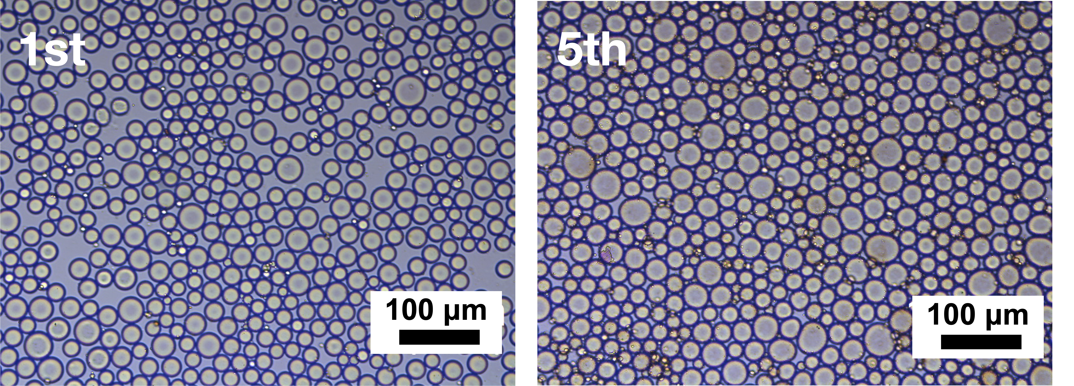
Fig. S7 Optical images of the emulsion droplets after 1st and 5th catalytic cycles.

