MAPkinases regulate secondary metabolism, sexual development and light dependent cellulase regulation in Trichoderma reesei

Miriam Schalamun¹, Sabrina Beier¹, Wolfgang Hinterdobler^{1,2}, Nicole Wanko¹, Johann Schinnerl³, Lothar Brecker⁴, Dorothea Elisa Engl⁴ and Schmoll Monika^{1,5}*

¹AIT Austrian Institute of Technology GmbH, Center for Health and Bioresources, Bioresources Unit, Konrad Lorenz Strasse 24, 3430 Tulln
² MyPilz GmbH, Wienerbergstrasse 55/13-15, 1120 Vienna, Austria
³Chemodiversity Research Group, Department of Botany and Biodiversity Research, University of Vienna, Rennweg 14, 1030 Vienna, Austria
⁴ Department of Organic Chemistry, University of Vienna, Währinger Strasse 38, A-1090 Vienna, Austria
⁵ University of Vienna, Department of Microbiology and Ecosystem Science, Division of Terrestrial Ecosystem Research, Djerassiplatz 1, 1030 Vienna, Austria

Supplementary material

Supplementary Figure S1. HPLC analysis of MAPK deletion mutants and identification of sorbicillin derivatives. Chromatograms of biological replicates of wild type (Δku80) and MAPkinase deletion mutants (Δtmk1-3) at 230 nm. For Δtmk1 only two replicates were used for analysis.

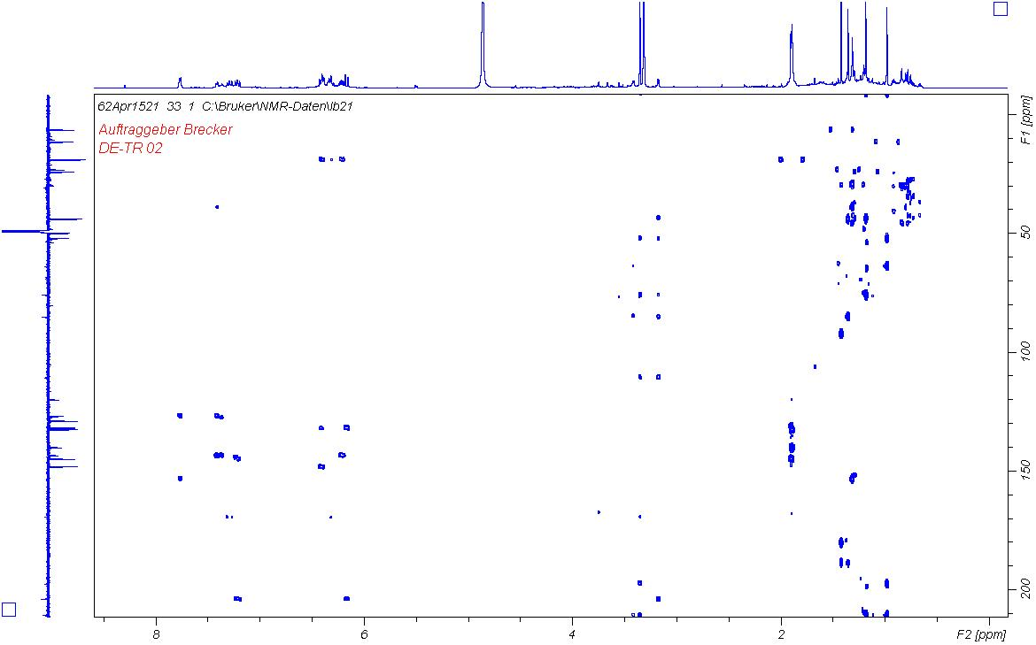
Supplementary Figure S2. HMBC of (21S)-bisorbibutenolide in CD₃OD.

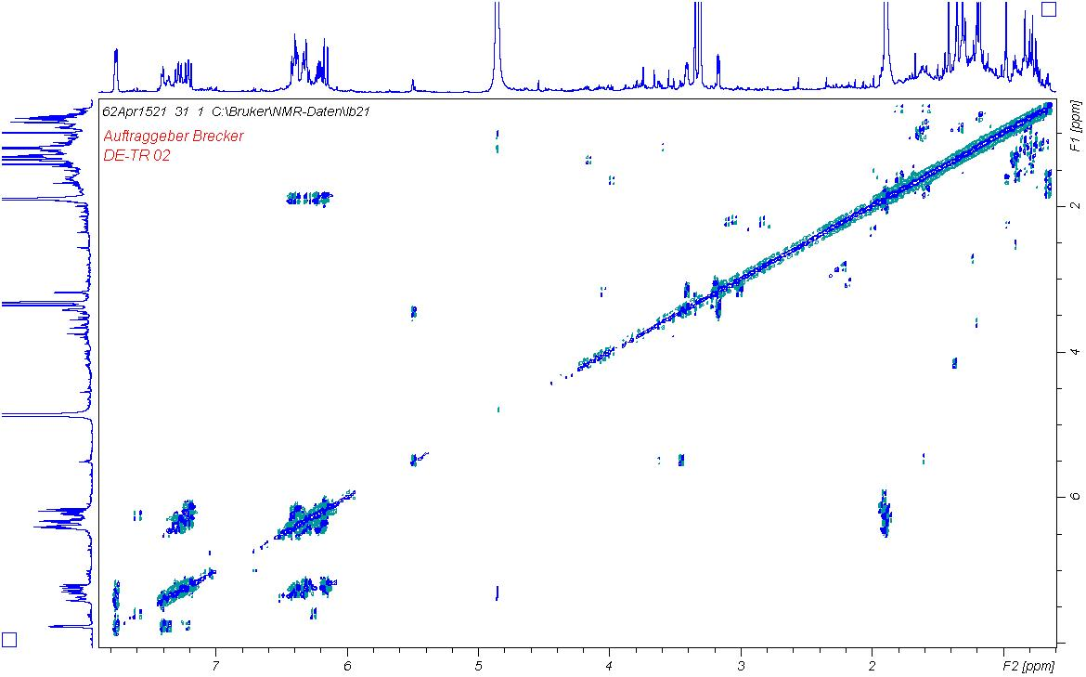
Supplementary Figure S3. COSY of (21S)-bisorbibutenolide in CD₃OD.

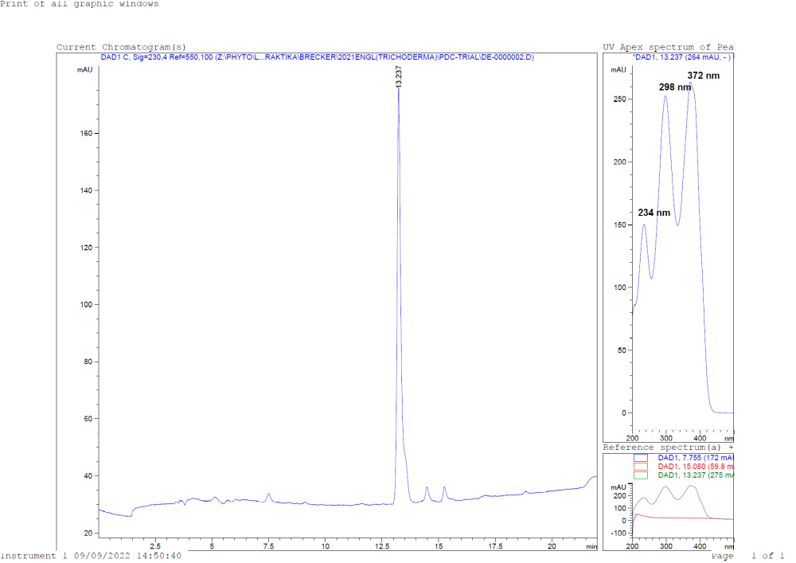
Supplementary Figure S4. Chromatogram and UV/Vis spectrum of (21S)-bisorbibutenolide.

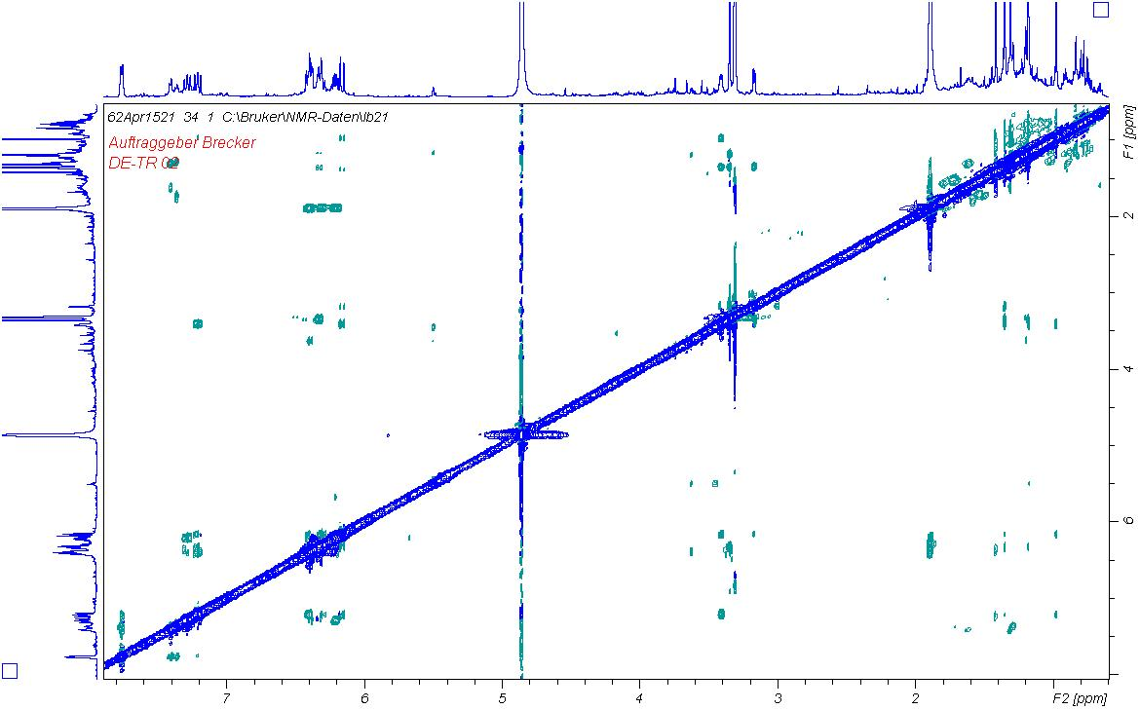
Supplementary Figure S5. NOESY of (21S)-bisorbibutenolide in CD₃OD.

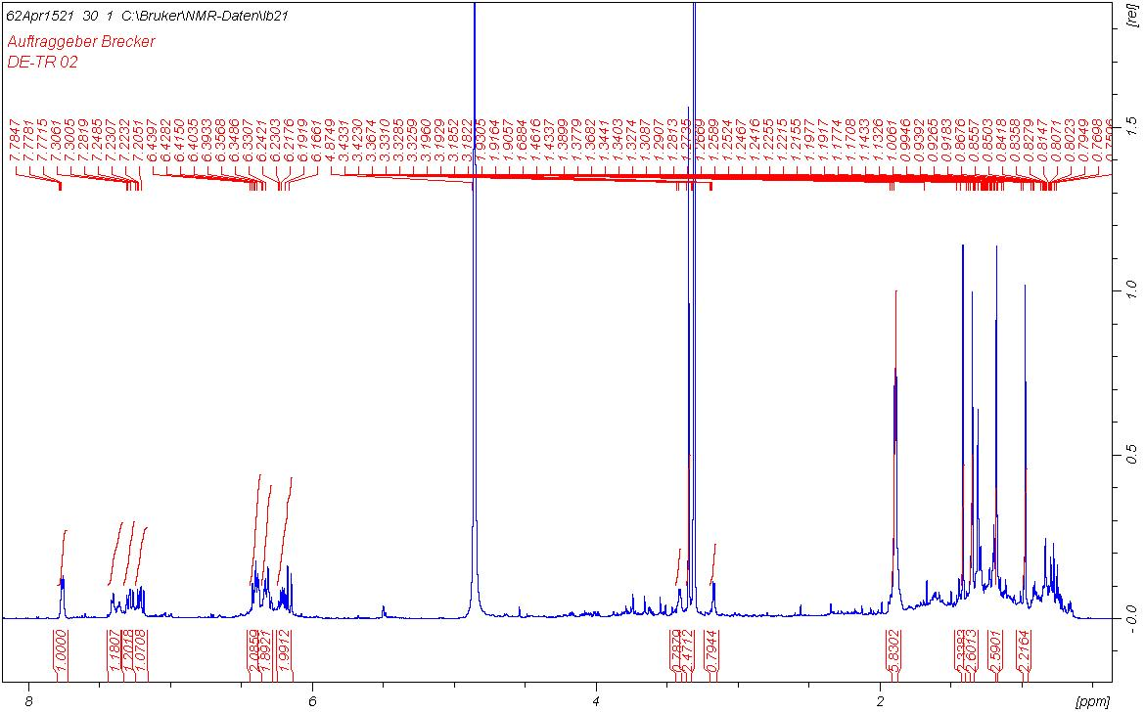
Supplementary Figure S6. ¹H NMR of (21S)-bisorbibutenolide in CD₃OD.

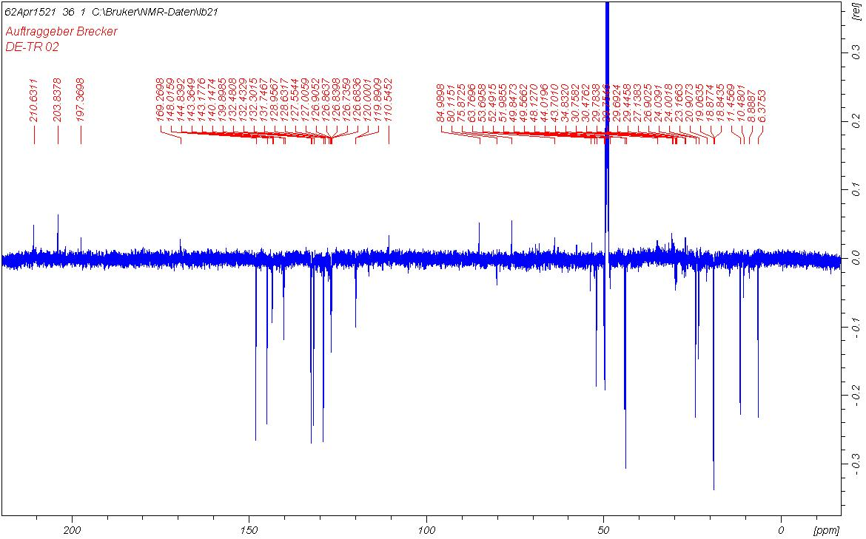
Supplementary Figure S7. ¹³C NMR [APT] of (21S)-bisorbibutenolide l in CD₃OD.

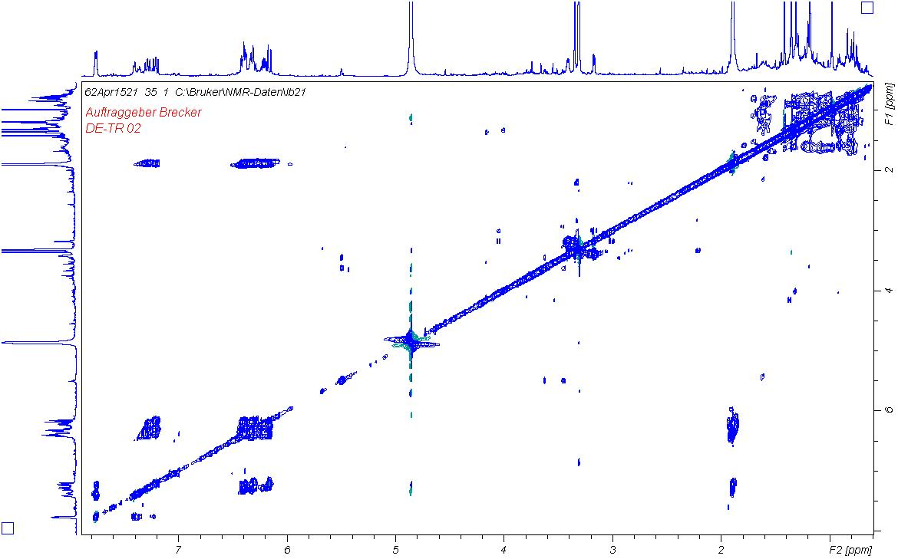

Supplementary Figure S8. TOCSY of (21S)-bisorbibutenolide in CD₃OD.

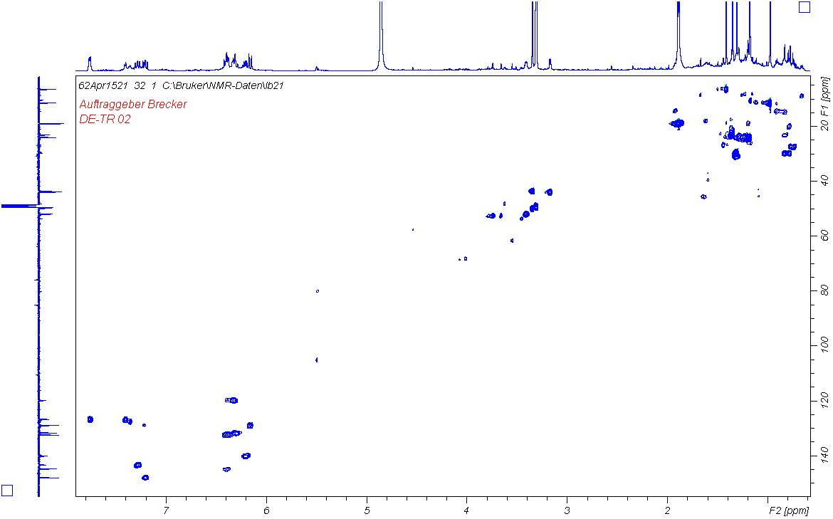
Supplementary Figure S9. HSQC of (21S)-bisorbibutenolide in CD₃OD.

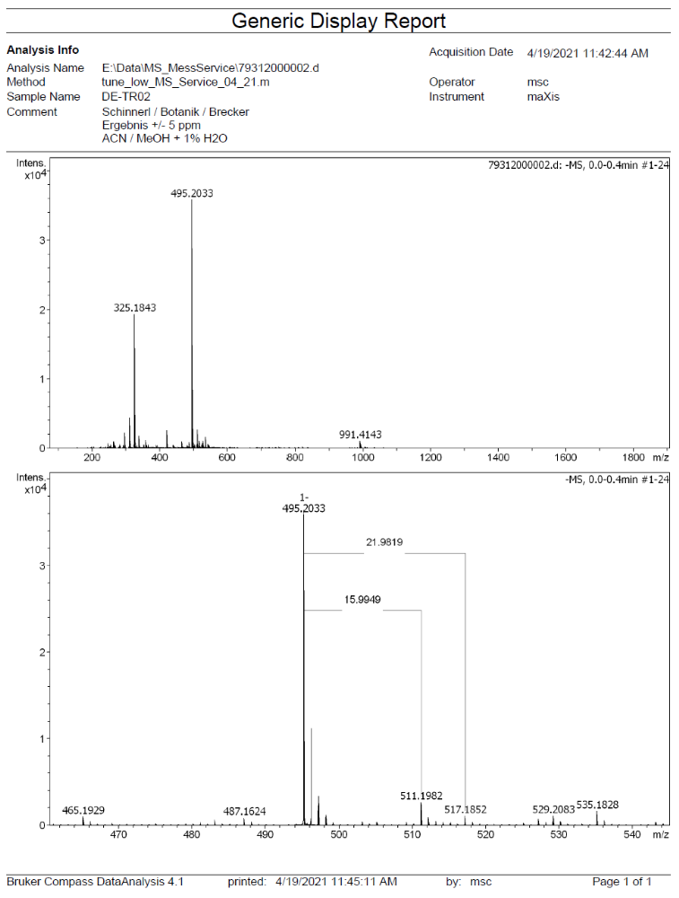
Supplementary Figure S10. HR-ESI-TOF-MS (negative mode) of (21S)-bisorbibutenolide.

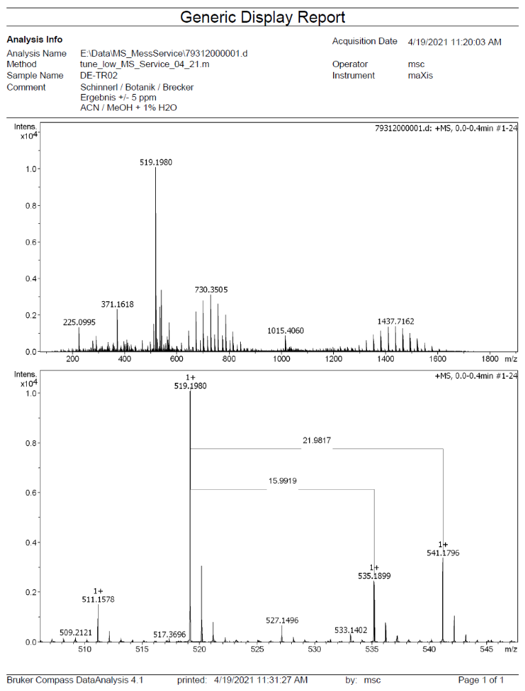

Supplementary Figure S11. HR-ESI-TOF-MS (positive mode) of (21S)-bisorbibutenolide.

Supplementary Table S1
primer name | information | Sequence 5' - 3' | Protein ID | name of target gene
121539_3F | construction of deletion cassette | CTCCTTCAATATCATCTTCTGTCTCCGACGTAGGTGTGGTCAGTGATGG | 121539 | tmk1
121539_3R | construction of deletion cassette | GCGGATAACAATTTCACACAGGAAACAGCTGTAGCAGTCTCTCTTGTCG | 121539 | tmk1
121539_5F | construction of deletion cassette | GTAACGCCAGGGTTTTCCCAGTCACGACGTTGATCCCTCTGTGTCAACC | 121539 | tmk1
121539_5R | construction of deletion cassette | ATCCACTTAACGTTACTGAAATCTCCAACGAACTGAAGAGGAGTTGAGG | 121539 | tmk1
121539_qF | internal primer | CACGCCCACCATGGAGGACTAC | 121539 | tmk1
121539_qR | internal primer | GCTCGAGGTACGGGTGCTTGAG | 121539 | tmk1
82351_3F | construction of deletion cassette | CTCCTTCAATATCATCTTCTGTCTCCGACGTTATCTGAGTGGTGTGTGG | 82351 | tmk2
82351_3R | construction of deletion cassette | GCGGATAACAATTTCACACAGGAAACAGCCCATGTTCTACGACATCAGC | 82351 | tmk2
82351_5F | construction of deletion cassette | GTAACGCCAGGGTTTTCCCAGTCACGACGCACCTCTGTATCTCAAGACG | 82351 | tmk2
82351_5R | construction of deletion cassette | ATCCACTTAACGTTACTGAAATCTCCAACTATGTTGTCTGAGTCCCAGC | 82351 | tmk2
82351_qF | internal primer | CCAACGAAGAGACTCTCCGCCG | 82351 | tmk2
82351_qR | internal primer | AAGTTGAACGTCGTGGGGCAGT | 82351 | tmk2
45018_3F | construction of deletion cassette | CTCCTTCAATATCATCTTCTGTCTCCGACTATAGAGGTCTGGAGGTTGC | 45018 | tmk3
45018_3R | construction of deletion cassette | GCGGATAACAATTTCACACAGGAAACAGCAGAGAGATACTCCGTCTTCG | 45018 | tmk3
45018_5F | construction of deletion cassette | GTAACGCCAGGGTTTTCCCAGTCACGACGCTGAAGCTTAGACTTGCTGC | 45018 | tmk3
45018_5R | construction of deletion cassette | ATCCACTTAACGTTACTGAAATCTCCAACCGCAGGATTATAGCAGTTCC | 45018 | tmk3
45018_qF | internal primer | GACCCTACTGACGAGCCGGTTG | 45018 | tmk3
45018_qR | internal primer | CGGGAACTGCTCGTCCATGTTT | 45018 | tmk3
EF1-728F | internal primer | CATCGAGAAGTTCGAGAAGG | 46958 | tef1
TEF1 rev | internal primer | GCCATCCTTGGAGATACCAGC | 46958 | tef1
HRM_SNP3_F | HRM primer | ACAGCATTAGCCCCTTCGTC | 67350 | ham5
HRM_SNP3_R | HRM primer | GCACATTCGCGACAGACTTC | 67350 | ham5
matA1_F | mating type check | TCCTCTCAATGCGTTCATGGC | mat1-1 | mat1-1
matA1_R | mating type check | AGAAGATCATTCTCTGTGTTGGGA | mat1-1 | mat1-1
MATa1-R | mating type check | ATTTGCGCGGCTTGTATTGG | mat1-2 | mat1-2
MATa1-F | mating type check | GCGCACCACGGTATTTCATTG | mat1-2 | mat1-2
RTcbh1F | qPCR primer | ACCGTTGTCACCCAGTTCG | 123989 | cbh1
RTcbh1R | qPCR primer | ATCGTTGAGCTCGTTGCCAG | 123989 | cbh1
RT_VEL_R1 | qPCR primer | GCAGGAACACCAGTCAGGATG | 122284 | vel1
RT_VEL_F1 | qPCR primer | CGAGGAGGGCAAGGACATTAC | 122284 | vel1
SAR RTF1 | qPCR primer/HKG | TGGATCGTCAACTGGTTCTACGA | 61470 | sar
SAR RTR1 | qPCR primer/HKG | GCATGTGTAGCAACGTGGTCTTT | 61470 | sar
RT_82208_F | qPCR primer | ACTGAAGCAGTATCGGGCAACT | 82208 | pks4
RT_82208_R | qPCR primer | TCTTCGACGTAAAGAGCAGCCA | 82208 | pks4
xyr1RTF | qPCR primer | CTTCCTCCTCCTGCTCATCG | 122208 | xyr1
xyr1RTR | qPCR primer | TCGTGTGCCCTAACAATGGTC | 122208 | xyr1
RT_CRE1 F | qPCR primer | GCAGCACAATACGACTCCG | 120117 | cre1
RT_CRE1 R | qPCR primer | CGGCTAATGATGTCGGTAAG | 120117 | cre1
hpr2F | qPCR primer | TGGCACCACTTCATCAACTTC | 64018 | hpr2
hpr2R | qPCR primer | GGAGTAGGAGGAGGATGTGTTG | 64018 | hpr2

