Additional file 1: Supplementary materials
Figure 4. Study sheep providing blood for the culture of microbiology specimens
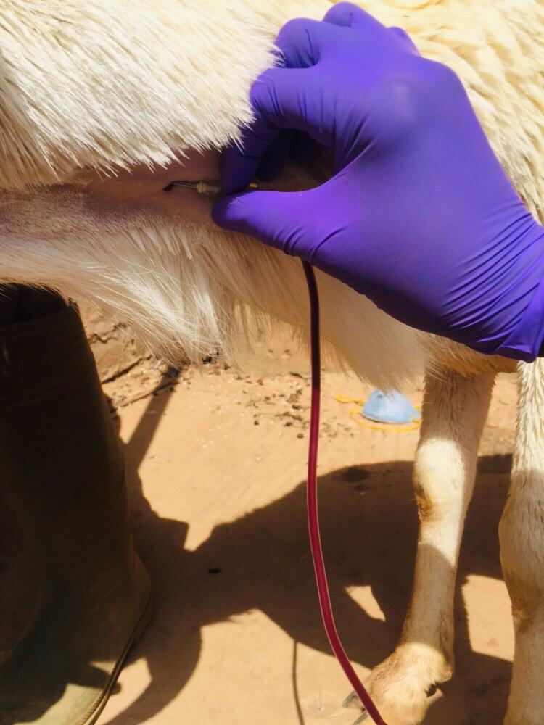
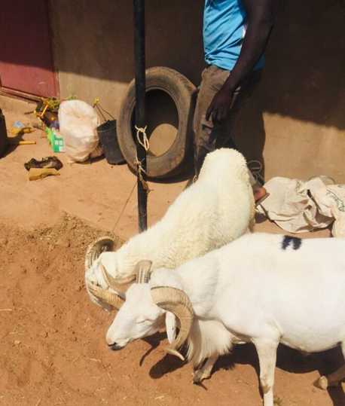

Figure 5. COVID-19 cases in The Gambia

Note: Case numbers have been very low since mid-September and less than 1% of the country’s cases have occurred in the study area.

