Cry41-related mutants against Myzus persicae based on its interaction with Cathepsin B
Liang Jin^{1, a}, Xiao-Di Zhao^{1, a}, Jun-Ao Liao¹, Li-Jun Fu², Yi Lin^{1*}
¹ Fujian Provincial Key Laboratory of Biochemical Technology (Huaqiao University), Department of Bioengineering & Biotechnology, College of Chemical Engineering, Huaqiao University, Xiamen 361021, China.
² Fujian Key Laboratory of Ecology-toxicological Effects & Control for Emerging Contaminants (Putian University), Putian, Fujian 351100, China.

*Corresponding authors: Yi Lin, Ph.D., E-mail: lyhxm@hqu.edu.cn
ª These authors contributed equally to this study.

Supplementary material

Figures
Fig. S1 Identification of two random peptides using Mass spectrometry. (a) NG-12 (³⁹³SSSTWEQSSSAIPIR⁴¹²). (b) NI-7 (⁵³¹LGGSATV⁵³⁷).

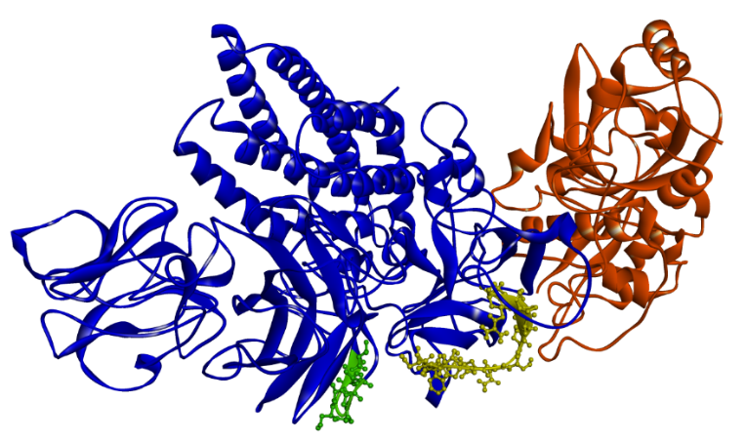
Fig. S2 The location of NG-12 and NI-7 in Cry41-related structure. Molecular docking of Cry41-related toxin (blue) with Cathepsin B (Orange). NG-12 (³⁹³SSSTWEQSSSAIPIR⁴¹²) and NI-7 (⁵³¹LGGSATV⁵³⁷) are shown in a stick diagram and colored yellow and green, respectively.

Tables
Table. S1 Alanine scanning of the interacting residues in Cry41-related.
Mutation | Effect of mutation | Mutation energy  (kcal/mol) | Term (kcal/mol)
Mutation | Effect of mutation | Mutation energy  (kcal/mol) | VDW | Electrostatic | Entropy
:GLY48>ALA | DESTABILIZING | 1.18 | -0.42 | 2.76 | 0.01
:LYS364>ALA | DESTABILIZING | 1.27 | 0.64 | 3.82 | -1.2
:GLN367>ALA | DESTABILIZING | 1.13 | 2.32 | -0.44 | 0.24
:GLN377>ALA | DESTABILIZING | 1.37 | 2.66 | -0.17 | 0.15
:TYR378>ALA | DESTABILIZING | 1.09 | 1.84 | 0.75 | -0.25
:PRO453>ALA | DESTABILIZING | 1.32 | 3.56 | -1.03 | 0.07
:VAL47>ALA | NEUTRAL | 0.17 | 2.35 | -1.33 | -0.42
:ASP58>ALA | NEUTRAL | -0.02 | 0 | -0.04 | 0
:SER401>ALA | NEUTRAL | 0.44 | 0.41 | 0.43 | 0.03
:SER402>ALA | NEUTRAL | 0.03 | 0.09 | 0.27 | -0.19
:ALA403>ALA | NEUTRAL | 0 | 0 | 0 | 0
:ASN419>ALA | NEUTRAL | 0.22 | 2.02 | -1.46 | -0.08
:GLU446>ALA | NEUTRAL | -0.3 | 1.61 | -0.68 | -0.96
:GLU450>ALA | NEUTRAL | -0.3 | 3.46 | -3.15 | -0.57
:ASN454>ALA | NEUTRAL | 0.41 | 3.54 | -2.68 | -0.03
:ILE59>ALA | STABILIZING | -4.46 | 0.82 | -9.08 | -0.41
:SER400>ALA | STABILIZING | -0.82 | 0.12 | -0.05 | -1.07
VDW: Van der Waals force.
Table. S2 Neutral mutagenesis in site-directed saturation mutagenesis.
Mutation | ΔG | Mutation | ΔG | Mutation | ΔG
:GLN377>ILE | -0.25 | :PRO453>PRO | 0.01 | :GLN367>VAL | 0.23
:GLN367>THR | -0.14 | :GLN367>GLN | 0.02 | :GLN377>PRO | 0.24
:TYR378>PHE | -0.13 | :TYR378>TYR | 0.06 | :TYR378>ILE | 0.27
:GLN377>TRP | -0.08 | :TYR378>MET | 0.09 | :GLY48>GLY | 0.28
:GLN377>VAL | -0.05 | :GLN377>HIS | 0.11 | :GLN367>SER | 0.45
:GLN377>GLN | -0.03 | :TYR378>HIS | 0.12 | :GLY48>ASP | 0.45
:GLN367>PRO | 0.01 | :PRO453>LYS | 0.22
ΔG means mutation energy (kcal/mol).

Table. S3 Stabilizing mutagenesis in site-directed saturation mutagenesis.
Mutation | Mutation energy  (kcal/mol) | Term (kcal/mol)
Mutation | Mutation energy  (kcal/mol) | VDW | Electrostatic | Entropy
:GLN367>LYS | -5.31 | -0.77 | -10.13 | 0.17
:GLN367>ARG | -4.6 | -3.76 | -5.32 | -0.07
:GLY48>TYR | -3.76 | 1.08 | -9.17 | 0.36
:GLY48>PRO | -3.69 | -0.99 | -6.45 | 0.04
:GLY48>THR | -3.22 | -0.2 | -6.32 | 0.05
:GLY48>TRP | -3.03 | 0.12 | -6.45 | 0.17
:GLY48>ILE | -2.93 | 1.61 | -7.72 | 0.16
:GLN377>LYS | -2.52 | 1.7 | -6.85 | 0.07
:GLY48>SER | -2.44 | -0.13 | -4.74 | 0
:GLY48>ARG | -2.32 | 6.74 | -11.94 | 0.35
:TYR378>LYS | -2.32 | -0.1 | -5.18 | 0.4
:GLY48>LYS | -2.28 | 4.02 | -9.03 | 0.28
:TYR378>ARG | -1.95 | -0.5 | -4.07 | 0.42
:GLY48>PHE | -1.91 | 3.4 | -7.84 | 0.39
:GLY48>VAL | -1.62 | -0.35 | -2.85 | -0.03
:GLN367>MET | -1.44 | -0.05 | -3.06 | 0.15
:LYS364>ARG | -1.03 | -1.94 | 0.35 | -0.29
:GLY48>LEU | -0.94 | 1.68 | -4.13 | 0.36
:LYS364>LYS | -0.93 | -1.25 | -0.09 | -0.32
:GLY48>ASN | -0.7 | 1.49 | -3.26 | 0.23
:GLN367>ILE | -0.54 | -0.12 | -0.87 | -0.06

Table. S4 Destabilizing mutagenesis in site-directed saturation mutagenesis.
Mutation | ΔG | Mutation | ΔG | Mutation | ΔG
:PRO453>GLU | 12.54 | :LYS364>ASN | 2.34 | :PRO453>SER | 1.44
:PRO453>ASP | 7.92 | :PRO453>VAL | 2.31 | :PRO453>THR | 1.44
:PRO453>PHE | 5.37 | :GLN377>TYR | 2.19 | :GLN377>ALA | 1.37
:GLN367>GLU | 5.14 | :GLN377>MET | 2.12 | :LYS364>GLY | 1.33
:GLN367>ASP | 4.54 | :PRO453>HIS | 1.77 | :GLN377>PHE | 1.33
:TYR378>ASP | 3.88 | :GLY48>HIS | 1.68 | :LYS364>TYR | 1.32
:LYS364>ASP | 3.85 | :GLN377>LEU | 1.65 | :PRO453>ALA | 1.32
:GLN377>GLU | 3.81 | :PRO453>GLY | 1.61 | :LYS364>PHE | 1.31
:GLN377>ASP | 3.8 | :PRO453>GLN | 1.55 | :LYS364>LEU | 1.3
:LYS364>GLU | 3.78 | :PRO453>MET | 1.54 | :LYS364>ALA | 1.27
:LYS364>TRP | 3.6 | :TYR378>GLY | 1.52 | :LYS364>SER | 1.27
:PRO453>ILE | 3.59 | :PRO453>ARG | 1.52 | :GLN377>SER | 1.27
:TYR378>GLU | 3.53 | :GLY48>CYS | 1.51 | :LYS364>CYS | 1.26
:GLY48>GLU | 3.39 | :TYR378>SER | 1.48 | :TYR378>GLN | 1.26
:PRO453>TYR | 2.93 | :LYS364>PRO | 1.46 | :GLN377>GLY | 0.88
:PRO453>TRP | 2.71 | :TYR378>LEU | 1.08 | :GLN377>ASN | 0.83
:GLY48>ALA | 1.18 | :TYR378>ASN | 1.06 | :LYS364>ILE | 0.82
:LYS364>MET | 1.18 | :GLN367>TYR | 1.03 | :GLN367>HIS | 0.76
:LYS364>THR | 1.18 | :PRO453>ASN | 1.03 | :TYR378>TRP | 0.74
:GLN367>LEU | 1.16 | :LYS364>VAL | 1.02 | :LYS364>GLN | 0.7
:GLN367>TRP | 1.15 | :GLY48>MET | 0.98 | :TYR378>CYS | 0.67
:GLN367>ALA | 1.13 | :LYS364>HIS | 0.98 | :TYR378>VAL | 0.64
:GLN367>PHE | 1.13 | :GLY48>GLN | 0.93 | :TYR378>PRO | 0.63
:GLN377>ARG | 1.13 | :PRO453>CYS | 0.93 | :TYR378>THR | 0.61
:GLN367>GLY | 1.12 | :GLN367>CYS | 0.88 | :GLN377>THR | 0.54
:TYR378>ALA | 1.09 | :GLN367>ASN | 1.46
:PRO453>LEU | 2.56 | :GLN377>CYS | 1.44

