Additional File 1
Table of Contents
Table S1. Exploratory factor analysis of adolescent psycho-cardiometabolic intermediary traits in NFBC1986 and Raine Study 2
Table S2. The indirect and total effect values of SEM model for NFBC1986 and Raine Study 3
Table S3. The study population characteristic of whole sample data and complete case data in NFBC1986 and Raine Study. 4
Fig S1. Correlation between prenatal and adolescent psycho-cardiometabolic latent factors with epigenetic biomarkers: DNAmMSS, PhenoAge and DNAmTL. 5

Table S1. Exploratory factor analysis of adolescent psycho-cardiometabolic intermediary traits in NFBC1986 and Raine Study

 | NFBC1986 |  |  |  | Raine Study
Observed Variables | Factor 1 | Factor 2 | Factor 3 | Factor 4 | Factor 1 | Factor 2 | Factor 3 | Factor 4
BMI | 0.91 | 0.25 | 0.00 | 0.01 | 0.95 | -0.02 | -0.00 | -0.01
WC | 0.99 | 0.11 | 0.02 | -0.09 | 0.92 | 0.03 | 0.03 | 0.02
Insulin | 0.29 | 0.95 | -0.03 | 0.07 | 0.23 | 0.39 | -0.04 | -0.02
Triglycerides | 0.28 | 0.91 | 0.03 | 0.08 | 0.00 | 0.59 | 0.02 | 0.02
Systolic BP | 0.02 | 0.03 | 1.35 | -0.09 | 0.00 | -0.00 | 1.17 | -0.00
Diastolic BP | -0.00 | -0.00 | 0.47 | 0.09 | -0.12 | 0.14 | 0.42 | 0.00
Anxious-depressed | -0.00 | -0.00 | -0.00 | 0.91 | -0.00 | 0.00 | -0.00 | 0.95
Withdrawn depressed | -0.00 | -0.00 | 0.05 | 0.67 | 0.00 | 0.00 | 0.00 | 0.99
Somatic complaints | 0.01 | 0.01 | 0.06 | 0.60 | 0.00 | -0.00 | 0.00 | 0.97
Model Fit Indices
Chi-sq | 821.32, df=30, P<0.001 |  |  |  | 243.04, df=33, P<0.001
RMSEA | 0.056 (0.053, 0.059) |  |  |  | 0.00 (0.00, 0.03)
CFI | 0.95 |  |  |  | 0.99
TLI | 0.96 |  |  |  | 0.98
Note: Values are factor loadings for exploratory factor analysis using geomin rotations (P<0.001). Values in bold fonts represent factor loading greater than 0.3. Abbreviations: BMI: Body Mass Index; CI: Confidence Interval; BP: Blood Pressure; NFBC1986: Northern Finland Birth Cohort 1986, WC: Waist Circumference.

Table S2. The indirect and total effect values of SEM model for NFBC1986 and Raine Study

NFBC1986 | Direct effect |  | Indirect effect |  | Total effect
Path variables | PhenoAge | Multimorbidity | PhenoAge | Multimorbidity | PhenoAge | Multimorbidity
F1_{prenatal}-BMI | 0 | 0.27 | -0.05 | -0.02 | -0.05 | 0.25
F3_{prenatal}-Lifestyle | 0 | 0 | 0.09 | 0.04 | 0.09 | 0.04
DNAmMSS | 0.15 | 0.08 | 0 | 0.006 | 0.15 | 0.08
DNAmTL | -0.39 | -0.07 | 0 | -0.02 | -0.39 | -0.09

Raine Study | Direct effect |  | Indirect effect |  | Total effect
Path variables | PhenoAge | Multimorbidity | PhenoAge | Multimorbidity | PhenoAge | Multimorbidity
F1_{prenatal}-BMI | 0 | 0.39 | 0.04 | 0.005 | 0.04 | 0.40
F3_{prenatal}-Lifestyle | 0 | 0 | 0.15 | 0.12 | 0.15 | 0.12
DNAmMSS | 0.21 | 0.12 | 0 | 0.15 | 0.21 | 0.14
DNAmTL | -0.55 | -0.01 | 0 | -0.07 | -0.55 | -0.06

Note: The values are standardized regression coefficients of indirect and total effect (P<0.001). Abbreviations: BMI: Body Mass Index; DNAmMSS: DNA methylation age maternal smoking score; DNAmTL: DNA methylation age telomere length; NFBC1986: Northern Finland Birth Cohort 1986.

Table S3. The study population characteristic of whole sample data and complete case data in NFBC1986 and Raine Study.

 | NFBC1986 |  | Raine Study
 | Full sample  n=6764 | Complete case sample  n=490 | Full sample  n=1261 | Complete case sample  n=990
Offspring measures at adolescence | Mean (SD)/ Median (IR) or n (%) | Mean (SD)/ Median (IR) or n (%) | Mean (SD)/ Median (IR) or n (%) | Mean (SD)/ Median (IR) or n (%)
Sex (Females) | 3424 (50.6%) | 293 (54.1%) | 625 (49.6%) | 495 (49.6%)
BMI | 20.1 (+3.5) | 20.6 (+3.7) | 22.9 (+4.4) | 22.2 (+4.6)
Waist Circumference | 72 (+9) | 72 (+10.1) | 76 (+11.3) | 77 (+12.2)
Glucose | 5.2 (+0.5) | 5.2 (+0.5) | 4.7 (+0.6) | 4.7 (+0.5)
Insulin | 9.5 (+4.9) | 10 (+5.5) | 7.5 (+5.8) | 7.7 (+5.7)
Triglycerides | 0.7 (+0.4) | 0.7 (+0.5) | 0.9 (+0.5) | 0.9 (+0.5)
HDL-C | 1.4 (+0.3) | 1.4 (+0.4) | 1.3 (+0.3) | 1.3 (+0.4)
Systolic BP | 115 (+12) | 115 (+12) | 114 (+10) | 114 (+10)
Diastolic BP | 68 (+10) | 68 (+9.5) | 59 (+6) | 59 (+6)
Anxious-depressed | 15 (+4) | 15 (+4) | 17 (+4) | 16 (+5)
Withdrawn depressed | 9 (+3) | 9 (+3) | 10 (+2) | 10 (+4)
Somatic complaints | 13 (+4) | 13 (+4) | 13 (+3) | 13 (+5)
Parental measures during pregnancy
Maternal pre-pregnancy BMI | 21.7 (+3.7) | 21.7(3.5) | 22.2 (+3.8) | 22.5 (+4.5)
Maternal end-pregnancy BMI | 26.9 (+4.4) | 27.1 (+4) | 27.3 (+4.9) | 27.6 (+4.6)
Maternal age | 27 (+7) | 28 (+7) | 29 (+5.8) | 28.9 (+5.8)
Marital status (Unmarried/single) | 251 (+3.7%) | 15 (+2.8%) | 164 (13.3%) | 120 (12.1%)
Nulliparous | 2165 (+32.7%) | 173 (+32.8%) | 485 (51.3%) | 367 (48%)
Maternal smoking | 416 (+6.9%) | 31 (+6.4%) | 246 (19.9%) | 232 (23.4%)
Maternal alcohol use | 752 (+11.6%) | 54 (+10.3%) | 607 (49.2%) | 489 (49.2%)
Paternal smoking | 2212 (+36.7%) | 169 (+34.5%) | 398 (32.7%) | 354 (35.7%)
Note: Values are percentages for categorical variables, mean (+SD) for continuous variables with normal distribution and median (IR) for skewed variables. Abbreviations: BMI: Body Mass Index, HDL-C: High Density Lipid - Cholesterol

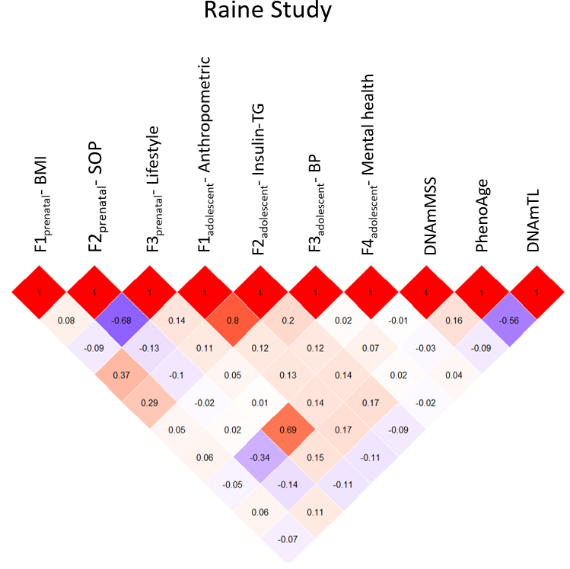
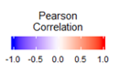
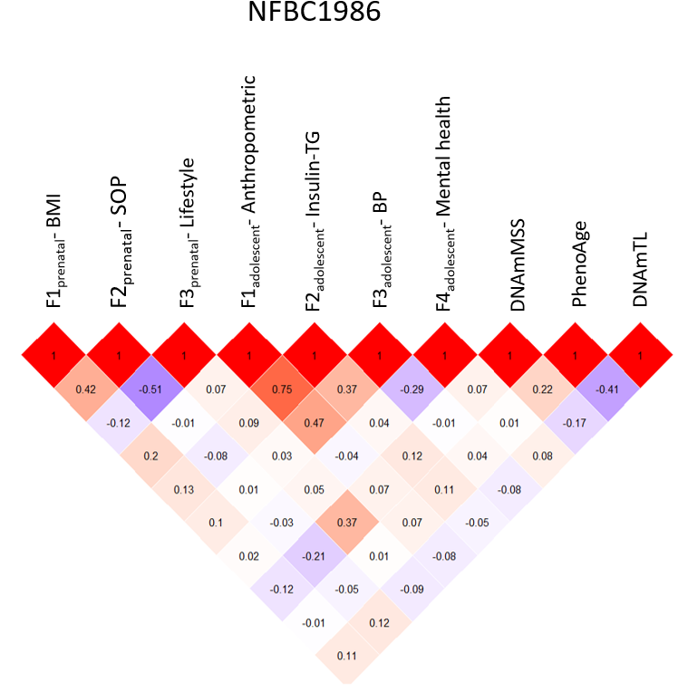

Fig S1. Correlation between prenatal and adolescent psycho-cardiometabolic latent factors with epigenetic biomarkers: DNAmMSS, PhenoAge and DNAmTL.
Abbreviations: BMI: Body Mass Index; BP: Blood Pressure; DNAmMSS: DNA methylation age smoking score; DNAmTL: DNA methylation age telomere length; NFBC1986: Northern Finland Birth Cohort 1986; SOP: Socio-obstetric profile; TG: Triglycerides.

