Supplementary materials

- Figure S1
- Protocol

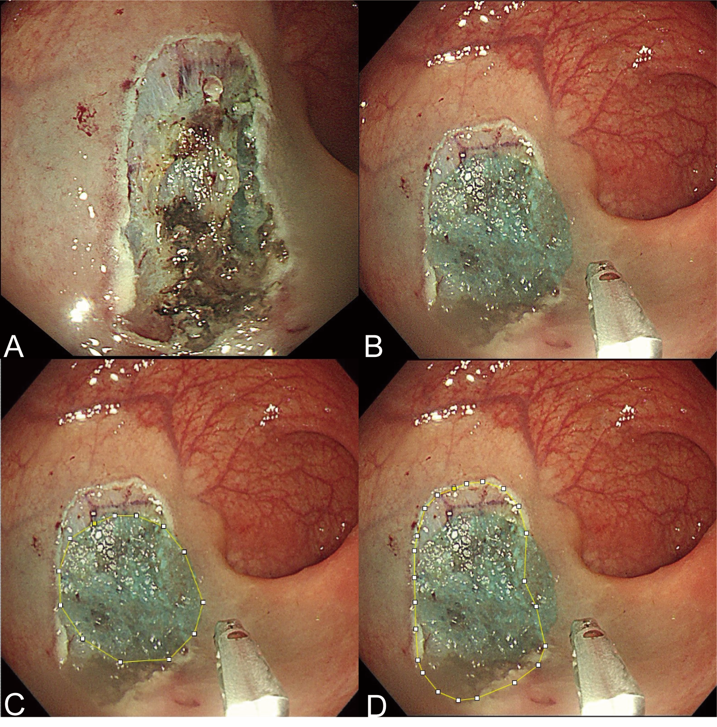
Figure S1. Protocol of measuring the ulcer area by ImageJ 1.53 analysis system. (A) The wound after endoscopic resection. (B) Put the same kind of reference around the ulcer. (C) Measure the area of reference detected from endoscopy. (D) Measure the area of wound detected from endoscopy. The real ulcer area = (The area of wound detected from endoscopy) / (The area of reference detected from endoscopy) * (The real area of the reference).

Protocol
Multi-center, randomized, controlled clinical trials evaluate the safety and efficacy of intestinal mucosal protective gel to promote wound healing and prevent bleeding
Objectives of Study: Assess the effectiveness and safety of temperature-sensitive intestinal wound repairing materials to prevent intestinal postoperative bleeding and promote wound healing.
Inclusion criteria: (1) age 18-80 years, (2) colonic ER scheduled at the hospitals that participated in the study, (3) estimated artificial ulcer size close to or larger than 2 cm and, (4) written consent provided for study participation.
Exclusion criteria: (1) diagnosis of coagulative dysfunction, hepatic or renal failure, or cardiopulmonary dysfunction, (2) diagnosis of other tumors, (3) a history of colectomy or radiotherapy, (4) inability to complete the ER operation, (5) pregnancy and, (6) refusal to participate in the study.
Study execute time: From 2020-12-01 To 2021-09-30
Randomization and masking: Participants are randomly assigned to the control or experimental group in a 1:1 ratio. Using a random number table, the patient number and group are assigned by a designated individual who was not involved with the rest of the study. Masking of the study group allocations is attempted for the participants but not the endoscopists.
Procedures: Following allocation to the respective groups, patients in the control group only undergo a standard colonic ER procedure, whereas those from the experimental group undergo application of the protective gel to the post-ER colonic ulcer. After ER, the colloidal solution is initially sprayed onto the ulcer to cover the wound in experimental group, followed by spraying of the fixative solution.
Following completion of the procedure, participants are instructed to report any adverse events, such as fever or abdominal pain on the first day after ER. Repeat endoscopy is performed to confirm resection site healing, gel status, and delayed bleeding or perforation, if any, at the two-week follow-up visit. Then, participants are followed up for any discomfort one month after the ER procedure.
Outcomes: The primary endpoint of the study is the healing rate, calculated using the following formula: [(Area of initial ulcer) - (Ulcer area 14 days later)] / (Area of initial ulcer) * 100%. And secondary endpoints include ulcer area 14 days later, absolute change of ulcer area, and the wound characteristics in endoscopic re-evaluation 14 days after ER. These endpoints are centrally assessed in the population completing the whole process. Safety outcome is the incidence of adverse events, which are measured among all the patients who are randomly assigned and complete the endoscopic resection.
Statistical analysis: The wound is measured by the same kind of reference through endoscopy initially after ER and 14 days later. Using the ImageJ 1.53 analysis system (National Institutes of Health, Bethesda, MD, USA), the ulcer area initially and 14 days later are quantified. The absolute change of ulcer area is calculated using the following formula: (Area of initial ulcer) - (Ulcer area 14 days later). And the healing rate is calculated using the following formula: (Absolute change of ulcer area) / (Area of initial ulcer) * 100%. Adverse events are summarized by study group and presented as number and proportion of patients.
The results are presented as mean ± standard deviation or counts (percentages). We used the t-test, chi-square, or the Wilcoxon rank sum test for data analysis. All P values are two-sided, and P-values < 0.05 are considered statistically significant. All statistical analyses are performed using the SPSS software, version 25.0.0.0 for macOS or Prism 8.4.0 for macOS.

