An Improved Route to the Regioselective Synthesis of 1,7-dibenzyl-1,4,7,10-tetraazacyclododecane

Xiaoting Zhang, Huirui Li, Dehao Kong, Fuxian Wan*
College of Chemistry and Material Science, Shan Dong Agricultural University, Taian 271018,
People’s Republic of China
*Corresponding author: Fuxian Wan - E-mail: wfx@sdau.edu.cn, The Orcid ID (https://orcid.org/0000-0002-6697-0945),
Contributing authors: Xiaoting Zhang - E-mail: zhangxt372930@163.com, Huirui Li - E-mail: lihuirui29@163.com, Dehao Kong - E-mail: 17866701532@163.com

Schemes and Figures

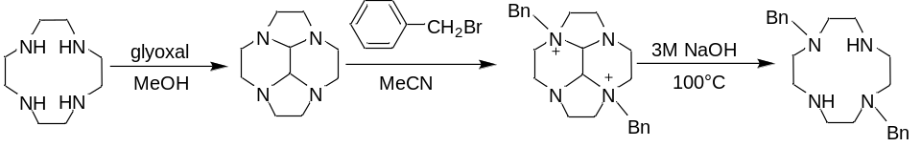
Scheme 1 A synthetic route to 1,7-dibenzyl-1,4,7,10-tetraazacyclododecane
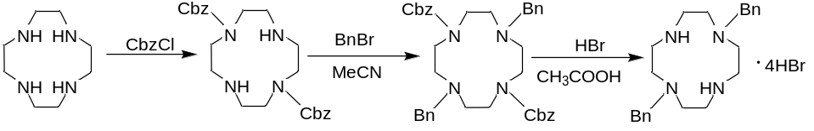
Scheme 2 A synthetic route to 1,7-dibenzyl-1,4,7,10-tetraazacyclododecane
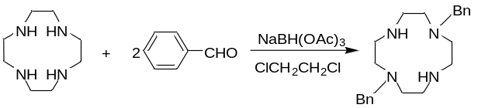
Scheme 3 A synthetic route to 1,7-dibenzyl-1,4,7,10-tetraazacyclododecane

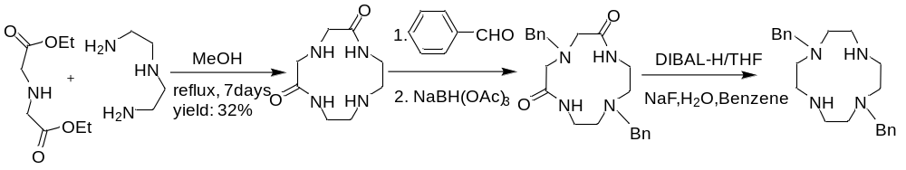
Scheme 4 A synthetic route to 1,7-dibenzyl-1,4,7,10-tetraazacyclododecane
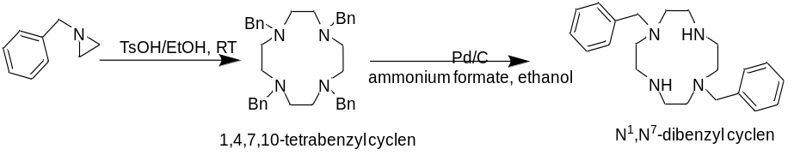
Scheme 5 Synthesis of 1,7-dibenzyl-1,4,7,10-tetraazacyclododecane

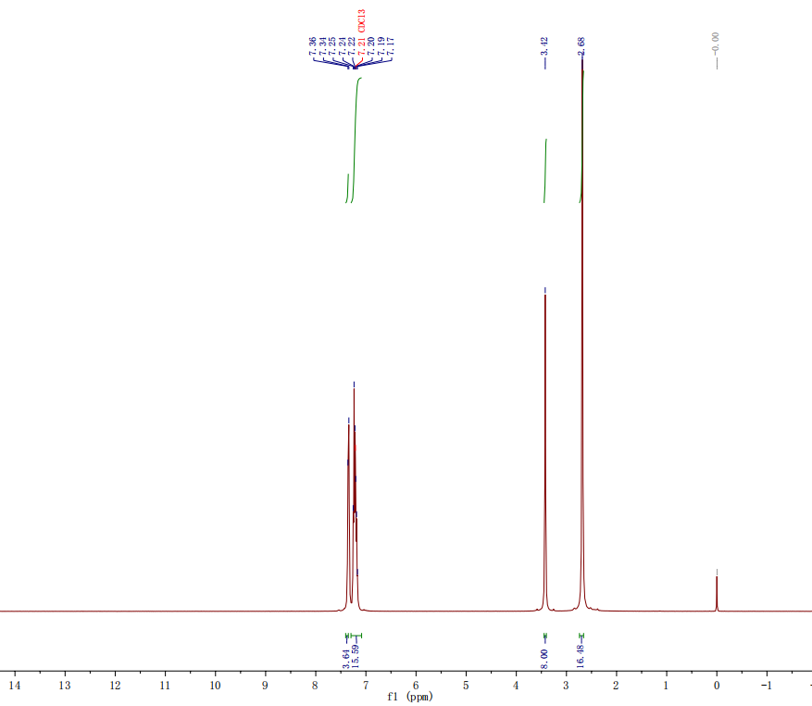
Fig. 1 ¹H NMR spectrum of 1,4,7,10-tetrabenzyl-1,4,7,10-tetraazacyclododecane
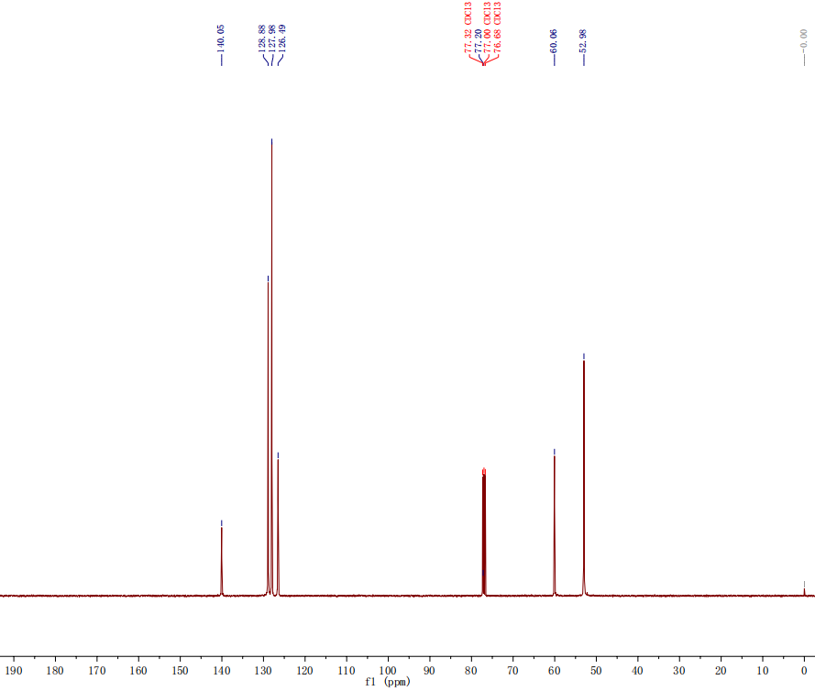
Fig. 2 ¹³C NMR spectrum of 1,4,7,10-tetrabenzyl-1,4,7,10-tetraazacyclododecane
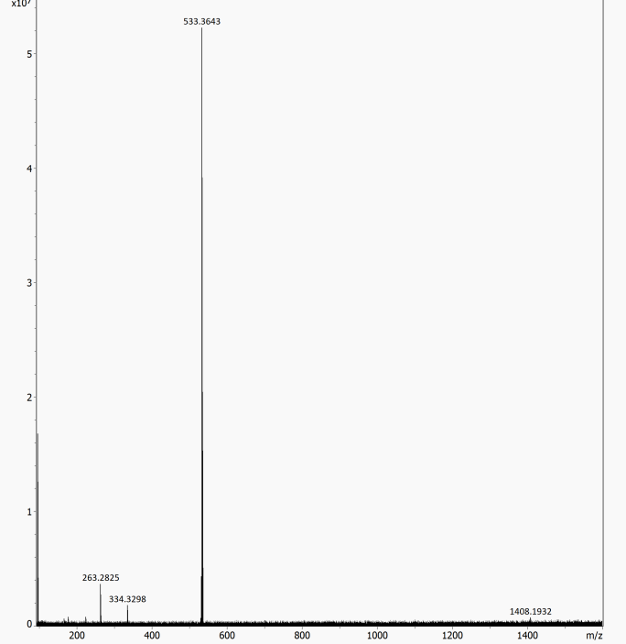
Fig. 3 HR-ESI-Ms spectrum of 1,4,7,10-tetrabenzyl-1,4,7,10-tetraazacyclododecane
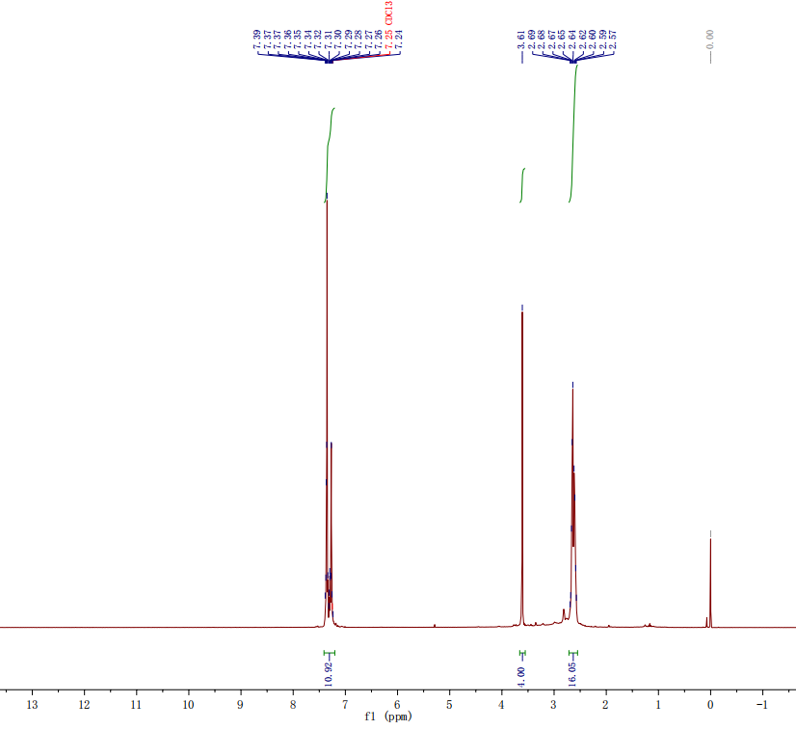
Fig. 4 ¹H NMR spectrum of 1,7-dibenzyl-1,4,7,10-tetraazacyclododecane
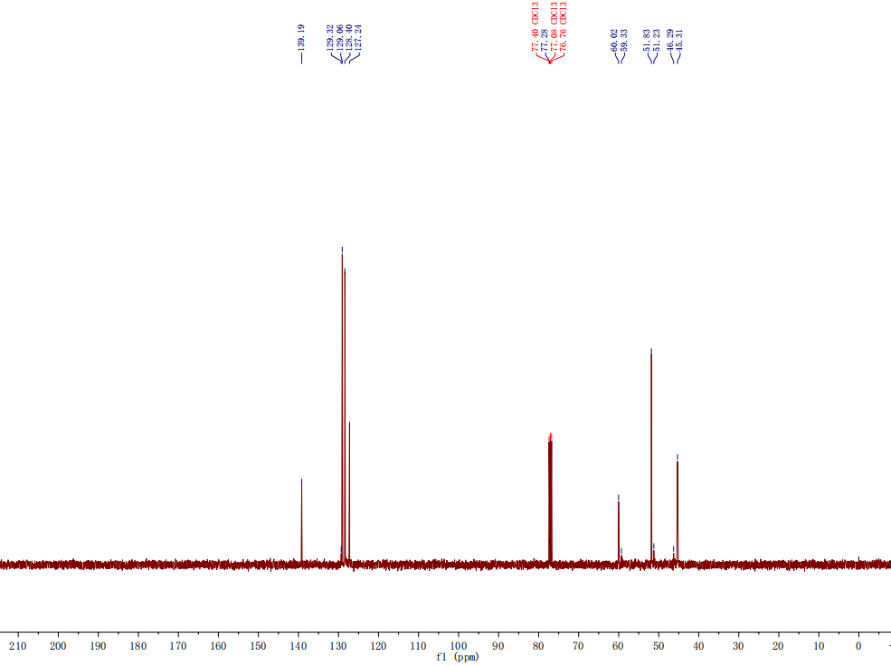
Fig. 5 ¹H NMR spectrum of 1,7-dibenzyl-1,4,7,10-tetraazacyclododecane
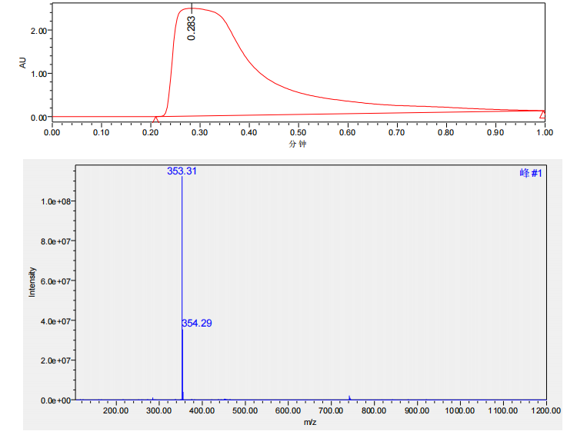
Fig. 6 ESI-MS spectrum of 1,7-dibenzyl-1,4,7,10-tetraazacyclododecane

