Supplementary Information for:

Atomic-level Chemical Reaction Promoting External Quantum Efficiency of Organic Photodetector Exceeding 10⁸% for Weak-Light Detection

Linlin Shi^{1,#}, Yizhi Zhu^{1,#}, Guohui Li^{1,*}, Ting Ji¹, Wenyan Wang¹, Ye Zhang¹, Yukun Wu¹, Yuying Hao¹, Kaiying Wang^{1,4}, Fujun Zhang⁵, Jun Yuan⁶, Yingping Zou⁶, Beng S. Ong^{3,*}, Furong Zhu^{3,*}, and Yanxia Cui^{1,2,*}

¹College of Physics and Optoelectronics, Key Lab of Interface Science and Engineering in Advanced Materials, Key Lab of Advanced Transducers and Intelligent Control System of Ministry of Education, Taiyuan University of Technology, Taiyuan 030024, China
²Shanxi-Zheda Institute of Advanced Materials and Chemical Engineering, Taiyuan 030032, China
³Department of Physics, Research Centre of Excellence for Organic Electronics, Institute of Advanced Materials, Hong Kong Baptist University, Kowloon Tong, Hong Kong, SAR, China
⁴Department of Microsystems, University of South-Eastern Norway, Horten, 3184, Norway
⁵Key Laboratory of Luminescence and Optical Information Ministry of Education, Beijing Jiaotong University, Beijing 100044, China
⁶College of Chemistry and Chemical Engineering, Central South University, Changsha 410083, P.R. China
⁷These authors contributed equally: Linlin Shi, Yizhi Zhu
*Correspondence and requests for materials should be addressed to:
Y. C. (email: yanxiacui@tyut.edu.cn), G. L. (email: liguohui@tyut.edu.cn), B. O. (email: bong@hkbu.edu.hk) or to F. Z. (email: frzhu@hkbu.edu.hk)

Methods
The work function of films were tested by an atomic force microscopy (AFM) instrument equipped with scanning Kelvin Probe Force Microscopy (KPFM), using highly oriented pyrolytic graphite (HOPG) as a calibration. The work functions of the films could be deduced from formula (1) ^{[1]}:
 (1),
where e is the absolute value of the charge of the electron, W_{sample} is the work function of the tested sample, W_{HOPG} is the work function of HOPG (with a fixed value of 4.65 eV), and V_{sample} and V_{HOPG} are the average surface potentials of the sample and HOPG obtained from the KPFM images.
The trap density of state (tDOS) can be calculated according to the formula (2):
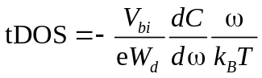 (2),
where V_{bi} is the built-in potential obtained from the intercept of linear region in C⁻²-V curves. k_{B} is Boltzmann constant, T is thermodynamic temperature, and ω is the angular frequency (ω = 2πf). W_{d} is the depletion region width calculated by formula (3):
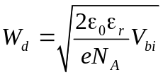 (3),
where ε₀ is the vacuum permittivity, and ε_{r} is the relative permittivity of P3HT:PCBM (100:1) that is approximately 3.8. N_{A} is charge concentration, which can be obtained from the slope of linear region in C⁻²-V curves by formula (4):
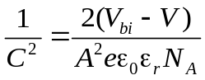 (4),
where A is active area. Besides, the frequency dependent demarcation energy (E_{ω}) can be calculated by the following equation (5):
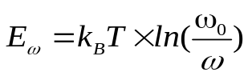 (5),
in which ω₀ is the attempt-to-escape angular frequency of 10¹² 1/s ^{[2]}.
The external quantum efficiency and responsivity values of PM-OPDs were derived according to the number of collected charges and the number of incident photons, as expressed by Equation (6-7) ^{[3]} :
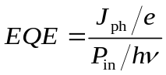 (6),
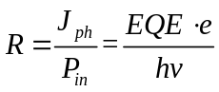 (7).
J_{ph} is the photogenerated current density (the measured current density under light (J_{L}) minus the dark current density (J_{d})), h is the Planck constant, and ν is the frequency of incident light, hν is photon energy, and P_{in} is the illumination power density.
Noise current (i_{n}) is a significant factor evaluating the sensitivity of photodetectors. i_{n} is the root mean square of random fluctuations in dark at a detection bandwidth, including shot noise (i_{sh}), thermal noise (i_{th}), flicker noise (i_{1/f}), and generation-recombination noise (i_{g-r}). Among them, the flicker noise and generation-recombination noise are frequency dependent noise. i_{n} can be expressed by Equation (8):
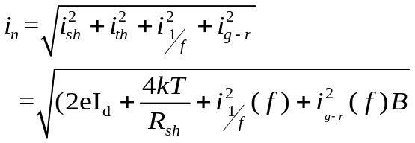 (8),
where e is the elementary electron charge, I_{d} is the dark current, k is the Boltzmann constant, T is the absolute temperature, B is the electrical bandwidth, and R_{sh} is the shunt resistance. Based on i_{n}, the detectivity (D*) of the PM-OPDs can be derived using the following equation:
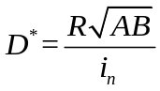 (9),
where A is the active area of the PM-OPDs . If the noise current is dominated by the shot noise, the D* of the PM-OPDs can be derived by the shot noise as an approximation according to the following equation ^{[4,5]}:
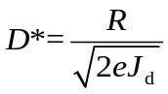 (10).
Dynamic range (DR) is refered as the predictable photoresponse genarated from the minimum to the maximum optical input and it should be determined from the light intensity-dependent photocurrent double logarithmic plot where the slope (β) is invariant. The photodiodes often show a linear dynamic range (LDR) with β=1, while the photoconductors with photogain (G) often show a sublinear DR with β＜1. Thus the DR and LDR of the devices are calculated by the following equation ^{[6-8]}:
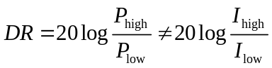 (12)
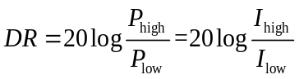 (13),
where P_{high} and P_{low} are the highest and lowest detectable illumination power densities of the photocurrent density versus light intensity curve which lie within the DR or LDR range, and I_{high} and I_{low} are repectively the corresponding photocurrent.
The response time of the PM-OPDs reflected the response speed of the photodetector to receive incident light radiation, which is generally defined as the time for the photocurrent to rise from 10% to 90% of the highest value (fall from 90% to 10% of the highest value) during the on and off cycles of light illumination. The sum of the rise time and the falling time is counted as the response time of the photodetector.
Simulations
The two-dimensional (2D) Finite Element Method (FEM) was used to investigate the optical absorption properties of the PM-OPDs in this paper. All simulations were carried out assuming a periodic boundary along the z axis, which is normal to the film plane. Perfectly matched layer (PML) boundaries were applied at two planes perpendicular to the z axis; one lied in the glass and the other was in the air region next to the Al electrode. Light was illuminated from the ITO glass side. The wavelength dependent refractive indices and extinction coefficients of the P3HT:PC₇₀BM (100:1) layer were taken by the ellipsometer (Wuhan Eoptics Technology Co., Ltd, SE-VM). The refractive indices and extinction coefficients of other materials used in this work were extracted from literatures .^{[9-11]}The wavelength dependent distribution of absorption within the PM-OPDs were calculated over the wavelength range between 300 nm and 800 nm.
Supplementary Figures
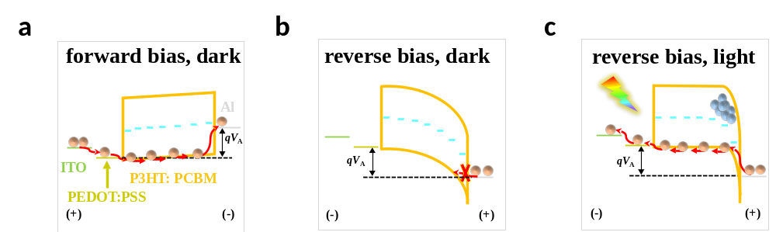
Supplementary Figure 1. Energy band diagrams of the control PM-OPD a-c) under different bias conditions. a) is for the forward biased case in dark. b,c) are for the reverse biased case in dark and under illumination.
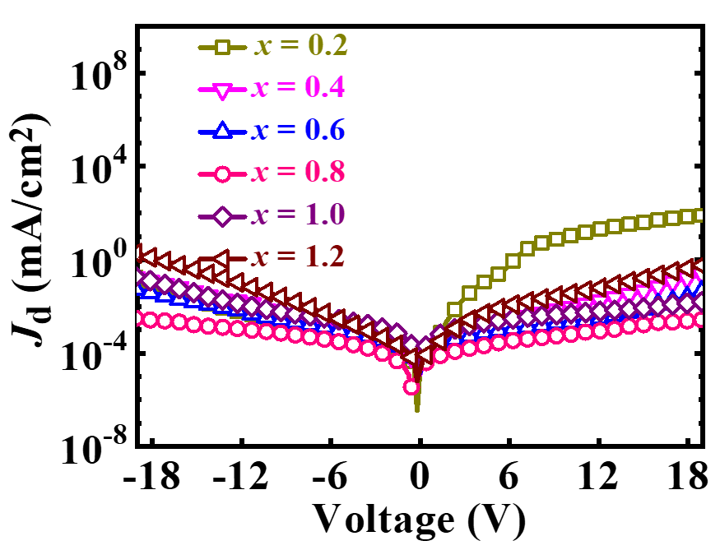
Supplementary Figure 2. J-V curves of the Al₂O₃-PM-OPDs when the thickness of Al₂O₃ layer was tuned from 0.2 nm to 1.2 nm in dark.
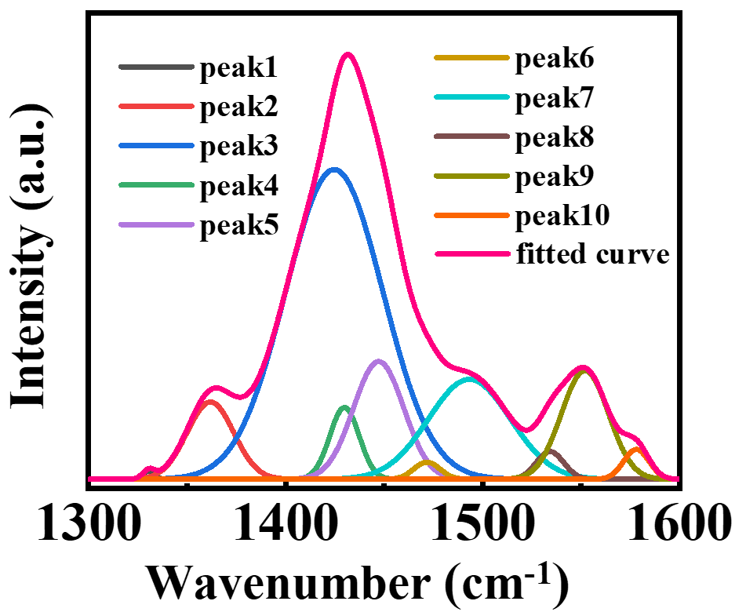
Supplementary Figure 3. Envelope Raman fitting results of the PEDOT:PSS films overlaid with 0.8 nm Al₂O₃ (1331 cm⁻¹, 1362 cm⁻¹, 1425 cm⁻¹, 1432 cm⁻¹, 1448 cm⁻¹, 1471 cm⁻¹, 1496 cm⁻¹, 1535 cm⁻¹, 1552 cm⁻¹, 1579 cm⁻¹, from peak1 to peak 10, respectively).
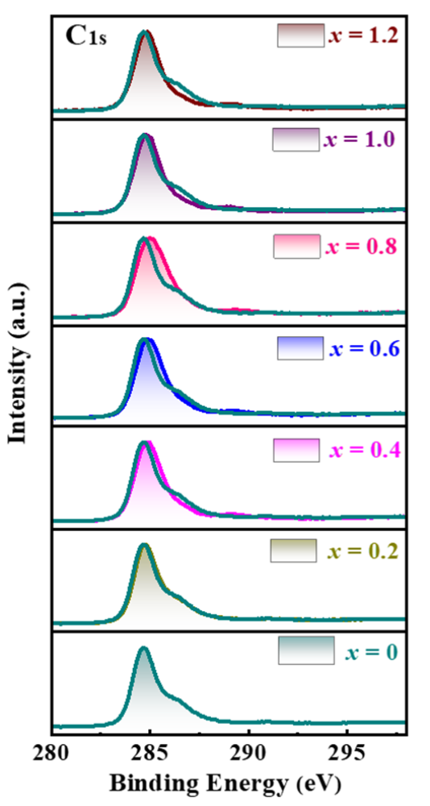
Supplementary Figure 4. Normalized C1s XPS spectroscopies of the PEDOT:PSS films overlaid with Al₂O₃ with different thicknesses (from 0 nm to 1.2 nm).
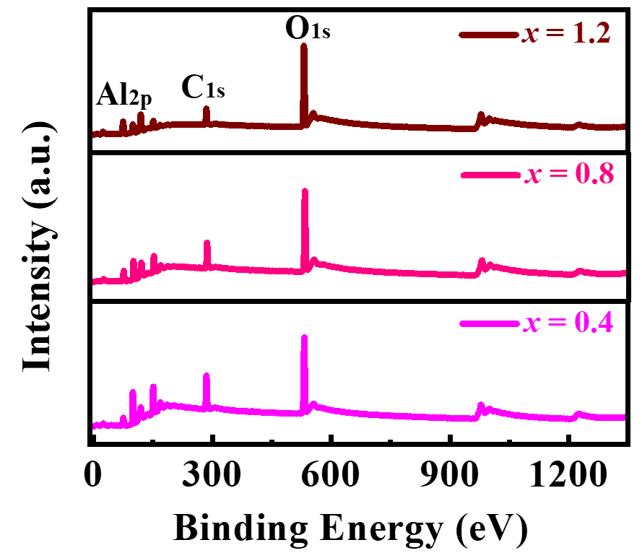
Supplementary Figure 5 Normalized XPS survey spectroscopies of the different thicknesses Al₂O₃ interlayer (from 0.4 nm to 1.2 nm).
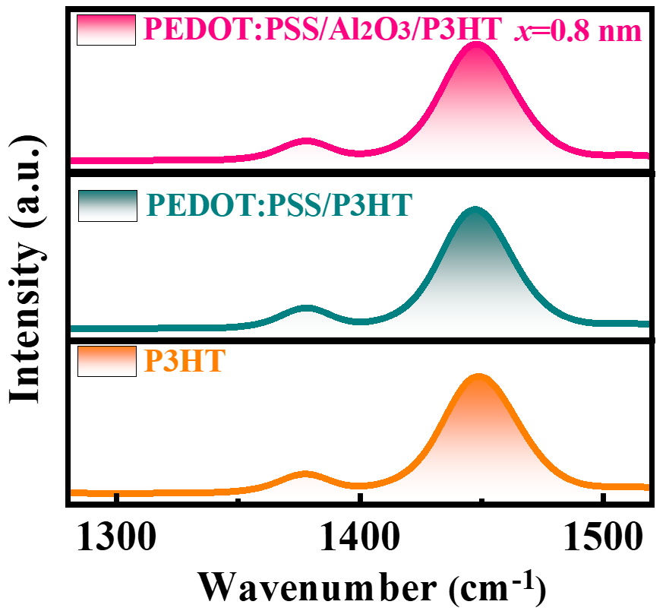
Supplementary Figure 6. Raman spectroscopies of the P3HT donor, PEDOT:PSS/P3HT donor, and PEDOT:PSS/Al₂O₃(0.8 nm)/P3HT dnonr films.
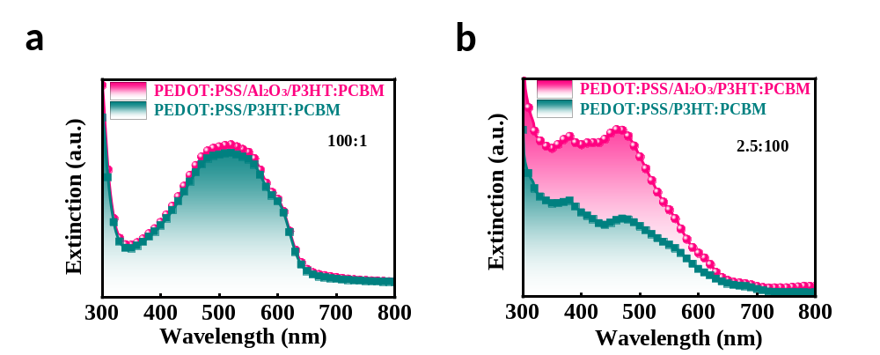
Supplementary Figure 7. The extinction spectrum of donor rich [P3HT:PCBM (100:1)] and acceptor rich [P3HT:PCBM (2.5:100)] films overlaid on the surface of PEDOT:PSS with or without 0.8 nm Al₂O₃.
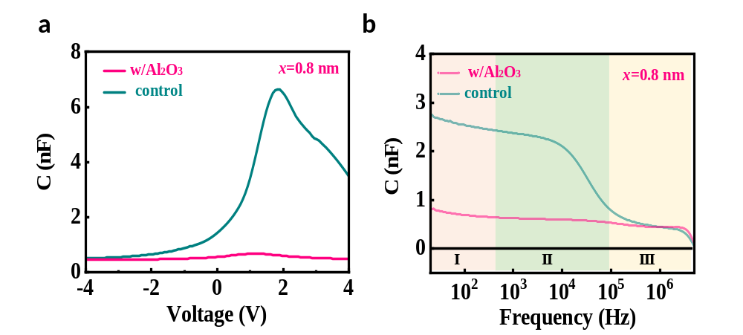
Supplementary Figure 8. Capacitance versus voltage (C-V) characteristic and capacitance versus frequency (C-F) characteristic of control and Al₂O₃-PM-OPD in dark.
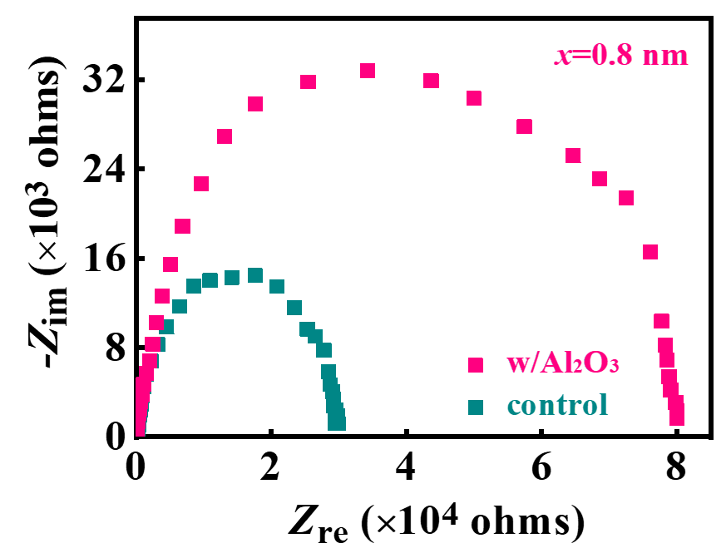
Supplementary Figure 9. Electrochemical impedance spectroscopy (EIS) characteristics of control and Al₂O₃-PM-OPDs measured under -19 V in dark .
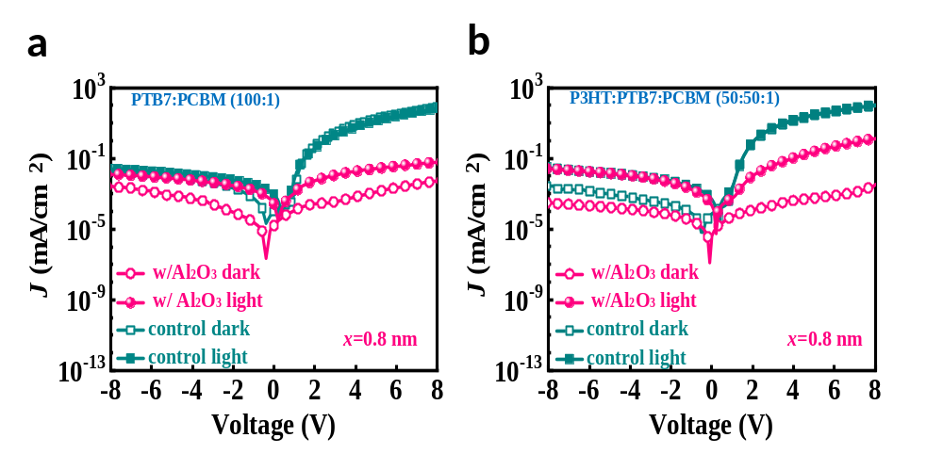
Supplementary Figure 10. J-V curves of photodetectors in dark and under illumination for the configurations of ITO/PEDOT:PSS/PTB7:PCBM/Al with or without Al₂O₃ interlayer a), and ITO/PEDOT:PSS/P3HT:PTB7:PCBM/Al with or without Al₂O₃ interlayer b). The PTB7:PC₇₁BM or PTB7:P3HT:PC₇₁BM solution were prepared by mixing the PTB7 with PC₇₁BM solutions at a weight ratio of 100:1 or 50:50:1, and then spin-coated onto the PEDOT:PSS layer with or without Al₂O₃ treatment at 1200 rpm for 30 s in the glove box.
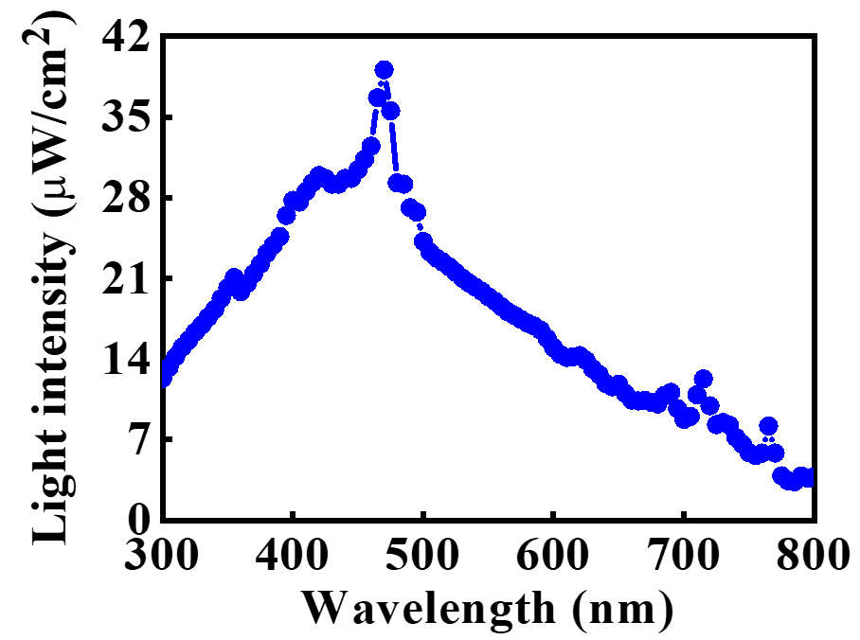
Supplementary Figure 11. Illumination power density spectrum used for resopnsivity spectrum measurements.
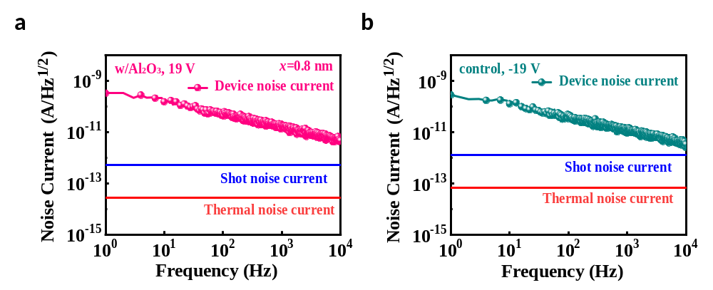
Supplementary Figure 12. Frequency-dependent noise current characteristic of Al₂O₃-PM-OPD (19 V bias) a) and control (-19 V bias) b). Their shot noise currents and thermal noise currents are also included for comparison.

Supplementary Tables
Supplementary Table 1. Performance summary of BHJ-based PM-OPDs.
Year ^{[Ref]} | Active layer |  | EQE@ Wavelength, bias | R (A/W) | D* (Jones) | Response time | D:A weight ratio
2017^{[12]} |  | P3HT:PC₆₁BM | 3.25×10³@550 nm, -1 V | 14.25 | 1.04×10^{12 a)} | 0.17 ms | equal to 1
2021^{[13]} |  | PBDB-T:Y6 | 6.00×10³@638 nm, 3 V | 30.87 | 1.58×10^{12 b)} | 2.21×10⁻² ms | equal to 1
2012^{[14]} |  | PVK:ZnO | 2.45×10⁵@360 nm, -9 V | 721 | 3.4×10^{15 b)} | - | less than 1
2020^{[15]} |  | P3HT:PC₇₁BM | 4.90×10³@640 nm, -5 V | - | 6.50×10^{12 b)} | - | less than 1
2015^{[16]} |  | P3HT:PC₇₁BM | 1.16×10⁵@610 nm, -19 V | 5.69×10² | 2.17×10^{14 a)} | - | larger than 1
2016^{[17]} |  | P3HT:ITIC | 1.17×10³@625 nm, 15 V | 8.80 | 5.95×10^{12 a)} | - | larger than 1
2016^{[18]} |  | P3HT:DC-IDT2T | 3.50×10⁴@640 nm, -20 V | 1.31×10² | 1.43×10^{14 a)} |  | larger than 1
2018^{[19]} |  | P3HT:PTB7-Th:PC₆₁BM | 2.00×10³@650nm, -50V | 0.80 | ~4.00×10^{11 b)} | 35.39 ms | larger than 1
2020^{[20]} |  | P3HT:TV-ITIC | 7.40×10⁴@565 nm, -20 V | - | ~2.30×10^{12 b)} | 4.55 ms | larger than 1
2021^{[21]} |  | P3HT:PC₇₁BM | 1.12×10³@660 nm, -13 V | 5 | 6.40×10^{11 b)} | 800 ms | larger than 1
2021^{[22]} |  | PMBBDT:Y6 | 2.17×10⁴@600 nm,7 V | ~30 | ~8.00×10^{10b)} | - | larger than 1
2021^{[23]} |  | ZnPc:C₆₀ | 2.00×10³@670 nm, -10 V | 10.81 | 2.20×10^{12 c)} | 0.02 ms | larger than 1
2022^{[24]} |  | PBDB-T:BTR:BTPV-4F | 6.00×10²@660 nm, -10 V | 3.19 | 4.67×10^{10 b)} | - | larger than 1
This work |  | P3HT:PC₇₁BM | 4.31×10⁸@532 nm, 19 V | 1.85×10⁶ | 1.13×10^{15 b)} | 562 ms | larger than 1
a) D* was calculated by the shot noise; b) D* was estimated by the noise current; c) D* was estimated by shot and thermal noise current.
Supplementary Table 2. Summary of functions in different solar cells/photodetectors with Al₂O₃.
Year^{[Ref]} | Structure | Main Functions
Solar cells
2018^{[25]} | FTO/bl-TiO₂/mp-TiO₂/perovskite/Spiro-OMeTAD/Au/Al₂O₃(16 nm) | Encapsulation for improving the long-term stability
2018^{[26]} | ITO/TiO₂/PCBM/perovskite/RT-Al₂O₃(9 cycles)/  spiro-OMeTAD/Au | Clean the perovskite surface by the ALD precursors and enhance stability over prolonged time
2020^{[27]} | FTO/bi-SnO₂/perovskite/Spiro-OMeTAD/Au/Al₂O₃  (300 cycles) | Encapsulation for enhancing the long-term stability against moisture and oxygen
2018^{[28]} | Graphene/Al₂O₃(2 nm)/Si | Increase the Schottky barrier height to facilitate the charge transport, and reduce the leakage current by prevent charge recombination
2018^{[29]} | FTO/TiO₂/Al₂O₃(6 cycles)/CuZnSnS₄–TiO₂ nanostructures/Spiro-OMeTAD/Au | Form the PIN junction and prevent surface charge recombination
2019^{[30]} | FTO/TiO₂/Al₂O₃(2-4 nm)/perovskite/carbon | Block holes and prevent charge recombination
2019^{[31]} | FTO/ Al₂O₃(0.6 nm) coated TiO₂ nanorods/Cu₂ZnSnS₄/Au | Prevent charge recombination
2019^{[32]} | FTO/c-TiO₂/mp-TiO₂/Al₂O₃(1 nm)/perovskite/  Spiro-OMeTAD/Au | Prevent charge recombination
Photodetectors
2020^{[33]} | Pt/WSe₂/Au/Al₂O₃(2 nm) | Surface doping and surface trap passivation to improve the device performance
2019^{[34]} | ITO/ZnO/CdS/CZTSSe/Al₂O₃(0.72 nm)/Mo | Protect Mo electrode, block electrons and allow holes tunneling to Mo under illumination, and suppress charge recombination
2019^{[35]} | ITO/ZnO/CdS/Al₂O₃(1.32 nm)/CIGS/Al₂O₃(8 cycles)/Mo | Increase Schottky barrier height, suppress dark current, decrease the tunneling of holes from CIGS to CdS under illumination, and block the recombination
2021^{[36]} | FTO/Al₂O₃(1.5 nm)/Cs₃Bi₂I₉/Au | Prevent the inter diffusion and interaction between halide ions and electrode, create large barrier prevent the transportation of electrons, and prevent surface charge recombination
2021^{[37]} | Al/Ti/Al₂O₃(0.8 nm) /4H-SiC | Passivate surface defects to improve interface inhomogeneity
2012^{[38]} | GaSb/Al_{(x)}GaAs_{(y)}Sb/GaSb:Be/InAs/GaSb:Be/InAs/GaSb/ InAs:Te/GaSb/InAs:Te/Al₂O₃(20 nm)/Ti/Au | Passivate surface defects and prevent current flow through the surface channel
2020^{[39]} | Ag/PbS-Al₂O₃(20 cycles)/Ag | Passivate surface defects and decrease the number of traps
2020^{[40]} | Ti/Au/SnS₂ nanosheets/Al₂O₃(3 nm)/Ti/Au | Introduce tensile strain, change the bond lengths and angles in lattice structure, and passivate the SnS₂ nanosheets
This work | ITO/PEDOT:PSS/Al₂O₃(0.8 nm)/P3HT:PCBM/Al | Form Schottky junction at the anode by changing the work function of PEDOT:PSS thanks to possible chemical interaction, and reduce surface defects through suppression of chemical reaction between PEDOT:PSS and PCBM

References
1. Ding, S. et al. Enhanced performance of perovskite solar cells by the incorporation of the luminescent small molecule DBP: perovskite absorption spectrum modification and interface engineering. J. Mater. Chem. C 7, 5686-5694 (2019).
2. Guo, D. et al. Structure design and performance of photomultiplication-type organic photodetectors based on an aggregation-induced emission material. Nanoscale 12, 2648-2656 (2020).
3. Lan, Z., Lee, M.-H. & Zhu, F. Recent advances in solution‐processable organic photodetectors and applications in flexible electronics. Adv. Intell. Syst. 4, 2100167 (2021).
4. Shi, L. et al. Status and outlook of metal–inorganic semiconductor–metal photodetectors. Laser Photonics Rev. 15, 2000401 (2020).
5. Lan, Z. et al. Near-infrared and visible light dual-mode organic photodetectors. Sci. Adv. 6, eaaw8065 (2020).
6. Fang, Y., Armin, A., Meredith, P. & Huang, J. Accurate characterization of next-generation thin-film photodetectors. Nat. Photon. 13, 1-4 (2018).
7. Wang, Y. et al. Narrowband organic photodetectors–towards miniaturized, spectroscopic sensing. Mater. Horiz. 9, 220-251 (2022).
8. Pierre, A., Gaikwad, A. & Arias, A. C. Charge-integrating organic heterojunction phototransistors for wide-dynamic-range image sensors. Nature Photonics 11, 193-199 (2017).
9. Wang, W. et al. Comparison of nanohole-type and nanopillar-type patterned metallic electrodes incorporated in organic solar cells. Nanoscale Res. Lett. 12, 538 (2017).
10. Zhang, Y., Cui, Y., Ji, T., Hao, Y. & Zhu, F. Absorption enhancement in thin organic solar cells with MoO₃/Ag/MoO₃ transparent anode based on short-pitched metallic grating. IEEE Photon. J. 9, 8400207 (2017).
11. Wang, Z. et al. Incorporating silver-SiO₂ core-shell nanocubes for simultaneous broadband absorption and charge collection enhancements in organic solar cells. Synth. Met. 220, 612-620 (2016).
12. Wang, Y. et al. High sensitivity and fast response solution processed polymer photodetectors with polyethylenimine ethoxylated (PEIE) modified ITO electrode. Opt. Express 25, 7719-7729 (2017).
13. Han, S. G. et al. Photomultiplication‐type organic photodetectors with fast response enabled by the controlled charge trapping dynamics of quantum dot interlayer. Adv. Funct. Mater. 31, 2102087 (2021).
14. Guo, F. et al. A nanocomposite ultraviolet photodetector based on interfacial trap-controlled charge injection. Nat. Nanotechnol. 7, 798-802 (2012).
15. Zhao, Z., Li, C., Shen, L., Zhang, X. & Zhang, F. Photomultiplication type organic photodetectors based on electron tunneling injection. Nanoscale 12, 1091-1099 (2020).
16. Wang, W., Zhang, F., Li, L., Gao, M. & Hu, B. Improved performance of photomultiplication polymer photodetectors by adjustment of P3HT molecular arrangement. ACS. Appl. Mater. Interfaces 7, 22660-22668 (2015).
17. Miao, J. et al. Highly sensitive organic photodetectors with tunable spectral response under bi-directional bias. Adv. Opt. Mater. 4, 1711-1717 (2016).
18. Wang, W. et al. Photomultiplication photodetectors with P3HT:fullerene-free material as the active layers exhibiting a broad response. Nanoscale 8, 5578-5586 (2016).
19. Wang, W. et al. Organic photodetectors with gain and broadband/narrowband response under top/bottom illumination conditions. Adv. Opt. Mater. 6, 1800249 (2018).
20. Sim, H. R. et al. Design and synthesis of a new non‐fullerene acceptor for high‐performance photomultiplication‐type organic photodiodes. Adv. Opt. Mater. 9, 2001836 (2020).
21. Zhao, Z. et al. Highly sensitive narrowband photomultiplication‐type organic photodetectors prepared by transfer‐printed technology. Adv. Funct. Mater. 31, 2106009 (2021).
22. Zhao, Z. et al. Highly sensitive, sub-microsecond polymer photodetectors for blood oxygen saturation testing. Sci. China Chem. 64, 1302-1309 (2021).
23. Kublitski, J. et al. Enhancing sub-bandgap external quantum efficiency by photomultiplication for narrowband organic near-infrared photodetectors. Nat. Commun. 12, 4259 (2021).
24. Yang, K. et al. Employing liquid crystal material as regulator to enhance performance of photomultiplication type polymer photodetectors. Chem. Eng. J. 427, 131802 (2022).
25. Ramos, F. J. et al. Versatile perovskite solar cell encapsulation by low-temperature ALD-Al₂O₃ with long-term stability improvement. Sustain. Energy Fuels 2, 2468-2479 (2018).
26. Kot, M. et al. Room-temperature atomic-layer-deposited Al₂O₃ improves the efficiency of perovskite solar cells over time. ChemSusChem 11, 3640-3648 (2018).
27. Singh, R., Ghosh, S., Subbiah, A. S., Mahuli, N. & Sarkar, S. K. ALD Al₂O₃ on hybrid perovskite solar cells: Unveiling the growth mechanism and long-term stability. Sol. Energy Mater. Sol. Cells 205, 110289 (2020).
28. Alnuaimi, A., Almansouri, I., Saadat, I. & Nayfeh, A. Interface engineering of graphene–silicon Schottky junction solar cells with an Al₂O₃ interfacial layer grown by atomic layer deposition. RSC Advances 8, 10593-10597 (2018).
29. Wang, Z., Brodusch, N., Gauvin, R. & Demopoulos, G. P. Nanoengineering of the Cu₂ZnSnS₄–TiO₂ interface via atomic layer deposition of Al₂O₃ for high sensitivity photodetectors and solid state solar cells. J. Mater. Chem. A 6, 11507-11520 (2018).
30. Ke, K., Kondamareddy, K. K., Gao, F., Zhang, X. & Yuan, X. Fabrication of highly efficient and stable hole‐transport material‐free perovskite solar cells through morphology and interface engineering: full ambient process. Energy Technol. 7, 1900446 (2019).
31. Wang, Z., Brodusch, N., Gauvin, R. & Demopoulos, G. P. New insight into sulfurized and selenized kesterite–titania nanostructures for CdS-free and HTM-free photovoltaic and voltage-modulated photodetecting applications. ACS Sustainable Chem. Eng. 7, 15093-15101 (2019).
32. Liang, Z. et al. Interface modification via Al₂O₃ with retarded charge recombinations for mesoscopic perovskite solar cells fabricated with spray deposition process in the air. Appl. Surf. Sci. 463, 939-946 (2019).
33. McVay, E., Zubair, A., Lin, Y., Nourbakhsh, A. & Palacios, T. Impact of Al₂O₃ passivation on the photovoltaic performance of vertical WSe₂ schottky junction solar cells. ACS. Appl. Mater. Interfaces 12, 57987-57995 (2020).
34. Yan, G. et al. Significantly enhancing response speed of self-powered Cu₂ZnSn(S,Se)₄ thin film photodetectors by atomic layer deposition of simultaneous electron blocking and electrode protective Al₂O₃ layers. ACS. Appl. Mater. Interfaces 11, 32097-32107 (2019).
35. Yuan, Y. et al. Significantly enhanced detectivity of CIGS broadband high-speed photodetectors by grain size control and ALD-Al₂O₃ interfacial-layer modification. ACS Appl. Mater. Interfaces 11, 20157-20166 (2019).
36. Li, W. et al. Tunneling-assisted highly sensitive and stable lead-free Cs₃Bi₂I₉ perovskite photodetectors for diffuse reflection imaging. J. Mater. Chem. C 9, 1008-1013 (2021).
37. Shi, D.-K. et al. Improving the barrier inhomogeneity of 4H-SiC Schottky diodes by inserting Al₂O₃ interface layer. Solid State Electron. 180, 107992 (2021).
38. Salihoglu, O. et al. Atomic layer deposited Al₂O₃ passivation of type II InAs/GaSb superlattice photodetectors. J. Appl. Phys. 111, 074509 (2012).
39. Jiang, C. C. et al. Atomic scale composite oxides infiltration to quantum dot photodetector with ultralow dark current. ACS Appl. Electron. Mater. 2, 155-162 (2020).
40. Liu, X. et al. Impact of Al₂O₃ stress liner on two-dimensional SnS₂ nanosheet for photodetector application. J Alloy Compd 830, 154716 (2020).

