Supplementary Information
The thermodynamic and kinetic aspects of midazolam ring closure from benzophenone to benzodiazepine form, its acid-base equilibria and aromaticity. A quantum-chemical study.

Wojciech Piotr Oziminski*. Michał Matysiak

Faculty of Pharmacy, Medical University of Warsaw, 1 Banacha Street, 02-097, Warsaw, Poland

Email address: wojciech.oziminski@wum.edu.pl

Table S1. Total electronic energy, enthalpy and Gibbs free energy of molecules involved in carbinolamine formation, optimized at B3LYP/6-311++G(d,p) in the Gas Phase and the water environment (PCM) for the first step of ring closure of midazolam
 | Gas Phase |  |  | Water environment (PCM)
 | E [Hartree] | H [Hartree] | G [Hartree] | E [Hartree] | H [Hartree] | G [Hartree]
2a | -1494.756698 | -1494.438167 | -1494.512804 | -1494.773319 | -1494.454933 | -1494.529625
2b (TS) | -1494.702770 | -1494.388167 | -1494.456905 | -1494.721296 | -1494.406775 | -1494.475550
2c | -1494.747405 | -1494.428309 | -1494.497465 | -1494.763469 | -1494.444517 | -1494.513719

Table S2. Total electronic energy, enthalpy and Gibbs free energy of protonated carbinolamine with fixed C-N bond length, optimized at B3LYP/6-311++G(d,p) in the Gas Phase and the water environment (PCM)
 | Gas Phase |  |  | Water environment (PCM)
 | E [Hartree] | H [Hartree] | G [Hartree] | E [Hartree] | H [Hartree] | G [Hartree]
3a | -1495.065870 | -1494.734006 | -1494.804350 | -1495.153212 | -1494.820568 | -1494.890244
3b | -1495.160322 | -1494.828870 | -1494.903840 | -1495.231640 | -1494.900373 | -1494.974966

Table S3. Total electronic energy, enthalpy and Gibbs free energy of closed form midazolam with water molecule attached to nitrogen atom of 7-membered and 5-membered ring in respect to open form, optimized at B3LYP/6-311++G(d,p) in the Gas Phase and in water environment (PCM)
 | Gas Phase |  |  | Water environment (PCM)
 | E [Hartree] | H [Hartree] | G [Hartree] | E [Hartree] | H [Hartree] | G [Hartree]
MDZo | -1494.756698 | -1494.438167 | -1494.512804 | -1494.773319 | -1494.454933 | -1494.529625
5a | -1494.764129 | -1494.446326 | -1494.521792 | -1494.784763 | -1494.467238 | -1494.541849
5b | -1494.76619 | -1494.448395 | -1494.523863 | -1494.785927 | -1494.468564 | -1494.54481

Table S4. Total electronic energy, enthalpy and Gibbs free energy of molecules involved in carbinolamine formation, optimized at B3LYP/6-311++G(d,p) in the Gas Phase and water environment (PCM) for midazolam model
 | Gas Phase |  |  | Water environment (PCM)
 | E [Hartree] | H [Hartree] | G [Hartree] | E [Hartree] | H [Hartree] | G [Hartree]
7a | -511.736258 | -511.565996 | -511.614083 | -511.752576 | -511.582162 | -511.629972
7b (TS) | -511.684567 | -511.517762 | -511.561073 | -511.688060 | -511.520610 | -511.563697
7c | -511.746052 | -511.573821 | -511.617589 | -511.761304 | -511.589087 | -511.632895

Table S5. Total electronic energy, enthalpy and Gibbs free energy of protonated carbinolamine with fixed C-N bond length, optimized at B3LYP/6-311++G(d,p) in the Gas Phase and in water environment (PCM)
 | Gas Phase |  |  | Water environment (PCM)
 | E [Hartree] | H [Hartree] | G [Hartree] | E [Hartree] | H[Hartree] | G [Hartree]
8a | -512.058978 | -511.874727 | -511.917609 | -512.157430 | -511.972536 | -512.015349
8b | -512.138711 | -511.954856 | -512.004271 | -512.219520 | -512.035726 | -512.085557

Table S6. Total electronic energy, enthalpy and Gibbs free energy of closed form midazolam with water molecule attached to nitrogen atom of 7-membered ring in respect to open form, optimized at B3LYP/6-311++G(d,p) in the gas-phase and in water environment (PCM)
 | Gas-phase |  |  | Water environment (PCM)
 | E [Hartree] | H [Hartree] | G [Hartree] | E [Hartree] | H[Hartree] | G [Hartree]
10a | -511.75008 | -511.580277 | -511.630875 | -511.768317 | -511.598621 | -511.648349

TABLE S7. Cartesian coordinates of molecules studied
Gas-phase optimized geometric parameters:
Midazolam (MDZ) – Figure 1
angstroms
X Y Z
Cl -0.817795000 4.374388000 -0.435381000
F -3.049066000 -1.579624000 -1.776792000
N 2.326132000 -0.669731000 -0.000482000
N -0.227279000 -1.834527000 -1.163343000
N 3.846105000 -2.170197000 0.614612000
C 1.560677000 0.517371000 -0.111481000
C 2.178660000 -1.770137000 -0.849230000
C 0.166143000 0.461459000 -0.327115000
C 1.073370000 -1.793119000 -1.844251000
C -0.600154000 -0.820631000 -0.485456000
C 3.363063000 -0.978258000 0.873387000
C 3.124378000 -2.668160000 -0.447685000
C 2.196709000 1.759533000 -0.013511000
C -0.546051000 1.666575000 -0.414706000
C -1.926250000 -0.898634000 0.204628000
C 3.830164000 -0.105861000 1.992427000
C 1.479114000 2.944132000 -0.103493000
C 0.103945000 2.886136000 -0.307039000
C -3.085018000 -1.318173000 -0.453284000
C -2.043304000 -0.587451000 1.566426000
C -4.305672000 -1.443185000 0.193864000
C -3.253010000 -0.717689000 2.240384000
C -4.386518000 -1.147454000 1.551582000
H 1.124951000 -0.919072000 -2.509657000
H 1.162032000 -2.685977000 -2.462764000
H 3.318842000 -3.648457000 -0.854524000
H 3.269762000 1.797674000 0.114692000
H -1.616638000 1.641317000 -0.569578000
H 4.555343000 0.645129000 1.662426000
H 3.003462000 0.417663000 2.478535000
H 4.325675000 -0.742195000 2.725223000
H 1.983017000 3.899302000 -0.032344000
H -1.162477000 -0.252045000 2.102119000
H -5.170176000 -1.765660000 -0.373102000
H -3.311043000 -0.485247000 3.296916000
H -5.334811000 -1.247961000 2.066466000
Number of imaginary frequencies: 0

2a
angstroms
X Y Z
C 0.008607000 -1.213253000 1.097214000
C -0.449630000 2.357627000 2.069130000
C -0.950073000 2.276234000 0.664101000
H -0.706174000 3.354973000 2.452225000
N -0.971775000 1.259125000 2.902253000
N -0.368881000 1.495036000 -0.343715000
C 2.370952000 -0.933362000 0.489472000
C 1.078828000 -0.397609000 0.405499000
C 0.894856000 0.825805000 -0.262657000
C 1.994526000 1.467511000 -0.839283000
C 3.266706000 0.912710000 -0.786529000
C 3.441793000 -0.292194000 -0.113217000
H 2.516698000 -1.860925000 1.026469000
H 1.843137000 2.424292000 -1.324644000
H 4.109265000 1.413449000 -1.245622000
C -2.011569000 2.891870000 0.058572000
H -2.714731000 3.576279000 0.510352000
N -2.101179000 2.543132000 -1.267968000
C -1.098778000 1.726536000 -1.498899000
C -0.747636000 1.169877000 -2.839591000
H -0.001927000 1.794164000 -3.343806000
H -0.349457000 0.157207000 -2.781834000
H -1.647103000 1.168996000 -3.455123000
Cl 5.042812000 -1.004998000 -0.018039000
C -1.331852000 -1.437343000 0.464062000
C -2.479641000 -1.413890000 1.267622000
C -1.492924000 -1.802012000 -0.869920000
C -3.730990000 -1.696589000 0.735039000
H -2.357172000 -1.156464000 2.311220000
C -2.725241000 -2.107891000 -1.423539000
C -3.854080000 -2.041026000 -0.611890000
H -4.609938000 -1.654832000 1.367111000
H -2.783927000 -2.398527000 -2.464909000
H -4.827222000 -2.268182000 -1.031211000
F -0.393207000 -1.912603000 -1.663218000
H 0.642320000 2.288701000 2.081330000
O 0.269569000 -1.751337000 2.153919000
H -0.506056000 1.237233000 3.804592000
H -1.963502000 1.393663000 3.073028000
Number of imaginary frequencies: 0

2b
angstroms
X Y Z
C -0.134945000 0.939288000 1.211652000
C 1.453109000 -0.805578000 2.378919000
C 2.009293000 -1.490051000 1.190707000
H 2.175892000 -0.823273000 3.195916000
N 1.135695000 0.617003000 2.078174000
N 1.240441000 -1.669857000 0.045381000
C -2.172158000 -0.175188000 0.414896000
C -0.777515000 -0.280350000 0.504411000
C -0.163360000 -1.427012000 -0.036556000
C -0.954338000 -2.424321000 -0.623440000
C -2.328758000 -2.289926000 -0.738434000
C -2.927925000 -1.149878000 -0.214165000
H -2.648242000 0.681531000 0.870982000
H -0.480616000 -3.331280000 -0.973828000
H -2.924484000 -3.066763000 -1.199621000
C 3.267284000 -1.914654000 0.861753000
H 4.145585000 -1.930831000 1.489847000
N 3.304640000 -2.341459000 -0.442122000
C 2.089385000 -2.183780000 -0.920817000
C 1.708004000 -2.459749000 -2.337983000
H 1.289936000 -3.462651000 -2.469566000
H 0.978143000 -1.738220000 -2.709961000
H 2.611675000 -2.397226000 -2.943845000
Cl -4.671304000 -0.960611000 -0.321934000
C 0.186939000 2.072374000 0.210755000
C -0.545986000 3.259794000 0.314256000
C 1.135392000 2.011965000 -0.806431000
C -0.341369000 4.318077000 -0.566755000
H -1.270699000 3.319753000 1.116471000
C 1.372310000 3.050370000 -1.692667000
C 0.618220000 4.214884000 -1.572498000
H -0.927386000 5.223832000 -0.464561000
H 2.134257000 2.934509000 -2.453591000
H 0.786307000 5.036057000 -2.259578000
F 1.893015000 0.887554000 -0.936132000
H 0.526607000 -1.260481000 2.739861000
O -0.882412000 1.380449000 2.267194000
H 0.342363000 1.156702000 2.815422000
H 1.968059000 1.119757000 1.770916000
Number of imaginary frequencies: 1

2c
angstroms
X Y Z
C 0.751550000 -0.644554000 1.137080000
C -1.396256000 -1.465816000 2.106866000
C -2.439784000 -1.258354000 1.070248000
H -1.669161000 -2.330727000 2.712328000
N -0.128624000 -1.747608000 1.417909000
N -2.242898000 -0.310756000 0.069036000
C 0.878753000 1.733779000 0.475933000
C 0.044285000 0.606316000 0.548445000
C -1.290674000 0.745989000 0.108068000
C -1.743247000 2.012629000 -0.296439000
C -0.906825000 3.113831000 -0.361309000
C 0.420834000 2.955360000 0.016065000
H 1.907029000 1.638881000 0.795622000
H -2.786421000 2.133311000 -0.550711000
H -1.282642000 4.076591000 -0.682215000
C -3.535897000 -1.975795000 0.690980000
H -3.986900000 -2.812940000 1.201969000
N -4.018371000 -1.520995000 -0.515232000
C -3.236763000 -0.533146000 -0.881702000
C -3.359114000 0.175470000 -2.192417000
H -3.969376000 1.082018000 -2.128367000
H -2.384648000 0.450426000 -2.600394000
H -3.854646000 -0.503722000 -2.886111000
Cl 1.520962000 4.322947000 -0.062279000
C 1.849701000 -1.154970000 0.192585000
C 3.174532000 -1.311325000 0.611578000
C 1.553089000 -1.526665000 -1.120005000
C 4.148995000 -1.820033000 -0.246061000
H 3.432440000 -1.026388000 1.622003000
C 2.502824000 -2.032554000 -1.991949000
C 3.814518000 -2.182119000 -1.547868000
H 5.167558000 -1.931173000 0.106546000
H 2.203925000 -2.299588000 -2.997997000
H 4.567331000 -2.577277000 -2.219925000
F 0.289731000 -1.381254000 -1.585279000
H -1.322840000 -0.610679000 2.797649000
O 1.454631000 -0.209071000 2.333308000
H 0.821941000 0.239423000 2.905147000
H 0.401548000 -2.487130000 1.861673000
Number of imaginary frequencies: 0

3a
angstroms
X Y Z
C 0.680246000 -0.649748000 1.147206000
C -1.556793000 -1.067376000 2.241877000
C -2.492454000 -0.893040000 1.112083000
H -1.950506000 -1.802407000 2.944020000
N -0.230317000 -1.555006000 1.781300000
N -2.203345000 0.012386000 0.088247000
C 1.144112000 1.679470000 0.398999000
C 0.162797000 0.678721000 0.539128000
C -1.152112000 0.957421000 0.099975000
C -1.437135000 2.253701000 -0.358238000
C -0.469728000 3.239205000 -0.461348000
C 0.838163000 2.940625000 -0.093529000
H 2.184314000 1.462252000 0.617483000
H -2.457214000 2.492335000 -0.623783000
H -0.728287000 4.227492000 -0.818928000
C -3.608424000 -1.566493000 0.708543000
H -4.138977000 -2.346430000 1.233710000
N -4.014972000 -1.124116000 -0.526173000
C -3.177157000 -0.188265000 -0.895409000
C -3.229909000 0.503140000 -2.217596000
H -3.771963000 1.452399000 -2.168667000
H -2.235325000 0.696456000 -2.624403000
H -3.772291000 -0.145117000 -2.904894000
Cl 2.094416000 4.136193000 -0.247186000
C 1.617591000 -1.395203000 0.192294000
C 2.974451000 -1.614815000 0.456745000
C 1.110591000 -1.890308000 -1.011311000
C 3.774811000 -2.303535000 -0.451689000
H 3.421020000 -1.248108000 1.371566000
C 1.884997000 -2.578510000 -1.926536000
C 3.232320000 -2.784834000 -1.640382000
H 4.821579000 -2.463290000 -0.225891000
H 1.429638000 -2.938272000 -2.840671000
H 3.853696000 -3.321010000 -2.347026000
F -0.199609000 -1.689284000 -1.288958000
H -1.401897000 -0.141321000 2.808015000
O 1.494111000 -0.219666000 2.267542000
H 1.386724000 0.729036000 2.498218000
H -0.303029000 -2.434696000 1.285073000
H 1.263285000 -0.827506000 3.010136000
Number of imaginary frequencies: 0

3b
angstroms
X Y Z
Cl 0.551086000 4.612502000 -0.812226000
F -3.258646000 -1.025319000 -1.379208000
N 2.197792000 -1.043346000 0.111321000
N -0.563971000 -1.523971000 -0.880608000
N 3.310185000 -2.825118000 0.839797000
C 1.775494000 0.285341000 -0.118174000
C 1.754660000 -2.145946000 -0.630729000
C 0.405488000 0.617915000 -0.305137000
C 0.652993000 -1.962894000 -1.603404000
C -0.695622000 -0.362338000 -0.302946000
C 3.159107000 -1.533200000 0.997177000
C 2.453920000 -3.217282000 -0.160437000
C 2.726182000 1.309234000 -0.149068000
C 0.051888000 1.966213000 -0.506759000
C -1.970661000 -0.020734000 0.348020000
C 3.877585000 -0.719819000 2.021757000
C 2.361429000 2.632476000 -0.352453000
C 1.018169000 2.958256000 -0.536763000
C -3.216144000 -0.379252000 -0.192341000
C -1.975928000 0.682914000 1.569096000
C -4.412687000 -0.058059000 0.419656000
C -3.165944000 0.987193000 2.212758000
C -4.383152000 0.621839000 1.635187000
H 0.879213000 -1.211398000 -2.366457000
H 0.413128000 -2.900337000 -2.100623000
H 2.394346000 -4.245379000 -0.483792000
H 3.772087000 1.060601000 -0.036114000
H -0.985069000 2.230893000 -0.661447000
H 4.774403000 -0.244170000 1.613453000
H 3.244734000 0.059418000 2.451793000
H 4.198633000 -1.393042000 2.815730000
H 3.117630000 3.406538000 -0.386291000
H -1.032282000 0.968830000 2.016079000
H -5.343692000 -0.336104000 -0.057872000
H -3.147761000 1.512001000 3.159385000
H -5.315202000 0.870511000 2.128214000
H -1.303529000 -2.235729000 -0.788001000
O -2.213804000 -3.801740000 -0.769169000
H -3.022718000 -3.951345000 -1.271392000
H -2.082829000 -4.586150000 -0.224800000
Number of imaginary frequencies: 0

4a
angstroms
X Y Z
Cl -0.497486000 4.465674000 -0.624495000
F -2.896808000 -2.246491000 -1.412545000
N 2.257907000 -0.773461000 0.079613000
N -0.269494000 -1.717468000 -1.158965000
N 3.684633000 -2.345671000 0.736795000
C 1.575861000 0.453601000 -0.078913000
C 2.110178000 -1.863635000 -0.788823000
C 0.179322000 0.505689000 -0.338603000
C 1.054761000 -1.814313000 -1.825718000
C -0.682761000 -0.685377000 -0.464954000
C 3.248515000 -1.136642000 0.992366000
C 2.994872000 -2.807125000 -0.357308000
C 2.285803000 1.652816000 0.023805000
C -0.441083000 1.760011000 -0.497729000
C -2.002767000 -0.710575000 0.173620000
C 3.713139000 -0.294178000 2.132937000
C 1.659443000 2.881553000 -0.128836000
C 0.292370000 2.931661000 -0.400714000
C -3.073999000 -1.492805000 -0.300182000
C -2.238897000 0.039641000 1.347140000
C -4.312741000 -1.518077000 0.305165000
C -3.469063000 0.008139000 1.984510000
C -4.508181000 -0.761795000 1.459543000
H 1.150583000 -0.954238000 -2.495641000
H 1.054467000 -2.720622000 -2.427781000
H 3.177430000 -3.788111000 -0.769113000
H 3.352182000 1.620110000 0.198789000
H -1.497898000 1.813338000 -0.720763000
H 4.511282000 0.392833000 1.835864000
H 2.903533000 0.292875000 2.571705000
H 4.121365000 -0.958235000 2.893895000
H 2.233044000 3.797223000 -0.060131000
H -1.435097000 0.630072000 1.765537000
H -5.099788000 -2.124894000 -0.124218000
H -3.619937000 0.581231000 2.890338000
H -5.473627000 -0.780975000 1.950616000
H -0.868958000 -2.533974000 -1.205713000
Number of imaginary frequencies: 0

4b
angstroms
X Y Z
Cl -0.707444000 4.434030000 -0.463634000
F -3.015454000 -1.777383000 -1.718511000
N 2.277138000 -0.689029000 0.007441000
N -0.259738000 -1.756347000 -1.204930000
N 3.651047000 -2.238142000 0.600964000
C 1.540266000 0.541950000 -0.101356000
C 2.117406000 -1.749971000 -0.895837000
C 0.149012000 0.506652000 -0.314161000
C 1.025128000 -1.689861000 -1.904411000
C -0.637166000 -0.764735000 -0.489321000
C 3.213533000 -1.011818000 0.924212000
C 2.985673000 -2.720621000 -0.512906000
C 2.228376000 1.752514000 -0.021402000
C -0.524904000 1.730141000 -0.410823000
C -1.956568000 -0.843734000 0.193570000
C 3.678126000 -0.216877000 2.090731000
C 1.543731000 2.955359000 -0.126414000
C 0.163511000 2.935184000 -0.320789000
C -3.084606000 -1.389543000 -0.433146000
C -2.109018000 -0.402711000 1.518359000
C -4.305065000 -1.508106000 0.213672000
C -3.319138000 -0.528005000 2.189142000
C -4.418637000 -1.082413000 1.533648000
H 1.117024000 -0.777341000 -2.508304000
H 1.100693000 -2.544415000 -2.576108000
H 3.171239000 -3.700161000 -0.918014000
H 3.304579000 1.762836000 0.094899000
H -1.595562000 1.734901000 -0.566484000
H 4.525156000 0.423758000 1.829490000
H 2.875271000 0.417688000 2.466460000
H 3.996422000 -0.886264000 2.891710000
H 2.075171000 3.896499000 -0.074591000
H -1.258309000 0.032264000 2.030742000
H -5.145605000 -1.926681000 -0.325527000
H -3.407001000 -0.193492000 3.215339000
H -5.368337000 -1.177795000 2.046169000
H 4.357802000 -2.739652000 1.121670000
Number of imaginary frequencies: 0

5a
angstroms
X Y Z
Cl 0.518581000 4.575886000 -0.875118000
F -3.323408000 -0.709197000 -1.399165000
N 2.199855000 -1.055651000 0.112690000
N -0.624257000 -1.590987000 -0.858651000
N 3.288606000 -2.838481000 0.871119000
C 1.779012000 0.274882000 -0.125394000
C 1.719424000 -2.160404000 -0.597159000
C 0.412400000 0.581805000 -0.309502000
C 0.604438000 -1.987718000 -1.565051000
C -0.680884000 -0.445549000 -0.296583000
C 3.159169000 -1.539452000 0.996502000
C 2.406673000 -3.233543000 -0.110363000
C 2.730168000 1.299097000 -0.186725000
C 0.048661000 1.918397000 -0.530833000
C -1.937012000 -0.079941000 0.428342000
C 3.900903000 -0.712372000 1.995077000
C 2.355917000 2.617127000 -0.407255000
C 1.008399000 2.917142000 -0.581839000
C -3.205419000 -0.262490000 -0.127352000
C -1.882011000 0.432481000 1.732740000
C -4.372747000 0.031013000 0.560252000
C -3.038440000 0.720443000 2.448868000
C -4.286459000 0.519322000 1.860640000
H 0.854410000 -1.239249000 -2.329978000
H 0.410026000 -2.932643000 -2.071299000
H 2.306752000 -4.267854000 -0.400638000
H 3.778401000 1.055819000 -0.080975000
H -0.994796000 2.171043000 -0.665064000
H 4.784111000 -0.229644000 1.564192000
H 3.272527000 0.067090000 2.432589000
H 4.243095000 -1.376951000 2.787896000
H 3.102431000 3.399036000 -0.459240000
H -0.912386000 0.590736000 2.190504000
H -5.325736000 -0.125360000 0.070434000
H -2.966475000 1.099510000 3.461045000
H -5.193198000 0.744899000 2.409372000
O -2.439258000 -3.844971000 -1.321069000
H -3.205965000 -3.495040000 -1.783737000
H -1.926916000 -3.054529000 -1.069345000
Number of imaginary frequencies: 0

5b
angstroms
X Y Z
Cl -2.294373000 4.122156000 -0.024597000
F -3.121430000 -2.121972000 -1.676698000
N 2.029872000 0.039052000 -0.396932000
N -0.278939000 -1.660383000 -1.397093000
N 3.925768000 -1.062790000 -0.087424000
C 0.985510000 0.996376000 -0.313442000
C 2.053172000 -1.000679000 -1.330490000
C -0.366104000 0.596133000 -0.385815000
C 0.872447000 -1.236352000 -2.203750000
C -0.803353000 -0.826954000 -0.586145000
C 3.201359000 -0.049928000 0.337939000
C 3.229061000 -1.656972000 -1.116892000
C 1.302512000 2.350447000 -0.167785000
C -1.360181000 1.580276000 -0.284781000
C -1.968803000 -1.291589000 0.229251000
C 3.578895000 0.835051000 1.480009000
C 0.307868000 3.313692000 -0.071470000
C -1.024347000 2.916750000 -0.133352000
C -3.056479000 -1.959823000 -0.338693000
C -1.989189000 -1.104912000 1.618538000
C -4.114526000 -2.439317000 0.419475000
C -3.032066000 -1.588562000 2.401391000
C -4.096737000 -2.257963000 1.799401000
H 0.623436000 -0.332750000 -2.778538000
H 1.100626000 -2.029488000 -2.915355000
H 3.608034000 -2.524504000 -1.633767000
H 2.339897000 2.654800000 -0.148052000
H -2.401720000 1.290371000 -0.327937000
H 4.036878000 1.770079000 1.142385000
H 2.715725000 1.088020000 2.100040000
H 4.318285000 0.311251000 2.086175000
H 0.563981000 4.359725000 0.035461000
H -1.162376000 -0.583285000 2.087157000
H -4.933277000 -2.942081000 -0.080178000
H -3.014216000 -1.443945000 3.474852000
H -4.916412000 -2.634626000 2.399953000
O 6.263591000 -1.327230000 1.560793000
H 5.537112000 -1.371441000 0.905748000
H 6.521358000 -2.238391000 1.723960000
Number of imaginary frequencies: 0

Midazolam model MMDZ – Figure 6
angstroms
X Y Z
N -0.578682000 0.676034000 0.145210000
N 1.864356000 -1.211609000 -0.343369000
N -2.643103000 -0.033988000 -0.293656000
C 0.492925000 1.551398000 0.285104000
C -0.529212000 -0.719099000 0.154332000
C 1.785175000 1.242329000 0.068877000
C 0.715242000 -1.442693000 0.542686000
C 2.311552000 -0.022172000 -0.459451000
C -1.891509000 1.018483000 -0.126520000
H 0.999389000 -1.160519000 1.567455000
H 0.503239000 -2.512281000 0.549675000
H 3.218300000 0.088227000 -1.059332000
H 0.201965000 2.562605000 0.546223000
H 2.499781000 2.051804000 0.171136000
H -2.202827000 2.049317000 -0.209680000
C -1.807247000 -1.121567000 -0.121267000
H -2.179405000 -2.132280000 -0.185342000
Number of imaginary frequencies: 0

7a
angstroms
X Y Z
C -2.147064000 -0.438863000 -0.603403000
C 0.422451000 1.810883000 0.701553000
C 1.152788000 0.616022000 0.178781000
H 1.150013000 2.631156000 0.767792000
N -0.761882000 2.134103000 -0.111166000
N 0.711989000 -0.702956000 0.319118000
C -1.686982000 -0.999629000 0.687704000
C -0.413793000 -1.167581000 1.056793000
C 2.354424000 0.512649000 -0.475586000
H 3.010439000 1.319933000 -0.765547000
N 2.673023000 -0.799824000 -0.735461000
C 1.686121000 -1.500301000 -0.236702000
H 0.074320000 1.617133000 1.721523000
O -3.324556000 -0.312000000 -0.862215000
H -1.307352000 2.874694000 0.318530000
H -0.487596000 2.452459000 -1.035667000
H -1.366367000 -0.205620000 -1.343162000
H -0.167700000 -1.683545000 1.980572000
H -2.472720000 -1.352459000 1.348005000
H 1.593819000 -2.576096000 -0.256605000
Number of imaginary frequencies: 0

7b
angstroms
X Y Z
C -2.068190000 0.245448000 0.511714000
C -0.322699000 -1.366030000 -0.626044000
C 0.939345000 -0.699214000 -0.221268000
H -0.153044000 -2.436149000 -0.753295000
N -1.417145000 -1.176663000 0.359473000
N 1.022810000 0.684987000 -0.118432000
C -1.318646000 1.406812000 -0.103497000
C -0.018994000 1.618808000 -0.318050000
N 3.058505000 -0.114581000 0.307592000
C 2.329836000 0.969115000 0.197213000
H -0.698097000 -0.971101000 -1.574836000
O -3.246010000 -0.071280000 -0.078217000
H -2.545682000 -1.276493000 -0.035894000
H -1.187369000 -1.602988000 1.257482000
H -2.117305000 0.418969000 1.607277000
H 2.671083000 1.982932000 0.344467000
H 0.329260000 2.573107000 -0.696054000
H -1.992760000 2.220671000 -0.348072000
C 2.203803000 -1.160083000 0.048461000
H 2.546073000 -2.184044000 0.053062000
Number of imaginary frequencies: 1

7c
angstroms
X Y Z
C 2.133440000 0.112459000 -0.428524000
C 0.344583000 -1.465130000 0.243123000
C -0.943752000 -0.725636000 0.112940000
H 0.138306000 -2.525434000 0.089881000
N 1.321346000 -1.028455000 -0.760507000
N -0.995707000 0.663122000 0.045960000
C 1.362460000 1.375652000 -0.154699000
C 0.054321000 1.588269000 0.030578000
N -3.106552000 -0.055755000 -0.001687000
C -2.336225000 0.996724000 -0.019787000
H 0.737106000 -1.374643000 1.269388000
O 3.079037000 -0.114582000 0.648795000
H 2.640499000 0.053013000 1.490431000
H 1.921510000 -1.795219000 -1.038172000
H 2.784098000 0.288731000 -1.289019000
H -2.658304000 2.025088000 -0.091866000
H -0.293263000 2.602032000 0.195182000
H 1.991289000 2.257251000 -0.092833000
C -2.249103000 -1.135447000 0.079137000
H -2.621490000 -2.147898000 0.113680000
Number of imaginary frequencies: 0

8a
angstroms
X Y Z
C -2.009193000 0.115448000 0.512773000
C -0.277091000 -1.442893000 -0.407336000
C 0.997502000 -0.728586000 -0.136360000
H -0.103560000 -2.518811000 -0.380350000
N -1.366084000 -1.137178000 0.541133000
N 1.050154000 0.672876000 -0.101925000
C -1.307716000 1.365466000 0.071610000
C 0.011226000 1.576202000 -0.113941000
N 3.146030000 -0.057685000 0.103973000
C 2.399270000 0.999675000 0.041452000
H -0.639159000 -1.218028000 -1.418133000
O -3.162319000 -0.002098000 -0.368374000
H -3.018152000 0.341084000 -1.274261000
H -1.208983000 -1.488068000 1.476854000
H -3.496868000 -0.925142000 -0.389026000
H 2.726758000 2.026750000 0.114700000
H -2.483485000 0.284173000 1.482356000
H 0.338613000 2.597119000 -0.279593000
H -1.931931000 2.253368000 0.070474000
C 2.291945000 -1.140325000 -0.009331000
H 2.668951000 -2.151680000 -0.011496000
Number of imaginary frequencies: 1

8b
angstroms
X Y Z
N -1.476026000 0.436538000 0.045289000
N 1.595678000 0.109568000 0.158862000
N -2.852882000 -1.263879000 -0.397524000
C -1.032665000 1.723299000 0.044480000
C -0.741570000 -0.743677000 0.246549000
C 0.263667000 2.159443000 0.019466000
C 0.610198000 -0.728720000 0.868595000
C 1.440616000 1.376425000 -0.108632000
C -2.763688000 0.021762000 -0.341612000
H 0.558727000 -0.362562000 1.901065000
H 1.004735000 -1.742966000 0.897087000
H 2.514698000 -0.314285000 -0.047524000
H 2.329184000 1.874961000 -0.486932000
H -1.827086000 2.460311000 -0.006206000
H 0.404972000 3.229513000 -0.055410000
H -3.532738000 0.739612000 -0.588935000
O 4.107021000 -0.986464000 -0.427909000
H 4.872530000 -1.045557000 0.155510000
H 4.366333000 -1.411828000 -1.253599000
C -1.607380000 -1.757152000 -0.026181000
H -1.429986000 -2.819359000 0.045831000
Number of imaginary frequencies: 0

9a
angstroms
X Y Z
N -0.623050000 0.671222000 0.150765000
N 1.889470000 -1.081029000 -0.244192000
N -2.691336000 -0.065773000 -0.260801000
C 0.388574000 1.571220000 0.218890000
C -0.551696000 -0.731617000 0.095418000
C 1.731310000 1.341462000 0.047893000
C 0.673147000 -1.472368000 0.500680000
C 2.364969000 0.137934000 -0.330691000
C -1.980254000 0.990883000 -0.072361000
H 0.887936000 -1.321737000 1.565209000
H 0.517655000 -2.538039000 0.341677000
H 3.361506000 0.214295000 -0.756569000
H 0.057468000 2.594524000 0.362262000
H 2.368494000 2.215662000 0.065846000
H -2.313064000 2.018497000 -0.111360000
C -1.822660000 -1.147729000 -0.150387000
H -2.186819000 -2.160774000 -0.229653000
H 2.460898000 -1.832080000 -0.614480000
Number of imaginary frequencies: 0

9b
angstroms
X Y Z
N -0.530398000 0.686180000 0.158847000
N 1.824048000 -1.229456000 -0.392614000
N -2.520562000 -0.019655000 -0.294252000
C 0.579430000 1.555966000 0.351249000
C -0.491971000 -0.712825000 0.223251000
C 1.838241000 1.208761000 0.059961000
C 0.760156000 -1.426631000 0.598393000
C 2.287747000 -0.054367000 -0.555027000
C -1.776696000 1.076993000 -0.150344000
H 1.090748000 -1.081458000 1.587251000
H 0.549383000 -2.492985000 0.673694000
H 3.128610000 0.046248000 -1.242523000
H 0.310749000 2.540789000 0.710514000
H 2.593640000 1.975413000 0.198880000
H -2.107572000 2.093900000 -0.281658000
C -1.749852000 -1.145191000 -0.075664000
H -2.153513000 -2.141418000 -0.134345000
H -3.505991000 -0.016202000 -0.526590000
Number of imaginary frequencies: 0

10a
angstroms
X Y Z
N -1.428034000 0.465669000 -0.008442000
N 1.640983000 -0.030755000 0.282649000
N -2.802168000 -1.218959000 -0.491387000
C -0.926595000 1.759905000 0.028998000
C -0.758706000 -0.708000000 0.344765000
C 0.377648000 2.096486000 0.052645000
C 0.556325000 -0.664612000 1.045310000
C 1.521814000 1.191845000 -0.070990000
C -2.662167000 0.076465000 -0.501936000
H 0.448690000 -0.133348000 2.002174000
H 0.857069000 -1.687015000 1.275383000
O 4.179545000 -1.012970000 -0.723783000
H 4.717483000 -1.323814000 0.009420000
H 3.311702000 -0.792356000 -0.332156000
H 2.396071000 1.628584000 -0.558012000
H -1.691335000 2.527082000 -0.014920000
H 0.604352000 3.156305000 0.025144000
H -3.377932000 0.797010000 -0.869221000
C -1.624893000 -1.719067000 0.033987000
H -1.478487000 -2.778512000 0.176034000
Number of imaginary frequencies: 0

10b
angstroms
X Y Z
N -0.064328000 0.596806000 -0.279849000
N -2.581359000 -1.066799000 0.524287000
N 1.961608000 -0.274037000 -0.031542000
C -1.072925000 1.557082000 -0.340555000
C -0.228932000 -0.789346000 -0.243642000
C -2.352500000 1.360509000 0.024118000
C -1.563295000 -1.411726000 -0.477057000
C -2.914977000 0.157841000 0.652192000
C 1.286373000 0.838507000 -0.152801000
H -1.933324000 -1.123172000 -1.471967000
H -1.442778000 -2.495353000 -0.478586000
O 4.788370000 0.251771000 0.446164000
H 3.872167000 -0.047925000 0.292708000
H 5.327508000 -0.266532000 -0.157292000
H -3.733952000 0.358292000 1.347012000
H -0.731653000 2.531457000 -0.670446000
H -3.009045000 2.221917000 -0.032485000
H 1.695044000 1.837444000 -0.129320000
C 1.031505000 -1.294795000 -0.084704000
H 1.326126000 -2.330520000 -0.024519000
Number of imaginary frequencies: 0
Water solution optimized geometric parameters
Midazolam (MDZ) – Figure 1

angstroms
X Y Z
Cl -0.818385000 4.376035000 -0.435977000
F -3.059315000 -1.586936000 -1.777931000
N 2.321928000 -0.670540000 0.001501000
N -0.216494000 -1.823612000 -1.192934000
N 3.823328000 -2.183711000 0.619118000
C 1.558145000 0.521923000 -0.106538000
C 2.183341000 -1.754718000 -0.866850000
C 0.166791000 0.464289000 -0.334935000
C 1.088055000 -1.758827000 -1.873116000
C -0.595972000 -0.816416000 -0.503590000
C 3.336673000 -0.989451000 0.888736000
C 3.117167000 -2.665227000 -0.465267000
C 2.195515000 1.760621000 0.004304000
C -0.547396000 1.667973000 -0.422820000
C -1.915880000 -0.903610000 0.196256000
C 3.786141000 -0.125052000 2.020221000
C 1.477816000 2.945523000 -0.087449000
C 0.105304000 2.884678000 -0.304132000
C -3.082973000 -1.321219000 -0.446531000
C -2.018216000 -0.594525000 1.560909000
C -4.298217000 -1.446640000 0.208248000
C -3.222033000 -0.726483000 2.246027000
C -4.364117000 -1.153271000 1.568363000
H 1.139624000 -0.867919000 -2.513402000
H 1.186482000 -2.635187000 -2.512659000
H 3.313377000 -3.638895000 -0.887453000
H 3.266641000 1.802481000 0.143943000
H -1.616090000 1.643666000 -0.589203000
H 4.521357000 0.620651000 1.703356000
H 2.951161000 0.403792000 2.484052000
H 4.258752000 -0.759528000 2.769832000
H 1.983585000 3.898475000 -0.005485000
H -1.133309000 -0.258197000 2.088679000
H -5.171000000 -1.764537000 -0.348521000
H -3.268971000 -0.494906000 3.303099000
H -5.307443000 -1.252428000 2.091942000
Number of imaginary frequencies: 0

2a
angstroms
X Y Z
C 0.028209000 -1.083947000 1.215499000
C -0.382255000 2.697936000 1.722429000
C -0.959062000 2.338638000 0.391217000
H -0.718113000 3.716545000 1.955550000
N -0.733282000 1.719784000 2.769576000
N -0.388740000 1.428713000 -0.507606000
C 2.384999000 -0.865839000 0.557955000
C 1.087997000 -0.349693000 0.433350000
C 0.887462000 0.790845000 -0.365616000
C 1.971794000 1.376456000 -1.021730000
C 3.250713000 0.842006000 -0.920386000
C 3.441221000 -0.281582000 -0.123451000
H 2.546955000 -1.734894000 1.180915000
H 1.809170000 2.270617000 -1.610836000
H 4.081166000 1.299226000 -1.441975000
C -2.075632000 2.803504000 -0.247817000
H -2.788242000 3.523317000 0.127205000
N -2.205167000 2.237544000 -1.498401000
C -1.171785000 1.433120000 -1.645138000
C -0.836514000 0.686187000 -2.893837000
H -0.158504000 1.269041000 -3.525913000
H -0.357385000 -0.270951000 -2.691081000
H -1.751738000 0.510659000 -3.459299000
Cl 5.051131000 -0.971818000 0.029241000
C -1.327704000 -1.348401000 0.633363000
C -2.475964000 -1.116919000 1.403392000
C -1.500719000 -1.949248000 -0.611154000
C -3.737710000 -1.437886000 0.915344000
H -2.357350000 -0.666317000 2.380100000
C -2.742229000 -2.299379000 -1.113849000
C -3.870593000 -2.028541000 -0.342753000
H -4.616003000 -1.234360000 1.515703000
H -2.812723000 -2.778934000 -2.082004000
H -4.850970000 -2.289240000 -0.723142000
F -0.398509000 -2.252124000 -1.352960000
H 0.708912000 2.734314000 1.655351000
O 0.301062000 -1.530579000 2.315746000
H -0.243669000 1.953115000 3.629399000
H -1.725701000 1.786670000 2.977712000
Number of imaginary frequencies: 0

2b
angstroms
X Y Z
C -0.023011000 0.916805000 1.244597000
C 1.279843000 -1.067347000 2.365998000
C 1.765611000 -1.750333000 1.143723000
H 1.990391000 -1.202644000 3.180742000
N 1.128626000 0.395527000 2.141227000
N 0.995463000 -1.771975000 -0.015568000
C -2.208079000 0.100241000 0.434145000
C -0.838265000 -0.180215000 0.515170000
C -0.371631000 -1.367868000 -0.080767000
C -1.275155000 -2.237868000 -0.703636000
C -2.624733000 -1.934403000 -0.802537000
C -3.075648000 -0.752242000 -0.228286000
H -2.577741000 0.996335000 0.911455000
H -0.918105000 -3.179797000 -1.096732000
H -3.308029000 -2.615377000 -1.292270000
C 2.962453000 -2.311760000 0.801185000
H 3.824195000 -2.463115000 1.433502000
N 2.960083000 -2.670814000 -0.528984000
C 1.776431000 -2.336437000 -1.006000000
C 1.365759000 -2.496391000 -2.432855000
H 0.829048000 -3.433586000 -2.606654000
H 0.725266000 -1.677111000 -2.764096000
H 2.264978000 -2.510549000 -3.048817000
Cl -4.787029000 -0.341740000 -0.317739000
C 0.466099000 1.981106000 0.240977000
C -0.270531000 3.167630000 0.131049000
C 1.570534000 1.860384000 -0.598283000
C 0.077917000 4.161398000 -0.779051000
H -1.119557000 3.295216000 0.789544000
C 1.953949000 2.835172000 -1.506120000
C 1.192518000 3.996625000 -1.601544000
H -0.515324000 5.065966000 -0.840345000
H 2.833885000 2.675579000 -2.116972000
H 1.474960000 4.767491000 -2.308581000
F 2.345198000 0.739772000 -0.519405000
H 0.310131000 -1.444170000 2.700101000
O -0.733042000 1.482257000 2.291850000
H 0.362371000 1.022046000 2.878494000
H 2.027020000 0.821139000 1.918727000
Number of imaginary frequencies: 1

2c
angstroms
X Y Z
C 0.745406000 -0.645700000 1.144570000
C -1.412631000 -1.434082000 2.121153000
C -2.445842000 -1.239718000 1.070941000
H -1.693058000 -2.284140000 2.742276000
N -0.143983000 -1.743872000 1.437535000
N -2.246374000 -0.297117000 0.066318000
C 0.887297000 1.728335000 0.468485000
C 0.046097000 0.606551000 0.544299000
C -1.287063000 0.758598000 0.105211000
C -1.736762000 2.025991000 -0.297198000
C -0.894123000 3.122879000 -0.363708000
C 0.432692000 2.950850000 0.008842000
H 1.914686000 1.629726000 0.789047000
H -2.779279000 2.156778000 -0.548297000
H -1.267959000 4.086653000 -0.682905000
C -3.534652000 -1.965612000 0.686721000
H -3.983866000 -2.801705000 1.200960000
N -4.008786000 -1.515378000 -0.529312000
C -3.225244000 -0.521185000 -0.892832000
C -3.345733000 0.198593000 -2.197490000
H -3.965490000 1.097029000 -2.124568000
H -2.372115000 0.493870000 -2.591700000
H -3.823190000 -0.473555000 -2.910877000
Cl 1.546202000 4.313323000 -0.073290000
C 1.839507000 -1.166228000 0.198323000
C 3.170579000 -1.305017000 0.605952000
C 1.540902000 -1.557712000 -1.107743000
C 4.144039000 -1.813309000 -0.254026000
H 3.437934000 -1.008113000 1.610118000
C 2.486143000 -2.063385000 -1.984161000
C 3.804062000 -2.193754000 -1.549861000
H 5.166127000 -1.909870000 0.092321000
H 2.184118000 -2.345161000 -2.985339000
H 4.554998000 -2.588142000 -2.224058000
F 0.266168000 -1.434674000 -1.567184000
H -1.338138000 -0.564829000 2.789858000
O 1.449917000 -0.207363000 2.333198000
H 0.810430000 0.193719000 2.934170000
H 0.380473000 -2.459804000 1.927329000
Number of imaginary frequencies: 0

3a
angstroms
X Y Z
C 0.640859000 -0.686244000 1.165879000
C -1.604004000 -1.062479000 2.222490000
C -2.543437000 -0.826515000 1.100307000
H -2.019702000 -1.799942000 2.908071000
N -0.314750000 -1.576489000 1.722929000
N -2.209576000 0.064831000 0.082030000
C 1.184807000 1.632062000 0.417109000
C 0.176950000 0.663265000 0.555885000
C -1.125242000 0.983567000 0.109548000
C -1.380154000 2.284797000 -0.343368000
C -0.384086000 3.242171000 -0.447197000
C 0.909128000 2.895805000 -0.080262000
H 2.208557000 1.394754000 0.677113000
H -2.392112000 2.556210000 -0.606679000
H -0.615863000 4.237109000 -0.803090000
C -3.679674000 -1.455208000 0.684339000
H -4.233732000 -2.223600000 1.201533000
N -4.056062000 -0.993361000 -0.559560000
C -3.167215000 -0.090116000 -0.913795000
C -3.163782000 0.604866000 -2.235977000
H -3.670107000 1.573577000 -2.198702000
H -2.151300000 0.767719000 -2.609093000
H -3.702307000 -0.021875000 -2.946696000
Cl 2.207285000 4.063751000 -0.233647000
C 1.575303000 -1.429146000 0.201178000
C 2.935841000 -1.630608000 0.455787000
C 1.071419000 -1.926390000 -1.002010000
C 3.740449000 -2.309379000 -0.457276000
H 3.379156000 -1.254975000 1.367749000
C 1.848178000 -2.604429000 -1.922822000
C 3.199463000 -2.797159000 -1.643878000
H 4.790204000 -2.454193000 -0.235089000
H 1.393780000 -2.966469000 -2.836339000
H 3.822791000 -3.325335000 -2.354839000
F -0.243613000 -1.736537000 -1.287170000
H -1.414869000 -0.157580000 2.806232000
O 1.457763000 -0.294832000 2.298118000
H 1.294625000 0.600781000 2.660973000
H -0.397855000 -2.449132000 1.219931000
H 1.369200000 -0.971354000 3.007095000
Number of imaginary frequencies: 0

3b
angstroms
X Y Z
Cl 0.580363000 4.608364000 -0.749886000
F -3.254075000 -0.886820000 -1.466094000
N 2.200836000 -1.068972000 0.087132000
N -0.559442000 -1.520765000 -0.925915000
N 3.282775000 -2.865879000 0.813588000
C 1.786261000 0.269293000 -0.123725000
C 1.751680000 -2.153990000 -0.669774000
C 0.420643000 0.605307000 -0.307141000
C 0.657154000 -1.951369000 -1.649497000
C -0.683733000 -0.373545000 -0.327046000
C 3.137618000 -1.568261000 0.980639000
C 2.430382000 -3.239315000 -0.203505000
C 2.744702000 1.283436000 -0.142684000
C 0.069699000 1.954917000 -0.486736000
C -1.955525000 -0.036810000 0.334348000
C 3.841459000 -0.762273000 2.020725000
C 2.385868000 2.611649000 -0.326657000
C 1.044410000 2.937574000 -0.501380000
C -3.203367000 -0.325073000 -0.236217000
C -1.947073000 0.589716000 1.594672000
C -4.395715000 -0.015987000 0.390326000
C -3.133946000 0.882844000 2.251054000
C -4.356238000 0.583706000 1.647265000
H 0.896248000 -1.189294000 -2.396020000
H 0.421505000 -2.879406000 -2.163973000
H 2.348532000 -4.262436000 -0.536238000
H 3.789827000 1.030895000 -0.035900000
H -0.966841000 2.223434000 -0.634088000
H 4.743732000 -0.284490000 1.628380000
H 3.199413000 0.017053000 2.435020000
H 4.143685000 -1.432547000 2.824936000
H 3.146769000 3.380644000 -0.348841000
H -0.998597000 0.822352000 2.061708000
H -5.330884000 -0.241715000 -0.105684000
H -3.107186000 1.347760000 3.228135000
H -5.284912000 0.822070000 2.151181000
H -1.310001000 -2.231786000 -0.840185000
O -2.399979000 -3.600924000 -0.617985000
H -3.070585000 -3.774704000 -1.289498000
H -2.035245000 -4.462853000 -0.383783000
Number of imaginary frequencies: 0

4a
angstroms
X Y Z
Cl -0.510106000 4.461557000 -0.607258000
F -2.933560000 -2.140001000 -1.486012000
N 2.260834000 -0.773043000 0.069319000
N -0.260584000 -1.712152000 -1.176619000
N 3.667402000 -2.352601000 0.739502000
C 1.576328000 0.458552000 -0.081422000
C 2.113006000 -1.853086000 -0.804866000
C 0.183139000 0.502813000 -0.336342000
C 1.058904000 -1.796831000 -1.846534000
C -0.672629000 -0.694107000 -0.470983000
C 3.226660000 -1.138099000 0.993994000
C 2.985115000 -2.805387000 -0.369265000
C 2.288817000 1.653992000 0.017032000
C -0.444624000 1.751179000 -0.488430000
C -1.986688000 -0.726045000 0.179268000
C 3.665506000 -0.294754000 2.143866000
C 1.657992000 2.881739000 -0.130536000
C 0.291644000 2.919860000 -0.391679000
C -3.078210000 -1.454068000 -0.326070000
C -2.188658000 -0.032231000 1.390565000
C -4.309572000 -1.485525000 0.294609000
C -3.411822000 -0.071930000 2.042583000
C -4.473305000 -0.790371000 1.491626000
H 1.158535000 -0.928652000 -2.502812000
H 1.060633000 -2.695708000 -2.456697000
H 3.153729000 -3.786775000 -0.784713000
H 3.356155000 1.626159000 0.184315000
H -1.503065000 1.798510000 -0.702599000
H 4.454485000 0.407255000 1.859621000
H 2.838173000 0.279558000 2.564644000
H 4.066387000 -0.950536000 2.916195000
H 2.230910000 3.797085000 -0.062667000
H -1.366658000 0.518702000 1.827066000
H -5.117309000 -2.047657000 -0.155616000
H -3.538234000 0.457236000 2.978116000
H -5.433114000 -0.815268000 1.992783000
H -0.849956000 -2.536019000 -1.230054000
Number of imaginary frequencies: 0

4b
angstroms

X Y Z
Cl -0.853395000 4.396812000 -0.417230000
F -3.053410000 -1.646803000 -1.772110000
N 2.298115000 -0.636391000 -0.007640000
N -0.224166000 -1.777074000 -1.227545000
N 3.727885000 -2.135056000 0.575456000
C 1.527698000 0.566957000 -0.112140000
C 2.162709000 -1.707800000 -0.902085000
C 0.138315000 0.493302000 -0.324930000
C 1.073062000 -1.684387000 -1.913583000
C -0.613344000 -0.792796000 -0.509933000
C 3.260646000 -0.925094000 0.897405000
C 3.066789000 -2.645560000 -0.524642000
C 2.173632000 1.798255000 -0.017226000
C -0.579144000 1.693815000 -0.403873000
C -1.926901000 -0.906661000 0.191424000
C 3.722729000 -0.107780000 2.045924000
C 1.450022000 2.980188000 -0.104465000
C 0.074210000 2.913196000 -0.297138000
C -3.082840000 -1.364920000 -0.445760000
C -2.034786000 -0.583042000 1.552616000
C -4.292747000 -1.513431000 0.213246000
C -3.233526000 -0.739231000 2.240781000
C -4.364226000 -1.204610000 1.569642000
H 1.135860000 -0.773263000 -2.521326000
H 1.179070000 -2.540140000 -2.577958000
H 3.285560000 -3.618404000 -0.927418000
H 3.247125000 1.843603000 0.103251000
H -1.649337000 1.666545000 -0.558084000
H 4.537388000 0.558777000 1.751479000
H 2.907056000 0.495063000 2.443865000
H 4.092219000 -0.765882000 2.832113000
H 1.954191000 3.934600000 -0.035194000
H -1.158927000 -0.217965000 2.076119000
H -5.157681000 -1.861079000 -0.337826000
H -3.285441000 -0.496093000 3.294888000
H -5.303952000 -1.322255000 2.095761000
H 4.458643000 -2.610858000 1.088753000
Number of imaginary frequencies: 0

5a
angstroms
X Y Z
Cl 0.530807000 4.589975000 -0.778949000
F -3.305327000 -0.680680000 -1.480254000
N 2.198383000 -1.065791000 0.088417000
N -0.599654000 -1.574497000 -0.946435000
N 3.262907000 -2.872627000 0.814349000
C 1.782344000 0.275753000 -0.118631000
C 1.739020000 -2.140256000 -0.675201000
C 0.419440000 0.583525000 -0.319486000
C 0.642551000 -1.929395000 -1.656844000
C -0.670165000 -0.444378000 -0.349056000
C 3.126245000 -1.573246000 0.983105000
C 2.409639000 -3.233225000 -0.209232000
C 2.735424000 1.297482000 -0.134371000
C 0.055797000 1.924493000 -0.511273000
C -1.931181000 -0.102479000 0.376719000
C 3.835463000 -0.772952000 2.025016000
C 2.363399000 2.620856000 -0.328051000
C 1.018715000 2.920877000 -0.518862000
C -3.196539000 -0.260844000 -0.192425000
C -1.882606000 0.376642000 1.695002000
C -4.368872000 0.024040000 0.488744000
C -3.044605000 0.653803000 2.407405000
C -4.289538000 0.478517000 1.802926000
H 0.901280000 -1.143942000 -2.378361000
H 0.468297000 -2.849960000 -2.212174000
H 2.319507000 -4.255033000 -0.544598000
H 3.782335000 1.056158000 -0.015217000
H -0.984743000 2.180138000 -0.659526000
H 4.731681000 -0.284308000 1.631547000
H 3.192258000 -0.000691000 2.451497000
H 4.147979000 -1.447914000 2.821594000
H 3.112212000 3.401700000 -0.344259000
H -0.916682000 0.519669000 2.164819000
H -5.319823000 -0.107942000 -0.012095000
H -2.978747000 1.008444000 3.428632000
H -5.199319000 0.699720000 2.347965000
O -2.481876000 -3.739895000 -1.004313000
H -3.293392000 -3.403649000 -1.398638000
H -1.882270000 -2.961571000 -0.969479000
Number of imaginary frequencies: 0

5b

angstroms
X Y Z
Cl -2.530799000 4.023152000 -0.100038000
F -2.943753000 -2.316282000 -1.720488000
N 2.018411000 0.178828000 -0.285883000
N -0.145551000 -1.632348000 -1.386460000
N 3.950226000 -0.828517000 0.095706000
C 0.921754000 1.082757000 -0.242458000
C 2.136491000 -0.840712000 -1.232665000
C -0.400114000 0.608463000 -0.373375000
C 1.004027000 -1.125090000 -2.154040000
C -0.747257000 -0.835423000 -0.588444000
C 3.151248000 0.140066000 0.502211000
C 3.332989000 -1.442241000 -0.976282000
C 1.162063000 2.449576000 -0.082978000
C -1.451070000 1.534869000 -0.316007000
C -1.900902000 -1.368931000 0.200493000
C 3.417099000 1.027484000 1.672098000
C 0.112851000 3.357407000 -0.030715000
C -1.190160000 2.886071000 -0.151146000
C -2.927909000 -2.118608000 -0.377552000
C -1.971836000 -1.157521000 1.585863000
C -3.974494000 -2.652146000 0.358094000
C -3.002821000 -1.694861000 2.350105000
C -4.006170000 -2.443483000 1.734961000
H 0.721584000 -0.225757000 -2.717362000
H 1.303144000 -1.888204000 -2.871376000
H 3.778755000 -2.280521000 -1.488338000
H 2.178238000 2.813101000 -0.019446000
H -2.472506000 1.190105000 -0.406444000
H 3.861023000 1.981270000 1.372935000
H 2.504078000 1.242230000 2.230500000
H 4.122412000 0.525313000 2.333899000
H 0.310356000 4.414545000 0.087585000
H -1.196311000 -0.572279000 2.066100000
H -4.747546000 -3.214993000 -0.150232000
H -3.024311000 -1.527746000 3.420063000
H -4.816795000 -2.860112000 2.320732000
O 6.444583000 -1.656546000 1.145316000
H 5.583618000 -1.338828000 0.781744000
H 7.098625000 -1.024617000 0.829632000
Number of imaginary frequencies: 0

Midazolam model MMDZ – Figure 6

angstroms
X Y Z
N -0.578682000 0.676034000 0.145210000
N 1.864356000 -1.211609000 -0.343369000
N -2.643103000 -0.033988000 -0.293656000
C 0.492925000 1.551398000 0.285104000
C -0.529212000 -0.719099000 0.154332000
C 1.785175000 1.242329000 0.068877000
C 0.715242000 -1.442693000 0.542686000
C 2.311552000 -0.022172000 -0.459451000
C -1.891509000 1.018483000 -0.126520000
H 0.999389000 -1.160519000 1.567455000
H 0.503239000 -2.512281000 0.549675000
H 3.218300000 0.088227000 -1.059332000
H 0.201965000 2.562605000 0.546223000
H 2.499781000 2.051804000 0.171136000
H -2.202827000 2.049317000 -0.209680000
C -1.807247000 -1.121567000 -0.121267000
H -2.179405000 -2.132280000 -0.185342000
Number of imaginary frequencies: 0

7a
angstroms
X Y Z
C -2.102589000 -0.456101000 -0.602345000
C 0.353932000 1.791998000 0.725535000
C 1.116639000 0.627893000 0.176992000
H 1.059759000 2.627274000 0.812142000
N -0.835191000 2.118566000 -0.083100000
N 0.733076000 -0.708811000 0.316964000
C -1.659093000 -1.043823000 0.673471000
C -0.384321000 -1.217979000 1.037539000
C 2.319932000 0.576223000 -0.478668000
H 2.940559000 1.412123000 -0.764889000
N 2.690803000 -0.726677000 -0.739676000
C 1.731054000 -1.469393000 -0.237383000
H 0.010474000 1.561767000 1.738451000
O -3.283093000 -0.326956000 -0.883030000
H -1.361388000 2.862267000 0.367195000
H -0.550946000 2.471707000 -0.992940000
H -1.318683000 -0.210751000 -1.331380000
H -0.130247000 -1.770201000 1.936047000
H -2.439827000 -1.425338000 1.322845000
H 1.680900000 -2.547651000 -0.253394000
Number of imaginary frequencies: 0

7b
angstroms
X Y Z
C -2.043061000 0.239471000 0.511182000
C -0.329214000 -1.367431000 -0.609569000
C 0.936501000 -0.703628000 -0.207369000
H -0.172299000 -2.441357000 -0.704761000
N -1.436916000 -1.155853000 0.352583000
N 1.031504000 0.681235000 -0.118713000
C -1.306794000 1.406883000 -0.095617000
C -0.006132000 1.619442000 -0.306195000
N 3.064092000 -0.123904000 0.295053000
C 2.338221000 0.965875000 0.180928000
H -0.677785000 -0.997140000 -1.577620000
O -3.260524000 -0.062517000 -0.093611000
H -2.617245000 -1.232395000 -0.081688000
H -1.243723000 -1.600800000 1.247577000
H -2.133123000 0.419619000 1.594852000
H 2.683919000 1.980524000 0.313455000
H 0.344760000 2.581034000 -0.662167000
H -1.968428000 2.239237000 -0.313700000
C 2.198112000 -1.170739000 0.053982000
H 2.531548000 -2.198182000 0.066432000
Number of imaginary frequencies: 1

7c

angstroms
X Y Z
C 2.130328000 0.113800000 -0.431734000
C 0.346332000 -1.467301000 0.242846000
C -0.941483000 -0.726304000 0.114539000
H 0.143150000 -2.527613000 0.091049000
N 1.318164000 -1.026611000 -0.767866000
N -0.995970000 0.662040000 0.045688000
C 1.361646000 1.377760000 -0.156603000
C 0.055653000 1.593586000 0.032548000
N -3.103757000 -0.056527000 -0.002134000
C -2.329436000 1.000349000 -0.019557000
H 0.740487000 -1.371540000 1.265749000
O 3.070498000 -0.117576000 0.656008000
H 2.623447000 0.038317000 1.496832000
H 1.917963000 -1.795369000 -1.043710000
H 2.786707000 0.290642000 -1.286968000
H -2.648618000 2.029425000 -0.088810000
H -0.293905000 2.605222000 0.199580000
H 1.989117000 2.260184000 -0.096640000
C -2.245982000 -1.139745000 0.079471000
H -2.613748000 -2.153840000 0.115979000
Number of imaginary frequencies: 0

8a
angstroms
X Y Z
C -2.002171000 0.103131000 0.503454000
C -0.266577000 -1.444717000 -0.421229000
C 1.011578000 -0.724756000 -0.160369000
H -0.086601000 -2.518974000 -0.387298000
N -1.333606000 -1.129293000 0.532524000
N 1.056448000 0.667621000 -0.091024000
C -1.308011000 1.354302000 0.043433000
C -0.000254000 1.576835000 -0.140529000
N 3.153195000 -0.046359000 0.122945000
C 2.383271000 1.009559000 0.074821000
H -0.626800000 -1.225368000 -1.431421000
O -3.192541000 0.008328000 -0.329594000
H -3.052038000 0.133359000 -1.289549000
H -1.207784000 -1.508670000 1.459528000
H -3.688979000 -0.822661000 -0.180940000
H 2.694521000 2.039027000 0.168853000
H -2.438431000 0.284422000 1.486868000
H 0.326828000 2.589710000 -0.341385000
H -1.951226000 2.224157000 -0.025539000
C 2.308193000 -1.134220000 -0.022687000
H 2.682398000 -2.146209000 -0.034853000
Number of imaginary frequencies: 1

8b
angstroms
X Y Z
N -1.469334000 0.424239000 0.033317000
N 1.591551000 0.134476000 0.165634000
N -2.810741000 -1.296672000 -0.408999000
C -1.041415000 1.729500000 0.047949000
C -0.725824000 -0.736696000 0.274567000
C 0.244274000 2.169526000 0.023317000
C 0.619464000 -0.687157000 0.907284000
C 1.429251000 1.388123000 -0.126479000
C -2.729859000 0.000721000 -0.373234000
H 0.555812000 -0.280261000 1.922044000
H 1.024901000 -1.693786000 0.974950000
H 2.504845000 -0.301674000 -0.059008000
H 2.299621000 1.882612000 -0.546376000
H -1.846173000 2.453740000 0.009254000
H 0.382855000 3.240112000 -0.038227000
H -3.497747000 0.708238000 -0.647035000
O 4.077250000 -0.960237000 -0.472113000
H 4.642073000 -1.307379000 0.228842000
H 4.138699000 -1.596496000 -1.194725000
C -1.568431000 -1.769427000 -0.002503000
H -1.367976000 -2.825046000 0.092108000
Number of imaginary frequencies: 0

9a
angstroms
X Y Z
N -0.622905000 0.670786000 0.144251000
N 1.865474000 -1.085341000 -0.258129000
N -2.684064000 -0.060656000 -0.274397000
C 0.404716000 1.571434000 0.240190000
C -0.555597000 -0.727665000 0.116710000
C 1.733491000 1.329112000 0.062998000
C 0.672725000 -1.458665000 0.525814000
C 2.347713000 0.119624000 -0.362374000
C -1.955346000 0.999581000 -0.095999000
H 0.906950000 -1.267412000 1.577913000
H 0.518493000 -2.527578000 0.403899000
H 3.318483000 0.192435000 -0.841448000
H 0.078566000 2.590056000 0.411506000
H 2.385115000 2.190786000 0.102744000
H -2.276713000 2.028627000 -0.154056000
C -1.824542000 -1.146017000 -0.139112000
H -2.181595000 -2.161544000 -0.206419000
H 2.402203000 -1.843321000 -0.665583000
Number of imaginary frequencies: 0

9b
angstroms
X Y Z
N -0.534882000 0.684194000 0.148597000
N 1.852879000 -1.227246000 -0.379722000
N -2.525257000 -0.025856000 -0.281164000
C 0.564490000 1.556431000 0.331868000
C -0.489744000 -0.714992000 0.199110000
C 1.831169000 1.215833000 0.064882000
C 0.758917000 -1.428661000 0.582774000
C 2.306542000 -0.043137000 -0.527709000
C -1.789529000 1.070243000 -0.138444000
H 1.074947000 -1.091108000 1.578300000
H 0.541921000 -2.493618000 0.647363000
H 3.165997000 0.069471000 -1.189727000
H 0.289589000 2.548740000 0.662192000
H 2.575015000 1.993630000 0.195423000
H -2.129433000 2.085225000 -0.252792000
C -1.748438000 -1.149402000 -0.082702000
H -2.153289000 -2.144291000 -0.136033000
H -3.514362000 -0.023573000 -0.497372000
Number of imaginary frequencies: 0

10a
angstroms
X Y Z
N -1.437301000 0.414680000 0.013003000
N 1.660726000 0.133385000 0.146876000
N -2.702454000 -1.360297000 -0.426709000
C -1.031013000 1.746351000 0.055635000
C -0.671768000 -0.706989000 0.333437000
C 0.246602000 2.170327000 0.019722000
C 0.664850000 -0.566047000 0.976228000
C 1.438454000 1.349634000 -0.186889000
C -2.655536000 -0.052133000 -0.432766000
H 0.562104000 -0.027064000 1.927895000
H 1.047823000 -1.560416000 1.204032000
O 4.067403000 -1.174767000 -0.586110000
H 4.720826000 -0.934328000 0.078806000
H 3.240186000 -0.710981000 -0.313503000
H 2.244849000 1.853243000 -0.722446000
H -1.849259000 2.455903000 0.065964000
H 0.399760000 3.242841000 0.001718000
H -3.434084000 0.619233000 -0.761759000
C -1.471173000 -1.779434000 0.049927000
H -1.240717000 -2.824932000 0.184224000
Number of imaginary frequencies: 0

10b
angstroms
X Y Z
N -0.121924000 0.689007000 -0.237275000
N -2.464255000 -1.241327000 0.473136000
N 1.972816000 0.011650000 0.016989000
C -1.222708000 1.547873000 -0.294359000
C -0.150720000 -0.705811000 -0.258845000
C -2.479154000 1.209425000 0.044579000
C -1.414994000 -1.442331000 -0.540389000
C -2.920335000 -0.057657000 0.636412000
C 1.190187000 1.060496000 -0.076023000
H -1.805012000 -1.136971000 -1.521395000
H -1.189843000 -2.507118000 -0.596002000
O 4.787197000 -0.006405000 0.420846000
H 3.815794000 -0.000346000 0.257305000
H 5.183762000 -0.216369000 -0.430870000
H -3.755250000 0.043534000 1.332612000
H -0.977425000 2.559520000 -0.592325000
H -3.220244000 1.999430000 0.002206000
H 1.491273000 2.094754000 -0.012712000
C 1.149467000 -1.095467000 -0.094832000
H 1.542450000 -2.099673000 -0.074808000
Number of imaginary frequencies: 0

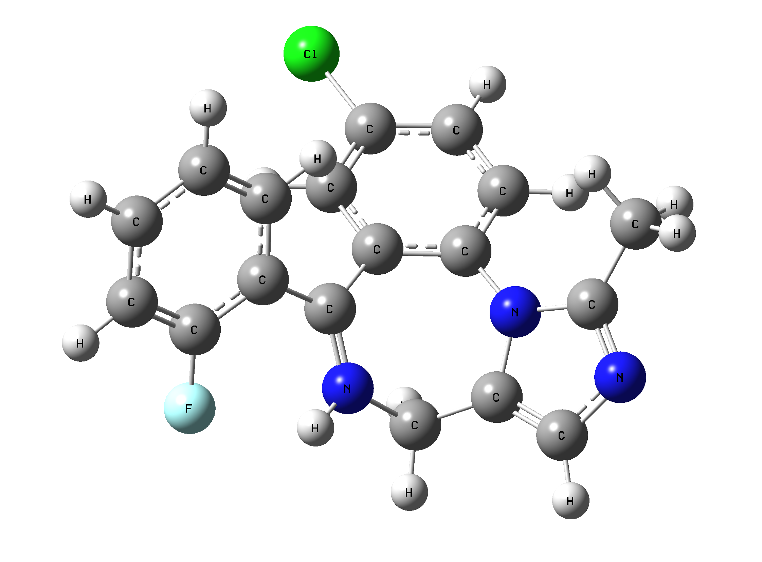 | 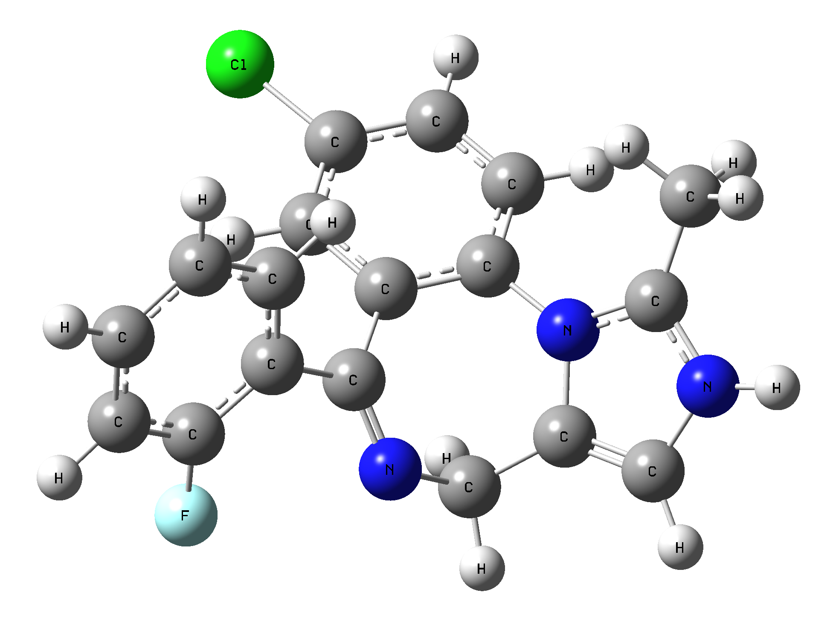
4a-gp | 4b-gp
Figure S1. Gas-phase optimized MDZ+ substituted at (a) 7-membered ring and (b) 5-membered ring

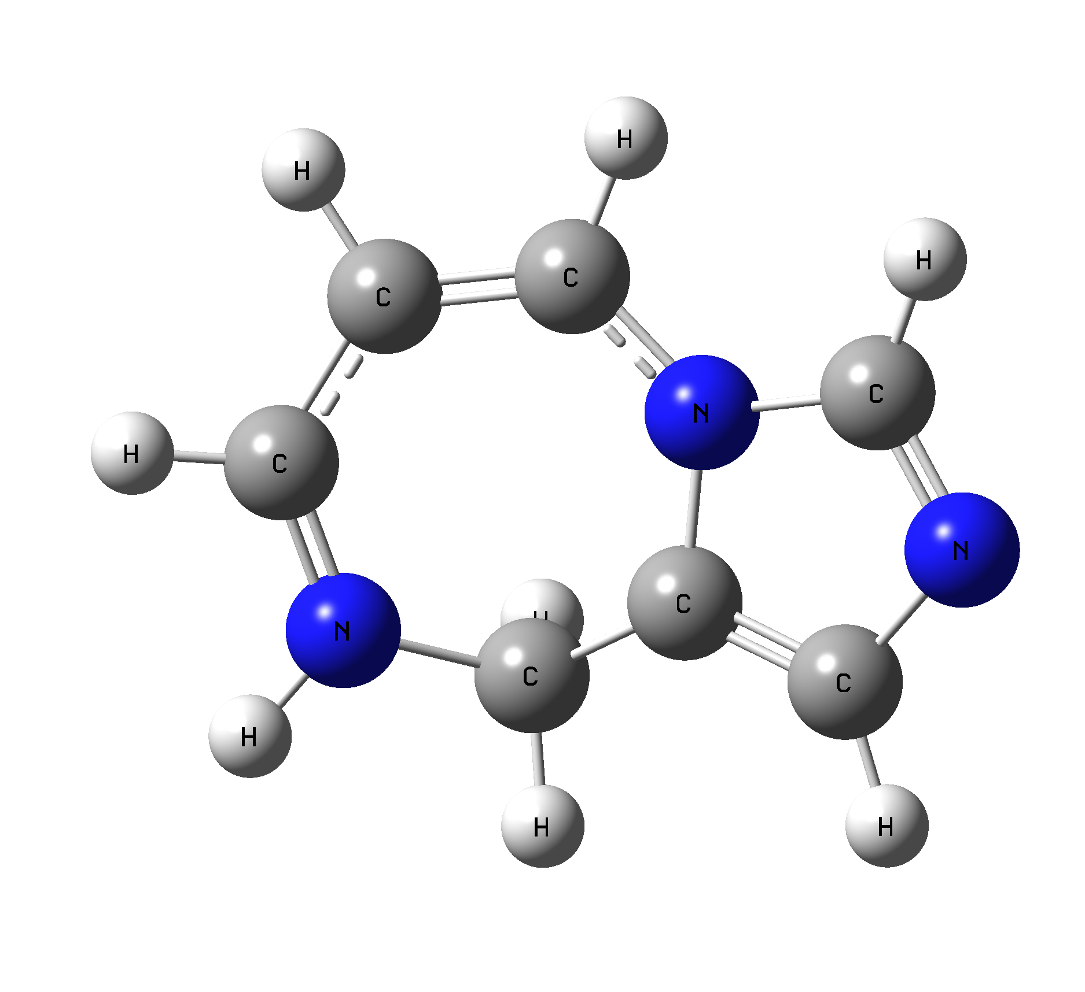 | 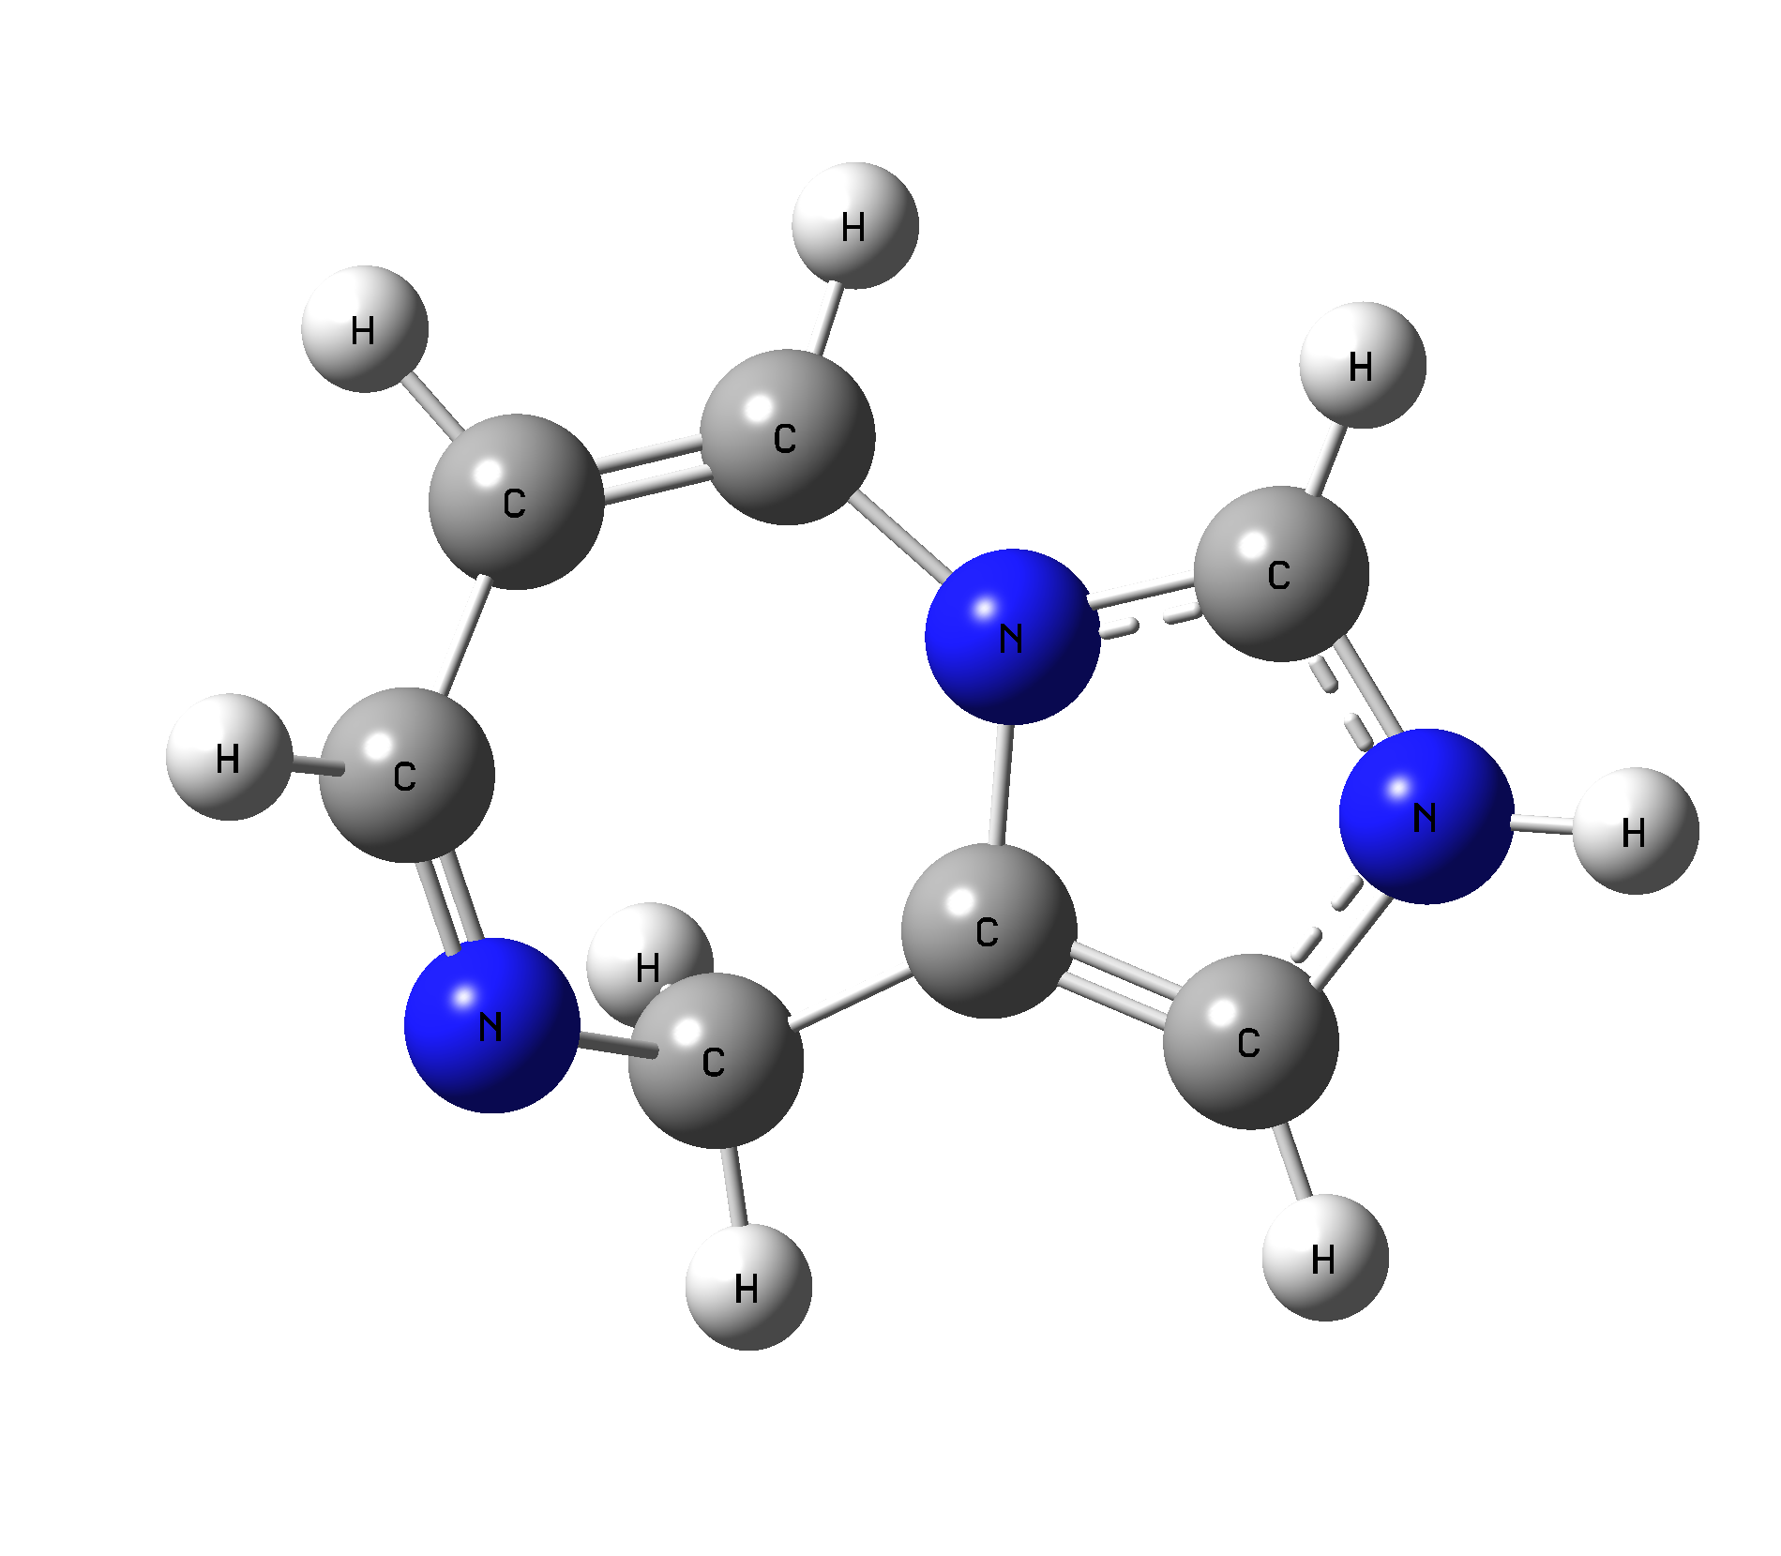
9a-gp | 9b-gp
Figure S2. Gas-phase optimized MMDZ+ substituted at (a) 7-membered ring and (b) 5-membered ring

