Assessing the Future Carbon Budget through the Lens of Policy-Driven Acidification and Temperature Targets
Sandy Avrutin*¹, Philip Goodwin¹ ORCID: 0000-0002-2575-8948,
Thomas H.G. Ezard¹ ORCID: 0000-0001-8305-6605
¹ School of Ocean and Earth Science, University of Southampton, Southampton SO14 3ZH, UK
*a.l.avrutin@soton.ac.uk
For submission to Climatic Change

Supplementary 2 – Extra Figures
These are figures that provide extra detail to the narrative the paper, but do not directly contribute to the conclusions drawn in the study.
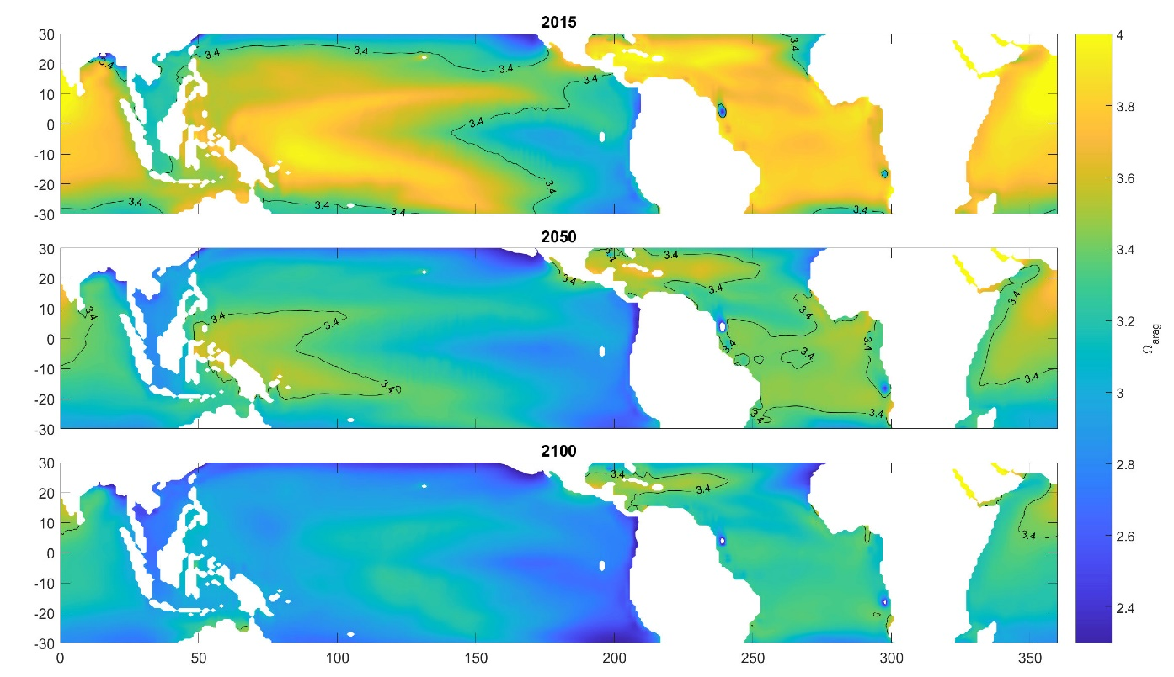
Figure S1: Tropical aragonite saturation (ꭥ_{arag}) in 2015, 2050 and 2100, with the 3.4 contour highlighted. The reducing saturation indicates increasing acidification.
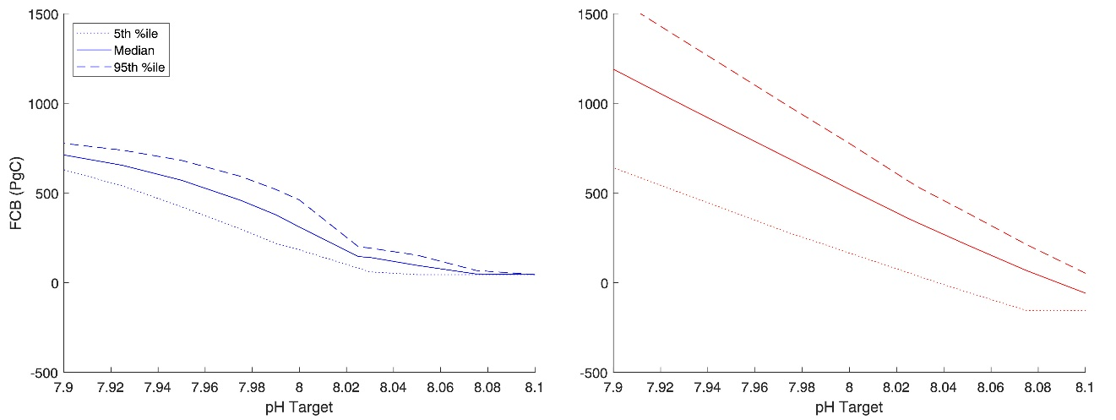
Figure S2: 5th, 50th and 95th percentile future carbon budget for 2100 (above) and 2300 (below) for the pH targets considered in the study

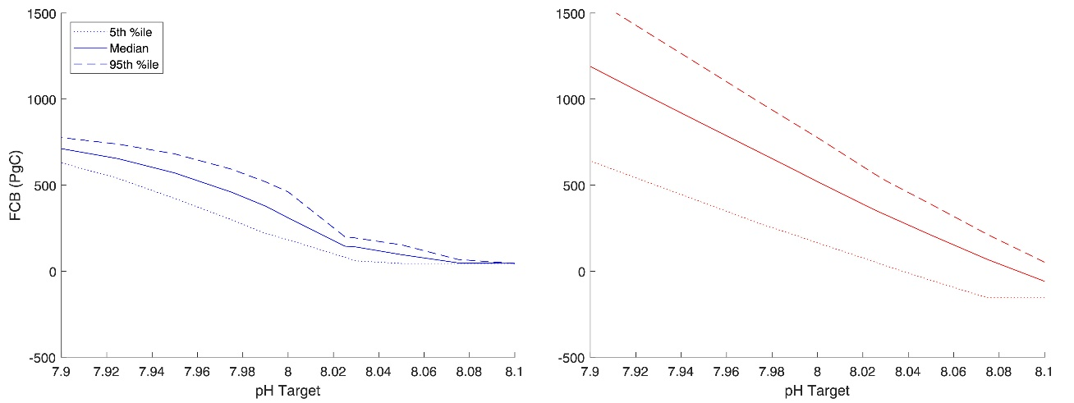
Figure S3: 5th, 50th and 95th percentile future carbon budget for 2100 (left) and 2300 (right) for the warming targets considered in the study
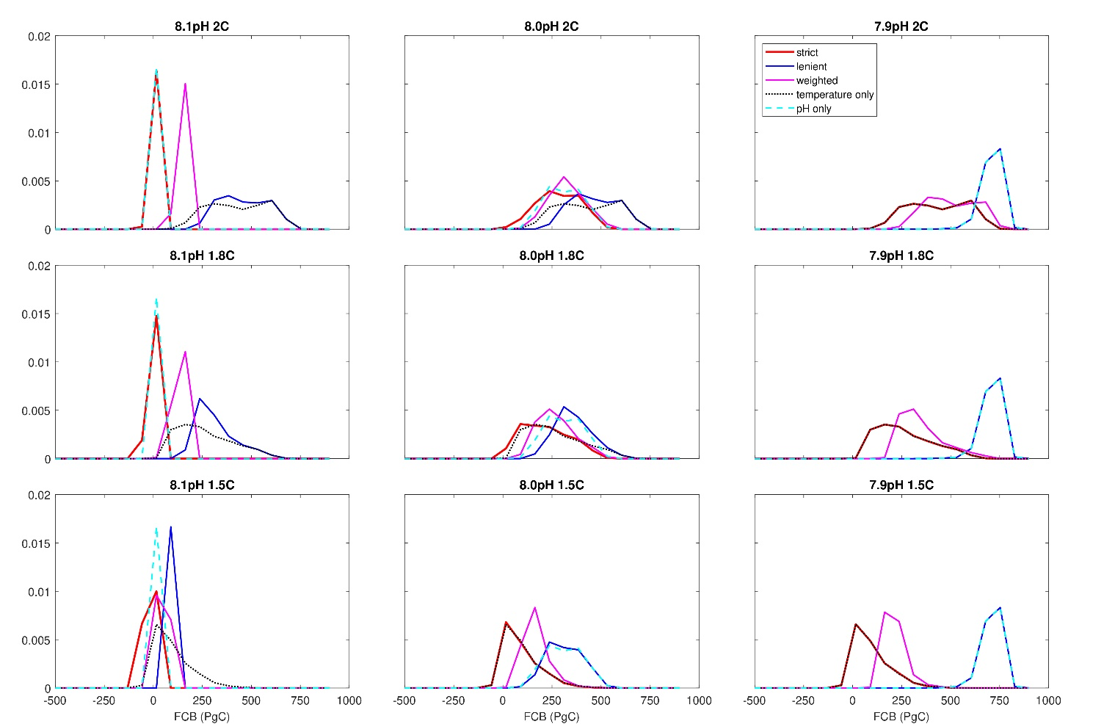Figure S4: probability density functions of the future carbon budget for 2100 for combinations of the highest, lowest and central warming and pH targets

