Photodynamic Therapy Changes Tumour Immunogenicity and Promotes Immune-Checkpoint Blockade Response, Especially When Combined with Enhanced Tumour Infiltration by Micromechanical Priming
Catarina S. Lobo, M. Inês P. Mendes, Diogo A. Pereira, Lígia C. Gomes-da-Silva*, Luis G. Arnaut*
CQC, Chemistry Department, University of Coimbra, 3004-535 Coimbra, Portugal

Supplementary data
Figure S1. Exploratory studies with the orthotopic 4T1 tumor model to determine the treatment day when tumor resection does not prevent lung metastases.
Table S1. Redaporfin-PDT parameters of the several tested protocols for 4T1-luc2 mammary carcinoma model.
Table S2. Macroscopic evaluation score criteria for PDT treatment impact on primary tumors.
Figure S2. Schematic representation of frontal (conventional) (A) and transversal (B) irradiation of 4T1-luc2 tumors.
Figure S3. Normalized photoacoustic spectra of redaporfin, oxy- and deoxy-hemoglobin.
Figure S4. Kinetics of tumor volume growth for PDT and immunotherapies in three different tumor models.
Figure S5. Expression of the irradiance of 4T1-luc2 metastases in the lungs according to the linearized Gompertz function.
Figure S6. PAT of redaporfin in CT26 tumors using excitation at 750 nm.
Video S1. Real-time tracking of redaporfin tumor accumulation assessed by PAT imaging of the CT26 tumor region (8x speed up). The red marker on the timeline represents the i.v. injection time.
Video S2-S4. 3D-rendered photoacoustic/ultrasounds representation of CT26 (S2), B16F10 (S3) and 4T1-luc2 (S4) tumors, after intravenous redaporfin administration. The timepoints of acquisition are specified for each case.

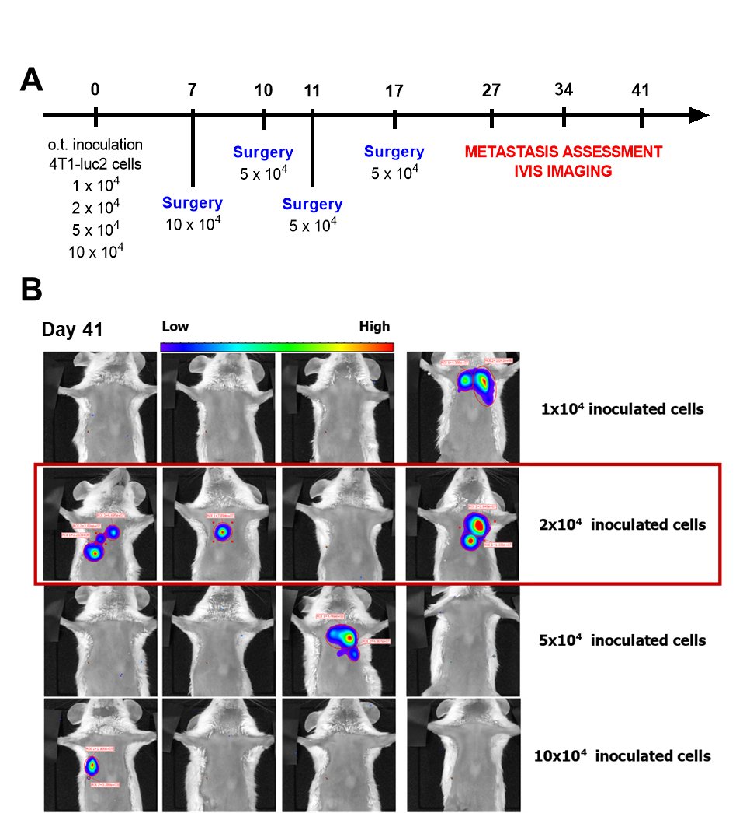
Figure S1. Exploratory studies with the orthotopic 4T1 tumor model to determine the treatment day when tumor resection does not prevent lung metastases. (A) Schematic outline of metastatic model optimization protocol: Different number of cells were inoculated in the mammary gland (1x10⁴, 2x10⁴, 5x10⁴ and 10x10⁴ cells) and surgery was performed when tumor diameter attained 4-5 mm. Bioluminescence imaging was performed on days 27, 34 and 41. (B) IVIS bioluminescence of 4T1-luc2 mammary carcinoma tumor at day 41, showing that the inoculation of 2x10⁴ cells originated the highest metastasization.

Table S1. Redaporfin-PDT parameters of the several tested protocols for 4T1-luc2 mammary carcinoma model. Drug and light doses, illumination spot diameter and fluence were tested to obtain the best outcome in terms of impact on treatment. Macroscopic alterations on tumor, as edema and necrosis, were evaluated and scored according to criteria on Table S2. o.t. - orthotopic; s.c. - subcutaneous; Prtcl - Protocol: V - vascular protocol; C - cellular protocol; CV - cellular and vascular protocol; TV/TC - transversal irradiation of tumor, as schematized in Figure S2, with vascular/cellular protocol.
Prtcl | Model | Drug dose (mg/kg) | DLI | Light dose (J/cm²) | Spot diameter (cm) | Fluence (mW/cm²) | Survival to PDT | Impact Score
 |  |  |  |  |  |  |  | Edema | Necrosis
V1 | o.t. | 1.00 | 15 min | 50 | 1.3 | 130 | 43 % | 0 | 1
V2 | o.t. | 0.75 | 15 min | 50 | 1.3 | 130 | 100 % | 0 | 1
V3 | o.t. | 0.75 | 15 min | 50 | 1.1 | 182 | 100 % | 0 | 1
V4 | o.t. | 1.00 | 15 min | 50 | 1.1 | 182 | 100 % | 0 | 1
V5 | s.c. | 1.00 | 15 min | 50 | 1.3 | 130 | 100 % | 2 | 0
V6 | s.c. | 1.00 | 15 min | 100 | 1.3 | 130 | 100 % | 2 | 1
C1 | o.t. | 1.00 | 72 h | 100 | 1.3 | 130 | 100 % | 0 | 2
C2 | o.t. | 2.00 | 72 h | 50 | 1.0 | 220 | 100 % | 2 | 1
C3 | o.t. | 2.00 | 72 h | 75 | 1.0 | 131 | 0 % | 1 | 1
C4 | o.t. | 2.00 | 72 h | 65 | 1.0 | 131 | 0 % | 1 | 1
C5 | o.t. | 1.00 | 72 h | 100 | 1.3 | 130 | 100 % | 1 | 1
C6 | o.t. | 1.00 | 72 h | 120 | 1.0 | 150 | 83 % | 0 | 1
C7 | o.t. | 1.00 | 48 h | 120 | 1.0 | 150 | 0 % | 0 | 1
C8 | o.t. | 1.00 | 96 h | 120 | 1.0 | 150 | 100 % | 0 | 1
CV1 | o.t. | 1.00  0.5 | 72 h  15 min | 80 | 1.3 | 130 | 0 % | - | -
CV2 | o.t. | 1.00  0.5 | 72 h  15 min | 60 | 1.3 | 130 | 100 % | 1 | 1
CV3 | o.t. | 1.00  0.5 | 24 h  15 min | 50 | 1.0 | 220 | 0 % | - | -
CV4 | o.t. | 1.00  1.00  0.4 | 144 h  72 h  15 min | 50 | 1.0 | 220 | 100 % | 1 | 1
CV5 | o.t. | 2.00  0.4 | 72 h  15 min | 50 | 1.0 | 220 | 0 % | - | -
TV1 | o.t. | 1.8 | 15 min | 120 | 1.1 | 178 | 100 % | 1 | 1
TC1 | o.t. | 1.0 | 48 h | 120 | 1.1 | 178 | 100 % | 1 | 1
TC2 | o.t. | 1.8 | 72 h | 100 | 1.2 | 137 | 100 % | 1 | 2
TC3 | o.t. | 1.8 | 72 h | 150 | 1.2 | 137 | 100 % | 1 | 2

Table S2. Macroscopic evaluation score criteria for PDT treatment impact on primary tumors.

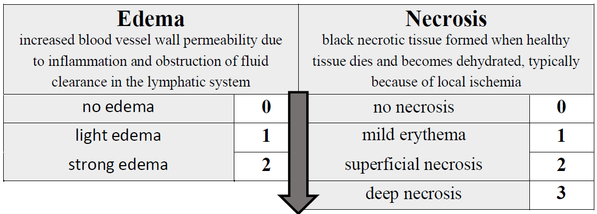

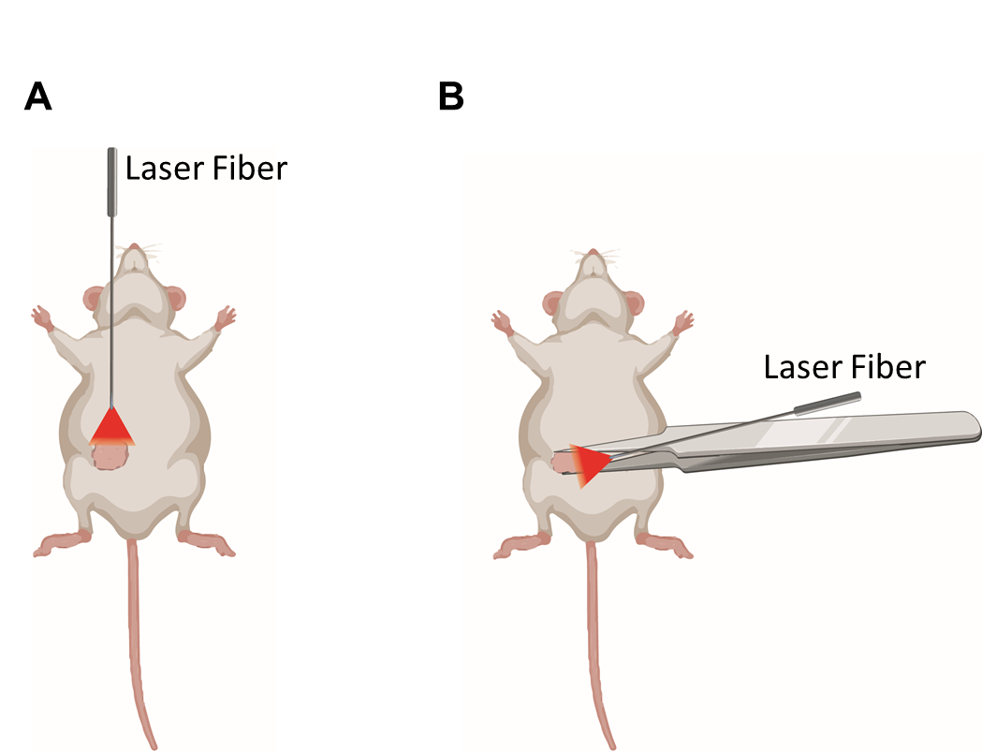
Figure S2. Schematic representation of (A) frontal (conventional) and (B) transversal irradiation of 4T1-luc2 tumors.

Figure S3. Normalized photoacoustic spectra of redaporfin, oxy- and deoxy-hemoglobin. Redaporfin was prepared in Kolliphor EL formulation and its photoacoustic spectrum was acquired in a phantom apparatus with the Vevo LAZR-X multimodal imaging system. Oxy- and deoxy-hemoglobin photoacoustic spectra are part of the Vevo LAZR-X analysis software.

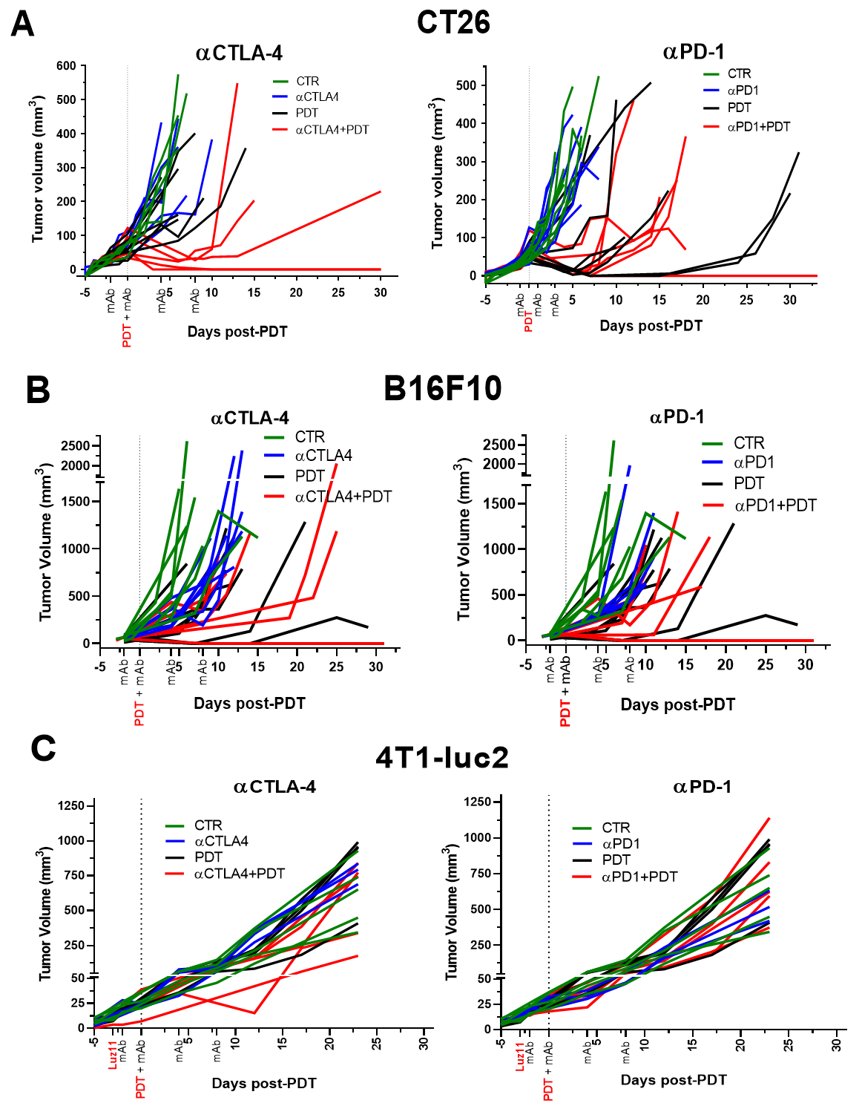
Figure S4. Kinetics of tumor volume growth for PDT and immunotherapies in three different tumor models. Tumor volumes of (A) CT26, (B) B16F10 and (C) 4T1-luc2 models are represented individually for each animal with the colors corresponding to the treatment group. Schedule of administrations of immunotherapy antibodies are indicated in the x-axis, as well as the PDT treatment day, which was established as the day 0 of the experiment.

Figure S5. Expression of the irradiance of 4T1-luc2 metastases in the lungs according to the linearized Gompertz function. The PDT group changes temporarily the sign of the growth kinetics, but the αCTLA-4 and αCTLA-4+PDT groups invert definitively the kinetics, from growth to remission.

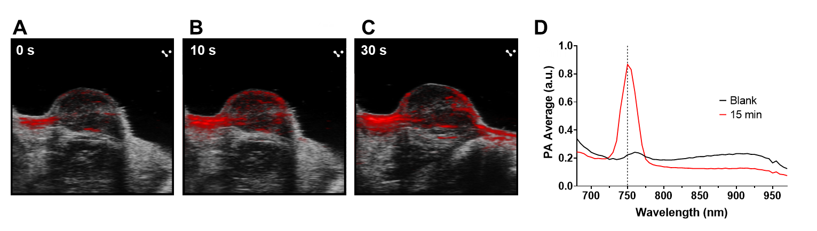
Figure S6. PAT of redaporfin in CT26 tumors using excitation at 750 nm. (A) Before i.v. administration. (B) 10 sec after administration. (C) 30 sec after administration. (D) photoacoustic spectra of the tumor before and 15 min after redaporfin administration.

