Supporting Information

Bottom-up accounting of landfills across 346 cities reveals overlooked carbon stocks

Shijun Ma^{a, b}, Mingzhen Lu^{c,d}, Guang Yang^{a,b}, Yuehao Zhi^{a,b}, Zutao Ouyang^{d}, Ningxin Huang^{a,b}, Chuanbin Zhou^{a,b,*}

a. Stake Key Laboratory of Urban and Regional Ecology, Research Center for Eco-Environmental Sciences, Chinese Academy of Sciences, Beijing 100085, China;
b. College of Resources and Environment, University of Chinese Academy of Sciences, Beijing 101408, China;
c. Santa Fe Institute, Santa Fe, NM 87501, USA;
d. Department of Earth System Science, Stanford University, Stanford, CA 94305, USA.

* Corresponding author. E-mail address: cbzhou@rcees.ac.cn (C. Zhou).

SI Method
- The calculation of some parameters in the estimation model of the solid-liquid-gas phase transformation of the stored carbon in landfills.
In the FOD model recommended by the IPCC, the methane production rate constant (k), degradable organic carbon (DOC) and fraction of DOC that can decompose (DOCf) were calculated by Equations (S1)-(S3).
$k_{r,p}=k_{a}×A_{r,p}+k_{b}×B_{r,p}+k_{c}×C_{r,p}+k_{d}×D_{r,p}$ Equation (S1)
${DOC}_{r,p}={DOC}_{a}×A_{r,p}+{DOC}_{b}×B_{r,p}+{DOC}_{c}×C_{r,p}+{DOC}_{d}×D_{r,p}$ Equation (S2)
${DOCf}_{r,p}={DOCf}_{a}×A_{r,p}+{DOCf}_{b}×B_{r,p}+{DOCf}_{c}×C_{r,p}+{DOCf}_{c}×D_{r,p}$ Equation (S3)
where A-D represent the proportions of organic fractions, paper, textile and wood in municipal solid waste (MSW) in a prefecture-level city p in a geographical region r, respectively, which come from Ma et al. (2020)¹; the methane production rate for each component is detailed in Table S14; the DOC of each component in MSW is shown in Table S15; and the DOCf of each component in MSW is shown in Table S16.

- The details of the scenario simulation
Based on the policies of current MSW management policies implemented and encouraged in China, i.e., no-waste city, zero landfilling, waste sorting, and ectopic remediation of old landfill sites and so forth, this study sets up four scenarios, which are business-as-usual scenario, raising-methane-collection scenario, minimizing-landfill scenario, and landfill-remediation scenario. The base year for the scenario analysis is 2020, and the analysis spans from 2021 to 2030, which is the time point when the commitment for achieving the global methane reduction².
Business-as-usual scenario
The business-as-usual scenario describes MSW management in China will follow the same policies applied in the year 2020. This means that China will not issue and apply any specific additional mitigation strategies, and there will be no changes to the way MSW is disposed of. This scenario is intended to provide a baseline scenario of how landfill organic carbon stocks and their associated GHG emissions will change without any new policy interventions. The forecast of the amount of MSW Collected and Transported was from Chhay et al. (2018)³, while the composition of MSW in China from 2020 to 2030 was obtained by using the back propagation neural network (BPNN) model of Ma et al. (2020)¹. The organic carbon stock in landfills under this scenario was calculated by using the landfill solid‒liquid-gas material flow analysis model in this study, and GHG emissions were only caused by methane escaping from the landfill into the air. The organic carbon stock in landfills and GHG emissions were calculated for this scenario, as shown in Equations (S4) and (S5). Detailed parameters of the business-as-usual scenario are shown in Table S10.
$C_{BAU,y}=C_{Fin,y}$ Equation (S4)
$E_{BAU,y}=E_{CH4,y}×R_{BAU,y}×27.9$ Equation (S5)
where C_{BAU,y} and E_{BAU,y} are the organic carbon stock and GHG emissions in landfills in a certain year y under the business-as-usual scenario, Mt; the warming potential of methane is 27.9 times that of carbon dioxide⁴; and R_{BAU,y} is the methane collection rate in a certain year y under the business-as-usual scenario.
Raising-methane-collection scenario
The raising-methane-collection scenario describes that based on the business-as-usual scenario, the methane collection rate will be significantly increased in MSW landfills in China, thereby reducing the amount of methane emissions from landfills escaping into the air; that is, the methane collection rate increases from 24% in 2020 to 40% in 2030. Detailed parameters for this scenario are shown in Table S11. The organic carbon stock in landfills and GHG emissions were calculated for this scenario, as shown in Equations (S4) and (S5).
Minimizing-landfill scenario
On the basis of improving the methane collection rate in landfills, the minimizing-landfill scenario takes into account the new policies and recommendations leading to the change in MSW treatment and disposal methods in China before 2020, including no-waste cities, mandatory MSW sorting and the 14th Five-Year Plan for the development of MSW sorting and treatment facilities^{5, 6}. These policies and plans include detailed targets for developing waste treatment facilities, including the 65% incineration rate for MSW by 2025 and no dumps. So we used linear interpolation to extrapolate these data to 2030. In this scenario, the proportion of dumps is reduced to 0%, the proportion of sanitary landfills is reduced to 12%, and the proportion of incineration is increased to 68% by 2030. China has not set a specific target for the separation rate of food waste. Therefore, we refer to the separation rate of food waste in large cities in China; that is, the separation rate of food waste in MSW will reach 20% by 2030. Besides, we assume that all food waste is separated and then composted. The GHG abatement benefit of landfills in the minimizing-landfill scenario is the sum of the reduction in methane emissions from landfills and the abatement due to the increased amount of incineration and composting due to lowering the landfilling rate. Detailed parameters of this scenario are shown in Table S12. The organic carbon stock for this scenario was calculated using Equation (S4). See Equations (S6)-(S9) for the GHG emission estimation.
$E_{ML,y}=E_{CH4,y}×R_{ML,y}×27.9-E_{Inc,y}-E_{Com,y}$ Equation (S6)
$E_{MLR,CH4,y}=E_{CH4,y}×27.9$ Equation (S7)
$E_{Inc,y}={MSW}_{Inc,y}×C_{pla,y}×c_{pla}/12×44-{MSW}_{Inc,y}×\sum_{i=1}^{n=5}{C_{i,y}}×{hlv}_{i}/3600×δ×\frac{E_{Ele,coal}}{1000000}$ Equation (S8)
$E_{Com,y}={MSW}_{Com,y}×E_{org}-{MSW}_{Com,y}×N_{org}/μ×E_{Urea}/10000$ Equation (S9)
where, E_{Inc,y} represents GHG emissions from increased MSW incineration power generation relative to coal-fired power generation due to the reduction of landfilling in a certain year y, Mt; E_{com,y} represents GHG emissions from increased MSW composting relative to urea fertilizer production due to the reduction of landfilling in a certain year y, Mt; MSW_{Inc,y} and MSW_{Com,y} are the increased amount of incineration and composting due to the decrease of landfilling in a certain year y, Mt; C_{pla,y} is the proportion of plastic waste in MSW that was input into landfills in a certain year y; c_{pla} is carbon content of plastic waste; C_{i,y} is the proportion of component i in MSW that was input into landfills in a certain year y, including organic fraction, plastic and rubber, paper, textile and wood; hlv_{i} is the calorific value of component i in MSW, which comes from Ma et al. (2022)⁷, kJ·kg⁻¹; $δ$ is Energy conversion rate of incineration power generation, which comes from Gradus et al. (2017)⁸; E_{Ele,coal} is the GHG emissions caused by generating 1Kwh of electricity with raw coal as fuel, which is from Ecoinvent database⁹, kg·Kwh⁻¹; E_{org} is GHG emissions from composting, which is from Colon et al. (2012)¹⁰; N_{org} is nitrogen content of organic fraction, as shown in Table S4; $μ$ is nitrogen content of urea fertilizer; E_{Urea} is GHG emissions for producing 1t of urea fertilizer, which is from Ecoinvent database⁹, t/t; R_{ML,y} is Methane collection rate under the minimizing-landfill scenario in a given year y.
Landfill-remediation scenario
Based on the minimizing-landfill scenario, the landfill-remediation scenario gradually considers the ecological restoration (including ectopic remediation and in situ aerobic remediation) of old landfill sites in China after 2020. In accordance with the estimated annual residual capacity of waste incineration in the 14th Five-Year Plan, the mining of organic carbon stock will be carried out in landfills in China. To be more specific, 50% of soil-like material and all plastics and rubber, textile and wood will be incinerated to generate electricity, while 50% of the soil-like material exploited through ectopic remediation is used as organic mulching for urban landscaping^{11, 12}. In addition, the organic carbon stocks in other end-of-life landfills are treated by in situ aerobic remediation. Figure S11 shows the calculation process of the amount of stored waste in landfills for ectopic remediation under the landfill-remediation situation. This scenario is designed to reasonably utilize organic carbon stock in landfills and illustrates that landfill mining will influence the organic carbon stock and GHG emissions of landfills in China. Detailed parameters of this scenario are shown in Table S13. The organic carbon stock under this scenario was calculated by Equation (S10). The GHG emissions were calculated by Equations (S11)-(S14).
$C_{LME,y}=C_{Fin,y}-C_{Ect,inc,y}-C_{Ect,lan,y}$ Equation (S10)
where C_{Ect,inc,y} represents the organic carbon stock in landfills exploited by ectopic treatment for incineration power generation in a certain year y, Tg, and C_{Ect,lan,y} represents the organic carbon stock in soil-like materials exploited by ectopic treatment, which is used for landscaping in a given year y, Tg.
$E_{LR,y}=E_{LR,CH4,y}-E_{Inc,y}-E_{Com,y}-E_{Ect,inc,y}-E_{Ect,lan,y}$ Equation (S11)
$E_{Ect,inc,y}={Stock}_{Ect,inc,y}×{SC}_{pla,y}×{Sc}_{pla}/12×44-{Stock}_{Ect,inc,y}×\sum_{i=1}^{n=4}{{SC}_{i,y}}×{hlv}_{i}/3600×δ×E_{Ele,coal}/1000000$ Equation (S12)
$E_{Ect,lan,y}=-{Stock}_{Ect,ilan,y}×{SN}_{org}/μ×E_{Urea}/10000$ Equation (S13)
$E_{LR,CH4,y}={(E}_{MLR,CH4,y}-E_{Aerobic,CH4,y}-E_{Ect,CH4,y})×R_{LR,y}$ Equation (S14)
where E_{Ect,inc,y} is GHG emissions from ectopic MSW incineration power generation relative to coal-fired power generation in a certain year y, Tg; E_{Ect,lan,y} is GHG emissions from ectopic treatment of organic carbon stocks for landscaping humus soils relative to urea fertilizer production in a certain year y, Tg; Stock_{Ect,inc,y} is the amount of stored waste in landfills for ectopic incineration power generation in a certain year y, Tg; Stock_{Ect,lan,y} is the amount of stored waste in landfills of ectopic treatment for landscaping humus soils in a certain year y, Tg; SC_{pla,y} is the proportion of plastic waste stock in landfills in a certain year y; Sc_{pla} is Carbon content of plastic waste stock in landfills; SC_{i,y} is the proportion of component i in stored waste in landfills in a certain year y, including organic fraction, plastic and rubber, paper, textile and wood; SN_{org} is nitrogen content of soil-like material in landfills in China; E_{AerobicCH4,y} is reduction in equivalent carbon dioxide emissions by aerobic remediation, Tg; E_{AerobicCH4,y} is reduction in equivalent carbon dioxide emissions by ectopic remediation, Tg; R_{LR,y} is methane collection rate in acertain year y under the landfill-remediation scenario.

- Other models using in scenario simulation
The model for predicting the physical composition of MSW (PCMSW) in China
To solve the problem of missing PCMSW in prefecture-level cities, Ma et al. (2020) collected and sorted 503 pieces of PCMSW data covering 135 prefecture-level cities from scientific literature and technological reports on PCMSW. Then, the spherical coordinate transformation method was used to reduce the dimension of the component data, thus eliminating the influence of the "constant sum constraint". Finally, based on the BPNN model, a quantitative estimation model of MSW composition was constructed. In this paper, the model in Ma et al. (2020) was applied to predict the PCMSW of China from 2021-2030. The specific input parameters are shown in Table S17.
Landfill material stock model
The landfill material stock was calculated using Equation (S15), that is, the amount of MSW input to the landfill minus the amount of major element loss and self-produced water. The calculation of the amount of main element loss can be seen in Equations (S16)-(S21). The amount of self-produced water in landfills was calculated by Equation (S22). We take the results of material stock in sanitary landfills and dumps in China from 2001 to 2020 as examples in the supplemental information (see Figure S12 for details).
$M_{Fin,r,p}=M_{input,r,p}-M_{E,r,p}-M_{W,r,p}$ Equation (S15)
where M_{Fin,r,p} represents the annual increase in stored waste in landfills in a prefecture-level city p in a geographical region r, Tg·a⁻¹; M_{input,r,p} is MSW entering landfills every year in a prefecture-level city p in a geographical region r, Tg·a⁻¹; M_{E,r,p} refers to the annual loss of elements from MSW in the form of landfill gas and leachate in a prefecture-level city p in a geographical region r, Tg·a⁻¹; and M_{W,r,p} is the annual loss of water in domestic waste because of the physical squeeze of stored waste and precipitation in a prefecture-level city p in a geographical region r, Tg·a⁻¹.
The loss of key elements due to leachate production and landfill gas escape is detailed in Equations (S16)-(S21).
$M_{E,r,p}=C_{E,r,p}+C_{L,r,p}+N_{E,r,p}+P_{L,r,p}+K_{L,r,p}$ Equation (S16)
$C_{E,r,p}=E_{CH4,r,p}×12/16×2$ Equation (S17)
$C_{L,r,p}=L_{r,p}×\frac{COD+0.0582}{3}/10000000000$ Equation (S18)
${ N}_{L,r,p}=L_{r,p}×LN/100000000$00 Equation (S19)
${ P}_{L,r,p}=L_{r,p}×LP/100000000$00 Equation (S20)
${ K}_{L,r,p}=L_{r,p}×LK/10000000000$ Equation (S21)
where C_{E,r,p} is the loss of carbon in the form of landfill gas every year in a prefecture-level city p in a geographical region r, Tg·a⁻¹; C_{L,r,p,} N_{L,r,p}, P_{L,r,p} and K_{L,r,p} are the losses of carbon, nitrogen, phosphorus and potassium in the form of leachate every year in a prefecture-level city p in a geographical region r, Tg·a⁻¹; COD is the concentration of chemical oxygen demand, total nitrogen and total phosphorus in leachate, g·(m³)⁻¹. See Tables S6 and S7 for the parameters of each prefecture-level city from 2001 to 2008 and Tables S8 and S9 for the parameters from 2009 to 2020; COD is converted into TOC using a conversion formula¹³. LK is the concentration of total potassium content in leachate, g·(m³)⁻¹, from Ma et al. (2022)¹⁴.
The calculation of the wastewater (self-produced water) production caused by squeezing of stored waste during landfill is shown in Equation (S22).
${ M}_{W,r,p}={MSW}_{L,r,p}×(\sum_{i=1}^{n=9}{{(C}_{i,r,p}×w_{i})-}FC)$ Equation (S22)
where C_{i,r,p} is the proportion of each fraction of MSW in a prefecture-level city p in a geographical region r, which comes from Ma et al. (2020)¹; w_{i} is the water content of each fraction, which is given in Table S18; and FC refers to the field moisture capacity¹⁵.

SI Figures
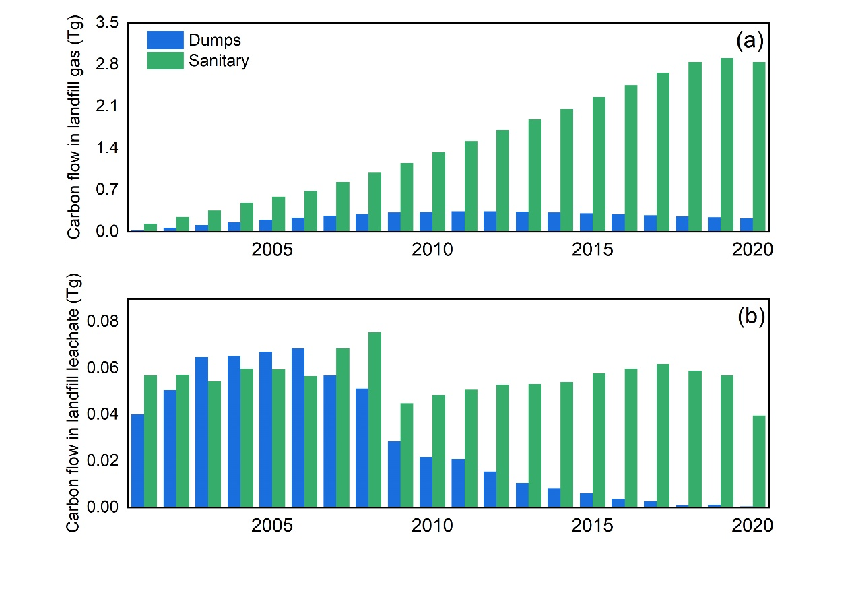
Figure S1 Carbon flow in landfill gas and leachate in China (2001 to 2020)

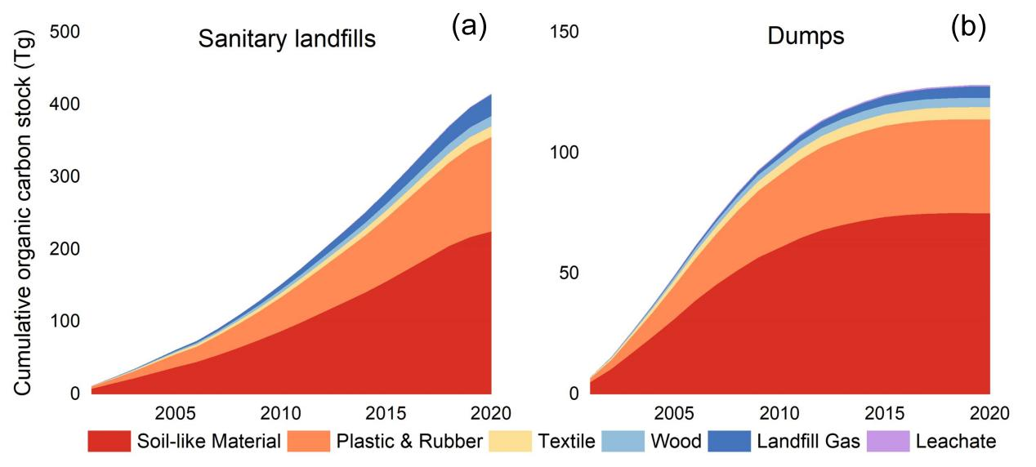
Figure S2 Temporal trends of cumulative organic carbon stock in sanitary and dumps in China (2001 to 2020). (a) sanitary landfills; (b) dumps.

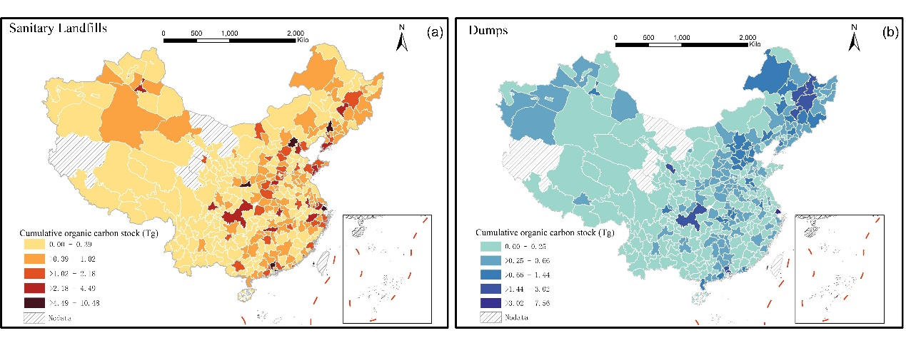
Figure S3 The spatial distribution of cumulative organic carbon stock in sanitary landfills and dumps in China (2001 to 2020). (a) sanitary landfills; (b) dumps.

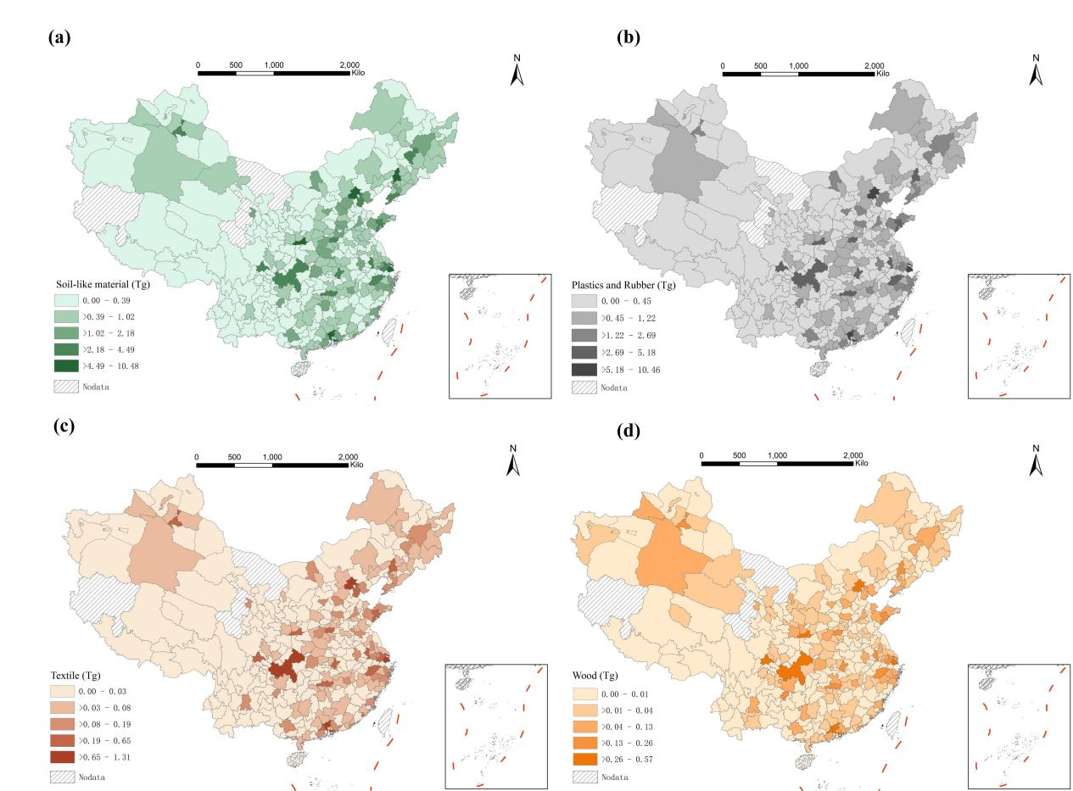
Figure S4 The spatial distribution of the cumulative organic carbon stock of each component in sanitary landfills in China (2001 to 2020). (a)-(d) represent the cumulative organic carbon stock of soil-like material, plastics and rubber, textile and wood, respectively.

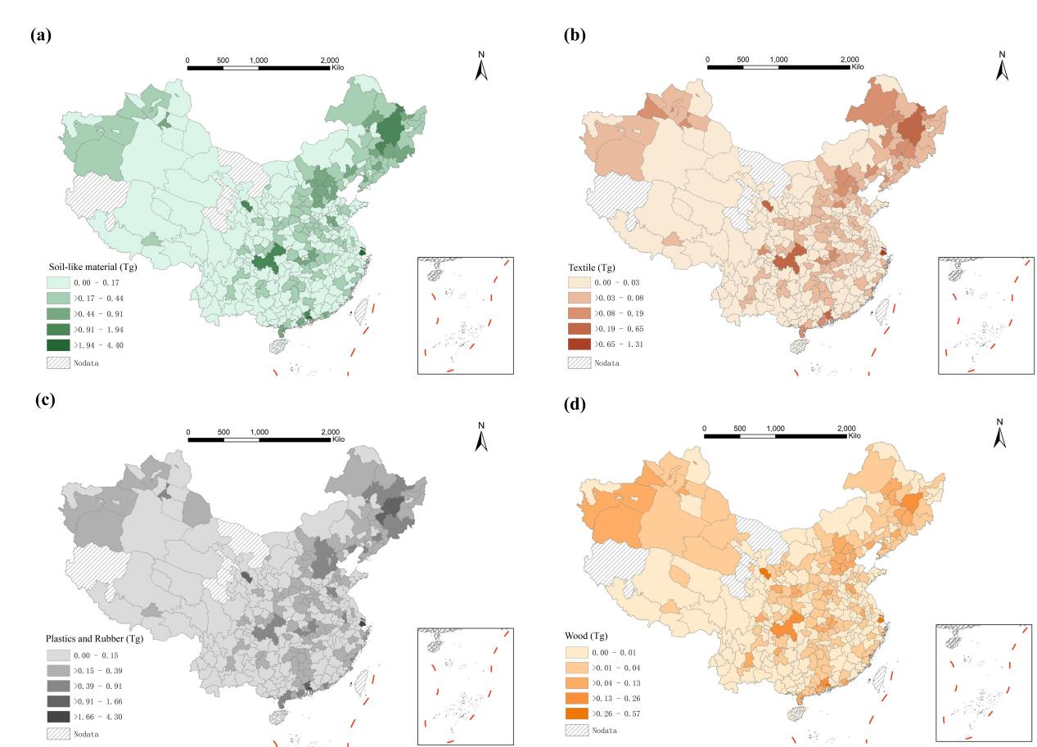
Figure S5 The spatial distribution of the cumulative organic carbon stock of each component in dumps in China (2001 to 2020). (a)-(d) represent the cumulative organic carbon stock of soil-like material, plastics and rubber, textile and wood, respectively.

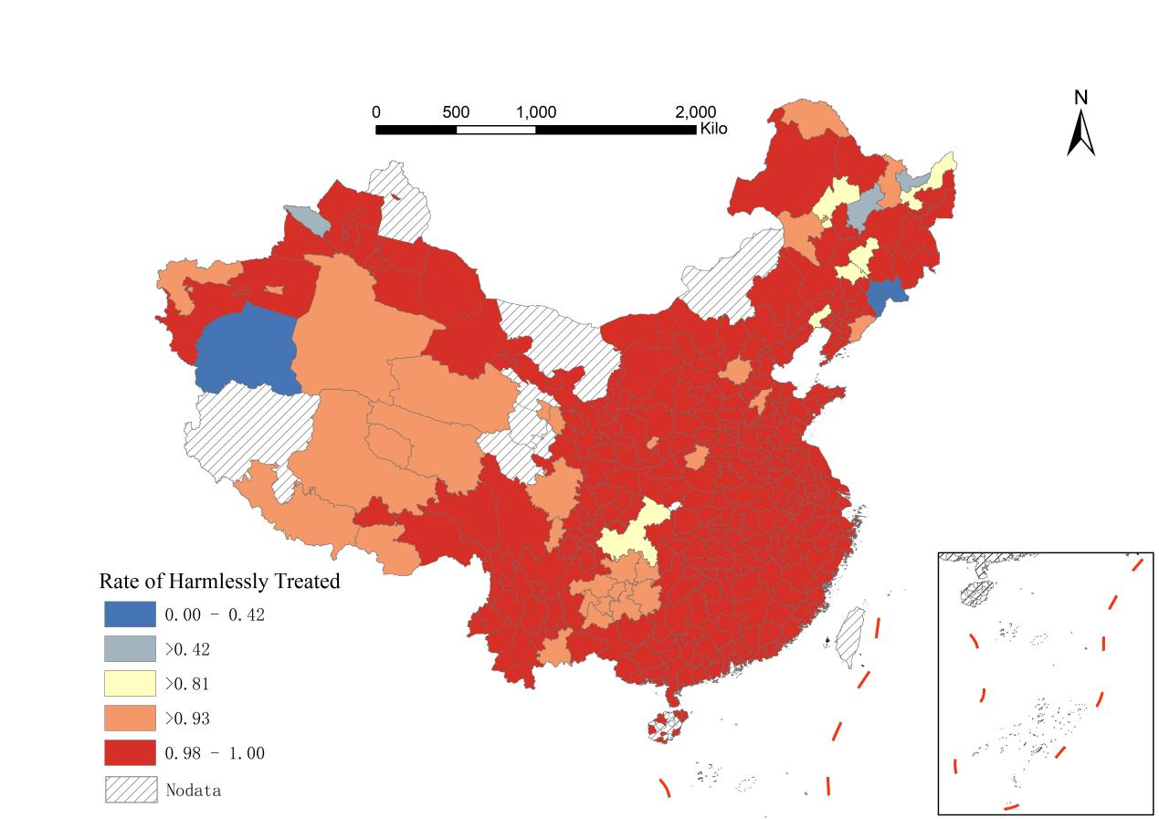
Figure S6 Rate of harmless treatment in municipal solid waste management in China in 2020

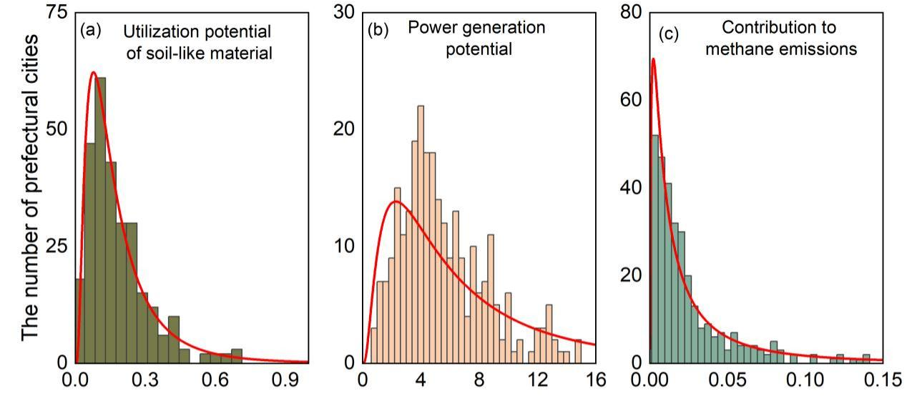
Figure S7 Distribution of resource, energy potential and environmental impacts at the prefecture level in China. (a)-(c) represent the distribution of the utilization potential of soil-like material, power generation potential and contribution to methane emissions of organic carbon stock in landfills at the prefecture level in China, respectively.
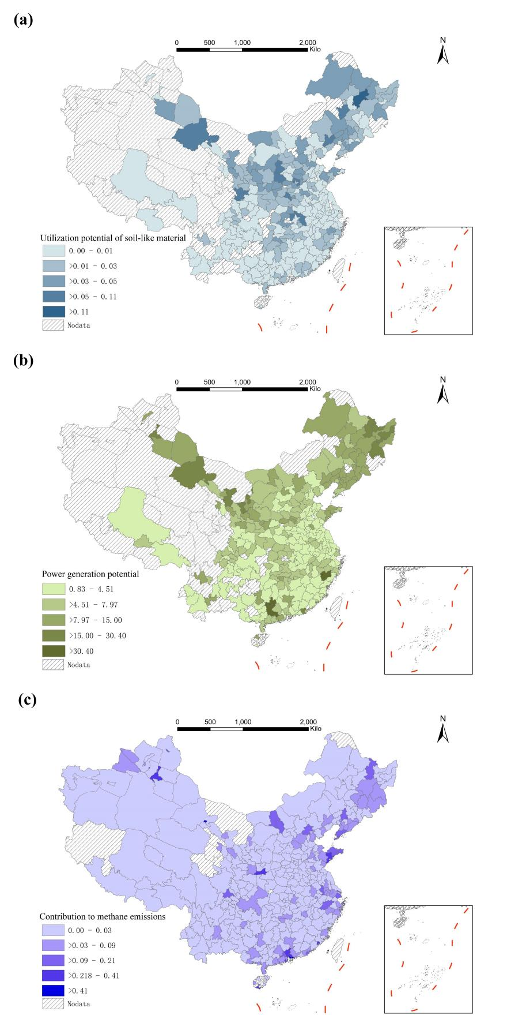
Figure S8 Resource, energy potential and environmental impact at the prefecture level in China. (a)-(c) represent the utilization potential of soil-like material, power generation potential and contribution to methane emissions of organic carbon stock in landfills at the prefecture level in China, respectively.
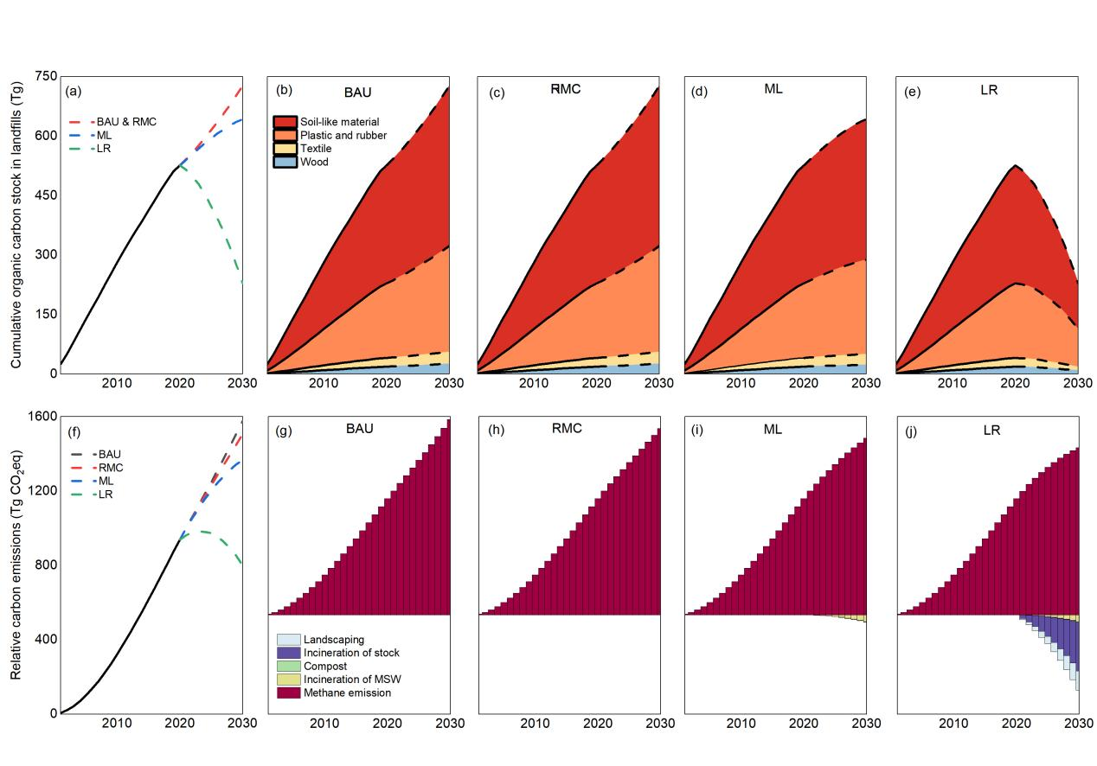
Figure S9 Organic carbon stocks and GHG emission reduction benefits of landfills in China from 2001 to 2030. (a) and (f) are those in landfills in China under the business-as-usual scenario (BAU), raising-methane-collection scenario (RMC), minimizing-landfill scenario (ML), and landfill-remediation scenario (LR) from 2001 to 2030; (b)-(e) and (g)-(j) represent the composition of those in China from 2001 to 2030 under business-as-usual scenario, raising-methane-collection scenario, minimizing-landfill scenario, and landfill-remediation scenarios, respectively. Note: 1) soil-like material, plastic and rubber, textile and wood are the carriers of organic carbon stock; 2) the legends, incineration of MSW, compost, incineration of stored waste, and landscaping represent GHG reduction from adopting relative interventions; the results are based on life cycle assessment methodology, and GHG reductions from recovered energy (incineration) and recycling nutrients (composting and landscaping) are included herein.

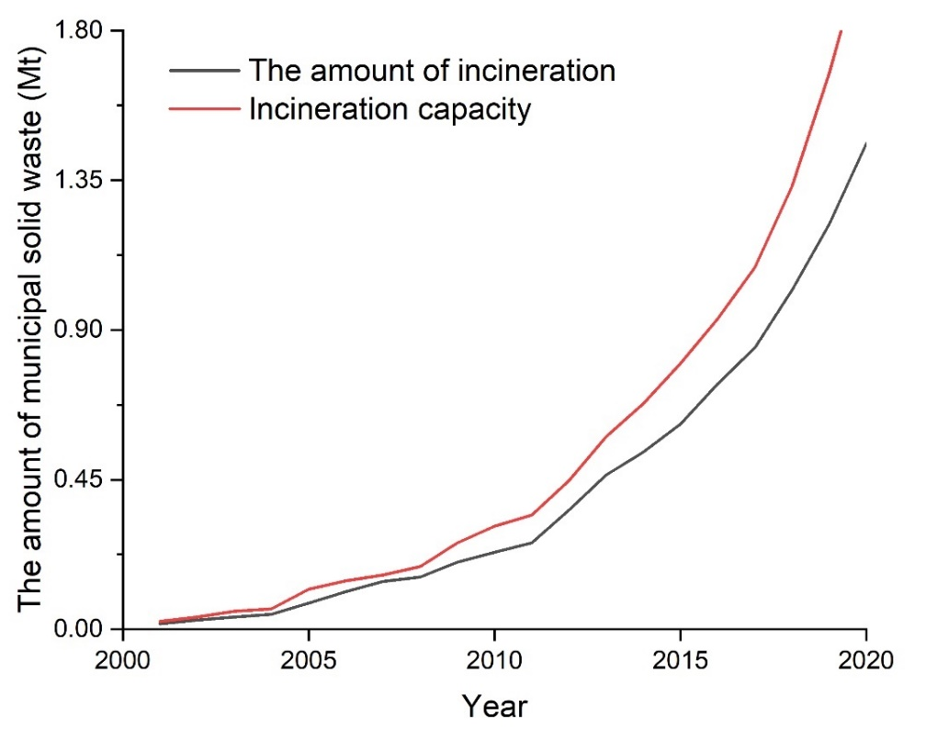
Figure S10 Difference between the amount of incineration and incineration capacity in China (2001-2020).

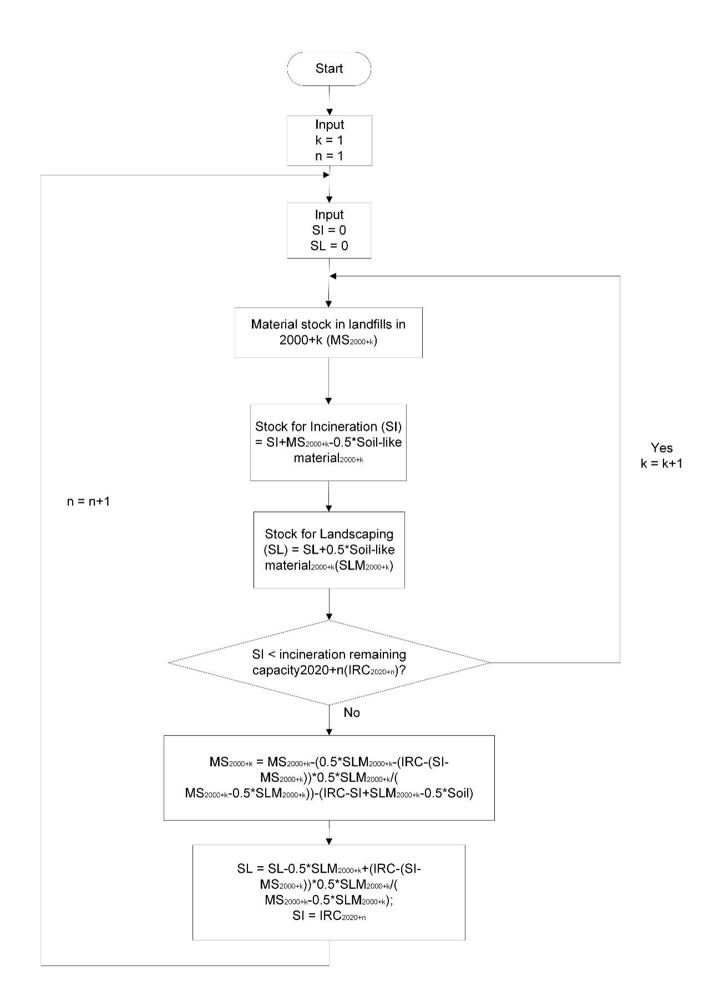
Figure S11 Calculation of the stored waste in landfills treated by ectopic remediation under the landfill-remediation scenario.
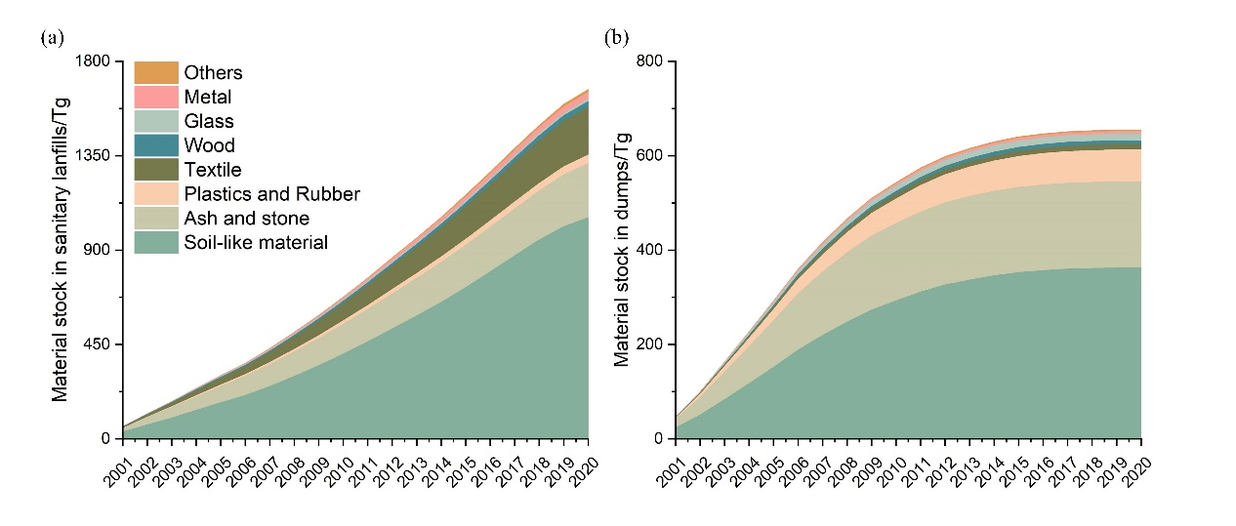
Figure S12 Material stock in landfills in China (2001-2020). (a) Sanitary landfills; (b) dumps.

Table S1 Cost‒benefit analysis for landfill-remediation scenario
Year | Ectopic remediation (Mt) | Aerobic remediation (Mt) | In situ screening (RMB/t)¹⁶ | Aerobic remediation (RMB/t)¹⁶ | closure of landfill (RMB/t)¹⁶ | Ectopic treatment for incineration power generation (Twh) | Ectopic treatment for landscaping (Mt) | electricity price (RMB/kwh)ª | Price of nitrogen fertilizer (RMB/t)¹⁷ | The cost of ectopic remediation in this study (billion RMB) | The cost of aerobic remediation in this study （billion RMB） | The cost of closure of landfill in this study (billion RMB) | Profit from incineration power generation (billion RMB) | Profit from composting (billion RMB) | Total profit (billion RMB)
2021 | 117.89 | 37.81 | 110.00 | 70.00 | 25.00 | 39.64 | 1.78 | 0.50 | 2050 | 12.97 | 2.65 | 3.89 | 19.82 | 3.65 | 11.75
2022 | 130.60 | 83.16 | 110.00 | 70.00 | 25.00 | 46.76 | 2.02 | 0.50 | 2050 | 14.37 | 5.82 | 5.34 | 23.38 | 4.14 | 12.67
2023 | 143.61 | 83.37 | 110.00 | 70.00 | 25.00 | 53.39 | 2.19 | 0.50 | 2050 | 15.80 | 5.84 | 5.67 | 26.70 | 4.49 | 15.23
2024 | 154.54 | 83.37 | 110.00 | 70.00 | 25.00 | 62.14 | 2.44 | 0.50 | 2050 | 17.00 | 5.84 | 5.95 | 31.07 | 5.01 | 19.19
2025 | 169.65 | 83.37 | 110.00 | 70.00 | 25.00 | 65.06 | 1.68 | 0.50 | 2050 | 18.66 | 5.84 | 6.33 | 32.53 | 3.44 | 17.80
2026 | 185.21 | 83.16 | 110.00 | 70.00 | 25.00 | 65.94 | 2.92 | 0.50 | 2050 | 20.37 | 5.82 | 6.71 | 32.97 | 5.98 | 19.47
2027 | 195.41 | 83.37 | 110.00 | 70.00 | 25.00 | 75.11 | 3.09 | 0.50 | 2050 | 21.49 | 5.84 | 6.97 | 37.55 | 6.34 | 23.53
2028 | 204.00 | 83.37 | 110.00 | 70.00 | 25.00 | 83.02 | 3.33 | 0.50 | 2050 | 22.44 | 5.84 | 7.18 | 41.51 | 6.82 | 27.24
2029 | 217.60 | 83.37 | 110.00 | 70.00 | 25.00 | 89.54 | 3.43 | 0.50 | 2050 | 23.94 | 5.84 | 7.52 | 44.77 | 7.02 | -29.54
2030 | 230.11 | 83.16 | 110.00 | 70.00 | 25.00 | 94.70 | 3.51 | 0.50 | 2050 | 25.31 | 5.82 | 7.83 | 47.35 | 7.20 | -31.25
Total | 1748.63 | 787.51 | 1100.00 | 700.00 | 250.00 | 675.30 | 26.39 | 5.00 | 20500.00 | 192.35 | 55.13 | 63.40 | 337.65 | 54.10 | -207.68
Note: The electricity price refers to that in Beijing, 0.50 RMB/Kwh.

Table S2 Geographical regions of China
Code | Geographical region | Province
0 | China | Central China, East China, North China, Northeast China, Northwest China, South China, Southwest China
1 | Northeast China | Heilongjiang, Jilin, Liaoning, Northeast Hebei (Chengde, Qinhuangdao), East Inner Mongolia (Xilinguole League, Chifeng, Tongliao, Hinggan League, Hulun Buir)
2 | Northwest China | Shaanxi, Gansu, Qinghai, Ningxia, Xinjiang, West Inner Mongolia (Alxa League, Bayan Nur, Wuhai)
3 | Central-South China | Henan, Hubei, Hunan, Guangdong, Guangxi, Hainan
4 | East China | Shanghai, Jiangsu, Zhejiang, Anhui, Jiangxi, Shandong, Fujian, Taiwan
5 | North China | Beijing, Tianjin, Central and South Hebei, Shanxi, Central Inner Mongolia (Hohhot, Ulanqab, Baotou, Ordos)
6 | Northeast China | Heilongjiang, Jilin, Liaoning, Northeast Hebei (Chengde, Qinhuangdao), East Inner Mongolia (Xilinguole League, Chifeng, Tongliao, Hinggan League, Hulun Buir)

Table S3 Methane oxidation factor
Landfill type | Northwest China | North, Northeast, Central and East China | South and Southwest China
sanitary landfill | 0 | 0 | 0
dumps | 0.15 | 0.2 | 0.3
Note: The mathane oxidation factors by regions come from Cai et al. (2018)¹⁸.
Table S4 Leachate production per ton of municipal solid waste (m³·t⁻¹)
Precipitation regions | Sanitary landfills | dumps
Arid and semiarid area (annual precipitation: 0-400 mm) | 0.07(0~0.15) | 0.05(0~0.15)
Semihumid area (annual precipitation: 400-800 mm | 0.15(0.08~0.25) | 0.25(0.08~0.45)
Humid area I (annual precipitation: 800-1600 mm | 0.30(0.20~0.80) | 0.55(0.08~0.80)
Humid area II (annual precipitation: >1600 mm) | 0.40(0.25~1.00) | 0.75(0.15~1.25)
Note: The leachate production per ton of municipal solid waste by regions comes from Office of the First State Council Leading Group for National Pollution Sources Survey (2008)¹⁹.

Table S5 Content of key elements in municipal solid waste components
Component | C (%) | N (%) | K (%) | Uncertaintyª | P (%)
Organic waste | 18.4 | 1.08 | 0.7 | 0.11 | 0.2
Asn ahd stone | 50 | 0.5 | 1.3 | 0.32 | 3.8
Paper | 35 | 0.365 | 0.07 | 0.32 | 0.01
Plastic and rubber | 57.4 | 0.354 | 0.08 | 0.32 | 0.04
Textile | 35.7 | 2.35 | 0.07 | 0.32 | 0.08
Wood | 45 | 0.4 | 0.10 | 0.32 | 0.02
Glass | 0.3 | 0 | 0.7 | 0.32 | 0
Metal | 21 | 0.09 | 0.05 | 0.32 | 0.009
Others | 20.3 | 0.7 | 0 | 0.01 | 0.01
Note: a is the uncertainty of NPK content in each component of MSW; The content of key elements in municipal solid waste components come from Allesch et al. (2017)²⁰.

Table S6 Contaminant concentration of sanitary landfill leachate (from 2001 to 2008)
Precipitation regions | COD  (mg·L⁻¹) | TN  (mg·L⁻¹) | TP  (mg·L⁻¹)
Arid and semiarid area (annual precipitation: 0-400 mm) | 12000(2000~60000) | 1264 | 15(0.5~22)
Semihumid area (annual precipitation: 400-800 mm | 11500(2000~60000) | 2038 | 15(0.5~22)
Humid area I (annual precipitation: 800-1600 mm | 10500(1500~50000) | 1600 | 15(0.5~22)
Humid area II (annual precipitation: >1600 mm) | 10000(1500~50000) | 1500 | 15(0.5~22)
Note: The Contaminant concentrations of sanitary landfill leachate by regions from 2001 to 2008 come from Office of the First State Council Leading Group for National Pollution Sources Survey (2008)¹⁹.
Table S7 Contaminant concentration of dump leachate (from 2001 to 2008)
Precipitation regions | COD  (mg·L⁻¹) | TN  (mg·L⁻¹) | TP  (mg·L⁻¹)
Arid and semiarid area (annual precipitation: 0-400 mm) | 8000(2000~15000) | 972 | 14(1~25)
Semihumid area (annual precipitation: 400-800 mm | 8000(1000~35000) | 1420 | 13(1~24)
Humid area I (annual precipitation: 800-1600 mm | 7000(700~35000) | 1200 | 10(0.5~20)
Humid area II (annual precipitation: >1600 mm) | 6500(700~20000) | 1120 | 9(0.5~19)
Note: The Contaminant concentrations of dump leachate by regions from 2001 to 2008 come from Office of the First State Council Leading Group for National Pollution Sources Survey (2008)¹⁹.

Table S8 Contaminant concentration of sanitary landfill leachate (From 2009 to 2020)
Precipitation regions | COD  (mg·L⁻¹) | TN  (mg·L⁻¹) | TP  (mg·L⁻¹)
Arid and semiarid area (annual precipitation: 0-400 mm) | 7940 | 1264 | 7.1
Semihumid area (annual precipitation: 400-800 mm | 6550 | 2038 | 15
Humid area I (annual precipitation: 800-1600 mm | 5900 | 1600 | 19
Humid area II (annual precipitation: >1600 mm) | 5020 | 1500 | 13
Note: The Contaminant concentrations of sanitary landfill leachate by regions from 2009 to 2020 come from Office of the Second State Council Leading Group for National Pollution Sources Survey (2019)²¹.
Table S9 Contaminant concentration of dump leachate (From 2009 to 2020)
Precipitation regions | COD  (mg·L⁻¹) | TN  (mg·L⁻¹) | TP  (mg·L⁻¹)
Arid and semiarid area (annual precipitation: 0-400 mm) | 6000 | 972 | 5.5
Semihumid area (annual precipitation: 400-800 mm | 5150 | 1420 | 12.3
Humid area I (annual precipitation: 800-1600 mm | 4380 | 1200 | 14.1
Humid area II (annual precipitation: >1600 mm) | 3720 | 1120 | 9.6
Note: The Contaminant concentrations of dump leachate by regions from 2009 to 2020 come from Office of the Second State Council Leading Group for National Pollution Sources Survey (2019)²¹.

Table S10 Detailed parameters for the business-as-usual scenario
Year | MSW Collected and Transported (Mt)ª | The proportion of dumps (%)^{b} | The proportion of sanitary landfills (%)^{b} | The proportion of incineration (%)^{b} | The proportion of biochemical treatment (%)^{b} | The methane collection rate in sanitary landfills (%)^{c} | PCMSW | Other parameters
2021 | 246.11 | 0.17 | 33.08 | 62.18 | 4.57 | 24 | The PCMSW will change with the variation of PRGRP, urban population, and gas consumption rate. See Ma et al. (2020) for details.¹ | remain unchanged
2022 | 257.10 | 0.17 | 33.08 | 62.18 | 4.57 | 24 |  | remain unchanged
2023 | 268.10 | 0.17 | 33.08 | 62.18 | 4.57 | 24 |  | remain unchanged
2024 | 279.09 | 0.17 | 33.08 | 62.18 | 4.57 | 24 |  | remain unchanged
2025 | 290.08 | 0.17 | 33.08 | 62.18 | 4.57 | 24 |  | remain unchanged
2026 | 301.07 | 0.17 | 33.08 | 62.18 | 4.57 | 24 |  | remain unchanged
2027 | 312.06 | 0.17 | 33.08 | 62.18 | 4.57 | 24 |  | remain unchanged
2028 | 323.06 | 0.17 | 33.08 | 62.18 | 4.57 | 24 |  | remain unchanged
2029 | 334.05 | 0.17 | 33.08 | 62.18 | 4.57 | 24 |  | remain unchanged
2030 | 345.04 | 0.17 | 33.08 | 62.18 | 4.57 | 24 |  | remain unchanged
Note: a The forecast of the amount of MSW collected and transported is from Chhay et al. (2018)³; b The proportions of sanitary landfills, incineration, dumps and biochemical treatment of organic fractions from 2021 to 2030 are consistent with the data of 2020, which were obtained from the China Urban and Rural Construction Statistical Yearbook in 2020²²; c The methane collection rate of sanitary landfills refers to deep landfills with standardized management, which is from Cai et al. (2018)²³.
Table S11 Detailed parameters for the raising-methane-collection scenario
Year | MSW Collected and Transported (Mt)ª | The proportion of dumps (%)^{b} | The proportion of sanitary landfills (%)^{b} | The proportion of incineration (%)^{b} | The proportion of biochemical treatment (%)^{b} | The methane collection rate in sanitary landfills (%)^{c} | Physical composition of MSW (PCMSW) | Other parameters
2021 | 246.11 | 0.17 | 33.08 | 62.18 | 4.57 | 25.6 | The PCMSW will change with the variation of PRGRP, urban population, and gas consumption rate. See Ma et al. (2020) for details.¹ | remain unchanged
2022 | 257.10 | 0.17 | 33.08 | 62.18 | 4.57 | 27.2 |  | remain unchanged
2023 | 268.10 | 0.17 | 33.08 | 62.18 | 4.57 | 28.8 |  | remain unchanged
2024 | 279.09 | 0.17 | 33.08 | 62.18 | 4.57 | 30.4 |  | remain unchanged
2025 | 290.08 | 0.17 | 33.08 | 62.18 | 4.57 | 32 |  | remain unchanged
2026 | 301.07 | 0.17 | 33.08 | 62.18 | 4.57 | 33.6 |  | remain unchanged
2027 | 312.06 | 0.17 | 33.08 | 62.18 | 4.57 | 35.2 |  | remain unchanged
2028 | 323.06 | 0.17 | 33.08 | 62.18 | 4.57 | 36.8 |  | remain unchanged
2029 | 334.05 | 0.17 | 33.08 | 62.18 | 4.57 | 38.4 |  | remain unchanged
2030 | 345.04 | 0.17 | 33.08 | 62.18 | 4.57 | 40 |  | remain unchanged
Note: a The forecast of the amount of MSW collected and transported is from Chhay et al. (2018)³; b The proportions of sanitary landfills, incineration, dumps and biochemical treatment of organic fractions from 2021 to 2030 are consistent with the data of 2020, which were obtained from the China Urban and Rural Construction Statistical Yearbook in 2020²²; c The methane collection rate of sanitary landfills refers to deep landfills with standardized management, which is from Cai et al. (2018)²³.

Table S12 Detailed parameters for the minimizing-landfill scenario
Year | MSW Collected and Transported (Mt)ª | The proportion of dumps (%)^{b} | The proportion of sanitary landfills (%) | The proportion of incineration (%)^{c} | The proportion of biochemical treatment (%)^{d} | The methane collection rate in sanitary landfills (%)^{e} | PCMSW | Other parameters
2021 | 246.11 | 0.23 | 31.05 | 62.6 | 6.12 | 25.6 | The PCMSW will change with the variation of PRGRP, urban population, and gas consumption rate. See Ma et al. (2020) for details.¹ | remain unchanged
2022 | 257.10 | 0.2 | 28.94 | 63.2 | 7.66 | 27.2 |  | remain unchanged
2023 | 268.10 | 0.18 | 26.82 | 63.8 | 9.2 | 28.8 |  | remain unchanged
2024 | 279.09 | 0.15 | 24.7 | 64.4 | 10.75 | 30.4 |  | remain unchanged
2025 | 290.08 | 0.13 | 22.58 | 65.0 | 12.29 | 32 |  | remain unchanged
2026 | 301.07 | 0.1 | 20.47 | 65.6 | 13.83 | 33.6 |  | remain unchanged
2027 | 312.06 | 0.08 | 18.35 | 66.2 | 15.37 | 35.2 |  | remain unchanged
2028 | 323.06 | 0.05 | 16.23 | 66.8 | 16.92 | 36.8 |  | remain unchanged
2029 | 334.05 | 0.03 | 14.11 | 67.4 | 18.46 | 38.4 |  | remain unchanged
2030 | 345.04 | 0 | 12 | 68 | 20 | 40 |  | remain unchanged
Note: a The forecast of the amount of MSW Collected and Transported is from Chhay et al. (2018)³; b The completion rate of informal landfill remediation reaches 100%, which is taken from Guidelines for Compiling Pilot Implementation Plans for "Zero-Waste Cities"²⁴; c The proportion of incineration from 2021 to 2030 is based on the target of the 14th Five-Year Plan⁵; d The separation rate of organic fraction under this scenario is taken from the Annual Report on the Prevention and Control of Environmental Pollution caused by Solid Waste in Large and medium-sized Cities in China in 2018²⁵; e The methane collection rate of sanitary landfills refers to deep landfills with standardized management, which is from Cai et al. (2018)²³.

Table S13 Detailed parameters for the landfill-remediation scenario
Year | MSW Collected and Transported (Mt)ª | The proportion of dumps (%)^{b} | The proportion of sanitary landfills (%) | The proportion of incineration (%)^{c} | The proportion of biochemical treatment (%)^{d} | The capacity for Waste incineration (Wt·d⁻¹)^{e} | The methane collection rate in sanitary landfills (%)^{f} | The Proportion of ecological restoration for old landfills^{g} | Physical composition of MSW (PCMSW) | Other parameters
2021 | 246.11 | 0.23 | 31.05 | 62.6 | 6.12 | 56.78 | 25.6 | According to the residual capacity of waste incineration, the annual ectopic ecological restoration will be determined. All plastics, textile and wood will be put into the incineration plant, while 50% of soil-like materials will be put into the incineration plant, and the remaining 50% is used as humus soil for landscaping. In addition to the operational landfills, the remaining landfill stocks will undergo aerobic remediation. | The PCMSW will change with the variation of PRGRP, urban population, and gas consumption rate. See Ma et al. (2020) for details.¹ | remain unchanged
2022 | 257.10 | 0.2 | 28.94 | 63.2 | 7.66 | 61.42 | 27.2 |  |  | remain unchanged
2023 | 268.10 | 0.18 | 26.82 | 63.8 | 9.2 | 66.07 | 28.8 |  |  | remain unchanged
2024 | 279.09 | 0.15 | 24.7 | 64.4 | 10.75 | 70.71 | 30.4 |  |  | remain unchanged
2025 | 290.08 | 0.13 | 22.58 | 65.0 | 12.29 | 75.36 | 32 |  |  | remain unchanged
2026 | 301.07 | 0.1 | 20.47 | 65.6 | 13.83 | 80 | 33.6 |  |  | remain unchanged
2027 | 312.06 | 0.08 | 18.35 | 66.2 | 15.37 | 84.64 | 35.2 |  |  | remain unchanged
2028 | 323.06 | 0.05 | 16.23 | 66.8 | 16.92 | 89.29 | 36.8 |  |  | remain unchanged
2029 | 334.05 | 0.03 | 14.11 | 67.4 | 18.46 | 93.93 | 38.4 |  |  | remain unchanged
2030 | 345.04 | 0 | 12 | 68 | 20 | 98.58 | 40 |  |  | remain unchanged
Note: a The forecast of the amount of MSW Collected and Transported is from Chhay et al. (2018)³; b The completion rate of informal landfill remediation reaches 100%, which is taken from Guidelines for Compiling Pilot Implementation Plans for "Zero-Waste Cities"²⁴; c The proportion of incineration from 2021 to 2030 is based on the target of the 14th Five-Year Plan⁵; d The separation rate of organic fraction under this scenario is taken from the Annual Report on the Prevention and Control of Environmental Pollution caused by Solid Waste in Large and medium-sized Cities in China in 2018²⁵; e The incineration capacity from 2021 to 2030 refers to the target of the 14th Five-Year Plan⁵； f The methane collection rate of sanitary landfills refers to deep landfills with standardized management, which is from Cai et al. (2018)²³; g We still use the landfill material stock model in our study to calculate the landfills for aerobic restoration, and MCF refers to the parameter of semi anaerobic landfill as that of aerobic treatment, which is 0.6²⁶.
Table S14 Methane production rate coefficient
Type of Waste |  | Climate Zone
 |  | Temperate (MAT≤20℃) |  |  | Tropics (MAT>20℃)
 |  | Dry (MAP/PET<1) | Wet (MAP/PET<1) | Dry (MAP<1000 mm) |  | Wet (MAP≥1000 mm)
Slowly Degrading Waste | Paper/Textile | 0.04 | 0.06 | 0.045 |  | 0.07
Slowly Degrading Waste | Wood | 0.02 | 0.03 | 0.025 |  | 0.035
Rapidly Degrading Waste | Organic waste | 0.06 | 0.185 | 0.085 |  | 0.4
Note: Methane production rate coefficients by regions are from Fei et al. (2019)²⁶.

Table S15 Degradable organic carbon
Component | Northeast, North and Northwest China % | Southwest, Central-South, East China %
Paper | 28.53 | 23.34
Wood | 35.51 | 21.07
Textile | 27.68 | 32.71
Kitchen waste | 10.19 | 4.27
Note: The content of degradable organic carbon by regions are from Gao et al. (2007)²⁷.

Table S16 Decomposable biodegradable organic carbon
Component | DOCf
Organic waste | 0.8
Wood | 0.5
Plastic and Rubber | 0.0
Paper | 0.5
Textile | 0.2
Note: The content of Decomposable biodegradable organic carbon by regions are from Chen and Xue (2013)¹⁵.

Table S17 Socioeconomic factor parameters for the prediction of PCMSW in China, 2021-2030
 | GDPª | Urbanization rate of permanent residents^{b} | Total population^{b} | Urban population/city population (using fixed values in 2020)^{c} | Gas consumption rate^{d}
2021 | The growth rate of GDP is 5.5% in 2021-2025, while from 2026 to 2030, it will grow by 5% | 0.6450 | 142127 | 56.82% | 0.9808
2022 |  | 0.6511 | 142594 | 56.82% | 0.9830
2023 |  | 0.6572 | 142986 | 56.82% | 0.9851
2024 |  | 0.6633 | 143309 | 56.82% | 0.9872
2025 |  | 0.6694 | 143560 | 56.82% | 0.9893
2026 |  | 0.6756 | 143746 | 56.82% | 0.9915
2027 |  | 0.6817 | 143864 | 56.82% | 0.9936
2028 |  | 0.6878 | 143933 | 56.82% | 0.9957
2029 |  | 0.6939 | 143935 | 56.82% | 0.9979
2030 |  | 0.7000 | 143901 | 56.82% | 1.0000
Note: a The growth rate of GDP was based on the government work report delivered at the Fifth Session of the 13th National People's Congress²⁸; b Data come from the National Population Development Plan (2016-2030)²⁹; c The data are from the Urban and Rural Construction Statistical Yearbook in 2020⁵; PCGRP: GDP/UP; UP: Urbanization rate of permanent residents*Total population*Urban population/City population/292; d Gas consumption rate：100% by 2030.

Table S18 Water content of each component of municipal solid waste
Organic waste | Ash and stone | Paper | Plastic and rubber | Textile | Wood | Glass | Metal | Others | Field Moisture Capacity
0.7 | 0.08 | 0.1 | 0.002 | 0.1 | 0.2 | 0.02 | 0.02 | 0.032 | 0.35
Note: Water content of each component of municipal solid waste is from Björklund (2002)³⁰.

References
1. Ma, S., Zhou, C., Chi, C., Liu, Y., Yang, G. Estimating Physical Composition of Municipal Solid Waste in China by Applying Artificial Neural Network Method. Environ. Sci. Technol. 54, 9609-9617 (2020).
2. Global Methane Pledge (the Climate & Clean Air Coalition Secretariat, 2021); Available from: https://www.globalmethanepledge.org/
3. Chhay, L., Reyad, M. A. H., Suy, R., Islam, M. R., Mian, M. M. Municipal solid waste generation in China: influencing factor analysis and multi-model forecasting. J. Mater. Cycles Waste. 20, 1761-1770 (2018).
4. Summary for Policymakers (Cambridge University Press., 2021);
5. The 14th Five-Year Plan for the development of municipal solid waste sorting and treatment facilities (National Development and Reform Commission, Ministry of Housing and Urban-Rural Development of the People's Republic of China, 2021); https://www.ndrc.gov.cn/xxgk/zcfb/tz/202105/t20210513_1279763_ext.html
6. Gu, B., et al. The recyclable waste recycling potential towards zero waste cities - A comparison of three cities in China. J. Clean Prod. 295, (2021).
7. Zhou, C., Ma, S., Yu, X., Chen, Z., Liu, J., Yan, L. A comparison study of bottom-up and top-down methods for analyzing the physical composition of municipal solid waste. J. Ind. Ecol. 26, 240-251 (2022).
8. Gradus, R. H. J. M., Nillesen, P. H. L., Dijkgraaf, E., van Koppen, R. J. A Cost-effectiveness Analysis for Incineration or Recycling of Dutch Household Plastic Waste. Ecol. Econ. 135, 22-28 (2017).
9. Ecoinvent database (Ecoinvent Centre, 2022); Available from: https://v35.ecoquery.ecoinvent.org/Account/LogOn?ReturnUrl=%2f
10. Colon, J., et al. Determination of the energy and environmental burdens associated with the biological treatment of source-separated Municipal Solid Wastes. Energ. Environ. Sci. 5, 5731-5741 (2012).
11. Weng, Y.-C., Fujiwara, T., Houng, H. J., Sun, C.-H., Li, W.-Y., Kuo, Y.-W. Management of landfill reclamation with regard to biodiversity preservation, global warming mitigation and landfill mining: experiences from the Asia-Pacific region. J. Clean Prod. 104, 364-373 (2015).
12. Burlakovs, J., et al. On the way to 'zero waste' management: Recovery potential of elements, including rare earth elements, from fine fraction of waste. J. Clean Prod. 186, 81-90 (2018).
13. Fang, W., Jiang, C., Li, L., Qiang, C. Study on the Correlation between TOC and COD of Landfill Leachate (in Chinese with English Abstract). Journal of Anhui Agricultural Sciences 36, 6494-6495 (2008).
14. Ma, S., et al. Leachate from municipal solid waste landfills in a global perspective: Characteristics, influential factors and environmental risks. J. Clean Prod. 333, 130234 (2022).
15. Chen, Z., Xue, Q. Practical technical guide for sanitary landfill engineering of household waste: China Architecture & Building Press,(2013).
16. Fan, X., Wang, Y. Stocking Waste Treatment Technologies in China (in Chinese with English Abstract). Environmental Sanitation Engineering 23, 14-16 (2015).
17. Original shipment of urea agricultural fertilizer (Taobao, 2022); Available from: https://detail.1688.com/offer/668023329841.html?spm=a312h.2018_new_sem.dh_002.1.6228926bEcUT6p&cosite=360jj&tracelog=p4p&clickid=20e13afb40bc4c83b1f5aaea02df048f&sessionid=d35e87591ce233d09c49b3df4b6fcffb
18. Cai, B., et al. CH4 mitigation potentials from China landfills and related environmental co-benefits. Science Advances 4, (2018).
19. Manual of the production and discharge coefficient of industrial pollution sources for the First National Pollution Source Survey (Office of the First State Council Leading Group for National Pollution Sources Survey, 2008)
20. Allesch, A., Brunner, P. H. Material Flow Analysis as a Tool to improve Waste Management Systems: The Case of Austria. Environmental Science & Technology 51, 540-551 (2017).
21. Manual of the production and discharge coefficient of industrial pollution sources for the Second National Pollution Source Survey (Office of the Second State Council Leading Group for National Pollution Sources Survey, 2019)
22. Statistical Yearbook of urban and rural construction (Ministry of Housing and Urban-Rural Development of the People's Republic of China, 2001-2020); https://www.mohurd.gov.cn/gongkai/fdzdgknr/sjfb/tjxx/jstjnj/index.html
23. Cai, B., et al. CH₄ mitigation potentials from China landfills and related environmental co-benefits. Sci. Adv. 4, eaar8400 (2018).
24. Guide for compiling the pilot implementation plan of "No Waste City" (Ministry of Ecology and Environment of the People's Republic of China, 2018)
25. 2018 Annual report on the prevention and control of environmental Pollution by municipal solid waste in large and medium-sized cities (Ministry of Ecology and Environment of the People's Republic of China, 2018); https://www.mee.gov.cn/hjzl/sthjzk/gtfwwrfz/201901/P020190102329655586300.pdf
26. Fei, F., Wen, Z., De Clercq, D. Spatio-temporal estimation of landfill gas energy potential: A case study in China. Renew. Sust. Energ. Rev. 103, 217-226 (2019).
27. Gao, Q., et al. The Measurement and Research of Degradable Organic Carbon of Municipal Solid Waste in China (in Chinese with English Abstract). Research of Environmental Sciences, 10-15 (2007).
28. Government Work Report (The fifth Session of the 13th National People's Congress, 2022); http://www.gov.cn/xinwen/2022-03/11/content_5678586.htm
29. National Population Development Plan (2016-2030) (State Council of the People's Republic of China, 2016); http://www.gov.cn/xinwen/2017-01/25/content_5163431.htm
30. Björklund, A. Integrated solid waste management: A life cycle inventory (2nd edition). Int. J. Life Cycle Assess. 7, 54-54 (2002).

