Supplemental Material

Value and limitations of Machine Learning in high-frequency nutrient data for gap- filling, forecasting, and transport process interpretation
Victoria Barcala¹, Joachim Rozemeijer², Kevin Ouwerkerk², Laurens Gerner⁴, Leonard Osté¹
¹ Deltares, Unit Inland Water Systems, Daltonlaan 600, 3584 BK Utrecht, The Netherlands
² Deltares, Unit Subsurface and Groundwater Systems, Daltonlaan 600, 3584 BK, Utrecht, The Netherlands
⁴ Water Board Rijn and IJssel, Liemersweg 2, 7006 GG Doetinchem, The Netherlands
The supplemental material includes the full data series, basic statistical exportation of the data series, model results including time calculations, plots of the modeled and measured data for 2017-2018 and 2018-2019 seasons, plots of the cumulative load for each season, scatter plots of measured vs modeled data with Random Forest for every season. The data series are available on https://github.com/victoriabarcala/Huppel .
Full high-frequency datasets per season with measured TP and NO₃ with data gaps
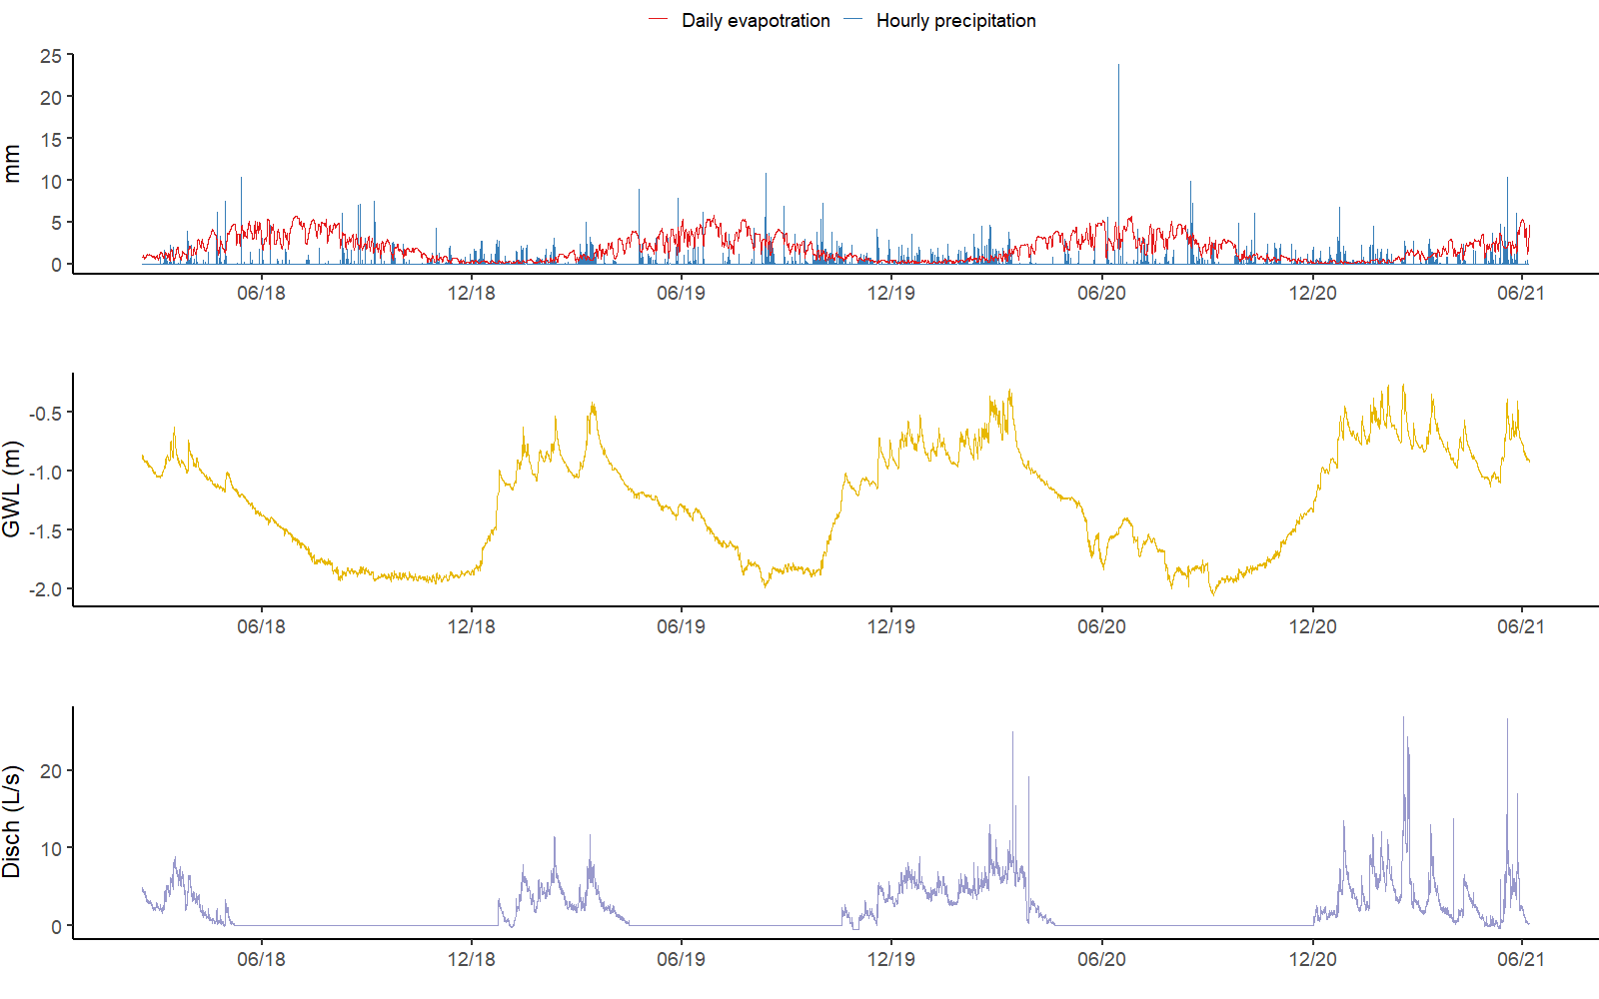
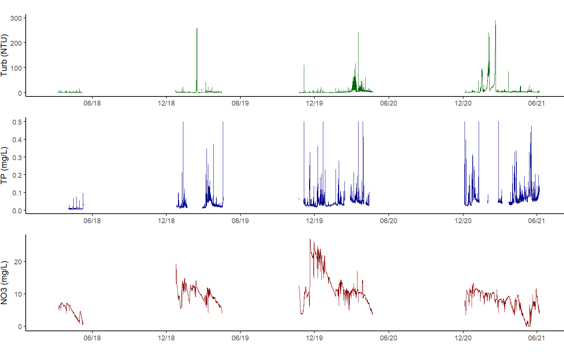
Figure S1 Measured time series with gaps in the data

2017-2018 season correlation matrix | 2018-2019 season correlation matrix
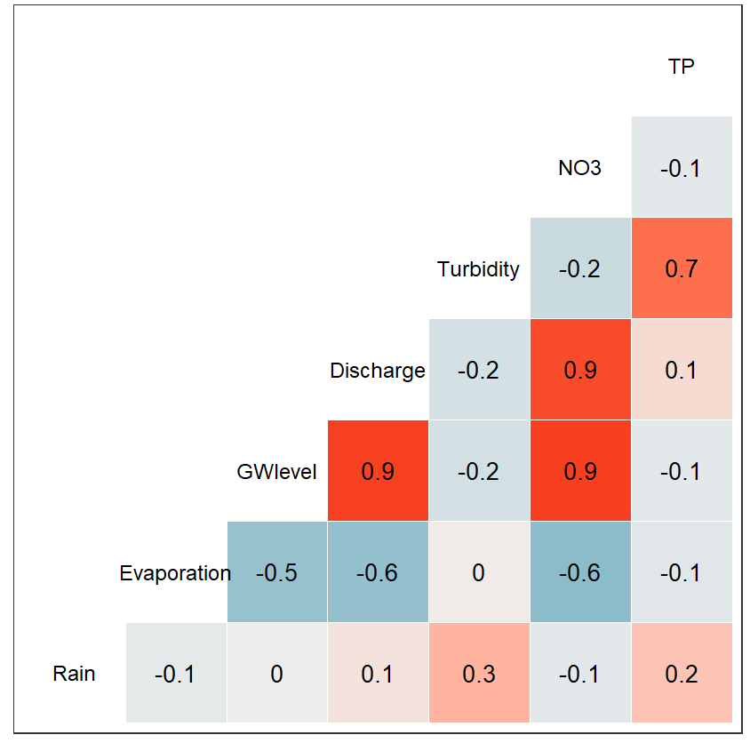 | 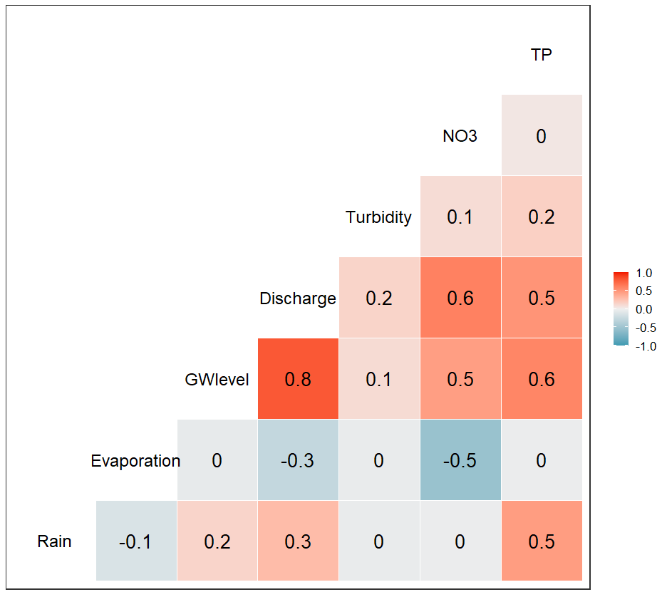
2019-2020 season correlation matrix | 2020-2021 season correlation matrix
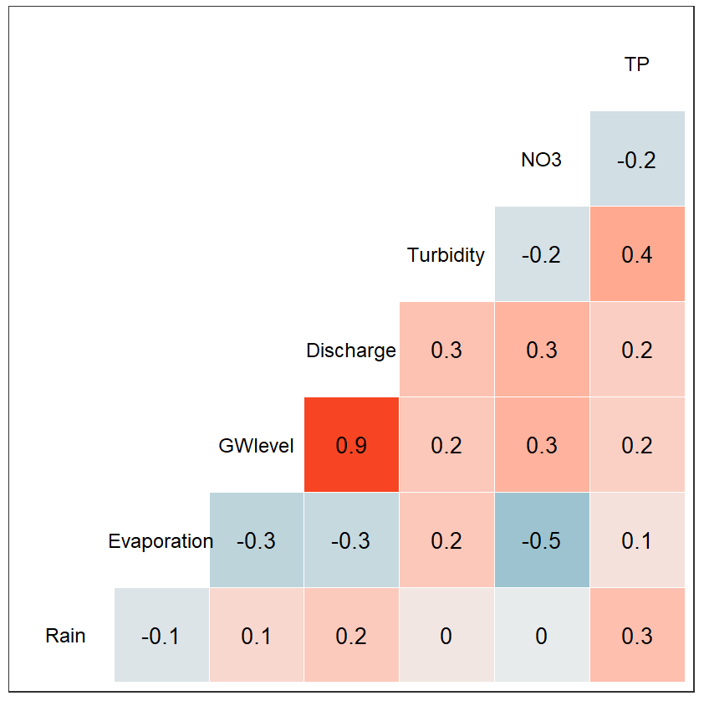 | 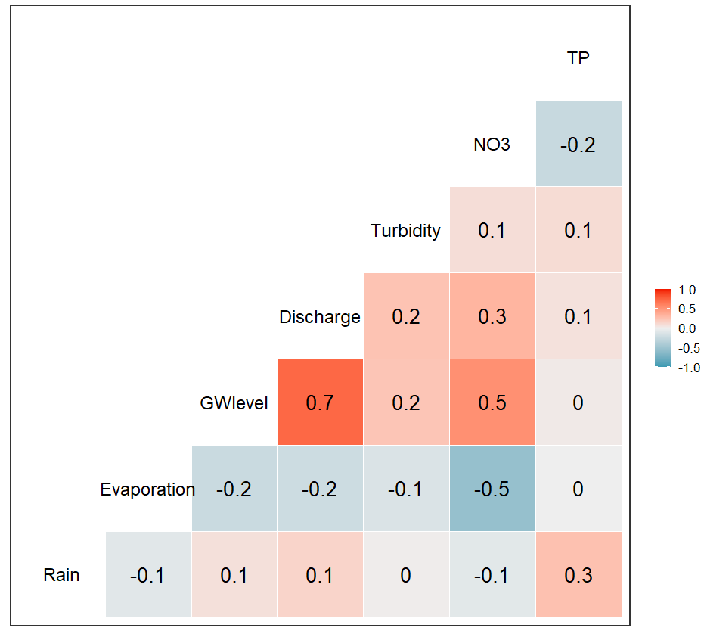
Figure S2 Matrix with the correlation coefficients of the measured data series in the four drainage seasons
Table S1 Statistical summary of the groundwater, turbidity, NO₃, and TP data for all seasons
 |  | All seasons | 2017-2018 | 2018-2019 | 2019-2020 | 2020-2021
Groundwater level (m) | Min* | -1.34 | -1.18 | -1.20 | -1.24 | -1.34
Groundwater level (m) | 1Q | -1.18 | -1.06 | -1.04 | -1.04 | -0.907
Groundwater level (m) | Median | -1.23 | -0.994 | -0.935 | -0.854 | -0.754
Groundwater level (m) | Mean | -1.28 | -0.989 | -0.916 | -0.858 | -0.769
Groundwater level (m) | 3Q | -0.898 | -0.917 | -0.838 | -0.726 | -0.630
Groundwater level (m) | 95 perc | -0.261 | -0.630 | -0.417 | -0.301 | -0.261
Turbidity (NTU) | Min | 0.21 | 0.93 | 0.21 | 0.40 | 1.04
Turbidity (NTU) | 1Q | 1.51 | 1.47 | 1.30 | 1.04 | 2.78
Turbidity (NTU) | Median | 2.59 | 1.82 | 2.03 | 2.19 | 3.51
Turbidity (NTU) | Mean | 9.40 | 2.06 | 14.1 | 4.89 | 13.4
Turbidity (NTU) | 3Q | 4.15 | 2.29 | 2.88 | 4.84 | 5.50
Turbidity (NTU) | 95 perc | 23.1 | 7.12 | 5.26 | 19.4 | 52.4
NO₃ (mg/L) | Min | 0.10 | 0.601 | 3.98 | 3.73 | 0.10
NO₃ (mg/L) | 1Q | 6.81 | 3.23 | 8.46 | 9.73 | 6.29
NO₃ (mg/L) | Median | 9.32 | 5.57 | 9.78 | 11.1 | 8.23
NO₃ (mg/L) | Mean | 9.52 | 4.91 | 9.97 | 12.7 | 7.77
NO₃ (mg/L) | 3Q | 11.18 | 6.49 | 11.7 | 15.0 | 10.1
NO₃ (mg/L) | 95 perc | 20.81 | 3.46 | 13.63 | 23.0 | 11.37
TP (mg/L) | Min | 0.005 | 0.005 | 0.007 | 0.016 | 0.023
TP (mg/L) | 1Q | 0.030 | 0.008 | 0.020 | 0.029 | 0.047
TP (mg/L) | Median | 0.040 | 0.005 | 0.026 | 0.036 | 0.059
TP (mg/L) | Mean | 0.050 | 0.010 | 0.035 | 0.045 | 0.077
TP (mg/L) | 3Q | 0.060 | 0.010 | 0.038 | 0.050 | 0.084
TP (mg/L) | 95 perc | 0.120 | 0.017 | 0.077 | 0.091 | 0.182
*Below this level there was no water flow discharge
Table S2 Results of the different NO₃ models, showing R², MAE, RMSE, and computation times
 |  |  | All seasons (2017-2021) | 2017-2018 | 2018-2019 | 2019-2020 | 2020-2021
NO3 | Random Forest* | R² | 0,996/0,995/0,995 | 0,998/0,998/0,998 | 0,998/0,998/0,998 | 0,995/0,994/0,994 | 0,998/,998/0,998
NO3 | Random Forest* | MAE | 0,112/0,113/0,113 | 0,027/0,026/0,027 | 0,043/0,040/0,041 | 0,134/0,140/0,148 | 0,046/0,047/0,047
NO3 | Random Forest* | RMSE | 0,311/0,322/0,328 | 0,039/0,036/0,040 | 0,086/0,074/0,086 | 0,375/0,357/0,415 | 0,077/0,080/0,080
NO3 | Random Forest* | Time(s) | 118/102/100 | 0,52/0,54/0,48 | 5,45/6,10/5,66 | 22/22/22 | 21/23/22
NO3 | K-Nearest Neighbor | R² | 0,735/0,735/0,721 | 0,737/0,753/0,712 | 0,998/0,998/0,998 | 0,821/0,812/0,812 | 0,846/0,848/0,846
NO3 | K-Nearest Neighbor | MAE | 1,21/1,20/1,23 | 0,638/0,615/0,709 | 0,018/0,017/0,017 | 0,900/0,925/0,926 | 0,567/0,565/0,561
NO3 | K-Nearest Neighbor | RMSE | 2,71/2,72/2,79 | 1,14/1,11/1,22 | 0,049/0,046/0,049 | 2,37/2,42/2,42 | 1,20/1,199/1,197
NO3 | K-Nearest Neighbor | Time(s) | 4151/2458/2161 | 8,38/7,52/8,33 | 6,69/6,18/6,81 | 84/73/97 | 128/103/93
NO3 | M5 rules | R² | 0,941/0,877/0,968 | 0,996/0,996/0,996 | 0,988/0,984/0,984 | 0,964/0,964/0,924 | 0,988/0,982/0,980
NO3 | M5 rules | MAE | 0,454/0,503/0,368 | 0,071/0,074/0,070 | 0,158/0,156/0,156 | 0,471/0,471/0,503 | 0,179/0,193/0,166
NO3 | M5 rules | RMSE | 1,13/1,66/0,826 | 0,109/0,116/0,104 | 0,270/0,298/0,298 | 1,02/1,02/1,49 | 0,328/0,389/0,418
NO3 | M5 rules | Time(s) | 1494/1361/2143 | 12,97/14,09/12,03 | 34/26/30 | 137/124/119 | 282/258/287
NO3 | Multivariable Linear Regression | R² | 0,389/0,386/0,388 | 0,974/0,843/0,841 | 0,612/0,621/0,621 | 0,322/0,329/0,327 | 0,522/0,518/0,519
NO3 | Multivariable Linear Regression | MAE | 2,48/2,49/2,48 | 0,583/0,585/0,590 | 1,10/1,11/1,10 | 3,59/3,55/3,57 | 1,54/1,55/1,55
NO3 | Multivariable Linear Regression | RMSE | 3,58/3,58/3,58 | 0,731/0,736/0,740 | 1,48/1,46/1,46 | 4,41/4,36/4,38 | 2,00/2,02/2,02
NO3 | Multivariable Linear Regression | Time(s) | 0,3/0,5/0,3 | 0,04/0,03/0,03 | 0,03/0,03/0,02 | 0,06/0,07/0,06 | 0,06/0,06/0,06
NO3 | Sequential minimal optimization | R² | 0,386/0,379/0,384 | 0,838/0,848/0,848 | 0,604/0,615/0,612 | 0,293/0,300/0,300 | 0,497/0,497/0,493
NO3 | Sequential minimal optimization | MAE | 2,39/2,40/2,40 | 0,565/0,572/0,572 | 1,0885/1,0902/1,0843 | 3,2899/3,2433/3,253 | 1,4976/1,4976/1,5094
NO3 | Sequential minimal optimization | RMSE | 3,6367/3,6376/3,6362 | 0,768/0,783/0,783 | 1,49/1,47/1,48 | 4,78/4,72/4,73 | 2,06/2,06/2,08
NO3 | Sequential minimal optimization | Time(s) | 154983/166755/173023 | 1320/1479/1728 | 1834/2020/1880 | 15876/19126/20921 | 18976/14022/18456
NO3 | Zero Rules | R² | 0/0/0 | 0/0/0 | 0/0/0 | 0/0/0 | 0/0/0
NO3 | Zero Rules | MAE | 3,25/3,24/3,25 | 1,64/1,65/1,64 | 1,92/1,94/1,93 | 4,25/4,24/4,24 | 2,25/2,27/2,26
NO3 | Zero Rules | RMSE | 4,58/4,57/4,58 | 1,85/1,86/1,86 | 2,37/2,38/2,37 | 5,36/5,33/5,34 | 2,89/2,92/2,91
NO3 | Zero Rules | Time(s) | 0,2/0,3/0,2 | 0,01/0,01/0,01 | 0,01/0,01/0,01 | 0,01/0,01/0,01 | 0,01/0,01/0,01
NO3 | Artificial Neural Networks | R² | 0,663/0,667/0,669 | 0,978/0,980/0,980 | 0,880/0,882/0,880 | 0,672/0,664/0,664 | 0,870/0,863/0,863
NO3 | Artificial Neural Networks | MAE | 1,87/2,28/2,28 | 0,205/0,201/0,201 | 0,603/0,879/0,603 | 2,16/2,10/2,10 | 0,896/0,812/0,812
NO3 | Artificial Neural Networks | RMSE | 2,87/2,96/2,96 | 0,285/0,269/0,269 | 0,857/1,12/0,857 | 3,08/3,10/3,10 | 1,16/1,08/1,08
NO3 | Artificial Neural Networks | Time (s) | 97/103/111 | 10/11/12 | 16/12/12 | 37/32/29 | 42/37/48

Table S3 Results of the different TP models, showing R², MAE, RMSE, and computation times
 |  |  | All seasons (2017-2021) | 2017-2018 | 2018-2019 | 2019-2020 | 2020-2021
TP | Random Forest* | R² | 0,963/0,958/0,958 | 0,960/0,975/0,969 | 0,934/0,934/0,934 | 0,927/0,917/0,917 | 0,972/0,967/0,967
TP | Random Forest* | MAE | 0,002/0,003/0,003 | 0,001/0,001/0,001 | 0,002/0,002/0,002 | 0,002/0,002/0,002 | 0,003/0,003/0,003
TP | Random Forest* | RMSE | 0,010/0,010/0,010 | 0,001/0,001/0,001 | 0,007/0,007/0,007 | 0,010/0,010/0,010 | 0,010/0,011/0,011
TP | Random Forest* | Time(s) | 134/112/131 | 3,13/3,04/3,05 | 11,3/7,4/8,9 | 23/22/25 | 21/15/15
TP | K-Nearest Neighbor | R² | 0,836/0,817/0,877 | 0,946/0,966/0,962 | 0,874/0,941/0,876 | 0,589/0,532/0,584 | 0,945/0,958/0,948
TP | K-Nearest Neighbor | MAE | 0,002/0,003/0,002 | 0,001/0,001/0,001 | 0,001/0,001/0,001 | 0,004/0,005/0,004 | 0,002/0,002/0,002
TP | K-Nearest Neighbor | RMSE | 0,020/0,021/0,017 | 0,002/0,001/0,001 | 0,011/0,007/0,010 | 0,028/0,032/0,027 | 0,014/0,012/0,014
TP | K-Nearest Neighbor | Time(s) | 1598/1455/1590 | 1,92/1,90/1,77 | 11,3/6,5/6,4 | 56/51/49 | 31/32/37
TP | M5 rules | R² | 0,808/0,815/0,815 | 0,901/0,858/0,858 | 0,798/0,798/0,799 | 0,561/0,701/0,701 | 0,828/0,880/0,880
TP | M5 rules | MAE | 0,008/0,008/0,008 | 0,001/0,001/0,001 | 0,005/0,005/0,005 | 0,01/0,007/0,007 | 0,010/0,009/0,009
TP | M5 rules | RMSE | 0,021/0,020/0,020 | 0,002/0,002/0,002 | 0,013/0,013/0,012 | 0,024/0,019/0,019 | 0,025/0,021/0,021
TP | M5 rules | Time(s) | 1351/1151/1047 | 22/20/24 | 62/61/56 | 125/111/80 | 171/196/157
TP | Multivariable Linear Regression | R² | 0,211/0,199/0,213 | 0,548/0,529/0,524 | 0,523/0,542/0,534 | 0,212/0,23/0,219 | 0,158/0,168/0,163
TP | Multivariable Linear Regression | MAE | 0,023/0,023/0,023 | 0,002/0,002/0,002 | 0,010/0,010/0,010 | 0,015/0,015/0,015 | 0,032/0,033/0,032
TP | Multivariable Linear Regression | RMSE | 0,041/0,042/0,042 | 0,004/0,005/0,004 | 0,020/0,019/0,019 | 0,031/0,031/0,030 | 0,053/0,055/0,054
TP | Multivariable Linear Regression | Time(s) | 1,6/0,5/0,5 | 0,01/0,01/0,01 | 0,05/0,06/0,06 | 0,06/0,05/0,06 | 0,06/0,04/0,04
TP | Sequential minimal optimization regression | R² | 0,190/0,180/0,193 | 0,533/0,514/0,503 | 0,237/0,246/0,246 | 0,156/0,170/0,171 | 0,123/0,120/0,112
TP | Sequential minimal optimization regression | MAE | 0,020/0,020/0,020 | 0,002/0,002/0,002 | 0,009/0,008/0,008 | 0,013/0,013/0,012 | 0,028/0,028/0,028
TP | Sequential minimal optimization regression | RMSE | 0,042/0,043/0,043 | 0,005/0,005/0,004 | 0,030/0,029/0,030 | 0,033/0,034/0,032 | 0,056/0,058/0,059
TP | Sequential minimal optimization regression | Time(s) | 60008/55637/51993 | 191/210/207 | 1098/1019/1018 | 7193/7126/4746 | 3559/5722/6457
TP | Zero Rules | R² | 0/0/0 | 0/0/0 | 0/0/0 | 0/0/0 | 0/0/0
TP | Zero Rules | MAE | 0,027/0,028/0,028 | 0,003/0,003/0,003 | 0,018/0,017/0,017 | 0,018/0,018/0,018 | 0,035/0,036/0,036
TP | Zero Rules | RMSE | 0,046/0,047/0,047 | 0,007/0,007/0,006 | 0,029/0,027/0,028 | 0,035/0,036/0,034 | 0,058/0,060/0,060
TP | Zero Rules | Time(s) | 0,8/0,6/1,5 | 0/0/0 | 0/0/0 | 0/0/0 | 0/0/0
TP | Artificial Neural Networks | R² | 0,489/0,534/0,534 | 0,753/0,516/0,516 | 0,702/0,699/0,724 | 0,438/0,524/0,524 | 0,510/0,557/0,557
TP | Artificial Neural Networks | MAE | 0,018/0,016/0,016 | 0,002/0,002/0,002 | 0,020/0,008/0,010 | 0,0124/0,0111/0,0111 | 0,0236/0,022/0,0226
TP | Artificial Neural Networks | RMSE | 0,034/0,033/0,033 | 0,003/0,004/0,004 | 0,024/0,015/0,016 | 0,029/0,024/0,024 | 0,044/0,040/0,040
TP | Artificial Neural Networks | Time(s) | 70/68/75 | 8/7/9 | 12/12/12 | 35/28/30 | 22/23/26
* the RF times include computing the variable importance
2017-2018 | 2018-2019
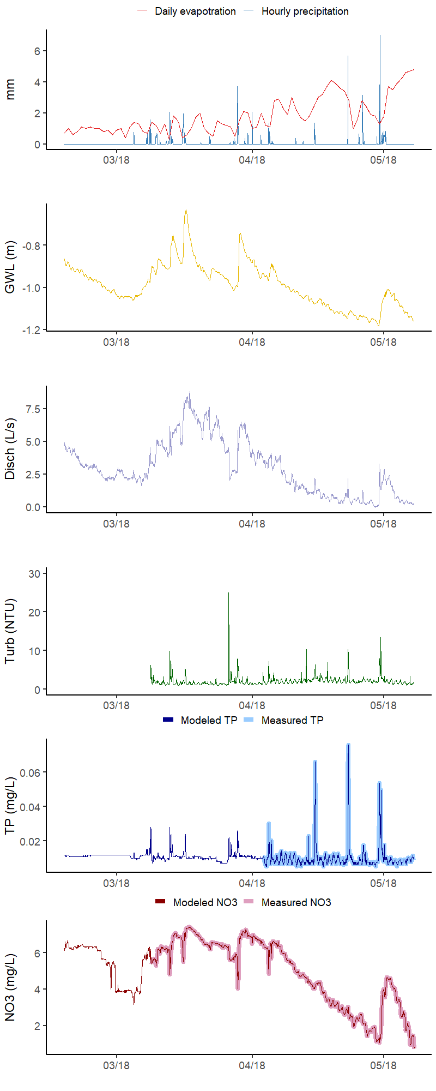 | 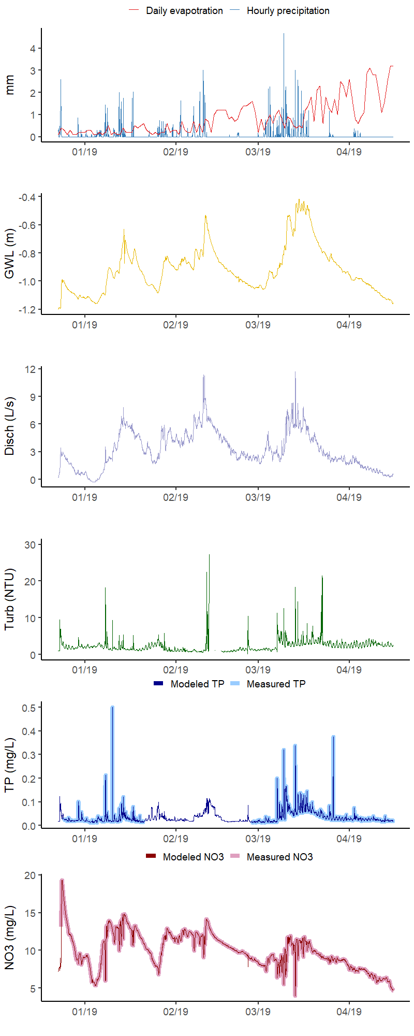
Figure S3 2017-2018 and 2018-2019 datasets with measured and modeled TP and NO3. The dash boxes show data gaps.

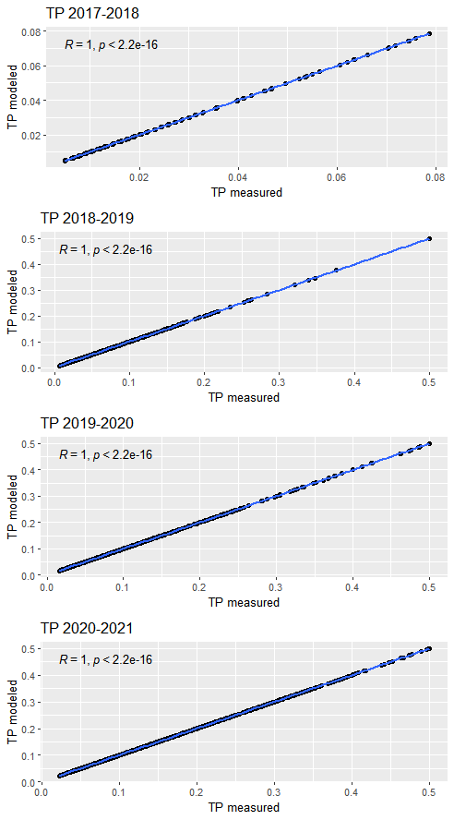 | 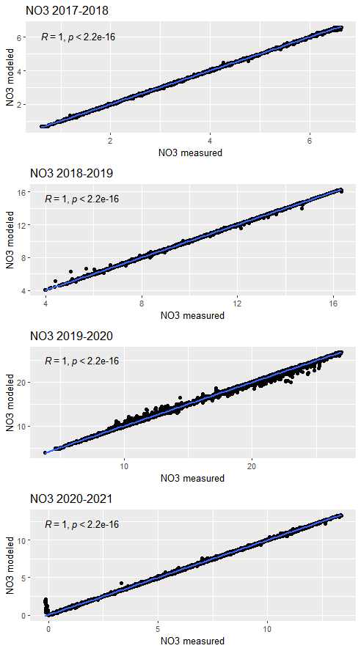
Figure S4 Correlation coefficients for TP and NO3 Random Forest models for each season
Seasonal loads vs time
TP export loads per season | NO₃ export loads per season
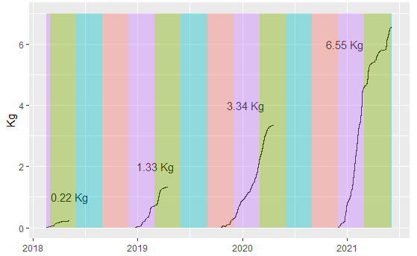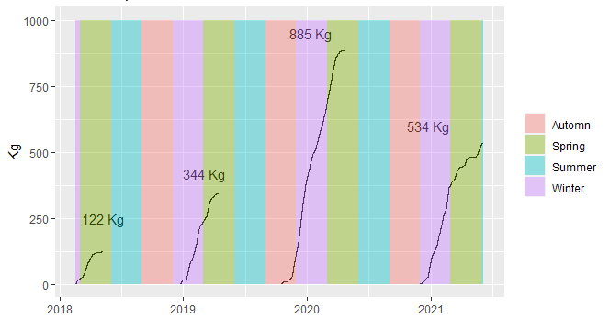
Figure S5 NO3 and TP in the different drainage seasons: measured and modeled with Random Forest

