Invasion of the Polyphagous Shot Hole Borer beetle in South Africa:
A preliminary assessment of the economic impacts

Supplementary Material

Table S1 Agricultural tree species affected by the Polyphagous Shot Hole Borer beetle in global case studies

Latin name | Common name
Citrus limon | Lemon
Citrus sinensis | Orange
Ficus carica | Common fig
Macadamia integrifolia tetraphylla | Macadamia nut
Prunus persica | Peach
Psidium guajava | Guava
Vitis vinifera | Grapevine
Carya illinoinensis | Pecan nut

Fig S1 Gross production value (GPV) of avocado trees in South Africa (Int. $ m, 1994/5 – 2017/18)

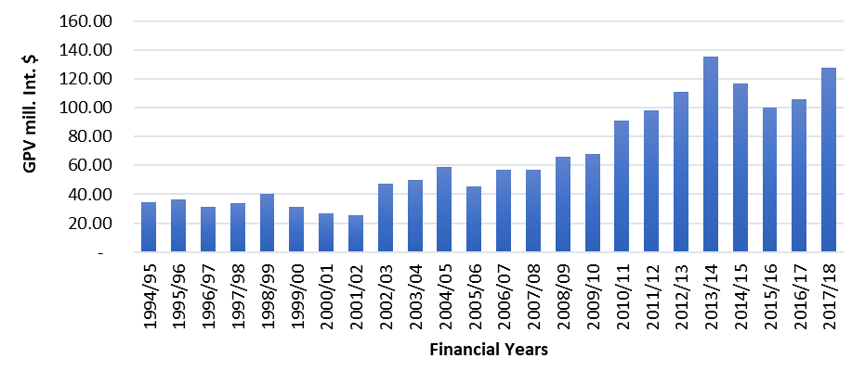
Source: DAFF (2020: 44)

Fig S2 Gross production value (GPV) of black wattle in South Africa (Int. $ m, 2005 – 2018)

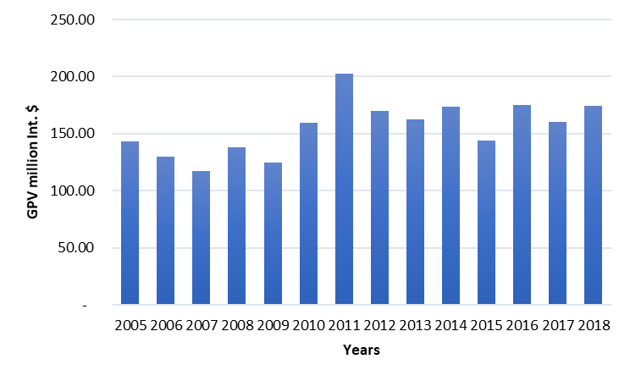
Sources: Oberholzer and Godsmark (2020); Craig Norris (NCT), pers comm, 2020

Benefit-Transfer Method Equations
The adjustment equations used for the economic value of natural forests in South Africa are represented by equations (1) (the currency conversion formula), (2) (the CPI adjustment formula), and (3) (GDP-PPP adjustment), respectively as follows:
$$A_{1}i= X^{0},oc. e^{t}tc, oc$$ | (1)

where $A_{1}i$ is the $i^{th}$ original context value after adjustment, $X^{0},oc$ is the $i^{th}$ initial original context value and $e^{t}tc, oc$ is the currency ratio of the transfer context to the original context at the base year. For Natural Forests, total value per hectare is provided by Brenner et al. (2013), de Groot et al. (2013) and de Groot et al. (2012). For Urban Environments, total value per tree quantities provided by McPherson (2003), Soares et al. (2011) and Peper et al. (2007) are used. The quantities provided by these studies are converted from U.S dollars to Rands using the average annual exchange rates provided by Investing.com (2020), in accordance with equation 1. These values are then adjusted for CPI using the following equation:

$$A_{2}i=A_{1}i ({CPI}^{t}tc, oc/{CPI}^{0}tc, 0)$$ | (2)
where $A_{2}i$ is the $i^{th}$ original context value after second adjustment, is the $i^{th}$ original context value after first adjustment, ${CPI}^{t}tc, oc$ is the CPI of the transfer context/country for the current year and ${CPI}^{0}tc, 0$ is the CPI of the transfer context/country for the initial year / study date. CPI, or the Consumer Price Index, measures the monthly changes in prices for a range of consumer products, with these changes recording the rate of inflation (StatsSA 2013). This adjustment allows for the values obtained by equation 1 to be represented in current prices. The CPI headline year-on-year rates are obtained from StatsSA (2020). Finally, the per tree values for Urban Environments are adjusted for the PPP-GDP using the following equation:

$$A_{3}i= A_{2}i {({GDP}^{t}tc/ {GDP}^{t}oc)}^{ε}$$ | (3)
where $A_{3}i$ is the $i^{th}$ original context value after third adjustment, $A_{2}i$ is the $i^{th}$ original context value after second adjustment, ${GDP}^{t}tc$ is the PPP GDP of the transfer context/country for the current year, the ${GDP}^{t}oc$ is the PPP GDP of the original context/country for the current year and $ε$ is the income elasticity of demand for environmental quality. The GDP (PPP) adjustment captures the conversion of the gross domestic product to international dollars using purchasing power parity rates. An international dollar has the same purchasing power over GDP as a U.S. dollar has in the United States. Purchasing power parities (PPPs) are the rates of currency conversion that eliminate the differences in price levels between countries (Global Finance, 2020). This allows for Equation 2’s values to capture the different income levels from the original study, to the local study. To prevent double-counting, this step was omitted for Natural Forests as the original studies had already adjusted the local values to the international dollar’s metric. For Urban Environments, the GDP per capita (PPP) conversion values are obtained from the World Bank (2020), with the ‘World’ GDP per capita (PPP) equating to Int. $17 680.20 and the South African GDP per capita (PPP) equating to Int. $12 999.10. To obtain the int. $ Gross Production Values, the rand values for Avocado Trees and Black Wattle are converted using this formula with the same ‘World’ and South African GDP per capita (PPP) values provided by the World Bank (2020).

Table S2 Adjusted Total Economic Value (TEV) for natural forests in South Africa (2019 Int. $/ha)

Value per hectare | Original study
3 260.80 | De Groot et al (2012)
6 642.87 | Brenner et al (2010)
2 111.23 | De Groot et al (2013)

Table S3 Adjusted Total Economic Value (TEV) for selected urban trees in South Africa (2019 Int. $/tree)

Urban tree species | Value per tree | Original study
London Plane | 11.52 | McPherson (2003)
Modesto Ash | 10.82 | McPherson (2003)
Chinese Sweetgum | 8.22 | McPherson (2003)
Modesto Ash | 10.82 | McPherson (2003)
Variety of Lisbon Trees | 21.21 | Soares et al. (2011)
Variety of New York Trees | 29.97 | Peper et al. (2007)
London Plane | 44.04 | Peper et al. (2007)
Sweetgum | 22.20 | Peper et al. (2007)
Pin Oak | 39.31 | Peper et al. (2007)
Honey Locust | 31.67 | Peper et al. (2007)
Unknown Large | 37.84 | Peper et al. (2007)
Other | 22.31 | Peper et al. (2007)
Oak, northern red | 32.24 | Peper et al. (2007)
Maple average | 28.77 | Peper et al. (2007)
Mean value | 25.07 | Calculated

Table S.4. Estimated total number of urban trees affected by a PSHB invasion
 | Tree coverage |  | Source | Urban area (ha) | Source | Number of trees (million) | Source
Cape Town | 13.4 | % | Treepedia (2020) | 400 300 |  | 13.8 | Calculation¹
Johannesburg | 23.6 | % | Treepedia (2020) | 164 542 | Schäffler et al. (2013) | 10 | JUFA (2020)
Durban | 23.7 | % | Treepedia (2020) | 229 200 |  | 14.0 | Calculation²
Sub-total |  |  |  | 794 042 |  | 37.8
Total Urban area (SA) |  |  |  | 5 346 000 |  | 254.5 | Calculation³

Notes:
1) 10m trees / 164 542ha / 23.6% * 13.4% * 400 300ha
2) 10m trees /164 542ha / 23.6% * 23.7% * 229 200ha
3) 5 346 000 ha / 794 042 ha * 37.8m trees

Equations used in the model
Equations
Avocado trees with dieback= INTEG (avocado growth-avocado mortality,
initial number of avocado trees)
~ tree
growth price avocados= growth rate price avocados*producer price Avocados ~ Dollar/(tonne*Month)
External cost urban trees= INTEG (rate, 0) ~ Dollar
tree spread= urban tree growth rate*Urban trees
~ tree/Month
Polyphagous Shothole Borer= INTEG (
growth PSHB-mortality PSHB,
initial proportion PSHB)
~ Dmnl
~ no of trees infested (assumption) x no. of PSHB per tree
Fusarium euwallaceae= INTEG (
growth Fusarium-mortality Fusarium,
  - ~ Dmnl
growth Fusarium=
growth rate Fusarium*Fusarium euwallaceae+beta*Polyphagous Shothole Borer*Fusarium euwallaceae
~ 1/Month
growth PSHB=
Polyphagous Shothole Borer*growth rate PSHB+alpha*Polyphagous Shothole Borer*Fusarium euwallaceae
~ 1/Month
producer price Avocados= INTEG (growth price avocados,
19343/14.5*17.68/13) ~ Dollar/tonne
~ constant 2019 International US$
NPC avocado= INTEG (rate avocado, 0) ~ Dollar
growth wattles= Wattle trees with dieback*growth rate wattle
~ tree/Month
growth price wattle bark= growth rate price wattle*producer price wattle bark
~ Dollar/(tonne*Month)
producer price wattle bark= INTEG (growth price wattle bark,
1545/14.5*17.68/13) ~ Dollar/tonne ~ constant 2019 prices
NPC wattle= INTEG (rate wattle, 0) ~ Dollar
avocado growth= Avocado trees with dieback*growth rate avocados ~ tree/Month
Avocado producer value with dieback= producer price Avocados*production volume avocados ~ Dollar/Month
wattle mortality= growth rate wattle*Wattle trees with dieback^2/carrying capacity wattle+Fusarium mortality rate wattle*Wattle trees with dieback*Fusarium euwallaceae ~ tree/Month
rate avocado= (Avocado producer value baseline-Avocado producer value with dieback)/((1+monthly effective discount rate)^(Time/TIME STEP)) ~ Dollar/Month
rate wattle= (wattle producer value baseline-wattle producer value with dieback)/((1+monthly effective discount rate)^(Time/TIME STEP)) ~ Dollar/Month
wattle trees baseline= INTEG (growth wattles baseline-mortality wattles baseline, 2.73304e+006) ~ tree
growth wattles baseline= growth rate wattle*wattle trees baseline ~ tree/Month
Wattle trees with dieback= INTEG (growth wattles-wattle mortality, Initial number of trees wattle bark) ~ tree
avocado growth baseline= Avocado trees baseline*growth rate avocados ~ tree/Month
avocado mortality= growth rate avocados*Avocado trees with dieback^2/carrying capacity avocados+Avocado trees with dieback*Fusarium mortality rate avocados*Fusarium euwallaceae ~ tree/Month
avocado mortality baseline= growth rate avocados*Avocado trees baseline^2/carrying capacity avocados ~ tree/Month
mortality wattles baseline= growth rate wattle*wattle trees baseline^2/carrying capacity wattle ~ tree/Month
Avocado trees baseline= INTEG (avocado growth baseline-avocado mortality baseline, initial number of avocado trees) ~ tree
carrying capacity avocados= initial number of avocado trees/proportion of total production
~ tree
carrying capacity wattle=Initial number of trees wattle bark*ratio maximum to initial wattle ~ tree
production volume wattle bark= area planted wattle bark*production bark per hectare ~ tonne/Month
urban tree mortality= urban tree growth rate*Urban trees^2/carrying capacity urban trees+Fusarium euwallaceae*Fusarium mortality rate urban trees*Urban trees ~ tree/Month
Carrying capacity PSHB number= average number PSHB per tree*maximum number of trees ~ number
average number PSHB per tree= average weight of tree*number of PSHB per kilogram host ~ number/tree
mortality PSHB= (growth rate PSHB*Polyphagous Shothole Borer^2)/carrying capacity PSHB proportion ~ 1/Month
wattle producer value with dieback= producer price wattle bark*production volume wattle bark*adjustment factor for timber products ~ Dollar/Month ~ 2019 constant prices
decline trees treated= growth rate trees treated*number of infected trees treated^2/(maximum trees treated*Fusarium euwallaceae) ~ tree/Month
mortality Fusarium= (growth rate Fusarium*Fusarium euwallaceae^2)/carrying capacity Fusarium ~ 1/Month
primary forest mortality= Fusarium euwallaceae*Fusarium mortality rate primary forests*Primary forest with dieback ~ hectare/Month
NPC primary forest= INTEG (rate forest, 0) ~ Dollar
rate forest= (average carbon density*loss due to PSHB*unit carbon value*factor for other values from forests)/((1+monthly effective discount rate)^(Time/TIME STEP))
~ Dollar/Month
Primary forest with dieback= INTEG (growth forests-primary forest mortality, 947000) ~ hectare
Urban trees= INTEG (tree spread-urban tree mortality, urban trees no dieback) ~ tree
Social cost= Financial cost+External cost ~ Dollar ~ 2019 International dollars
External cost= NPC primary forest+External cost urban trees ~ Dollar
initial proportion PSHB= number PSHB per tree*initial no of trees infested/Carrying capacity PSHB number ~ Dmnl
monthly effective discount rate= (1+annual discount rate)^(1/12)-1 ~ Dmnl
growth forests= growth rate natural forests*Primary forest with dieback ~ hectare/Month
rate private cost= (urban tree mortality*physical clearing cost)/((1+monthly effective discount rate)^(Time/TIME STEP)) ~ Dollar/Month
rate= (urban tree mortality*Value of urban trees)/((1+monthly effective discount rate)^(Time/TIME STEP)) ~ Dollar/Month
effectiveness of treatment= biocontrol*IF THEN ELSE(Time>59,effectiveness biocontrol,0)+physical clearing*effectiveness physical clearing ~ 1/Month
Private cost= INTEG (rate private cost, 0) ~ Dollar
maximum trees treated= carrying capacity avocados+carrying capacity urban trees+carrying capacity wattle+initial area primary forest\number of trees per hectare ~ tree
Financial cost= NPC avocado+NPC wattle+Private cost ~ Dollar
production volume avocados= avocado production per tree*net growth avocados with dieback ~ tonne/Month
area planted wattle bark= net growth wattle with dieback/wattle trees planted per hectare ~ hectare/Month
Avocado producer value baseline= net growth avocados baseline*avocado production per tree*producer price Avocados ~ Dollar/Month
net growth wattle baseline= growth wattles baseline-mortality wattles baseline ~ tree/Month
net growth wattle with dieback= growth wattles-wattle mortality ~ tree/Month
loss due to PSHB= net growth primary forest no dieback-net growth forest with dieback ~ hectare/Month
net growth avocados baseline= avocado growth baseline-avocado mortality baseline ~ tree/Month
net growth avocados with dieback= avocado growth-avocado mortality ~ tree/Month
net growth forest with dieback= growth forests-primary forest mortality ~ hectare/Month
wattle producer value baseline= net growth wattle baseline/wattle trees planted per hectare*production bark per hectare*producer price wattle bark*adjustment factor for timber products ~ Dollar/Month ~ 2019 international dollars

Table S.5. Input parameters used in the model
Parameter | Value | Unit | Source
adjustment factor for timber products | 9.15 | Dmnl | Forestry South Africa (2020)
Alpha | 0.3 | 1/Month | effect of beetle-fungus interactions on PSHB spread [calibration]
annual discount rate | 0.06 | Dmnl | calculation based on Van Zyl and De Wit (2013) (range: 0.04 - 0.08)
average carbon density | 29/12 | tC/hectare | Mongabay (2011)
average weight of tree | 1 384 | kg/tree | Jacaranda as indicative of urban tree (Stoffberg 2006)
avocado production per tree | 0.0272155 | tonne/tree | https://homeguides.sfgate.com/much-avocado-trees-yield-56000.html
Beta | 0.3 | 1/Month | effect of beetle-fungus interactions on Fusarium spread [calibration]
carrying capacity Fusarium | 1 | Dmnl | maximum=100% of area
carrying capacity PSHB proportion | 1 | Dmnl | 100% of area
carrying capacity urban trees | 2.55e+008 | tree | calculation [see Table S.4]
factor for other values from forests | 6.75 | Dmnl | Turpie et al. (2017)
Fusarium mortality rate avocados | 0.04 | 1/Month | calibrated to achieve a 25% decrease in avocado trees over 10 years
Fusarium mortality rate primary forests | 0.0065 | 1/Month | calibrated to generate a 5% decline over 10 years
Fusarium mortality rate urban trees | 0.0378 | 1/Month | calibrated to achieve a 25% decrease in urban trees over 10 years
Fusarium mortality rate wattle | 0.008 | 1/Month | baseline calibrated to achieve a 5% decrease wattle trees over 10 years
growth rate avocados | 0.002 | 1/Month | average monthly growth rate in number of trees based on historical trends in DAFF (2020)
growth rate Fusarium | 0.025 | 1/Month | calibrated to match expectation of future trends in PSHB spread
growth rate natural forests | 0 | 1/Month | assumption
growth rate price avocados | 0.003 | 1/Month | average real monthly growth rate based on historical trends in DAFF (2020)
growth rate price wattle | 0.003 | 1/Month | average real monthly growth rate based on historical trends in DAFF (2020)
growth rate PSHB | 0.08 | 1/Month | calibrated to match expectation of future trends in PSHB spread
growth rate wattle | 0.0002 | 1/Month | average monthly growth rate in number of trees based on historical trends (DAFF, 2020).
initial area primary forest | 947 000 | hectare | Mongabay (2011)
initial no of trees infested | 1 000 | tree | no of trees infested (assumption)
initial number of avocado trees | 303 686 | tree | forecasted monthly production June 2020 (based on DAFF 2020) divided by avocado production per tree]
Initial number of trees wattle bark | 2.73304e+006 | tree | calculation*
net growth primary forest no dieback | 0 | hectare/Month | Mongabay (2011)
number of PSHB per kilogram host | 9 | number/kg | Jones and Paine (2015)
number of which? trees per hectare | 1 500 | tree/hectare | assumed the same as for wattle
physical clearing cost | 656.55 | Dollar/tree | R7000 / 14.5 * 17.68/1 = Int. $ 656.55 (2019). Range: Int. $281.38 - 3282.76 per tree)
production bark per hectare | 6 | tonne/hectare | average production of 18 tons wattle bark per hectare and 3 tonnes bark makes 1 tonne saleable product (SA Forestry Online, 2009). So average production is 6 tonnes of saleable product per hectare
proportion of total production | 0.5 | Dmnl | Garret (2016)
ratio Fusarium mortality to PSHB mortality | 1 | Dmnl | assumption 1:1 ratio
ratio maximum to initial wattle | 180 000 / 110 000 | Dmnl | 1973 values = 180 000 hectares. 2020 values = around 110 000 hectares
unit carbon value | 11.26 | Dollar/tonne | Crookes (2012), converted to 2019 Int. $
urban tree growth rate | 0 | 1/Month | assumption
urban trees no dieback | 2.55e+008 | tree | calculation - see Supplementary Material Table S.4
Value of urban trees | 25.07 | Dollar/tree | 2019 values: R87.66 - R469.57 ($8.22 - $44.04 / tree).  Int. $: R14.5 / $ (PPP adjustment) R267.24 / 14.5 * 17.68 / 13 = Int $ 25.07
wattle trees planted per hectare | 1 500 | tree/hectare | calculation (note 1)
Notes:
¹ Calculation of initial number of wattle trees: Monthly production volume wattle bark: 10,932 tonnes (forecasted monthly production volume based on historical trends reported in DAFF (2020)). The wattle is grown on a 10-year rotation with 10% harvested each year and average production of 18 tons bark per hectare and 3 tonnes bark makes 1 tonne saleable product (SA Forestry Online, 2009). Wattle tree density: 1500 trees/ha (NCT Forestry Co-Operative Ltd, 2014). Therefore, initial number of trees per month grown for wattle bark: 10 932 tonnes / 18 tonnes / hectare * 3 tonnes * 1 500 trees / hectare = 2.733 million trees.

Stock flow diagrams for the sub-models
Diagram 1: Forestry
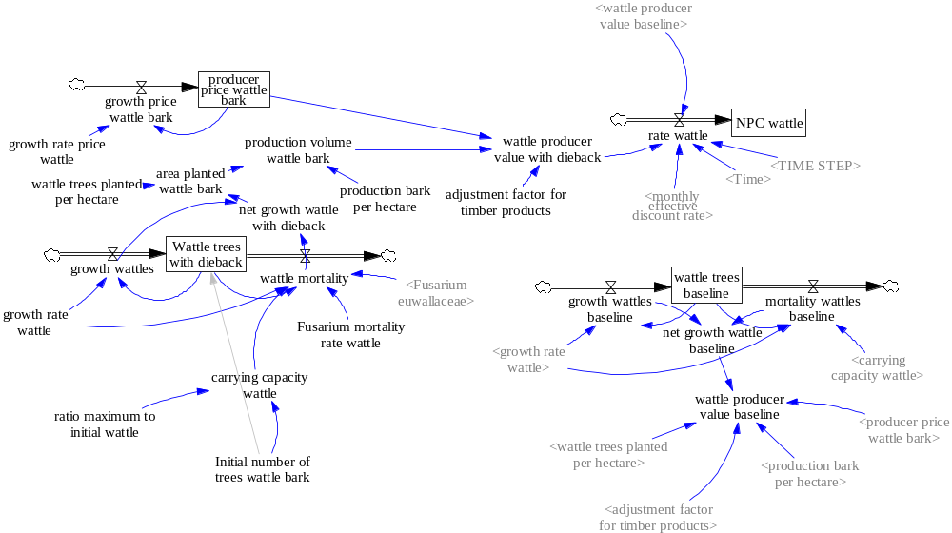
Diagram 2: Crops
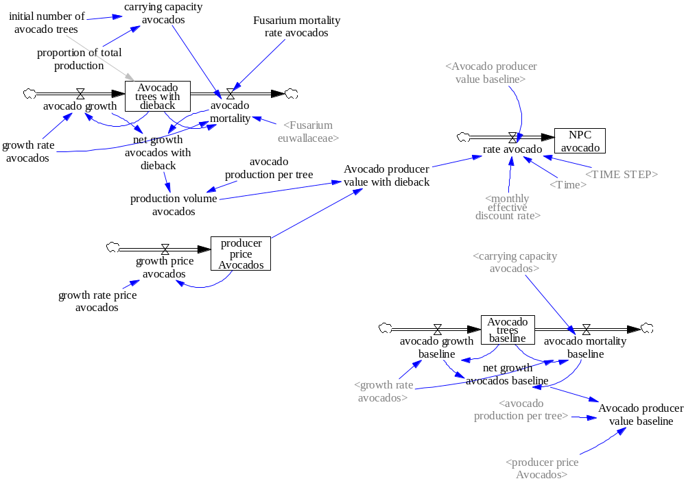

Diagram 3: Primary forest
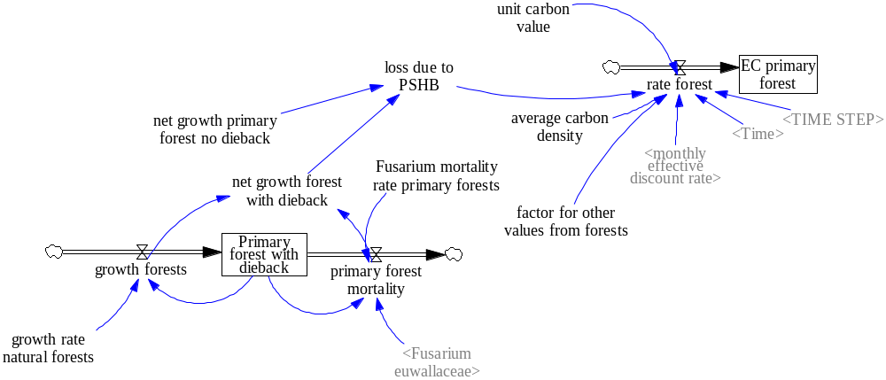

Diagram 4: Urban trees
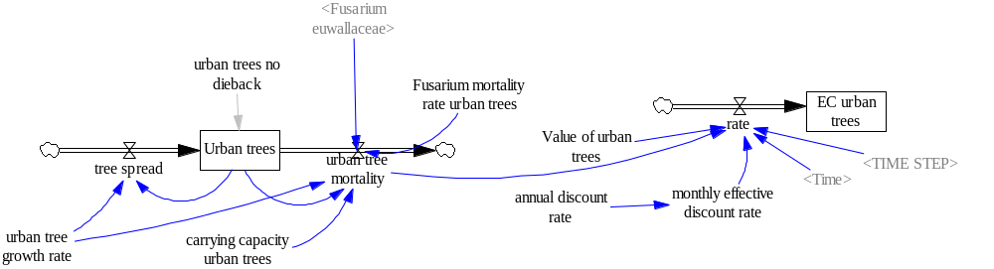

Diagram 5: Economics
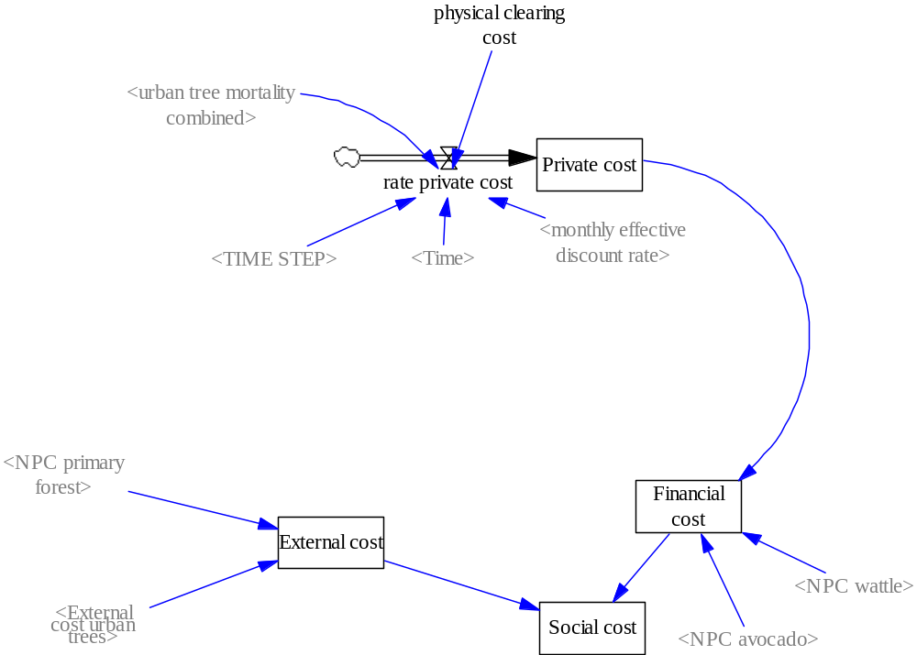

References
Crookes DJ (2012) Modelling the ecological-economic impacts of restoring natural capital, with a special focus on water and agriculture, at eight sites in South Africa. Stellenbosch. Stellenbosch University
Brenner J, Jiménez JA, Sardá R, Garola A (2010) An assessment of the non-market value of the ecosystem services provided by the Catalan coastal zone, Spain. Ocean Coast Manag 53:27–38. https://doi.org/10.1016/j.ocecoaman.2009.10.008
De Groot R, Brander L, van der Ploeg S, et al (2012) Global estimates of the value of ecosystems and their services in monetary units. Ecosyst Serv 1:50–61 https://doi.org/10.1016/j.ecoser.2012.07.005
De Groot RS, Blignaut J, Van der Ploeg S, et al (2013) Benefits of investing in ecosystem restoration. Conserv Biol 27:1286–1293. https://doi.org/10.1111/cobi.12158
Department of Agriculture, Forestry and Fisheries (DAFF) (2020) Abstract of Agricultural Statistics 2019 [Excel spreadsheet]. Government Printer, Pretoria
Forestry South Africa (2020) South African Forestry & Forest Products Industry Facts: 1980 - 2017 (Excel document). https://forestry.co.za/statistical-data. Accessed: 11 June 2020
Garret C (2016) South Africa: ramping up avocado production. https://www.freshplaza.com/article/2155043/south-africa-ramping-up-avocado-production/. Accessed: 23 November 2020
Global Finance. 2020. GDP-GNI-Definitions https://www.gfmag.com/global-data/glossary/gdp-gni-definitions#:~:text=PPP%20GNI%20is%20gross%20national,has%20in%20the%20United%20States. Accessed 12 November 2020
Investing.com. 2020. USD/ZAR Historical Data. https://za.investing.com/currencies/. Accessed 12 November 2020
Johannesburg Urban Forest Alliance (JUFA) (2020). Johannesburg as an urban forest http://www.jufa.org.za/about.html . Accessed: 23 November 2020
Jones ME, Paine TD (2015) Effect of chipping and solarization on emergence and boring activity of a recently introduced Ambrosia Beetle (Euwallacea sp., Coleoptera: Curculionidae: Scolytinae) in Southern California. J Econ Entomol 108:1852–1859. https://doi.org/10.1093/jee/tov169
NCT Forestry Co-Operative Ltd, 2014. News and Views No. 84 April 2014. http://www.nctforest.com/upload/Publications/News%20n%20Views%20April%202014%20electronic.pdf. Accessed: 23 November 2020
McPherson EG (2003) A benefit-cost analysis of ten tree species in Modesto, California, U.S.A. J Arboric 29:1–8
Mongabay (2011) South Africa Forest Information and Data. https://rainforests.mongabay.com/deforestation/2000/South_Africa.htm. Accessed: 11 June 2020
Oberholzer F, Godsmark R (2020). Forestry South Africa Roundwood Sales Analysis for 2019 Financial Year. Forestry South Africa. 1–31.
Peper P, McPherson EG, Simpson JR, et al (2007) New York City, New York. Municipal Forest Resource Analysis. Davis, CA
SA Forestry Online (2009) Harvesting wattle bark the UCL way. http://saforestryonline.co.za/articles/harvesting_silviculture/harvesting_wattle_bark_the_ucl_way/. Accessed: 23 November 2020.
Schäffler A, Christopher N, Bobbins K, et al (2013) State of Green Infrastructure in the Gauteng City-Region. Gauteng City-Region Observatory, Johannesburg.
Soares AL, Rego FC, McPherson EG, et al (2011) Benefits and costs of street trees in Lisbon, Portugal. Urban For Urban Green 10:69–78. https://doi.org/10.1016/j.ufug.2010.12.001
StatsSA (2013) What is the Consumer Price Index. http://www.statssa.gov.za/?p=955. Accessed 12 November 2020
StatsSA (2020) Consumer Price Index (CPI) http://www.statssa.gov.za/. Accessed: 12 November 2020Stoffberg GH (2006) Growth and carbon sequestration by street trees in the City of Tshwane, South Africa. University of Pretoria
Stoffberg GH (2006) Growth and carbon sequestration by street trees in the City of Tshwane, South Africa. University of Pretoria
Treepedia (2020) Exploring the green canopy in cities around the world. http://senseable.mit.edu/treepedia/cities/cape%20town. Accessed: 23 November 2020
Turpie JK, Forsythe KJ, Knowles A, et al (2017) Mapping and valuation of South Africa’s ecosystem services: A local perspective. Ecosyst Serv 27:179-192 https://doi.org/10.1016/j.ecoser.2017.07.008
Van Zyl H, De Wit MP (2013) Environmental Impact Assessment for the proposed National Road 3: Keeversfontein To Warden (De Beers Pass Section). Environmental Resource Economics Draft Specialist Report
World Bank (2020) GDP per capita, PPP (current international $) - South Africa https://data.worldbank.org/indicator/NY.GDP.PCAP.PP.CD?locations=ZA&name_desc=true. Accessed 13 November 2020

