Supplementary material

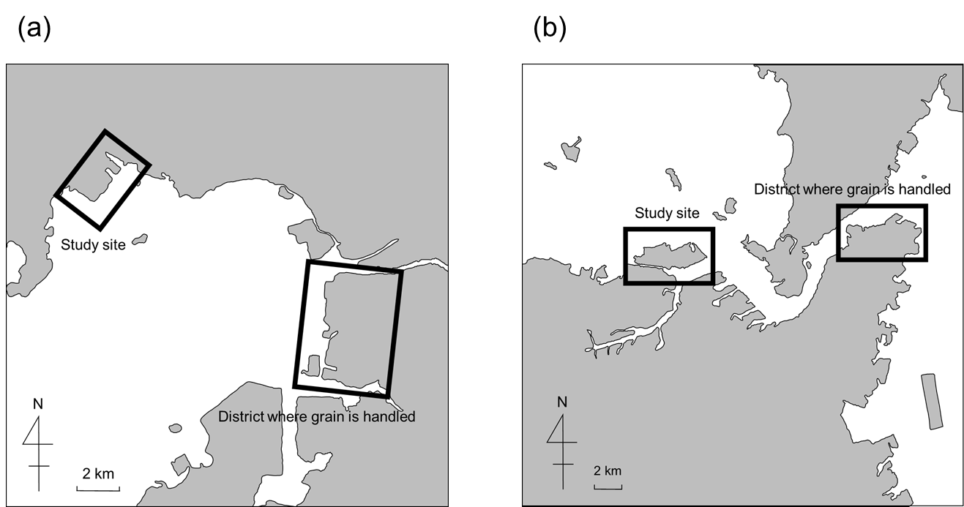

Supplementary material Figure 1
Locations of the study site and the grain handling district in Mikawa port (a) and Kitakyusyu port (b).

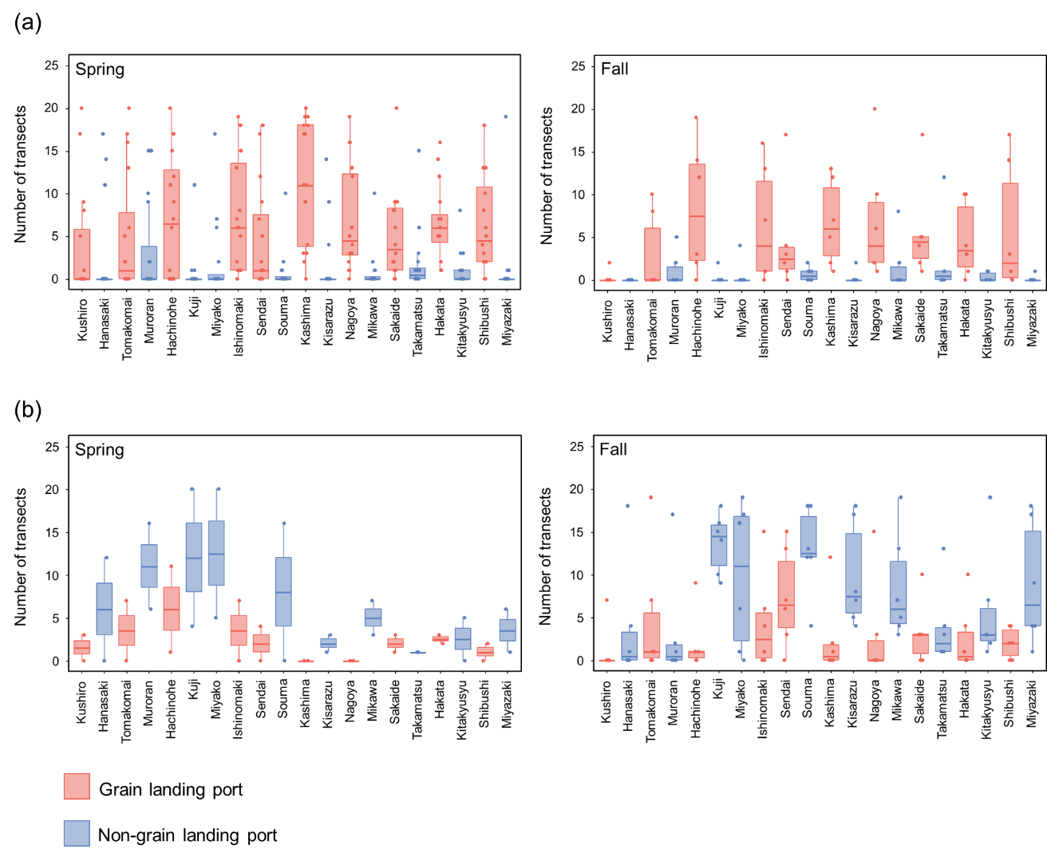

Supplementary material Figure 2
Frequency of occurrence of indicator species for the grain landing ports (a) and the non-grain landing ports (b) based on the number of transects with these species recorded at each port in spring and fall.

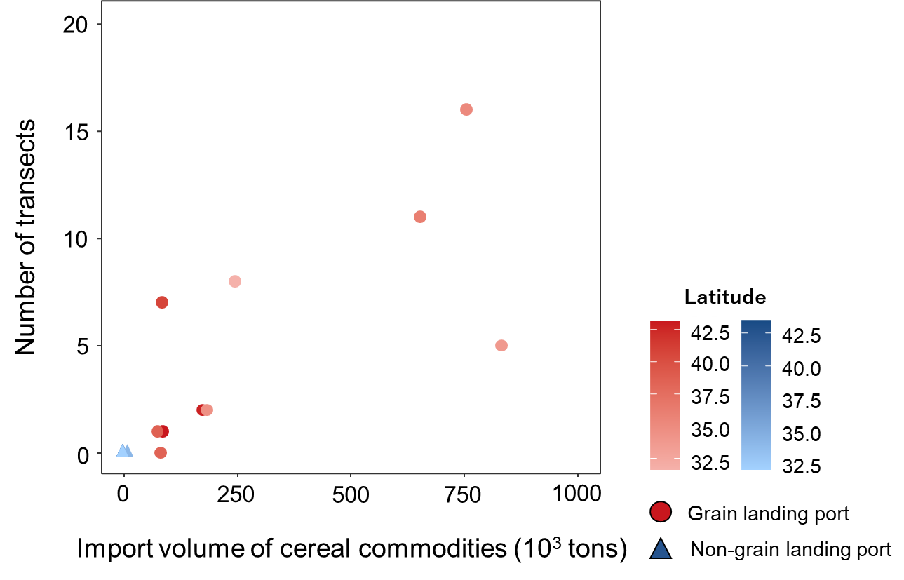

Supplementary material Figure 3
Relationship between the import volume of cereal commodities and the number of transects with wheat recorded at each port. Cereal commodities include wheat, barley, and rye. The import volume is the sum of those imported directly from overseas and those transferred from other ports in Japan. The import volume is the average from 2007 to 2016.

