Supplementary information for:

MOFTransformer: A Multi-modal Pre-training Transformer for Universal Transfer Learning in Metal-Organic Frameworks
Yeonghun Kang†,⊥, Hyunsoo Park†,⊥, Berend Smit‡, and Jihan Kim†,*
† Department of Chemical and Biomolecular Engineering, Korea Advanced Institute of Science and Technology (KAIST), 291, Daehak-ro, Yuseong-gu, Daejeon 34141, Republic of Korea
‡ Laboratory of Molecular Simulation, École Polytechnique Fédérale de Lausanne (EPFL), Rue de l’Industrie 17, CH-1951 Sion, Switzerland
⊥ These authors contributed equally to this work
*Correspondence to : jihankim@kaist.ac.kr

Contents
Supplementary Note S1. Selection of the unique-atom algorithm
Supplementary Note S2. Ablation studies of the fine-tuning results
Supplementary Note S3. Feature importance analysis of band gap for QMOF database
Supplementary Note S4. Details for construction of hypothetical MOFs
Supplementary Note S5. Training details of the three baseline models
Supplementary Figure S1. Unique atoms for IRMOF-1
Supplementary Figure S2. Violin plot for three properties according to the linker
Supplementary Figure S3. Local and global features for O₂ diffusivity and CO₂ henry coefficient
Supplementary Figure S4. T-SNE plot embeds the class tokens of the pre-training for all topologies.
Supplementary Figure S5. Plots results of the fine-tuning model from three single pre-train tasks
Supplementary Figure S6. Plots results of the fine-tuning model from four multi pre-train tasks
Supplementary Figure S7. Plots results of the fine-tuning model from different size of pre-training dataset.
Supplementary Figure S8. Attention score analysis for O₂ diffusivity and CO₂ henry coefficient
Supplementary Figure S9. Schematic for attention score and density of state for randomly selected 20 MOFs.
Supplementary Figure S10. A scatter plot for the average of attention cores according to the standard deviation of the band gaps concerning metal and non-metal in the QMOF database
Supplementary Figure S11. Box plot for band gap and attention score corresponding to metal atoms and non-metal atoms
Supplementary Figure S12. A scatter plot for the average of attention cores according to the standard deviation of the band gaps concerning metal atoms in the QMOF database.
Supplementary Table S1. Topologies used in MOF topology prediction
Supplementary Note S1. Selection of the unique-atom algorithm
MOF contains many equivalent metal clusters and organic linkers in the unit cell, so the topologically identical atoms are repeated. Here, a set of topologically identical atoms assumed to have similar chemical properties was defined as unique atoms. However, finding a set of atoms with perfectly the equal surrounding atom coordinates is challenging. Thus, we defined "topologically identical" as the comprised of the same elements until three connected bonds.
The unique atom is obtained through the following steps. First, calculate the bond according to the natural cutoff of the atom of the unit cell atom by considering the periodic condition. Second, calculate the following vectors for each atom. $n_{k}$ refers to the atomic number of atom k, and $N_{k,n}$ means the set of atoms located at a distance of n bonds from the atom k.
$$V_{i}=\left[n_{i},\sum_{n_{j}∈N_{i,1}}{n_{j}},\sum_{n_{j}∈N_{i,1}}{n_{j}^{2}}, \sum_{n_{j}∈N_{i,2}}{n_{j}},\sum_{n_{j}∈N_{i,2}}{n_{j}^{2}}\sum_{n_{j}∈N_{i,3}}{n_{j}},\sum_{n_{j}∈N_{i,3}}{n_{j}^{2}}\right]$$
The vectors are determined depending on the atom configuration of the three connected bonds, thus vectors can abbreviate and store surrounding information. Finally, the atom with the same vector above is grouped into one set, and one of these sets is determined as a unique atom. This method allows the atoms of a unit cell to be converted into a small number of unique atom sets, which greatly helps to save the transformer's memory.

Supplementary Note S2. Ablation studies of the fine-tuning results
We perform ablation studies of the fine-tuning results to demonstrate the effect of the data size on the pre-training tasks. The results of fine-tuning for the MOFTransformer trained with respective pre-training tasks are shown in Supplementary Figure S5. Interestingly, the pre-training models with the MTP and VFP tasks have lower MAE than the MOC task for H₂ uptake and diffusivity. The reason is that the MTP and VFP tasks predict topology and void fraction, which belong to the global features. In contrast, the pre-training model with the MOC task exhibited better performance than the MTP and VFP tasks for the prediction of the band gap. It is evident that the MOC task facilitates capturing the local features. Supplementary Figure S6 shows the results of the fine-tuning for the combinations of the MTP, MOC, and VFP tasks. The model which was trained with all MTP, VFP, and MOC tasks has the lowest MAE across all properties. Moreover, the MOFTransformer was trained with a different size of pre-training dataset from scratch to 1M as shown in Supplementary Figure S7. It can be seen that it obtained better performance as the number of dataset increases. Given the MAE difference between 500k and 1M was insignificant, one can conclude that it was converged since the dataset size is 500k, which means that 1M data can be sufficient to train the models in the pre-training step.

Supplementary Note S3. Feature importance analysis of band gap for QMOF database
Beyond the examples of the IRMOF series, we examine an in-depth investigation into the feature importance of band gap with the QMOF database. Supplementary Figure S10 shows a relationship between the average attention scores and standard deviations of the band gap with respect to atom types. It can be observed that the metal atoms with low standard deviations have high attention scores (see Supplementary Figure S11) Meanwhile, the non-metal atoms almost have relatively higher standard deviations, which means that other many factors influence on determining the band gap values. That is, the non-metal atoms play a less important role on determining the band gaps than metal atoms such that they have relatively lower attention scores. Interestingly, it is essential to highlight that the Zn atom out of the 3d orbital atoms only have low attention scores. It is associated with underestimation of the band gap with open-shell transition metal atoms (see Supplementary Figure S12). Rosen et al.¹ demonstrated that the open-shell metals mainly suffer from significant self-interaction errors that lead to the underestimation of band gaps. It is partially solved as the inclusion of HF exchange increases from the PBE functional² (0 % HF exchange) to the HSE06 functional³ (25 % HF exchange). Provided that the fine-tuning model was trained with the band gaps calculated by the PBE functional, the 3d open-shell metals have narrow distributions (i.e., low standard deviation) of band gaps, which leads to high attention scores. On the other hand, the 3d closed-shell metal that is the Zn atom has a relatively low attention score but a high standard deviation because the closed-shell atoms can avoid the underestimation problem of the open-shell atoms.

Supplementary Note S4. Details for construction of hypothetical MOFs
To generate feasible MOFs, hMOFs were conducted with the following constraints. First, the number of edges or nodes being less than three. MOFs can be comprised of a maximum of four building blocks that are two nodes and two edges. Second, to prevent making COF or multi-metal MOFs, the number of building blocks containing metal is exactly one. Third, the number of total atoms in a unit cell is less than one thousand. Last, the cell length of the primitive cells are less than 60 angstroms.
PORMAKE use the root mean squared deviation (RMSD) of atomic positions between building blocks and target node position to measure the strain energy. According to the paper, the constraint was adopted because generating MOFs with low strain energy make sense if the RMSD is less than 0.3.⁴
All building blocks and topologies were uniformly and randomly selected in the generation step. The finally made hMOF of 1M consists of 719 node building blocks, 234 edge building blocks, and 1775 topologies.

Supplementary Note S5. Training details of the three baseline models
The descriptor-based model is the most commonly used method of machine learning of MOF, and predicts property through the values of various descriptors. The descriptor-based model has five geometrical properties (largest cavity diameter, pore-limiting diameter, gravimetric accessible surface area, volumetric accessible surface area, and volume fraction) and 12 chemical properties (metal type present, number of specified element atoms in unit cell), and 6 chemical properties (total degree of unsaturation, metallic percentage, oxygen to metal ratio, electronegative to total ratio, weighted electronegativity per atom, and nitrogen to oxygen ratio) as input. All geometric descriptors ware calculated using zeo++⁵. The model was learned using random forest in scikit-learn⁶, and the default value was used for hyperparameters. More details are in original descriptor-based model paper⁷.
Energy-grid histogram model is a machine learning method of predicting properties of a material based on the distribution of energy grid. The energy grids for methane were calculated using "griday" written in c++, using Lennard-Jones potential and universal force field (UFF)⁸ with spacing of 1 Å. The energy histogram was calculated from 0 to -10 kJ/mol with 1 kJ/mol intervals. Values greater than 0 kJ/mol and values less than -10 kJ/mol were treated as single bin, respectively. Least absolute shrinkage and selection operator regression (LASSO) from scikit-learn⁶ was learned with 12 bins per MOF as input. Alpha was set to have the highest validation value through grid search from 0.001 to 1. More details are in original energy-grid histogram model paper⁹.
Crystal graph convolution neural network (CGCNN) is a machine learning method specialized in periodic crystal systems. It represents the crystal structure to graph with atoms as nodes and edges as bonds. For high performance, CGCNN was trained with the following hyperparameters: 5 convolution payers, 1 hidden layer after pooling, 64 hidden atom features in convolution layers, and 128 hidden features after pooling. The models are trained with 16 batch sizes using the “adam” optimizer with a learning rate of 0.01. The model with the highest validation score among up to a max of 300 epochs was saved. More details are in the original CGCNN paper¹⁰ and the QMOF paper¹¹.

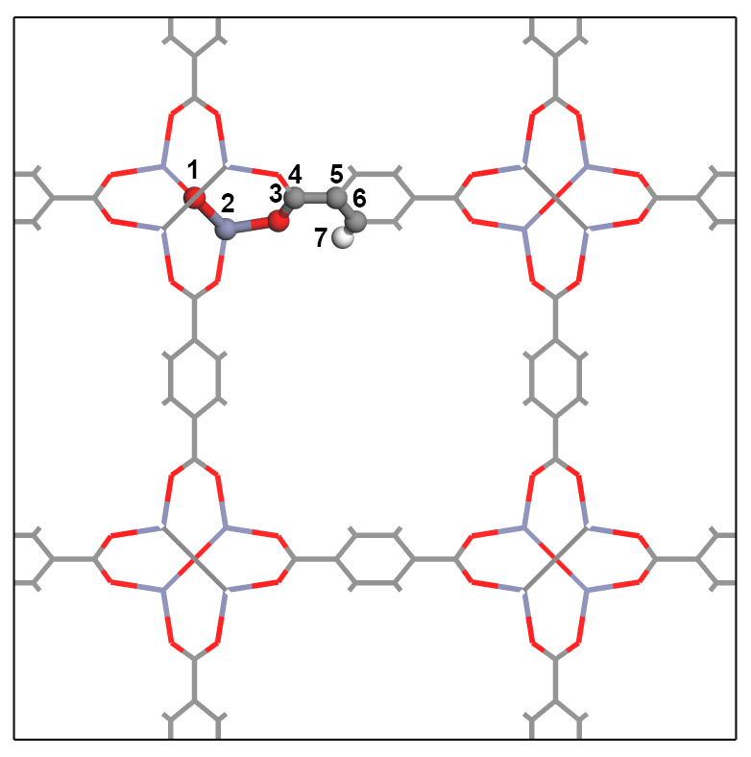
Supplementary Figure S1. Unique atoms for IRMOF-1. Gray, blue, red, and white refer to carbon, zinc, oxygen, and hydrogen respectively. The stick-and-ball model which has a number label describes unique atoms, and the line model describes total atoms in the unit cell. All-atom in the unit cell can be expressed as a number label of the unique atom. IRMOF-1 has seven unique atoms.

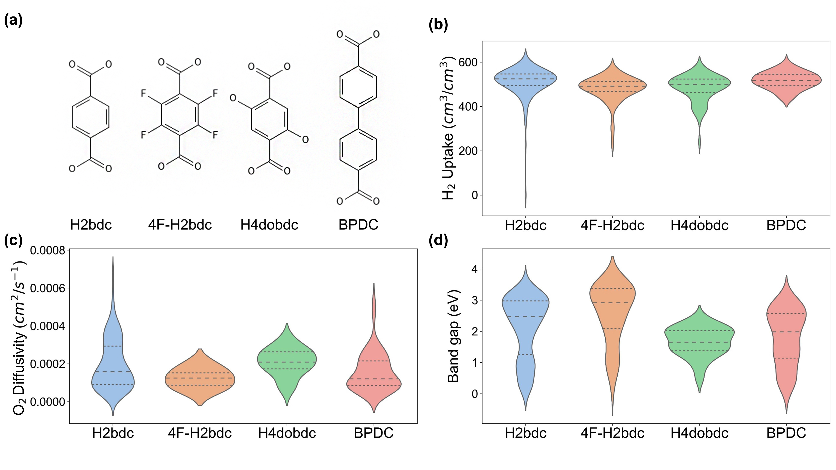
Supplementary Figure S2. (a) Structure formula of four linkers with the different functional groups: H2bdc, 4F-H2bdc, H4dobdc, and BPDC. (b-d) Violin plot for three properties (H₂ uptake, H₂ diffusivity, and Band gap) according to the linker.

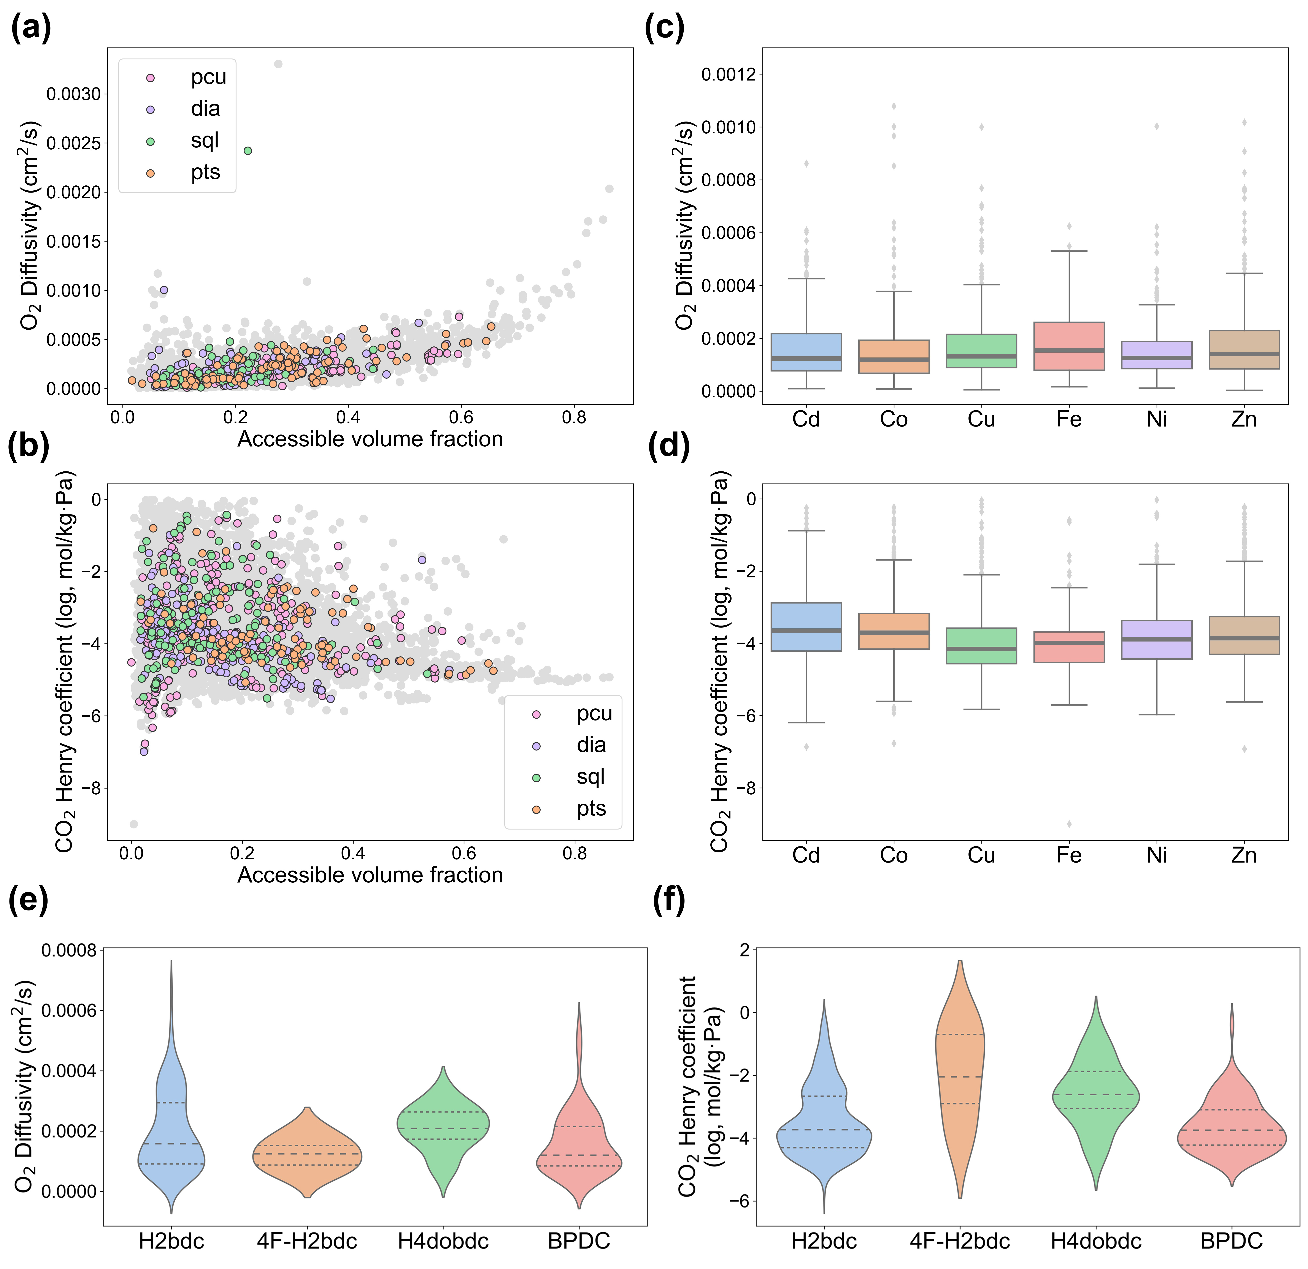
Supplementary Figure S3. (a-b) Scattered plots showing the relationship between accessible volume fraction and properties (i.e. O₂ diffusivity, CO₂ henry coefficient). Gray dots represent the overall MOF of each database, and colored dots represents MOFs with the top four topologies obtained from MOFid.¹² (c-d) The box plot of properties (diffusivity and henry coefficient) for each metal type. The dark line in the center of the box represents the median. (e-f) Violin plot for O₂ diffusivity and CO₂ henry coefficient according to the linker.
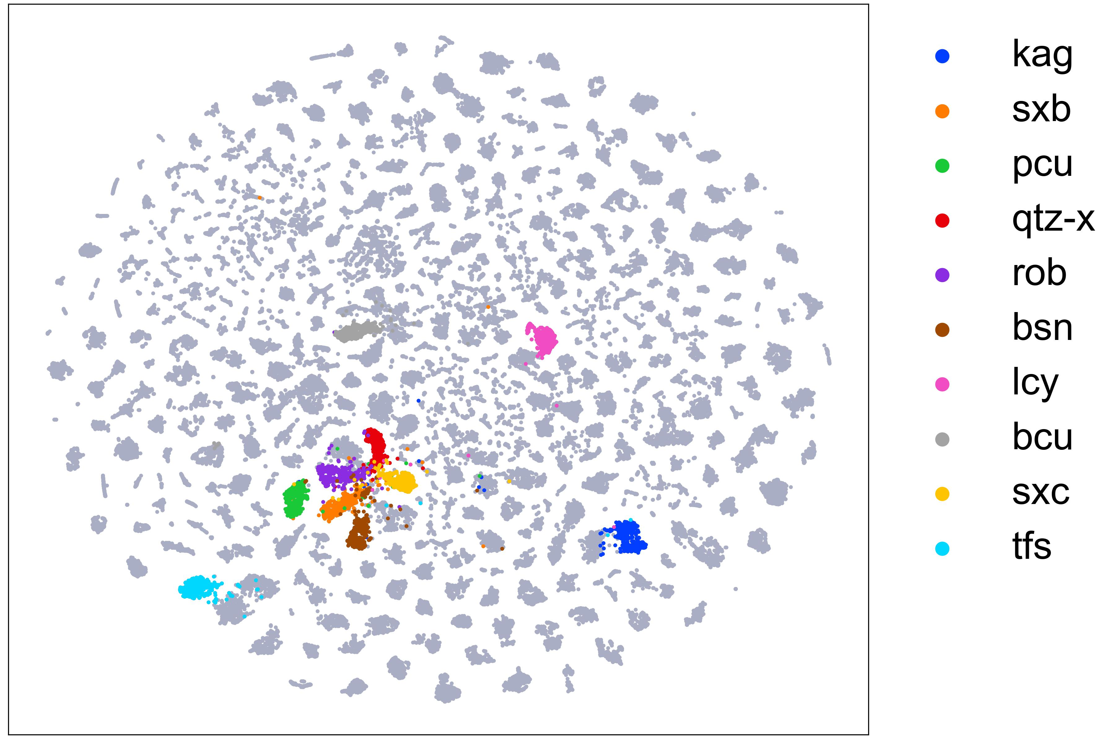
Supplementary Figure S4. T-SNE plot embeds the class tokens of the pre-training models with MTP, MOC, and VFP tasks for all topologies. Top 10 frequently appearing topologies are colored.

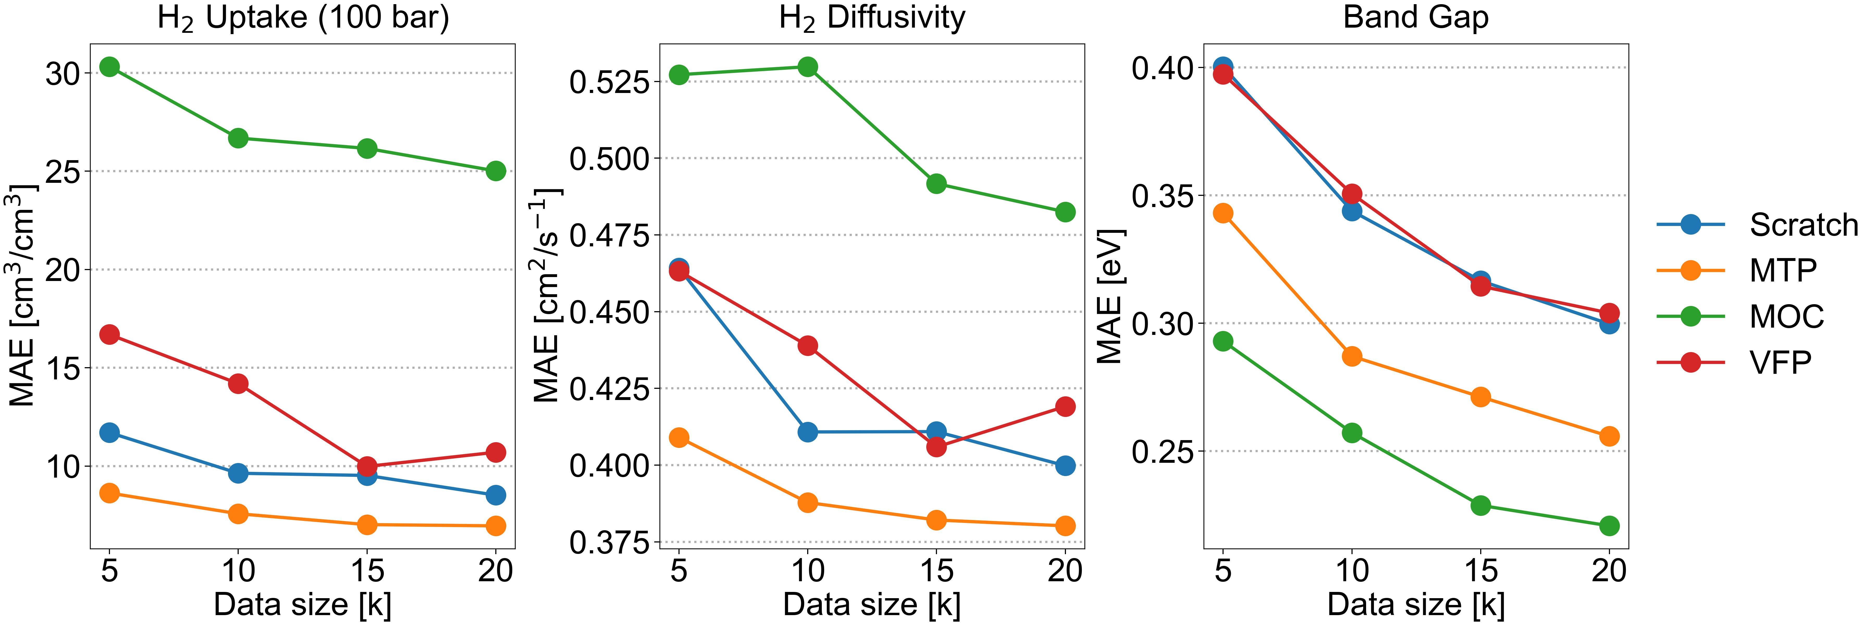Supplementary Figure S5. Plots of MAE results of the fine-tuning model from three single pre-train tasks and scratch model with datasets of H₂ uptake, H₂ diffusivity, and band gap according to dataset size from 5k to 20k.

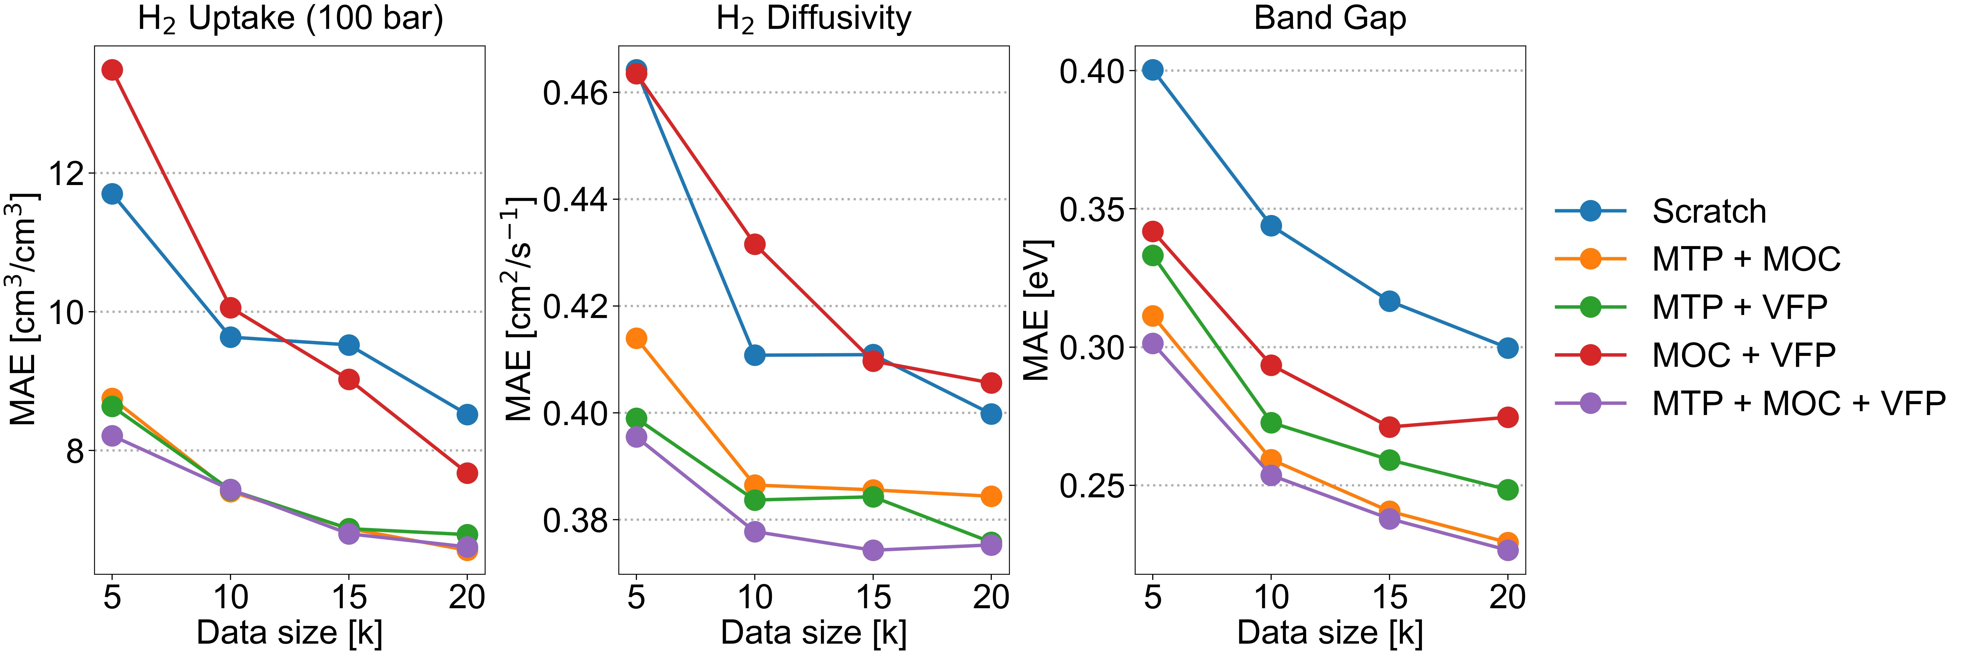Supplementary Figure S6. Plots of MAE results of the fine-tuning model from four multi pre-train tasks and scratch model with datasets of H2 uptake, H2 diffusivity, and band gap according to dataset size from 5k to 20k.

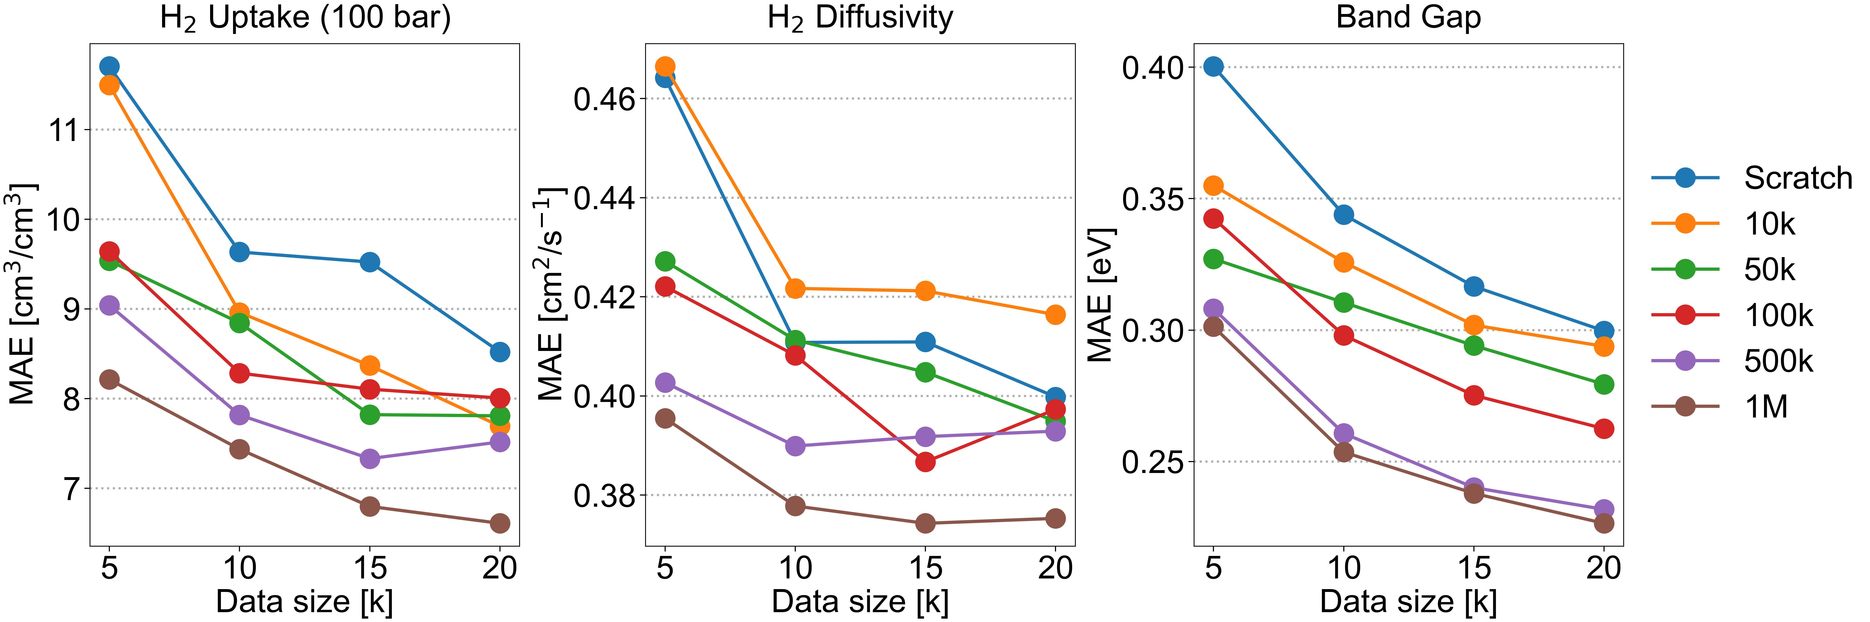
Supplementary Figure S7. Plots of MAE results of the fine-tuning model from different size of pre-training dataset and scratch model with datasets of H2 uptake, H2 diffusivity, and band gap according to dataset size from 5k to 20k.
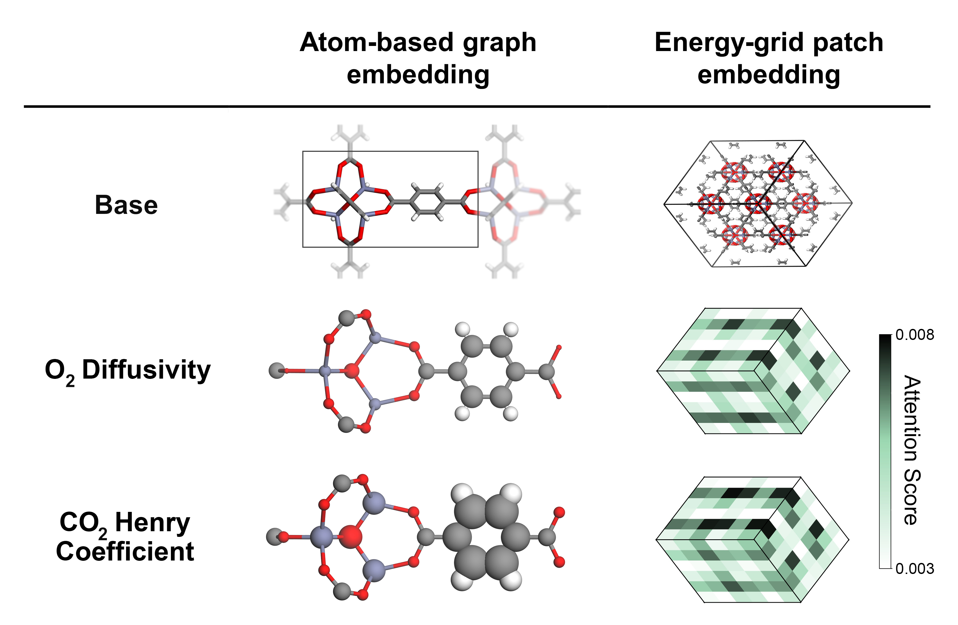
Supplementary Figure S8. The schematics for attention score of atom-based embedding and energy-grid embedding in IRMOF-1. (left) Cluster model that represents high attention scores for larger atom size. (right) Energy-grids that represent attention scores by color. The original form of the cluster and energy-grid are shown in the “base.”

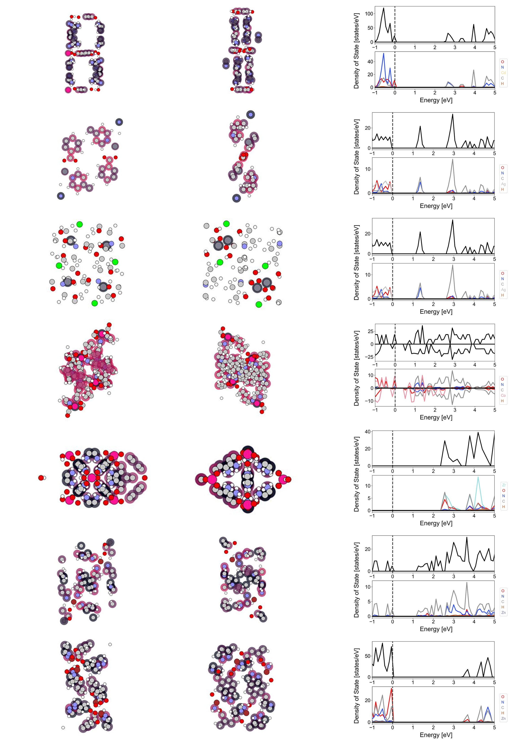
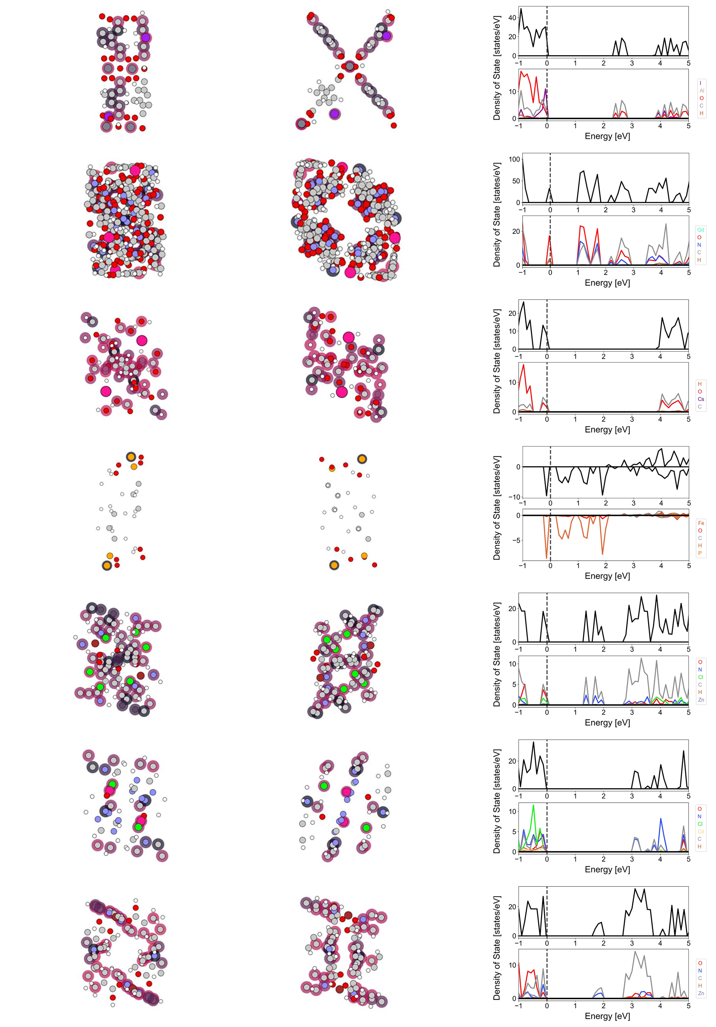
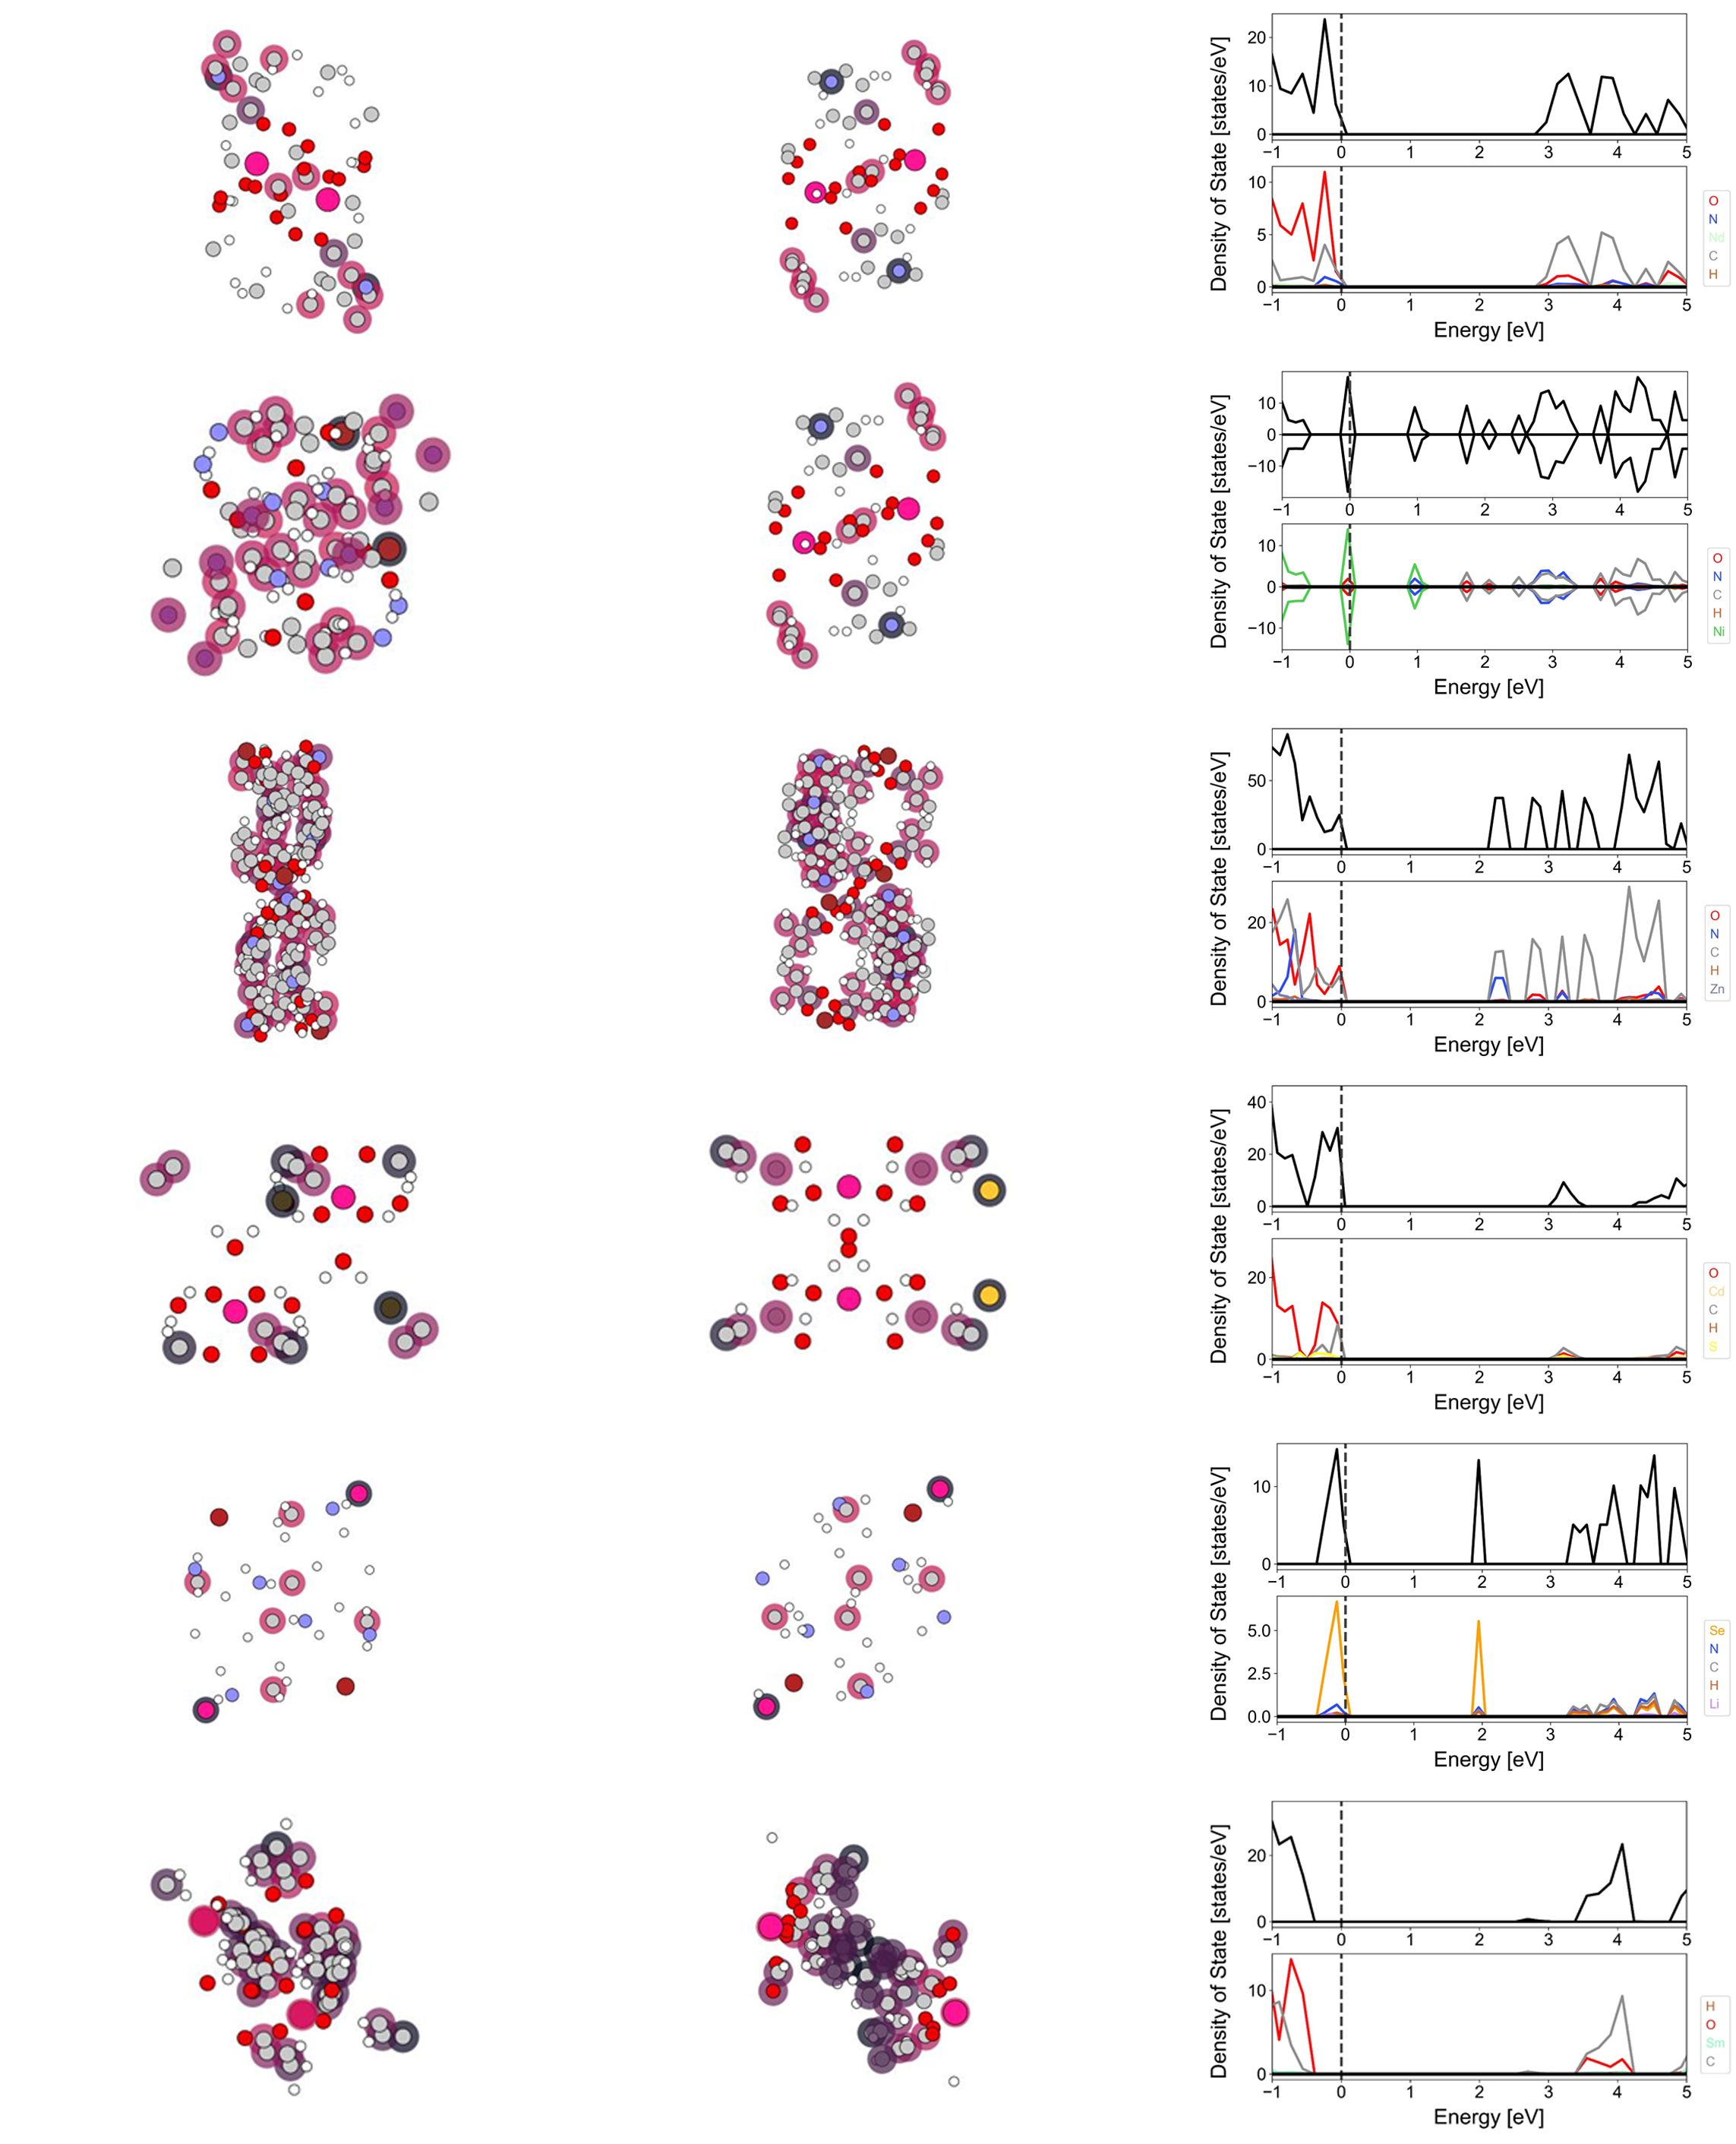
Supplementary Figure S9. Attention score of front view (left) and attention score of side view (middle), and density of state (right) for randomly selected 20 MOFs. Color of edge represent attention score, and color represent type of atoms.

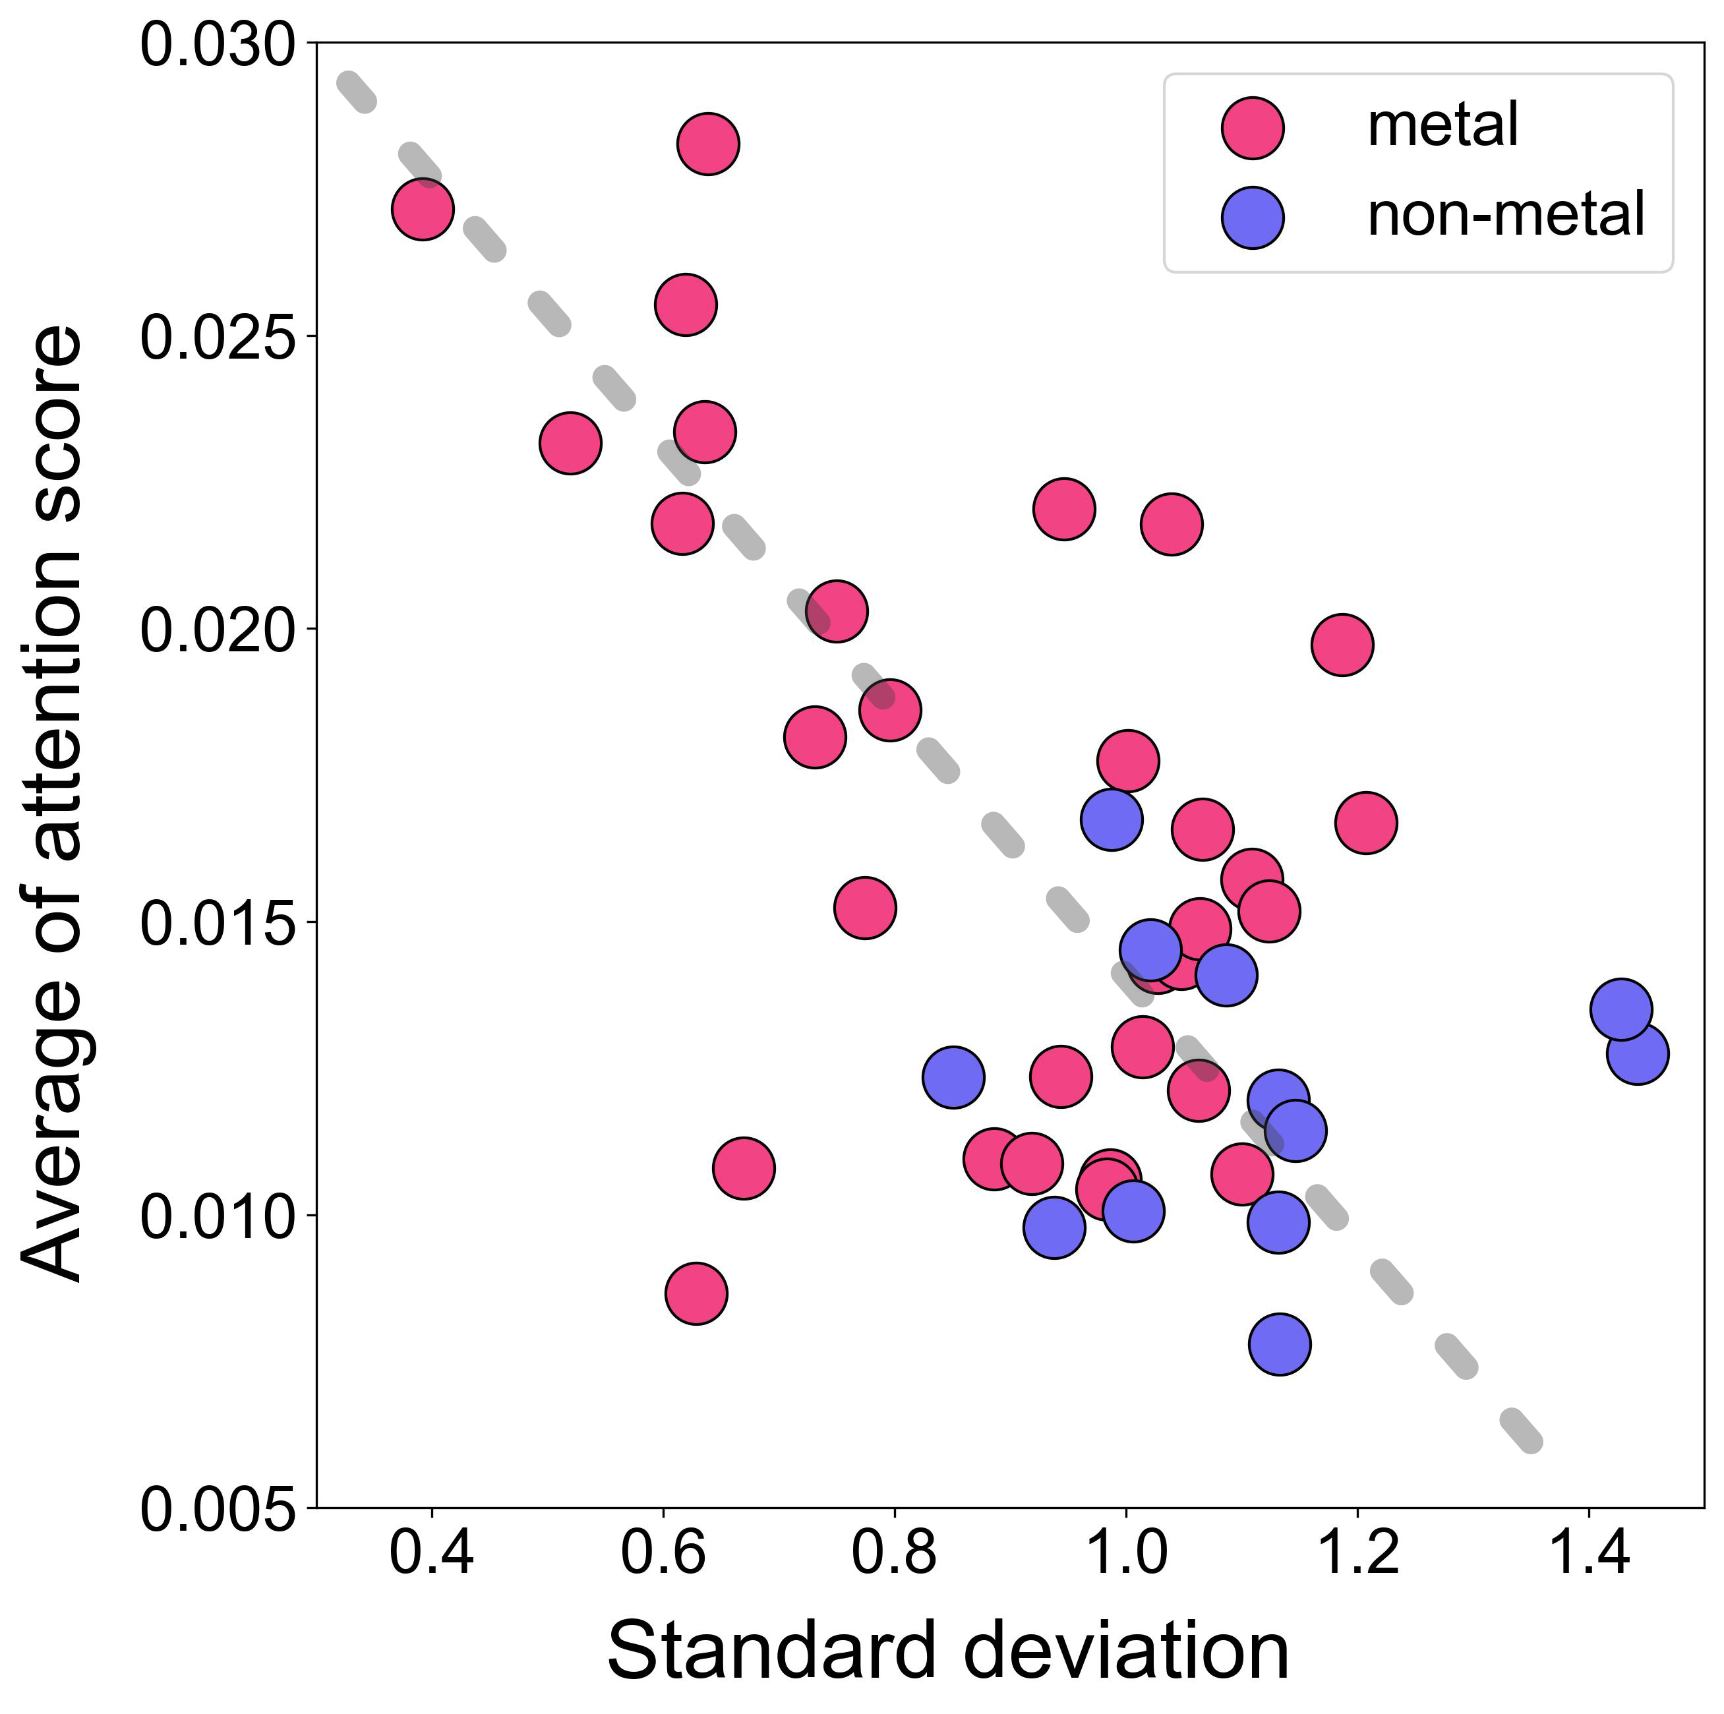
Supplementary Figure S10. A scatter plot for the average of attention cores according to the standard deviation of the band gaps concerning atom types in the QMOF database (PBE functional). The attention scores were obtained from the fine-tuned MOFTransformer model to predict the band gaps. The pink points and the blue points indicate metal atoms and non-metal atoms, respectively.

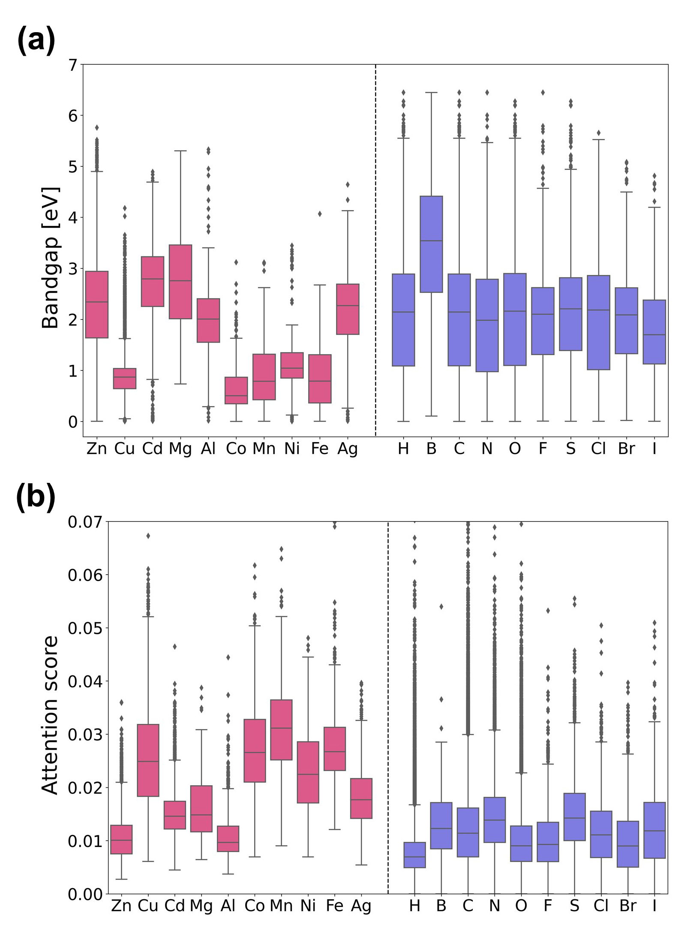
Supplementary Figure S11. (a) Box plot for band gap corresponding to metal atoms (pink) and non-metal atoms (blue). (b) Box plot for attention scores corresponding to metal atoms (pink) and non-metal atoms (blue).

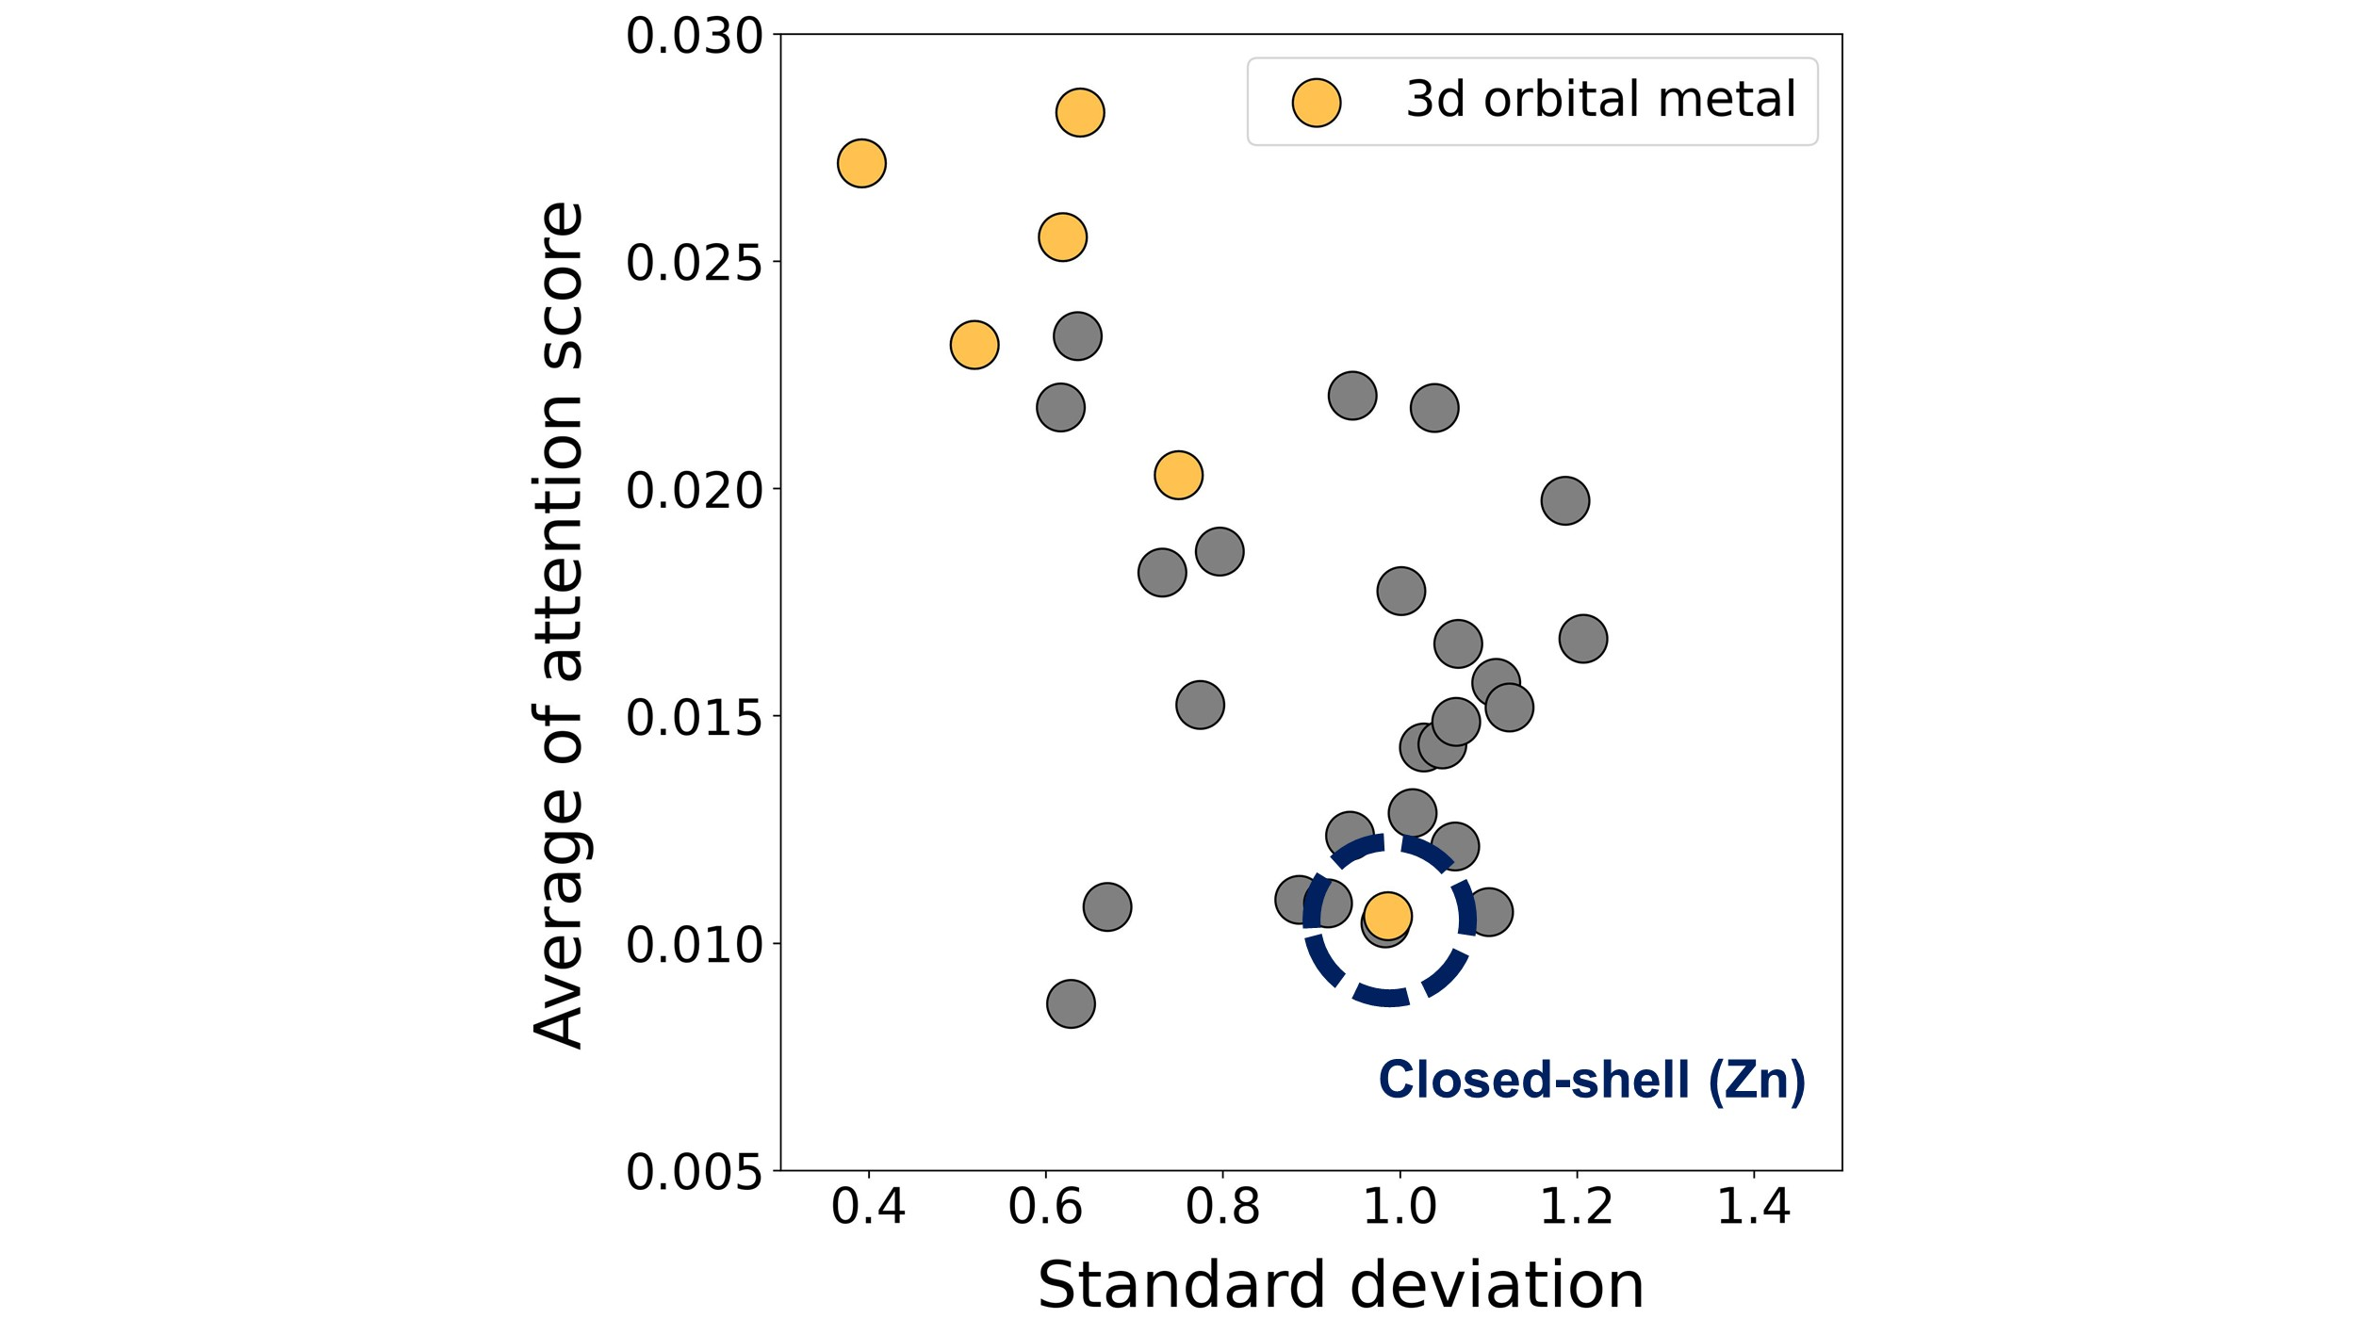
Supplementary Figure S12. A scatter plot for the average of attention cores according to the standard deviation of the band gaps concerning atom types in the QMOF database (PBE functional). The attention scores were obtained from the fine-tuned MOFtransformer model to predict the band gaps. The yellow points indicate 3d-orbital metal atoms, and the gray points indicate all metal atoms.

Supplementary Table S1. Topologies used in MOF topology prediction (MTP).
fsc | wjr | wjo | ctn | ssd | isq | ecb | zfu | uod | vtx
lcw-x | uol | noh | fnb | crs-d | xxv | loh | pem | etc | fof
edi | bor-e | wgz | tfz-d | snf | xbl | snx | xbj | umj | swk
vab | yfy | svk | sqs | bcu-j | tcd | umk | ant | uke | pcu-h-e
ben | wut | svj | unl | ecn | uop | yav-d | anh | wnm | pts-x
uno | fse | wiv | sab | wjz | etb-e | ins | cap | wfj | wip
swf | wmd | ukl | ctn-d | vcv | soj | dmf | wje | wjq | tfq
cha | etd | zfg | wjm | wgd | apo | wmr | vcu | ssc | osd
wnj | pyr | vct | cbt | yav | pcl | ptd | smc | hea | baa
umo | skd | hxg | wnb | smw | vcz | zfm | vdb | zfa | tbo
bsn | wjb | ctn-x | acs-g | xab | bmn | xby | vci | swd | yfn
yfs | xfb | cco | tty | phw | wfw | wlq | sxh | ddc | unn
bcg | ukd | wib | nce | wkr | vbq | sni | wfg | uon | whn
wjv | why | bbh | stp | nfa | maw | vmz | uoo | wkd | ulj
umz | wjc | fct | snr | wfy | und | lta | unj | dia-f | lcv-f
wkp | vmr | fcs | wjp | wlt | cda | unv | asf | sou | utc
ghw | tej | yfz | deh | zfh | vbr | xfy | tcg | pto-d | wnq
wgv | bbm | upa | wnw | smm | wgj | ssb | sqc | tsi | yff
utm | vmg | zfs | wfa | sqp | svb | ggl | bbn | yfo | cdt
wlk | snk | deh-d | ttv | wns | bbg | wkc | twt | mst | wiq
eco | fnj | xfz | wjg | ptr | hjm | wkb | uma | vcd | vmd
une | smb | vmu | oob | cdq | flu | fud | qtz-e | yfw | wha
svf | fnl | ukn | dgp | vbn | soh | wkf | zfz | rgd | lcy
wgt | hex | ths-e | vca | src | nbo-a | wmx | wlf | hcp | rac
wls | tph | bor | jxj | wiy | noy | mok | zft | mcf-d | fdb
unw | wkm | unp | srs-f | yft | vcq | boe | rtl | ssa | ukb
umv | yfj | fcg | lsz | srs | sod-e | fnh | uow | svs | utn
uox | lim | eta-c | whf | wma | xff | wli | ecf | reo-e | wja
seh | zec | ums | nlr | vbc | sev | wjl | yfd | wij | vda
wlc | qtz-g | uoa | sof | wei | eci | bcu-h | wku | wlh | wfx
swg | wif | soc | zfn | xfj | qtz-x | fsf | wni | ukg | bbj
ukm | zfy | wnk | swe | wgw | osb | whw | tof | vbj | snm
fnn | fto | cds-f | wiz | wmv | wnf | pts-f | wka | lcv-e | wmw
wgh | vmk | icd | dia-g | vcc | uoy | xai | sxg | srs-a | mot-e
sow | wgi | ecc | wmz | svc | bcu-g | umc | ybh | wfs | cat
umw | ubt | yfu | bnn | skc | sny | umh | vmi | vmv | xbt
wfr | sne | wju | wiu | ana | bcu-l | uom | vbo | hbr | yan
twf-e | ecl | wfd | bcs | lil | sxj | swj | qtz-h | fns | cab
vmc | irl | lvt-a | scu | snv | yfg | osa | fch | gpu | sml
fet | qza | jea | lcs | nfc | wit | vmp | zfq | pth | sms
pha | wfl | asv | wix | wko | mrc | fog | vck | utg | fnz
svn | wik | the | wmn | pbz | unh | fcr | tes | ece | vcj
cag | noo | ncb | lon | srd | crr | xly | wge | osf | xfw
ure | whp | zfr | fcl | ecd | dia-a | smr | xak | whk | wnh
svp | wfk | sin | upd | wmq | fcb | ecj | wgn | zfi | uos
wio | pcb | lhh | sgn | sod-b | wjh | wme | bwt | uml | wht
snw | bto-e | znz | vna | vbt | wff | bbq | fgl | bcn | vbw
bne | wgb | sva | sxd | omy | rhr | wfq | xfd | soe | xfa
sog | umm | svq | vcy | ukk | vbf | vmo | cdp | umx | xlz
fiq | qtz-a | stj | zfl | acs-h | eea | crb | umy | vbh | fnp
vcf | dag | sod-f | sxi | edq | ukh | wfc | unx | bcu | qzd
whv | wnp | wim | uoj | wgl | lig | zfe | wmg | whj | noq
lnj | vcg | smn | vmh | sth | yfm | ato | msp | myc | bbi
nip | gfy | wfm | uko | xat | ttw | vbv | xda | itv | yfc
wfu | wnc | toc | zfp | phx | ecr | ocu | sit | una | who
tca | wie | xal | kwh | ukt | nat | dft | xfm | dia | uog
vbk | unr | xfq | wjx | lcs-e | wmc | whc | wii | wlj | mon
swh | fne | wnu | dei | uob | wft | utq | wgx | vcr | rho
wfp | ecu | wkl | wmf | wkq | wlp | fcd | teo | yfx | ooa
sty | smv | nfb | sos | tcf | ibd | xft | crs | fsa | nia-e
vbs | vbu | wng | sng | toc-e | wkh | xam | snq | unb | umn
cuz | nbo-h | xah | ukp | gsi | fcj | zga | umr | msw | uoi
smq | xfo | wgc | fst | bcu-k | wfn | lom | xfh | feb | xac
lcx | wjk | vmb | vbb | fny | wgo | ofo | uou | mgg | zfx
gan | wkx | skb | sve | acs-i | thp | snp | nox | mgc | wfo
sop | uov | vbd | unm | uny | xmz | zfv | svd | uoc | rtw
bva | ths | qtz | ukr | wke | ict | vbl | yfq | fcu | wmh
wmj | vbe | smp | umb | unf | ull | wmu | whs | wml | fsh
acs | vmt | snv-x | lcv | rkf | wno | zfo | wkn | twf | sra
wfb | whr | bcu-f | bow | vmw | acs-a | ske | zfb | dmd | vme
wgf | fnv | mou | wlm | fna | pts-e | sod-h | shp | sst | sxc
fsb | wlr | tcc | ith-d | tfa | wia | whh | lcy-a | tci | smg
sea | lbt | uka | umu | wks | whu | ect | neb | whz | whl
uns | wnn | wys | smt | dmc | sxa | yfv | ftw | pto | wld
vmq | iac | ctn-e | wgy | sod | cdl | ech | gme | xfn | flu-e
npo | etb | snl | bcu-i | bbf | wny | wmm | soq | frl | wji
unu | vmn | whb | nom | oof | svi | vms | zni | sku | sxf
smu | gis | rob | ukf | htp | wfz | tce | gra | tfz | wkt
bcl | llk | stw | tfk | fsn | ttx | wir | ith | ecm | ung
sod-a | pcu | yfl | wjn | vba | wlu | bcu-b | wbl | wjf | nsp
wgu | pts | cbo | mog | dmp | fce | mer | wky | nor | wfh
fcp | tfg | tfv | yfe | ecg | xfc | swi | vce | xaw | foa
tzs | xad | uku | yfh | wkk | wjd | zfw | kag | fcm | wgs
vmj | wnl | svo | noz | yfi | ffa | ecv | wfi | stu | ucp
skf | vcs | wll | fni | fob | wnt | uoq | ilc | smh | sod-g
vbg | qdl | win | hwx | uto | fnk | tfs | hms-e | vco | bcm
pbp | svn-d | fcn | whe | wle | vcn | utp | yfk | vmx | ftb
fnd | ecs | smk | cao | srs-a-e | est | she | llj | fee | whx
utj | vby | lcv-a | vmf | xbg | wiw | mot | sno | lhb | umg
fnc | wkw | zfc | svr | wnr | uky | fnr | lqm | sur | wil
nbo-a-e | cor | utb | unc | zff | bbp | ukv | tsj | qtz-f | wjw
uof | fnq | mmt | kea | xux | ume | xfk | vbi | bbo | wmo
whi | tsx | wlg | cml | fca | dgn | uot | tch | bod | sxe
oso | can | reo | uli | cds | fno | snh | smj | lvt | wgp
hww | wgk | wfv | myd | utk | fng | pbg | cut | kdd | umq
dmj | wlb | wna | svl | uks | xfi | cds-b | tcs | ukj | uoh
nba | chb | sol | gwg | lll | vbp | bct | tfi | cdj | fnw
upb | son | wmb | xbm | wid | hms | acs-f | wuy | vcp | xfu
oft | hst | soi | zzz | whg | edc | afw | wfe | etq | wmy
lcy-a-x | ose | wln | hbo | afi | xww | tfl | vbx | srs-g | vcl
wmk | wig | wmt | csq | nbo-x-d | upc | xfg | wjy | fnt | ecp
pyr-e | pcu-g | jph | vml | fit-e | fci | spn | eye | thp-x | rhr-a
swl | nbo | yfr | uoz | vma | hof | umf | vcb | wjt | uni
xae | vbm | xfx | vmm | zfd | pcu-h | ukc | pts-g | whq | wla
bto | wmi | umd | wki | sda | eta | som | wih | yfa | osc
wkj | wgm | atn | zfj | whm | usf | lcy-e | svg | yfb | ska
wmp | sxb | vmy | brl | sma | snz | sme | gar | wne | pbz-e
whd | wjs | swc | uoe | fsl | wkv | mjd | twt-e | smi | wkg
fnu | smd | ttp | nab | stx | nov | sok | uki | pcu-i | fcq
vcm | etf | wga | sxk | zfk | mdf | vch

Reference
1 Rosen, A. S. et al. High-throughput predictions of metal–organic framework electronic properties: theoretical challenges, graph neural networks, and data exploration. npj Computational Materials 8, 1-10 (2022).
2 Perdew, J. P., Burke, K. & Ernzerhof, M. Generalized gradient approximation made simple. Physical review letters 77, 3865 (1996).
3 Krukau, A. V., Vydrov, O. A., Izmaylov, A. F. & Scuseria, G. E. Influence of the exchange screening parameter on the performance of screened hybrid functionals. The Journal of chemical physics 125, 224106 (2006).
4 Lee, S. et al. Computational screening of trillions of metal–organic frameworks for high-performance methane storage. ACS Applied Materials & Interfaces 13, 23647-23654 (2021).
5 Willems, T. F., Rycroft, C. H., Kazi, M., Meza, J. C. & Haranczyk, M. Algorithms and tools for high-throughput geometry-based analysis of crystalline porous materials. Microporous and Mesoporous Materials 149, 134-141 (2012).
6 Pedregosa, F. et al. Scikit-learn: Machine learning in Python. the Journal of machine Learning research 12, 2825-2830 (2011).
7 Orhan, I. B., Daglar, H., Keskin, S., Le, T. C. & Babarao, R. Prediction of O2/N2 Selectivity in Metal–Organic Frameworks via High-Throughput Computational Screening and Machine Learning. ACS Applied Materials & Interfaces 14, 736-749 (2021).
8 Rappé, A. K., Casewit, C. J., Colwell, K., Goddard III, W. A. & Skiff, W. M. UFF, a full periodic table force field for molecular mechanics and molecular dynamics simulations. Journal of the American chemical society 114, 10024-10035 (1992).
9 Bucior, B. J. et al. Energy-based descriptors to rapidly predict hydrogen storage in metal–organic frameworks. Molecular Systems Design & Engineering 4, 162-174 (2019).
10 Xie, T. & Grossman, J. C. Crystal graph convolutional neural networks for an accurate and interpretable prediction of material properties. Physical review letters 120, 145301 (2018).
11 Rosen, A. S. et al. Machine learning the quantum-chemical properties of metal–organic frameworks for accelerated materials discovery. Matter 4, 1578-1597 (2021).
12 Bucior, B. J. et al. Identification schemes for metal–organic frameworks to enable rapid search and cheminformatics analysis. Crystal Growth & Design 19, 6682-6697 (2019).

