Supplementary data

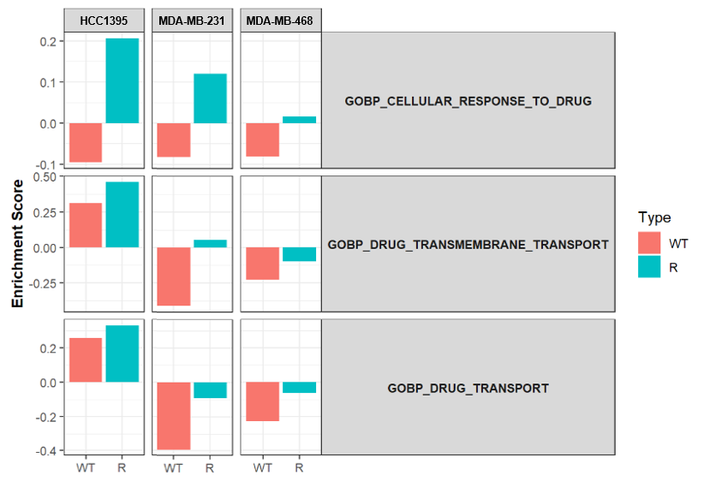

Figure S1. Bar plots of Gene set variation analysis (GSVA) about 3 drug resistance-related gene ontology biological process (GOBP) terms including “cellular response to drug”, “drug transmembrane transport”, and “drug transport”.

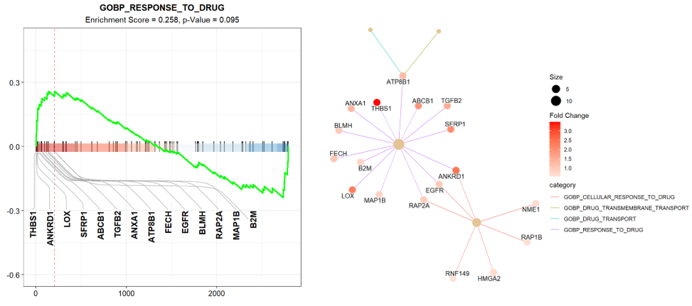

Figure S2. Gene set enrichment analysis (GSEA) enrichment score curves of response to drug and gene network analysis in HCC1395/R cell line.

Figure S3. NTA analysis of EVs released from wild-type (WT) cell lines (a-c) and R cell lines (d-f). The samples were measured triplicate and the collected data for all the samples were processed using the same parameters.

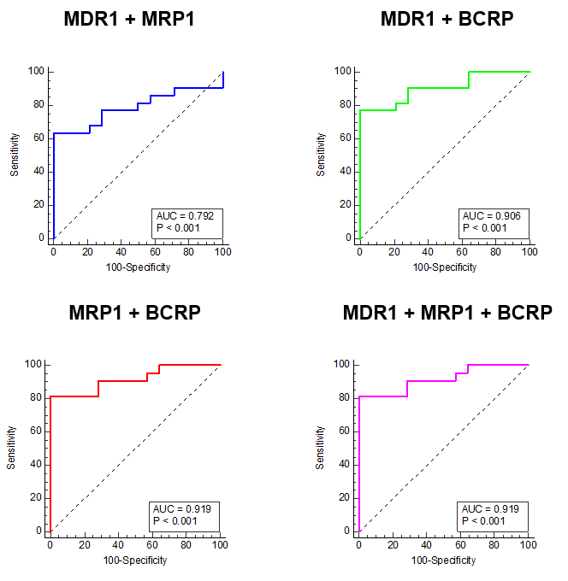
Figure S4. ROC curves for each drug-resistant EV marker or combination of three markers. The AUC represents drug resistance predictive performance.
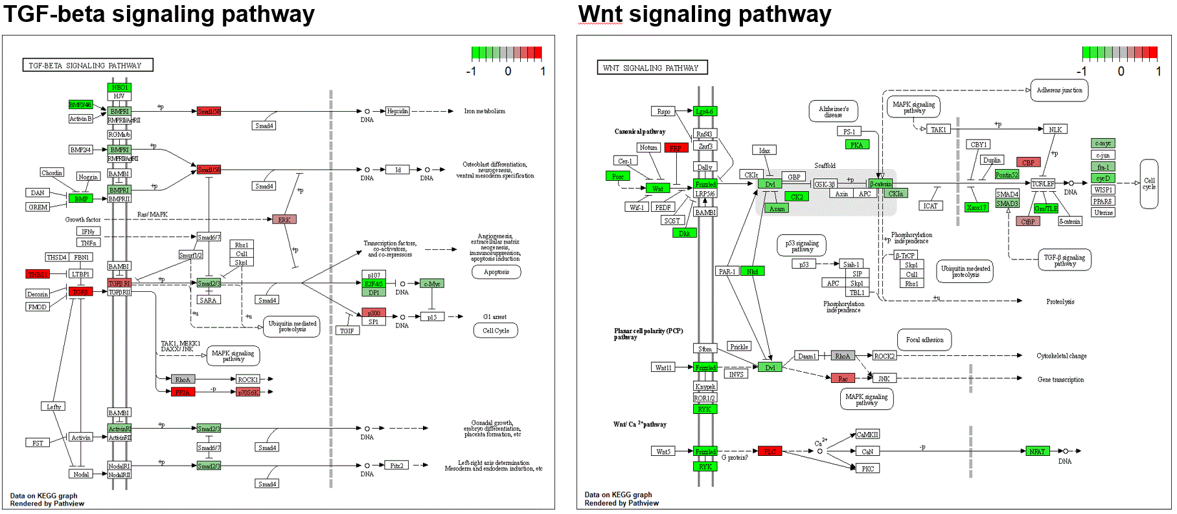
Figure S5. KEGG graphs on a metabolic pathway in HCC1395/R cell line compared with HCC1395/WT

Table S1. Clinical information of patients with breast cancer
Clinical variable | No pCR |  |  |  | pCR |  |  |  | Total
 | n |  | % |  | n |  | % |  | N |  | %
All | 22 |  | 61.1% |  | 14 |  | 38.9% |  | 36 |  | 100%
Age
≤50 | 11 |  | 50.0% |  | 8 |  | 57.1% |  | 19 |  | 52.7%
>50 | 11 |  | 50.0% |  | 6 |  | 42.9% |  | 17 |  | 47.3%
Clinical Stage
I | 2 |  | 9.1% |  | 1 |  | 7.1% |  | 3 |  | 8.3%
II | 11 |  | 50.0% |  | 10 |  | 71.5% |  | 21 |  | 58.4%
III | 9 |  | 40.9% |  | 3 |  | 21.4% |  | 12 |  | 33.3%
Subtype
Luminal A | 4 |  | 18.2% |  | 1 |  | 7.1% |  | 5 |  | 13.8%
Luminal B | 6 |  | 27.3% |  | 3 |  | 21.5% |  | 9 |  | 25.0%
HER2 | 2 |  | 9.1% |  | 0 |  | 0% |  | 2 |  | 5.6%
TNBC | 10 |  | 45.4% |  | 10 |  | 72.4% |  | 20 |  | 55.6%
Distant recurrence
No | 15 | 68.2% |  | 14 |  | 100% |  | 29 |  | 80.6%
Yes | 7 | 31.8% |  | 0 |  | 0% |  | 7 |  | 19.4%
Death
No | 17 | 77.3% |  | 14 |  | 100% |  | 31 |  | 86.1%
Yes | 5 | 22.7% |  | 0 |  | 0% |  | 5 |  | 13.9%

Table S2. Mean fluorescence intensity of drug-resistant EVs from patients with breast cancer
 | Class |  |  | MFI |  |  | Score
Subtype | Pt | 0 : pCR / 1 : no pCR | MDR1 |  | MRP1 | BCRP |  | Combi-3
TNBC | 1 | 1 | 886.52 |  | 994.56 | 22052.37 |  | 1.00
TNBC | 2 | 1 | 1286.12 |  | 1257.26 | 12557.8 |  | 1.00
TNBC | 3 | 1 | 1612.83 |  | 853.96 | 1426.72 |  | 0.76
TNBC | 4 | 1 | 1689.3 |  | 1328.25 | 3302.42 |  | 1.00
TNBC | 5 | 1 | 1042.07 |  | 2812.51 | 2877.45 |  | 1.00
TNBC | 6 | 1 | 804.5 |  | 1593.86 | 1636.01 |  | 0.97
TNBC | 7 | 1 | 582.43 |  | 1506.35 | 2398.14 |  | 1.00
TNBC | 8 | 1 | 1221.86 |  | 3972.91 | 1299.35 |  | 0.72
TNBC | 9 | 1 | 285.89 |  | 476.9 | 5569.45 |  | 1.00
TNBC | 10 | 1 | 422.65 |  | 984.91 | 706.71 |  | 0.26
TNBC | 11 | 0 | 1021.2 |  | 634.92 | 244.94 |  | 0.02
TNBC | 12 | 0 | 482.48 |  | 376.66 | 1175.86 |  | 0.55
TNBC | 13 | 0 | 461.42 |  | 630.43 | 435.31 |  | 0.07
TNBC | 14 | 0 | 322.61 |  | 391.35 | 977.43 |  | 0.37
TNBC | 15 | 0 | 484.51 |  | 330.76 | 830.32 |  | 0.21
TNBC | 16 | 0 | 307.49 |  | 1074.53 | 1033.02 |  | 0.63
TNBC | 17 | 0 | 506.87 |  | 479.19 | 917.21 |  | 0.31
TNBC | 18 | 0 | 269.13 |  | 427.67 | 869.57 |  | 0.29
TNBC | 19 | 0 | 272.87 |  | 337.98 | 435.06 |  | 0.05
TNBC | 20 | 0 | 732.62 |  | 979.64 | 1146.55 |  | 0.65
Luminal A | 21 | 1 | 645.33 |  | 1694.15 | 1304.28 |  | 0.90
Luminal A | 22 | 1 | 230.88 |  | 426.24 | 1010.84 |  | 0.43
Luminal A | 23 | 1 | 622.34 |  | 183.52 | 1555.48 |  | 0.82
Luminal A | 24 | 1 | 1729.75 |  | 832.5 | 3745.14 |  | 1.00
Luminal B | 25 | 1 | 277.5 |  | 209.42 | 656.38 |  | 0.11
Luminal B | 26 | 1 | 537.98 |  | 688.2 | 2352.09 |  | 1.00
Luminal B | 27 | 1 | 1123.94 |  | 2874.39 | 938.04 |  | 0.85
Luminal B | 28 | 1 | 3598.99 |  | 564.62 | 2849.74 |  | 1.00
Luminal B | 29 | 1 | 835.09 |  | 412.92 | 1729.38 |  | 0.91
Luminal B | 30 | 1 | 199.06 |  | 304.14 | 1014.54 |  | 0.40
HER2 | 31 | 1 | 1157.36 |  | 561.66 | 1390.09 |  | 0.71
HER2 | 32 | 1 | 1242.46 |  | 1158.1 | 14872.89 |  | 1.00
Luminal A | 33 | 0 | 265 |  | 292.2 | 940.17 |  | 0.32
Luminal B | 34 | 0 | 198.69 |  | 404.04 | 459.54 |  | 0.07
Luminal B | 35 | 0 | 198.69 |  | 404.04 | 459.54 |  | 0.07
Luminal B | 36 | 0 | 925 |  | 585.34 | 1162.91 |  | 0.53

