SUPPORTING INFORMATION
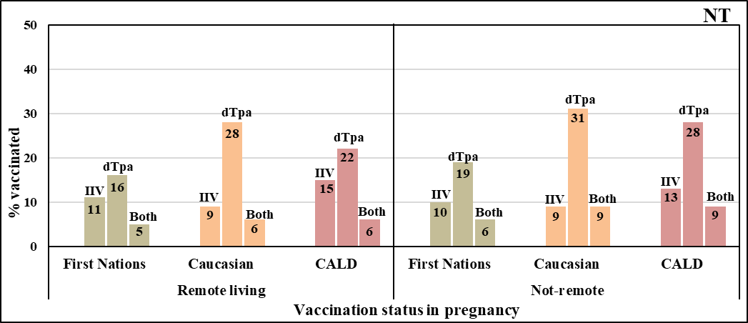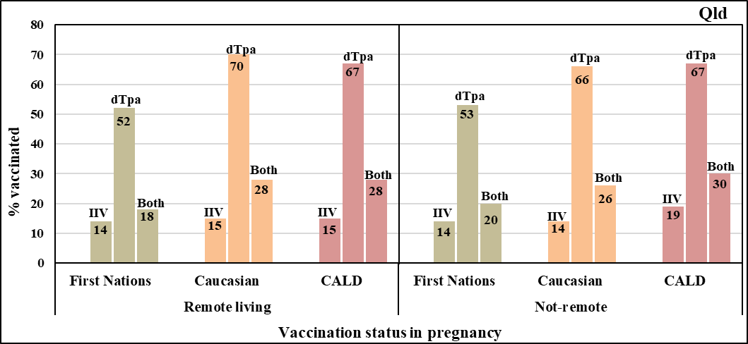
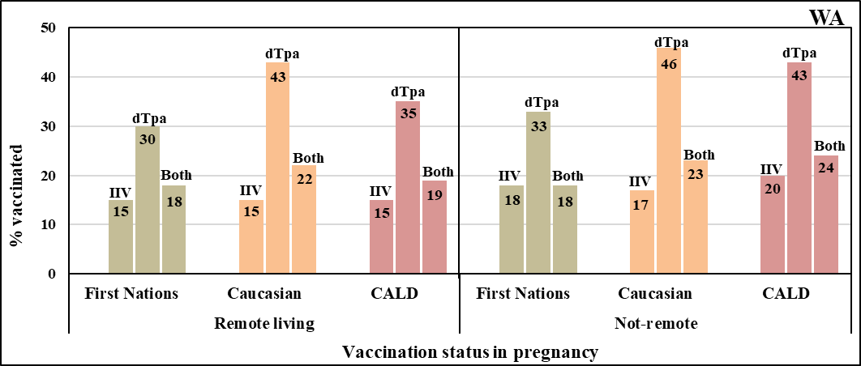
Supplementary figure 2: Vaccination status in pregnancy by Indigenous status and remoteness by jurisdiction

