SUPPORTING INFORMATION
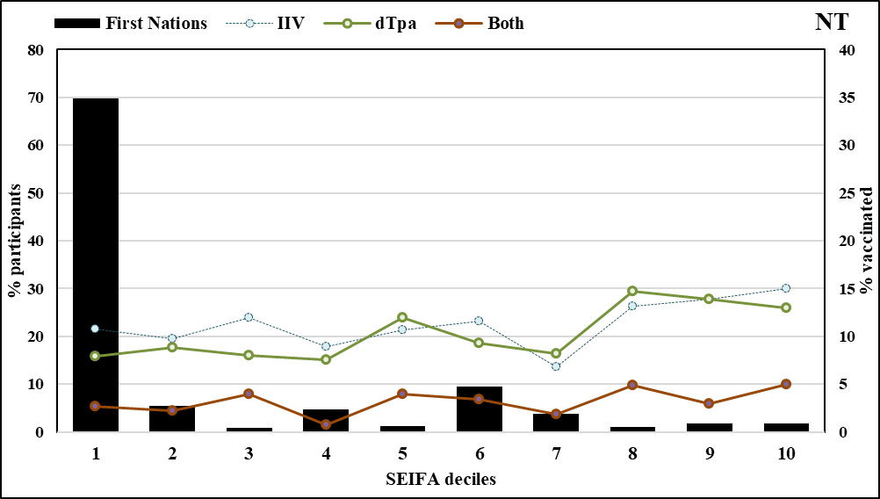
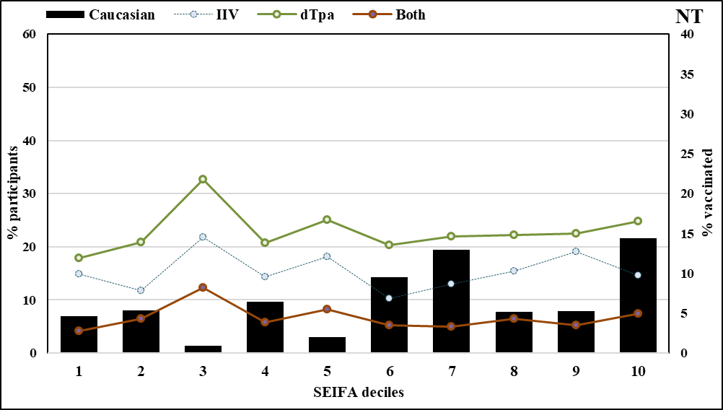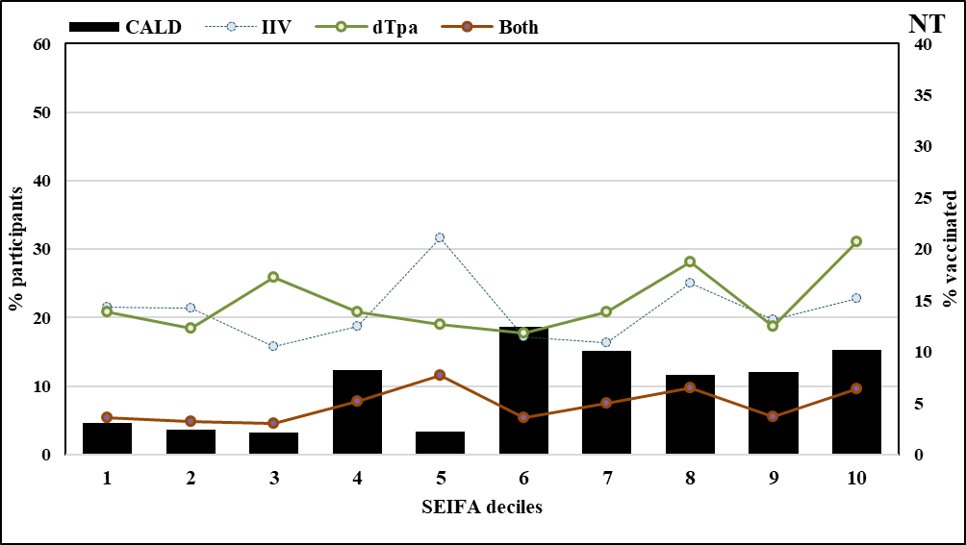
Supplementary figure 3a: Antenatal vaccination by Indigenous status, ethnicity, and socio-economic variation in NT

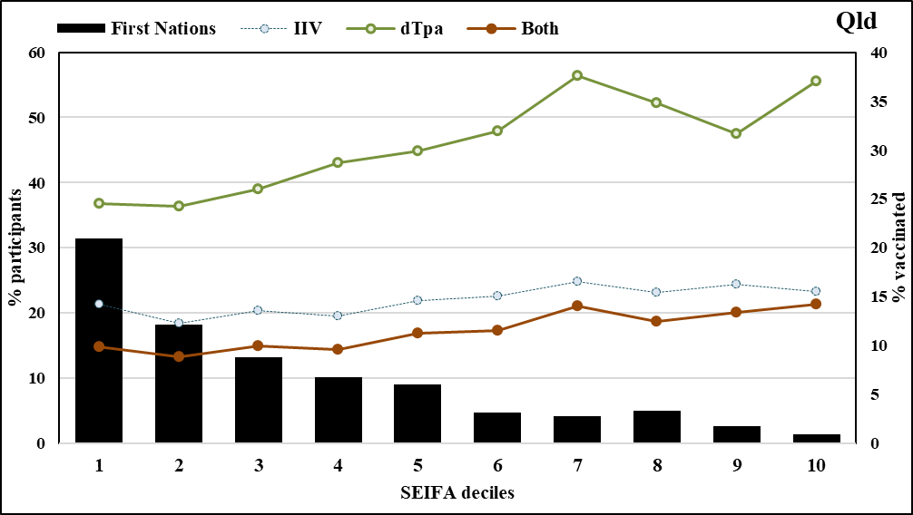
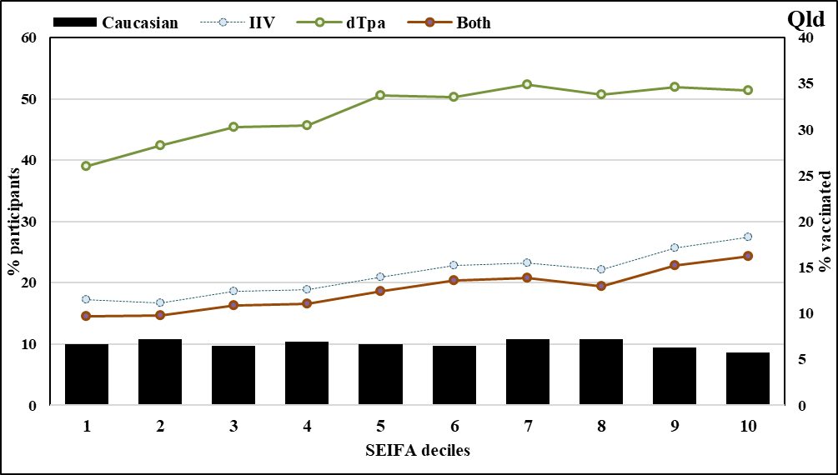
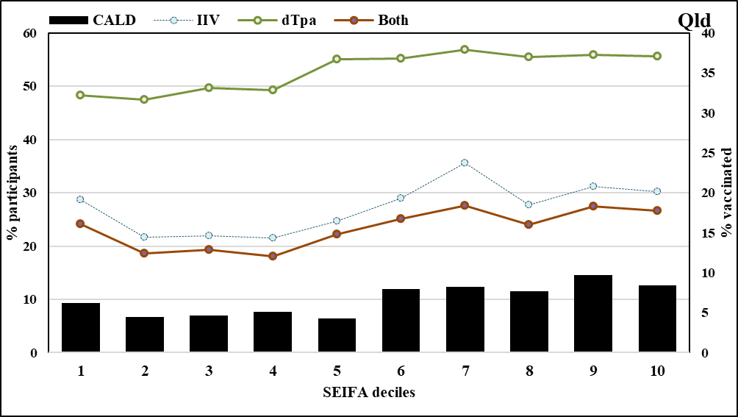
Supplementary figure 3b: Antenatal vaccination by Indigenous status, ethnicity, and socio-economic variation in Qld

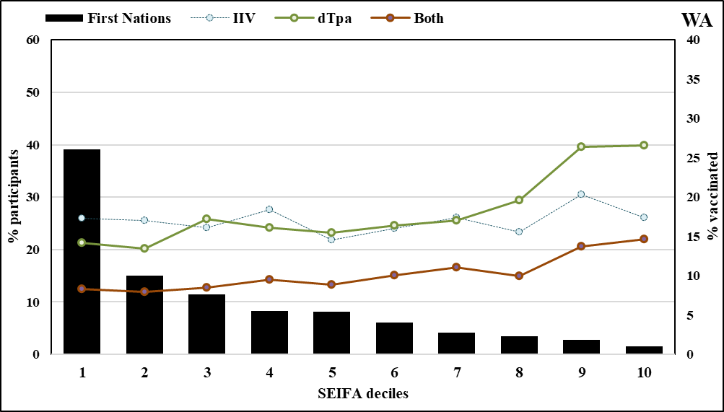
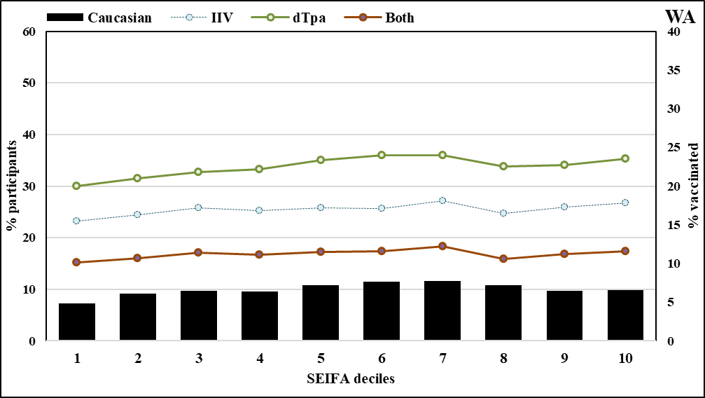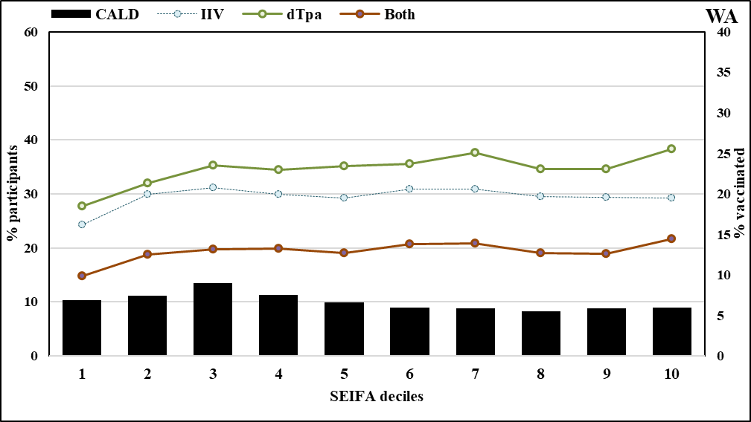
Supplementary figure 3c: Antenatal vaccination by Indigenous status, ethnicity, and socio-economic variation in WA

