SUPPORTING INFORMATION

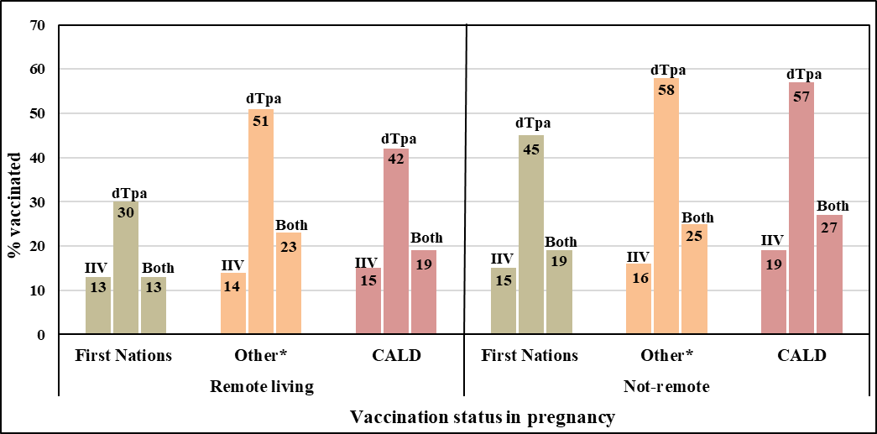
Supplementary figure 1: Vaccination status in pregnancy by Indigenous status and remoteness
ABBREVIATIONS: CALD, Culturally and linguistically diverse;
* Australian born, who did not identify as First Nations and were classified as ‘Caucasian’ in the variable ‘Ethnicity’
NB: dTpa vaccination data are from 2015 onwards

