Present and Future Distribution of Two Non-Indigenous Orchids and Their Acquired Enemy in Puerto Rico

Evan Foster^{1,3} and James Ackerman²

¹ Department of Environmental Sciences, Colorado College, 14 E Cache la Poudre, Colorado Springs, CO 80903, USA.
² Department of Biology, University of Puerto Rico, 17 Avenue Universidad Suite 1701, San Juan, PR 00925-2537, U.S.A.
³Corresponding author; e-mail: evanfoster101@gmail.com

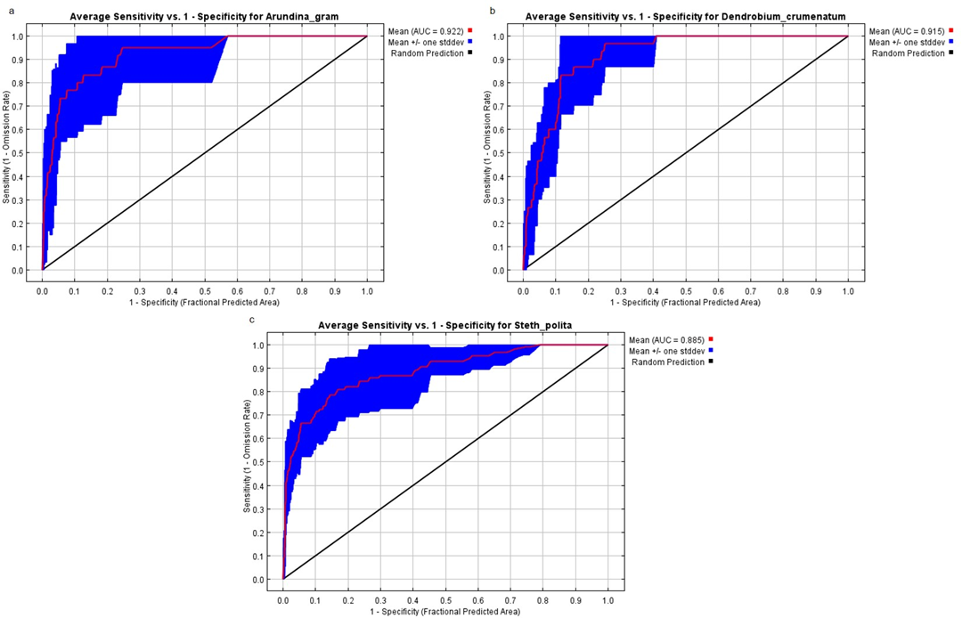
Fig. S1 Average area under the receiver operator characteristic (ROC) curve (AUC) for A. graminifolia (a; AUC = 0.922, standard deviation = 0.076), D. crumenatum (b; AUC = 0.915, standard deviation = 0.031), and S. polita (c; AUC = 0.885, standard deviation = 0.061). Area under the receiver operator characteristic (ROC) curve (AUC) is a measure of model fit. AUC > 0.5 indicates better than random

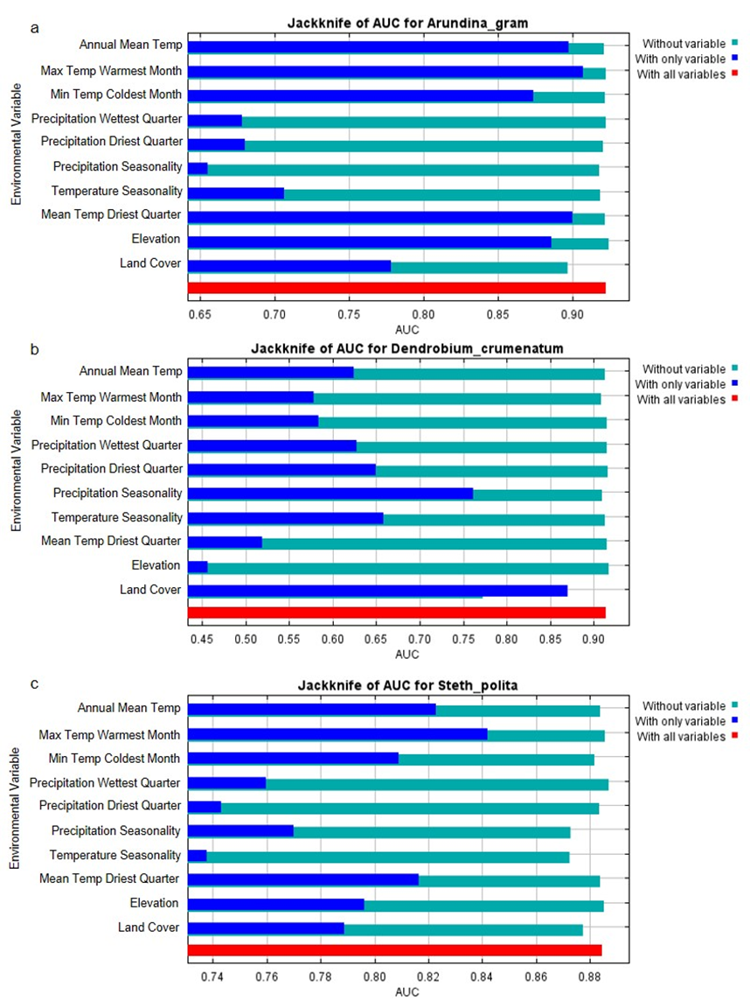
Fig. S2 Jackknife tests calculate the AUC when each variable is removed from the model and when the model is run with only each variable, identifying variable importance in the model. Jackknife tests are for A. graminifolia (a), D. crumenatum (b) and S. polita (c)

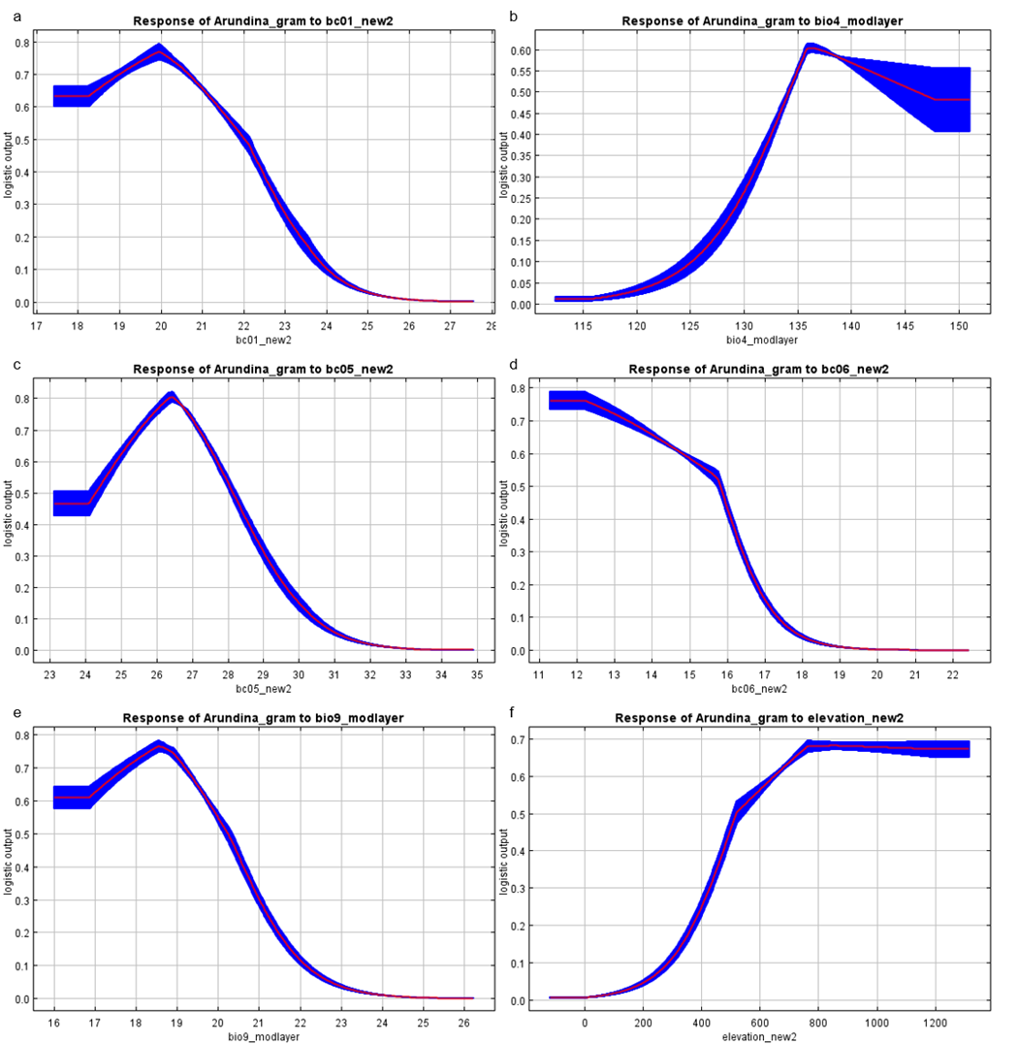
Fig. S3 Average response curves for logistic suitability of A. graminifolia presence using only one variable and dependencies induced by correlations with other variables, in the following order: a. Annual Mean Temperature (Bio 1), b. Temperature Seasonality (Bio 4), c. Max Temperature of Warmest Month (Bio 5), d. Min Temperature of Coldest Month (Bio 6), e. Mean Temperature of Driest Quarter (bio 9), f. Elevation. Listed response curves are for variables identified as important for the model by jackknife tests (S2a)

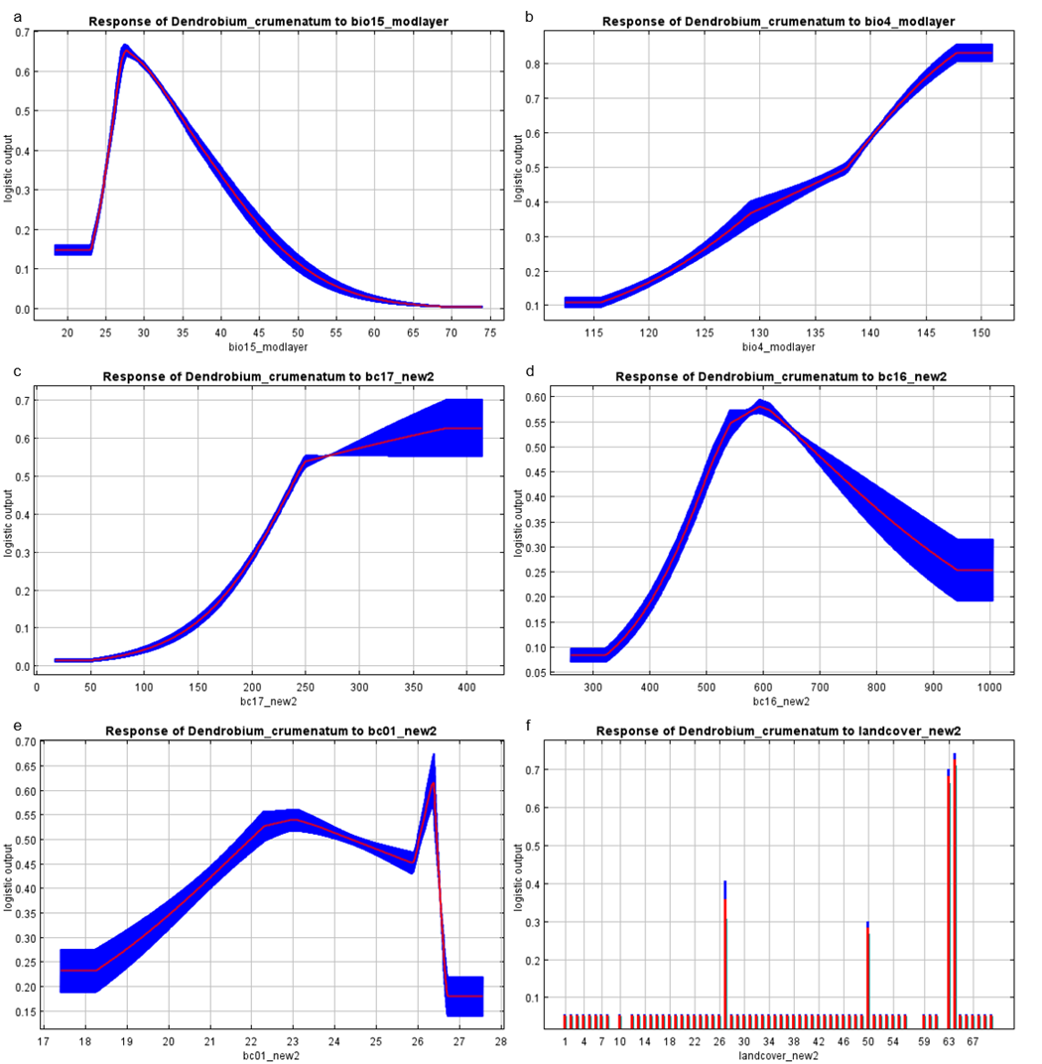
Fig. S4 Average response curves for logistic suitability of D. crumenatum presence using only one variable and dependencies induced by correlations with other variables, in the following order: a. Precipitation Seasonality (Bio 15), b. Temperature Seasonality (Bio 4), c. Precipitation of Driest Quarter (Bio 17), d. Precipitation of Wettest Quarter (Bio 16), e. Annual Mean Temperature (Bio 1), f. Land Cover (26 = young secondary lowland moist noncalcerous evergreen forest; 50 = moist grasslands and pastures; 63 = high-density urban development; 64 = low-density urban development). Listed response curves are for variables identified as important for the model by jackknife tests (S2b)

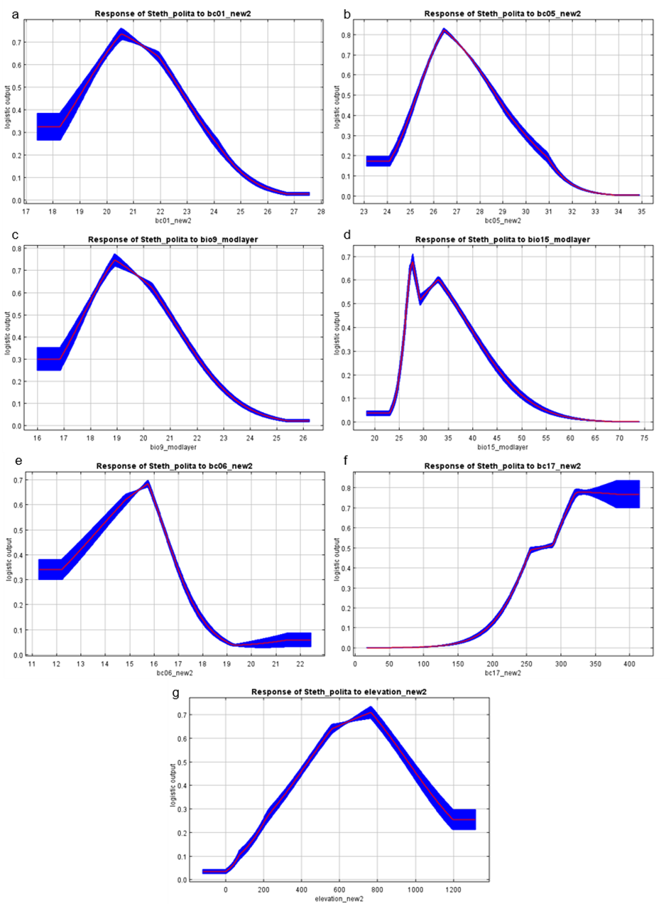
Fig. S5 Average response curves for logistic suitability of S. polita presence in models using only one variable and dependencies induced by correlations with other variables, in the following order: a. Annual Mean Temperature (Bio 1), b. Max Temperature of Warmest Month (Bio 5), c. Mean Temperature of Driest Quarter (bio 9), d. Precipitation Seasonality (Bio 15), e. Min Temperature of Coldest Month (Bio 6), f. Precipitation of Driest Quarter (Bio 17), g. Elevation. Listed response curves are for variables identified as important for the model by jackknife tests (S2c)

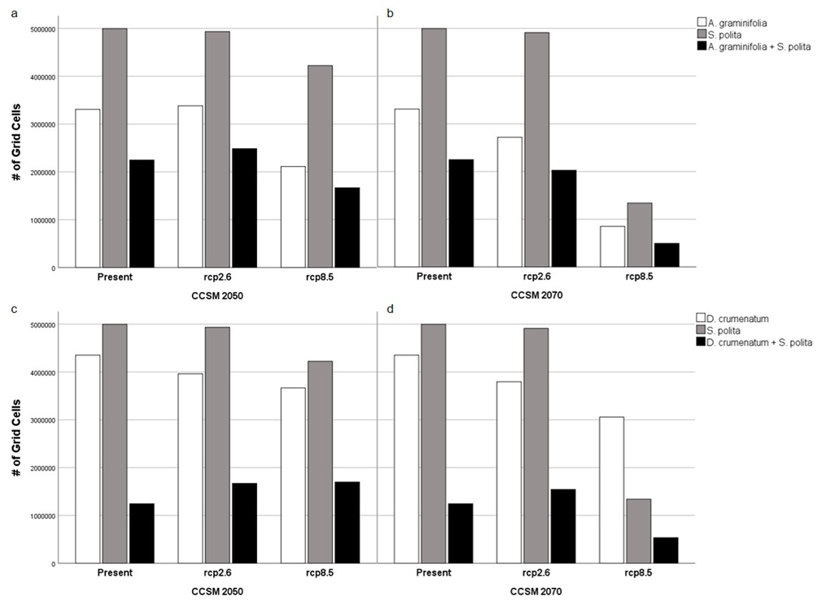
Fig. S6 Bar charts of the number of occupied grid cells above the threshold for S. polita with A. graminifolia (a-b) and D. crumenatum (c-d) for present day and two Representative Concentration Pathways in 2050 (a, c) and 2070 (b, d) under the CCSM model

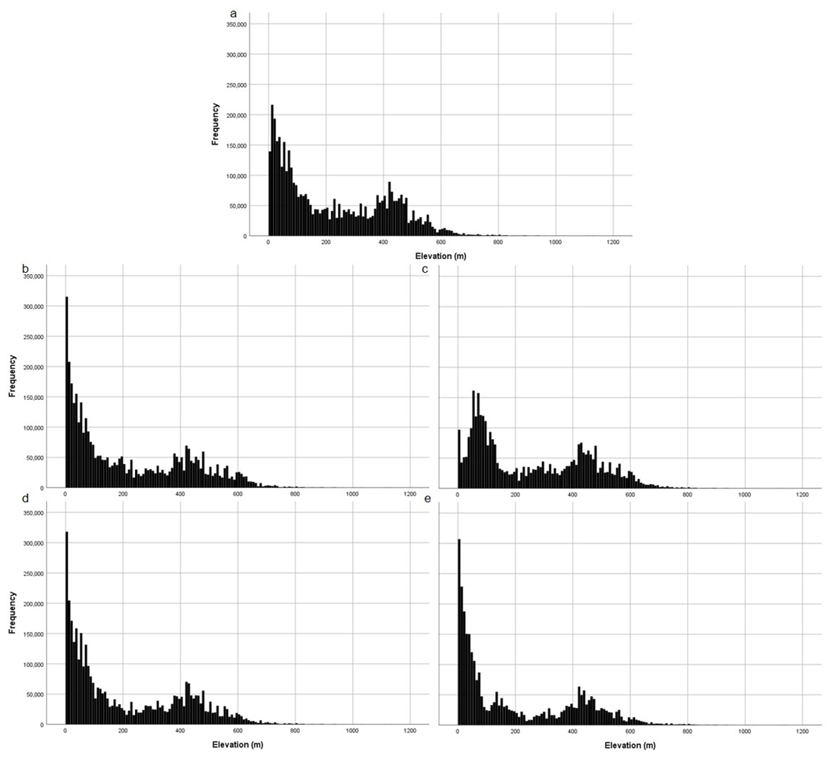
Fig. S7 Histograms for elevation values at D. crumenatum presence cells in the present (a), 2050 (b-c) and 2070 (d-e) in RCP 2.6 (b,d) and rcp 8.5 (c,e) from the CCSM model. a Histogram of D. crumenatum elevations in present day (x = 225.68 ± 186.119). b Histogram of D. crumenatum elevations in 2050 under rcp 2.6 (x = 221.89 ± 201.261). c Histogram of D. crumenatum elevations in 2050 under rcp 8.5 (x = 260.19 ± 196.508 ). d Histogram of D. crumenatum elevations in 2070 under rcp 2.6 (x = 209.96 ± 195.765). e Histogram of D. crumenatum elevations in 2070 under rcp 8.5 (x = 201.81 ± 202.53)

