Western blot：
Figure 2a and c:

A549 N-cadherin
A549 MBD2
A549 E-cadherin
A549 Vimentin
A549 GAPDH

Figure 2d:
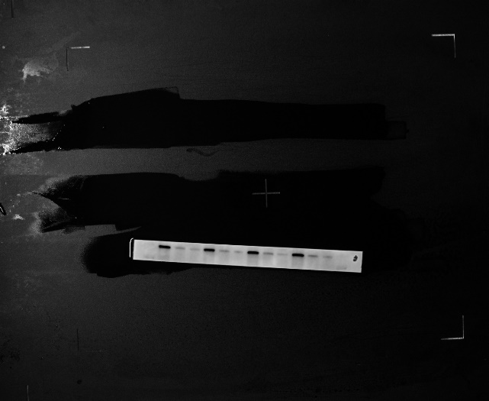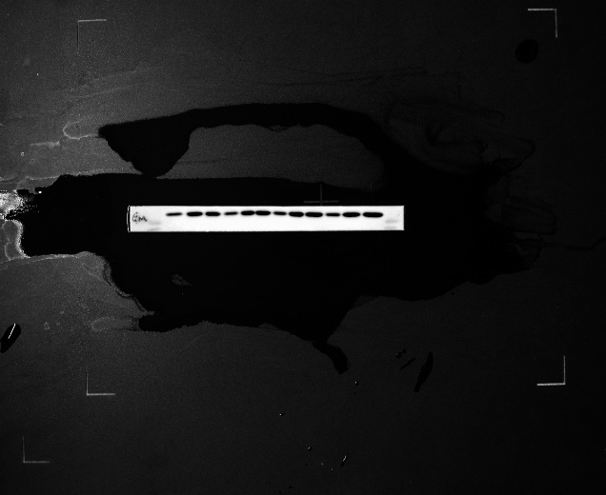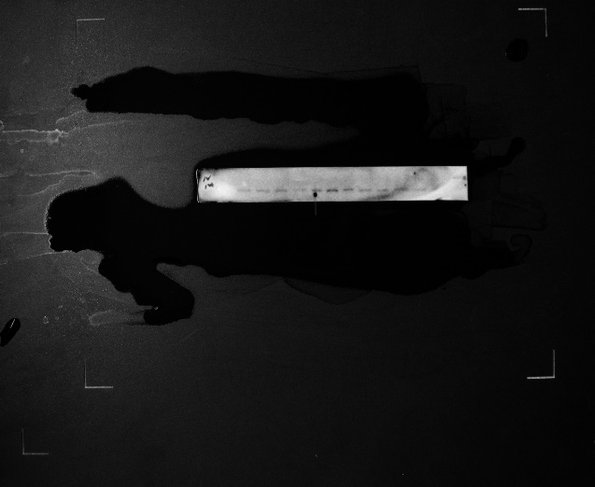
A549 Vimentin
A549 N-cadherin
A549 MBD2
A549 GAPDH
A549 E-cadherin

Figure 2e and g：(B16F10 cells)
Figure 2h：
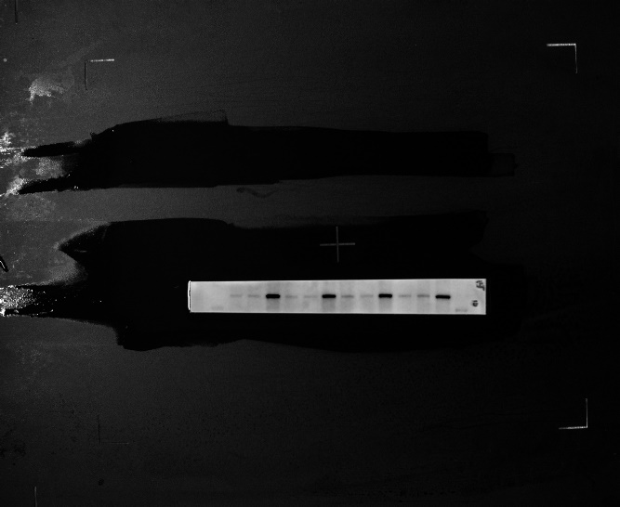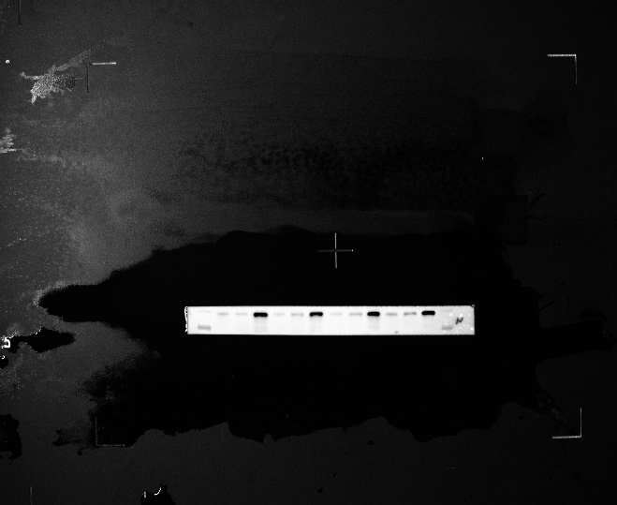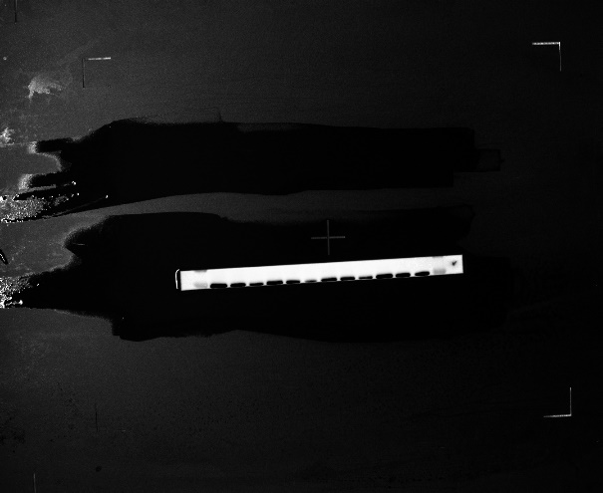
B16F10 Vimentin
B16F10 N-cadherin
B16F10 MBD2
B16F10 GAPDH
B16F10 E-cadherin

Figure 4c (A549 cells):
MBD2

Figure 4d (B16F10 cells)：

Figure 5d：
GAPDH
MBD2

