Gene expression analysis of a giant embryo rice mutant with high GABA content
Pingli Chen, Qing Liu, Bingrui Sun, Shuwei Lv, Liqun Jiang, Jing Zhang, Xingxue Mao, Hang Yu, Yangyang Chen, Wenfeng Chen, Zhilan Fan, Dajain Pan, Chen Li*
Rice Research Institute, Guangdong Academy of Agricultural Sciences / Guangdong Key Laboratory of New Technology in Rice Breeding / Guangdong Rice Engineering Laboratory, Guangzhou 510640, China
*Correspondence should be addressed to: 2369538973@qq.com

Supplemental Figure 1 Differential expression volcano diagram at 5 (a) and 9 (b) days after flowering (DAF). Each point in the differential expression volcano map represents a gene, and the abscissa represents the logarithm of the multiple difference of expression of a gene in two samples. The ordinate represents the negative logarithm of the statistical significance of the change in gene expression. The larger the absolute value of the abscissa, the larger the expression fold difference between the two samples. The higher the ordinate value, the more significant the differential expression is, and the more reliable the differential expression genes are. In the figure, green dots represent downregulated differentially expressed genes in the ge-1 mutant compared with WT, red dots represent upregulated differentially expressed genes in the ge-1 mutant compared with WT, and black dots represent non-differentially expressed genes

Supplemental Figure 2 Cluster diagram of differentially expressed genes at 5 (a) and 9 (b) DAF. The abscissa represents the sample name and the clustering result of the sample, and the ordinate represents the differential gene and the clustering result of the gene. Different columns represent different samples, and different rows represent different genes. The color represents the level of expression of the gene in the sample. WT-1, WT-2, and WT-3 are three biological replicates of WT, and ge-1-1, ge-1-2, and ge-1-3 are three biological replicates of mutant ge-1

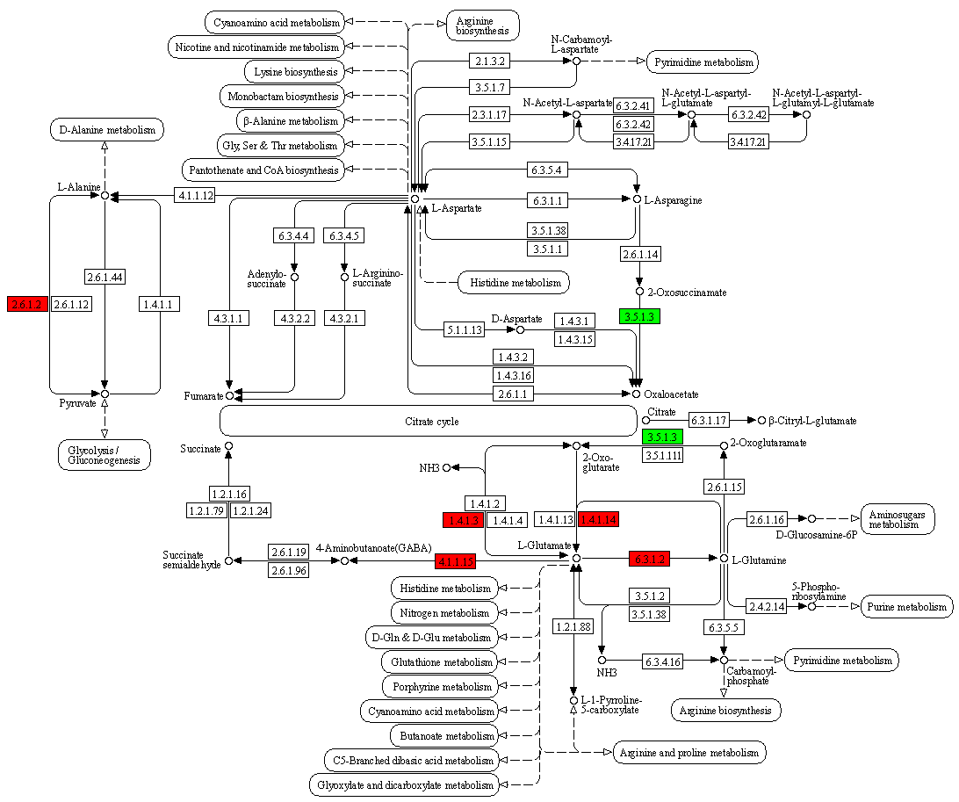
Supplemental Figure 3 Differentially expressed genes (DEGs) of RNA-seq results in alanine, aspartate and glutamate metabolism pathway annotation. Enzymes marked in red boxes were associated with upregulated genes in the giant embryo mutants, while enzymes marked in green boxes were associated with downregulated genes in the giant embryo mutants. The numbers in the boxes represent the enzyme numbers

Supplemental Table 1 Primers used in this study
Primer | Sequence (5' to 3')
HPT-F | TACTTCTACACAGCCATCGG
HPT-R | AATGTCCTGACGGACAATGG
GE-g-F | ATGGCGCTCTCCTCCATGGC
GE-g-R | GGCCCTAGCCACGGCCTTGC
Actin-F | AGCAGCATGAAGATCAAGGTGGTC
Actin-R | CCTTGGCAATCCACATCTGCTG
OsNADH-GOGAT2-F | CGAAGCGACTGTTGCTAAC
OsNADH-GOGAT2-R | GTGATTGCCCACGTCTGCAG
LOC_Os09g26380-F | CATGTACCTCTTCCCACGGC
LOC_Os09g26380-R | CCGGAGACTGGGTGAAATCC
GS1;3-F | GGACGGCAAAGGTTACTTCG
GS1;3-R | TTGCCGTTGGATTGGCCGTG
LOC_Os06g10420-F | AAGGGATAACCTCCCTTTGG
LOC_Os06g10420-R | TCACCTCATTGCAGTTGTGC
DAO1-F | TGGAGCAAGAGGAACAGAAG
DAO1-R | GTTGGATGGACGGACCTC
DAO2-F | AACTTGGTCCGAAAGGGACC
DAO2-R | AGAAGTTCACTGGCTTAAGG
DAO4-F | GCTTAGCTACCTGGGTCAAG
DAO4-R | ACCCATGTGGCATGAGCATG
LOC_Os02g12730-F | GCCGGTACTGGTCGTACAAG
LOC_Os02g12730-R | CACATGGTACCATCTTTGGG
LOC_Os03g59190-F | TGTCTGTTCCAGGAGAAGGG
LOC_Os03g59190-R | AATCCCCTCATAGTGAAGC
LOC_Os04g38530-F | GAACAAGGATTCCCAGGCGC
LOC_Os04g38530-R | AGGTTCCAGTACGAGTGCTG
LOC_Os05g35360-F | GGAGGCAATCGTATCTCATC
LOC_Os05g35360-R | TCCTGCCTATGCAAGACTGC
Supplemental Table 1 to be continued
LOC_Os05g44922-F | CTATAGGGTGACATCCACAC
LOC_Os05g44922-R | TTGGCCGTCCTATCGTTCTC
LOC_Os06g46284-F | GGATTCAGCTTGGCGCGTTC
LOC_Os06g46284-R | TGTACAAGTAGGGGAGCAGC
LOC_Os07g26900-F | AATCGAGGTATGGGCAGGGC
LOC_Os07g26900-R | CGTGCAGCCAGACGTTCTTC
LOC_Os07g48160-F | TGGTAACCGTCTGGCTGTTG
LOC_Os07g48160-R | AGAGTTTCATGCTTCCACAG
LOC_Os09g30240-F | CGACAACCTGTACTGCACGC
LOC_Os09g30240-R | TGGGGATGTAGGCGTAGTTG
LOC_Os09g38340-F | CTCTTCTCCAGGAGGGACAG
LOC_Os09g38340-R | GAGCCCAAGTGTCATGTTGC
LOC_Os10g35330-F | TGGTGGATGGAACGGTTTGG
LOC_Os10g35330-R | CAAACGCCCATAGATCACG
GABA-T1-F | GGAGAGATACGTGGTGTAGG
GABA-T1-R | GATGTTGTCTCCAGCAACTC
GABA-T2-F | GGCGAGATACGTGGTTTAGG
GABA-T2-R | ATTCCGCGCTTCTCACACTC
GABA-T3-F | TTGAGTGGGGAGTTGCGCAA
GABA-T3-R | TATATGCTCACCAGTCCATC
GAD1-F | CTCCAAAGGGATACAAGAAC
GAD1-R | CGCTGTCCTTGAGCGAGAAC
GAD2-F | GATTTGAGGGGTACAAGAGC
GAD2-R | CGTCCTTGAACGTGAAGGC
GAD5-F | GATTCGAGGGGTACAAGGAC
GAD5-R | ACGAGTCCTTGAGGGAGAAG
GDH2-F | GGGTTCAGAACATTCAAGGG
GDH2-R | GGTTGACTCCCAGGGTGAAC
PAO1-F | TCCTCGGGTCATACAGCTAC
Supplemental Table 1 to be continued
PAO1-R | TTGAGTAGTGCGTGCGGTG
PAO3-F | CGAGCCGATACATTACCTAG
PAO3-R | ACTGGGATCCGCAGCTTCTC
PAO4-F | CTGACGCCACTGAACCTACG
PAO4-R | GCGAAGTAGAGGTTCTCCAC
PAO5-F | GAGCTACTGAACCGGTCCAG
PAO5-R | ACCCAGAGTGATCGATGCAG
PAO6-F | TCATGGAGGTTGTGAGGTGC
PAO6-R | GCCCTGAGCTGGTCATACTC
PAO7-F | GAGTCTGGCAGGAGTTTGAG
PAO7-R | ACATGCTCCTCACAACCTCC
LOC_Os01g56380-F | TCAACAGGAGGCTCCTGGAG
LOC_Os01g56380-R | TTCCACGCTTCGCGGACATG
LOC_Os02g19924-F | ATCACCTGCCCTCACAAGCC
LOC_Os02g19924-R | ATCCACTCCCTGGGCAGATG
LOC_Os02g19970-F | CCACACAAGCCAGAGGGATC
LOC_Os02g19970-R | ATCCTAATGCACTCCCTGGC
LOC_Os03g15340-F | CGTCCTTGTGTTCAGCTACG
LOC_Os03g15340-R | TGCAGATGAAGTAGCTCGTG
LOC_Os04g02754-F | GCCAGGTGAGTATTCCACTG
LOC_Os04g02754-R | GCTTCGTCTATGAGCGTCTG
LOC_Os11g33090-F | TGGTGCCGACAGGCTTGAAG
LOC_Os11g33090-R | GCTAGAGCAACGTGGTCATG
LOC_Os11g42510-F | CATGATGGTTGAAGTCAAC
LOC_Os11g42510-R | AGTATCACACTAGTAGGTGC

