Additional file 2

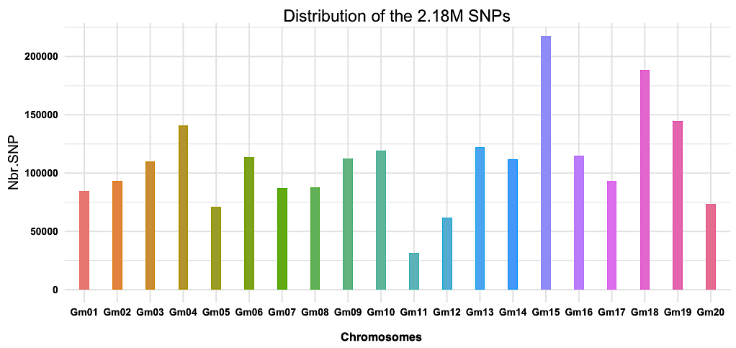
Figure S1: Distribution of the 2.18M SNPs in the soybean genome
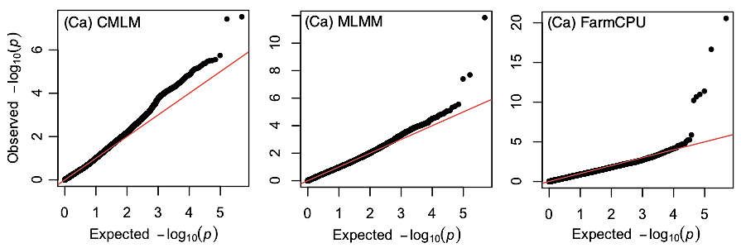
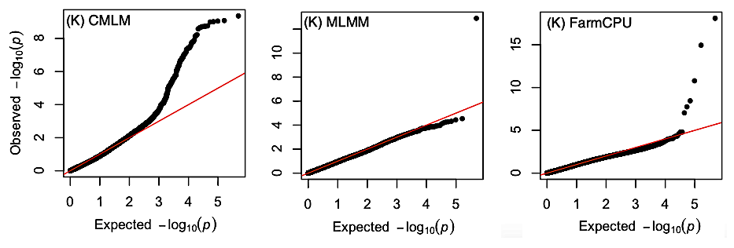
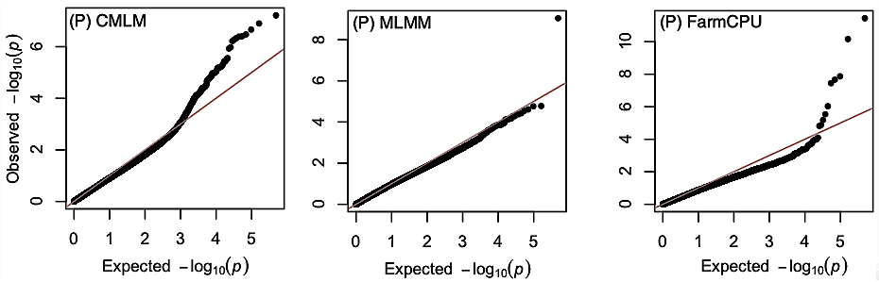
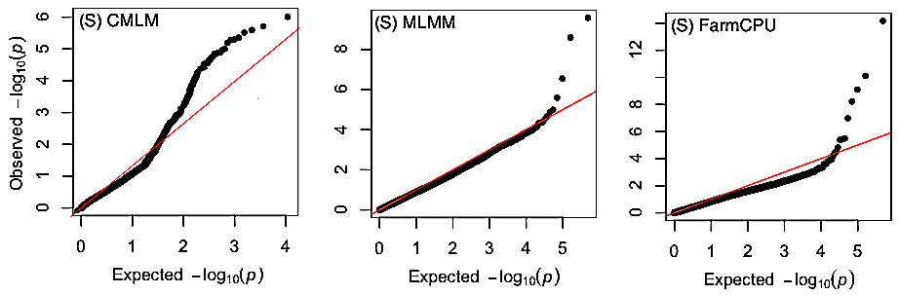
Figure S2: Quantile-quantile (Q-Q) plot of p-values for the association between SNP markers (black dots) and Ca, K, P and S contents using CMLM, MLMM and FarmCPU. The Y-axis is the observed negative base 10 logarithm of the p-values, and the X-axis is the expected observed negative base 10 logarithm of the p-values under the assumption that the p-values follow a uniform (0,1) distribution.
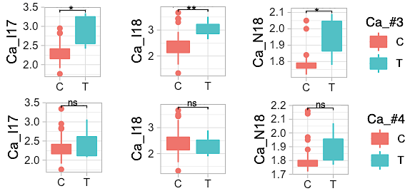
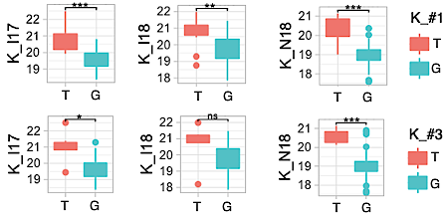
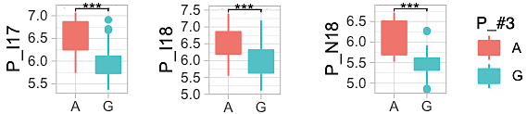
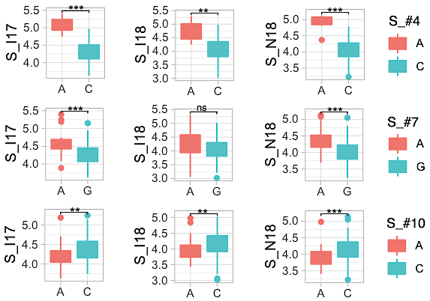
Figure S3: The boxplot and p-values for t-test (difference between means) in validation population. The three trials were conducted in Ottawa (ON) in 2017 (17) and 2018 (18), with (I) or without (N) supplemental irrigation. Phenotypic contrasts were declared significant using a Bonferroni correction (α = 0.05/n where n is the total number of the QTLs for a trait) and significant differences are indicated using an asterisk. ns: not significant, p-value > 0.025, ** and *** Significant, p-value ≤ 0.001 and ≤ 0.0001, respectively.

Figure S4a : Identification of candidate gene underlying QTL Ca_#3 within the haplotype block on chromosome 06. Top panel: position and orientation of 30 genes models present in the 199-kb region that is defined by the left-most (Gm06: 3,321,336) and right-most (Gm06: 3,520,462) markers that are in perfect LD with the peak SNP (Gm06: 3,354,869). The most likely candidate gene (Glyma.06G046000, Calcium ion transport) is highlighted with a green asterisk. Bottom panel: pairwise LD among markers falling within the defined genomic region of interest. LD is indicated as D’x100 and the empty squares indicate complete LD (D’=1). The position of the peak SNP (blue arrow) and candidate gene (green arrow) are shown.
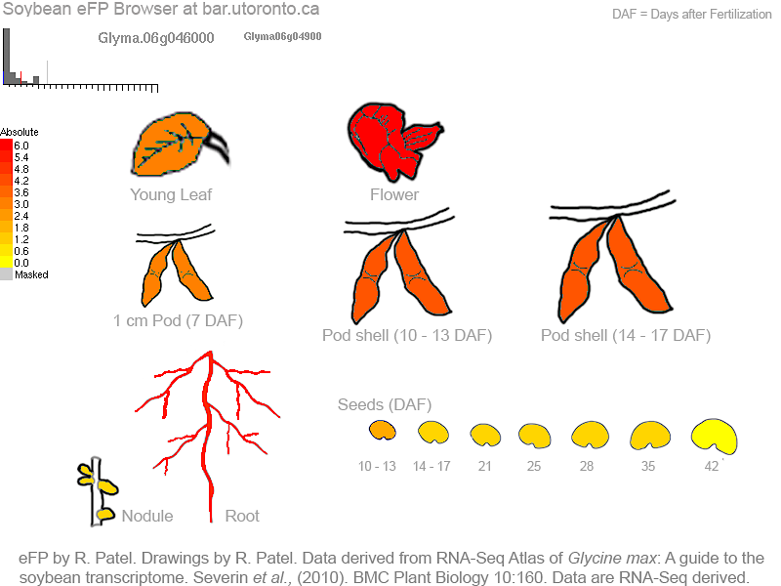
Figure S4b: eFP browser view (www.bar.utoronto.ca) of gene expression in soybeans. Expression strength coded by color: yellow = low, red = high. As shown, Glyma.06G046000 is expressed in root, flowers, pod shell and seeds. Data derived from RNA-seq of Glycine max, published by (Severin et al. 2010)

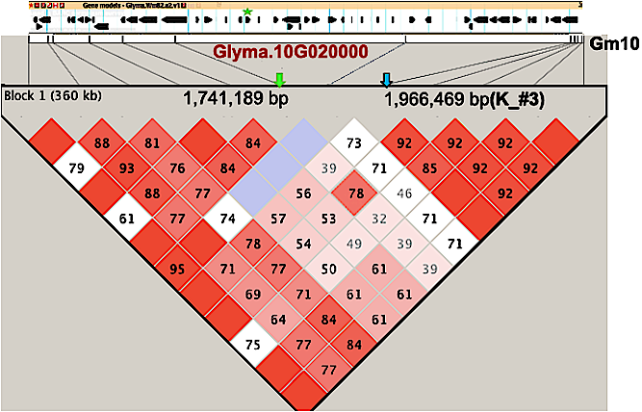

Figure S4c : Identification of candidate gene underlying QTL K_#3 within the haplotype block on chromosome 10. Top panel: position and orientation of 43 genes models present in the 360-kb region that is defined by the left-most (Gm10: 1,611,678) and right-most (Gm10: 1,972,235) markers that are in perfect LD with the peak SNP (Gm06: 1,966,469). The most likely candidate gene (Glyma.10G020000, Potassium ion transport) is highlighted with a green asterisk. Bottom panel: pairwise LD among markers falling within the defined genomic region of interest. LD is indicated as D’x100 and the empty squares indicate complete LD (D’=1). The position of the peak SNP (blue arrow) and candidate gene (green arrow) are shown.

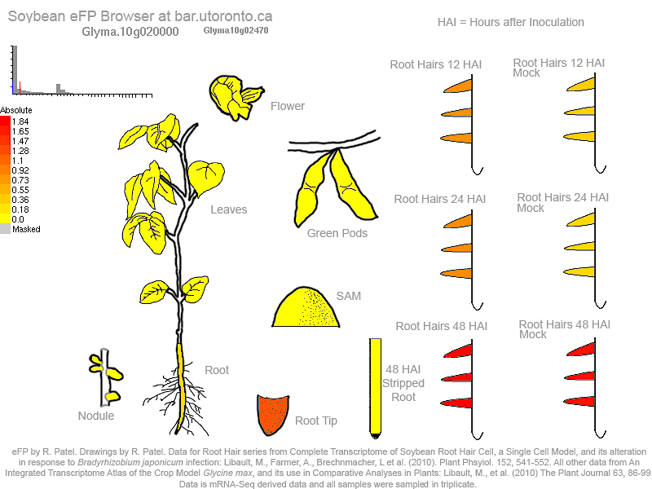
Figure S4d : eFP browser view (www.bar.utoronto.ca) of gene expression in soybeans. Expression strength coded by color: yellow = low, red = high. As shown, Glyma.06G046000 is expressed in root tips and hairs. Data derived from RNA-seq of Glycine max, published by (Libault et al. 2010).

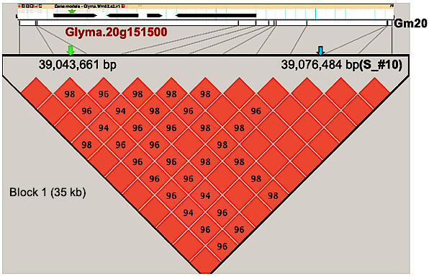
Figure S4e : Identification of candidate gene underlying QTL S_#10 within the haplotype block on chromosome 20. The top panel shows the position and orientation of all four genes models present in the QTL region 35-kb region that is defined by the left-most (Gm20: 39,042,071) and right-most (Gm20: 39,076,880) markers that are in perfect LD with the peak SNP (Gm20:39,076,484). The most likely candidate gene (Glyma.20G151500, Sulfate assimilation) is highlighted with a green asterisk. Bottom panel: pairwise LD among markers falling within the defined genomic region of interest. LD is indicated as D’x100 and the empty squares indicate complete LD (D’=1). The position of the peak SNP (blue arrow) and candidate gene (green arrow) are shown.

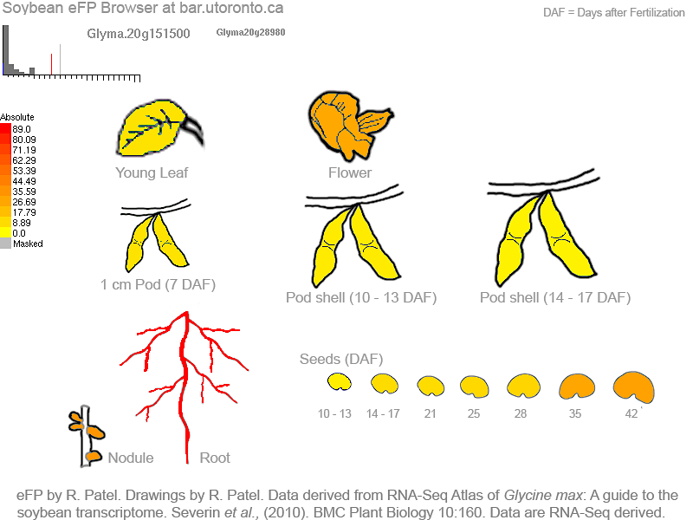
Figure S4f : eFP browser view (www.bar.utoronto.ca) of gene expression in soybeans. Expression strength coded by color: yellow = low, red = high. As shown, Glyma.20G0151500 is expressed in root, nodule, flowers and seeds. Data derived from RNA-seq of Glycine max, published by (Severin et al. 2010)

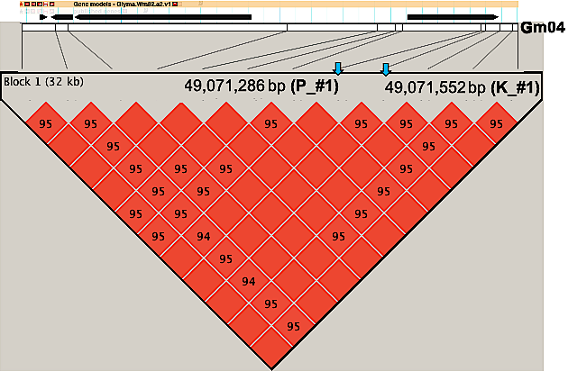
Figure S4g : Identification of candidate gene underlying QTL P_#1 and K_#1 within the haplotype block on chromosome 06. Top panel: position and orientation of 4 genes models present in the 32-kb region that is defined by the left-most (Gm04: 49,041,258) and right-most (Gm04: 49,073,656) markers that are in perfect LD with the peaks SNPs (Gm04:49,071,286 and Gm04: 49,071,552). No candidate gene falling within the defined LD blocks and meeting our criteria was found. Bottom panel: pairwise LD among markers falling within the defined genomic region of interest. LD is indicated as D’x100 and the empty squares indicate complete LD (D’=1). The position of the peaks SNPs (blue arrow) are shown.

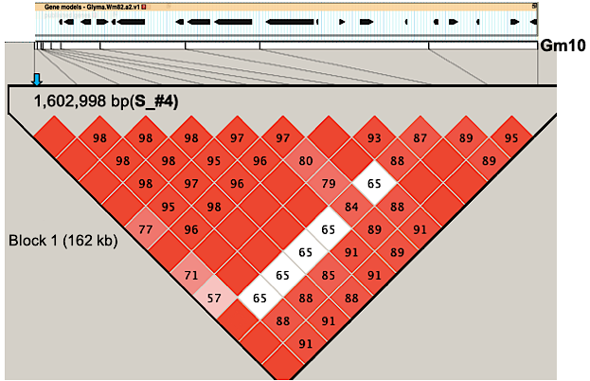
Figure S4h : Identification of candidate gene underlying QTL S_#4 within the haplotype block on chromosome 10. Top panel: position and orientation of 18 genes models present in the 162-kb region that is defined by the left-most (Gm10: 1,602,998) and right-most (Gm10: 1,764,775) markers that are in perfect LD with the peaks SNPs (Gm10: 1,602,998). No candidate gene falling within the defined LD blocks and meeting our criteria was found. Bottom panel: pairwise LD among markers falling within the defined genomic region of interest. LD is indicated as D’x100 and the empty squares indicate complete LD (D’=1). The position of the peak SNP (blue arrow) is shown.

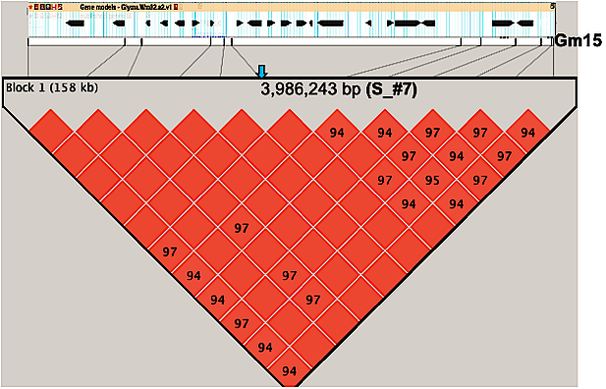
Figure S4i : Identification of candidate gene underlying QTL S_#7 within the haplotype block on chromosome 15. Top panel: position and orientation of 20 genes models present in the 158-kb region that is defined by the left-most (Gm15: 3,924,891) and right-most (Gm15: 4,082,937) markers that are in perfect LD with the peaks SNPs (Gm15: 3,986,243). No candidate gene falling within the defined LD blocks and meeting our criteria was found. Bottom panel: pairwise LD among markers falling within the defined genomic region of interest. LD is indicated as D’x100 and the empty squares indicate complete LD (D’=1). The position of the peak SNP (blue arrow) is shown.

