Supplemental Information for

Leveraging propionate-induced growth inhibition in Corynebacterium glutamicum to evolve improved methylmalonyl-CoA-dependent polyketide production pathway

Zhan et al.

Supplementary Figures, Supplementary Figure 1 - Figure 18.

Supplementary Tables.

Supplementary Figures
Supplementary Figure 1. Carbon utilization efficiency comparison between glucose, branched-chain amino acids and propionate. Glucose is one of the most common carbon sources. 2 mol CO₂ are generated (during TCA cycle) when 1 mol glucose is converted to succinyl-CoA. Then, succinyl-CoA is converted into methylmalonyl-CoA, which is subsequently decarboxylated when it is loaded by ATs domain. This means that 3 mol CO₂ will be lost when 1 mol glucose is used for PKSs production. The carbon utilization efficiency is approximately 50%. For branched chain amino acids like valine, approximately 40% carbon will be lost when it is utilized by PKSs. However, compared with the above two carbon sources, there is no carbon lost when propionate is utilized by PKSs because 1 CO₂ will be fixed at the beginning, even though this carbon will be lost when methylmalonyl-CoA is loaded by PKSs. All of the above statement indicated that compared with other carbon source, propionate is better because the carbon utilization efficiency is much higher.

Supplementary Figure 2. Lag phase among different engineered strains. Cz01, pta-ack (acetate utilization) pathway¹ removed from wild type. Cz02, cgI2569 knocked out of wild type. Cz03, cgI2569 knocked out of Cz01. All strains were pre-cultivated in BHI medium overnight (30 ℃), then cells were inoculated into CGXII minimal medium, 30 ℃ for 16 h. Finally, cells were inoculated into fresh CGXII minimal medium with different concentrations of propionate. All data represent the mean ± SD, and error bars indicate the standard error (n = 3).

Supplementary Figure 3. CgI2569 is involved in propionate utilization. a: SDS-PAGE of CgI2569, (marked band) represents purified CgI2569 protein. b: LC-MS results from the reaction between propionate and succinyl-CoA, indicating that purified CgI2569 catalyzed the reaction between propionate and succinyl-CoA. c: LC-MS results from the reaction between propionate and free CoA, indicating that purified CgI2569 did not catalyze the reaction between propionate and free CoA. d: LC-MS results for the reaction between propionate and free CoA, showing that purified CgI2569 catalyzed the reaction between propionate and acetyl-CoA. e: LC-MS results for the reaction between propionate and free CoA, showing that purified CgI2569 did not catalyze the reaction between propionate and methylmalonyl-CoA. f: Growth curves of wild-type in GXII minimal medium with different concentrations of propionate (0, 0.2, 0.6 and 1 g/L), showing that cell growth is inhibited when propionate concentration is increased. g: Growth curve of different strains in CGXII minimal medium, which show that knockout pta-ack or cgl2569 did not affect cell growth in glucose medium. Cz01 (∆pta-ack), Cz02 (∆cgl2569), Cz03 (∆cgl2569∆pta-ack). All data represent the mean ± SD, and error bars indicate the standard error (n = 3).

Supplementary Figure 4. Knocking out cgI2537 (acdh) further inhibits cell growth in propionate medium. a: Alternate metabolic pathways for propionate in wild type. b: Acyl-CoA dehydrogenase-based propionyl-CoA utilization pathway. c: Growth curves of different strains (WT, Cz05, Cz06, Cz23, Cz24, Cz25) in CGXII minimal medium. d: Growth curves of strains encoding acdh mutations in CGXII minimal medium with 1 g/L propionate. Cz05 (∆prpDBC1/2). Cz06 (∆prpDBC1/2, ∆mcmAB). Cz23 (∆acdh). Cz24 (∆acdh, ∆prpDBC1/2). Cz25 (∆acdh, ∆prpDBC1/2, ∆mcmAB). Transcriptomic data indicate that acdh was significantly upregulated in propionate medium (log2 ^{(Fold change)} = 4.5), indicating that acdh may be involved in propionate inhibition. Growth results showed that deleting acdh in Cz05 or Cz06 further inhibits cell growth. All data represent the mean ± SD, and error bars indicate the standard error (n = 3).

Supplementary Figure 5. Free CoA in WT, Cz05 and, Cz06 strains. Cz05 (∆prpDBC1/2). Cz06 (∆prpDBC1/2, ∆mcmAB). Results showed that compared with wild-type, free CoA and acetyl-CoA were both decreased in Cz05 and Cz06 strain. This is consistent with our hypothesis that accumulation of methylmalonyl-CoA is causing slower growth by depleting acetyl-CoA and free CoA-SH. This result is consistent with previous results^{2, 3}, in which propionate or its derivatives were proved to inhibit acetyl-CoA production. All data represent the mean ± SD, and error bars indicate the standard error (n = 3).

Supplementary Figure 6. a: Growth curves of different strains in CGXII minimal medium with 1 g/L propionate and 10 µM sodium pantothenate. b: Growth curves of Cz05 in CGXII minimal medium with 0.6 g/L propionate with 10 µM vb12 or 10/100 µM sodium pantothenate. c: Growth curve of Cz05 in CGXII minimal medium with 1 g/L propionate with 10 µM vb12 or 10/100 µM sodium pantothenate. d: Growth curve of Cz05 in CGXII minimal medium with 1.6 g/L propionate with 10 µM vb12 or 10/100 µM sodium pantothenate. e: Transcriptomic analysis of genes in the CoA biosynthesis pathway. Cz04 (∆mcmAB). Cz05 (∆prpDBC1/2). Cz06 (∆prpDBC1/2, ∆mcmAB). All data represent the mean ± SD, and error bars indicate the standard error (n = 3).

Supplementary Figure 7. Expression of methylmalonyl-CoA dependent LipLM-M1-DebsTE can rescue cell growth in propionate medium. a: Comparison of indigoidine production in C. glutamicum with and without heterologous expression of the phosphopantetheinylase sfp. BpsA, the enzyme that produces indigoidine, requires modification by a PPTase similar to all type I PKS enzymes. b: 3-hydroxy acid production by introducing LipLM-LipM1-DebsTE. Cells were cultivated in CGXII minimal medium with unlabeled propionate or [¹³C₃]propionate. c: Growth curves of different strains in CGXII minimal medium with 0.6 g/l propionate. Cz34 (∆prpDBC1, prpDBC2::sfp, ∆mcmAB). Cz26, introducing DebsLM-M6-TE into Cz34. All data represent the mean ± SD, and error bars indicate the standard error (n = 3).

Supplementary Figure 8. Germicidin C production among different engineered strains in CGXII minimal medium with unlabeled propionate or [¹³C3]propionate. Cz34 (∆prpDBC1, prpDBC2::sfp, ∆mcmAB). Cz12 is a derivative of Cz34 with the entire germicidin pathway integrated (Supplementary Table). No targeted compound was detected in Cz34. There is a significant peak in Cz12 pink arrow) (MS[H+H]⁺ = 183). No peak was detected in MS[H+H]⁺ = 186 when Cz12 was cultivated in unlabeled propionate. However, this peak disappeared in original MS[H+H]⁺ = 183, and a new peak was detected at the same retention time with a mass increase of 3 amu (MS[H+H]⁺ = 186) when Cz12 was cultivated in [¹³C3]propionate.

Supplementary Figure 9. Introduction of methylmalonyl-CoA dependent Mmar_2470 type III PKS can rescue cell growth in propionate medium. a: LC-MS detection of targeted compound in Cz34 (without 2470 PKS), MS[H+H]⁺ = 335 (pink arrow). b: LC-MS to detect targeted compound in Cz34 (without 2470 PKS), MS[H+H]⁺ = 338. c: LC-MS to detect targeted compound in Cz27 (with Mmar_2470 PKS), MS[H+H]⁺ = 335. d: LC-MS detection of targeted compound in Cz27 (with Mmar_2470 PKS), MS[H+H]⁺ = 338. e: LC-MS detection of targeted compound in Cz27 (with Mmar_2470 PKS), MS[H+H]⁺ = 335. f: LC-MS detection of targeted compound in Cz27 (with Mmar_2470 PKS), MS[H+H]⁺ = 338. g: Growth curve of initial strain and Cz27 (with Mmar_2470 PKS) in CGXII minimal medium. h: Growth curve of initial strain and Cz27 (with Mmar_2470 PKS) in CGXII minimal medium with 0.6 g/L propionate. a/c/d: strains were cultivated in CGXII minimal medium with unlabeled propionate, b/e/f: strains were cultivated in CGXII minimal medium with [¹³C₃]propionate.

Supplementary Figure 10. Introduction of the methylmalonyl-CoA dependent Mmar_2474 type III PKS can rescue cell growth in propionate medium. a: LC-MS detection of targeted compound in Cz34 (without Mmar_2474), MS[H+H]⁺ = 350. b: LC-MS detection of targeted compound in Cz34 (without Mmar_2474), MS[H+H]⁺ = 357. c: LC-MS detection of targeted compound in Cz28 (with Mmar_2474), MS[H+H]⁺ = 351 (pink arrow). d: LC-MS detection of targeted compound in Cz28 (with Mmar_2474), MS[H+H]⁺ = 357. e: LC-MS detection of targeted compound in Cz28 (with Mmar_2474), MS[H+H]⁺ = 351. f: LC-MS detection of targeted compound in Cz28 (with Mmar_2474), MS[H+H]⁺ = 357. G: Growth curves of Cz34 and Cz28 in CGXII minimal medium. h: Growth curves of Cz34 and Cz28 in CGXII minimal medium with 0.6 g/L propionate. a/c/d: strains were cultivated in CGXII minimal medium with unlabeled propionate, b/e/f: strains were cultivated in CGXII minimal medium with [¹³C₃] propionate. Mmar_2474 type III PKS product comprises two equivalents methylmalonyl-CoA, so the mass increased 6 amu when grown in [¹³C₃] propionate medium compared to unlabeled propionate.

Supplementary Figure 11. Propionate tolerance assay. a: Growth curve of Cz34 (∆prpDBC1, prpDBC2::sfp, ∆mcmAB) in CGXII minimal medium with various concentrations of propionate. b: lag phase of Cz34 in CGXII minimal medium with various concentrations of propionate. All strains were pre-cultivated in BHI overnight, inoculated into CGII minimal medium, and grown for 16h. Then cells were inoculated into CGXII minimal medium with various concentration of propionate. All data represent the mean ± SD, and error bars indicate the standard error (n = 3).

Supplementary Figure 12. ALE strategy to evolved germicidin production strain (Cz12). Cells were cultivated in BHI medium overnight (30 ℃), then inoculated into CGXII minimal medium, and finally transferred into fresh CGXII medium with increasing concentration of propionate.

Supplementary Figure 13. a: Biomass production of different strains after 7h. b: Biomass production of different strains after 12h. c: Biomass production of different strains after 17h. d: Biomass production of different strains after 21h. e: Growth curve of Cz34, initial strain (Cz12) and various evolved strains. f: Growth rate of initial strain and various evolved strains. All data represent the mean ± SD, and error bars indicate the standard error (n = 3).

Supplementary Figure 14. a: Growth curves of various strains harboring different mutated gcs in CGXII minimal medium with 8 g/L propionate. b: Germicidin C titer among different reverse engineered strains. All data represent the mean ± SD, and error bars indicate the standard error (n = 3).

Supplementary Figure 15. a: Modeled surface structure of GltA2 (Citrate Synthase) based on module 4TVM (PDB)⁴. Residues that were mutated in evolved strains are labeled. Green represents mutations E239G, R310C, and S60F. Active site catalytic triad residues are shown in pink. b: SDS-PAGE gel results of purified GltA2. Lanes 1-3 are three fractions of purified GltA2; we moved forward with the fraction in lane 2 for subsequent experiments. C: Growth of different strains in CGXII minimal medium. CzEv208, single colony from evolved strain Cz13 (population) . Cz34 (∆prpDBC2, ∆mcmAB, prpDBC1::sfp). Cz12 (integrate whole germicidin production pathway in Cz34). Cz16 (GltA2 Glu239Gly in Cz12), Cz17 (GltA2 Arg310Cyc in Cz12), Cz18 (GltA2 Ser60Phe in Cz12).

Supplementary Figure 16. LC-MS results to detect ¹³C labeled germicidin C product. LC-MS results showed that compared to unlabeled propionate, there is a peak at the same retention time but the MS[H+H]⁺ = 188, which indicates that evolved methylcitrate pathway is involved in germicidin C production.

Supplementary Figure 17. Candidate SNPs test. a: Growth curves of various reverse engineered strains in CGXII minimal medium with 8 g/L propionate. b: Growth curves of various reverse engineered strains in CGXII minimal medium.

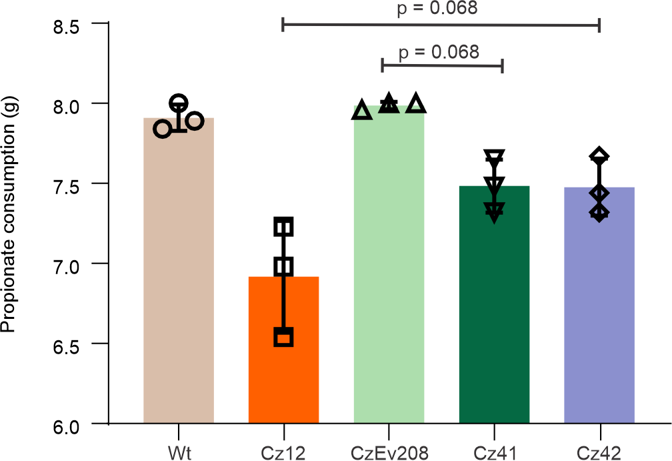
Supplementary Figure 18. Propionate consumption among different bmr3 engineered strains.

Supplementary Tables
Supplementary Table. Strains and Plasmids used in this study
Name | JBEI ID | JBEI PUB ID | Description | Reference
E. coli strains
E. coli DH5α |  |  | Subcloning strain | NEB
E. coli BL21(DE3) |  |  | Expression strain | NEB
Corynebacterium glutamicum strains
C. glutamicum 13032 |  |  |  | Keasling lab
Cz01 | JBx_190451 | JPUB_020693 | C. glutamicum 13032 derived, knockout pta and ack gene (acetate utilization pathway) | This study
Cz02 | JBx_161480 | JPUB_020695 | C. glutamicum 13032 derived, knockout cgl2569 gene (succinyl-CoA: acetate CoA-transferase) | This study
Cz03 | JBx_161481 | JPUB_020697 | knockout pta and ack gene based on Cz02 | This study
Cz04 | JBx_193548 | JPUB_020698 | C. glutamicum 13032 derived, knockout mutaseAB (cgl1529-1530) | This study
Cz05 | JBx_227543 | JPUB_020700 | C. glutamicum 13032 derived, knockout prpDBC1 and prpDBC2 | This study
Cz06 | JBx_190427 | JPUB_020703 | knockout mutaseAB based on Cz05 | This study
Cz07 | JBx_227611 | JPUB_020704 | integrate prpE into Cz05 | This study
Cz08 | JBx_227612 | JPUB_020706 | integrate pcc into Cz05 | This study
Cz09 | JBx_227613 | JPUB_020708 | integrate prpE into Cz08 | This study
Cz10 | JBx_193560 | JPUB_020709 | integrate aspA and panD into Cz05 | This study
Cz11 | JBx_193555 | JPUB_020712 | integrate rfp into Cz34 | This study
Cz12 | JBx_226362 | JPUB_020715 | Integrate germicidin pathway into Cz34 | This study
Cz13 |  | JPUB_020722 | Evolved strains (population) based on Cz12 | This study
CzEv208 | JBx_227544 | JPUB_020723 | Single colony from Cz13
Cz14 | JBx_227625 | JPUB_020724 | replace evolved gltA2 with native gltA2 in CzEv208 | This study
Cz15 | JBx_228509 | JPUB_020726 | replace native gltA2 with evolved gltA2 in Cz12 | This study
Cz16 | JBx_233806 | JPUB_020728 | replace native GltA2 with evolved GltA2 (Glu239Gly) in Cz12 | This study
Cz17 | JBx_228512 | JPUB_0207730 | replace native GltA2 with evolved GltA2 (Arg310Cys) in Cz12 | This study
Cz18 | JBx_228508 | JPUB_020732 | replace native GltA2 with evolved GltA2 (Ser60Phe) in Cz12 | This study
Cz19 | JBx_193556 | JPUB_020734 | C. glutamicum 13032 derived, overexpress cgl2569 | This study
Cz20 | JBx_230628 | JPUB_020735 | Knockout aceAB based on CzEv208 | This study
Cz22 | JBx_193557 | JPUB_020737 | Overexpress cgl2569 in Cz02 | This study
Cz23 | JBx_193561 | JPUB_020738 | C. glutamicum 13032 derived, knockout acdh (cgl1017) | This study
Cz24 | JBx_193562 | JPUB_020740 | Knockout acdh (cgl1017) in Cz05 | This study
Cz25 | JBx_193563 | JPUB_020741 | Knockout acdh (cgl1017) in Cz06
Cz26 | JBx_193550 | JPUB_020742 | Integrate LipMLM-M1-DebsTE into Cz34 | This study
Cz27 | JBx_190464 | JPUB_020744 | Integrate type III PKS 2470 into Cz34 | This study
Cz28 | JBx_190462 | JPUB_020746 | Integrate type III PKS 2474 into Cz34 | This study
Cz29 | JBx_227623 | JPUB_020748 | integrate Gcs (T256A) into Cz12 | This study
Cz30 | JBx_227622 | JPUB_020750 | integrate Gcs (L216P) into Cz12 | This study
Cz31 | JBx_227621 | JPUB_020752 | integrate Gcs (L216P,T256A) into Cz12 | This study
Cz32 | JBx_227625 | JPUB_020754 | replace evolved gcs with native gcs in CzEv208 | This study
Cz33 | JBx_227624 | JPUB_020756 | replace native Gcs with Gcs R347L in Cz12 | This study
Cz34 | JBx_233807 | JPUB_020758 | integrate sfp into Cz06 | This study
Cz35 | JBx_228507 | JPUB_020759 | Knockout gltA2 in Cz12 | This study
Cz36 | JBx_231915 | JPUB_020761 | KO qrcA gene based on CzEv208 | This study
Cz37 | JBx_231916 | JPUB_020763 | KO IpqY gene based on CzEv208 | This study
Cz38 | JBx_233808 | JPUB_020765 | KO cgl0727 gene based on CzEv208 | This study
Cz39 | JBx_231918 | JPUB_020767 | KO lpdA gene based on CzEv208 | This study
Cz40 | JBx_233809 | JPUB_020769 | KO pstl gene based on CzEv208 | This study
Cz41 | JBx_231920 | JPUB_020771 | KO bmr3 gene based on CzEv208 | This study
Cz42 | JBx_231923 | JPUB_020773 | overexpress bmr3 gene based on Cz12 | This study
Cz43 | JBx_231921 | JPUB_020775 | KO prpP gene based on CzEv208 | This study
Cz44 | JBx_231922 | JPUB_020777 | KO cgl2569 gene based on CzEv208 | This study

Reference:
1. Claes, W.A., Puhler, A. & Kalinowski, J. Identification of two prpDBC gene clusters in Corynebacterium glutamicum and their involvement in propionate degradation via the 2-methylcitrate cycle. J Bacteriol 184, 2728-2739 (2002).
2. Patel, T.B., DeBuysere, M.S. & Olson, M.S. The effect of propionate on the regulation of the pyruvate dehydrogenase complex in the rat liver. Arch Biochem Biophys 220, 405-414 (1983).
3. MARUYAMA, K. & KITAMURA, H. Mechanisms of growth inhibition by propionate and restoration of the growth by sodium bicarbonate or acetate in Rhodopseudomonas sphaeroides S. The Journal of Biochemistry 98, 819-824 (1985).
4. Ferraris, D.M., Spallek, R., Oehlmann, W., Singh, M. & Rizzi, M. Structures of citrate synthase and malate dehydrogenase of M ycobacterium tuberculosis. Proteins: Structure, Function, and Bioinformatics 83, 389-394 (2015).

