Significantly Enhanced Dielectric and Energy Storage Performance of Epoxy Nanocomposites via Constructing Continuous 3D BaTiO₃ Network Collaborated with Graphene Oxide
Xueqing Bi¹, Wenqing Xue¹, Zhen Wang¹, Zi Wang², Yuchao Li¹*, Yanhu Zhan¹, Shuangshuang Wang¹, Jigong Hao¹, Wei Li¹, Weifang Han¹, Bo Ge¹, Junwen Ren^{2*}, Junwei Zha³*
- School of Materials Science and Engineering, Liaocheng University, Liaocheng, 252059, P.R. China;
- College of Electrical Engineering, Sichuan University, Chengdu, 610065, P.R. China;
3. School of Chemistry and Biological Engineering, University of Science and Technology Beijing, Beijing, 100083, P.R. China;
* Corresponding author: liyuchao@lcu.edu.cn; myboyryl@scu.edu.cn; zhajw@ustb.edu.cn

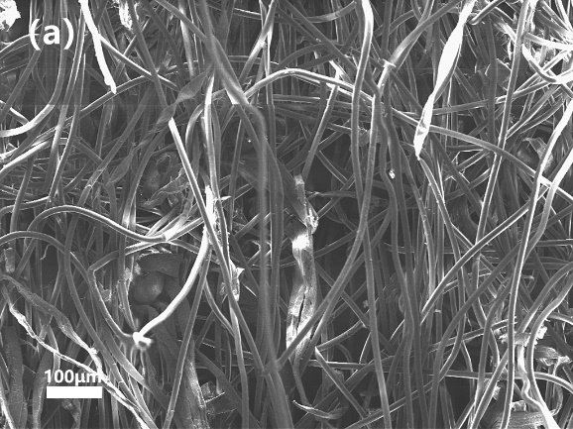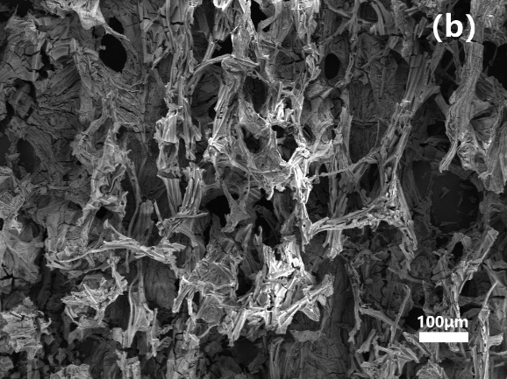
Figure S1. SEM images of (a) cleanroom wiper and (b) 3DBT network structure.

Figure S2. The variation of (a) ε′-ε″ and (b) M′-M″, and frequency denpendence of the (c) real and (d) imaginary parts of dielectric modulus for epoxy composites.

Table S1. The composition, dielectric and thermal properties of GEBT and EBT composites
Composites | BT Content | GO content | T_{di} (ºC) | T_{df} (ºC) | ε′  (100 Hz) | tanδ  (100 Hz) | E₀  (kV·mm⁻¹) | U_{e} (J·cm⁻³)  at 40 kV·mm⁻¹ | U_{l} (J·cm⁻³)  (Linear)
EP  GEBT-1  GEBT-2  GEBT-3  GEBT-4  EBT-1  EBT-2 | 0 wt%  15.0 wt%  14.3 wt%  14.5 wt%  15.4 wt%  15.0 wt%  25.0 wt% | 0 wt%  0 wt%  0.25 wt%  0.5 wt%  0.75 wt%  0 wt%  0 wt% | 363.5  357.0  356.0  317.1  305.1  314.0  369.6 | 538.7  529.0  536.9  543.4  519.4  513.8  533.0 | 4.4  9.2  9.4  12.0  15.6  5.2  6.3 | 0.023  0.020  0.021  0.012  0.020  0.015  0.017 | 140.2  128.8  133.8  224.9  239.8  137.6  121.0 | 0.25  0.30  0.37  0.47  0.36  0.23  0.23 | 0.38  0.68  0.75  2.68  3.97  0.44  0.41
Note: GO is a relative concentration just to epoxy.

