Supplementary Figure 1. Body weight gain of mice after 8 weeks of standard chow diet or high fat diet.
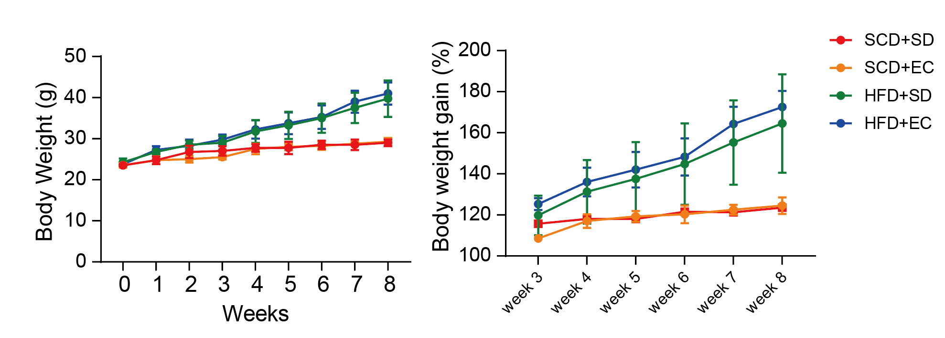

Supplementary Figure 2. Beta diversity, Bray-Curtis, and unweighted and weighted Unifrac.
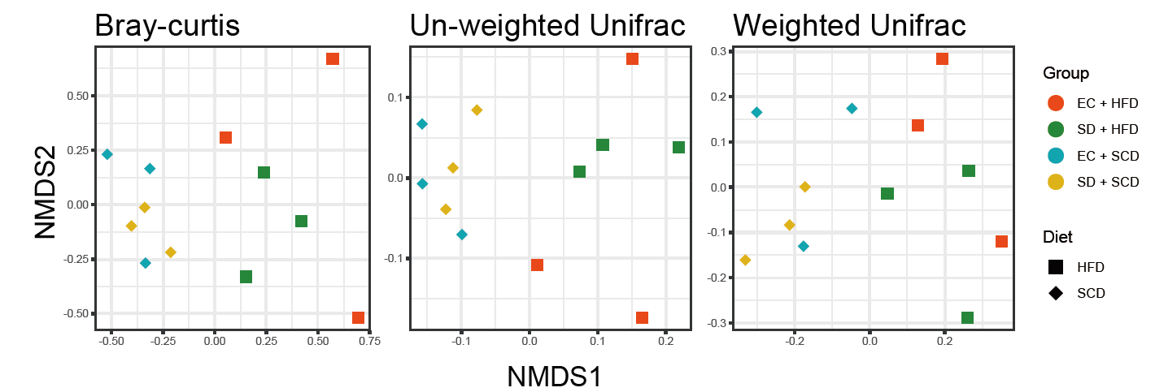

Supplementary Figure 3. Venn diagram for colon differentially expressed genes for sleep deprivation (SD) vs. exercise control (EC) under standard chow diet (SCD) and SD vs. EC under high fat diet (HFD) and their three intersecting genes.
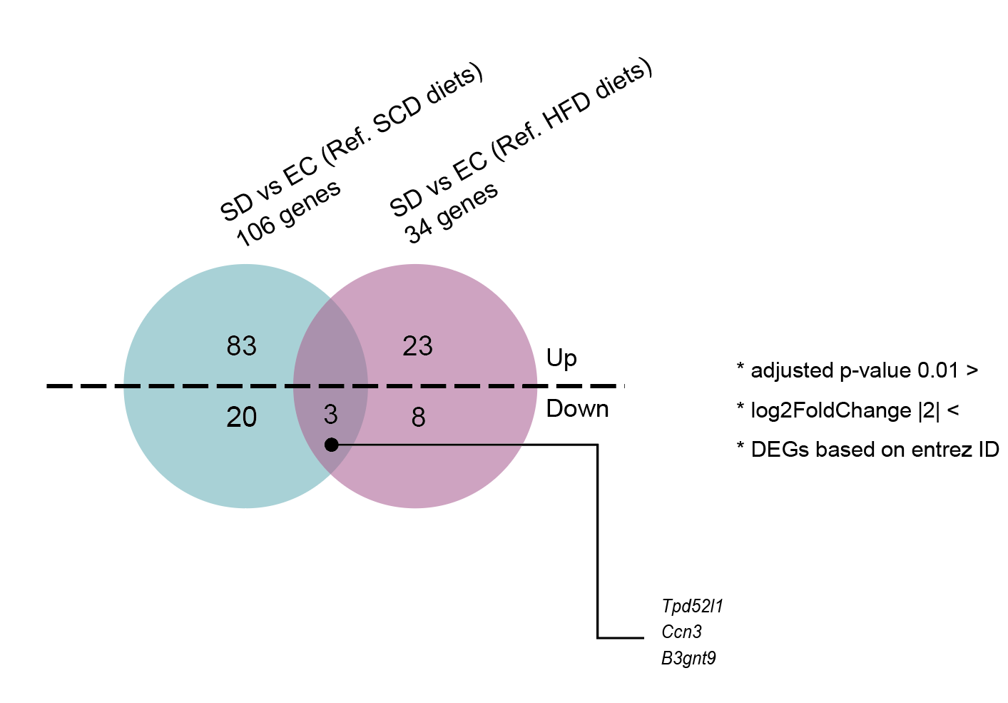

Supplementary Figure 4. An overview of variance composition of the multi-omics factor analysis for four datasets, colon RNA sequencing, Brain nCounter, microbiota phylogeny, and estimated gut microbiota genes. The barplot quantifies a total explanation for four factors.
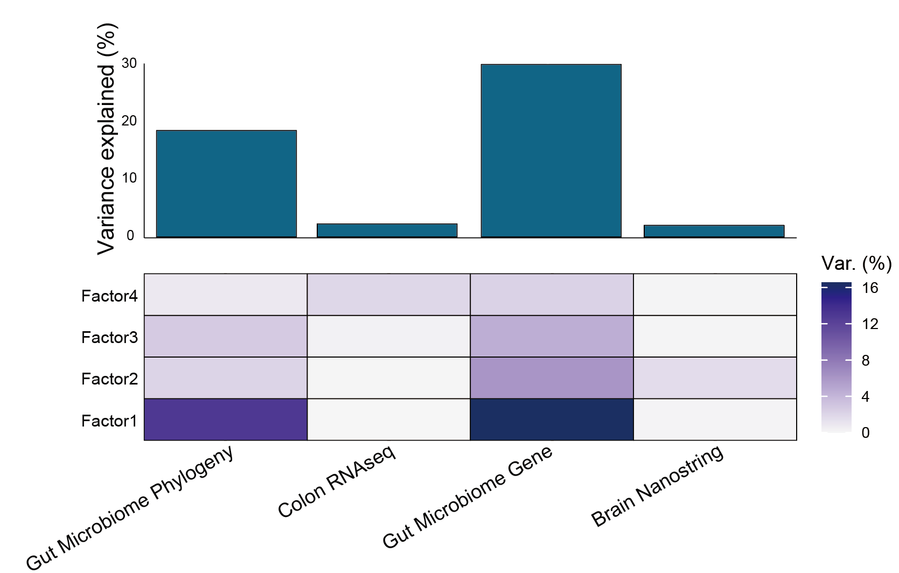

Supplementary Figure 5. The results of multi-omics factor analysis for factor 2.
