Supplementary Information

Matrix vesicle-inspired platelet membrane vesicles for biomineralization of dentin tubules

Shijie Shi, ^{ab} Li Zhen, ^{ab} Menglin Fan, ^{ab} Lizhong Sun, ^{ab} Siying Tao, ^{ab} Mingyue Han, ^{ab} Zhaohan Yu, ^{ab} Jiaojiao Yang *ª and Jiyao Li *^{ab}

a State Key Laboratory of Oral Diseases, National Clinical Research Center for Oral Diseases, West China Hospital of Stomatology, Sichuan University, Chengdu 610041, China. E-mail: jiaojiao.yang@scu.edu.cn, jiyaoliscu@163.com
b Department of Cariology and Endodontics, West China Hospital of Stomatology, Sichuan University, Chengdu 610041, China

Figure S1. ATR-FTIR spectrum of intact dentin.

Figure S2. After the collagen treated with PMV and DDW was degraded, the acid hydrolysis method was used to detect the concentration of HYP in the samples. The higher the HYP concentration, the weaker the resistance to enzymatic hydrolysis.

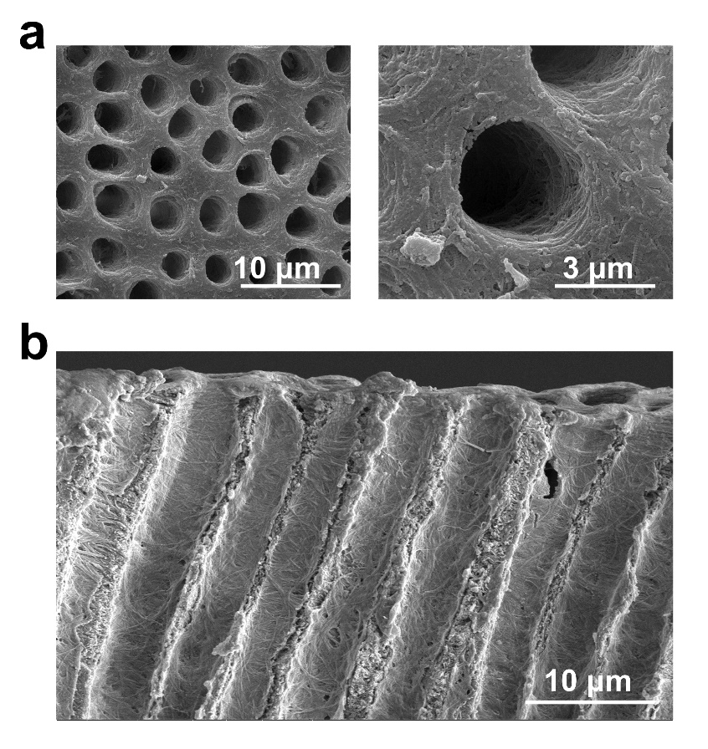
Figure S3. (a) Dentin surface after EDTA etching. (b) Longitudinal section of dentin after EDTA etching.

Figure S4. EDS analysis of regenerated minerals of the EDTA-etched dentin coated with PLM or PMVs after being immersed in artificial saliva for 1 w and 3 w.

