Graphical abstract

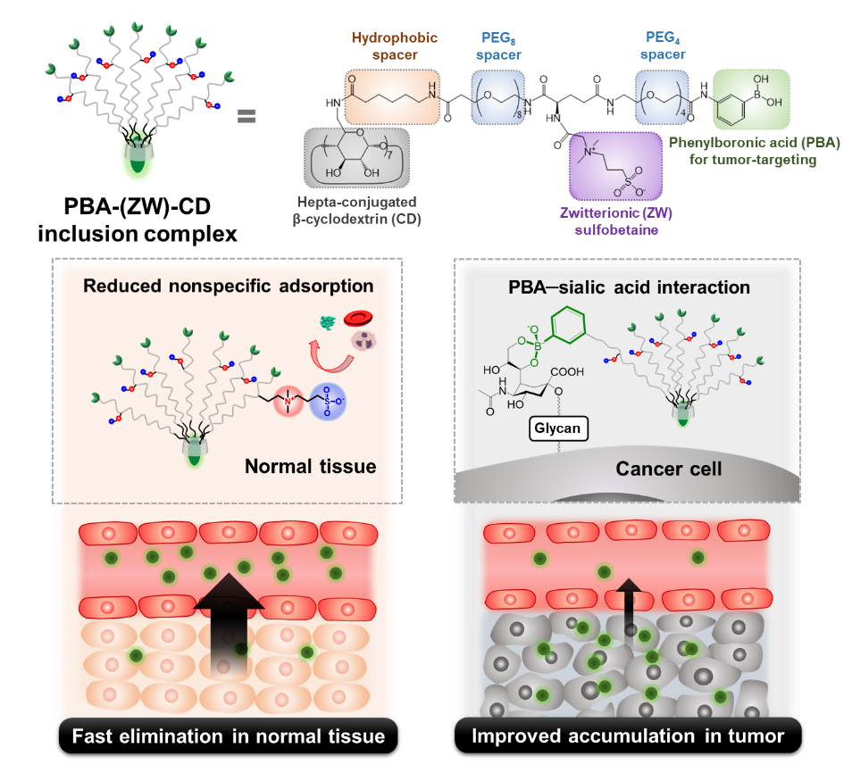

A delicately tailored design of renal-clearable zwitterionic cyclodextrin, hepatkis-(6-deoxy-6-((phenylboronic acid-tetraethyleneglycol-l-glutamic acid N^{α}-sulfobetaine)-octaethyleneglycol-caproamide))-β-cyclodextrin (PBA-(ZW)-CD), was developed for colorectal cancer (CRC)-selective imaging and drug delivery. The PBA-(ZW)-CD/adamantyl sulfocyanine 7 inclusion complex provided tumor-to-background ratio of around 4. Inclusion complexes of doxorubicin and ulixertinib exhibited enhanced tumor retention, while facilitating their elimination in normal tissues, displaying highly improved therapeutic efficacy in CRC models.

Supplementary Information

Tailoring Renal Clearable Zwitterionic Cyclodextrin for Colorectal Cancer-Selective Drug Delivery

Min-Jun Baek, Duy-Thuc Nguyen, Dahan Kim, So-Yeol Yoo, Sang Min Lee, Jae-Young Lee* and Dae-Duk Kim**

M.-J. Baek, D.-T. Nguyen, D. Kim, D.-D. Kim
College of Pharmacy and Research Institute of Pharmaceutical Sciences, Seoul National University, Seoul 08826, Republic of Korea

S.-Y. Yoo, S. M. Lee, J.-Y. Lee
College of Pharmacy, Chungnam National University, Daejeon 34134, Republic of Korea

* Corresponding author. Tel.: +82 42 821 5935
E-mail address: jaeyoung@cnu.ac.kr (J.-Y. Lee)

** Corresponding author. Tel.: +82 2 880 7870
E-mail address: ddkim@snu.ac.kr (D.-D. Kim)

S1. Experimental Section
S1.1. Materials
O-(benzotriazol-1-yl)-N,N,N',N'-tetramethyluronium hexafluorophosphate (HBTU), N-([dimethylamino]-1H-1,2,3-triazolo-[4,5-b]pyridin-1-ylmethylene)-N-methylmethanaminium hexafluorophosphate N-oxide (HATU), 3-aminophenylboronic acid, 6-(Boc-amino)caproic acid, lithium hydroxide, trifluoroacetic acid (TFA), triethylamine (TEA), N,N-diisopropylethylamine (DIPEA), N-(3-dimethylaminopropyl)-N'-ethylcarbodiimide hydrochloride (EDC·HCl), 2-(N-morpholino)ethanesulfonic acid (MES), succinic anhydride, betaine hydrochloride, glycolic acid, alizarin red S (ARS), 3-acetamindophenylboronic acid, fluorescamine, and l-serine were purchased from Sigma-Aldrich Co. (St. Louis, MO, USA). N-Boc-l-glutamic acid α-methyl ester was purchased from Santa Cruz Biotechnology (Dallas, TX, USA). t-Boc-N-amido-PEG_{n}-acids (n = 4, 8, and 12) were purchased from BroadPharm (San Diego, CA, USA). Heptakis-(6-amino-6-deoxy)-β-cyclodextrin (CD) heptahydrochloride was obtained from Cyclodextrin Shop (Tilburg, Netherlands). Doxorubicin (DOX) free base was purchased from MedKoo Biosciences, Inc. (Morrisville, NC, USA). Ulixertinib (UXT) was purchased from MedChemExpress (Monmouth Junction, NJ, USA). Deuterium oxide (D₂O) and dimethyl sulfoxide-d₆ (DMSO-d₆) were purchased from Cambridge Isotope Laboratories (Tewksbury, MA, USA). Dialysis membranes (Spectra/Por 7 Dialysis Tubing; molecular weight cut-off [MWCO]: 1 kDa) were obtained from Repligen Corporation (Waltham, MA, USA). Roswell Park Memorial Institute (RPMI) 1640 cell culture medium, penicillin–streptomycin, and fetal bovine serum (FBS) were obtained from Thermo Fisher Scientific (Waltham, MA, USA). N-hydroxysuccinimide esters of sulfocyanine 5 and 7 (SCy5-NHS and SCy7-NHS, respectively) were purchased from LumiProbe (Hunt Valley, MD, USA). All other reagents used were of analytical grade.

S1.2. Synthesis and Characterization of CD Derivatives
Nuclear Magnetic Resonance (NMR) Spectroscopy and Mass Spectrometry (MS)
Proton and rotating frame Overhauser enhancement spectroscopy (ROESY) NMR spectra were acquired using a JNM-ECZ400s (JEOL, Tokyo, Japan). Mass spectra of compounds with molecular weights lower than 1,000 Da were obtained using an Agilent Technologies 6430 Triple Quad LC/MS system (electrospray ionization [ESI]-MS; Agilent Technologies, Santa Clara, CA, USA). Mass spectra of the CD derivatives were recorded using a Voyager-DE STR Biospectrometry Workstation (matrix-assisted laser desorption/ionization time-of-flight MS; Applied Biosystems Inc., Waltham, MA, USA) with 2,5-dihydroxybenzoic acid (DHB) as the matrix.

Synthesis of Compounds 1 and 3
For the synthesis of compound 1, N,N-dimethylglycine ethyl ester (1,700 μL, 2.0 mmol) was dissolved in anhydrous dichloromethane (DCM), followed by the addition of 1,3-propane sultone (1600 mg, 13.1 mmol). The mixture was stirred at room temperature (RT) for 48 h under a nitrogen atmosphere. The mixture was filtered and the residue was washed with DCM to yield 1 as a white solid. The product was dried under reduced pressure (88% yield) and used directly in the next step without further purification. ¹H-NMR (400 MHz, D₂O, δ): 4.19 (s, 2H), 4.17 (m, 2H), 3.59 (m, 2H), 3.17 (s, 6H), 2.83 (t, 2H), 2.10 (m, 2H), and 1.15 (t, 3H). ESI-MS: m/z 254.1 [M + H]⁺. Similarly, methyl 3-(dimethylamino)propionate (1,717 μL, 12.0 mmol) was dissolved in anhydrous DCM, and 1,3-propane sultone (1,600 mg, 13.1 mmol) was added to prepare compound 3. The mixture was stirred at RT for 48 h under a nitrogen atmosphere. The product was filtered, washed with DCM, and dried under vacuum before use (86% yield). ¹H-NMR (400 MHz, D₂O, δ): 3.6 (s, 3H), 3.56 (t, 2H), 3.35 (m, 2H), 2.98 (s, 6H), 2.84 (m, 4H), and 2.09 (m, 2H). ESI-MS: m/z 254.1 [M + H]⁺.

Synthesis of Compounds 2 and 4
Compounds 2 and 4 were prepared by the ester hydrolysis of 1 and 3, respectively. Briefly, 1 or 3 dissolved in double-deionized water (DDW) was added with 2 equivalents of LiOH powder and stirred for 4 h. The completion of the reaction was confirmed using ESI-MS. After neutralizing the reaction mixture with 1 mol L^{–1} aqueous HCl, the products were directly used as zwitterionic moieties without further purification. ESI-MS: m/z 226.0 [M + H]⁺ for 2 and m/z 240.1 [M + H]⁺ for 4.

Synthesis of Compound 5
N-Boc-l-glutamic acid α-methyl ester (1,305 mg, 5.0 mmol) and HATU (2,298 mg, 6.0 mmol) were dissolved in anhydrous N,N-dimethylformamide (DMF). The mixture was added with DIPEA (3,040 µL, 17.5 mmol) and stirred for 30 min, to which 3-amino phenylboronic acid monohydrate (1,155 mg, 7.5 mmol) dissolved in anhydrous DMF was added and stirred for 30 h at RT under a nitrogen atmosphere. The mixture was then diluted with DCM and washed thrice with 0.5 mol L^{–1} aqueous HCl and DDW. The organic layer was dried over MgSO₄, filtered, and vacuum-dried to obtain compound 5 as a white solid (yield: 73%). ¹H-NMR (400 MHz, DMSO-d₆/D₂O, δ): 7.64 (1H, s), 7.47 (1H, d), 7.37 (1H, d), 7.25 (1H, t), 3.94 (1H, m), 3.55 (3H, s), 2.32 (2H, t), 1.98 (1H, m), 1.82 (1H, m), and 1.22 (9H, s).

Synthesis of Compound 6
Compound 5 (1,387 mg, 3.65 mmol) was dissolved in 40 mL of methanol/DDW (50:50, v/v), added to LiOH powder (175 mg, 7.3 mmol), and stirred for 4 h. The mixture was neutralized by adding 1 mol L^{–1} aqueous HCl and dried under reduced pressure. The resulting powder was dissolved in DDW and washed thrice with DCM to remove the non-polar impurities. The water layer was then acidified by adding 1 mol L^{–1} aqueous HCl and extracted with ethyl acetate. The organic layer was dried over MgSO₄, filtered, and freeze-dried to obtain the acid form of compound 6 as a white solid (yield: 69%). ¹H-NMR (400 MHz, DMSO-d₆/D₂O, δ): 7.72 (s, 1H), 7.55 (d, 1H), 7.37 (d, 1H), 7.22 (t, 1H), 3.78 (m, 1H), 2.26 (t, 2H), 1.95 (m, 1H), 1.75 (m, 1H), and 1.27 (s, 9H). ESI-MS: m/z 365.1 [M − H]⁻.

Synthesis of Compound 7
t-Boc-N-amido-PEG₄-acid (1,000 mg, 2.74 mmol) and HATU (1,249 mg, 3.29 mmol) were dissolved in anhydrous DMF. DIPEA (1,670 μL, 9.6 mmol) was added to the reaction mixture. After 30 min of stirring, 3-amino phenylboronic acid monohydrate (637 mg, 4.11 mmol) was added and stirred for 30 h at RT under a nitrogen atmosphere. The purification step was the same as that used for the Synthesis of Compound 5, yielding 7 as a yellow liquid (yield: 84%). ¹H-NMR (400 MHz, DMSO-d₆, δ): 9.82 (s, 1H), 7.10-7.95 (m, 6H), 6.7 (s, 1H), 3.65 (m, 2H), 3.43-3.47 (s, 12H), 3.12 (s, 1H), 3.0 (m, 2H), 2.65 (s, 2H), 2.50 (m, 2H), and 1.32 (s, 9H).

Synthesis of Compound 8
Compound 7 (1,110 mg, 2.3 mmol) dissolved in DCM (15 mL) was mixed with TFA (15 mL) in an ice bath, and the mixture was further stirred at RT for 1 h. When the reaction was complete, as monitored using TLC (DCM:MeOH = 10:1, v/v), the solvent was removed under reduced pressure. The evaporated residue was washed thrice with cold ether (20 mL) and dried under vacuum. The yellow solid product was directly used in the next step without further purification.

Synthesis of Compound 9
DIPEA (973 µL, 5.6 mmol) was added to N-Boc-l-glutamic acid α-methyl ester (417 mg, 1.6 mmol) and HATU (760 mg, 2 mmol), dissolved in anhydrous DMF, and the mixture was stirred for 30 min. Compound 8 (994 mg, 2 mmol), dissolved in anhydrous DMF, was added to the reaction mixture and stirred for 30 h at RT under a nitrogen atmosphere. The purification procedure was the same as that used for the Synthesis of Compound 5, which yielded 9 as a yellow liquid (75% yield). ¹H-NMR (400 MHz, DMSO-_{d6}/D₂O, δ): 7.73 (s, 1H), 7.57 (d, 1H), 7.39 (d, 1H), 7.22 (t, 1H), 3.87 (m, 1H), 3.64 (t, 2H), 3.55 (s, 3H), 3.41-3.45 (m, 12H), 3.32 (t, 2H), 3.11 (t, 2H), 2.50 (m, 2H), 2.07 (t, 2H), 1.84 (m, 1H), 1.49 (m, 1H), and 1.28 (s, 9H).

Synthesis of Compound 10
Compound 9 (750 mg, 1.2 mmol) was dissolved in 40 mL of methanol/DDW (50:50, v/v), and LiOH powder (57.6 mg, 2.4 mmol) was added. After the reaction was completed, monitored via TLC (DCM:MeOH = 10:1, v/v), the mixture was neutralized by adding 1 mol L^{–1} aqueous HCl and dried under reduced pressure. The resulting product was reconstituted with DDW and washed thrice with DCM to remove the non-polar impurities. Next, the water layer was acidified by adding 1 mol L^{–1} aqueous HCl, from which the acidic form of the product was extracted with ethyl acetate. The organic layer was dried over MgSO₄, filtered, and evaporated under vacuum to obtain compound 10 as a yellow liquid (yield: 69%). ¹H-NMR (400 MHz, DMSO-d₆/D₂O, δ): 7.73 (s, 1H), 7.58 (d, 1H), 7.39 (d, 1H), 7.22 (t, 1H), 3.80 (m, 1H), 3.63 (t, 2H), 3.41–3.45 (m, 12H), 3.31 (t, 2H), 3.11 (t, 2H), 2.50 (m, 2H), 2.09 (t, 2H), 1.85 (m, 1H), 1.67 (m, 1H), and 1.28 (s, 9H). ESI-MS: m/z 612.2 [M − H]⁻.

General Procedure for Boc Deprotection of CD Intermediates
Boc-protected intermediate compounds were added to acetonitrile/TFA (50:50, v/v) and stirred for 1.5 h at RT. The resulting solution was concentrated under reduced pressure and dialyzed against MeOH/DDW (90:10, v/v) for 12 h using a dialysis membrane (MWCO: 1 kDa; Cellu·Sep, Membrane Filtration Products, Inc., Seguin, TX, USA). The dialysis product was dried under vacuum.

General Procedure for HBTU Amide Coupling
A carboxylic-acid-containing compound (1.2 equiv.) and HBTU (1.5 equiv.) were dissolved in 5 mL of anhydrous DMF. DIPEA (4.2 equiv.) was then added to the mixture and stirred for 30 min at RT. Amine-containing compounds (1 equiv.) dissolved in anhydrous DMSO was added to the reaction mixture, followed by stirring at RT for 48 h under nitrogen atmosphere. The resulting solution was dialyzed against MeOH/DDW (90:10, v/v) for 60 h using a dialysis membrane (MWCO: 1 kDa; Cellu·Sep, Membrane Filtration Products, Inc.).

Synthesis of Compounds 11 and 12
Compound 11 was prepared by conjugating compound 6 to heptakis (6-deoxy-6-amino)-β-cyclodextrin heptahydrochloride, using the General Procedure for HBTU Amide Coupling. Boc of 11 was then deprotected according to the General Procedure for Boc Deprotection of CD Intermediates, which yielded compound 12 as a yellow solid (yield: 61%).

Synthesis of Compounds 13–20
Compounds 13 and 14 were prepared by conjugating heptakis (6-deoxy-6-amino)-β-cyclodextrin heptahydrochloride and t-Boc-N-amido-PEG_{n}-acid (n = 4 and 8, respectively), using the general procedure for HBTU coupling. Boc groups of 13 and 14 were removed according to the General Procedure for Boc Deprotection of CD Intermediates to yield TFA salts of 15 and 16, respectively, which were used in the next step without further purification. Compounds 17 and 18 were prepared by conjugating 6 with 15 and 16, respectively, using the General Procedure for HBTU Amide Coupling. Boc groups of 17 and 18 were deprotected using the method described above, resulting in compounds 19 and 20, respectively.

Synthesis of Compounds 21–26
Compound 21 was prepared by conjugating heptakis (6-deoxy-6-amino)-β-cyclodextrin heptahydrochloride and 6-(Boc-amino)hexanoic acid, using the General Procedure for HBTU Amide Coupling. Then, 22 was obtained by deprotecting the Boc groups of 21, following the General Procedure for Boc Deprotection of the CD Intermediates. t-Boc-N-amido-PEG_{n}-acid (n = 8 and 12) was conjugated to 22 using the General Procedure for HBTU Amide Coupling to yield 23 and 24. Compounds 25 and 26 were prepared by the removal of Boc groups from 23 and 24, respectively, according to the General Procedure for Boc Deprotection of CD Intermediates.

Synthesis of Compounds 27–30
Compound 27 was synthesized by introducing 6 into 26, following the General Procedure for HBTU Amide Coupling. Similarly, 29 was prepared by conjugating 10–25. Then, the Boc groups of 27 and 29 were removed using the General Procedure for Boc Deprotection of CD Intermediates to yield 28 and 30, respectively.

General Procedure for Sulfobetaine Conjugation (Synthesis of CD 1, 2, 6, 7, 11, 12, 16, and 17)
Sulfobetaine (compound 2 or 4; 14 equiv.), EDC·HCl (21 equiv.), NHS (21 equiv.), and amine-containing CD derivative (compound 12, 19, 20, or 30; 1 equiv.) were dissolved in a co-solvent of MES buffer (pH 6) and DMSO (70:30, v/v) and stirred at 40 °C for 24 h. The pH of the reaction mixture was adjusted to 7 and stirred at the same temperature for another 24 h. The resulting solution was dialyzed against MeOH/DDW (50:50, v/v) using a dialysis membrane (MWCO: 1 kDa; Cellu·Sep, Membrane Filtration Products, Inc.) for 60 h.

General Procedure for Amidation of Succinic Anhydride (Synthesis of CD 3, 8, 13, and 18)
Succinic anhydride (10 equiv.), TEA (20 equiv.), and amine-containing CD derivative (compound 12, 19, 20, or 30; 1 equiv.) was dissolved in anhydrous DMSO and stirred at RT for 48 h under a nitrogen atmosphere. The resulting solution was subjected to dialysis against MeOH/DDW (90:10, v/v) for 60 h using a dialysis membrane (MWCO: 1 kDa; Cellu·Sep, Membrane Filtration Products, Inc.).

General Procedure for Betaine Hydrochloride or Glycolic Acid Conjugation (Synthesis of CD 4, 5, 9, 10, 14, 15, 19, and 20)
Betaine hydrochloride and glycolic acid (10 equiv.), EDC·HCl (12 equiv.), NHS (12 equiv.), TEA (30 equiv.), and amine-containing CD derivative (compound 12, 19, 20, or 30; 1 equiv.) were dissolved in anhydrous DMSO and stirred at RT for 48 h under a nitrogen atmosphere. The resulting solution was purified using the dialysis method described in the General Procedure for Amidation of Succinic Anhydride section.

Turbidimetric Analysis of CD Derivatives
The colloidal stability of CD derivatives in phosphate-buffered saline (PBS) or FBS was evaluated using a turbidity assay. Briefly, each CD derivative powder sample was added to PBS or FBS to prepare a 1 mmol L^{–1} solution. The degree of aggregation was evaluated by measuring the absorbance at 600 nm (OD₆₀₀) using a UV-vis spectrophotometer (EMax Precision Microplate Reader, Molecular Devices Corp., Sunnyvale, CA, USA)⁸¹. The OD₆₀₀ values of the PBS and FBS solutions were normalized to that of the DDW/DMSO (50:50, v/v) solution of the corresponding CD derivatives to correct the molecular absorbance.

Degree of Phenylboronic Acid Conjugation
CD derivatives dissolved in MeOH (0.5 mg mL^{–1} for compound 11 and 1 mg mL^{–1} for compounds 17, 18, 27, and 29; 100 µL) was vortex-mixed with PBS (100 µL) and then with ARS in DMSO (1 mmol L^{–1}, 100 µL) for 1 h. Similarly, 3-acetamidophenylboronic acid solutions (0.05–0.3 mg mL^{–1} in MeOH), prepared as standard samples, were vortex-mixed with PBS and ARS solution for 1 h. An aliquot (100 µL) of each mixture was transferred to a 96-well plate, and the absorbance at 465 nm was measured using a UV-vis spectrophotometer (EMax Precision Microplate Reader, Molecular Devices Corp.).

Residual Amines After Charged Moiety Conjugation
Each CD derivative solution in PBS (1 mg mL^{–1}, 200 µL) was vortex-mixed with the same volume of fluorescamine solution in DMSO (2.5 mg mL^{–1}) for 1 h. l-Serine dissolved in PBS (5–100 nmol mL^{–1}) was prepared as a standard sample. Similarly, each l-serine solution was vortex-mixed with the same volume of fluorescamine solution for 1 h. Fluorescence intensity of each sample was measured using a SpectraMax M5 multimode microplate reader (λex/λem = 395/495 nm; Molecular Devices Corp.).

S1.3. Biodistribution Studies of CD Derivatives
Preparation of Near-Infrared Fluorescence (NIRF) Dye-Loaded Inclusion Complexes
Adamantyl sulfocyanine 7 (ACy7) was synthesized by adding 1-adamantylamine (1.1 mg, 0.007 mmol) and TEA (1 µL, 0.007 mmol) to SCy7-NHS (5 mg, 0.0056 mmol) dissolved in anhydrous DMSO. The mixture was monitored by ESI-MS and stirred at RT until SCy7-NHS was completely consumed, followed by 48 h of lyophilization to remove excess volatile impurities including 1-adamantylamine and TEA. The lyophilized product was washed with acetonitrile and dried under vacuum to yield ACy7 (yield: 82%). ACy5 was synthesized using the same method as described above, except that SCy5-NHS was used. To prepare ACy7 inclusion complexes, CD derivatives (1 µmol) and ACy7 (1.2 µmol) were agitated in DDW for 24 h, followed by dialysis against DDW in a dialysis membrane (MWCO: 3.5 kDa; Cellu·Sep, Membrane Filtration Products, Inc.) for 24 h to remove excess ACy7. The dialysis product was lyophilized to obtain the CD/ACy7 powder. The absorbance of the CD/ACy7 solution was measured at 740 nm to calculate ACy7 content.

Cellular Uptake in HT-29 Cells
HT-29 cells (Korean Cell Line Bank, Seoul, Republic of Korea) were cultured in RPMI 1640 supplemented with 10% FBS (v/v) and 1% penicillin-streptomycin (v/v) at 37 °C in a 5% CO₂ atmosphere with a relative humidity of 95%. HT-29 cells were seeded onto four-chamber culture slides (BD Falcon, Bedford, MA, USA) at a density of 1 × 10⁵ cells/well. After one day of incubation at 37 °C, the cells were treated with free ACy7 or PBA-(ZW)-CD/ACy7 (as ACy7, 10 µmol L^{–1}) and incubated for 2 h. To verify the PBA–sialic acid interaction, free sialic acid (500 µmol L^{–1}), a competitive inhibitor, was pre-incubated with the cells for 15 min before PBA-(ZW)-CD/ACy7 treatment. The cells were washed thrice with PBS (pH 7.4), fixed with 4% (w/v) formaldehyde solution, and treated with 4′,6-diamidino-2-phenylindole (DAPI; H-1200, Vector laboratories, Inc., Newark, CA, USA) and Fluoroshield (ImmunoBioScience Corp., Mukilteo, WA, USA). Fluorescence images were acquired using a fluorescence microscope (THUNDER Imager Live Cell & 3D Assay, Leica Biosystems, Wetzlar, Germany). For flow cytometry analysis, HT-29 cells were seeded in 6-well plates at a density of 3 × 10⁵ cells/well. The treatment schedule and reagent conditions were the same as those used in the fluorescence microscopy assay, except that free ACy5 and PBA-(ZW)-CD/ACy5 were used. The ACy5 fluorescence signal of HT-29 cells was measured using FACSCalibur (BD Biosciences, San Jose, CA, USA).

Animal Models
Male BALB/c nude mice (5 weeks old; Nara Biotech, Seoul, Republic of Korea) were maintained in a light-controlled room at a temperature of 22 ± 2 °C and relative humidity of 55 ± 5% (Animal Center for Pharmaceutical Research, College of Pharmacy, Seoul National University, Seoul, Republic of Korea). The animal study protocol (SNU-200630-1-1) was approved by the Animal Care and Use Committee of Seoul National University. A heterotopic HT-29 tumor xenograft mouse model was established by injecting HT-29 cells (2 × 10⁶ cells per mouse) into the right hind limb region of the mice. HT-29 cells (Korean Cell Line Bank) were cultured using the method described above. The tumor volume (V, mm³) was calculated using the following formula: V (mm³) = 0.5 × longest diameter × (shortest diameter)². The orthotopic xenograft model was established according to a previously reported method⁸². Briefly, under isoflurane anesthesia, the peritoneal cavity of the mice was opened carefully to expose the cecum. HT-29 cell suspension (2.0 × 10⁶ cells, 20 μL) was inoculated into the subserosal layer of the cecum walls. After inoculation, continuous suturing was performed to close the peritoneum and abdominal wall.

NIRF Imaging Studies of CD/ACy7 Inclusion Complexes in HT-29 Tumor Xenograft Model
NIRF imaging was performed using a heterotopic xenograft model. After the tumor volume exceeded 200 mm³, free ACy7 or ACy7 inclusion complexes of CD 16–20 dissolved in normal saline were injected into the tail vein of mice at an ACy7 dose of 1 µmol kg^{–1}. Whole-body scanning was performed at 0.17, 0.5, 1, 2, 4, 8, and 24 h post-injection using an IVIS Spectrum In Vivo Imaging System (PerkinElmer, Waltham, MA, USA), followed by ex vivo imaging of the major organs and tumor tissues using the same instrument. Ex vivo imaging studies were performed using an orthotopic xenograft model. Four weeks after inoculation, the same dose of free ACy7 or ACy7 inclusion complexes of CD 16–20 was administered intravenously. The mice were sacrificed 24 h post-injection, from which the muscle, small intestine, colon, and cecum with tumors were dissected for ex vivo NIRF imaging.

Pharmacokinetic Evaluation of CD/ACy7 Inclusion Complexes
BALB/c nude mice (5 weeks old; Nara Biotech) were intravenously injected with ACy7 or PBA-(ZW)-CD/ACy7 (as ACy7, 1 µmol kg^{–1}). Blood samples (~50 µL) were collected from the retro-orbital vein using heparinized capillary tubes (Fisher Scientific, Pittsburgh, PA, USA) at 1, 5, 15, 30, 60, 120, and 240 min post-injection under isoflurane anesthesia (staggered sampling). Blood samples were centrifuged at 16,000 × g for 5 min, and plasma samples (supernatant, 20 µL) were transferred to microsample tubes. The fluorescence intensities of the plasma samples were measured using an NIRF imaging system (VISQUE InVivo Smart-LF, Vieworks Co., Ltd., Anyang, Republic of Korea). The pharmacokinetic parameters of ACy7 were calculated by fitting a two-compartment model using WinNonlin software (version 5.0.1; Pharsight, CA, USA). For the evaluation of urinary excretion, ACy7 or PBA-(ZW)-CD/ACy7 was injected using the same protocol described above. Urine samples were collected and weighed at 4 and 8 h post injection, followed by centrifugation at 16,000 × g for 5 min. Aliquots of the supernatant (100 μL) were loaded into a 96-well plate, and ACy7 absorbance was measured at 740 nm using a UV-vis spectrophotometer (EMax Precision Microplate Reader, Molecular Devices Corp.).

S1.4. Fabrication and Application of CD/Drug Inclusion Complexes
Preparation of PBA-(ZW)-CD/Drug Inclusion Complexes
PBA-(ZW)-CD/drug inclusion complexes were fabricated using a freeze-drying method⁸³. To prepare PBA-(ZW)-CD/DOX, DOX base (1.33 mg, 1.3 equiv.) and PBA-(ZW)-CD (20 mg, 1 equiv.) were dissolved in a co-solvent of DMSO and DDW (80/20, v/v; 3 mL). To prepare PBA-(ZW)-CD/UXT, UXT (2.2 mg, 2.5 equiv.) and PBA-(ZW)-CD (20 mg, 1 equiv.) were dissolved in the same solvent. Each CD/drug mixture was vortexed overnight at RT, followed by freeze-drying at −90 °C. The resulting powder was reconstituted with DDW and filtered using a syringe filter (0.45 μm pore size; Minisart RC 15, Sartorius, Göttingen, Germany) to remove precipitated (i.e., unloaded) DOX base or UXT. The inclusion complex solution was lyophilized again to yield the PBA-(ZW)-CD/drug powder.

In Vitro Drug Release
The drug release behavior of PBA-(ZW)-CD/DOX and PBA-(ZW)-CD/UXT was evaluated under pH conditions representing endolysosomes of cancer cells (pH 5.5) and plasma (pH 7.4). The release test was conducted under sink conditions, wherein aliquots (200 µL) of PBA-(ZW)-CD/drug solution were transferred into dialysis tubes (Mini GeBAflex Tube; MWCO:3.5 kDa; Gene Bio-Application Ltd., Kfar Hanagide, Israel). The tubes were immersed in release media (PBS; pH 5.5, 7.4; 10 mL) and agitated at 50 rpm at 37 °C. Aliquots (200 µL) of the release medium were collected at 2, 4, 6, 8, 12, and 24 h, and the same volume of fresh medium was replenished at each time point. The amount of drug released was determined using high-performance liquid chromatography (HPLC). The amount of DOX in the sample was quantified using a Waters HPLC system (Waters Co., Milford, MA, USA) equipped with a reversed-phase C-18 column (Gemini, 250 × 4.6 mm, 3 µm; Phenomenex, Torrance, CA, USA), a separation module (Waters e2695), and a fluorescence detector (Waters 2475). The mobile phase consisted of 10 mmol L⁻¹ phosphate buffer (pH 2.5, adjusted with phosphoric acid) and acetonitrile with 0.1% TEA (70:30, v/v). The excitation and emission wavelengths were 470 nm and 565 nm, respectively. The injection volume and flow rate were set at 20 µL and 0.8 mL min^{–1}, respectively. The DOX retention time was 7.3 min. The amount of UXT in the sample was determined using a Waters HPLC system (Waters Co.) equipped with a Fortis C18 column (250 × 4.6 mm, 5 μm; Fortis Technologies, Ltd., Chesire, UK), autosampler (Waters 717), binary pump (Waters 1525), and UV detector (Waters 2487). The mobile phase was composed of a phosphate buffer (pH 2.5, adjusted with phosphoric acid) and acetonitrile (60:40, v/v). The eluent was monitored at an absorption wavelength of 255 nm. The injection volume and flow rate were 20 μL and 1 mL min^{–1}, respectively. The UXT retention time was 6.5 min.

Biodistribution in Heterotopic HT-29 Xenograft Model
The heterotopic HT-29 xenograft mouse model was prepared as described in Section S1.3. When the tumor volume reached approximately 200 mm³, the mice were randomly divided into four groups (DOX, UXT, PBA-(ZW)-CD/DOX, and PBA-(ZW)-CD/UXT) and intravenously administered each intervention at a dose of 5 mg kg^{–1}. The mice were sacrificed at 0.5, 2, and 8 h post-injection, and tumor and normal tissues were excised and weighed, followed by tissue homogenization in 1% Triton X-100 (25%, w/v). DOX or UXT was extracted from tissue homogenate (50 µL) using acidified isopropanol (200 µL, containing 0.5 mol L^{–1} HCl) or acetonitrile (200 µL, containing 100 ng mL^{–1} carbamazepine as an internal standard), respectively. The mixture was vortexed for 15 min and centrifuged at 16,000 × g for 5 min at 4 °C. The amount of DOX in the tissue homogenate was quantified using the HPLC method described in In Vitro Drug Release. The UXT amount was determined by using an LC-MS/MS system equipped with a reversed-phase C-18 column (SynergiTM Max-RP 80 Å, 75 × 4.6 mm, 4 μm; Phenomenex Co.), a 1260 Infinity HPLC system (Agilent Technologies), and 6430 Triple Quad LC/MS system (Agilent Technologies), and the gas temperature, gas flow rate, nebulizer pressure, and capillary voltage were manually optimized to be 300 °C, 11 L min^{–1}, 15 psi, and 4,000 V, respectively. The mobile phase consisted of 10 mmol L^{–1} ammonium formate buffer and acetonitrile (20:80, v/v). The m/z values of precursor/product ions in multiple reaction monitoring mode were set at 433.1/262.1 for UXT, and 237.0/194.0 for carbamazepine. The fragmentor voltage, collision energy, and cell accelerator voltage for UXT and carbamazepine were set to 89 V/15 eV/2 V and 126 V/18 eV/2 V, respectively. The retention times of UXT and carbamazepine were 2.3 and 2.1 min, respectively.

Ex Vivo Matrix-Assisted Laser Desorption/Ionization-MassSpectrometry Imaging (MALDI-MSI)
Intratumoral drug distribution was assessed using ex vivo MALDI-MSI. When the tumor volume reached approximately 200 mm³, DOX, UXT, PBA-(ZW)-CD/DOX, or PBA-(ZW)-CD/UXT (10 mg kg^{–1} drug) was intravenously injected into HT-29 tumor-bearing mice. Mice were sacrificed at 30 min, and the resected tumors were immediately frozen and sectioned at 10 μm thickness (CM3050S; Leica Biosystems). Tissue sections were placed onto indium tin oxide-coated glass slides and coated with 10 mg mL^{–1} DHB in a co-solvent of acetonitrile and DDW with 0.1% TFA (1:1, v/v). Mass spectrometry imaging of the tumor tissues was performed using a RapifleX MALDI Tissuetyper (Bruker Daltonics, Billerica, MA, USA).

In Vitro Cytotoxicity
HT-29 cells were cultured as described in section S1.3. HT-29 cells were seeded in a 96-well plate at a density of 5.0 × 10³ cells per well and incubated for 24 h at 37 °C. The free drug or PBA-(ZW)-CD/drug inclusion complex was treated at various concentrations (0.005–5 µmol L^{–1} and 0.005–50 µmol L^{–1} for DOX and UXT, respectively), and cell viability was measured after 48 h of incubation using a colorimetric method (CellTiter 96 AQueous One Solution Cell Proliferation Assay, Promega Co., Madison, WI, USA). Similarly, the cytotoxicity of blank PBA-(ZW)-CD was evaluated in HT-29 cells at PBA-(ZW)-CD concentrations of 1–500 µg mL^{–1}. After incubation for 24, 48, and 72 h, cell viability was assessed using the method described above.

Complete Blood Count
Male BALB/c mice (5 weeks old; Nara Biotech) were intravenously injected with an excess amount of PBA-(ZW)-CD (270 mg kg^{–1}; > 5-fold dose) once or thrice daily. Blood samples (0.5 mL) were collected 24 h post-injection, and a complete blood count test was performed using Scil Vet abc Plus (HORIBA, Kyoto, Japan). The white blood cell count, percentage of lymphocytes, monocytes, and eosinophils, red blood cell count, hematocrit, mean corpuscular volume, platelet count, and mean platelet volume were recorded.

Single-Drug Therapy in Heterotopic HT-29 Xenograft Model
The antitumor efficacy of PBA-(ZW)-CD/drug inclusion complexes was evaluated in subcutaneous HT-29 tumor xenograft mice, which were prepared according to the protocol described in section S1.3. For DOX monotherapy, the mice were randomized into four groups: PBS, PBA-(ZW)-CD (blank carrier), DOX solution, and PBA-(ZW)-CD/DOX, and intravenously administered each intervention at a dose of 5 mg kg^{–1} every three days. The tumor volume and body weight were monitored every other day. The efficacy test for UXT monotherapy was performed using the same protocol, except that UXT solution and PBA-(ZW)-CD/UXT were adopted.

Combination Therapy in Heterotopic HT-29 Xenograft Model
Subcutaneous HT-29 tumor-bearing mice were prepared as described in section S1.3. To evaluate the antitumor efficacy of the combination therapy, the mice were randomly divided into six groups: PBS, PBA-(ZW)-CD (blank carrier), DOX solution (3 mg kg^{–1}), UXT solution (3 mg kg^{–1}), DOX + UXT solutions (3 mg kg^{–1} each), PBA-(ZW)-CD/DOX + PBA-(ZW)-CD/UXT (as a drug, 3 mg kg^{–1} each), and each intervention every three days. The tumor volume and body weight were recorded every other day. On day 14, blood samples (0.5 mL) were collected from the left ventricle and centrifuged at 16,000 × g for 5 min to obtain plasma samples. The levels of aspartate transaminase, alanine transaminase, alkaline phosphatase, blood urea nitrogen, and creatinine were analyzed using Fuji Dri-Chem 3500s (Fujifilm Holdings Corp., Tokyo, Japan).

Evaluation of Therapeutic Efficacy in Orthotopic Colorectal Tumor Model
To establish an orthotopic colorectal tumor model, luciferase-expressing HT-29 (HT-29/Luc) (2.0 × 10⁶ cells, 20 μL) were inoculated into the cecum of male BALB/c nude mice (5 weeks old; Nara Biotech) under isoflurane anesthesia. Seven days after HT-29/Luc inoculation, d-luciferin (150 mg kg^{–1}) was injected intraperitoneally, and bioluminescence was measured with the IVIS Spectrum In Vivo Imaging System (PerkinElmer) to confirm tumor formation in the cecum region. The mice were randomly divided into three groups and intravenously administered PBS, DOX + UXT solutions (3 mg kg^{–1} for each), or PBA-(ZW)-CD/DOX + PBA-(ZW)-CD/UXT (as a drug, 3 mg kg^{–1} for each). Tumor growth (via bioluminescence) and body weight were measured on days 0, 4, 8, 11, and 14. On day 14, the organs and tissues of interest, including the tumor, heart, lungs, liver, kidneys, and spleen, were dissected and stained with hematoxylin and eosin. Tumor tissues were subjected to terminal deoxynucleotidyl transferase dUTP nick-end labeling staining.

S1.5. Statistical Analysis
All experiments in this study were performed at least three times, and the data are presented as the mean ± standard deviation. Statistical analyses were conducted using the two-tailed t-test or one-way analysis of variance with Tukey's multiple comparison test for post-hoc analysis. p-value < 0.05 was considered to be statistically significant.

S2. Supplementary Results
S2.1. Design, Synthesis, and Optimization of CD Derivatives
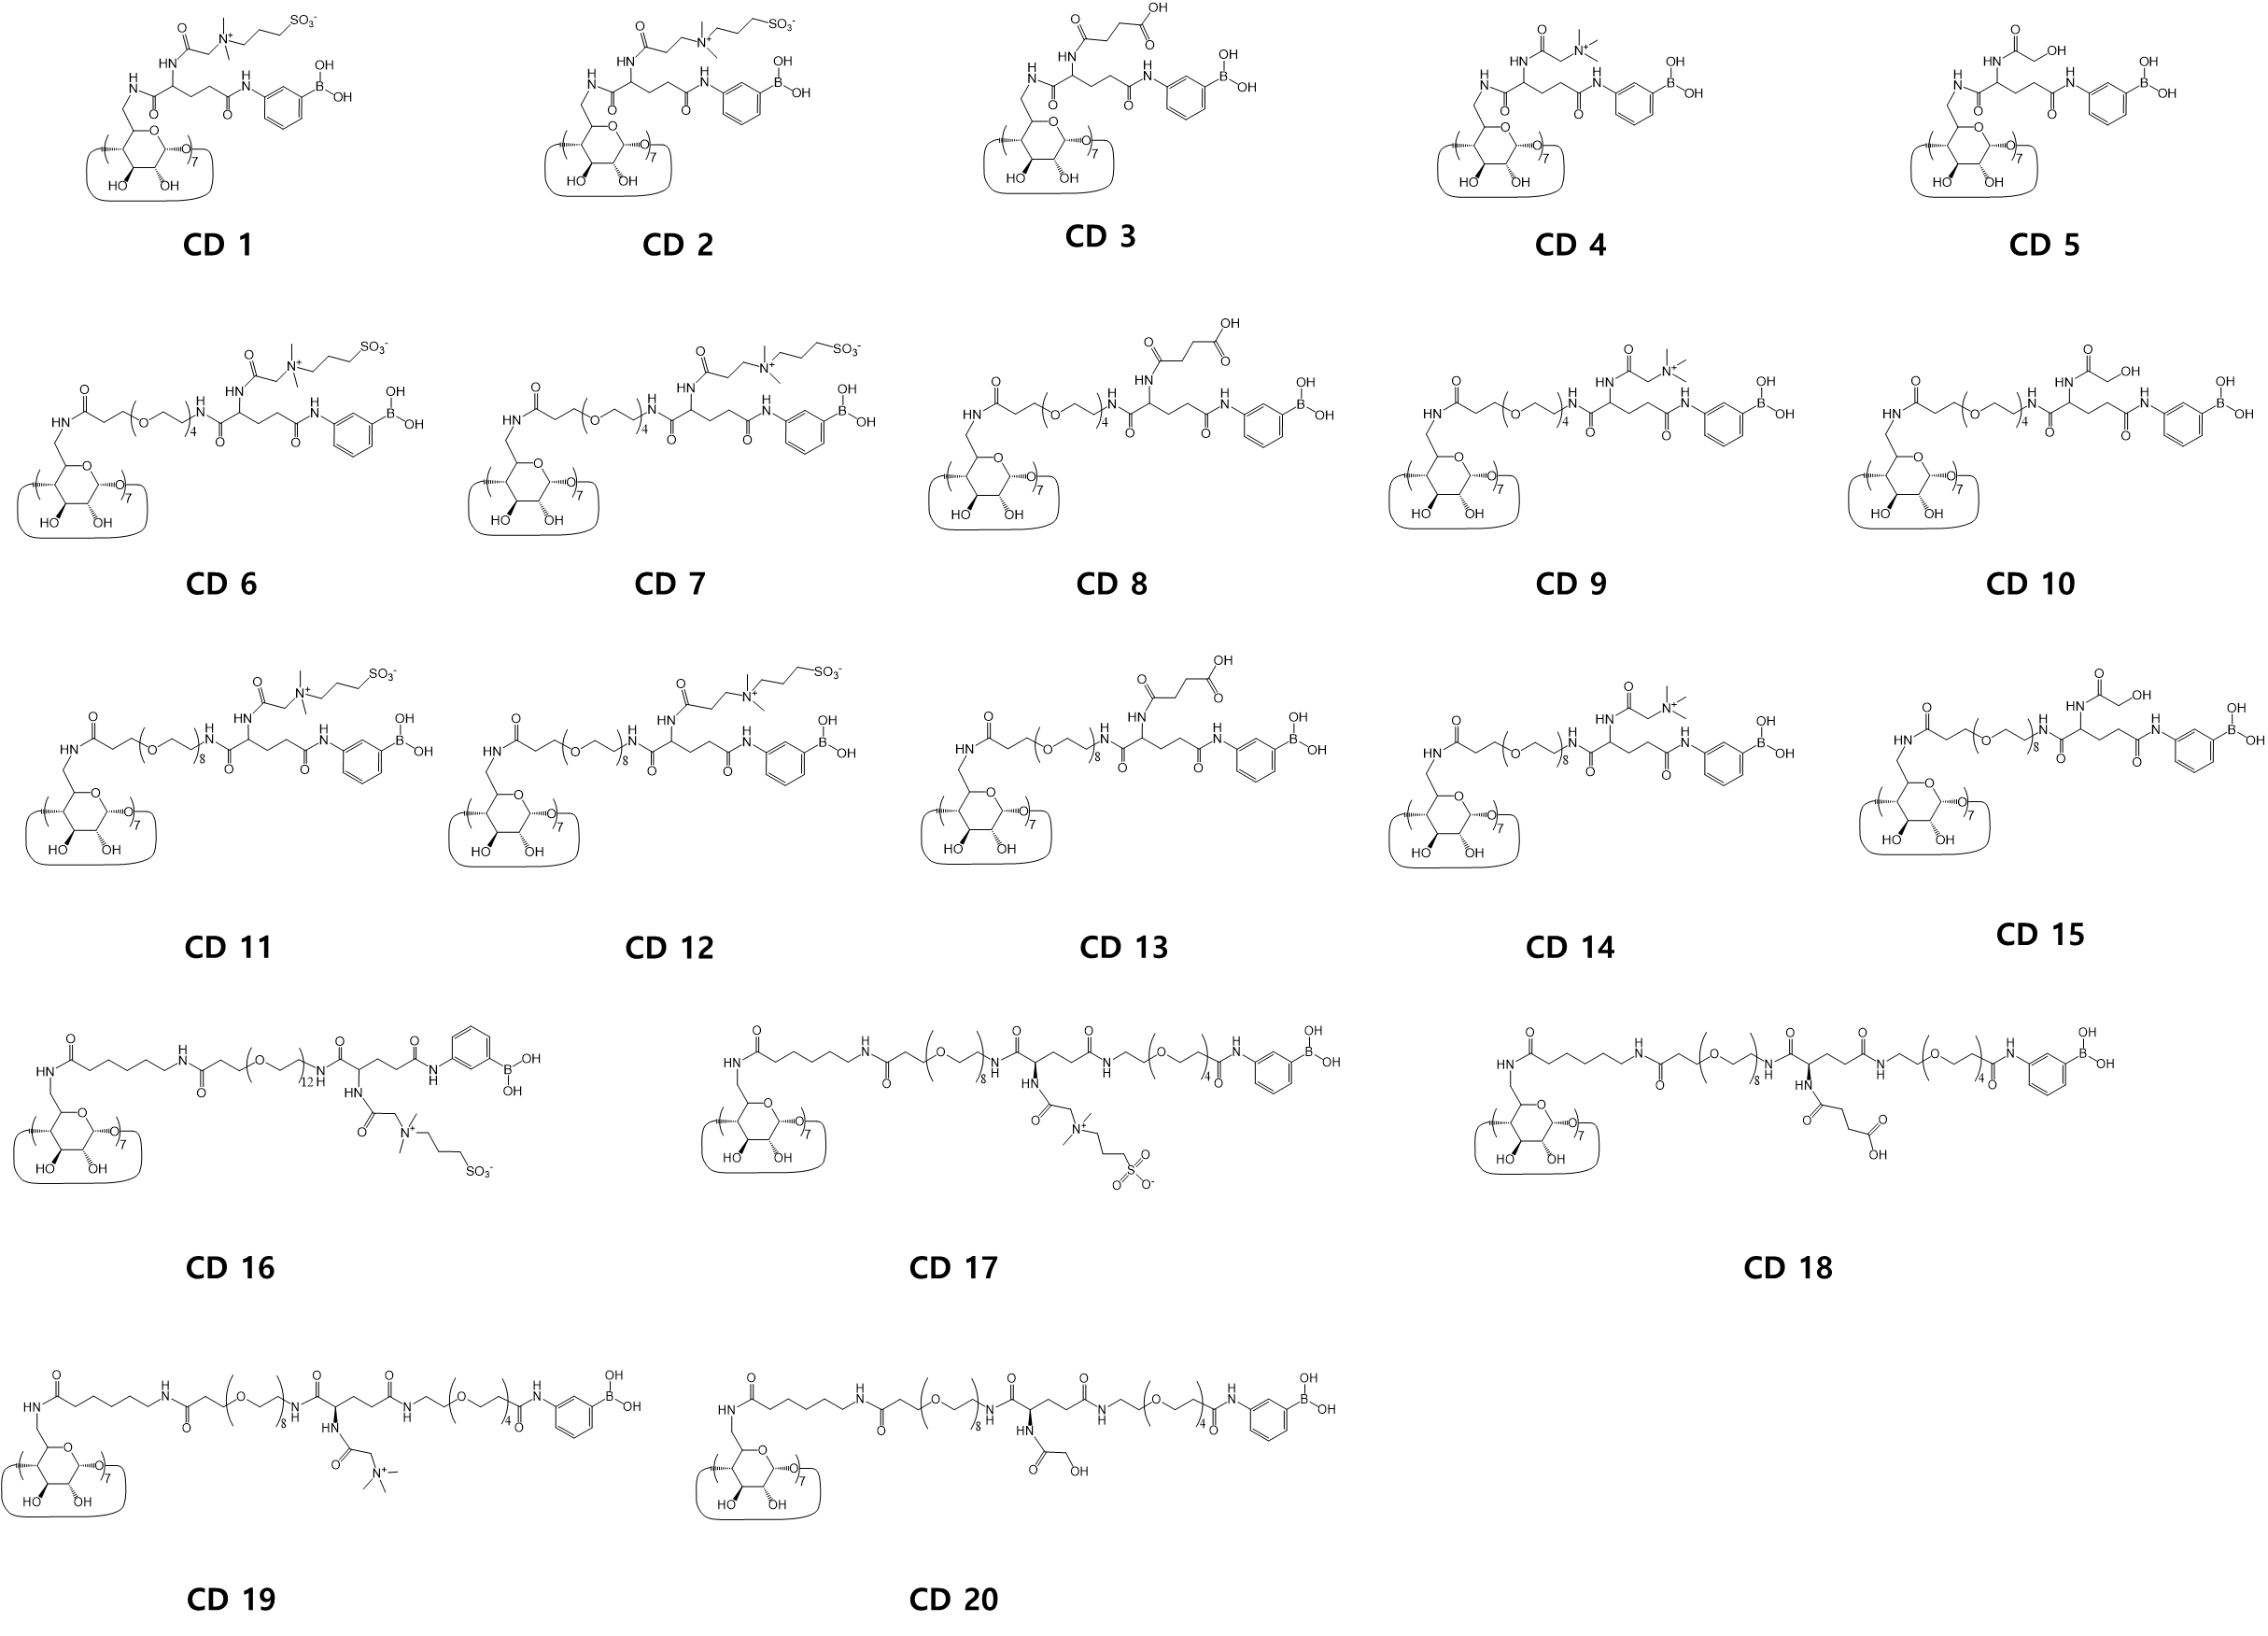
Figure 1A (magnified). Structures of cyclodextrin derivatives (CD 1–20) (cf. Figure 1 in the main text).

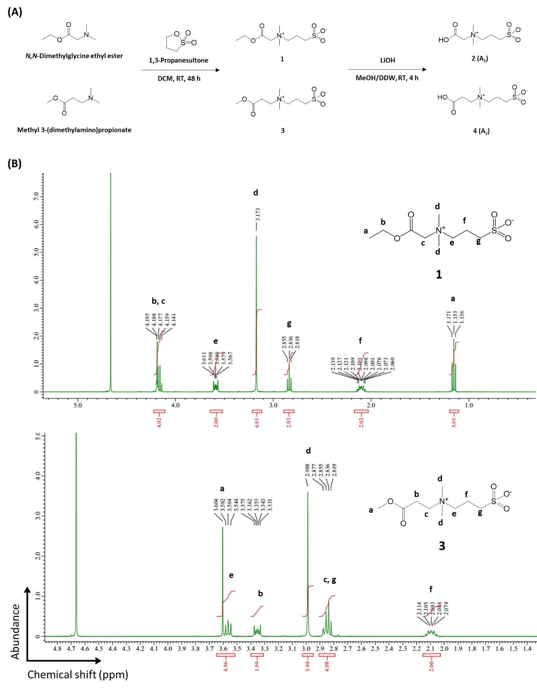

(Continued)
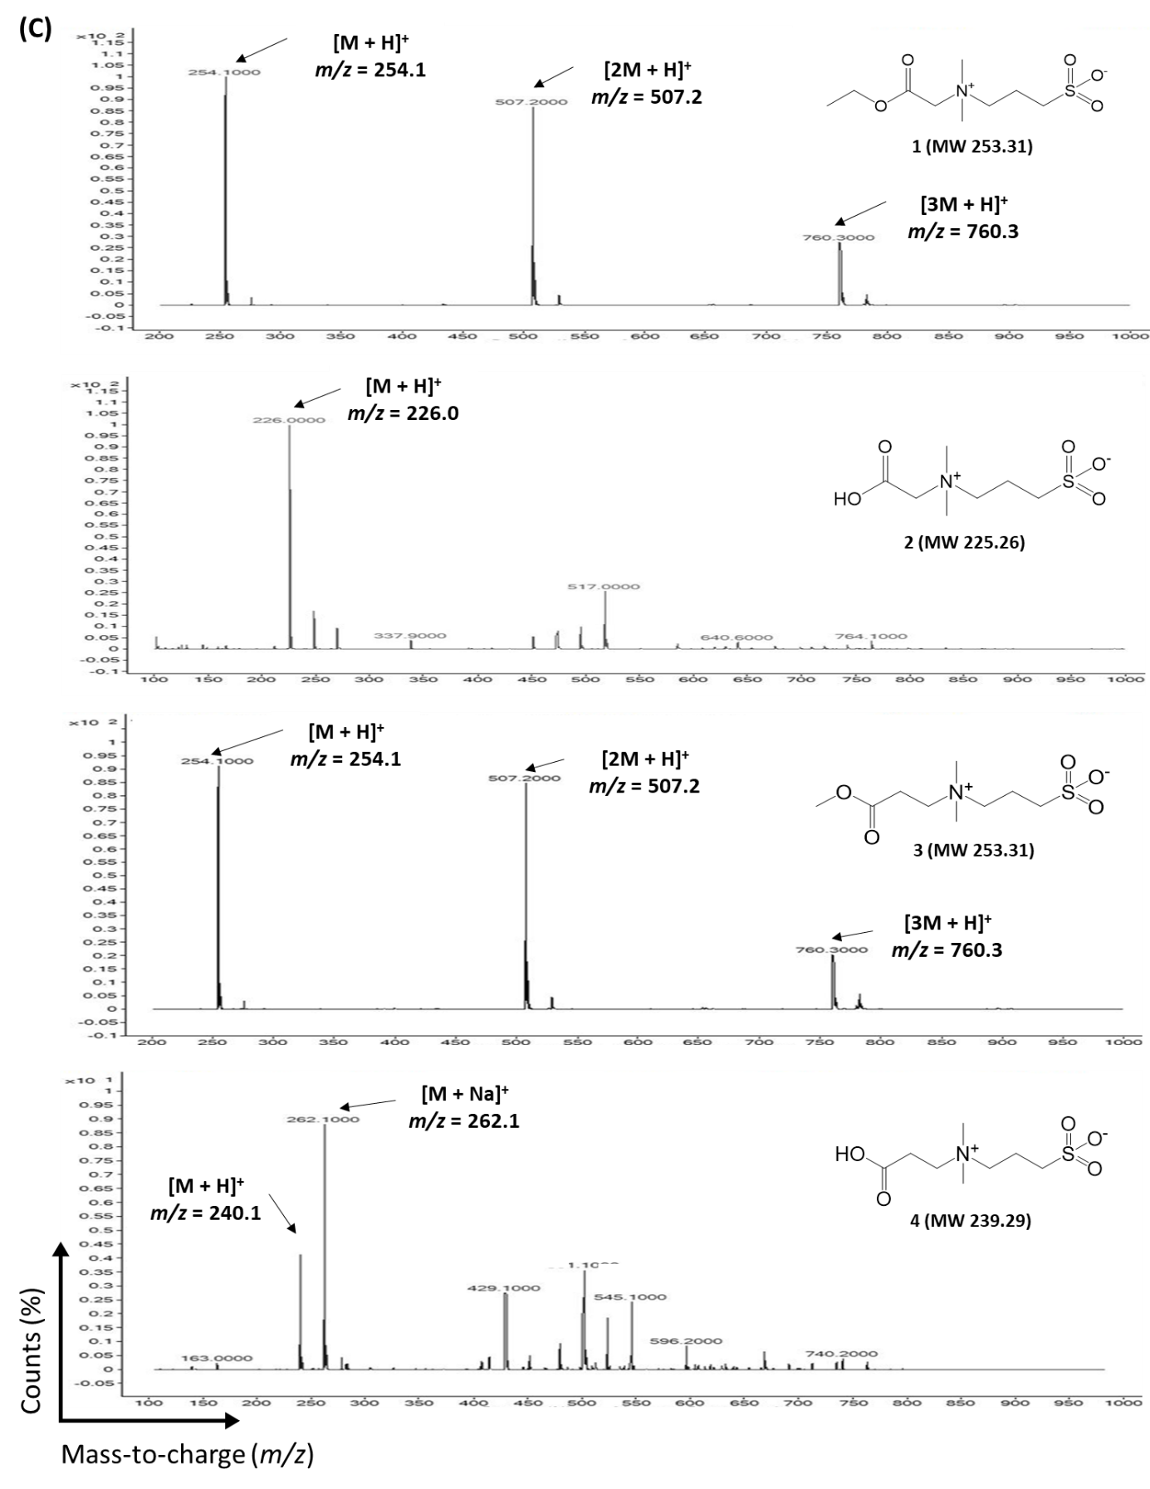
Figure S1. Synthesis of sulfobetaine 2 (A₁) and 4 (A₂) that have one and two methylene groups between quaternary ammonium and carboxylic acid, respectively. (A) Synthetic schemes of compounds 1–4, (B) Proton nuclear magnetic resonance (¹H-NMR) spectra of compounds 1 and 3, and (C) electrospray ionization-mass spectrometry (ESI-MS) spectra of compounds 1–4 are presented. Samples were dissolved in D₂O for ¹H-NMR analysis.

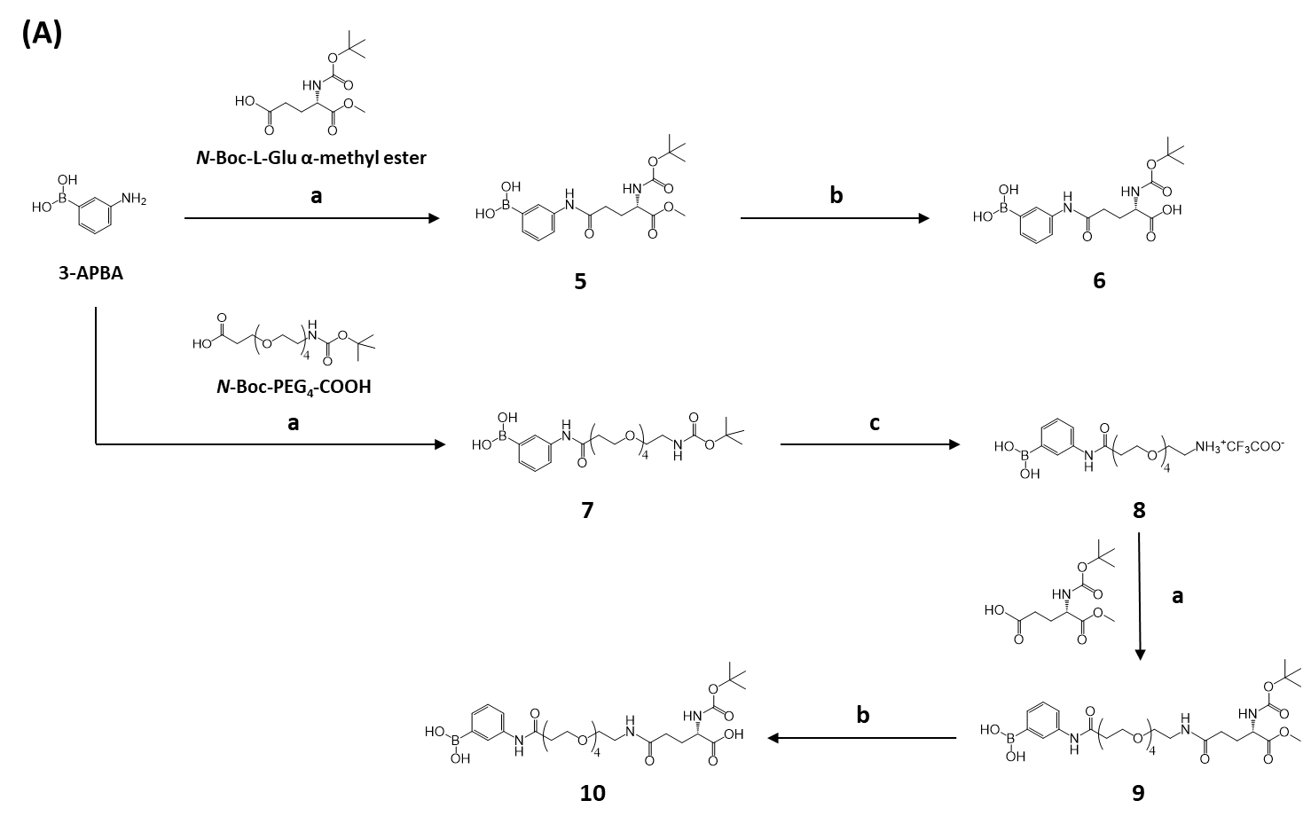

(Continued)
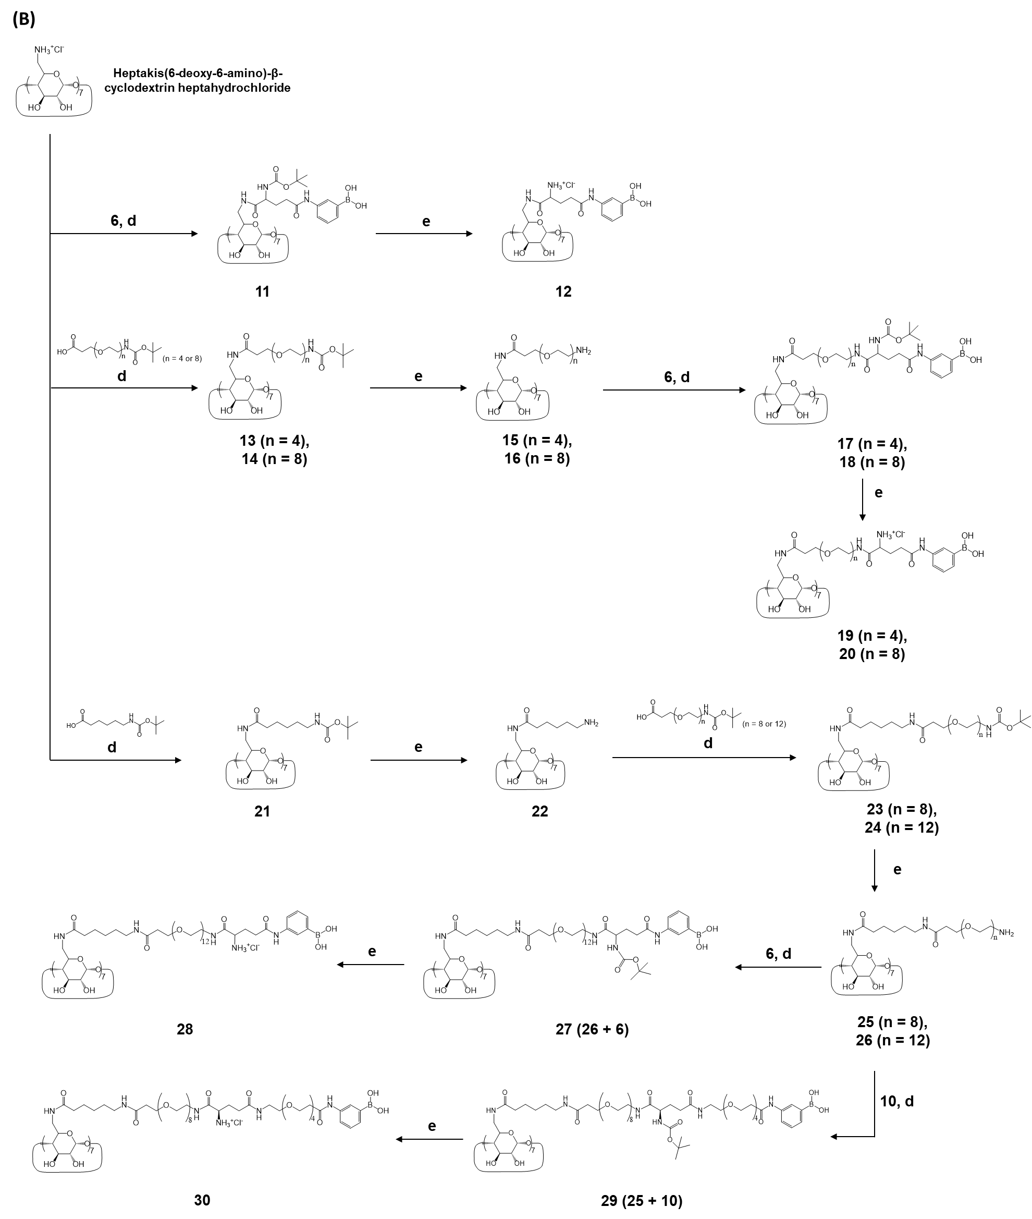

(Continued)
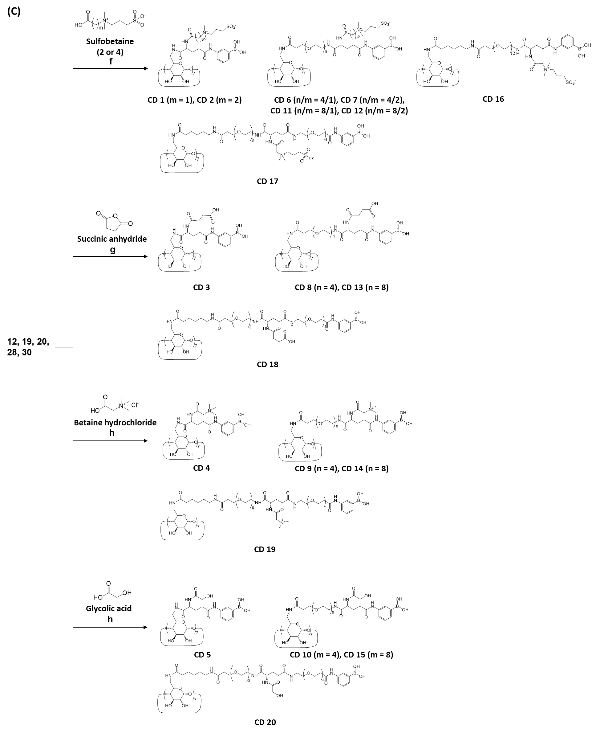
Figure S2. Synthetic schemes of cyclodextrin derivatives (CD 1–20). (A) Preparation of PBA moieties (compounds 6 and 10). (B) Synthesis of PBA-conjugated CD intermediates (compounds 12, 19, 20, 28, and 30). (C) Conjugation of charged moieties to CD intermediates to obtain CD 1–20. Reagents and conditions: a) N-([dimethylamino]-1H-1,2,3-triazolo-[4,5-b]pyridin-1-ylmethylene)-N-methylmethanaminium hexafluorophosphate N-oxide (HATU)/N,N-diisopropylethylamine (DIPEA) in N,N-dimethylformamide (DMF), room temperature (RT), 30 h; b) LiOH in MeOH/double-deionized water (DDW), RT, 4 h; c) Trifluoroacetic acid (TFA) in dichloromethane (DCM), RT, 1 h; d) O-(benzotriazol-1-yl)-N,N,N',N'-tetramethyluronium hexafluorophosphate (HBTU)/DIPEA in dimethyl sulfoxide (DMSO)/DMF, RT, 48 h; e) TFA/ACN, RT, 1.5 h; f) EDC/NHS in 2-(N-morpholino)ethanesulfonic acid (MES) buffer, 37 °C, 48 h; g) Triethylamine (TEA) in DMSO, RT, 48 h; and h) EDC/NHS/TEA in DMSO, RT, 48 h.
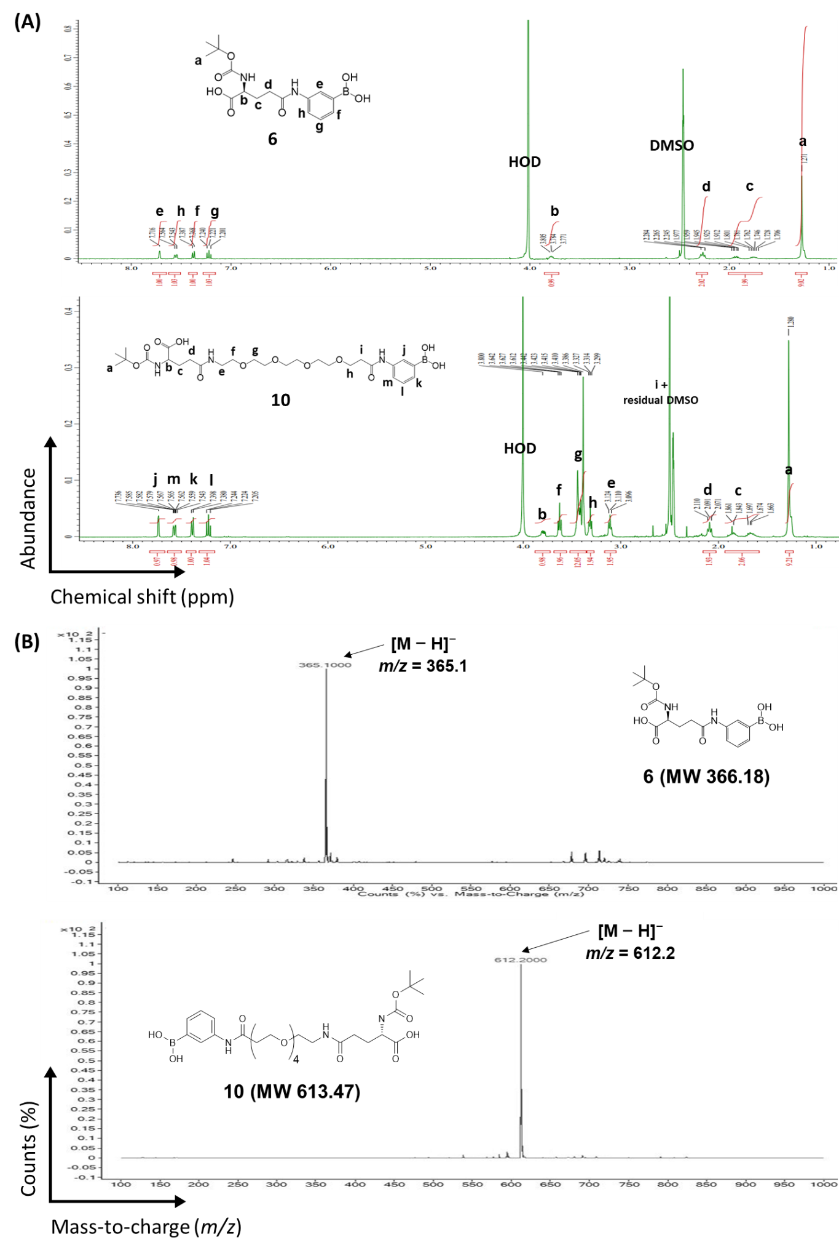
Figure S3. ¹H-NMR (A) and ESI-MS (B) spectra of compounds 6 and 10. Samples were dissolved in DMSO-d₆/D₂O for ¹H-NMR analysis.

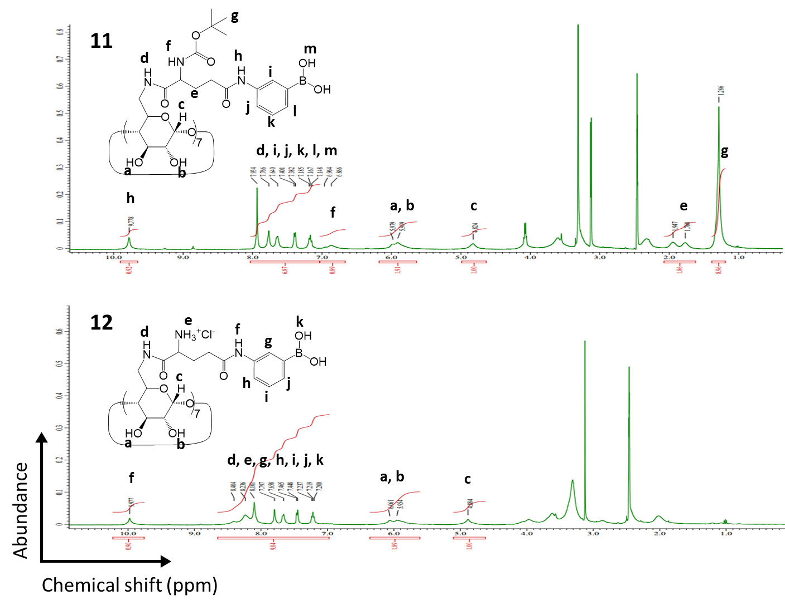
Figure S4. ¹H-NMR spectra of CD intermediates without spacers in the P2 position (compounds 11 and 12). Samples were dissolved in DMSO-d₆ for ¹H-NMR analysis.
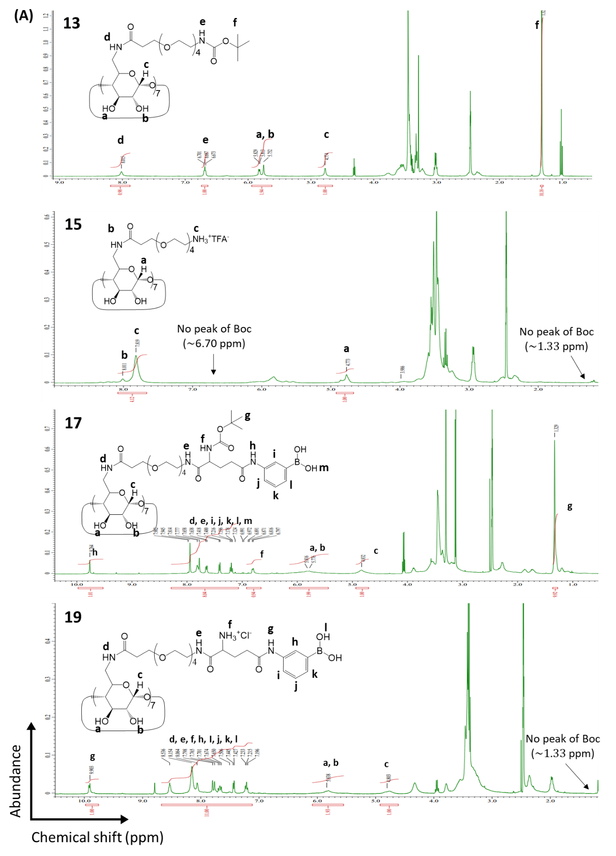
(Continued)

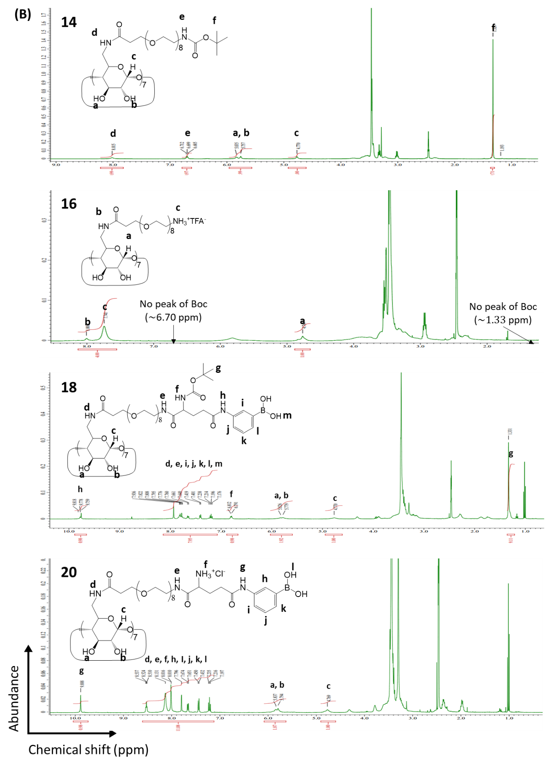
Figure S5. ¹H-NMR spectra of CD intermediates with PEG₄ (A; compounds 13, 15, 17, and 19) or PEG₈ (B; compounds 14, 16, 18, and 20) spacer in the P2 position. Samples were dissolved in DMSO-d₆ for ¹H-NMR analysis.
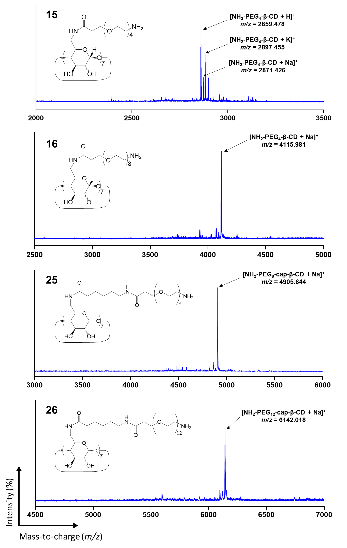
Figure S6. Matrix-assisted laser desorption/ionization time-of-flight (MALDI-TOF) spectra of CD intermediates conjugated with PEG (compounds 15 and 16) or caproic acid-PEG spacers (compounds 25 and 26) in the P2 position. Heptaconjugation of spacers was confirmed by the mass-to-charge ratio (m/z) of each CD derivative.
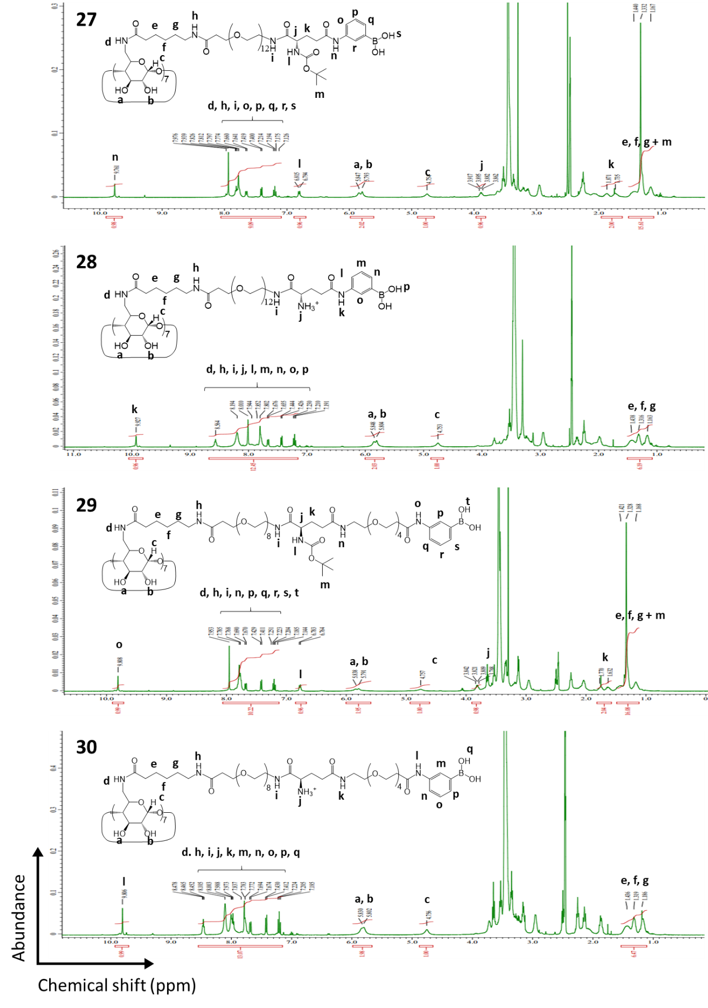
Figure S7. ¹H-NMR spectra of CD intermediates with the caproic acid-PEG spacer in the P2 position (compounds 27, 28, 29, and 30). Samples were dissolved in DMSO-d₆ for ¹H-NMR analysis.
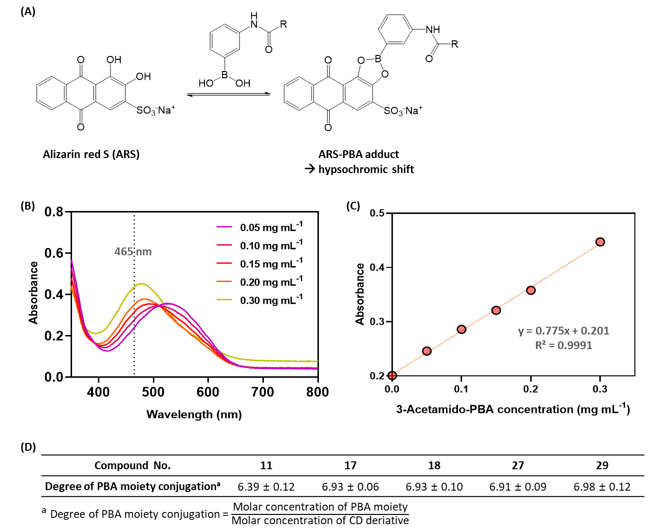
Figure S8. (A) Degree of PBA moiety conjugation was determined based on alizarin red S (ARS)–PBA moiety interaction. (B) Upon increasing PBA concentration, the absorption spectrum of ARS was blue-shifted by forming the ARS–PBA adduct. (C) A linear relationship was observed between the ARS absorbance at 465 nm and standard (3-acetamido-PBA) concentration within 0.05–0.30 mg mL^{–1}. (D) Degree of PBA moiety conjugation of compounds 11, 17, 18, 27, and 29 was approximately 7, indicating heptaconjugation of CD arms.

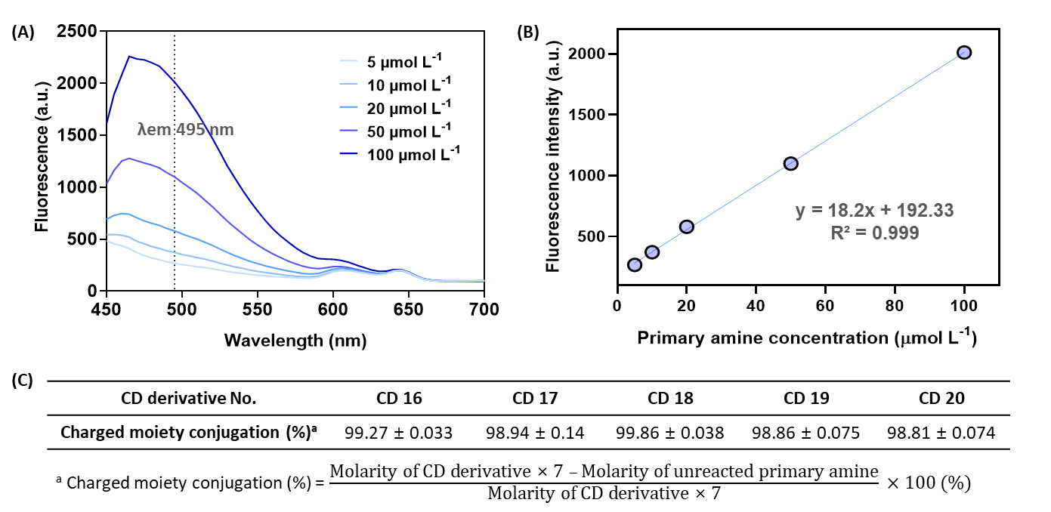
Figure S9. Percentage of charged moiety conjugation was determined by quantifying the residual amines via fluorescamine assay. (A) Fluorescence spectra of fluorescamine at various concentrations of l-serine (5–100 μmol L^{–1}). (B) Calibration curve was obtained by measuring the fluorescence intensity at λex/λem of 395/495 nm. (D) Charged moiety conjugation of CD 16–20 was higher than 98.8%, indicating complete conjugation.
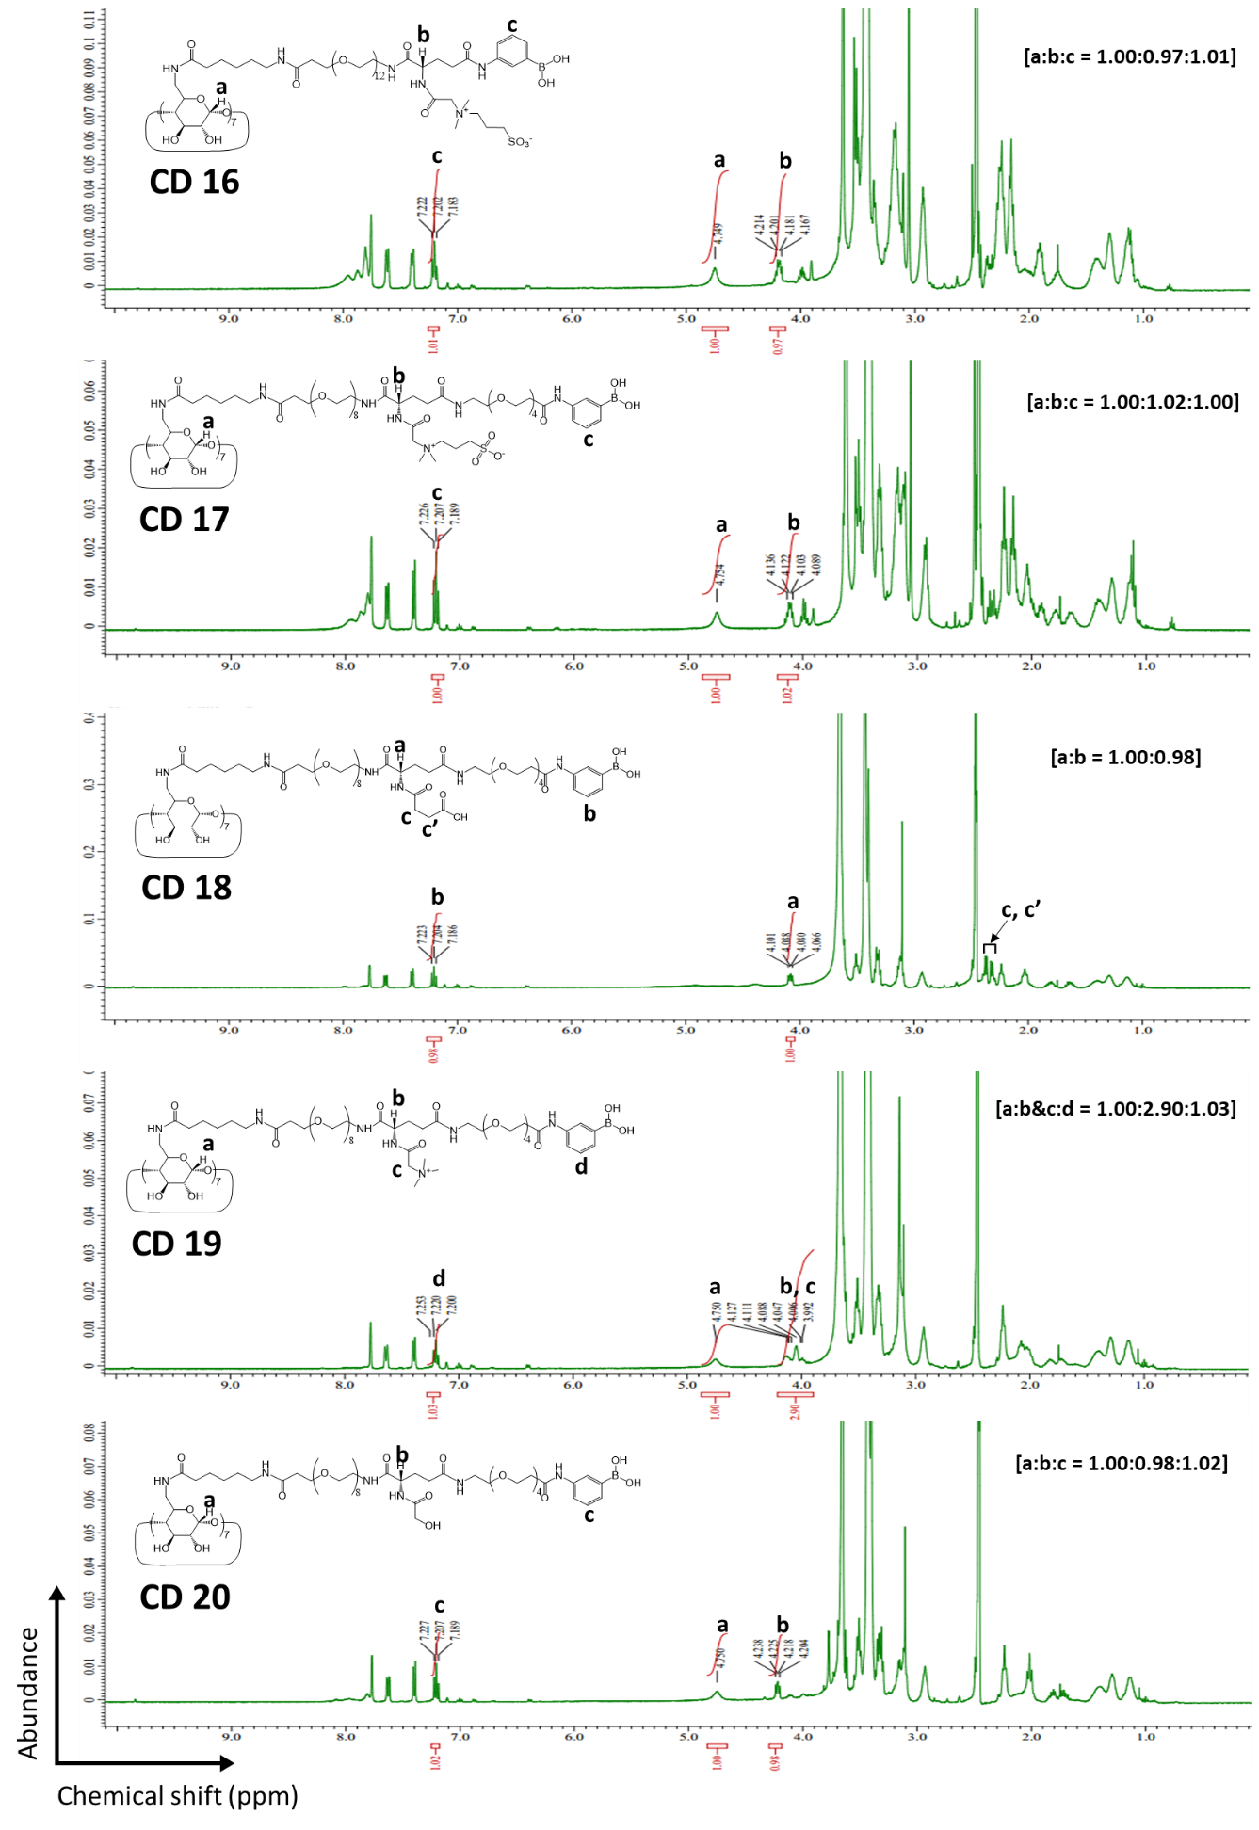
Figure S10. ¹H-NMR spectra of CD16–20. Samples were dissolved in DMSO-d₆/D₂O (9:1, v/v). Signal of Glu α-position proton appeared at 4.1–4.2 ppm.

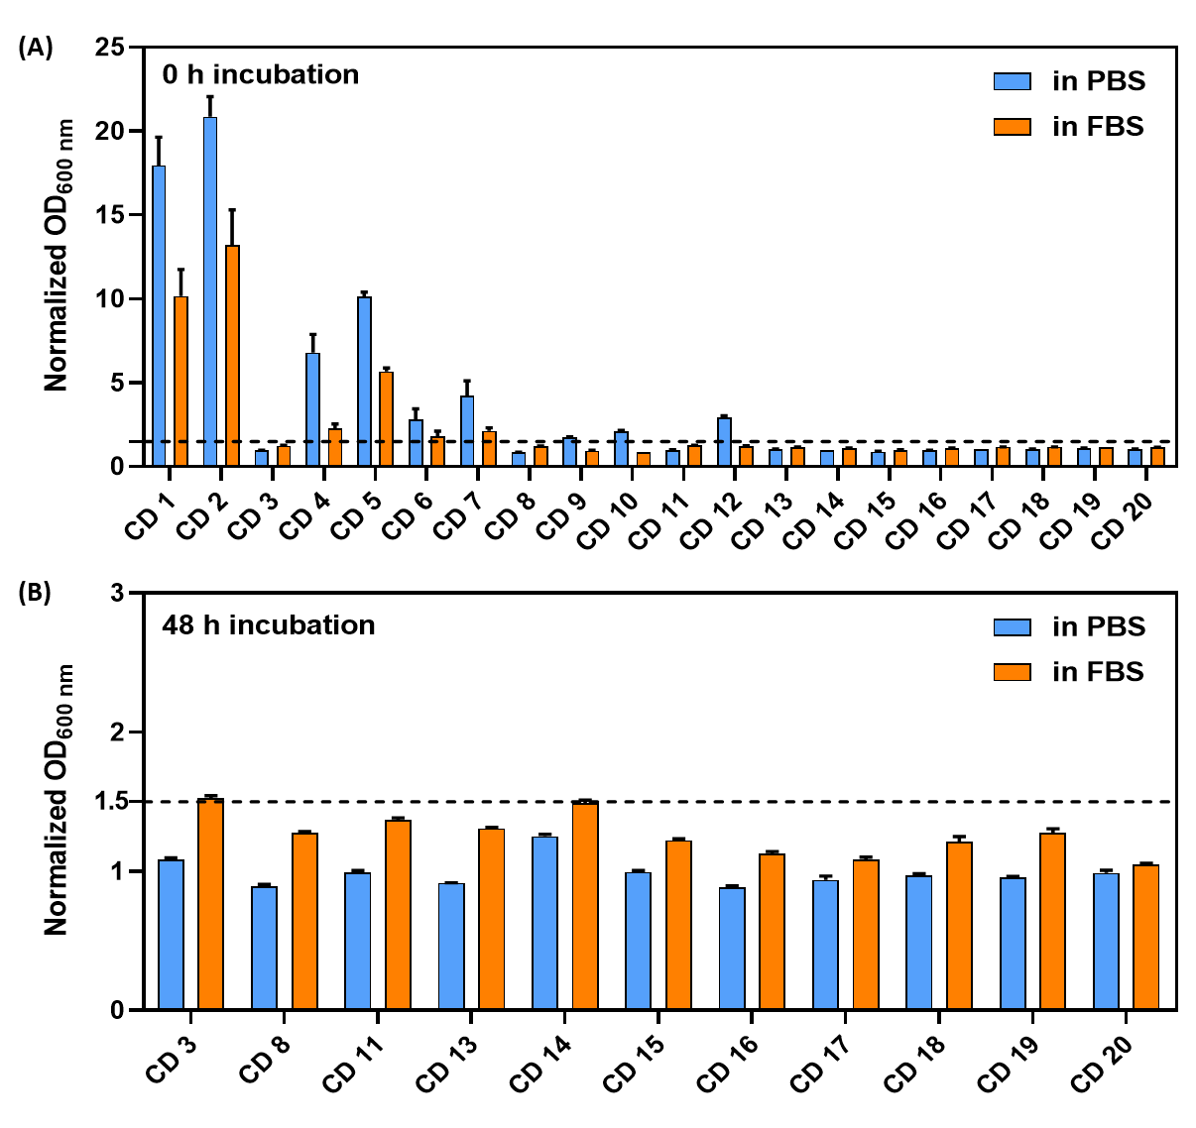
Figure S11. Solubility screening of CD derivatives via turbidimetric analysis. Normalized absorbance values at 600 nm (OD_{600 nm}) of CD derivatives were measured after 0 (A) or 48 (B) h incubation in phosphate-buffered saline (PBS) or fetal bovine serum (FBS) at CD 1–20 concentration of 1 mmol L^{–1}. Cut-off value of OD_{600 nm} for judging precipitation or aggregation was set to 1.5 (dashed line).

S2.2. Biodistribution of CD Derivatives
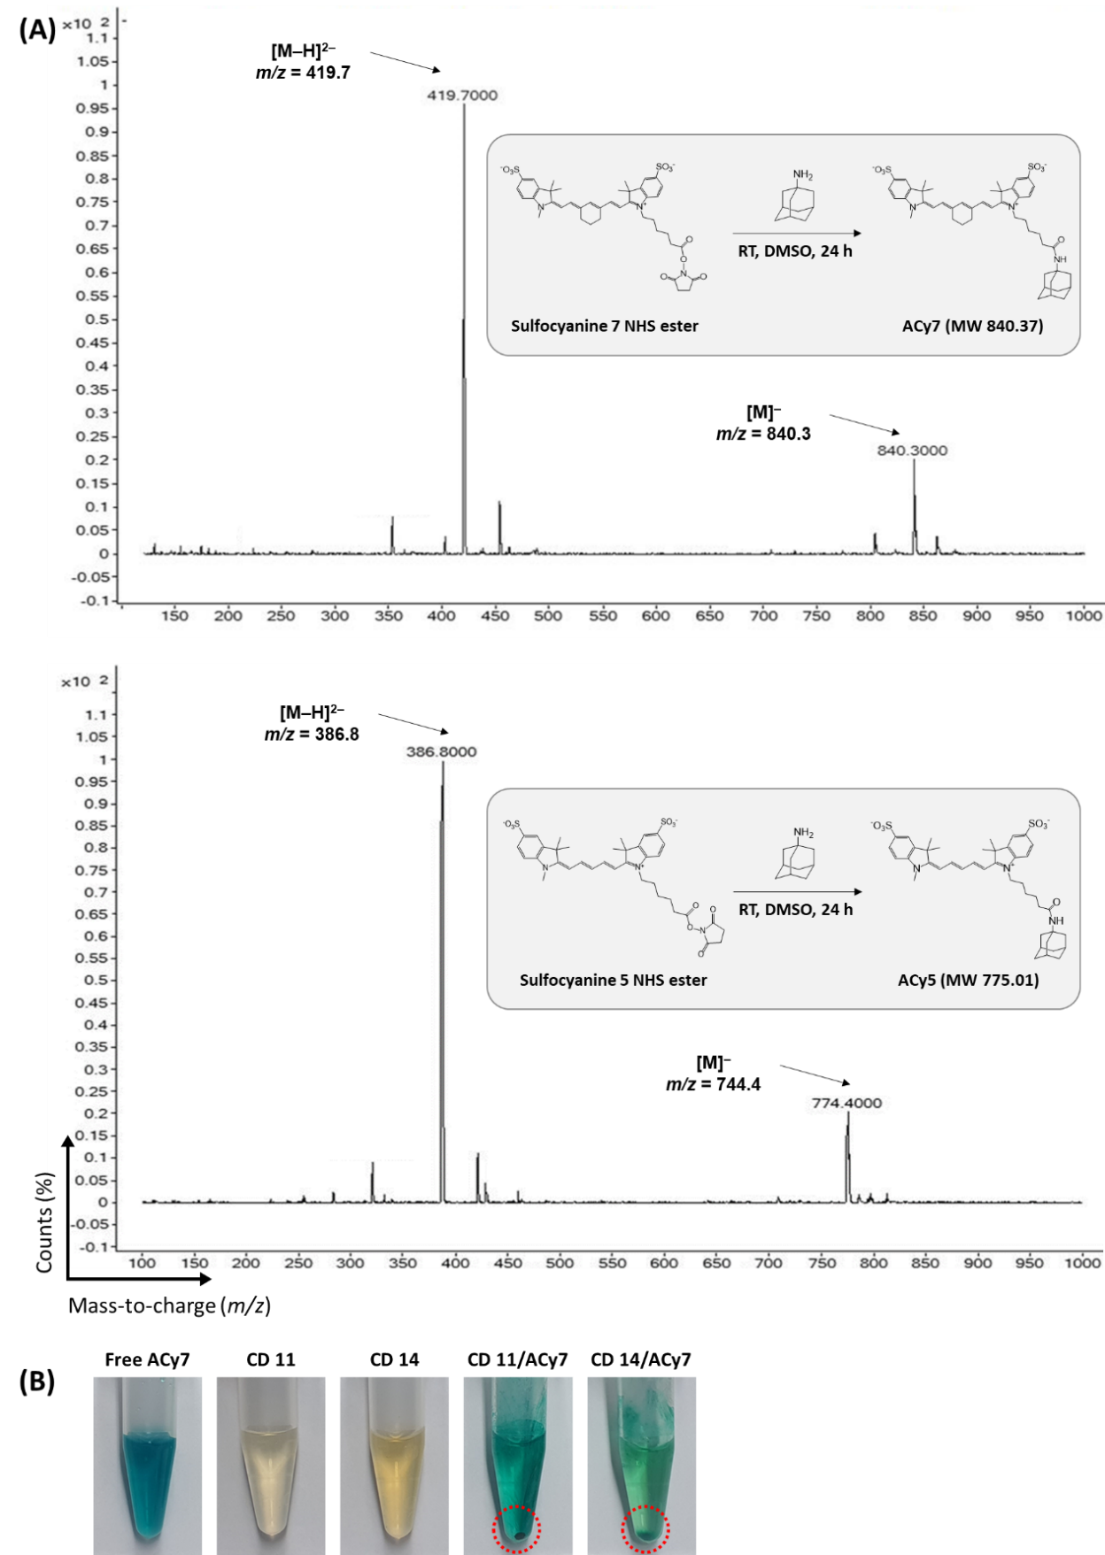
Figure S12. (A) Synthetic schemes and ESI-MS spectra of adamantyl sulfocyanine (Acy)-7 and ACy5. (B) Visual appearance of free ACy7, CD 11, CD 14, and their inclusion complexes. Both CD 11 and 14 exhibited precipitation in the presence of ACy7 (dashed circles). Concentrations of ACy7 and CD derivatives were both 200 µmol L^{–1} in all samples.
S2.3. Tumor Targetability, Pharmacokinetics, and Urinary Excretion of PBA-(ZW)-CD/ACy7
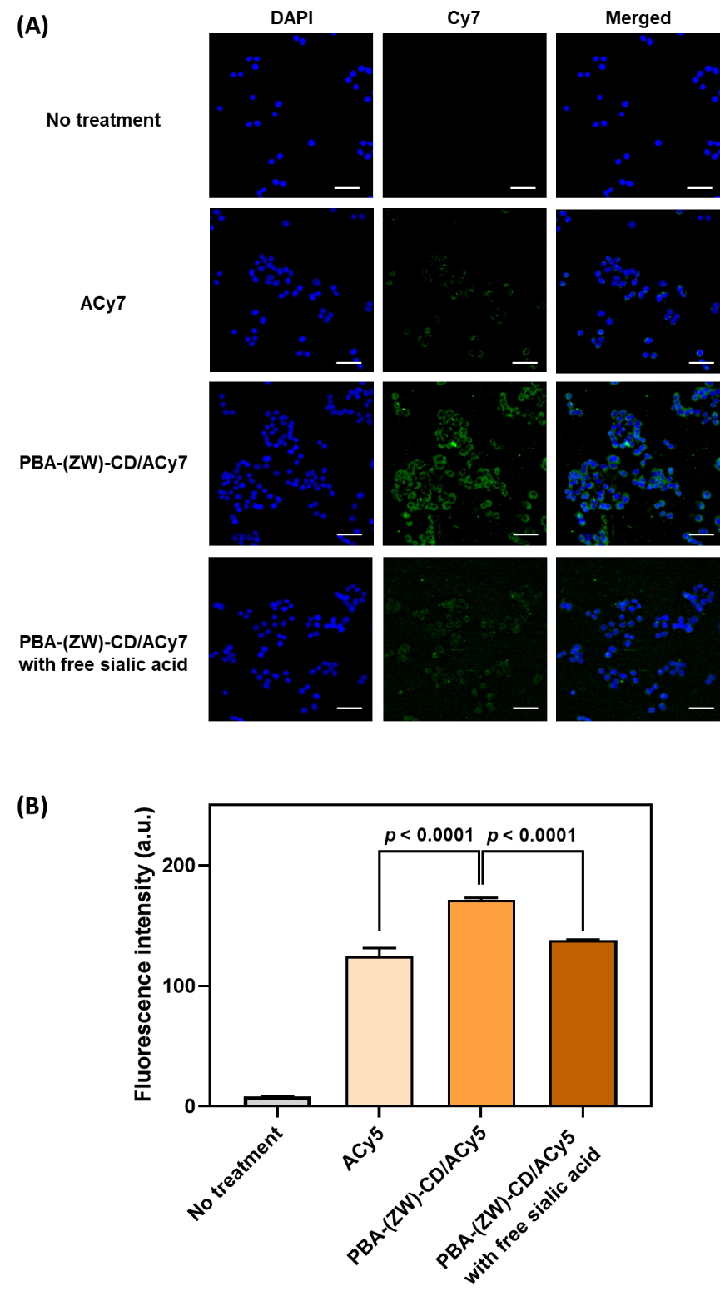
Figure S13. Cellular uptake of PBA-(ZW)-CD inclusion complexes. (A) Fluorescence images of HT-29 cells after 2 h incubation with ACy7 or PBA-(ZW)-CD/ACy7 at an ACy7 concentration of 10 µmol L^{–1}. The length of the scale bar is 50 µm. (B) Flow cytometry analysis of HT-29 cells incubated with ACy5 or PBA-(ZW)-CD/ACy5 for 2 h at an ACy5 concentration of 10 µmol L^{–1}. Free sialic acid (500 µmol L^{–1}) was used in both assays as a competitive inhibitor for PBA–sialic acid interaction.

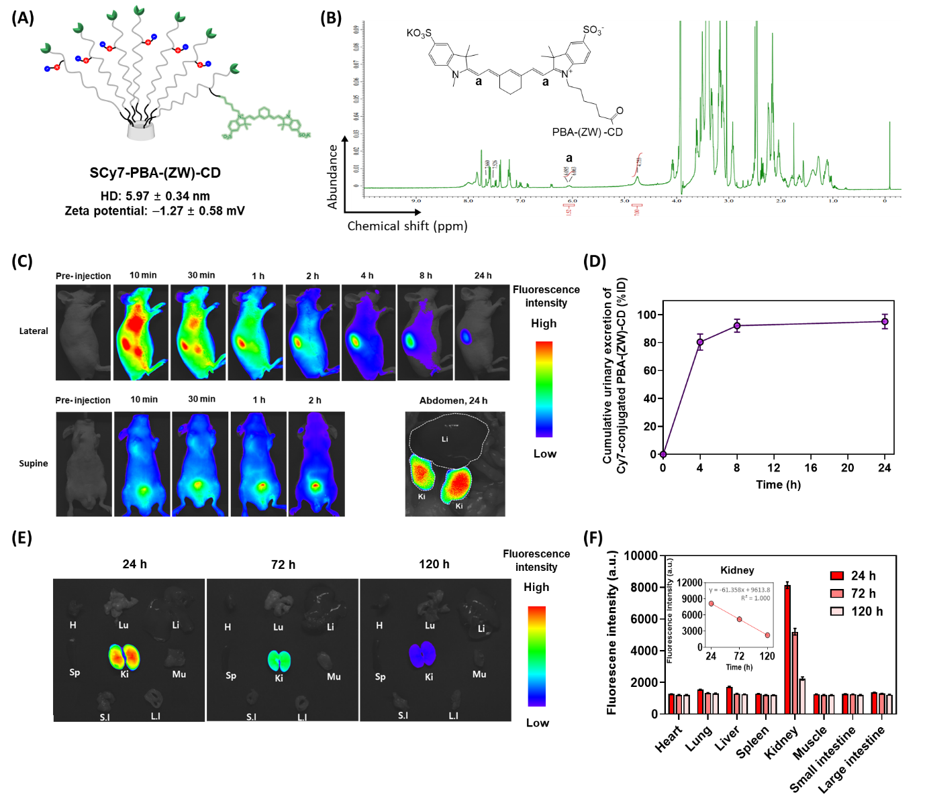
Figure S14. Real-time tracing of PBA-(ZW)-CD after intravenous injection. SCy7-NHS (1 equiv.) was conjugated to one arm of compound 30, and sulfobetaine was conjugated to the remaining six arms following the method described in section S1.2 to obtain a SCy7-conjugated CD 17 derivative (SCy7-PBA-(ZW)-CD). (A) SCy7-PBA-(ZW)-CD displayed hydrodynamic diameter (HD) and zeta potential values comparable to those of PBA-(ZW)-CD. (B) ¹H-NMR analysis of SCy7-PBA-(ZW)-CD was performed in DMSO-d₆/D₂O (9:1, v/v). (C) SCy7-PBA-(ZW)-CD (1 µmol kg^{–1}) was intravenously administered to male BALB/c nude mice (5 weeks old), and near-infrared fluorescence (NIRF) imaging was performed according to the method described in section S1.3. In lateral view images, as the whole-body fluorescence signals gradually decreased, the kidney signals became dominant. Meanwhile, supine view images revealed that the fluorescence intensity gradually increased in the bladder, implying the renal excretion of SCy7-PBA-(ZW)-CD. (D) Cumulative urinary excretion of SCy7-PBA-(ZW)-CD exceeded 80% of the initial dose (ID) within 4 h, reaching 95.2 ± 5.2% ID at 24 h, suggesting the preferential renal clearance of PBA-(ZW)-CD. (E) In an ex vivo imaging study, the SCy7-PBA-(ZW)-CD signal was mainly observed in the kidneys with negligible signals (i.e., autofluorescence level) detected in other organs, including the lungs, liver, and spleen at 120 h. Abbreviations: H, heart; Lu, lungs; Li, liver; Sp, spleen; Mu, muscles; S.I, small intestine; L.I, large intestine; and Ki, kidneys. (F) Kidney signals also decreased linearly (fluorescence intensity (a.u.) = –61.4 × elapsed time (h) + 9613.8; R² = 1.000), expected to reach the autofluorescence level within 136.3 h. Collectively, these results indicate that PBA-(ZW)-CD structure can evade mononuclear phagocyte system uptake (reduced distribution to the liver, lungs, and spleen), minimize the non-specific tissue binding, and be readily excreted via kidneys.

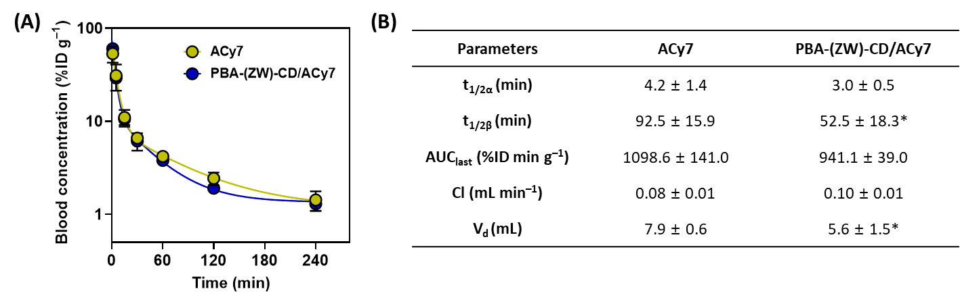
Figure S15. Pharmacokinetic study of PBA-(ZW)-CD/ACy7 inclusion complex. (A) ACy7 blood concentration versus time profiles and (B) pharmacokinetic parameters of free ACy7 and PBA-(ZW)-CD/ACy7 after intravenous administration at an ACy7 dose of 1 μmol kg^{–1}. Data are presented as the mean ± standard deviation (SD; n = 4, *p < 0.05). Abbreviations: t_{1/2α}, distribution half-life; t_{1/2β}, elimination half-life; AUC_{last}, Area under the curve from time 0 to the time of the last sampling; Cl, total body clearance; and V_{d}, volume of distribution.

S2.4. PBA-(ZW)-CD/Drug-Assisted Single-Drug and Combination Therapies in HT-29 Xenograft Model

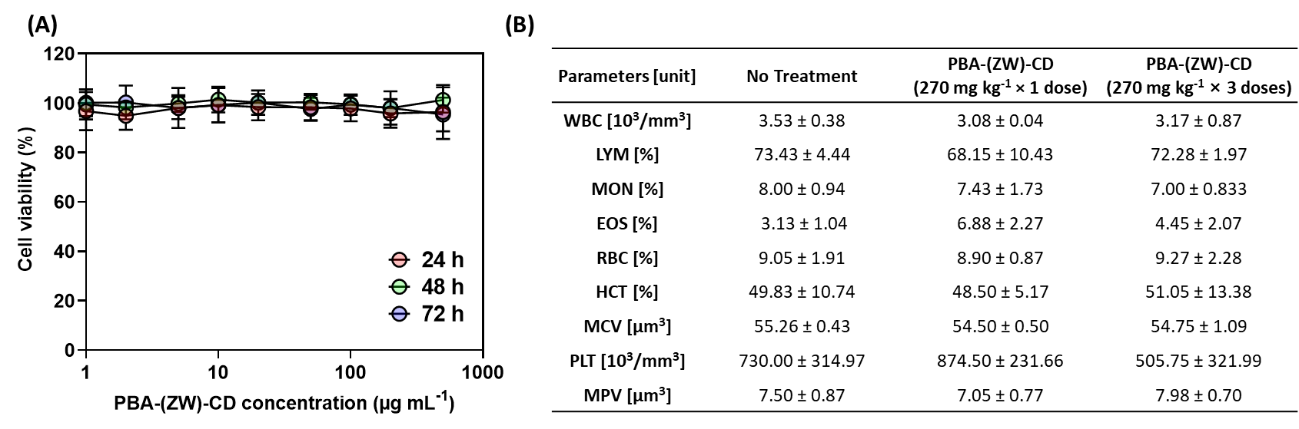
Figure S16. In vitro and in vivo toxicity studies of blank PBA-(ZW)-CD. (A) HT-29 cell viability after 24, 48, and 72 h incubation with PBA-(ZW)-CD at various concentrations (1–500 μg mL⁻¹). (B) Complete blood counts of male BALB/c mice (5 weeks old) after intravenous administration of excess PBA-(ZW)-CD (270 mg kg^{–1} day^{–1}, once or three times daily). Data are presented as the mean ± SD (n = 4). Abbreviations: WBC, white blood cell count; LYM, lymphocyte; MON, monocyte; EOS, eosinophil; RBC, red blood cell count; HCT, hematocrit; MCV, mean corpuscular volume; PLT, blood platelet count; and MPV, mean platelet volume.

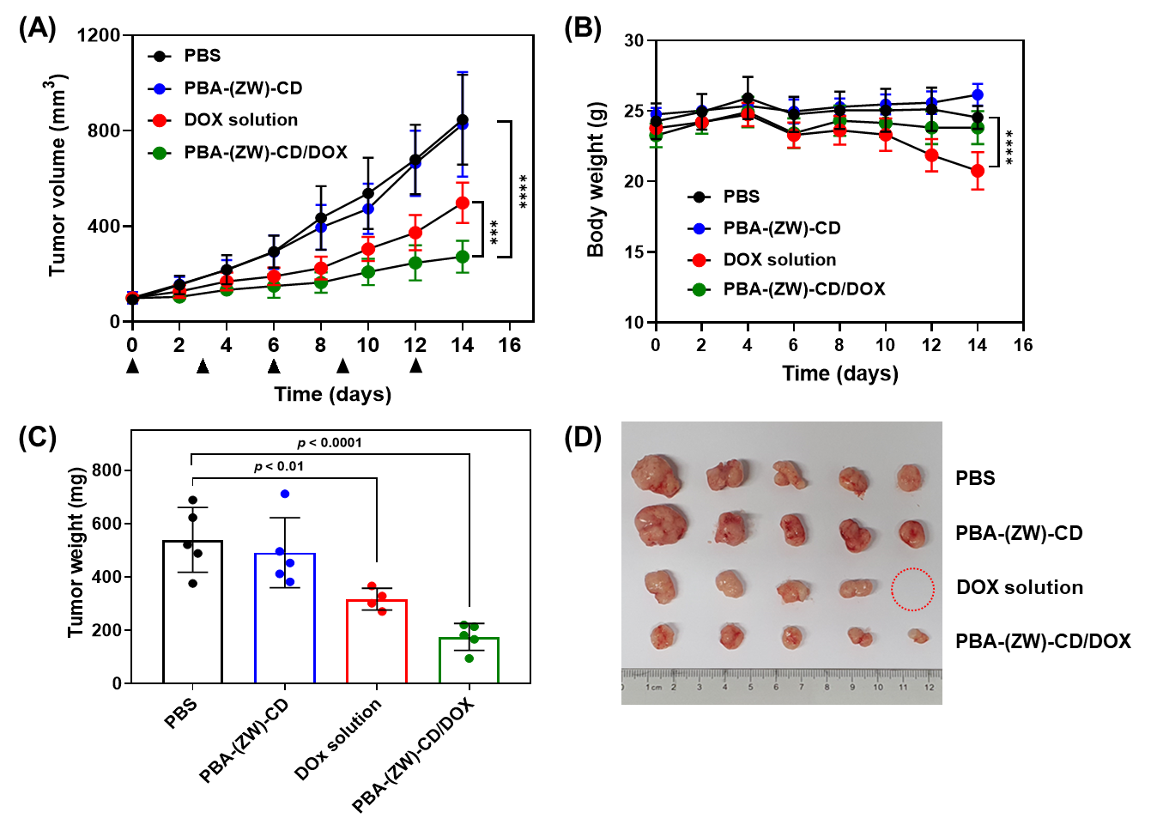
Figure S17. PBA-(ZW)-CD/doxorubicin (DOX)-assisted single-drug therapy in heterotopic HT-29 xenograft mice (n = 5). (A) Tumor growth profiles over 14 d. PBS, blank PBA-(ZW)-CD, DOX solution, or PBA-(ZW)-CD/DOX (as DOX, 5 mg kg^{–1}) was administered intravenously every three days. (B) Body weight of each mouse was monitored during the experimental period. (C) On day 14, the tumor tissues of mice were resected and weighed. (D) Digital images of excised tumors. One mouse of the DOX solution group died on day 12 (red circle). ***p < 0.005 and ****p < 0.001.

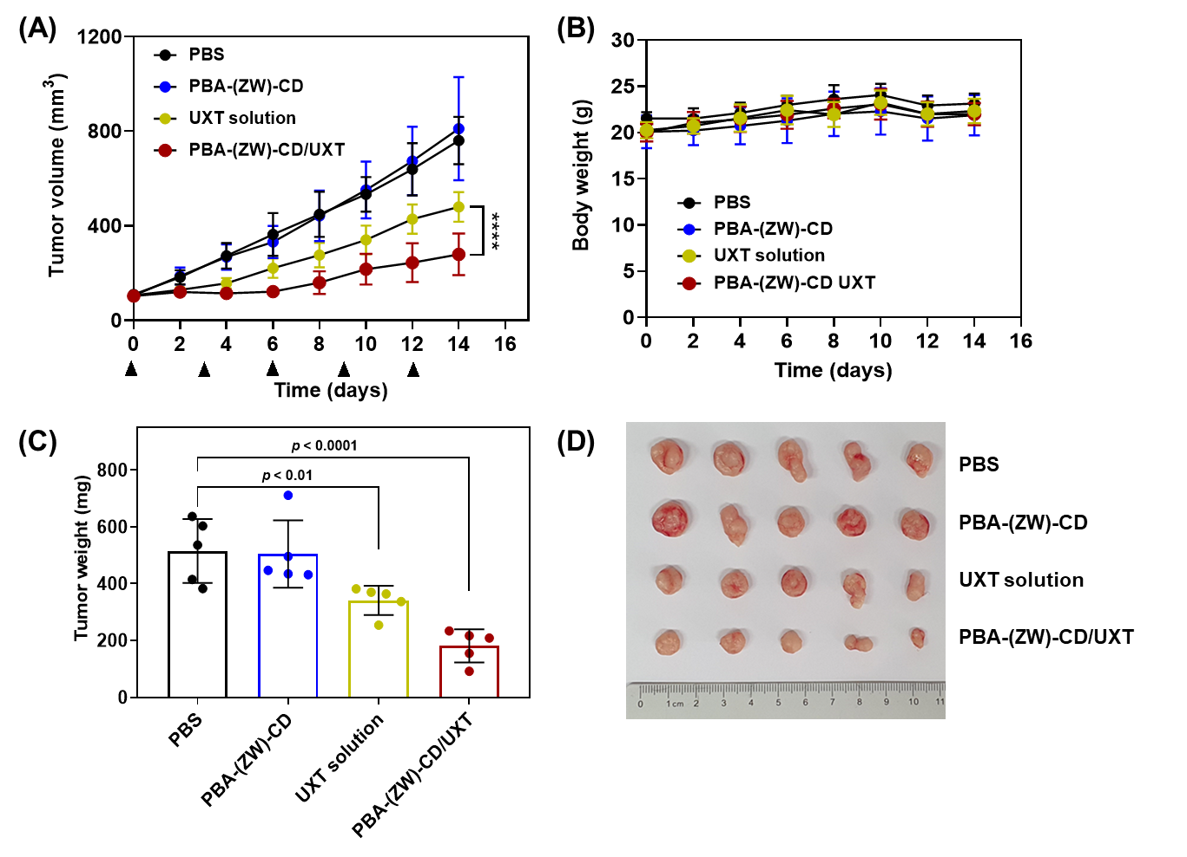
Figure S18. PBA-(ZW)-CD/UXT-based single-drug therapy in heterotopic HT-29 xenograft mice (n = 5). (A) Tumor growth profiles over 14 d. PBS, blank PBA-(ZW)-CD, UXT solution, or PBA-(ZW)-CD/UXT was intravenously administered at a UXT dose of 5 mg kg^{–1} every three days. (B) Body weight of each mouse was monitored every other day. (C) On day 14, the tumor tissues of mice were resected and weighed. (D) Digital images of excised tumors. ****p < 0.001.

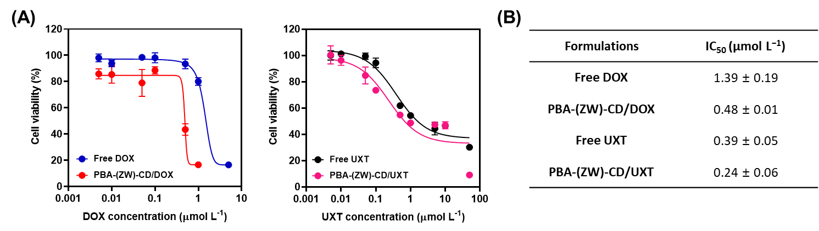
Figure S19. In vitro antitumor efficacies of free drug and PBA-(ZW)-CD/drug inclusion complexes in HT-29 cells. (A) Cell viability profiles at 48 h incubation and (B) corresponding half-maximal inhibitory concentration (IC₅₀) values are presented. Data are presented as the mean ± SD (n = 6).

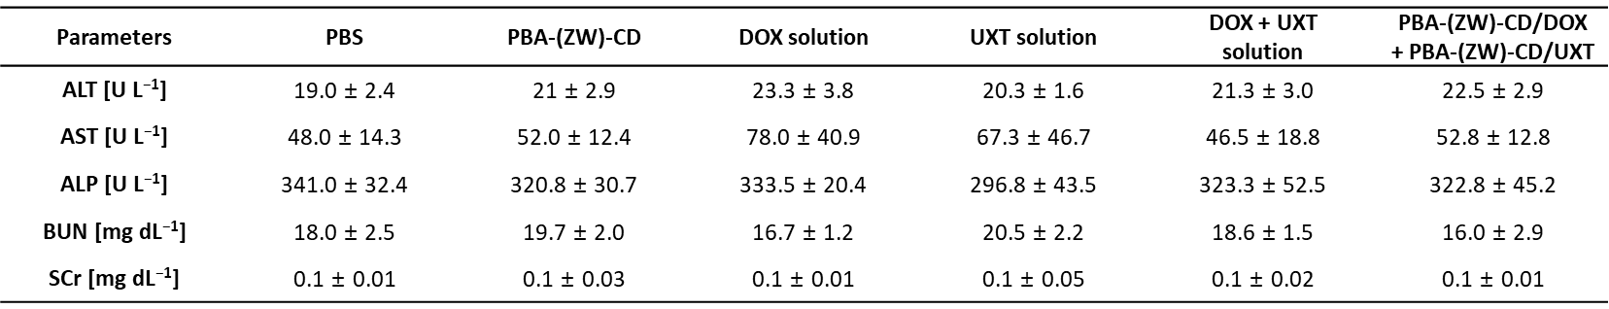
Figure S20. Blood biochemistry parameters after five rounds of treatment (as drug, 3 mg kg^{–1} for each) (refer to Figure 5A). Data are presented as the mean ± SD (n = 8). Abbreviations: ALT, alanine transaminase; AST, aspartate transaminase; ALP, alkaline phosphatase; BUN, blood urea nitrogen; and SCr, serum creatinine.

