SUPPLEMENTARY FIGURES

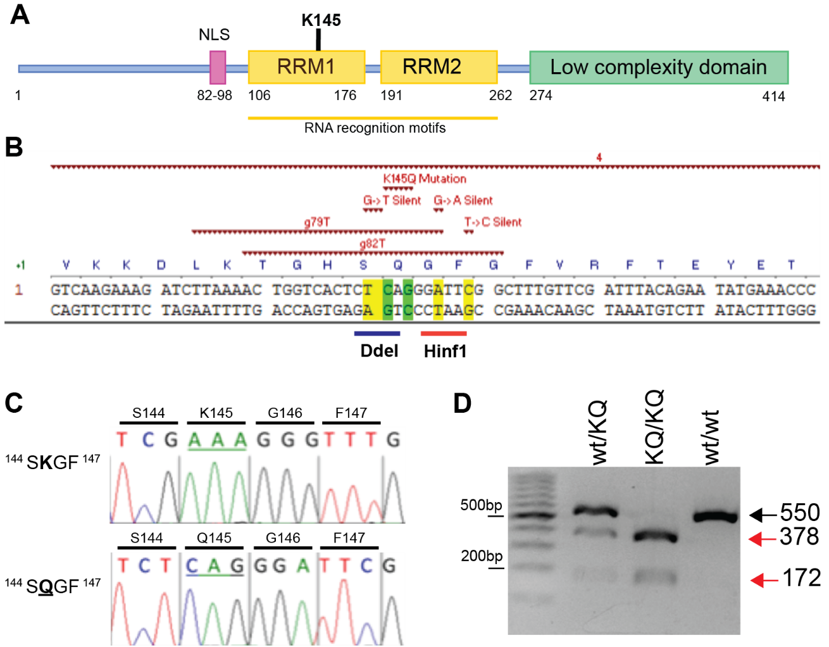
Figure 2 - Figure supplement 1: Generation, characterization, and genotyping of TDP-43^{K145Q} knock-in mice
A A schematic of the TDP-43 protein and its functional domains highlights the location of lysine 145 (K145) in the TDP-43 RNA-binding domain (RRM1). B Schematic of mouse Tardbp gene targeted with a validated guide RNA, g79T above, along with donor nucleotides to insert the K145Q mutation. Two silent mutations were included to create a Hinf1 enzyme digestion site to facilitate genotyping. C Chromatograph following Sanger sequencing confirms the inserted K145Q mutation in founder animals and subsequently propagated generations. D Gel electrophoresis of DNA fragments produced following PCR amplification of the modified Tardbp region and subsequent incubation of the PCR product with Hinf1 enzyme, which yielded a 550bp band in TDP-43^{wt} animals (wt/wt), both 378 bp and 172 bp bands in TDP-43^{KQ/KQ} (KQ/KQ) animals, and all three bands in heterozygous animals (wt/KQ). Figures showing uncropped DNA gel blot images are available in Figure 2 – Figure Supplement 1 Source Data 1 files.

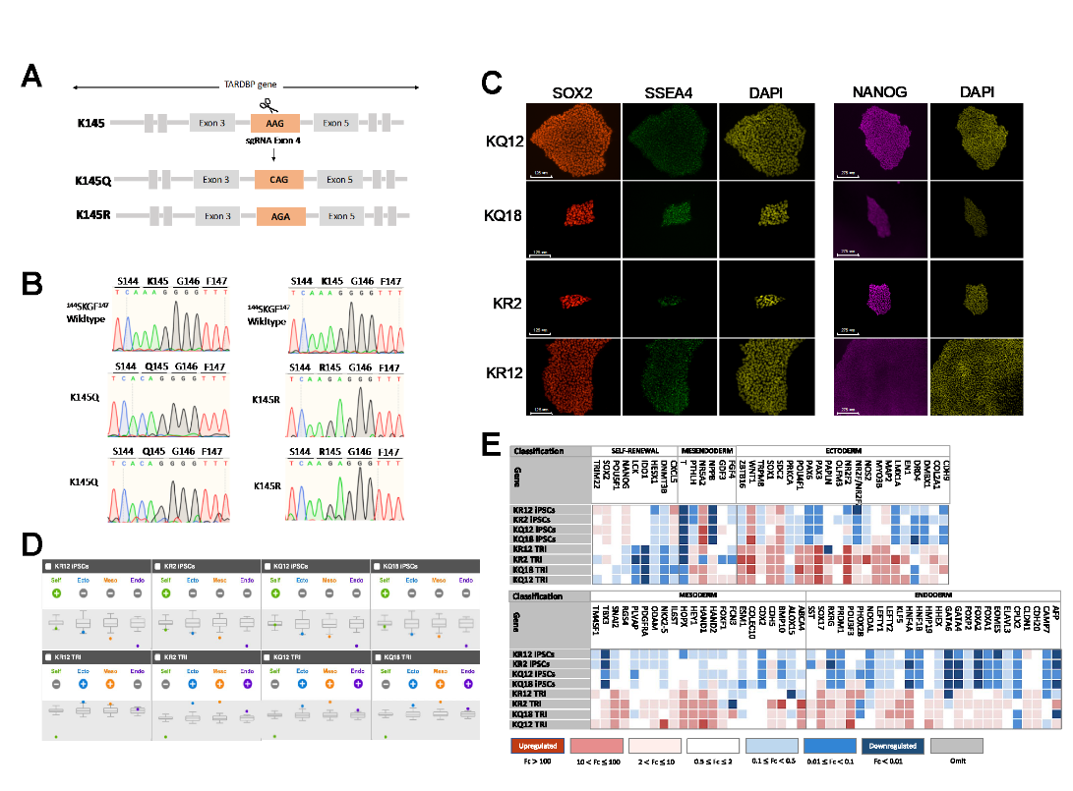
Figure 3 – Figure supplement 1: Development of endogenously encoded acetylation-mimic and acetylation-deficient TARDBP iPSC lines​
A Schematic representation of the nucleotide modifications introduced into exon 4 of the TARDBP locus to generate the K145Q and K145R substitutions. B Chromatograms following Sanger sequencing depicting the wildtype sequence and confirming the lysine modifications in two different subclones for each modification. C Immunofluorescence staining for pluripotency markers SOX2 (red), SSEA4 (green), and Nanog (magenta). Nuclear staining is shown in yellow. Scale bars = 125 µm (left) and 275 µm (right). D-E TaqMan hiPSC Scorecard comparing the pluripotency and differentiated capacity to the three germ layers of K145Q and K145R edited clones. Panel (D) shows the differentiation index plots of self-renewal genes (green) and differentiation genes for ectoderm (blue), mesoderm (orange), and endoderm (purple) on undifferentiated (top) and day seven differentiated cells (bottom). Panel (E) compares the gene expression profile of the undifferentiated and differentiated cells as a heat map of the genes that are up-regulated (red), have the same expression level (white), or are down-regulated (blue). Color legends indicate the fold change in expression of the indicated gene from day seven of differentiation into the three germ layers relative to the undifferentiated.

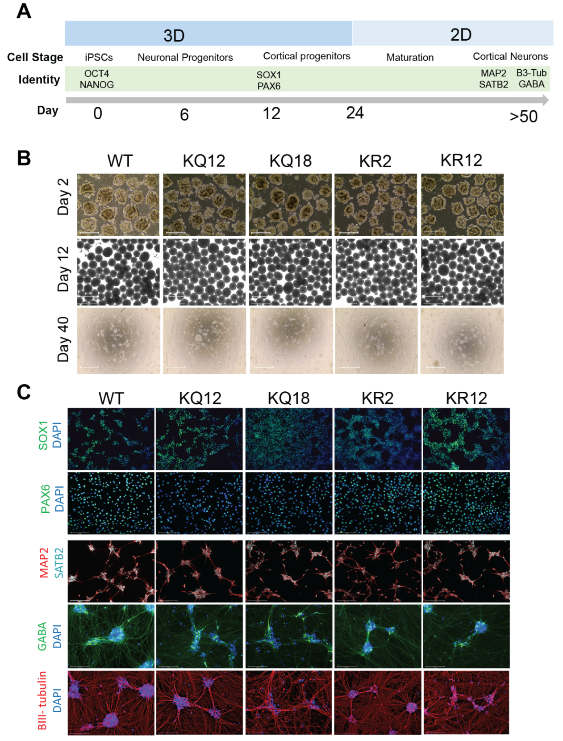
Figure 3 – Figure supplement 2​: Human iPSC-derived cortical neuron differentiation ​
A Schematic representation of the timeline of neuronal differentiation detailing culture conditions and identity markers at each cell stage. B Brightfield images illustrating cell morphology during the differentiation process on day 2 (Top), day 12 (middle) and day 45 (bottom). Scale bars = 650 μm (top and middle) and 125 μm (bottom). C Immunofluorescence staining of SOX1 (green) and PAX6 (green) in NPCs at day 12, as well as MAP2 (red), SATB2 (cyan), GABA (green) and B-III tubulin (red) in mature cortical neurons at day 46. DAPI (blue) is used to label the nucleus. Scale bars = 125 μm
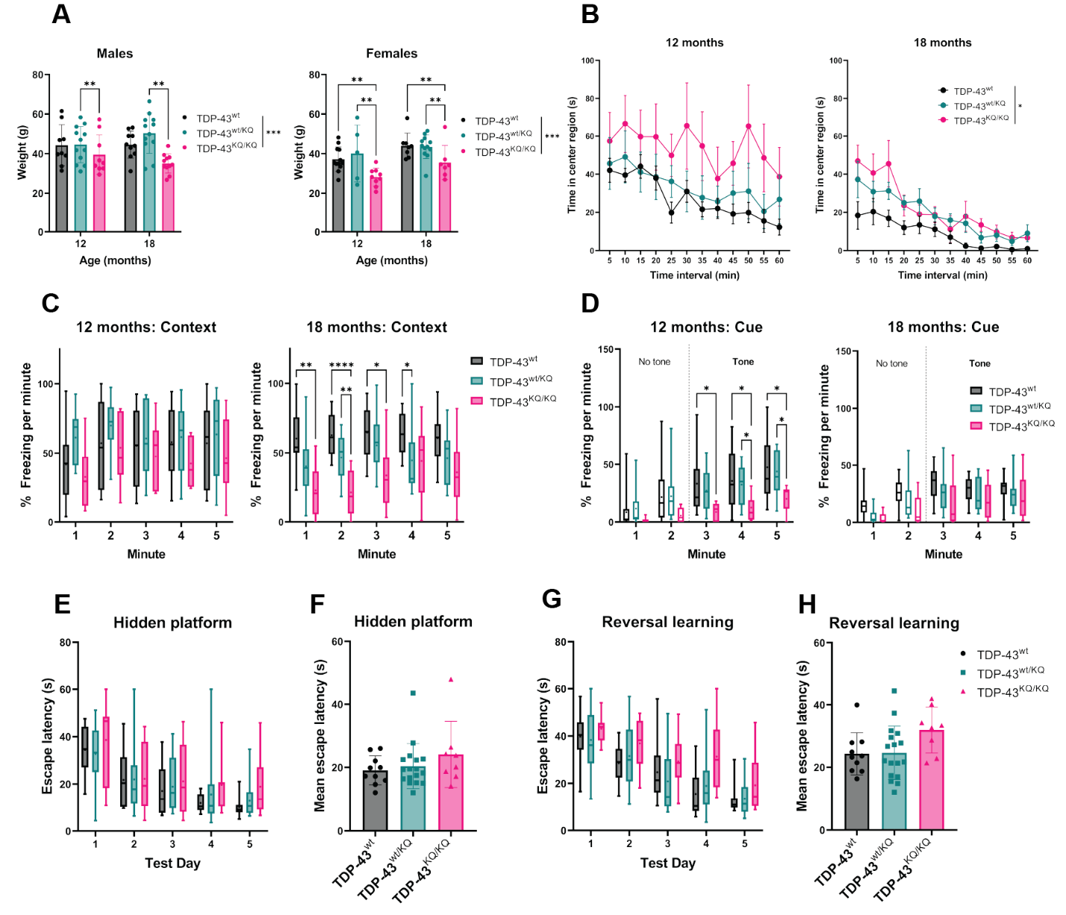
Figure 4 – Figure supplement 1: Heterozygous TDP-43^{wt/KQ} animals exhibit mild cognitive and behavioral deficits at levels intermediate to TDP-43^{wt} and TDP-43^{KQ/KQ} mice

A Body weight of TDP-43^{wt}, TDP-43^{wt/KQ}, and TDP-43^{KQ/KQ} mice in males [left panel; F(2,59)=7.794, p=0.001] and females [right panel; F(2,59)=8.744, p=0.0006] at different ages. B Quantification of time in the center region of an open field in mice at 12 months [left panel; F(2,28)=2.54, p=0.0964] and 18 months [right panel; F(2,32)=3.79, p=0.0329]. C Quantification of time spent frozen (immobile) following context-dependent conditioned fear testing at 12-months old [left panel; F(2,28)=1.43, p=0.255] and 18-months-old [right panel; F(2,33)=9.13, p=0.0007]. D Quantification of time spent frozen following cue-dependent conditioned fear testing at 12-months-old [left panel; F(2,28)=3.624, p=0.0398] and 18-months-old. Filled bars represent presence of auditory cue (tone) and period of statistical analysis. E-F Morris Water Maze (MWM) analysis displaying time to find a hidden platform (escape latency), quantified as daily trial means per animal (E) or average across all days (F). G-H Quantification of escape latencies during MWM reversal learning trials in daily trials (G) [F(2,32)=2.788, p=0.0765] and comparing averages per mouse across all days (H). ​Bar and scatter plots shown as mean ± SD. Box and whiskers show line at median, ‘+’ at mean, and whiskers run min to max. A Two-way ANOVA followed by Tukey’s multiple comparisons tests. B-D,E,G Two-way repeated measures ANOVA followed by Tukey's multiple comparisons tests. F, H One-way ANOVA followed by Tukey’s multiple comparisons testing. F statistics and p-values in legend represent main effect of genotype. Sample sizes as follows unless otherwise indicated: 12-month TDP-43^{wt} n=15; 12-month TDP-43^{wt/KQ} n=9; 12-month TDP-43^{KQ/KQ} n=7; 18-month TDP-43^{wt} n=10; 18-month TDP-43^{wt/KQ} n=17; 18-month TDP-43^{KQ/KQ} n=9; one 18-month TDP-43^{KQ/KQ} extreme outlier removed for MWM analysis (E,F). Statistical significance is represented by asterisks *p<0.05, **p<0.01, ***p<0.001; ns=not significant. Further statistical information is available in the Figure 4 – Figure supplement 1 Source Data 1 file.

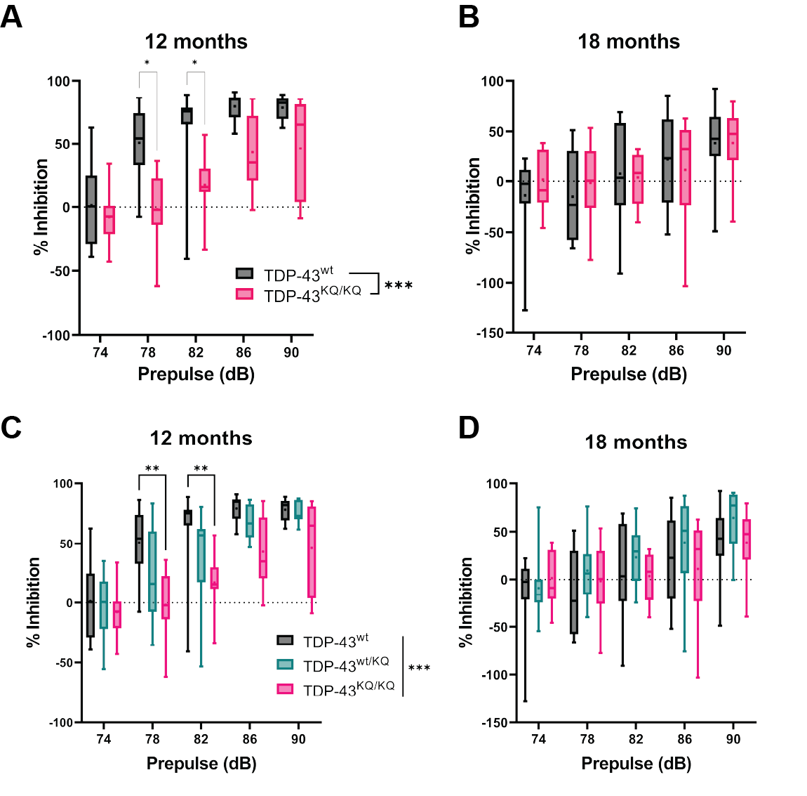
Figure 4 – Figure supplement 2: Altered sensorimotor gating and impaired prepulse inhibition in TDP-43^{KQ/KQ} mice
A-B Measurement of prepulse inhibition (PPI) during acoustic stimulus testing in TDP-43^{KQ/KQ} and TDP-43^{wt} mice showed significantly reduced pre-pulse inhibition at (A) 12 months [F (1, 20) = 19.90, p=0.0002] but not at (B) 18 months old (B). C-D Inclusion of heterozygous TDP-43^{wt/KQ} animals in analysis of prepulse inhibition (PPI) during acoustic stimulus testing demonstrates significantly reduced pre-pulse inhibition in TDP-43^{KQ/KQ} animals and an intermediate phenotype in TDP-43^{wt/KQ} mice at 12 months [F (2, 28) = 10.77, p=0.0003] but not 18 months old. Box and whiskers show line at median, ‘+’ at mean, and whiskers run min to max. 12-month TDP-43^{wt} n=15; 12-month TDP-43^{wt/KQ} n=9; 12-month TDP-43^{KQ/KQ} n=7; 18-month TDP-43^{wt} n=10; 18-month TDP-43^{wt/KQ} n=17; 18-month TDP-43^{KQ/KQ} n=9. Two-way repeated measures ANOVA followed by Šídák's multiple comparisons tests (A-B) or Tukey's multiple comparisons tests (C-D). F statistics represent main effect of genotype. Statistical significance is indicated by asterisks *p<0.05; **p<0.01; ***p<0.001. Further statistical information is located Figure 4 - Figure supplement 2 Source Data 1 file.

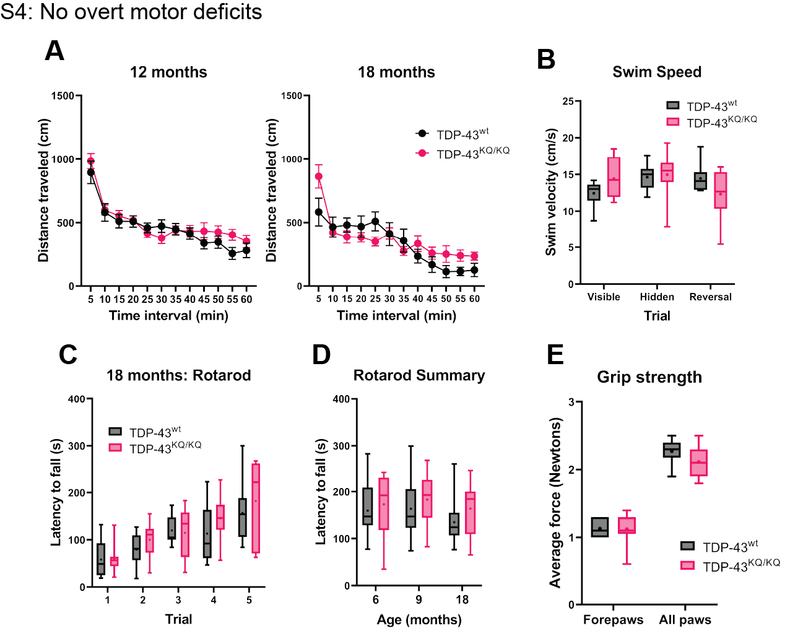
Figure 4 – Figure supplement 3: Lack of overt motor deficits in TDP-43^{KQ/KQ} mice up to 18 months of age
A Quantification of distance travelled by TDP-43^{wt} and TDP-43^{KQ/KQ} mice during open field assays at 12 and 18 months of age. B Quantification of swim velocity during Morris Water Maze testing in mice at 18 months old. C-D Assessment of latency to fall off an accelerating rotarod in TDP-43^{wt} compared to TDP-43^{KQ/KQ} mice at 18-months-old quantifying five individual trials (C) and the average latency to fall over all five trials at 6-, 9-, or 18-months old (D). E Grip strength in forepaws and all paws measured by digital force meters shows no genotype differences in grip strength at 18 months old. Scatter plots shown as mean ± SD. Box and whiskers show line at median, ‘+’ at mean, and whiskers run min to max. A,C Two-way repeated measures ANOVA followed by Holm-Šídák's multiple comparisons tests; B,D,E Two-way ANOVA followed by Holm-Šídák's multiple comparisons tests. Sample sizes as follows: 6- and 9-month TDP-43^{wt} n=10; 6 and 9-month TDP-43^{KQ/KQ} n=8; 12-month TDP-43^{wt} n=15; 12-month TDP-43^{KQ/KQ} n=7; 18-month TDP-43^{wt} n=10; 18-month TDP-43^{KQ/KQ} n=9; one extreme outlier from 18-month TDP-43^{KQ/KQ} group removed for Open Field analysis (A). Further statistical information is located Figure 4 - Figure supplement 2 Source Data 1 file.

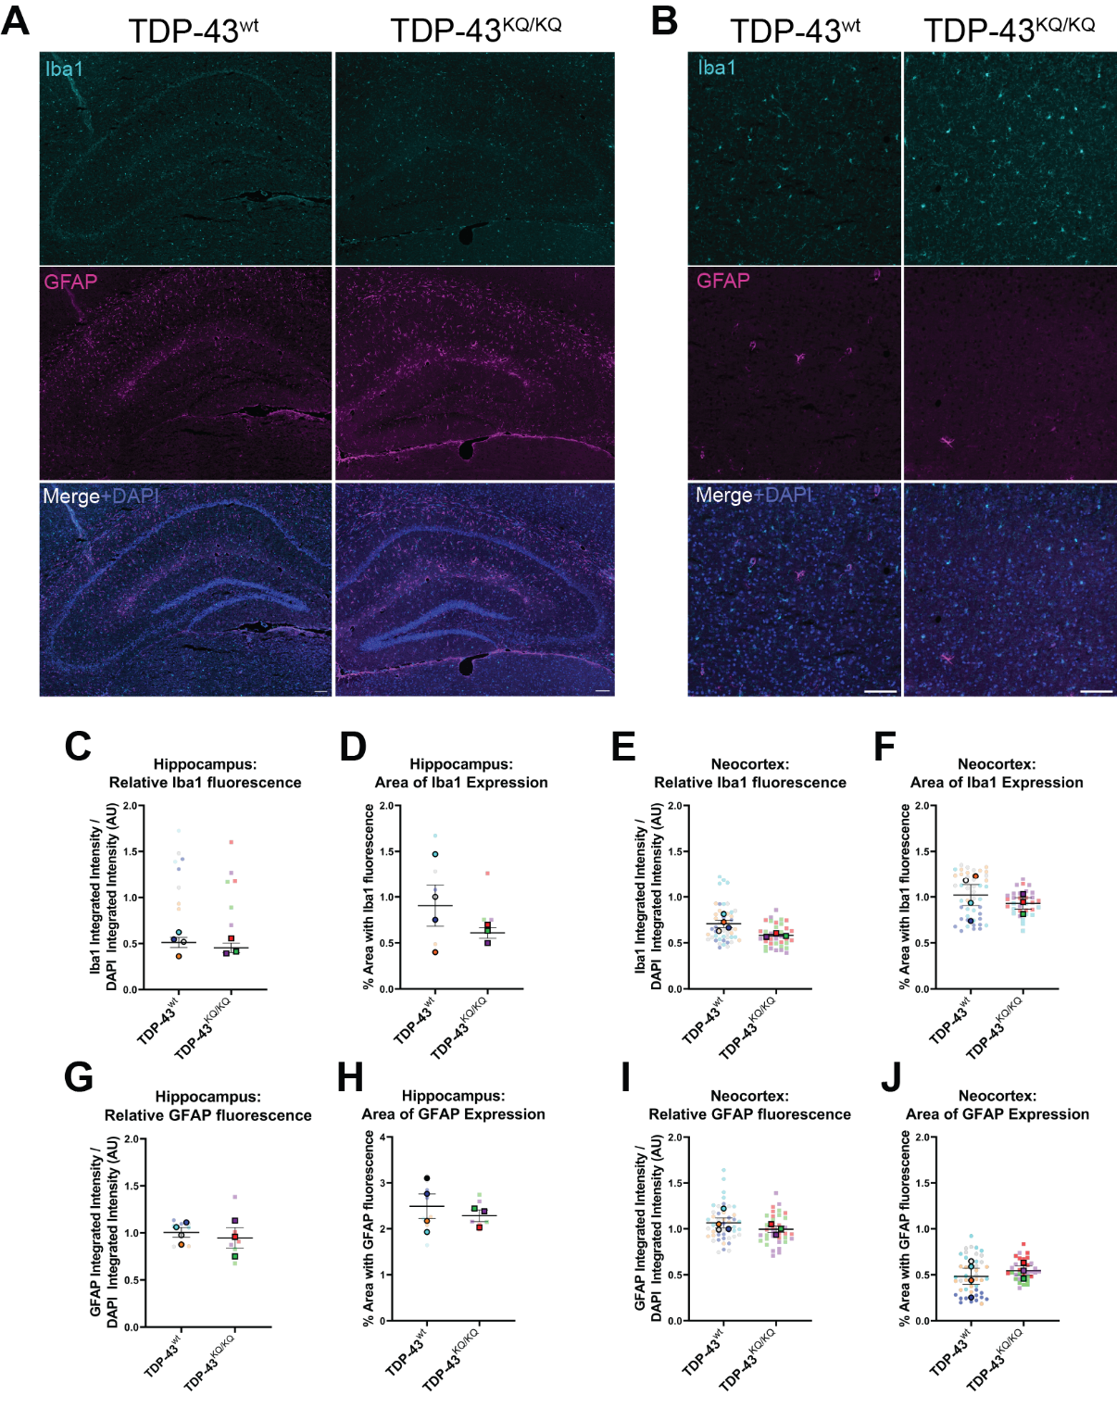
Figure 5 – Figure supplement 1: No evidence of astrogliosis or microgliosis in the hippocampus or neocortex of 18-month-old TDP-43^{KQ/KQ} mice
A-B Representative widefield microscopy images of immunofluorescent labelling of microglia (Iba1+ cells, top panel), astrocytes (GFAP+ cells, middle panel) and a DAPI counterstain (merged image, bottom panel) of 18-month TDP-43^{wt} or TDP-43^{KQ/KQ} mouse hippocampus (A) and neocortex (B). C-F Quantification of Iba1 protein expression as measured by the integrated intensity of Iba1 fluorescence relative to DAPI fluorescence in the hippocampus (C) and neocortex (E), and by the percent of the brain region occupied by Iba1 fluorescence in the hippocampus (D) and neocortex (F). G-J Quantification of GFAP protein expression as measured by the integrated intensity of GFAP fluorescence relative to DAPI fluorescence in the hippocampus (C) and neocortex (E), and by the percent of the brain region occupied by GFAP fluorescence in the hippocampus (D) and neocortex (F). SuperPlots⁸⁹ show average value per animal in a solid color bordered symbol (as mean ± SEM) over top of semi-transparent individual values from each animal. One color represents one animal. Individual datapoints in C,D,G,H represent one image of bilateral hippocampi from a coronal brain section (two sections per animal). Individual datapoints in E,F,I,J represent one image of a unilateral segment of neocortex from a coronal brain section (6 sections per animal, total of 12 cortical regions imaged). For statistical analyses in C-J, average values from n=4 TDP-43^{wt} and n=3 TDP-43^{KQ/KQ} 18-month mice were compared using unpaired student’s t-tests.

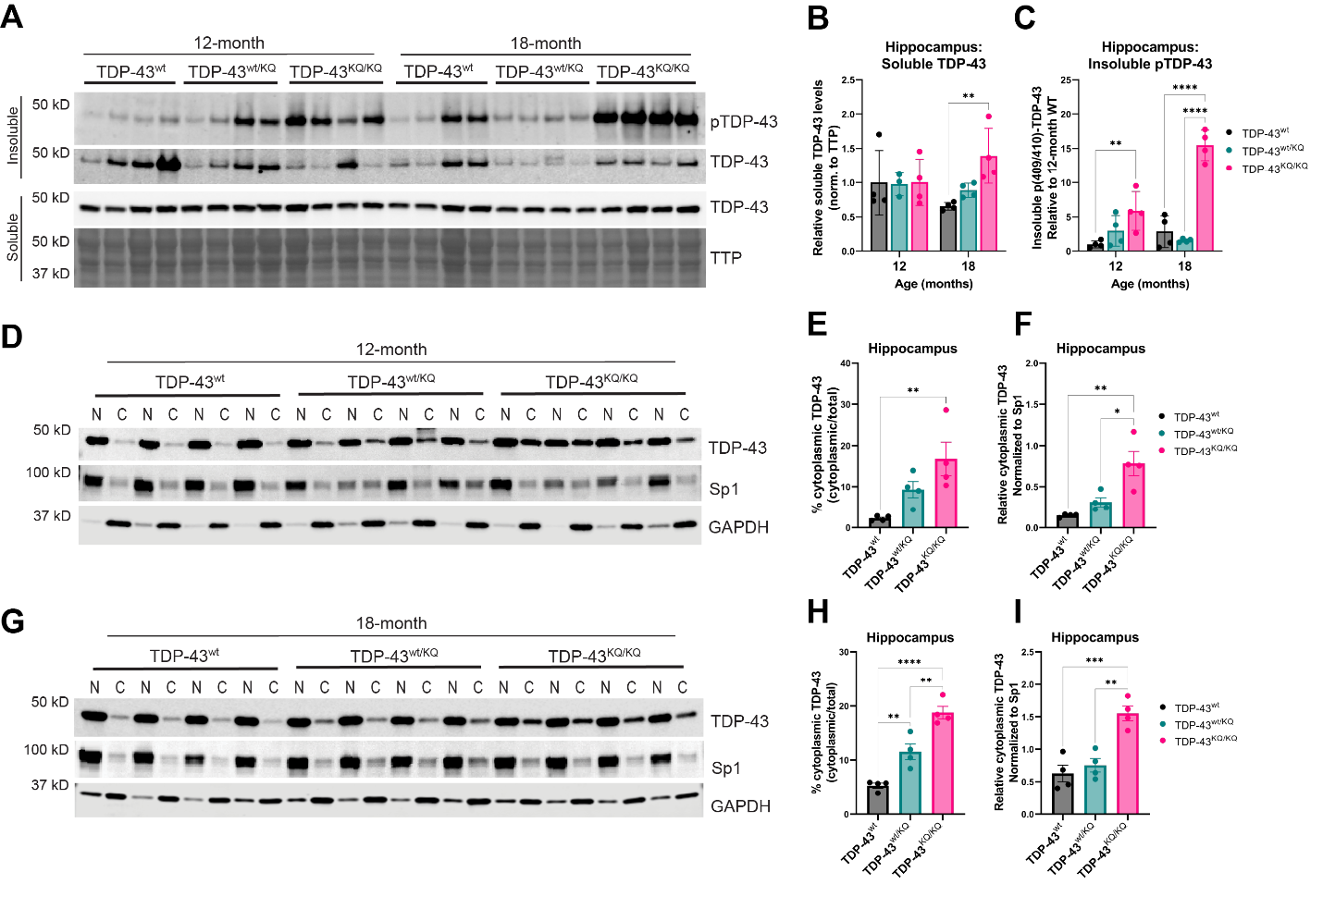
Figure 6 – Figure supplement 1: Intermediate levels of TDP-43 hyperphosphorylation and mislocalization in the hippocampus of aged heterozygous TDP-43^{wt/KQ} compared to TDP-43^{wt} and homozygous TDP-43^{KQ/KQ} mice
A Western blot images comparing soluble and insoluble protein fractions in the hippocampus from TDP-43^{wt}, TDP-43^{wt/KQ}, and TDP-43^{KQ/KQ} mice at 12- and 18-months of age. B Quantification of soluble TDP-43 protein levels in hippocampus tissue relative to total transferred protein (TTP) [F (1, 14) = 97.67, p<0.0001 and main effect of genotype*age interaction F (1,13) = 10.21, p=0.0070)]. C Quantification of insoluble phosphorylated p(409/410)-TDP-43 levels in hippocampus [F (1, 13) = 23.07, p=0.0003]. D Western blot images following isolation of soluble nuclear and cytoplasmic protein fractions from the hippocampus of TDP-43^{wt}, TDP-43^{wt/KQ}, and TDP-43^{KQ/KQ} mice at 12-months of age. E-F Quantification of cytoplasmic TDP-43 measured as (E) a percent of total TDP-43 [F (1, 8) = 22.40, p=0.0015] and (F) relative cytoplasmic mislocalization of TDP-43 after normalizing to cytoplasmic/nuclear ratio of the nuclear Sp1 protein [F (1, 8) = 29.94, p=0.0006]. G Western blot images following isolation of soluble nuclear and cytoplasmic protein fractions from the hippocampus of TDP-43^{wt}, TDP-43^{wt/KQ}, and TDP-43^{KQ/KQ} mice at 18-months of age. H-I Quantification of cytoplasmic TDP-43 measured as (H) a percent of total TDP-43 [F (1, 8) = 22.40, p=0.0015] and (I) relative cytoplasmic mislocalization of TDP-43 after normalizing to cytoplasmic/nuclear ratio of the nuclear Sp1 protein [F (1, 8) = 29.94, p=0.0006]. A-I Hippocampus samples from n=4 animals for each genotype and age tested. Data are presented as mean ± SD. B-C Two-way ANOVA followed by Tukey's multiple comparisons testing. E-F,G-H One-way ANOVA followed by Tukey’s multiple comparisons testing. F statistics represent the main effect of genotype unless otherwise stated. Statistical significance represented by asterisks, *p<0.05, **p<0.01, ***p<0.001, ****p<0.0001. Further statistical information is located Figure 6 – Figure Supplement 1 Source Data 1 file. Figures showing uncropped western blot images are available in Figure 6 – Figure Supplement 1 Source Data 2 files. Full images of western blots are available in Figure 6 – Figure Supplement 1 Source Data 3 files.
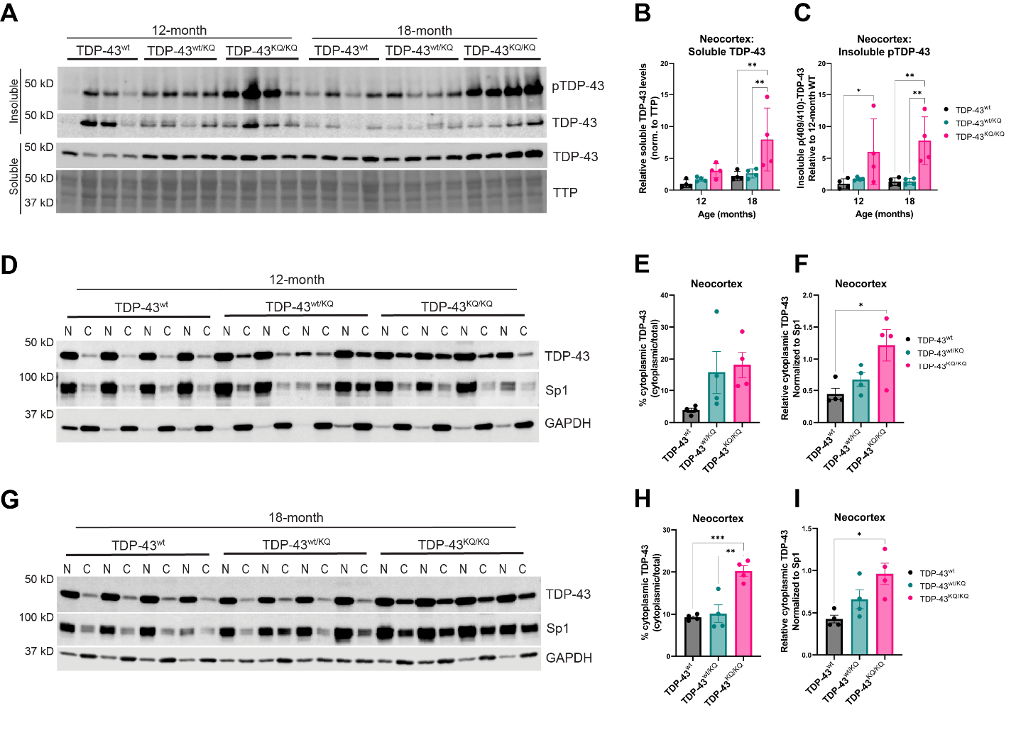
Figure 6 – Figure supplement 2: Intermediate levels of TDP-43 hyperphosphorylation and mislocalization in the neocortex of aged heterozygous TDP-43^{wt/KQ} compared to TDP-43^{wt} and homozygous TDP-43^{KQ/KQ} mice
A Western blot images comparing soluble and insoluble protein fractions in the neocortex from TDP-43^{wt}, TDP-43^{wt/KQ}, and TDP-43^{KQ/KQ} mice at 12- and 18-months of age. B Quantification of soluble TDP-43 protein levels in hippocampus tissue relative to total transferred protein (TTP) [F (2, 17) = 3.110, p=0.0706]. C Quantification of insoluble phosphorylated p(409/410)-TDP-43 levels in neocortex [F (2, 18) = 49.76, p<0.0001]. D Western blot images following isolation of soluble nuclear and cytoplasmic protein fractions from the neocortex of TDP-43^{wt}, TDP-43^{wt/KQ}, and TDP-43^{KQ/KQ} mice at 12-months of age. E-F Quantification of cytoplasmic TDP-43 measured as (E) a percent of total TDP-43 [F (2, 9) = 7.617, p=0.0116] and (F) relative cytoplasmic mislocalization of TDP-43 after normalizing to cytoplasmic/nuclear ratio of the nuclear Sp1 protein [F (2, 9) = 12.91, p=0.0023]. G Western blot images following isolation of soluble nuclear and cytoplasmic protein fractions from the neocortex of TDP-43^{wt}, TDP-43^{wt/KQ}, and TDP-43^{KQ/KQ} mice at 18-months of age. H-I Quantification of cytoplasmic TDP-43 measured as (H) a percent of total TDP-43 [F (2, 9) = 37.88, p<0.0001] and (I) relative cytoplasmic mislocalization of TDP-43 after normalizing to cytoplasmic/nuclear ratio of the nuclear Sp1 protein [F (2, 9) = 19.09, p=0.0006]. A-I Neocortex samples from n=4 animals for each genotype and age tested. Data are presented as mean ± SD. B-C Two-way ANOVA followed by Tukey's multiple comparisons testing. E-F,G-H One-way ANOVA followed by Tukey’s multiple comparisons testing. F statistics represent the main effect of genotype unless otherwise stated. Statistical significance represented by asterisks, *p<0.05, **p<0.01, ***p<0.001, ****p<0.0001. Further statistical information is located in the Figure 6 – Figure Supplement 2 Source Data 1 file. Figures showing uncropped western blot images are available in Figure 6 – Figure Supplement 2 Source Data 2 files. Full images of western blots are available in Figure 6 – Figure Supplement 2 Source Data 3 files.

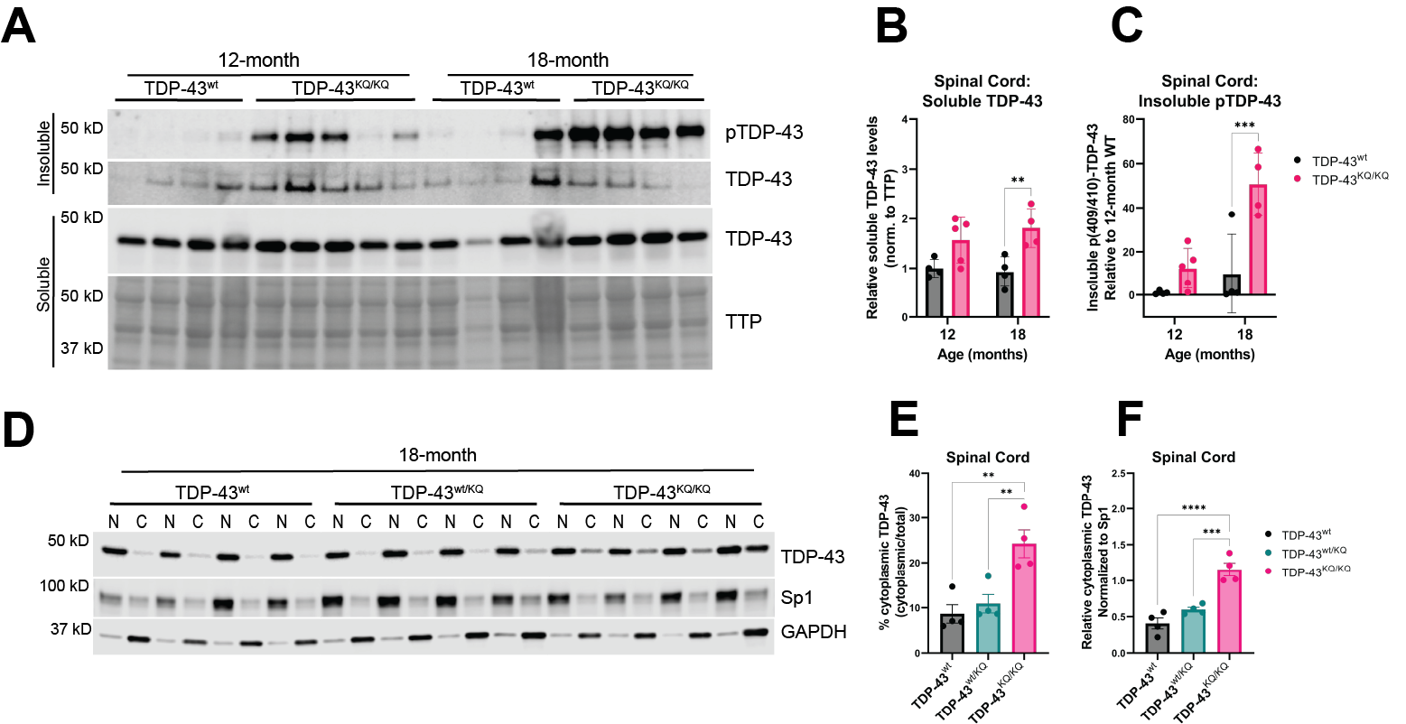
Figure 6 – Figure supplement 3: Spinal cord tissue from aged TDP-43^{KQ/KQ} mice contains insoluble, hyperphosphorylated, and mislocalized TDP-43
A Western blot images comparing soluble and insoluble protein fractions in spinal cord tissue from TDP-43^{wt} and TDP-43^{KQ/KQ} mice at 12- and 18-months of age. B Quantification of soluble TDP-43 protein levels in the spina cord relative to total transferred protein (TTP) [F (1, 13) = 17.13, p=0.0012]. C Quantification of insoluble phosphorylated p(409/410)-TDP-43 levels in spinal cord tissue [F (1, 13) = 19.27, p=0.0007]. D Western blot images following isolation of soluble nuclear and cytoplasmic protein fractions from the spinal cord of TDP-43^{wt}, TDP-43^{wt/KQ}, and TDP-43^{KQ/KQ} mice at 18-months of age. E-F Quantification of cytoplasmic TDP-43 measured as (E) a percent of total TDP-43 [F (2, 9) = 12.02, p=0.0029] and (F) relative cytoplasmic mislocalization of TDP-43 after normalizing to cytoplasmic/nuclear ratio of the nuclear Sp1 protein [F (2, 9) = 30.53, p<0.0001]. B-C Two-way ANOVA followed by Tukey's multiple comparisons testing. E-F One-way ANOVA followed by Tukey’s multiple comparisons testing. F statistics represent the main effect of genotype unless otherwise stated. Statistical significance represented by asterisks, *p<0.05, **p<0.01, ***p<0.001, ****p<0.0001. Further statistical information is located in the Figure 6 – Figure Supplement 3 Source Data 1 file. Figures showing uncropped western blot images are available in Figure 6 – Figure Supplement 3 Source Data 2 files. Full images of western blots are available in Figure 6 – Figure Supplement 3 Source Data 3 files.

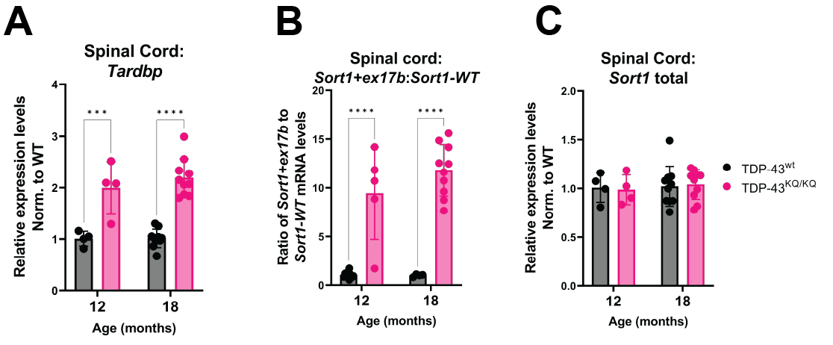
Figure 7 – Figure supplement 1: Spinal cord tissue from TDP-43^{KQ/KQ} mice shows evidence of altered TDP-43 autoregulation and aberrant splicing of Sort1 compared to TDP-43^{wt}
A Tardbp expression was analyzed by qPCR in the spinal cord of TDP-43^{wt} and TDP-43^{KQ/KQ} animals at 12- and 18-months-old [F (1, 24) = 68.79, p<0.0001]. B-C qPCR analysis of WT and TDP-43^{KQ/KQ} spinal cord tissue samples using primers specific for Sort1 splice variants to show (B) the ratio of Sort1-ex17b:Sort1-WT mRNA levels [F (1, 25) = 92.18, p<0.0001] and (C) total Sort1 mRNA levels. Relative expression (RQ) values in each sample were determined using the Plaff method and B-actin and Pgk1 as housekeeping genes. Data are presented as mean ± SD and F-statistic represents main effect of genotype, unless otherwise stated. Two-way ANOVA followed by Šídák's multiple comparisons test. ***p<0.001, ****p<0.0001. Further statistical information is available in the Figure 7 – Figure Supplement 1 Source Data 1 file.

Figure 7 – Figure supplement 2: Significant correlation between differentially expressed genes (DEGs) in the neocortex and hippocampus of TDP-43^{KQ/KQ} mice
Scatterplot and smoothed linear model relating the log2 fold-change of differentially expressed genes (DEGs) in the hippocampus and neocortex of TDP-43^{KQ/KQ} (TDP43-KQ) compared to TDP-43^{wt} (TDP43-WT) mice at 18-months-old. DEGs that are only significant in the hippocampus are colored in blue, DEGs that are significant only in the neocortex are colored in green, and DEGs significant in both tissues are colored in pink. Log2 fold-changes were moderately correlated (Pearson correlation coefficient R=0.61) and the relationship was statistically significant (p<0.0001).

Supplementary Files:
Supplementary File 1: Detailed RNA sequencing results and analysis.
Supplementary File 1a: Differentially expressed genes in the neocortex of 18-month TDP-43^{KQ/KQ} mice compared to WT
Supplementary File 1b: Differentially expressed genes in the hippocampus of 18-month TDP-43^{KQ/KQ} mice compared to WT
Supplementary File 1c: Gene Ontology terms enriched in each of the six groups of differentially expressed genes (DEGs) in TDP-43^{KQ/KQ} animals compared to TDP-43^{wt} at 18-months-old
Supplementary File 1d: Intersections between differentially expressed genes in TDP-43^{KQ/KQ} micec compared to differentially expressed genes in FTLD-TDP cortex and mouse TDP-43 knockdown
Supplementary File 1e: List of clusters within differentially spliced genes (analysis by LeafCutter, LeafViz) in the cortex of TDP-43^{KQ/KQ} mice compared to WT at 18-months of age
Supplementary File 1f: List of clusters within differentially spliced genes (analysis by LeafCutter, LeafViz) in the hippocampus of TDP-43^{KQ/KQ} mice compared to WT at 18-months of age
Supplementary File 2: Complete detailed results of Linear Mixed Effects Model statistical analyses
Supplementary File 3: Complete list of oligonucleotides used in the present study.
Supplementary File 4: Complete list of primary and secondary antibodies used in the present study.

Source Data:
Figure 2 – Figure Supplement 1 Source Data 1: Figures showing labeled and unlabeled versions of the uncropped DNA gel image presented in Figure 2 – Figure Supplement 1.

Figure 4 Source Data 1: Complete statistical results and information for quantitative elements shown in Figure 4.
Figure 4 – Figure Supplement 1 Source Data 1: Complete statistical results and information for quantitative elements shown in Figure 4 – Figure Supplement 1.
Figure 4 – Figure Supplement 2 Source Data 1: Complete statistical results and information for quantitative elements shown in Figure 4 – Figure Supplement 2.
Figure 4 – Figure Supplement 3 Source Data 1: Complete statistical results and information for quantitative elements shown in Figure 4 – Figure Supplement 3.

Figure 6 Source Data 1: Complete statistical results and information for quantitative elements shown in Figure 6.
Figure 6 Source Data 2: Figures showing uncropped western blot images of those presented in Figure 6 (A, D, G, J).
Figure 6 Source Data 3: Full uncropped images of western blots shown in Figure 6.

Figure 6 – Figure Supplement 1 Source Data 1: Complete statistical results and information for quantitative elements shown in Figure 6 – Figure Supplement 1.
Figure 6 – Figure Supplement 1 Source Data 2: Figures showing uncropped western blot images of those presented in Figure 6 – Figure Supplement 1 (A, D, G).
Figure 6 – Figure Supplement 1 Source Data 3: Full uncropped images of western blots shown in Figure 6 – Figure Supplement 1.

Figure 6 – Figure Supplement 2 Source Data 1: Complete statistical results and information for quantitative elements shown in Figure 6 – Figure Supplement 2.
Figure 6 – Figure Supplement 2 Source Data 2: Figures showing uncropped western blot images of those presented in Figure 6 – Figure Supplement 2 (A, D, G).
Figure 6 – Figure Supplement 2 Source Data 3: Full uncropped images of western blots shown in Figure 6 – Figure Supplement 2.

Figure 6 – Figure Supplement 3 Source Data 1: Complete statistical results and information for quantitative elements shown in Figure 6 – Figure Supplement 3.
Figure 6 – Figure Supplement 1 Source Data 2: Figures showing uncropped western blot images of those presented in Figure 6 – Figure Supplement 3 (A, D).
Figure 6 – Figure Supplement 2 Source Data 3: Full uncropped images of western blots shown in Figure 6 – Figure Supplement 3.

Figure 7 Source Data 1: Complete statistical results and information for quantitative elements shown in Figure 7.

Figure 8 Source Data 1: Complete statistical results and information for quantitative elements shown in Figure 8.
Figure 8 Source Data 2: Figures showing uncropped western blot images of those presented in Figure 8 (D, E).
Figure 8 Source Data 3: Full uncropped images of western blots shown in Figure 8.

