Supplementary Figures

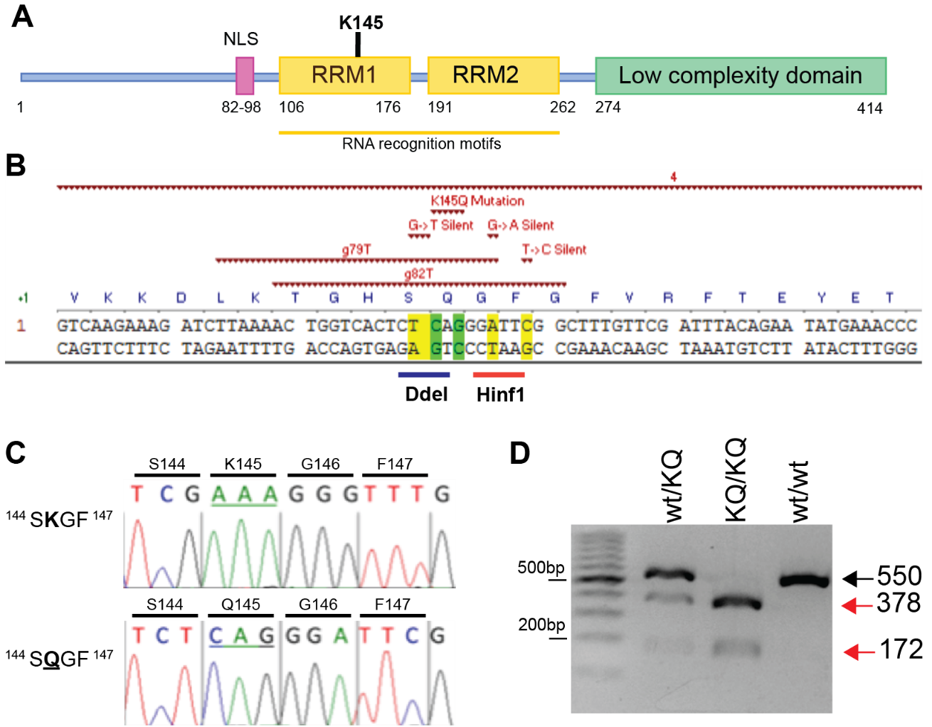
Supplementary Figure 1: Generation, characterization, and genotyping of TDP-43^{K145Q} knock-in mice
A A schematic of the TDP-43 protein and its functional domains highlights the location of lysine 145 (K145) in the TDP-43 RNA-binding domain (RRM1). B Schematic of mouse Tardbp gene targeted with a validated guide RNA, g79T above, along with donor nucleotides to insert the K145Q mutation. Two silent mutations were included to create a Hinf1 enzyme digestion site to facilitate genotyping. C Chromatograph following Sanger sequencing confirms the inserted K145Q mutation in founder animals and subsequently propagated generations. D Gel electrophoresis of DNA fragments produced following PCR amplification of the modified Tardbp region and subsequent incubation of the PCR product with Hinf1 enzyme, which yielded a 550bp band in TDP-43^{wt} animals (wt/wt), both 378 bp and 172 bp bands in TDP-43^{KQ/KQ} (KQ/KQ) animals, and all three bands in heterozygous animals (wt/KQ).

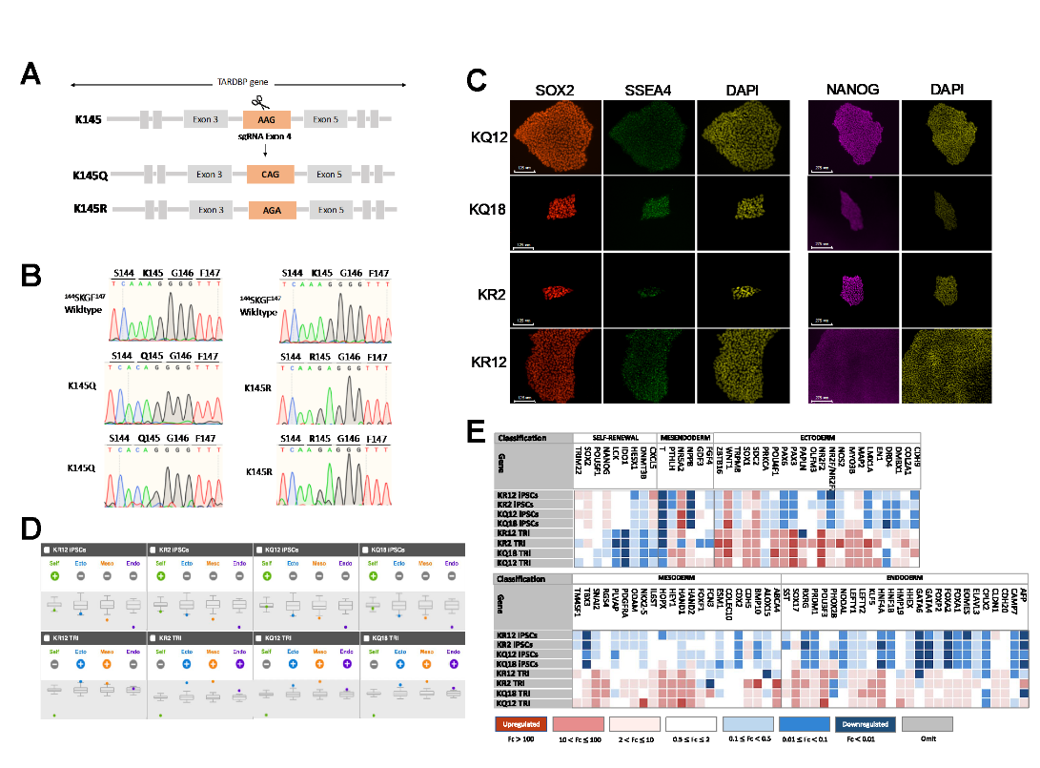
Supplementary Figure 2: Development of endogenously encoded acetylation-mimic and acetylation-deficient TARDBP iPSC lines​
A Schematic representation of the nucleotide modifications introduced into exon 4 of the TARDBP locus to generate the K145Q and K145R substitutions. B Chromatograms following Sanger sequencing depicting the wildtype sequence and confirming the lysine modifications in two different subclones for each modification. C Immunofluorescence staining for pluripotency markers SOX2 (red), SSEA4 (green), and Nanog (magenta). Nuclear staining is shown in yellow. Scale bars = 125 µm (left) and 275 µm (right). D-E TaqMan hiPSC Scorecard comparing the pluripotency and differentiated capacity to the three germ layers of K145Q and K145R edited clones. Panel (D) shows the differentiation index plots of self-renewal genes (green) and differentiation genes for ectoderm (blue), mesoderm (orange), and endoderm (purple) on undifferentiated (top) and day seven differentiated cells (bottom). Panel (E) compares the gene expression profile of the undifferentiated and differentiated cells as a heat map of the genes that are up-regulated (red), have the same expression level (white), or are down-regulated (blue). Color legends indicate the fold change in expression of the indicated gene from day seven of differentiation into the three germ layers relative to the undifferentiated.

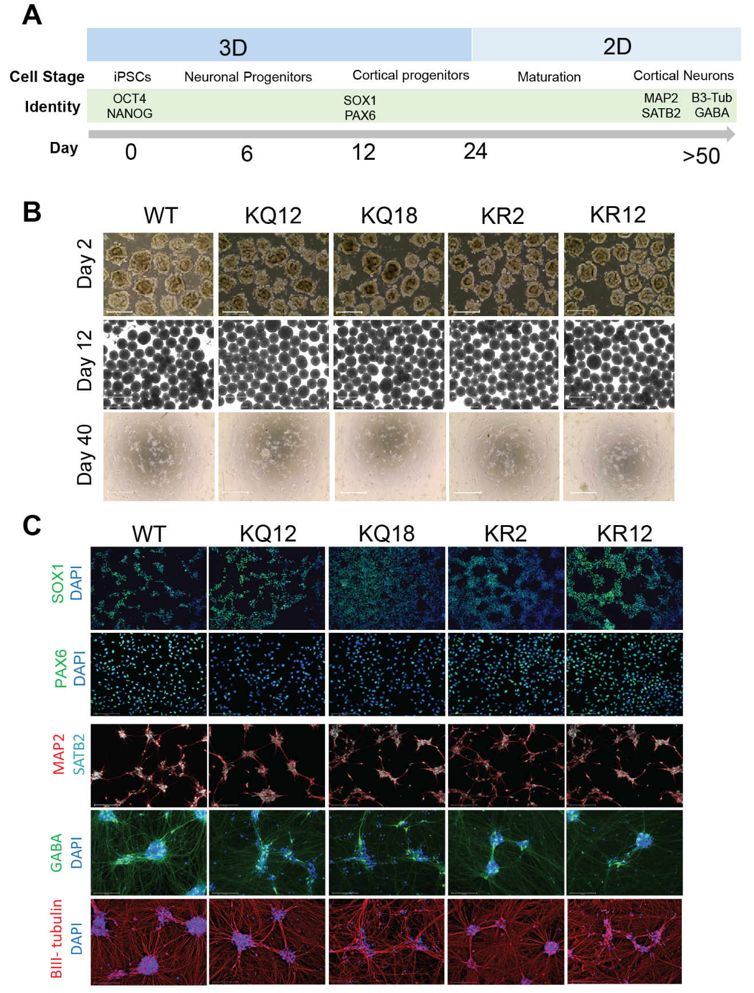
Supplementary Figure 3​: Human iPSC-derived cortical neuron differentiation ​
A Schematic representation of the timeline of neuronal differentiation detailing culture conditions and identity markers at each cell stage. B Brightfield images illustrating cell morphology during the differentiation process on day 2 (Top), day 12 (middle) and day 45 (bottom). Scale bars = 650 μm (top and middle) and 125 μm (bottom). C Immunofluorescence staining of SOX1 (green) and PAX6 (green) in NPCs at day 12, as well as MAP2 (red), SATB2 (cyan), GABA (green) and B-III tubulin (red) in mature cortical neurons at day 46. DAPI (blue) is used to label the nucleus. Scale bars = 125 μm

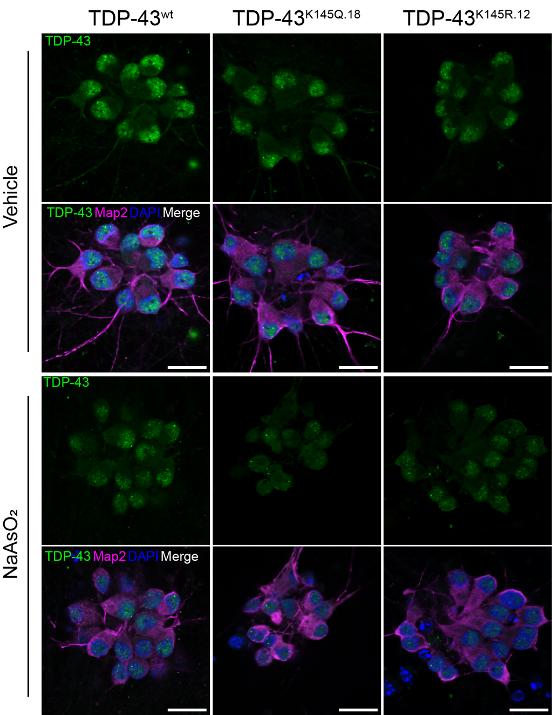
Supplementary Figure 4: Enhancement of nuclear depletion and TDP-43 phase separation in multiple TDP-43^{K145Q} lines but not TDP-43^{K145R} or wild-type lines
Representative confocal images of CRISPR-modified human iPSC-derived cortical neurons harboring TDP-43^{K145Q} (clonal line 18), TDP-43^{K145R} (clonal line 12) or no TARDBP modifications (wt) that were treated with vehicle or 200 µM NaAsO2 and immunolabeled for endogenous TDP-43 (green), Map2 (magenta), and DAPI (blue). Scale bars = 20µm.

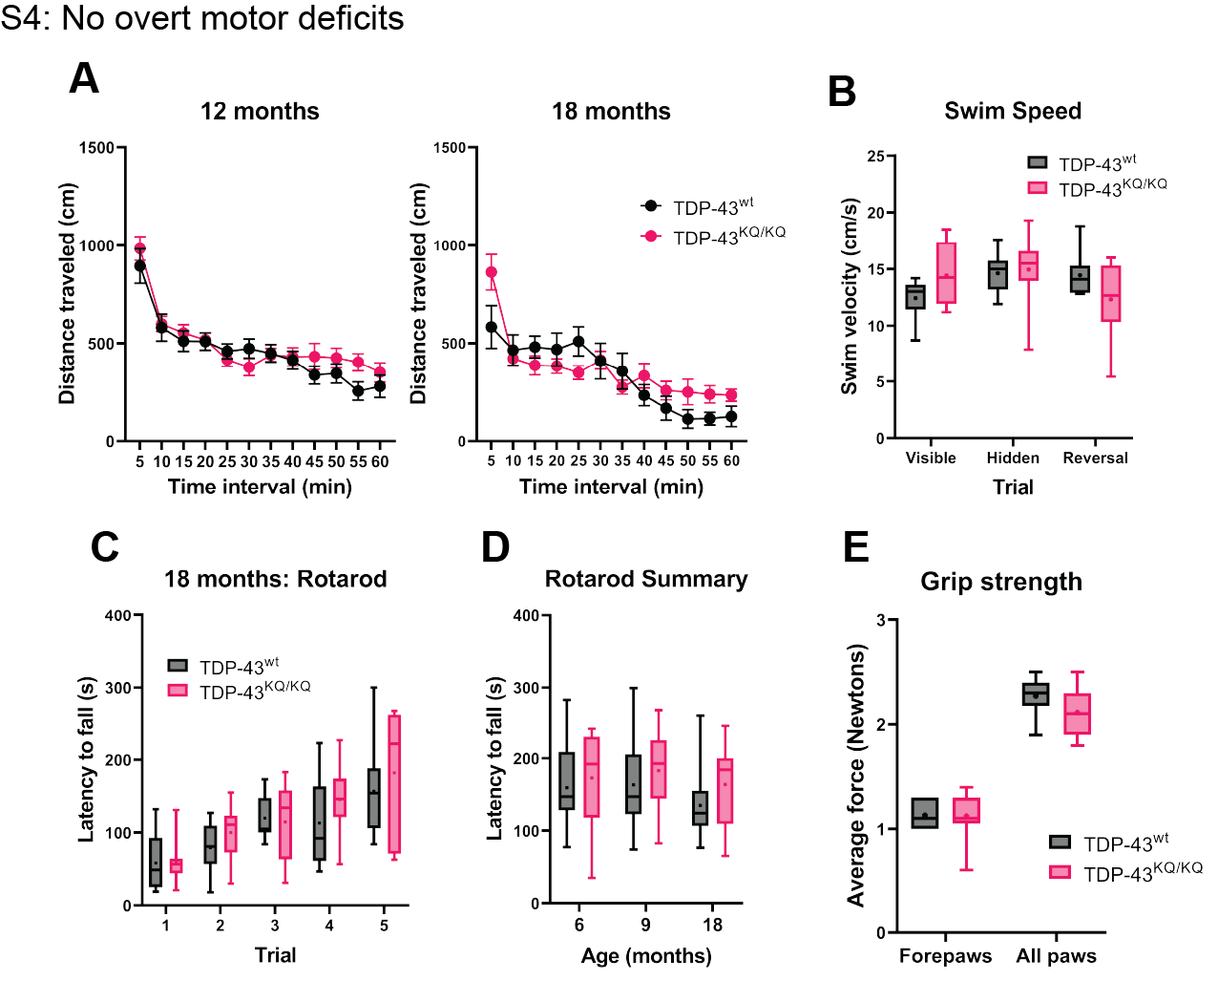
Supplementary Figure 5: No overt motor deficits in TDP-43^{KQ/KQ} mice up to 18 months of age
A Quantification of distance travelled by TDP-43^{wt} and TDP-43^{KQ/KQ} mice during open field assays at 12 and 18 months of age. B Quantification of swim velocity during Morris Water Maze testing in mice at 18 months old. C-D Assessment of latency to fall off an accelerating rotarod in TDP-43^{wt} compared to TDP-43^{KQ/KQ} mice at 18-months-old quantifying five individual trials (C) and the average latency to fall over all five trials at 6-, 9-, or 18-months old (D). E Grip strength in forepaws and all paws measured by digital force meters shows no genotype differences in grip strength at 18 months old. Scatter plots shown as mean ± SD. Box and whiskers show line at median, ‘+’ at mean, and whiskers run min to max. A,C Two-way repeated measures ANOVA followed by Holm-Šídák's multiple comparisons tests; B,D,E Two-way ANOVA followed by Holm-Šídák's multiple comparisons tests. Sample sizes as follows: 6- and 9-month TDP-43^{wt} n=10; 6 and 9-month TDP-43^{KQ/KQ} n=8; 12-month TDP-43^{wt} n=15; 12-month TDP-43^{KQ/KQ} n=7; 18-month TDP-43^{wt} n=10; 18-month TDP-43^{KQ/KQ} n=9; one extreme outlier from 18-month TDP-43^{KQ/KQ} group removed for Open Field analysis (A). Further statistical information is located Figure S5 Source Data 1 file.

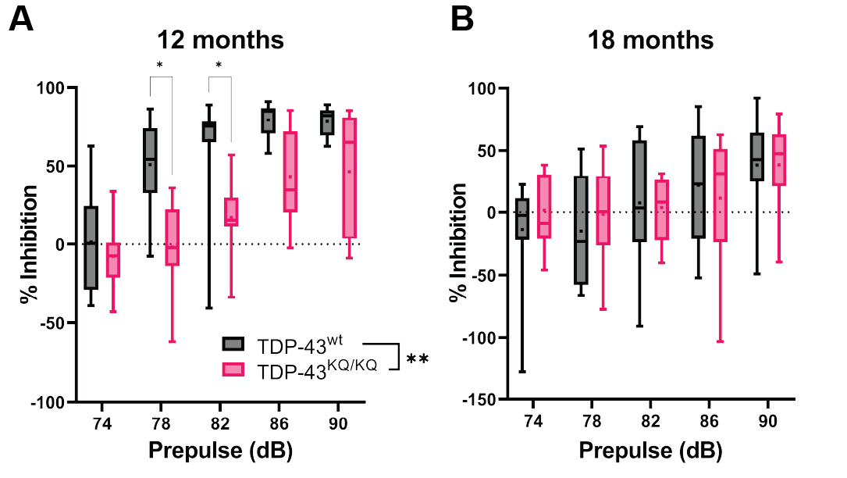
Supplementary Figure 6: Altered sensorimotor gating and impaired prepulse inhibition in TDP-43^{KQ/KQ} mice
A-B Measurement of prepulse inhibition (PPI) during acoustic stimulus testing in TDP-43^{KQ/KQ} and TDP-43^{wt} mice showed significantly reduced pre-pulse inhibition at 12 months (A) [main effect of genotype, F(1, 20)=19.90, p=0.0002] and not at 18 months old (B). Box and whiskers show line at median, ‘+’ at mean, and whiskers run min to max. 12-month TDP-43^{wt} n=15; 12-month TDP-43^{KQ/KQ} n=7; 18-month TDP-43^{wt} n=10; 18-month TDP-43^{KQ/KQ} n=9. Two-way ANOVA followed by Holm-Šídák's multiple comparisons tests. Statistical significance is indicated by asterisks *p<0.05; ***p<0.001. Further statistical information is located Figure S6 Source Data 1 file.

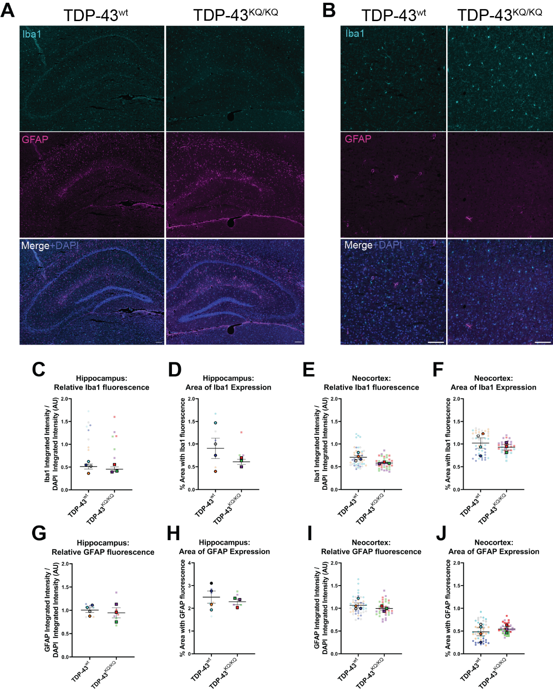
Supplementary Figure 7: No evidence of astrogliosis or microgliosis in the hippocampus or neocortex of 18-month-old TDP-43^{KQ/KQ} animals
A-B Representative widefield microscopy images of immunofluorescent labelling of microglia (Iba1+ cells, top panel), astrocytes (GFAP+ cells, middle panel) and a DAPI counterstain (merged image, bottom panel) of 18-month TDP-43^{wt} or TDP-43^{KQ/KQ} mouse hippocampus (A) and neocortex (B). C-F Quantification of Iba1 protein expression as measured by the integrated intensity of Iba1 fluorescence relative to DAPI fluorescence in the hippocampus (C) and neocortex (E), and by the percent of the brain region occupied by Iba1 fluorescence in the hippocampus (D) and neocortex (F). G-J Quantification of GFAP protein expression as measured by the integrated intensity of GFAP fluorescence relative to DAPI fluorescence in the hippocampus (C) and neocortex (E), and by the percent of the brain region occupied by GFAP fluorescence in the hippocampus (D) and neocortex (F). SuperPlots show average value per animal in a solid color bordered symbol (as mean ± SEM) over top of semi-transparent individual values from each animal. One color represents one animal. Individual datapoints in C,D,G,H represent one image of bilateral hippocampi from a coronal brain section (two sections per animal). Individual datapoints in E,F,I,J represent one image of a unilateral segment of neocortex from a coronal brain section (6 sections per animal, total of 12 cortical regions imaged). Unpaired student’s t-test were used to compare genotypes. Scale bars represent 100µm.

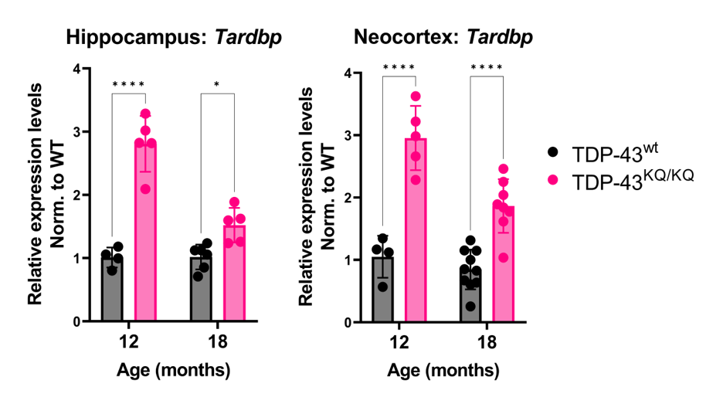
Supplementary Figure 8: Autoregulated induction of the Tardbp transcript in TDP-43^{KQ/KQ} brain at 12- and 18-months of age
Tardbp expression was analyzed by qPCR in the hippocampus and neocortex of TDP-43^{KQ/KQ} animals at 12- and 18-months-old. Relative expression (RQ) values in each sample were determined using the Plaff method and B-actin and Pgk1 as housekeeping genes. Data are presented as mean ± SD. Two-way ANOVA followed by Šídák's multiple comparisons test. *p<0.05, **p<0.01, ***p<0.001, ****p<0.0001. Further statistical information is located Figure S8 Source Data 1 file.

Supplementary Figure 9: Significant correlation between differentially expressed genes (DEGs) in the neocortex and hippocampus of TDP-43^{KQ/KQ} mice
Scatterplot and smoothed linear model relating the log2 fold-change of differentially expressed genes (DEGs) in the hippocampus and neocortex of TDP-43^{KQ/KQ} (TDP43-KQ) compared to TDP-43^{wt} (TDP43-WT) mice at 18-months-old. DEGs that are only significant in the hippocampus are colored in blue, DEGs that are significant only in the neocortex are colored in green, and DEGs significant in both tissues are colored in pink. Log2 fold-changes were moderately correlated (Pearson correlation coefficient R=0.61) and the relationship was statistically significant (p<0.0001).

