Additional information to
Steering the metabolism of Bacillus subtilis under oxygen-limited conditions with anode-assisted electro-fermentation

Yu Sun^{a, *}, Marika Kokkoª and Igor Vassilev^{a, *}

ª Faculty of Engineering and Natural Sciences, Tampere University, Korkeakoulunkatu 8, 33720 Tampere, Finland

* Corresponding authors
E-mails: yu.sun@tuni.fi (Y. Sun), marika.kokko@tuni.fi (M. Kokko), igor.vassilev@tuni.fi (I. Vassilev)

Supplementary figures and tables:
Fig. 1 | Schematic and photo of bioelectrochemical setup used in this study
Fig. 2 | Headspace gas compositions measured in nitrate-added serum flasks
Fig. 3 | Acetate concentrations for BES systems under different cultivation conditions
Fig. 4 | Glucose and end product concentrations measured from open-circuit reactors with moderate aeration rate
Fig. 5 | B. subtilis grown in BES under limited aeration without adding K₃[Fe(CN)₆]
Fig. 6 | B. subtilis grown in aerobic shake flasks with the addition of 0, 0.5, 1.5 and 5 mM K₃[Fe(CN)₆] in the M9 medium with 5 g/L glucose
Table 1 | Main parameters of B. subtilis grown using different electron acceptors
Table 2 | Student’s t-test results to compare the main parameters of B. subtilis growing in BES under 3 different conditions

Bioelectrochemical system and operation. Both chambers of the BES reactor were filled with 300 mL phosphate buffer solution (8.5 g/L Na₂HPO₄·2H₂O, 3 g/L KH₂PO₄, 1 g/L NH₄Cl and 0.5 g/L NaCl) and autoclaved at 121 °C for 20 minutes under the pressure of 1.5 bars. The anolyte was emptied and changed to a sterile M9 medium that contained per litre: 8.5 g Na₂HPO₄·2H₂O, 3 g KH₂PO₄, 1 g NH₄Cl, 0.5 g NaCl, 246 mg MgSO₄·7H₂O, 147 mg CaCl₂·2H₂O, 5 g glucose, and 10 mL filter-sterilized trace element solution, containing per litre: 1.5 mg EDTA, 450 mg ZnSO₄·7H₂O, 30 mg CoCl₂·6H₂O, 100 mg MnCl₂·4H₂O, 30 mg CuSO₄·5H₂O, 1.4 g FeSO₄·7H₂O, 40 mg Na₂MoO₄·2H₂O, 100 mg H₃BO₃, 10 mg KI by using the laminar flow cabinet. The reference electrode was sprayed with 70 % ethanol and cleaned with sterile MQ water before attaching it to the reactor through a glass tube with ceramic frit (4x50mm, Prosense, Germany).

Calculations. The total electrons transferred to the anode were calculated using a similar method described by Vassilev et al. (2019), i.e., the recorded current at each time point was multiplied by the time difference to the previous point(1 A s = 1 Coulomb (C)). Faraday constant (96485.3365 C/mol) was introduced to convert the A s value into mol electrons. Data of all time points were added to give the total mol of electrons and the reactor volume was taken into consideration during the calculations. The carbon balance (CB) was calculated for each measuring point until the substrate was consumed using the equation below:
$$the CB \left(\%\right)={\sum_{i}{{({m_{i} × n}_{i})}_{t}}}/{\sum_{i}{{({m_{i} × n}_{i})}_{t0}}}×100$$
Where, m_{i} is the absolute concentration of compound i at a specific time t; n_{i} is the carbon atom number of compound i. Time t₀ denotes the point of inoculation. The redox balance was calculated based on the CB by additionally multiplying each compound with its degree of reduction plus the mol electrons transferred to the anode. Carbon dioxide and biomass concentrations were not considered in the carbon and redox balance calculations. The yield coefficients were calculated by the slope of plots of mol product versus mol glucose consumed. For each condition tested, every data point result was averaged from three to four biological replicates and the standard deviations were calculated.
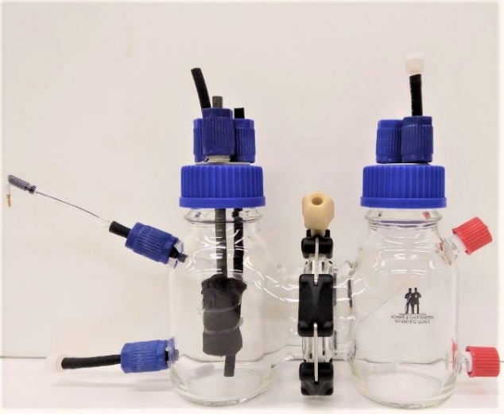
Gas out
Reference Electrode, Ag/AgCl 3M NaCl
Gas in
Working electrode, carbon rod + carbon felt
Counter electrode, platinum wire
Cation exchange membrane
Sampling port
Magnetic stirrer
Magnetic stirrer
Fermentation media
Gas out
Fig. 1 Schematic figure and photo of bioelectrochemical setup used in this study.

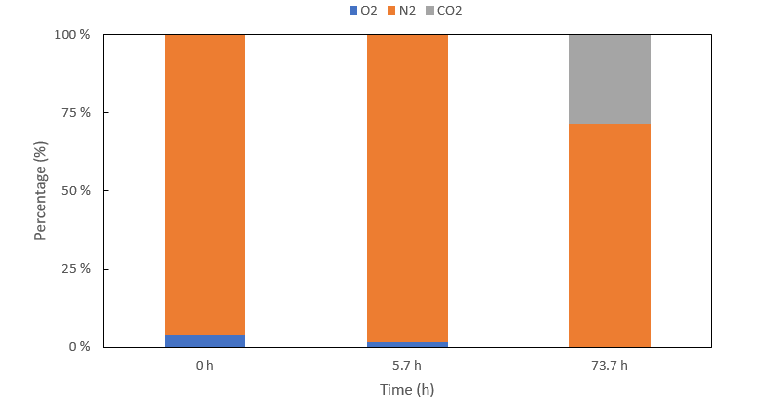
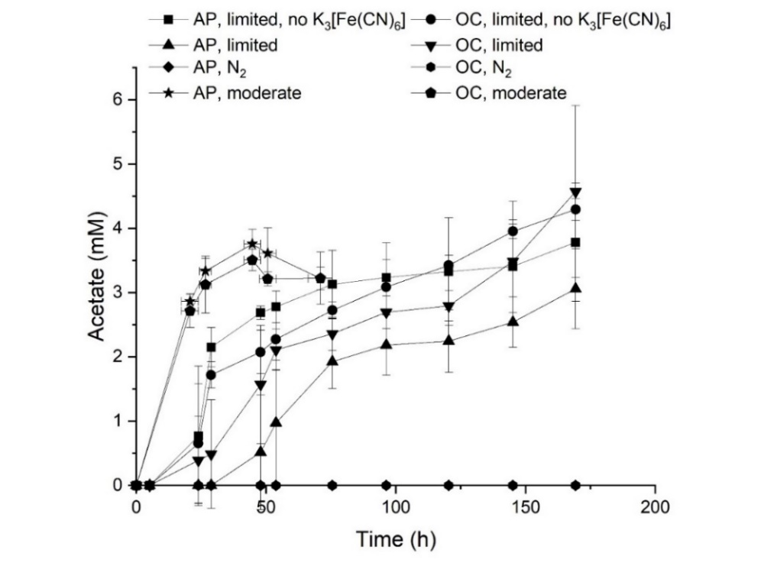
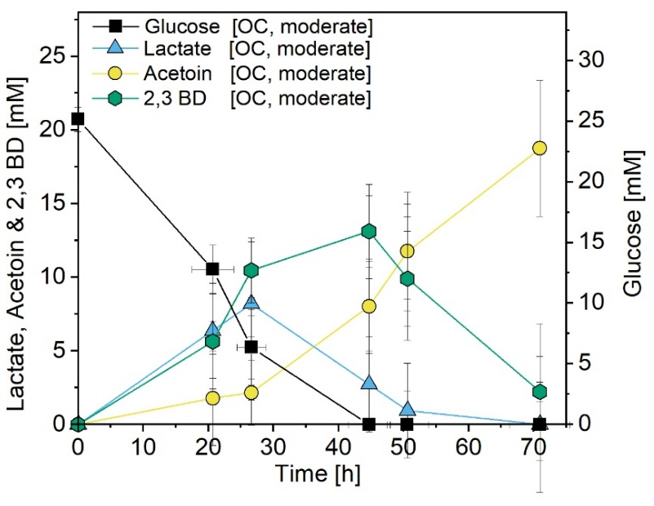
Fig. 2 Headspace gas compositions measured in microaerobic serum flasks. Results were based on the average data of three biological replicates.
Fig. 3 Acetate concentrations measured in BES systems under different cultivation conditions (see Table 1, main article). Results were based on the average data of three to four biological replicates and standard deviations are represented as error bars.
Fig. 4 Glucose and end product concentrations measured from open-circuit reactors with moderate aeration rate. Results were based on the average data of four biological replicates and standard deviations are represented as error bars.
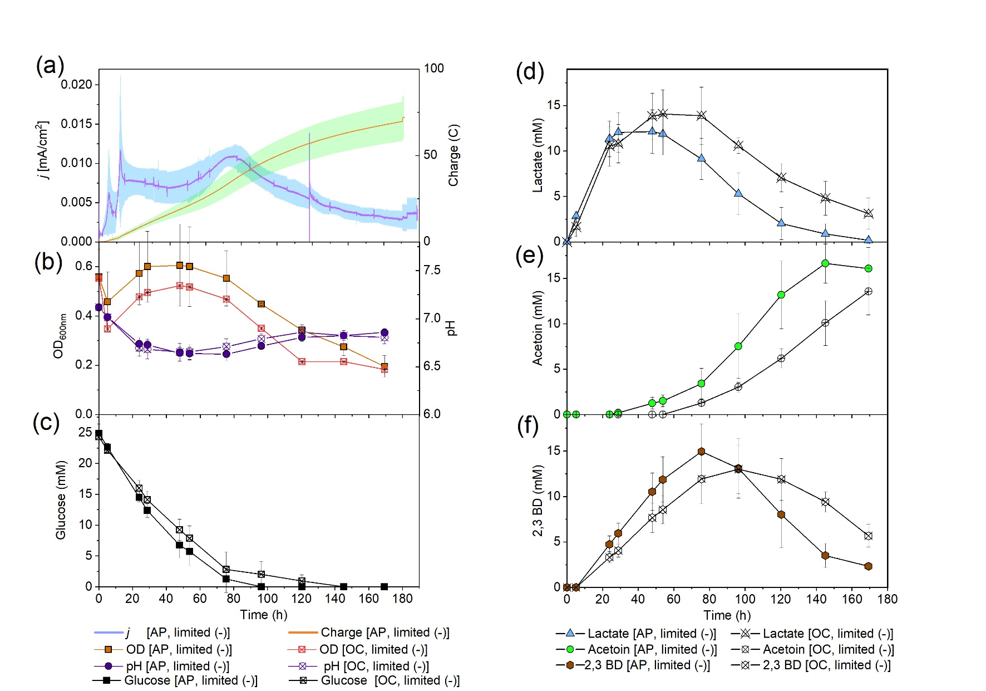
Fig. 5 B. subtilis grown in BES under limited aeration without adding K₃[Fe(CN)₆]. Ten times less current density and charge were logged at a poised anode potential of 0.7 V (vs. SHE) reactors compared to reactors amended with K₃[Fe(CN)₆] (a). Optical density and pH (b), glucose, lactate, acetoin, and 2,3-butanediol concentrations (c, d, e, f) were measured from applied potential (AP) and open-circuit (OC) reactors. Results were based on the average data of four biological replicates and standard deviations are represented as coloured areas or error bars.
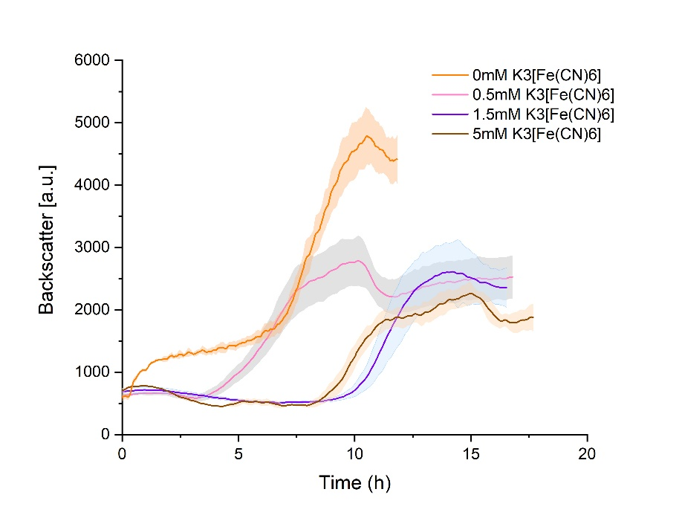
Fig. 6 B. subtilis grown in aerobic shake flasks with the addition of 0, 0.5, 1.5 and 5 mM K₃[Fe(CN)₆] in the M9 medium with 5 g/L glucose. The backscatter value corresponds to the biomass density. Each curve was based on the average data of three biological replicates and standard deviations are represented as coloured areas.

Table 1 Main parameters of B. subtilis grown using different electron acceptors. n.d.: not detected; (-): without the addition of K₃[Fe(CN)₆]; biomass and CO₂ concentrations were not included for carbon and redox balances.
 |  | Shake flask | Serum flask | Serum flask (+O₂) | Anaerobic AP | Anaerobic, OC | Moderate AP | Moderate OC | Limited AP | Limited OC | Limited AP (-)* | Limited OC (-)*
Carbon balance (%) |  | 60.70 ± 1.60 | 90.05 ± 3.34 | 65.0 ± 1.66 | 93.80 ± 2.25 | 97.48 ± 2.35 | 74.91 ± 1.66 | 76.77 ± 2.32 | 80.36 ± 1.89 | 81.20 ± 2.61 | 77.6 ± 1.70 | 80.5 ± 1.72
Redox balance (%) |  | 62.21 ± 1.79 | 88.64 ± 1.86 | 69.22 ± 1.60 | 97.02 ± 6.23 | 104.66 ± 2.36 | 85.48 ± 2.65 | 90.71 ± 5.90 | 89.26 ± 1.98 | 88.32 ± 2.30 | 89.0 ± 1.73 | 89.3 ± 2.91
 | Volumetric production rates (mmol/L/h)
Lactate |  | n.d.* | n.d. | n.d. | 0.05 ± 0.01 | 0.03 ±  0.01 | 0.29 ± 0.04 | 0.30 ± 0.04 | 0.22 ± 0.04 | 0.24 ± 0.01 | 0.29 ± 0.06 | 0.25 ± 0.04
Acetate |  | 1.50 ± 0.10 | n.d. | 0.21 ± 0.04 | n.d. | n.d. | 0.08 ± 0.01 | 0.09 ± 0.01 | 0.03 ± 0.003 | 0.03 ± 0.001 | 0.03 ± 0.01 | 0.02 ± 0.003
Acetoin |  | 0.21± 0.01 | n.d. | 0.31 ± 0.08 | n.d. | n.d. | 0.29 ± 0.02 | 0.26 ± 0.02 | 0.11 ± 0.01 | 0.06 ± 0.01 | 0.12 ± 0.02 | 0.08 ± 0.02
2,3-Butanediol |  | 0.02 ± 0.03 | n.d. | 0.05 ± 0.02 | 0.003 ± 0.004 | n.d. | 0.28 ± 0.03 | 0.36 ± 0.06 | 0.11 ± 0.02 | 0.09 ± 0.03 | 0.2 ± 0.04 | 0.13 ± 0.04
 | Volumetric consumption rates (mmol/L/h)
Glucose |  | 2.33 ± 0.09 | n.d. | 0.70 ± 0.17 | 0.03 ± 0.004 | 0.01 ±  0.01 | 0.58 ± 0.01 | 0.55 ± 0.02 | 0.21 ± 0.04 | 0.22 ± 0.05 | 0.31 ± 0.04 | 0.24 ± 0.08
Nitrate |  | n.d. | 0 | 0.45 ± 0.10 | n.d. | n.d. | n.d. | n.d. | n.d. | n.d. | n.d. | n.d.
Lactate |  | n.d. | n.d. | n.d. | 0 | 0 | 0.26 ± 0.06 | 0.29 ± 0.09 | 0.07 ± 0.04 | 0.13 ± 0.03 | 0.12 ± 0.03 | 0.10 ± 0.05
2,3-Butanediol |  | n.d. | n.d. | 0 | 0 | 0 | 0.44 ± 0.07 | 0.38 ± 0.10 | 0.17 ± 0.02 | 0.06 ± 0.02 | 0.15 ± 0.02 | 0.12 ± 0.03
 | Yields (mol_{product} / mol_{glucose})
Lactate |  | n.d. | n.d. | n.d. | 1.36 ± 0.34 | 0.28 ± 2.67 | 0 | 0 | 0 | 0.16 ± 0.05 | 0.01 ± 0.01 | 0.13 ± 0.07
Acetate |  | 0.65 ± 0.02 | n.d. | 0.43 ± 0.02 | n.d. | n.d. | 0.13 ± 0.01 | 0.13 ± 0.02 | 0.15 ± 0.04 | 0.17 ± 0.01 | 0.19 ± 0.06 | 0.13 ± 0.03
Acetoin |  | 0.1 ± 0.01 | n.d. | 0.32 ± 0.01 | n.d. | n.d. | 0.78 ± 0.04 | 0.75 ± 0.04 | 0.71 ± 0.02 | 0.39 ± 0.08 | 0.73 ± 0.04 | 0.56 ± 0.10
2,3-Butanediol |  | n.d. | n.d. | 0.12 ± 0.02 | 0.10 ± 0.10 | 0 | 0.03 ± 0.02 | 0.09 ± 0.03 | 0.12 ± 0.002 | 0.31 ± 0.07 | 0.10 ± 0.02 | 0.23 ± 0.05

Table 2 Student’s t-test results to compare the main parameters of B. subtilis growing in BES under 3 different conditions: T-tests have been performed via Microsoft Excel (data set of 3 (3 replicates), distribution tails = 1, two-sample unequal variance) to prove the null hypothesis (no difference between the conditions). To reject the null hypothesis a probability value (p-value) of lower than 0.05 has been chosen (p < 0.05 value in bold). A: limited aeration, 1.5 mM K₃[Fe(CN)₆], AP; B: limited aeration, 1.5 mM K₃[Fe(CN)₆], OC; C: limited aeration, no K₃[Fe(CN)₆], AP; D: moderate aeration, 1.5 mM K₃[Fe(CN)₆], AP; E: moderate aeration, 1.5 mM K₃[Fe(CN)₆], OC.
 |  | A*<->B* | A<->C* | A<->D* | D<->E*
Production rate (mmol/L/h) | Lactate | 0.242990722 | 0.080942992 | 0.088826462 | 0.367843657
Production rate (mmol/L/h) | Acetate | 0.33677822 | 0.463867591 | 0.000278804 | 0.317483796
Production rate (mmol/L/h) | Acetoin | 0.005888725 | 0.226379097 | 0.000859811 | 0.108204766
Production rate (mmol/L/h) | 2,3-Butanediol | 0.269433549 | 0.014031509 | 0.000984212 | 0.091851823
Yield (mol_{product}/mol_{glucose}) | Lactate | 0.020414271 | 0.195501109 | n.a. | n.a.
Yield (mol_{product}/mol_{glucose}) | Acetate | 0.255502088 | 0.235160147 | 0.233403189 | 0.482448804
Yield (mol_{product}/mol_{glucose}) | Acetoin | 0.012477393 | 0.32345382 | 0.05567697 | 0.209364145
Yield (mol_{product}/mol_{glucose}) | 2,3-Butanediol | 0.028081078 | 0.090376003 | 0.016377182 | 0.039384115
Consumption rate (mmol/L/h) | Glucose | 0.43162878 | 0.020414486 | 0.001348747 | 0.04912412
Consumption rate (mmol/L/h) | Lactate | 0.111922721 | 0.128928284 | 0.014415655 | 0.364155446
Consumption rate (mmol/L/h) | 2,3-Butanediol | 0.003954687 | 0.184453584 | 0.011837859 | 0.26092092

