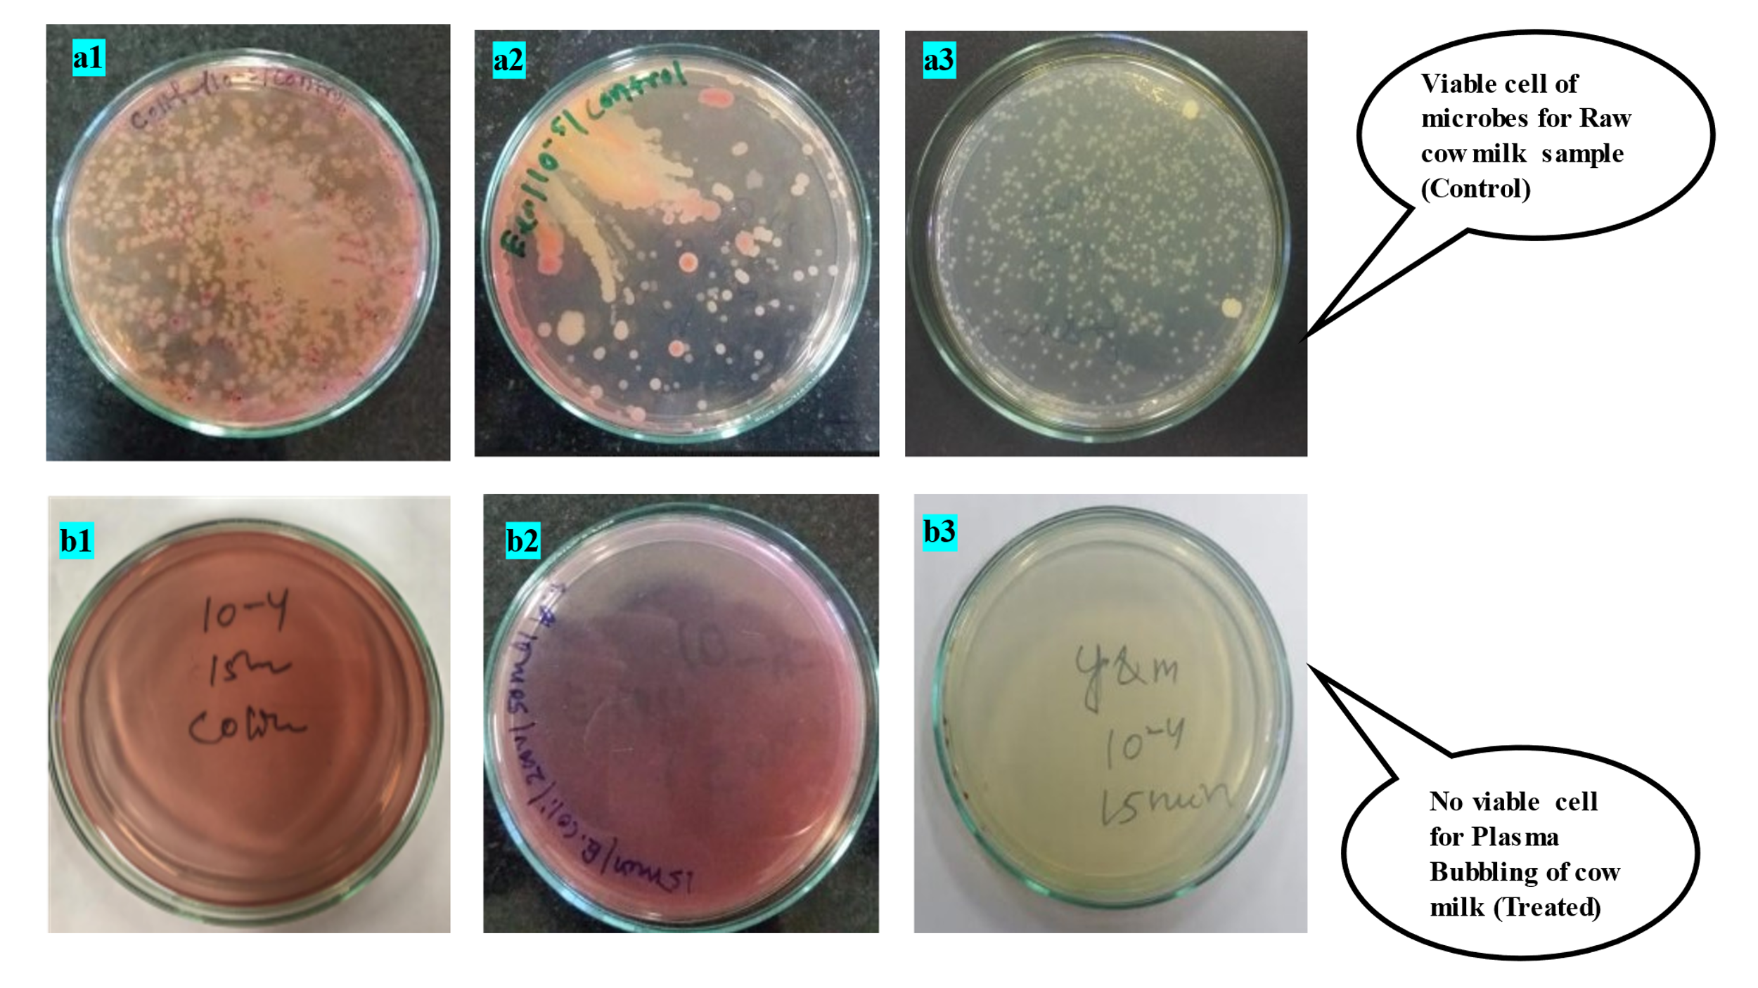
Fig 1. Comparative images of control and treated sample. Where a1) Viable cell counts for Coliform, a2) E. coli, a3) Yeast and mould for control sample and b1) coliform, b2) E. coli, b3) Yeast and Mould for treated sample (200V, 10L/h, 100mL, 15 min).

Table 1: A comparative analysis of wavenumber and transmittance of FTIR spectrum for standard, control and treated sample.
SI. No | Wavenumber of Standard Casein (cm-1) | Transmittance (%T) | Wavenumbers of Control Casein (cm-1) | Transmittance (%T) | Wavenumbers of Treated Casein (cm-1) | Transmittance (%T)
1 | 3276.56 | 95.55 | 3273.60 | 84.741 | 3270.63 | 80.080
2 | 2970.56 | 95.65 | 2923.54 | 88.510 | 2921.90 | 79.558
3 | 1739.32 | 89.65 | 1633.41 | 69.177 | 2851.92 | 85.801
4 | 1630.92 | 88.24 | 1515.23 | 72.095 | 1742.61 | 95.539
5 | 1523.6 | 89.35 | 1445.54 | 82.315 | 1626.01 | 61.991
6 | 1370.35 | 89.07 | 1237.39 | 86.543 | 1515.68 | 65.638
7 | 1217.09 | 87.41 | 1157.30 | 89.359 | 1445.85 | 76.205
8 | 665.41 | 89.53 | 1069.99 | 86.072 | 1237.16 | 79.642
9 | 538.8 | 89.89 | 536.64 | 77.170 | 1158.19 | 80.439
10 | - | - | 454.14 | 76.439 | 1070.98 | 78.221
11 | - | - | - | - | 421.07 | 60.365

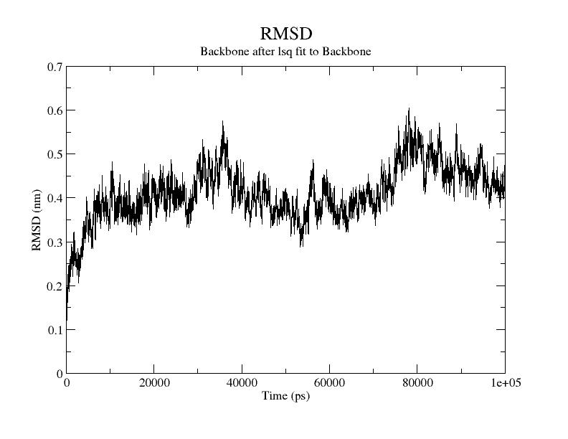
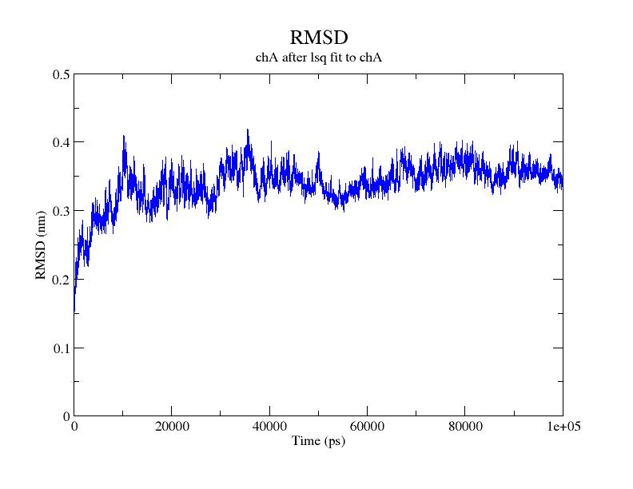
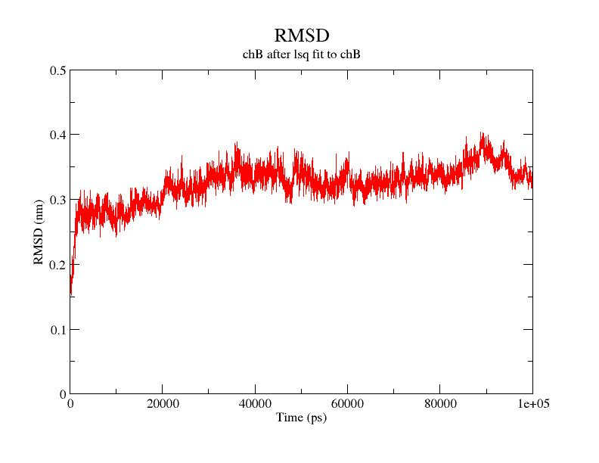
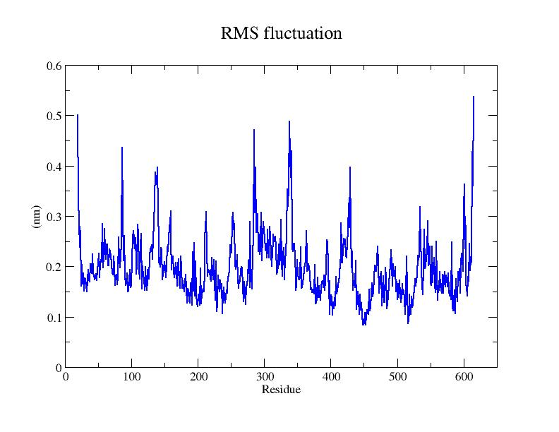
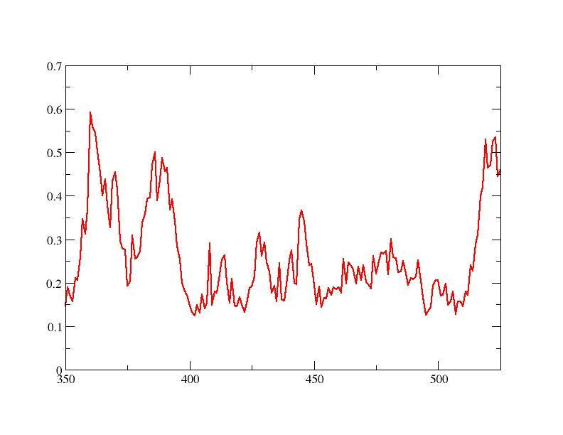
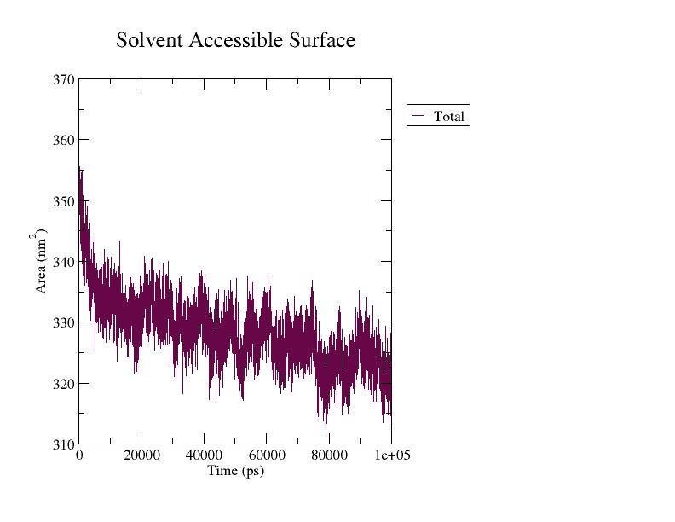
RMS fluctuation fluctuation
(nm)
Residue
A
B
C
D
E
F

Fig 6. Molecular dynamics stimulation of ACE2-RBD complex (A) overall RMSD (B) RMSD of ACE2 receptor (C) RMSD of RBD (D) RMS fluctuation of ACE2 receptor (E) RMSF analysis of RBD (F) SASA of ACE2-RBD.
Table 4. Potential H-bond interactions were identified in the ACE2-RBD and ACE2-RBD-peptide complex from 100 ns period.
Interaction  ACE2-RBD Complex | Distance (Å) | Interaction of  ACE2-RBD in peptide Complex | Distance (Å) | Interaction of peptide | Distance (Å)
Asp38-Gly496 | 3.11 | Glu23-Gly476 | 3.23 | Tyr5-Asn487 | 3.13
Asp38-Tyr449 | 2.75 | Asn64-Gly447 | 2.83 | Leu3-Phe490 | 3.31
Tyr83-Asn487 | 2.76 | Gln42-Asn448 | 3.32 | Arg1-Ser494 | 3.09
Tyr83-Tyr489 | 2.58 | Lys353-Tyr505 | 2.80 | Tyr5-Gly485 | 2.93
Glu35-Gln493 | 3.20 | Asp38-Tyr505 | 2.69 | Tyr2-Leu492 | 3.05
Tyr83-Tyr417 | 3.12 | Glu23-Ser477 | 3.08 | Tyr5-Val483 | 2.99
Arg357-Thr500 | 2.88 | Ser19-Cys488 | 2.99 | Tyr5-Cys488 | 3.15
Tyr41-Thr500 | 2.87 | Asn61-Gly447 | 3.09 | Arg1-Glu23 | 2.94
Lys353-Gly502 | 2.78 | Glu35-Gln493 | 3.05 | Lys3-Gln42 | 3.21
Glu37-Tyr505 | 3.00 | His34-Gln493 | 2.90
Ser19-Gly476 | 3.33 | Thr27-Ala475 | 3.03
Gln24-Ala475 | 2.99 | Asn61-Gly446 | 3.18
Arg393-Tyr505 | 3.18 | Asn49-Thr500 | 2.92
Gln24-Asn487 | 3.01 | Tyr41-Asn501 | 3.10
Asp355-Thr500 | 3.08 | Gln42-Gly447 | 3.02
Asp38-Gln498 | 2.96 | Lys68-Gly447 | 3.17
Lys353-Gly496 | 3.11 | Asp38-Gln498 | 3.19
Glu23-Tyr473 | 2.70 | Lys31-Leu492 | 3.12
Asp30-Lys417 | 2.96 | Gln42-Gly496 | 2.93
Gln42-Tyr449 | 2.68 | Lys353-Gln498 | 3.23
Gln42-Gln498 | 2.86 | Asn61-Val445 | 2.86
Lys353-Asn501 | 3.25 | Asp38-Phe497 | 3.02
Gln24-Gly476 | 2.64 | His34-Arg403 | 2.96
His34-Tyr453 | 3.07 | Thr27-Gln474 | 3.27
Glu24-Gln474 | 2.94 | Gln42-Lys444 | 3.01
Gln86-Ser477 | 3.06 | Glu42-Tyr449 | 2.73
Lys31-Gln493 | 3.16 | Lys26-Ser477 | 3.23
His34-Gln493 | 3.15 | Asp355-Gly502 | 3.30
Gln76-Tyr489 | 3.01 | Thr20-Phe486 | 2.91
Gly354-Tyr505 | 3.23 | Thr27-Tyr489 | 3.03
Gln86-Gly476 | 3.23 | Phe28-Ala475 | 3.02
Pro84-Ser477 | 3.16 | Glu37-Tyr505 | 2.76
Lys31-Leu492 | 2.88 | Thr20-Asn487 | 3.22
Asp30-Gln493 | 2.98
Lys353-Tyr449 | 3.17
Gln498-Lys353 | 2.84

