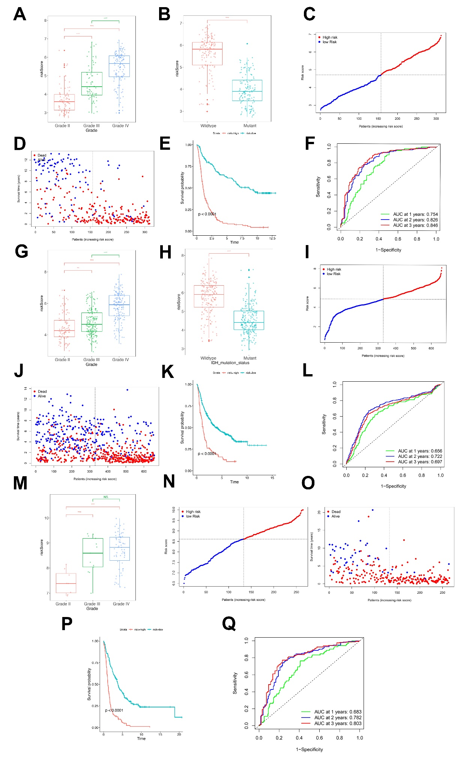
Supplementary Figure 1 (A-F) The reliability of the risk score was verified in CGGA-325 cohorts. (A) The risk score increased with WHO grade in glioma patients. (B) The risk score was higher in IDH wide-type group than in the mutant group. (C) Patients were divided into high-risk and low-risk groups based on the median risk score as the cutoff value. (D) Patients with dead state had higher risk scores. (E) Kaplan–Meier survival curves show that the survival time of high-risk patients was significantly shorter than that of low-risk patients. (F) The ROC curves and AUC of risk score cohort suggested a favorable predictive value of this model in short- and long-term follow-up.
(G-L) The reliability of the risk score was verified in CGGA-693 cohorts. (G)The risk score increased with WHO grade in glioma patients. (H)The risk score was higher in IDH wide-type group than in the mutant group. (I) Patients were divided into high-risk and low-risk groups based on the median risk score as the cutoff value. (J) Patients with dead state had higher risk scores. (K) Kaplan–Meier survival curves show that the survival time of high-risk patients was significantly shorter than that of low-risk patients. (L) The ROC curves and AUC of risk score cohort suggested a favorable predictive value of this model in short- and long-term follow-up.
(M-Q) The reliability of the risk score was verified in Rembrandt cohorts. (M) The risk score increased with WHO grade in glioma patients. (N) Patients were divided into high-risk and low-risk groups based on the median risk score as the cutoff value. (O) Patients with dead state had higher risk scores. (P) Kaplan–Meier survival curves show that the survival time of high-risk patients was significantly shorter than that of low-risk patients. (Q) The ROC curves and AUC of risk score cohort suggested a favorable predictive value of this model in short- and long-term follow-up.
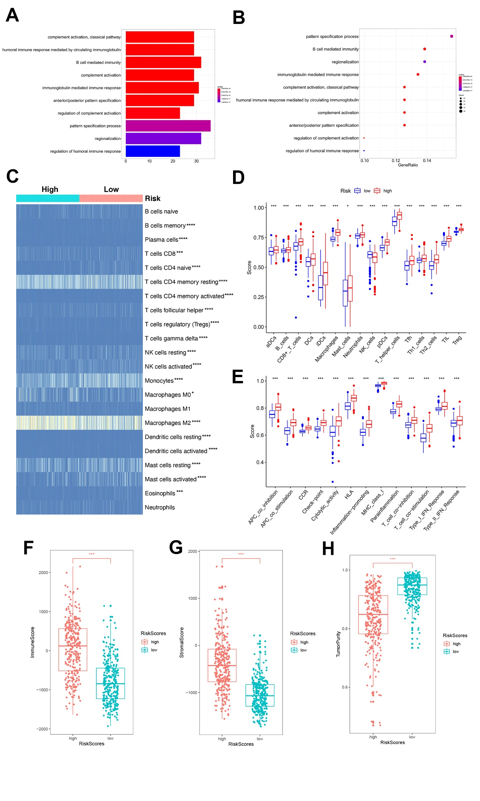
Supplementary Figure 2 The ferroptosis-related risk score was associated with immuno-suppressive microenvironment. (A-B) GO enrichment analysis indicated that the risk score was obviously correlated with immune-related biological processes (A, bar plot; B, pot plot). (C) CIBERSORT results showed patients with high-risk score showed significant enrichment of immune-infiltration cells. (D-E) ssGSEA analysis showed the immune-cell scores(D) and immunity-related pathways(E) in high-risk group were significantly higher than those in the low-risk group. (F-H) ESTIMATE results showed that patients in the high-risk group had higher immune scores, stromal scores, and lower tumor purity.
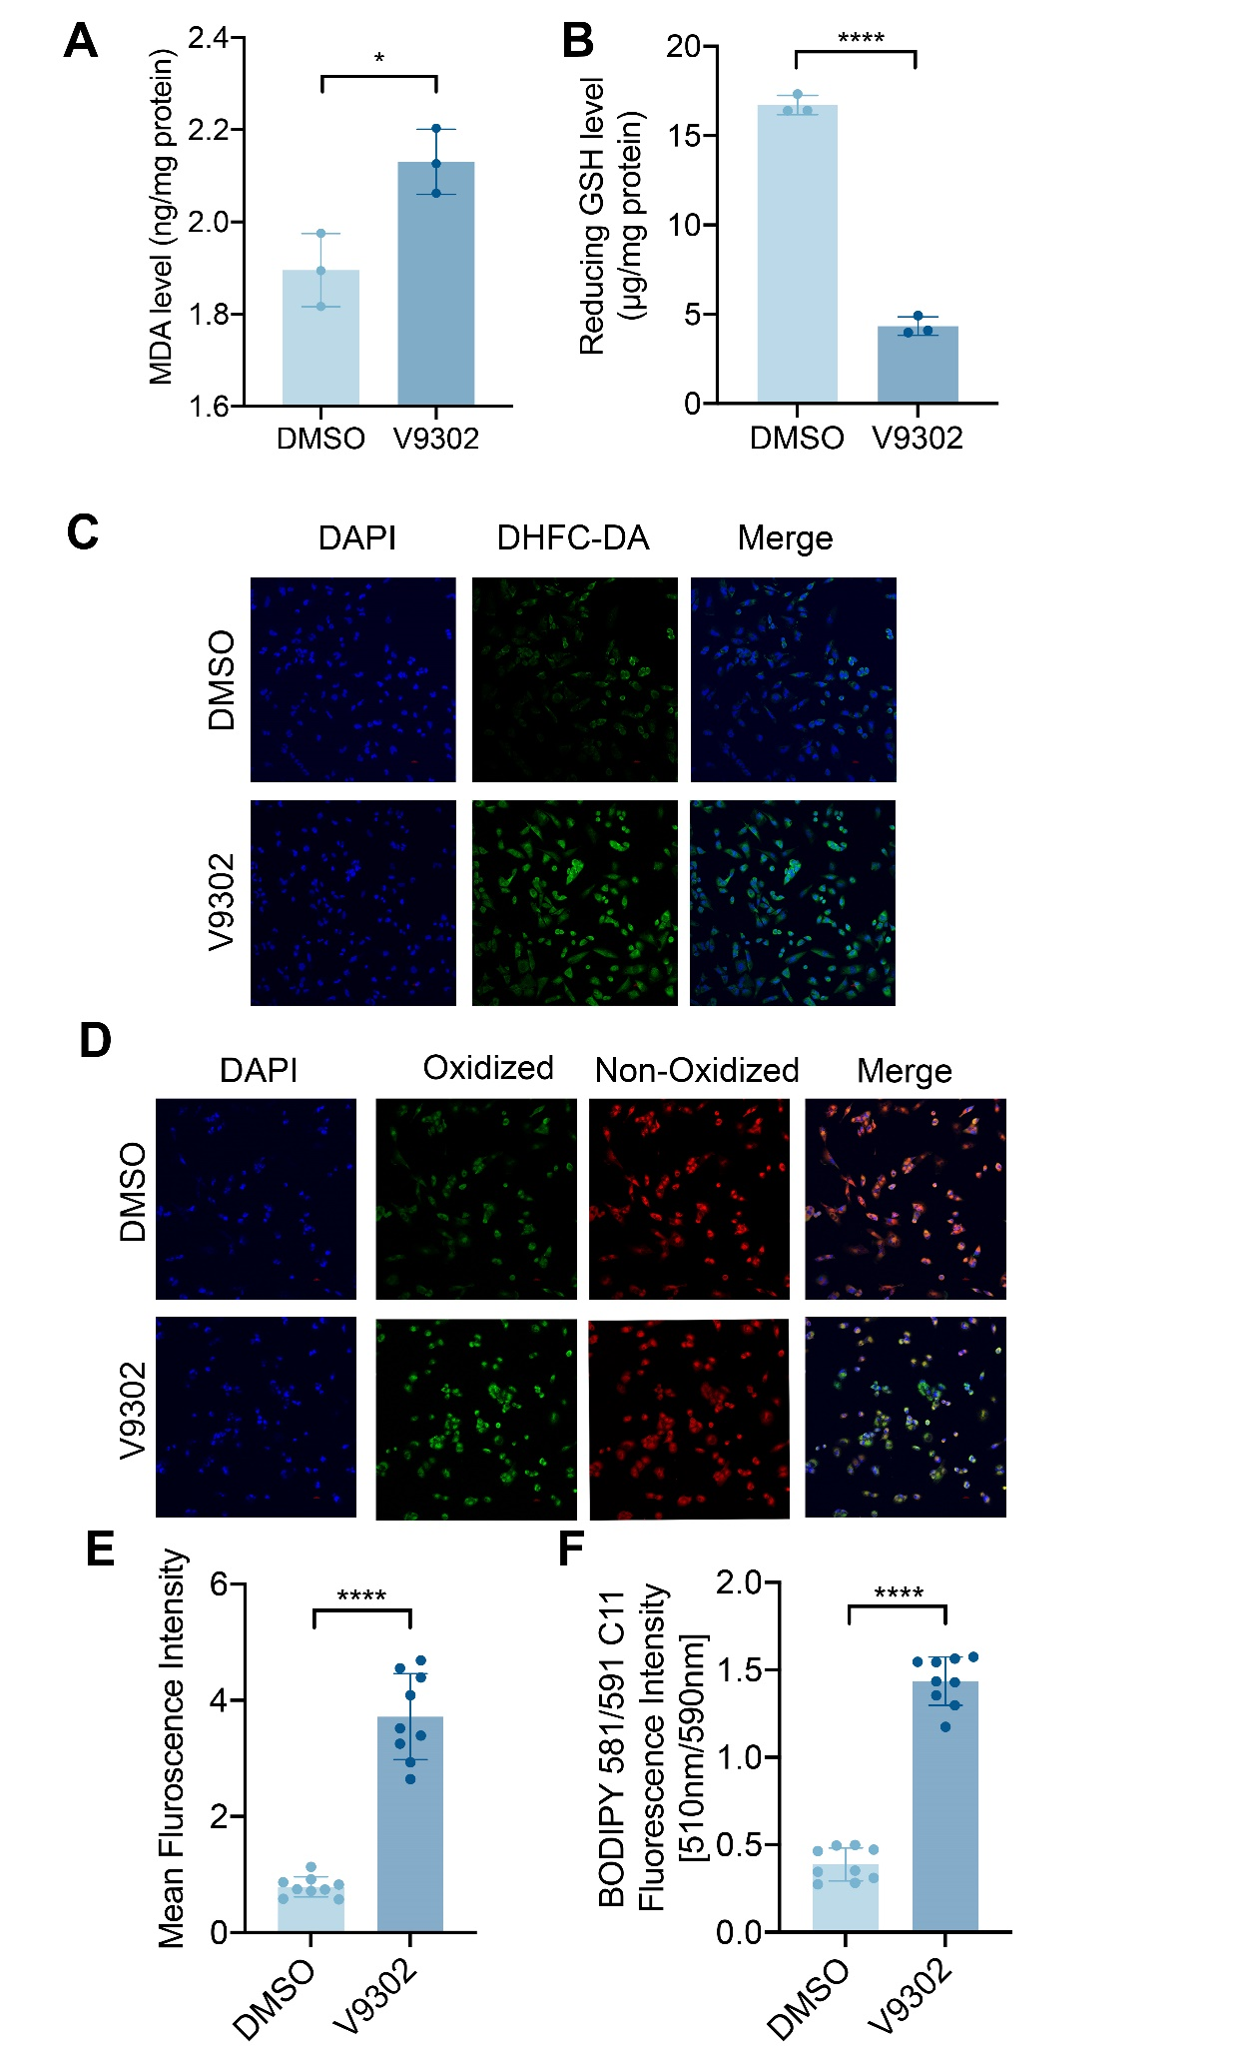
Supplementary Figure 3 Pharmacological inhibition of SLC1A5 enhanced intracellular level of oxidative stress. (A) The MDA level of T98G cell line in V9302 and control groups. (B) The reduced GSH level of T98G cell line in V9302 and control groups. (C, E) The fluorescence intensity of DHFC-DA (green) after V9302 treatment in T98G cells (Scale Bar=50 μm). (D, F) The level of oxidized lipid peroxides(green) after V9302 treatment in T98G cells (Scale Bar=50 μm).

