Appendix
Myocardial Guccione active tension model
The Guccione model (Guccione et al. 1993) was employed to describe myocardial active tension, which was based on a calcium activation model, where the active stress $σ_{a}$ was calculated as:
$$\begin{aligned}σ_{a}=T_{max}\frac{{Ca}_{0}^{2}}{{Ca}_{0}^{2}+E{Ca}_{50}^{2}}C_{t }\vec{e_{f}}⊗\vec{e_{f0}}\#\left(5\right)\end{aligned}$$
where $T_{max}$ was the maximum active tension, ${Ca}_{0}$ was the peak calcium concentration, $\vec{e_{f}}$ and $\vec{e_{f0}}$ were the local fiber directions in the current stage and the reference stage, ${ECa}_{50}$ was the calcium sensitivity which was dependent on sarcomere length and $C_{t}$ was the temporal variation coefficient. ${ECa}_{50}$ and $C_{t}$ were described as following equations:
$$\begin{aligned}{ECa}_{50}=\frac{{{(Ca}_{0})}_{max}}{\sqrt{\exp\left(B\left(l-l_{0}\right)\right)-1}}\#\left(6a\right)\end{aligned}$$
$$\begin{aligned}C_{t}=\frac{1}{2}\left(1-\cos{ω}\right)\#\left(6b\right)\end{aligned}$$
$$\begin{aligned}ω=\left\{\begin{matrix}π\frac{t}{t_{0}} when 0≤t<t_{0} \\ {π\frac{t-t_{0}+t_{r}}{t_{r}} when t}_{0}≤t<t_{0}+t_{r} \\ 0 when t ≥ t_{0}+t_{r}\end{matrix}\right.\#\left(6c\right)\end{aligned}$$
where $t_{0}$was the time to peak tension, which specifies how long it takes the myofibers to contract, and $t_{r}$ was the relaxation time. $t_{0}$ was specified according to measurements by (Mulieri et al. 1992), and depended on heart rate (HR), as follows:
$$\begin{aligned}t_{0}=-0.96*HR+243\#\left(7\right)\end{aligned}$$
while $t_{r}$ was calculated as following equation:
$$\begin{aligned}t_{r}=ml+b\#\left(8a\right)\end{aligned}$$
$$\begin{aligned}l=\sqrt{\vec{e_{f0}}∙\vec{C_{LV}}∙\vec{e_{f0}}} l_{r}\#\left(8b\right)\end{aligned}$$
$$\begin{aligned}\vec{C_{LV}}=\vec{{F_{LV}}^{T} }∙ \vec{F_{LV}}\#\left(8c\right)\end{aligned}$$
where m was the slope of the relaxation duration and b was the time-intercept of linear duration, and $l$ was the real time sarcomere length, and $\vec{C_{LV}}$ was the right Cauchy-Green deformation tensor calculated from the deformation tensor $\vec{F_{LV}}$.

Table A1: default fixed parameters for FE model (Shavik et al. 2018)
Parameters | Unit | Values
Fiber direction material stiffness, $B_{FF}$ | unitless | 29.8
Cross-fiber direction material stiffness, $B_{SS}$, $B_{NN}$ | unitless | 14.9
Shear mode material stiffness, $B_{FX}$ | unitless | 19.2
Peak intracellular Ca concentration, $Ca_{0}$ | $$μM$$ | 4.35
Maximum peak intracellular Ca concentration, ${(Ca_{0})}_{max}$ | $$μM$$ | 4.35
Parameter for isometric tension (sarcomere length relation), B | $${μm}^{-1}$$ | 4.75
Sarcomere length at zero-active tension, $l_{0}$ | $$μm$$ | 1.58
relaxed sarcomere length, $l_{r}$ | $$μm$$ | 1.85
Heart rate, HR | $$beat*\min^{-1}$$ | 1000
Time to LV peak tension, $t_{0}$ | $$ms$$ | 185.5
slope of linear relaxation duration (sarcomere length relation), m | $$ms*{μm}^{-1}$$ | 1049
time-intercept of linear relaxation duration (sarcomere length relation), b | $$ms$$ | -1600

Winkessel Lumped-Parameter Model
The time-varying LA elastance model was described as:
$$\begin{aligned}P_{LA}\left(t\right)=e\left(t\right){*E}_{es,LA}*\left(V_{LA}\left(t\right)-V_{0, LA}\right)+\left(1-e\left(t\right)\right)*A_{LA}*(e^{B_{LA}*\left(V_{LA}\left(t\right)-V_{0,LA}\right)}-1)\#\left(8a\right)\end{aligned}$$

$$\begin{aligned}e\left(t\right)=\left\{\begin{aligned}\frac{1}{2}\left(\sin\left[\left(\frac{π}{t_{max,LA}}\right)t-\frac{π}{2}\right]+1\right) when 0<t≤\frac{3}{2}t_{max,LA} \\ \frac{1}{2}e^{-\frac{t-\frac{3}{2}t_{max,LA}}{τ_{LA}}} when t>\frac{3}{2}t_{max,LA}\end{aligned}\right.\#\left(8b\right)\end{aligned}$$
Where $E_{es,LA}$ was the LA end-systolic elastance, $V_{LA}\left(t\right)$ and $V_{0,LA}$ were the LV volume at any time and volume intercept of the end-systolic pressure–volume relationship (ESPVR), and $A_{LA}$ and $B_{LA}$ were parameters of the end-diastolic pressure-volume relationship (EDPVR), $t_{max,LA}$ was the time point with the maximal LA elastance and $τ_{LA}$ was the LA relaxation time constant.

Table A2: default fixed parameters for Windkessel circulatory and LA elastance model, as obtained from (Shavik et al. 2018)

Parameters | Unit | Values
Aortic valve resistance, Rao | $$Pa*ms*{ml}^{-1}$$ | 6500
Mitral valve resistance, Rmv | $$Pa*ms*{ml}^{-1}$$ | 2500
Peripheral vascular resistance, Rper | $$Pa*ms*{ml}^{-1}$$ | 80000
Venous resistance, Rven | $$Pa*ms*{ml}^{-1}$$ | 2000
Arterial compliance, Cart | $$Pa*ml$$ | 0.033
Venous compliance, Cven | $$Pa*ml$$ | 0.4
Resting volume for arterial, Vart,0 | $$ml$$ | 580
Resting volume for venous, Vven,0 | $$ml$$ | 3600
LA end-systolic elastance, $E_{es,LA}$ | $$Pa/ml$$ | 60
Volume axis intercept from ESPVR, $V_{0,LA}$ | $$ml$$ | 10
Scaling factor for EDPVR, $A_{LA}$ | $$Pa$$ | 58.67
Exponent coefficient for EDPVR, $B_{LA}$ | $${ml}^{-1}$$ | 0.049
Time to LA end-systole, $t_{max,LA}$ | $$ms$$ | 200
LA relaxation time constant, $τ_{LA}$ | $$ms$$ | 25

Effects of shear stiffness $B_{FS}$ and $B_{FN}$ on LV functions and biomechanics.
Table A3: effects of shear stiffness $B_{FS}$ and $B_{FN}$ on LV functions and biomechanics for various FE simulations. SA: sheetlet angle; TA: transverse angle. Unit for peak systolic pressure is mmHg, and unit for maximal fiber stress is kPa.

TA 10$°$ |  | $B_{FN}$ 19.2 | $B_{FN}$ 19.2 | $B_{FN}$ 14.4 | $B_{FN}$ 14.4 | $B_{FN}$ 19.2 | $B_{FN}$ 9.6 | $B_{FN}$ 9.6
$B_{NS}$ 15.0 |  | $B_{FS}$ 19.2 | $B_{FS}$ 14.4 | $B_{FS}$ 19.2 | $B_{FS}$ 14.4 | $B_{FS}$ 9.6 | $B_{FS}$ 19.2 | $B_{FS}$ 9.6
Healthy  (SA 18$°$) | EF (%) | 53.8 | 53.9 | 53.8 | 53.9 | 54.0 | 53.8 | 54.0
Healthy  (SA 18$°$) | SV (ml) | 86.3 | 86.8 | 86.6 | 87.0 | 87.5 | 86.9 | 88.0
Healthy  (SA 18$°$) | Peak Systolic pressure | 119.7 | 120.2 | 119.7 | 120.2 | 121.0 | 119.8 | 121.0
Healthy  (SA 18$°$) | Maximal Fiber Stress | 55.1 | 54.9 | 55.4 | 55.2 | 54.9 | 56.0 | 55.7
HCM  (SA 48$°$) | EF | 60.6 | 60.7 | 60.7 | 60.8 | 60.9 | 60.9 | 60.9
HCM  (SA 48$°$) | SV | 92.4 | 92.9 | 92.8 | 93.3 | 93.7 | 93.4 | 93.7
HCM  (SA 48$°$) | Peak Systolic pressure | 140.7 | 140.6 | 140.9 | 140.6 | 140.5 | 141.2 | 140.5
HCM  (SA 48$°$) | Maximal Fiber Stress | 32.1 | 31.7 | 32.5 | 32.2 | 31.2 | 33.3 | 31.2
DCM  (SA 18$°$) | EF | 43.2 | 43.2 | 43.0 | 43.0 | 43.2 | 42.9 | 42.9
DCM  (SA 18$°$) | SV | 113.0 | 113.2 | 112.9 | 113.0 | 113.4 | 112.6 | 113.0
DCM  (SA 18$°$) | Peak Systolic pressure | 135.9 | 136.0 | 135.5 | 135.6 | 136.2 | 134.9 | 135.1
DCM  (SA 18$°$) | Maximal Fiber Stress | 77.7 | 77.6 | 77.8 | 77.7 | 77.6 | 78.2 | 77.9

Effects of transverse angle on LV function and biomechanics.
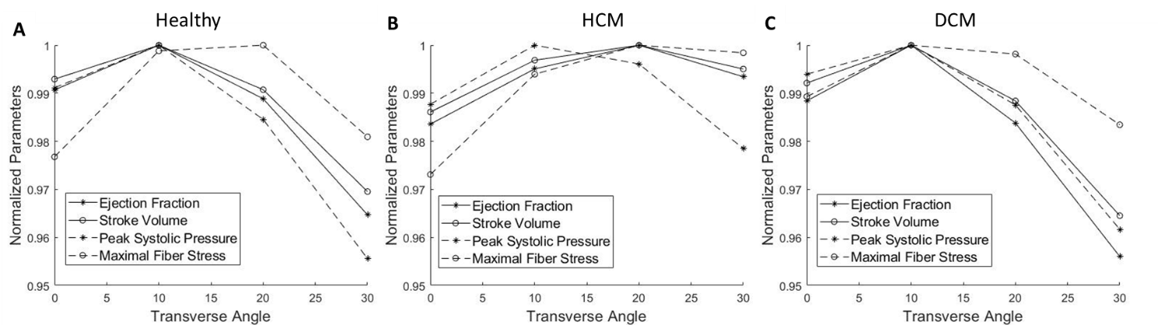
Figure A1: Effects of transverse angle on the LV function and biomechanics in the (A) healthy geometry, (B) HCM geometry and (C) DCM LV geometry. The sheetlet angles were 18$°$, 48$°$ and 18$°$, for healthy, HCM and DCM LV geometries respectively, and $B_{NS}$ was 15.0 for all cases. All the parameters were normalized to their maximal values.

Influences of myocardial contractility and stiffness on the hypertrophied and dilated geometries
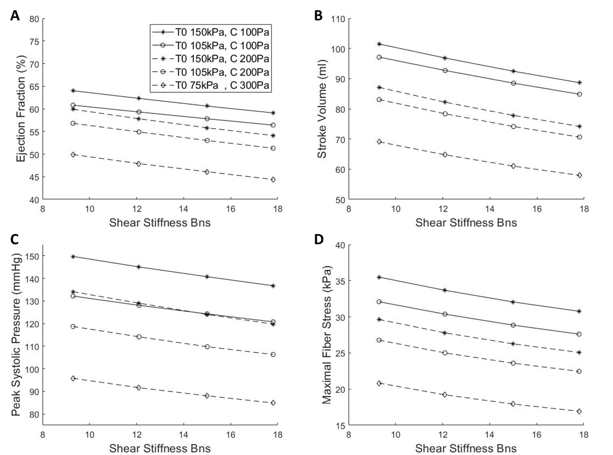
Figure A2: For the hypertrophic LV geometry, changing myocardial contractility and myocardial stiffness coefficient did not alter the influence of sheetlet sliding on LV cardiac function and biomechanical parameters, including (A) ejection fraction, (B) stroke volume, (C) peak systolic pressure and (D) maximal fiber stress when the LV geometry was hypertrophied.

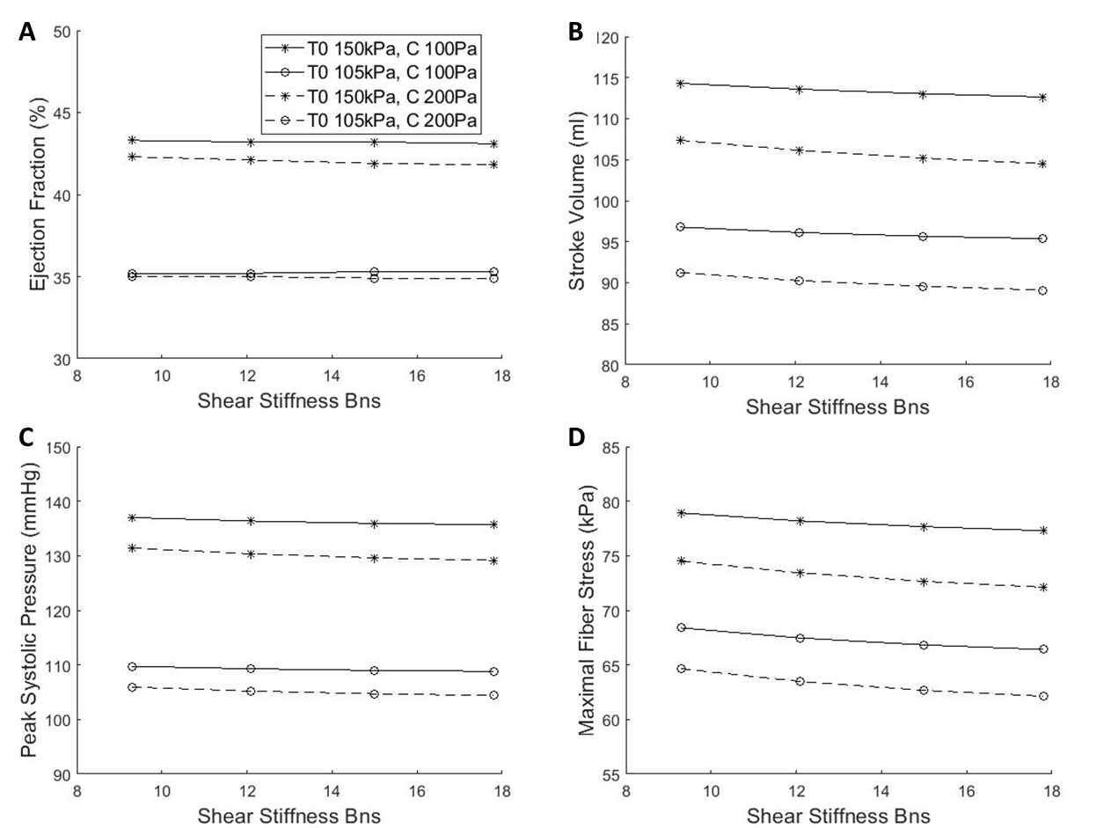
Figure A3: For the dilated LV geometry, changing myocardial contractility and myocardial stiffness coefficient did not alter the influence of sheetlet sliding on LV cardiac function and biomechanical parameters, including (A) ejection fraction, (B) stroke volume, (C) peak systolic pressure and (D) maximal fiber stress when the LV geometry was hypertrophied.

