Extended data for ‘Revealing a Solar Cycle Resonance through tree-rings’

Ali Khorchani¹*
Issam Touhami¹
Mohamed Tahar Elaieb¹
Abdelhamid Khaldi¹
1University of Carthage. The National Research Institute of Rural Engineering, Water, and Forestry. INRGREF. Laboratory of Management and Valorization of Forest Resources. BP 10 Ariana 2080. Tunisia
- * Correspondent author : ali.khorchani@ingref.ucar.tn
- ORCID : https://orcid.org/0000-0003-4241-524X

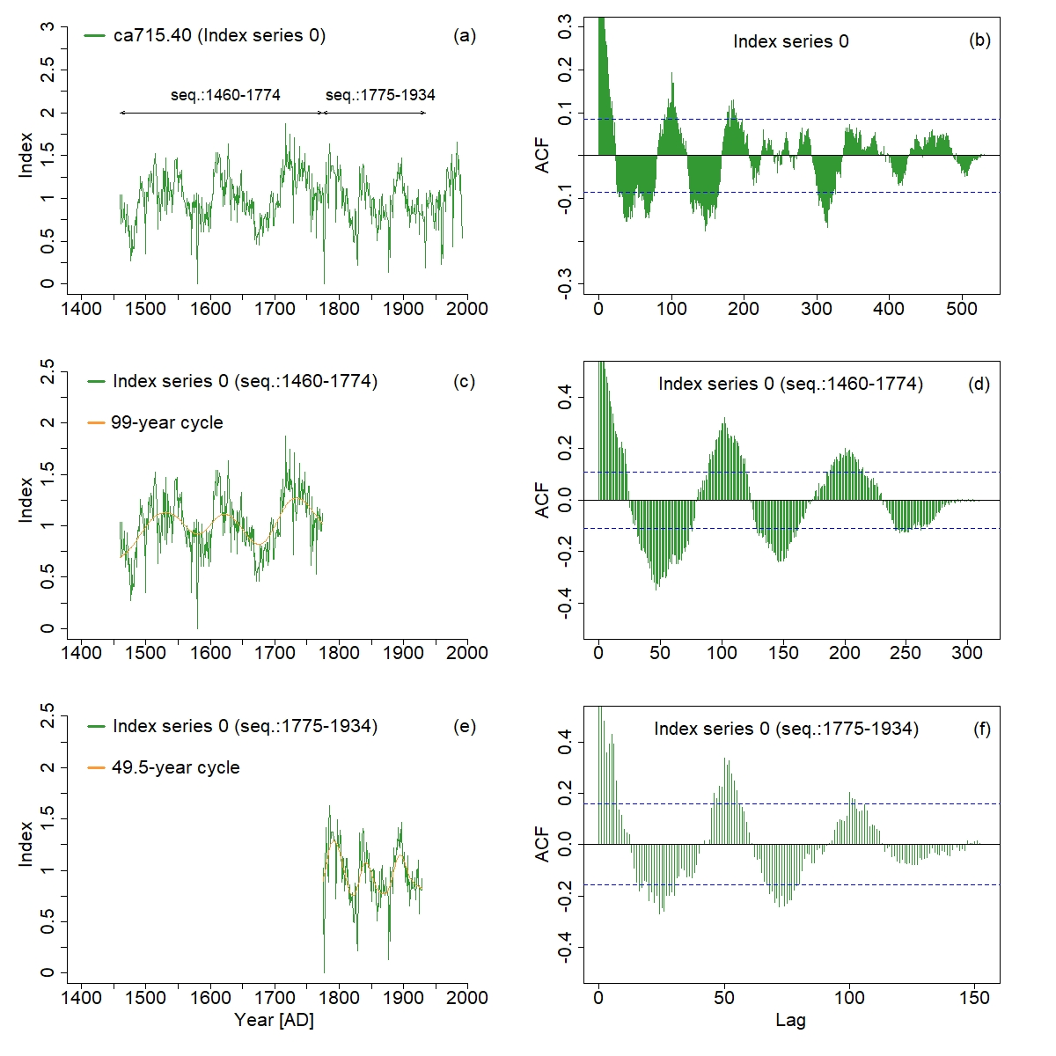
Extended data Fig. 1: Example showing the use of two sequences for the detection of inherent signals in a TRW-time series from Giant Sequoia (site code: ca715, series number: 40). Left: example of index series 0 (green curves) showing two inherent signals (orange curves) in two different time spans (c: 99-year and e: 49.5-year cycles). Right: ACF corresponding to each time span and 90% significance level (blue dashed lines).

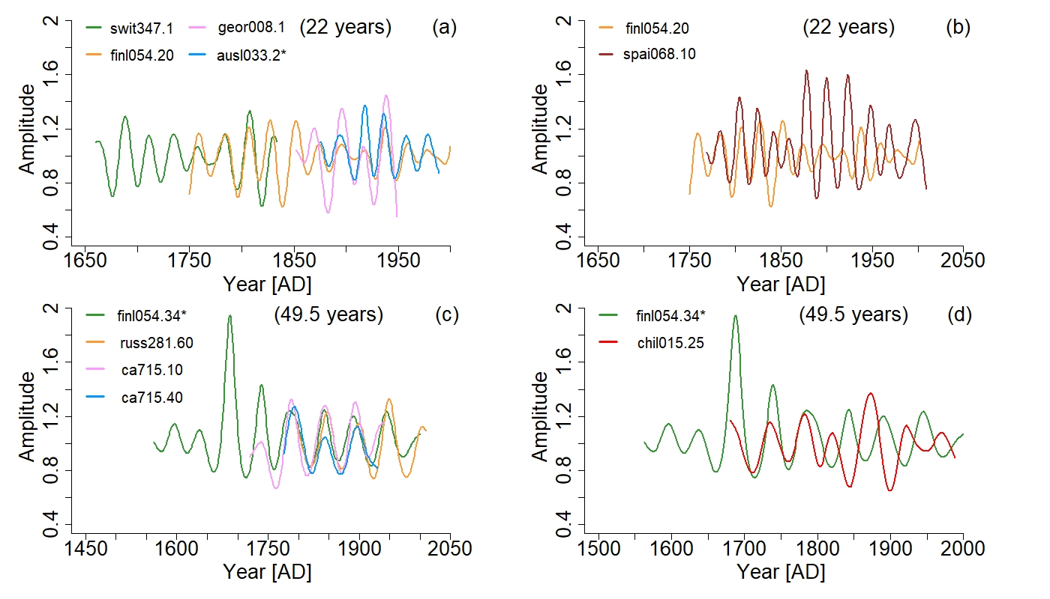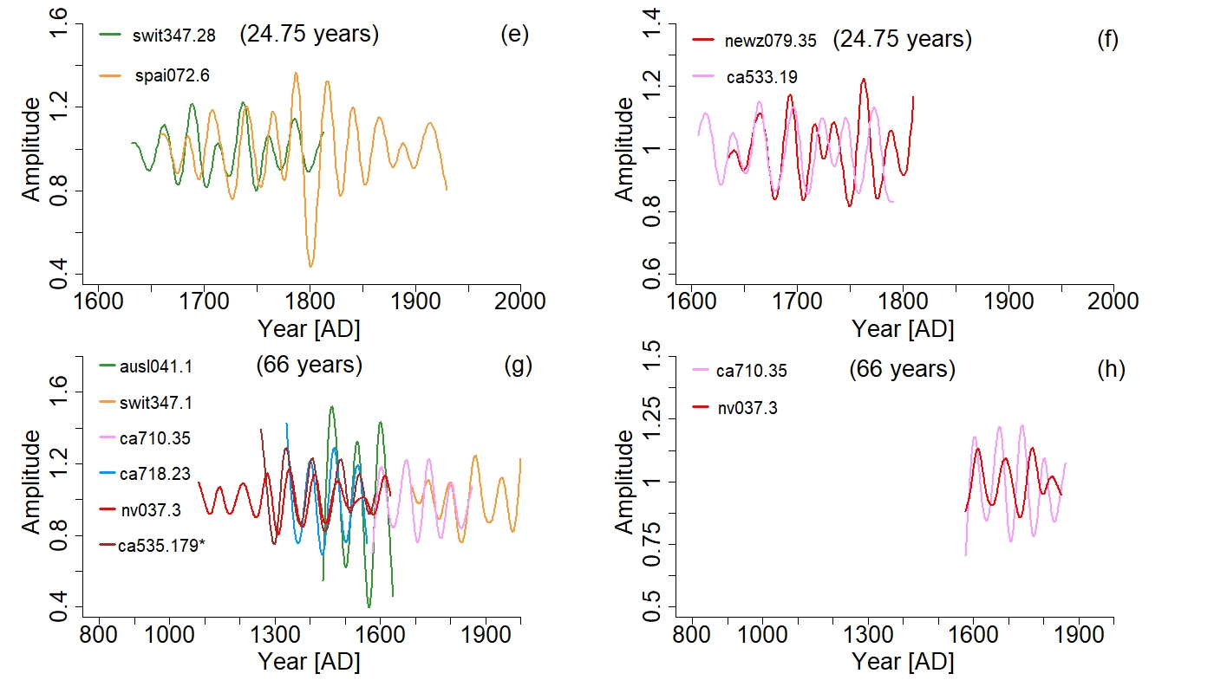
Extended data Fig.2: Examples of four extracted cycles (22-year, 49.5-year, 24.75-year and 66-year) from different examples showed in this study. (a, c, e and g) show the good matching from different sites, tree-species and time span when sites and tree-species are in-phase or in anti-phase (*) over the total length of the time series. (b, d, f and h) show a transition from an in-phase to an anti-phase stage. More details for the different sites and tree-species are given in table S1.

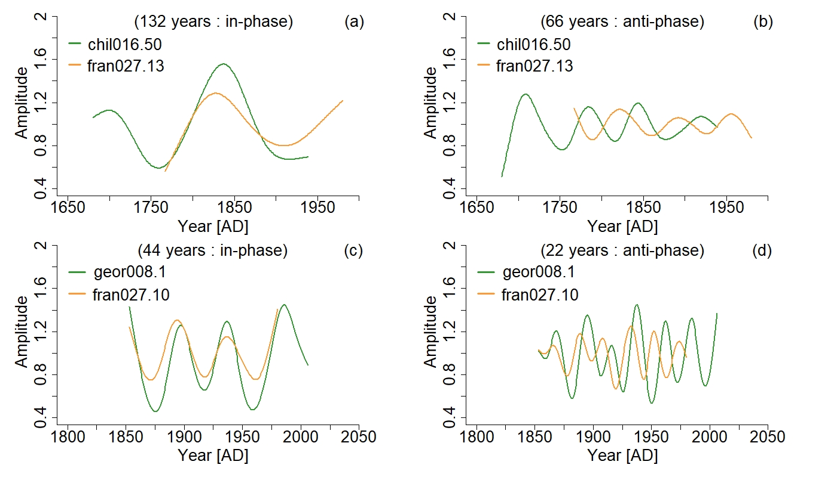
Extended data Fig.3: Examples of four extracted cycles (132-year, 66-year, 44-year and 22-year) from different species and sites. (a and c) show where the two cycles (132 and 44 years) are in-phase. (b and d) show where the two cycles (66 and 22 years) are in anti-phase. More details for the different sites and tree-species are given in table S1.

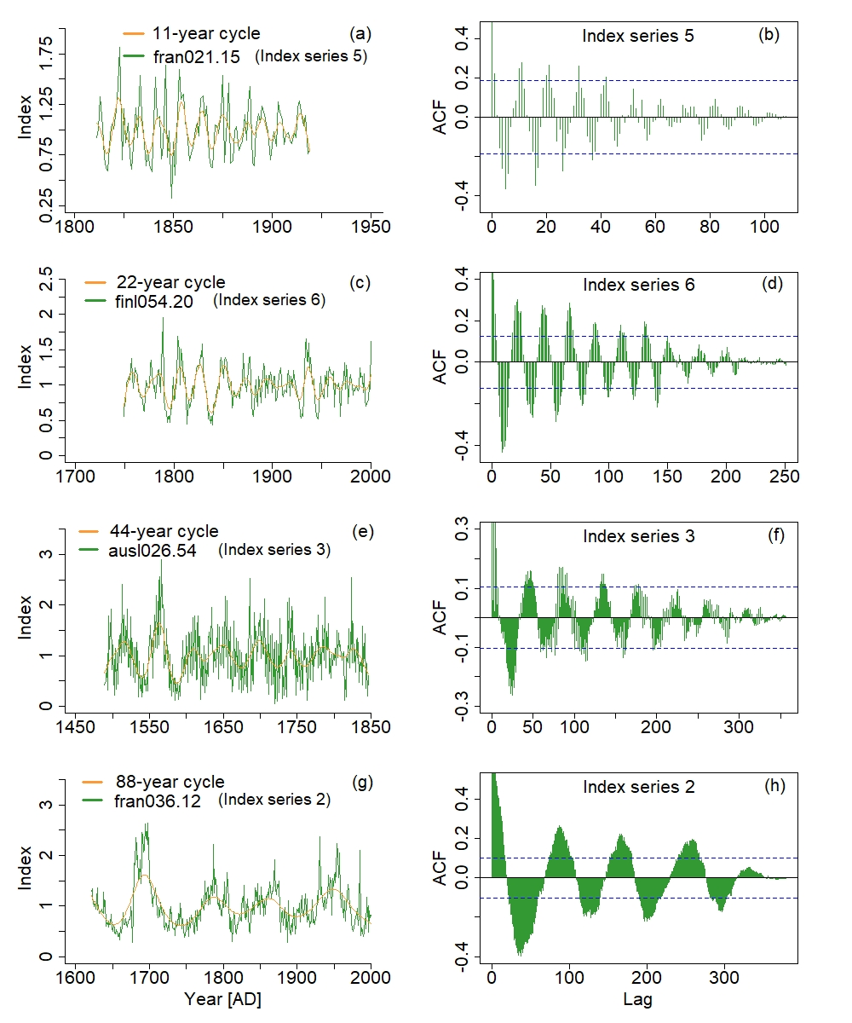
Extended data Fig.4: First harmonic mode (HM1) showing resonance 1.2 of the 11-year solar cycle. Left: example of different index series from different sites, species and time spans (green curves) and the extracted signals (orange curves). Right: ACF corresponding to each index series and 90% significance level (blue dashed lines). More details for the different sites and species are given in Supplementary table 1.

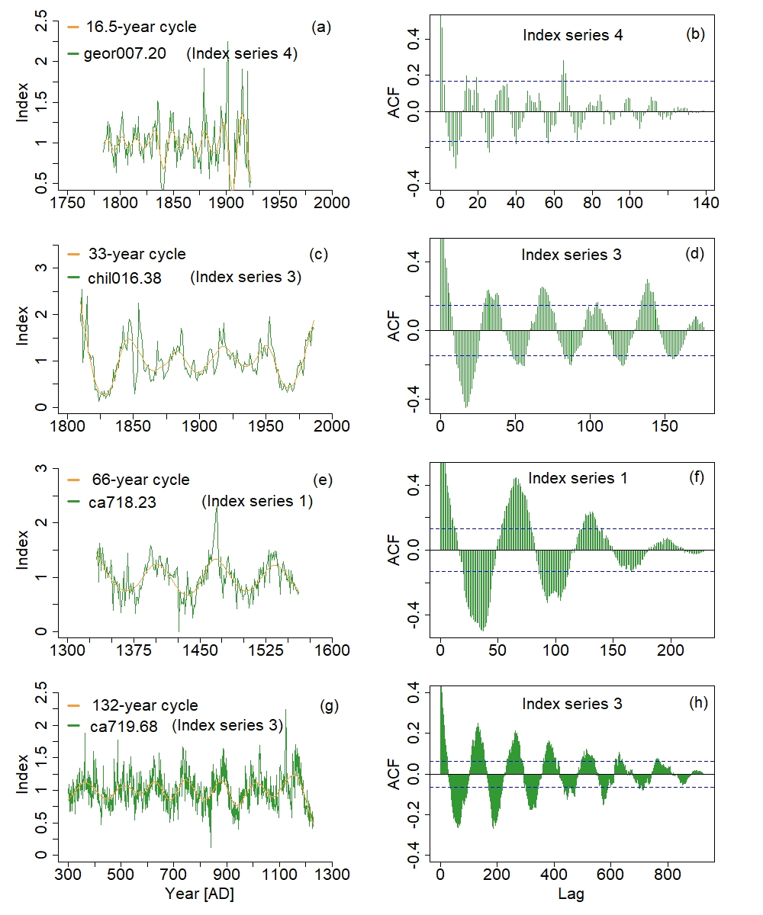
Extended data Fig.5: Second harmonic mode (HM2) showing resonance 1.2 of the 16.5-year solar cycle. Left: example of different index series from different sites, tree-species and time span (green curves) and the extracted signals (orange curves). Right: ACF corresponding to each index series and 90% significance level (blue dashed lines). More details for the different sites and tree-species are given in table S1

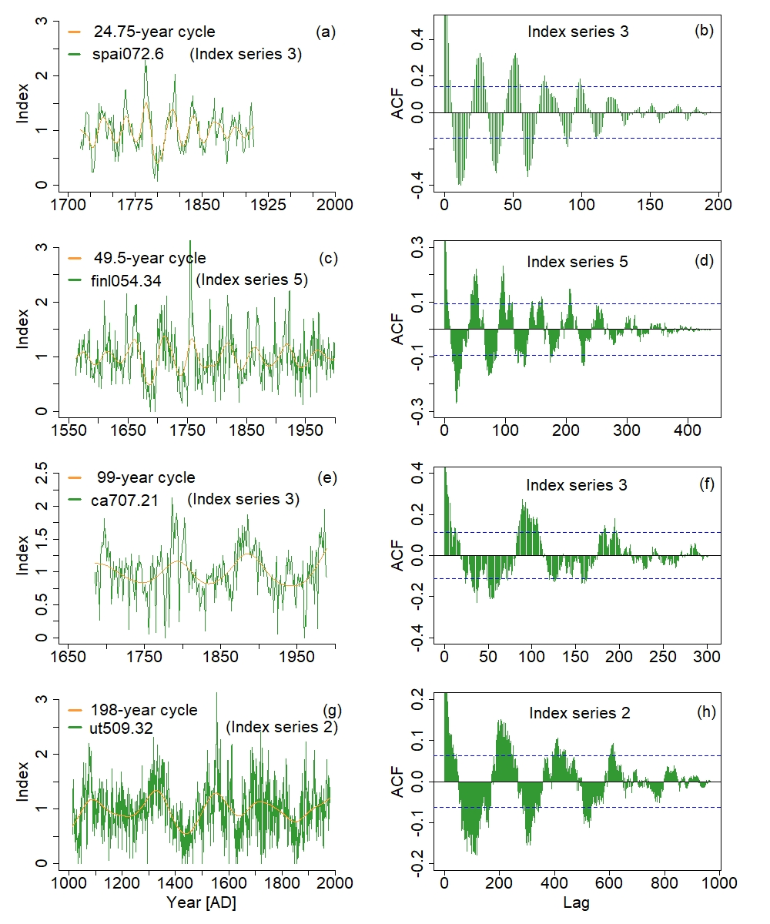
Extended data Fig.6: Third harmonic mode (HM3) showing resonance 1.2 of the 24.75-year solar cycle. Left: example of different index series from different sites, tree-species and time span (green curves) and the extracted signals (orange curves). Right: ACF corresponding to each index series and 90% significance level (blue dashed lines). More details for the different sites and tree-species are given in table S1

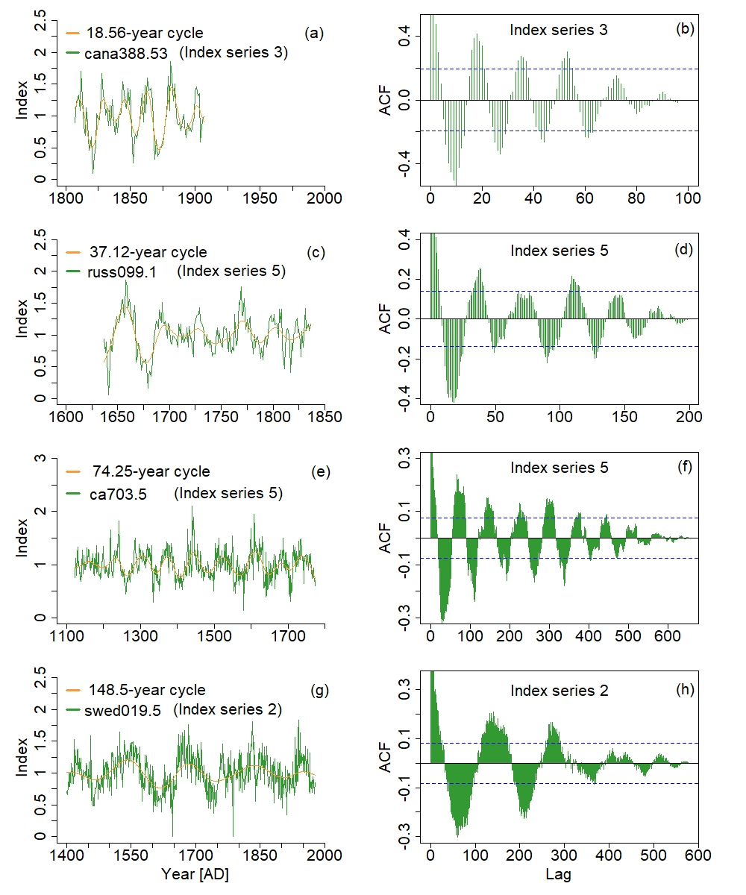
Extended data Fig.7: Fourth harmonic mode (HM4) showing resonance 1.2 of the 18.56-year solar cycle. Left: example of different index series from different sites, tree-species and time span (green curves) and the extracted signals (orange curves). Right: ACF corresponding to each index series and 90% significance level (blue dashed lines). More details for the different sites and tree-species are given in table S1

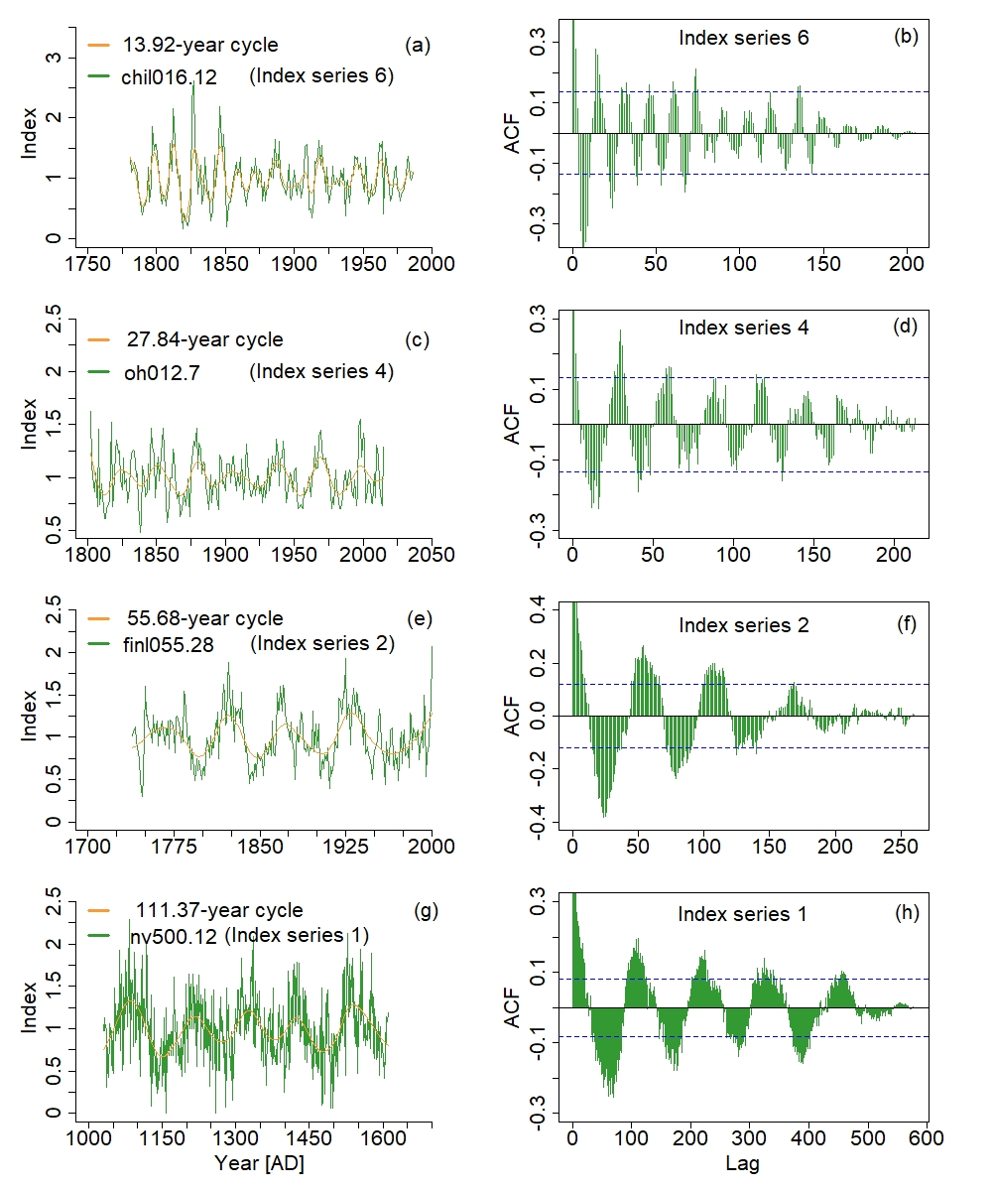
Extended data Fig.8: Fifth harmonic mode (HM5) showing resonance 1.2 of the 13.92-year solar cycle. Left: example of different index series from different sites, tree-species and time span (green curves) and the extracted signals (orange curves). Right: ACF corresponding to each index series and 90% significance level (blue dashed lines). More details for the different sites and tree-species are given in table S1

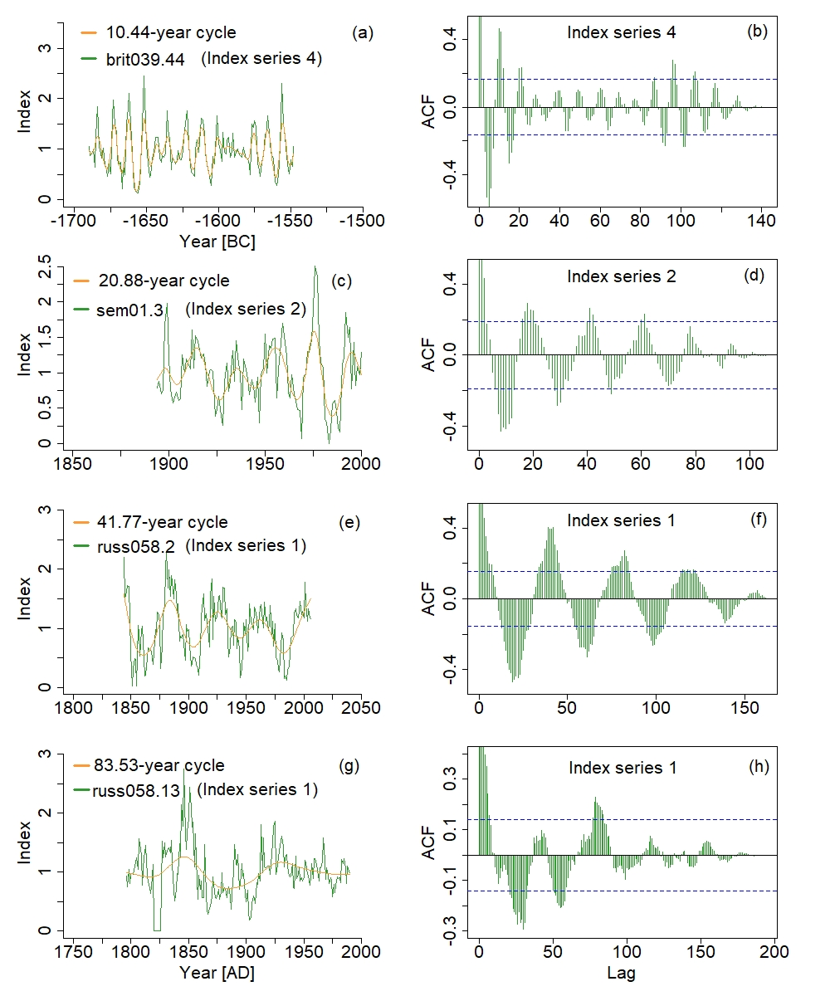
Extended data Fig.9: Sixth harmonic mode (HM6) showing resonance 1.2 of the 10.44-year solar cycle. Left: example of different index series from different sites, tree-species and time span (green curves) and the extracted signals (orange curves). Right: ACF corresponding to each index series and 90% significance level (blue dashed lines). More details for the different sites and tree-species are given in table S1

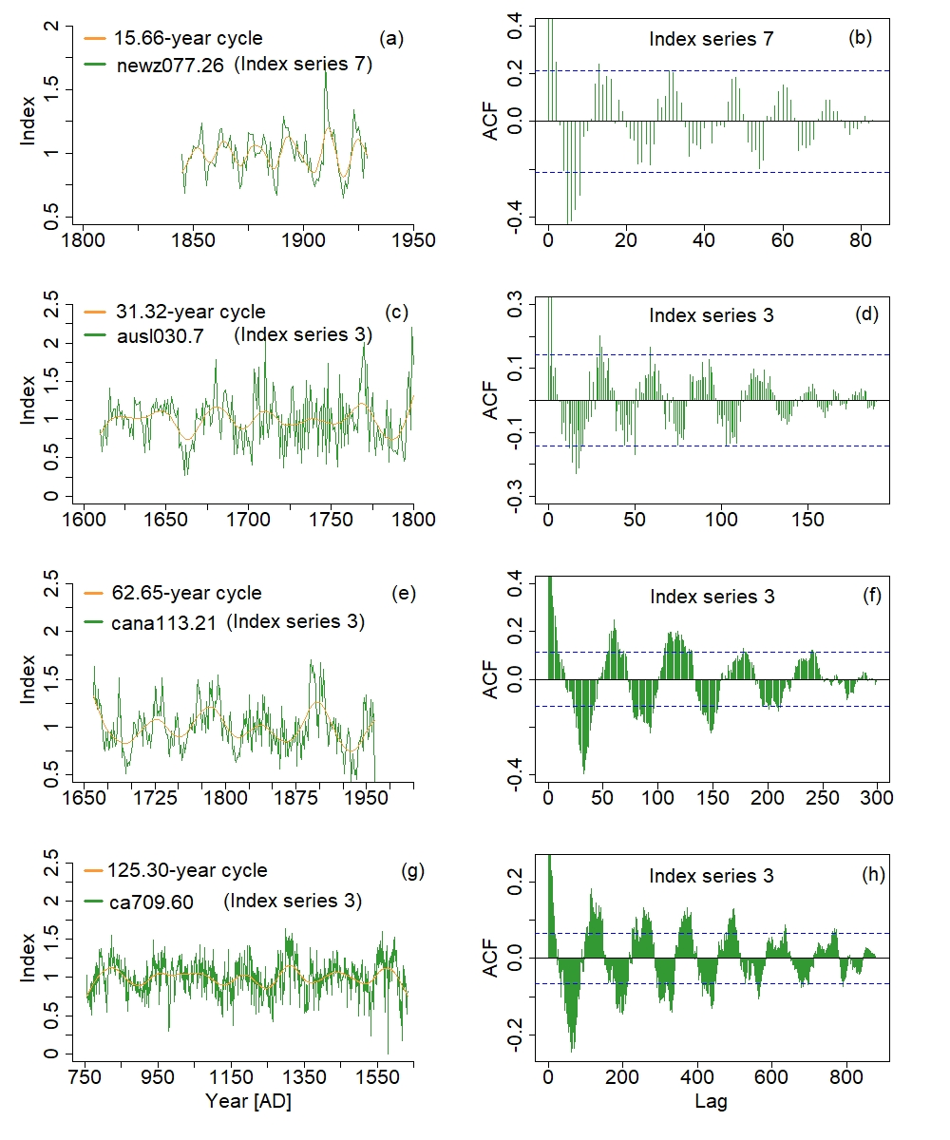
Extended data Fig.10: Seventh harmonic mode (HM7) showing resonance 1.2 of the 15.66-year solar cycle. Left: example of different index series from different sites, tree-species and time span (green curves) and the extracted signals (orange curves). Right: ACF corresponding to each index series and 90% significance level (blue dashed lines). More details for the different sites and tree-species are given in table S1

