Supplementary Material for ‘Revealing a Solar Cycle Resonance through tree-rings’

Ali Khorchani¹*
Issam Touhami¹
Mohamed Tahar Elaieb¹
Abdelhamid Khaldi¹
1University of Carthage. The National Research Institute of Rural Engineering, Water, and Forestry. INRGREF. Laboratory of Management and Valorization of Forest Resources. BP 10 Ariana 2080. Tunisia
- * Correspondent author : ali.khorchani@ingref.ucar.tn
- ORCID : https://orcid.org/0000-0003-4241-524X

ACF performance in time domain for signal detection

From a signal processing point of view, tree-ring time series are conceptually modeled as a linear aggregate of a certain number of harmonic signals and background noise. Although this approach is tested both in tree-ring width and on wood density parameters, the results presented in this study only concern the TRW parameter. In order to avoid misinterpreting the temporal trend, any long-term trend is considered as background noise and is automatically removed (Supplementary Fig. S1) even if the long term trend could describe a cyclic variation. Thereby, all the TRW-time series were firstly individually detrended using a conservative method based on fitting a linear least-square growth curve or a modified negative exponential curve (Mod.Neg.Exp). Then, the decomposition into a cyclic component was achieved by applying a consecutive filtering to TRW-time series based on the use of the autocorrelation function (ACF) analysis (see the Methods section). To check the cyclic component significance, the ACF confidence limits were fixed at 90% (p=0.1), and the peak-to-peak distances of the minima (min.–min.) and maxima (max.–max.) of the ACF were measured to obtain a first evaluation of the signal length. The exact length of each signal was estimated a second time according to an assumption model (see table 1).

The most impressive achievement of our approach is its ability to make the signal detection in time domain easier. The signal decomposition experiment applied to the artificial time series provides insight into how different the inherent harmonic signals in a time series could be extracted by successive filtering while relying on the ACF analysis. The first simulation experiment, illustrated by Supplementary Fig.1, shows how the ACF results are rather noisy due to the age-related-growth trend effect. The signal detection, by the ACF, becomes easier when chronology is detrended (Supplementary Fig.1c-d). In this first experiment (one signal of 88 years as illustrated by Supplementary Figs.1 and 2), the ACF follows a similar pattern regarding the appearance of regular peaks (each 88 years) between different lags. However, in the second experiment (two harmonic signals lasting 88 and 176 years) a slightly different pattern based on the number of inherent signals was detected (Supplementary Fig.3). This implies that the more signals present in a time series, the higher the possibility for difference between the amplitude of the detected peak in the ACF. The highest peak detected in the ACF describes the signal with the longest wavelength and so on. This implies that shorter cycles, present in the time series, might be dominated by longer cycles and their detection is possible only after the extraction of longer cycles. For the simulated experiment illustrated by Supplementary Fig.3, the ACF displays a high amplitude peak every 176 years and a second lower amplitude peak every 88 years. Our analysis shows that the extraction of a cycle with bigger amplitude and a longer period (176 years) allows the detection of the next inherent cycle in the series (88 years). This finding was verified in the case of aggregation of several cycles with harmonic wavelengths (analysis not shown). Compared to spectral analyses, our approach based on the ACF analysis enables us to easily detect signals in the time domain by the visualization of the corresponding autocorrelation coefficients between consecutive local maxima (or minima). This feature makes it possible to overcome the difficulty relative to the significance of the spectral peaks or the lag window estimate in the power spectrum.
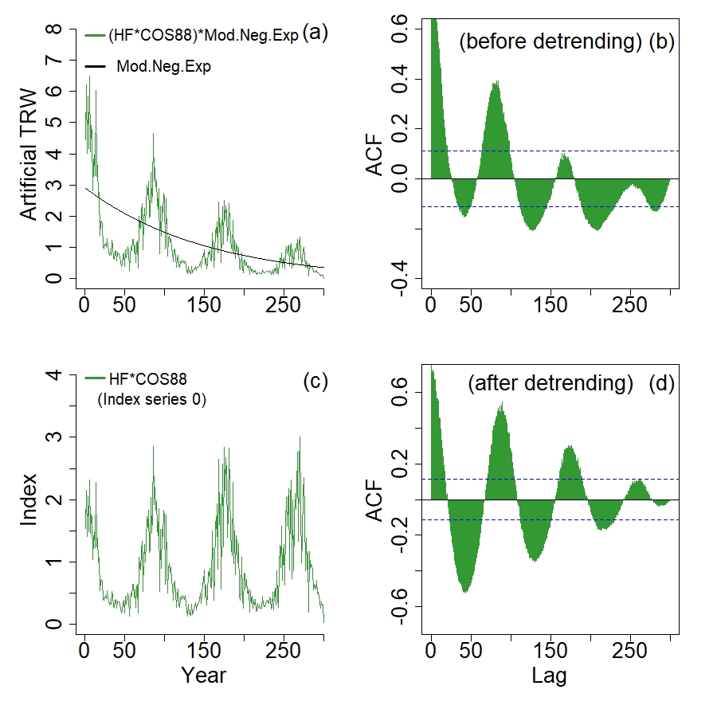
Supplementary Fig. 1: First simulation experiment: (a) a high frequency signal (HF: white noise signal) is scaled with a negative exponential curve (Mod.Neg.Exp: modeled as age trend effect (black curve)) and a signal of 88 years is added in form of a cosine wave (COS88 : green curve). (c) The resulting time series is detrended and resulting an index series 0. ACF before and after detrending is shown in b and d. Blue dashed lines represent the 90% significance level.
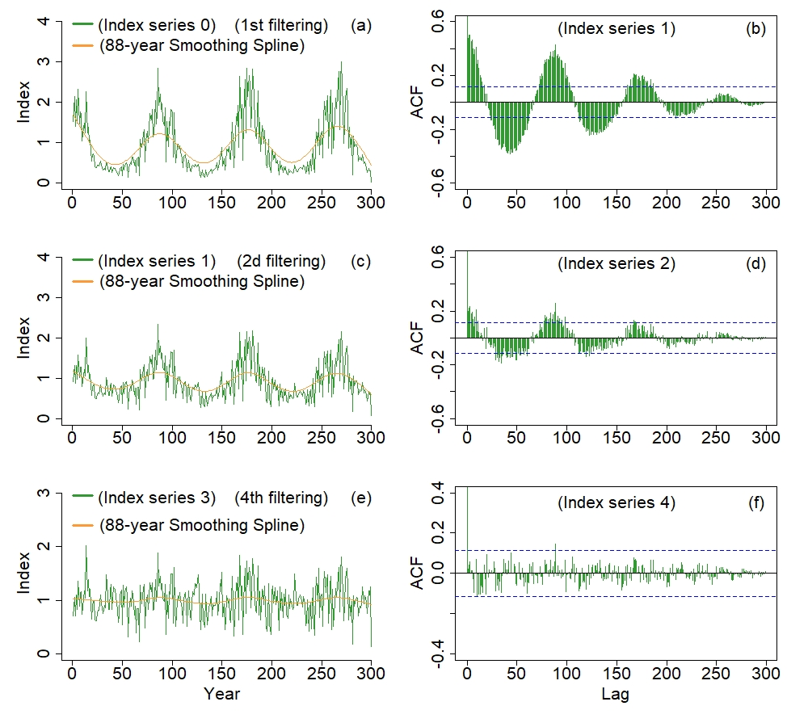
Supplementary Fig. 2: Different step of signal extraction for the first simulation experiment: (a) the resulting detrended time series (index series 0) is filtered in different step using 88-year Smoothing Spline (orange curves) and resulting in successive index series (1-4). ACFs of these corresponding index series are illustrated on the right side and allow to control the extraction of the signal as it evolve over the successive filtering. The filtering operation stops when the ACF profile no longer indicates any significant peaks (as shown by index series 4). Blue dashed lines represent the 90% significance level.

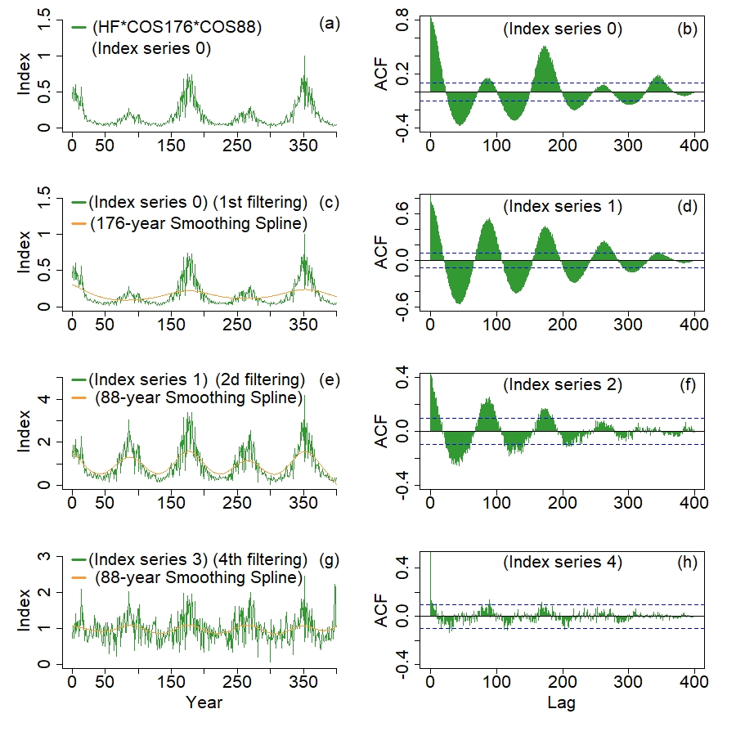
Supplementary Fig. 3: Second simulation experiment: the artificial time series is constructed like in the example of Fig. S1 except that two harmonic signals of 88 (COS88) and 176 years (COS176) are added as two cosine waves. In this example a cubic Smoothing Spline (176 years) is firstly applied on index series 0 (a) to extract the 176 cosine wave and (88 years) then applied to index series 1-3 (c, e and g) to extract the 88 cosine wave (orange curves). Peaks amplitude shown by the ACF profiles indicates the extraction status of each signal (b, d, f and h). Blue dashed lines represent the 90% significance level.

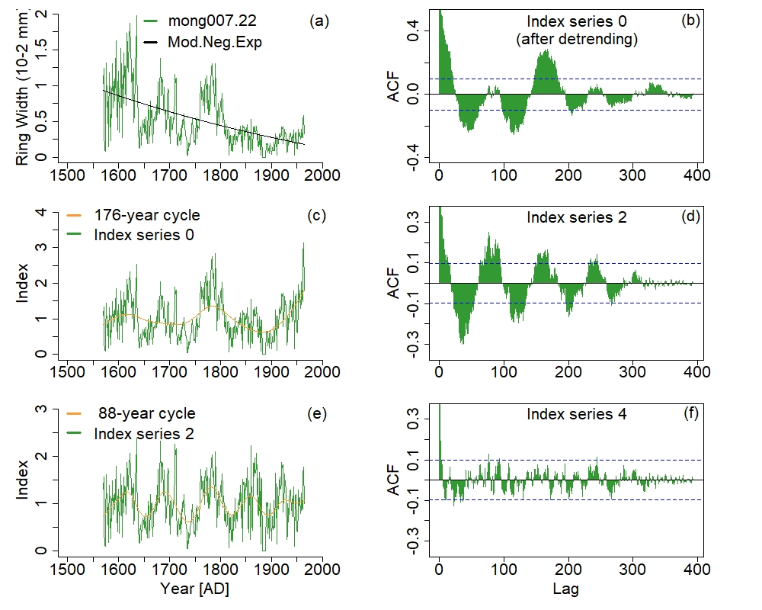
Supplementary Fig.4: Example of signal extraction on TRW-time series of Larix gmelinii (Rupr.) Kuzen (site code: mong007, series number: 22). The filtering procedure (after detrending by Mod.Neg.Exp (black curve)) is the same as that applied to artificial time series illustrated by Fig. S2 and S3. In this example two cycles (176 and 88-year) are extracted from this time series showing a resonance 1.2 for the 88-year cycle. Blue dashed lines represent the 90% significance level.

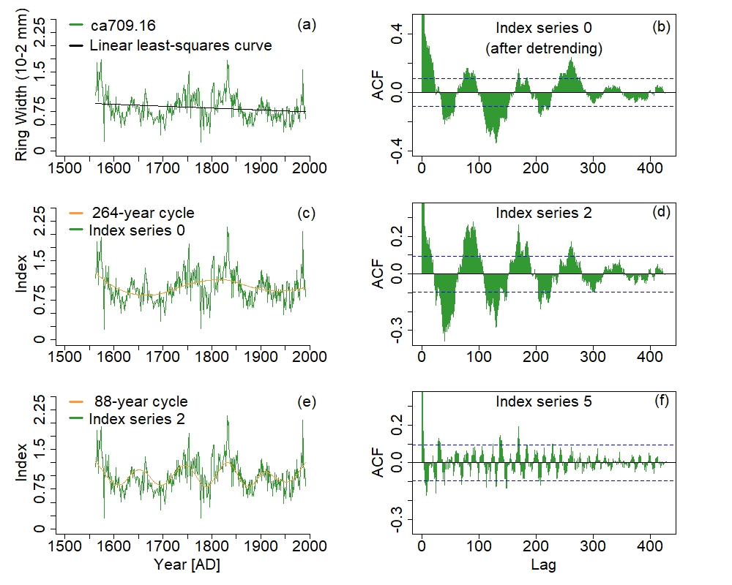
Supplementary Fig.5: Example of signal extraction on TRW-time series of giant sequoia (site code: ca709, series number: 16). The filtering procedure (after detrending by a linear least-squares growth curve (black curve)) is the same as that applied to artificial time series illustrated by Fig. S2 and S3. In this example two cycles (264 and 88-year) are extracted from this time series showing a resonance 1.3 for the 88-year cycle. Blue dashed lines represent the 90% significance level.

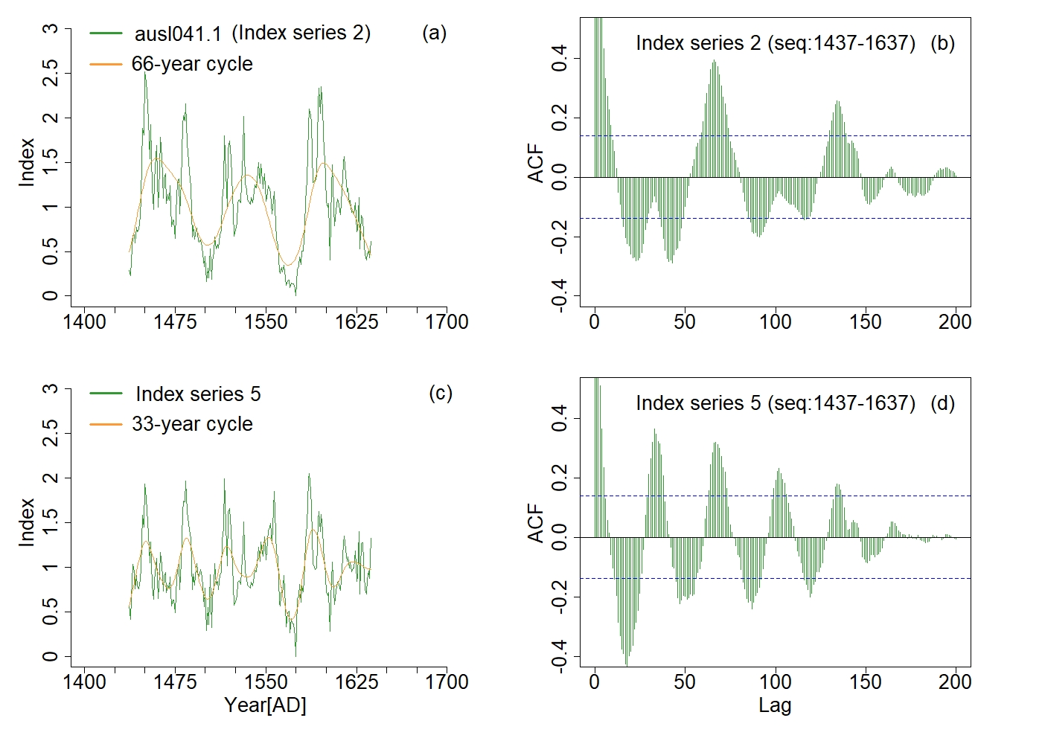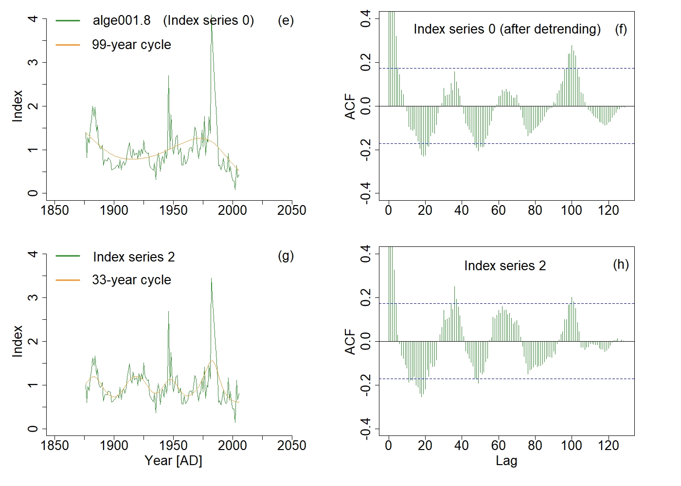
Supplementary Fig.6: Examples showing resonance 1.2 (a-d) and resonance 1.3 (e-h) of the 33-year solar cycle. Left: different index series (green curves) and the extracted signals (orange curves) for two tree-species (a and c for Athrotaxis selaginoides D.Don, 1838. and e and g for Cedrus atlantica (Manetti ex endl.)) located respectively a two different sites (ausl041 series number 1 and alge001 series number 8). Right: ACF corresponding to each index series and 90% significance level (blue dashed lines).
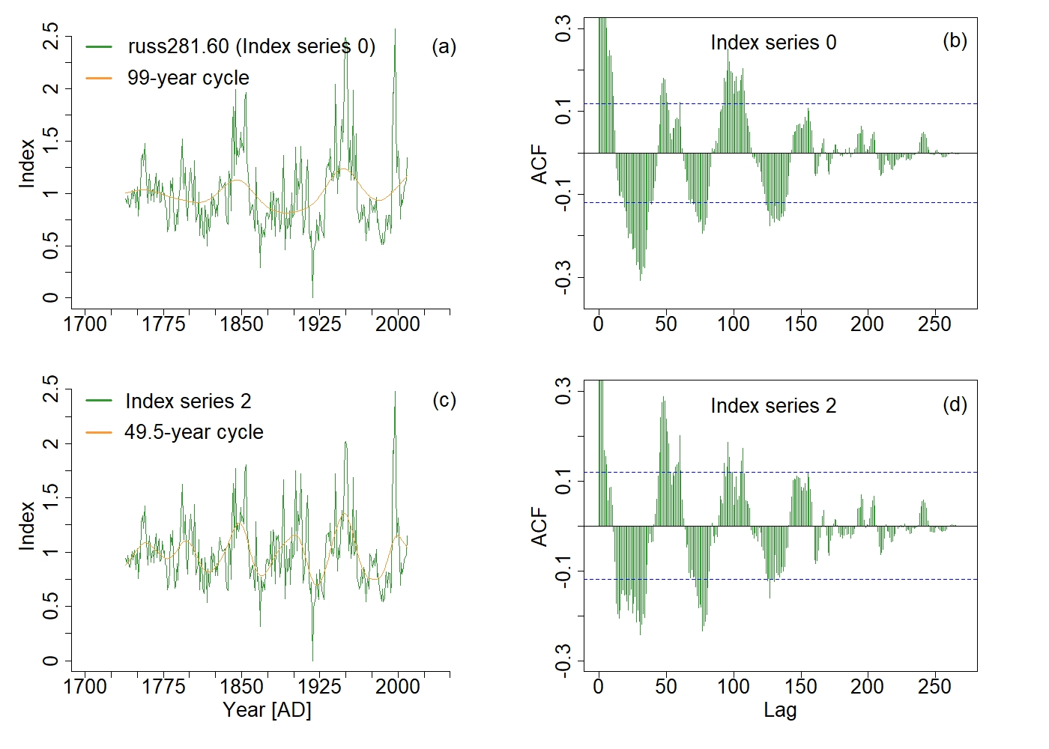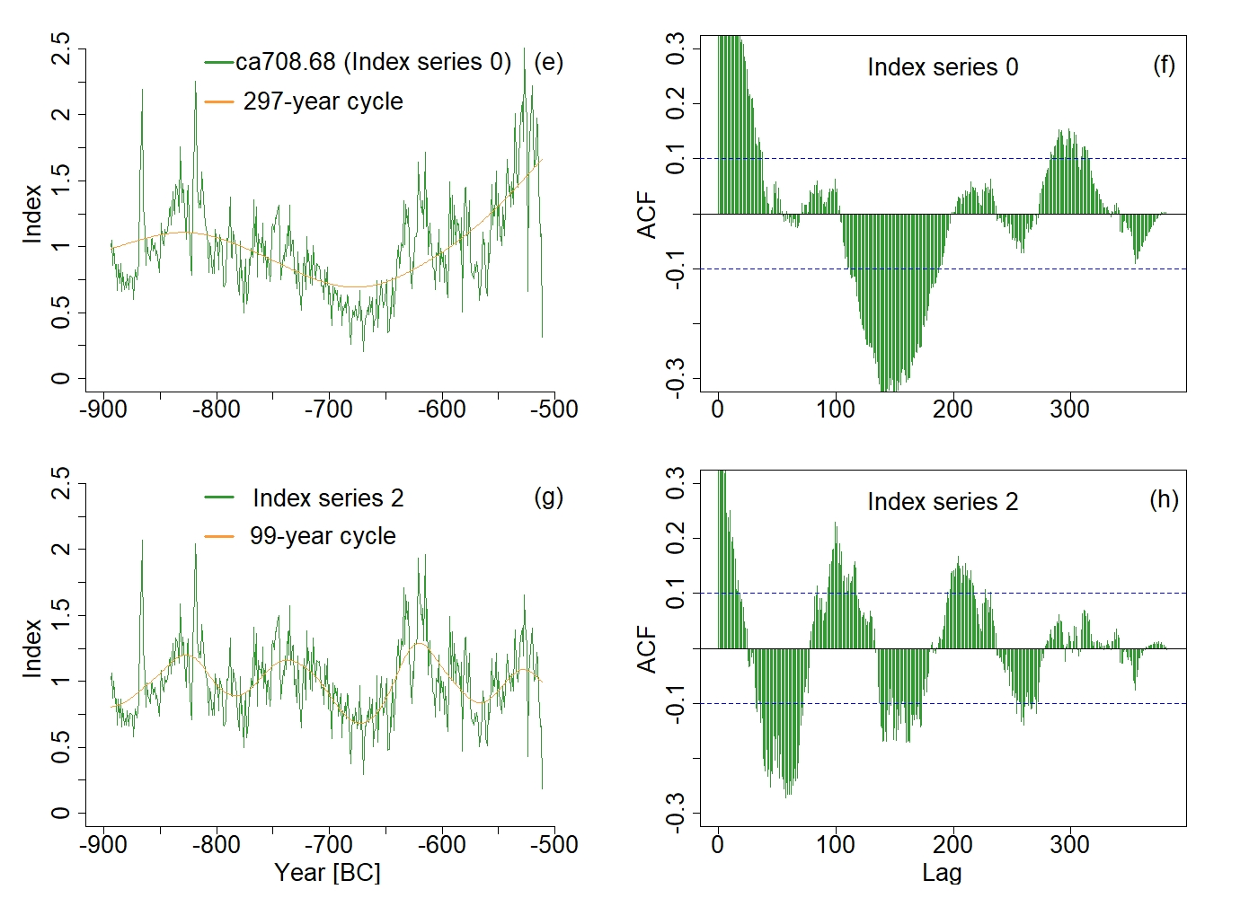
Supplementary Fig.7: Examples showing resonance 1.2 (a-d) of the 49.5-year solar cycle and resonance 1.3 (e-h) of the 99-year solar cycle. Left: different index series (green curves) and the extracted signals (orange curves) for two tree-species (a and c for Pinus sylvestris L. and e and g for giant sequoia) located respectively a two different sites (russ281 series number 60 and ca708 series number 68). Right: ACF corresponding to each index series and 90% significance level (blue dashed lines).

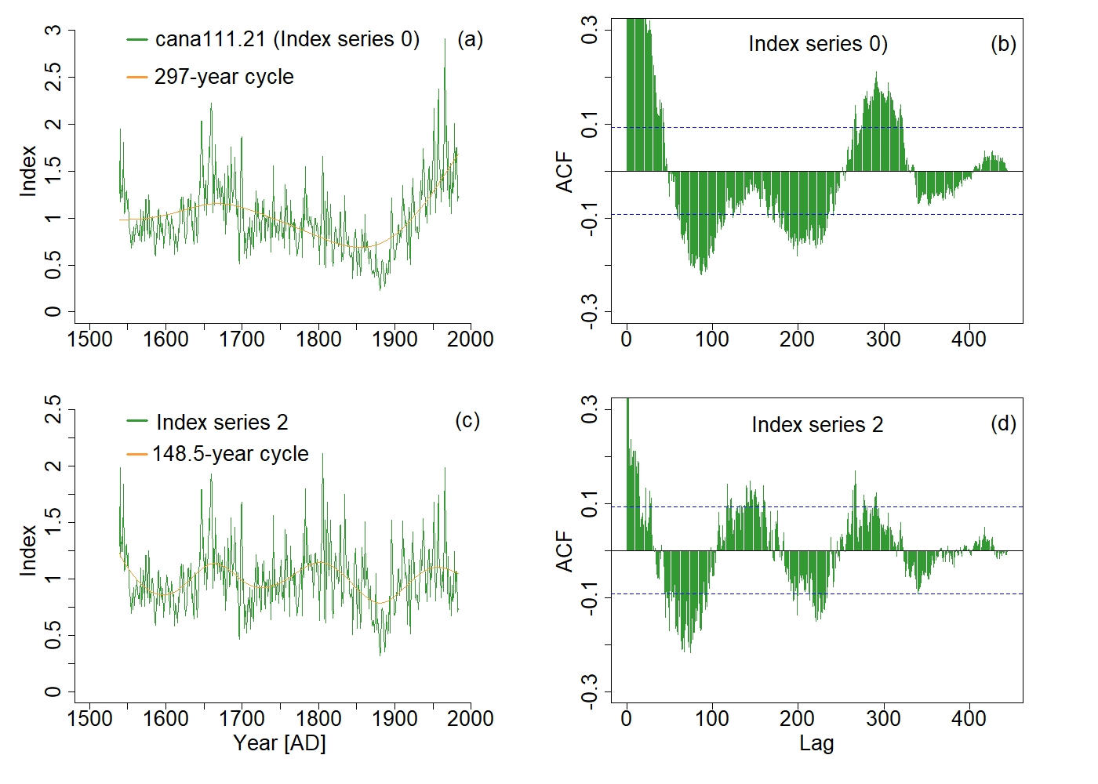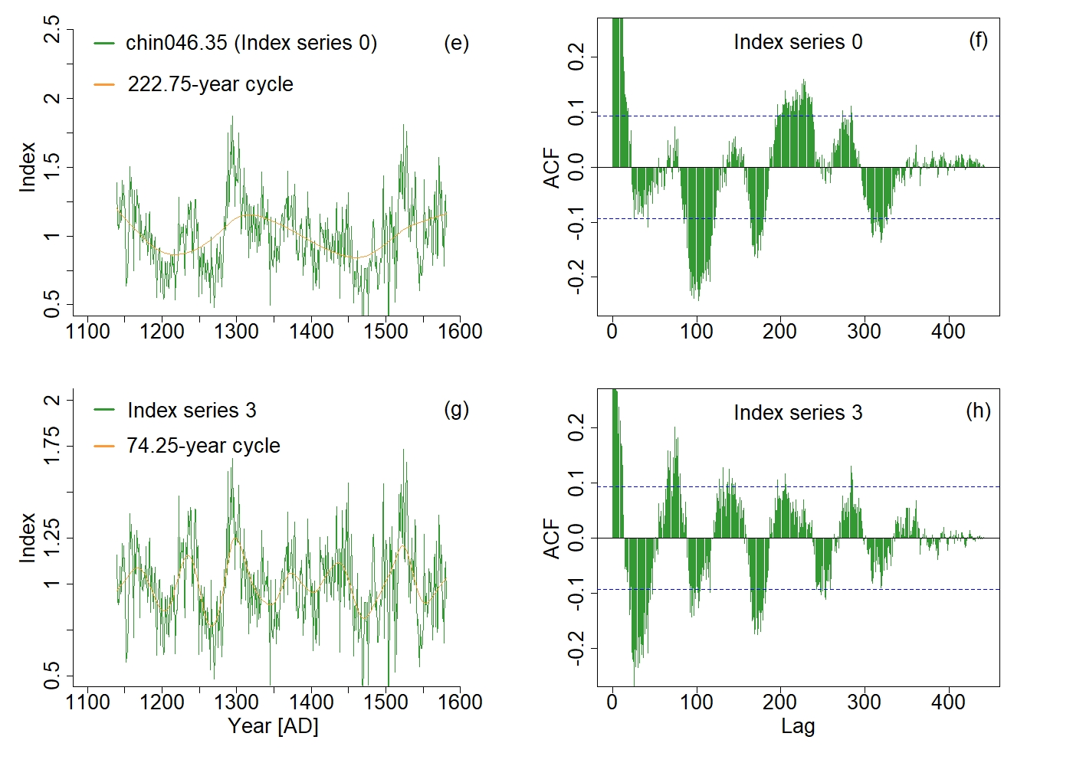
Supplementary Fig.8: Examples showing resonance 1.2 (a-d) of the 148.5-year solar cycle and resonance 1.3 (e-h) of the 74.25-year solar cycle. Left: different index series (green curves) and the extracted signals (orange curves) for two tree-species (a and c for Tsuga mertensiana (Bong.) Carrière, 1867 and e and g for Juniperus tibetica Kom.) located respectively a two different sites (cana111 series number 21 and chin046 series number 35). Right: ACF corresponding to each index series and 90% significance level (blue dashed lines).
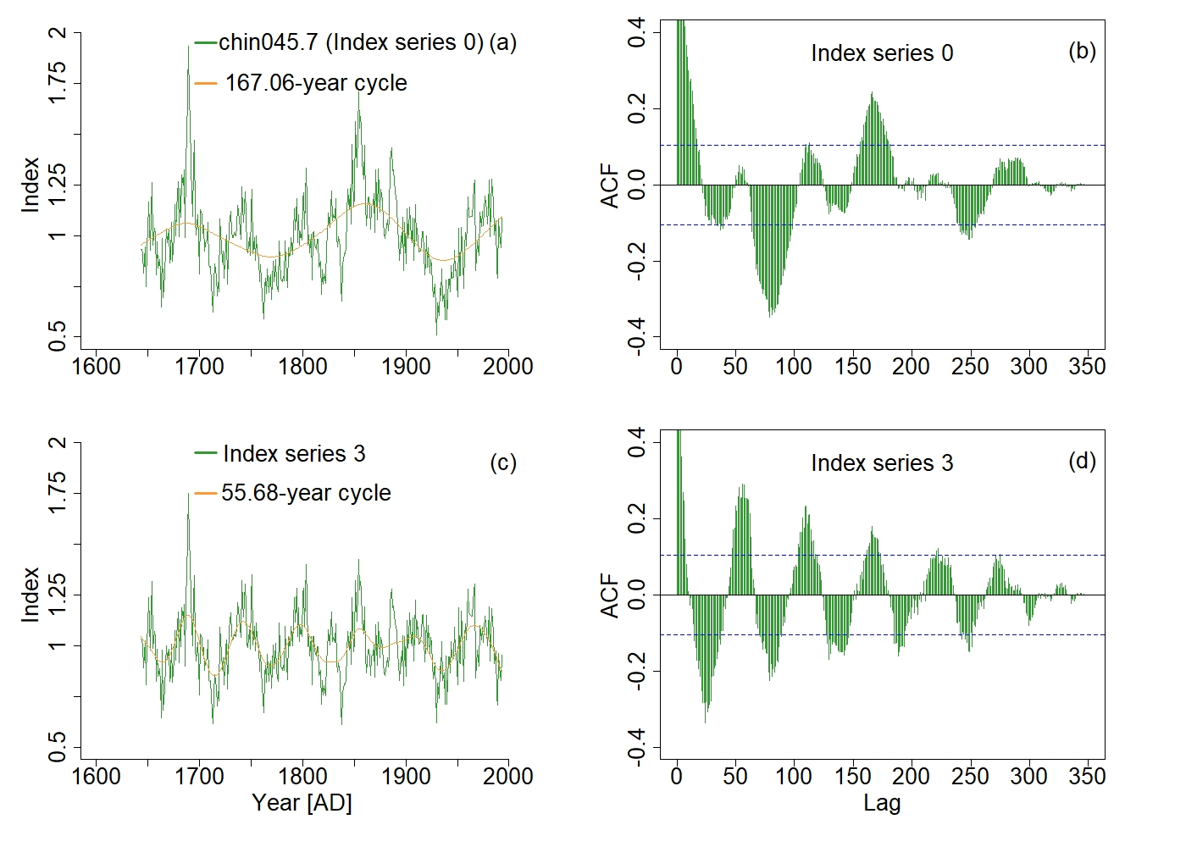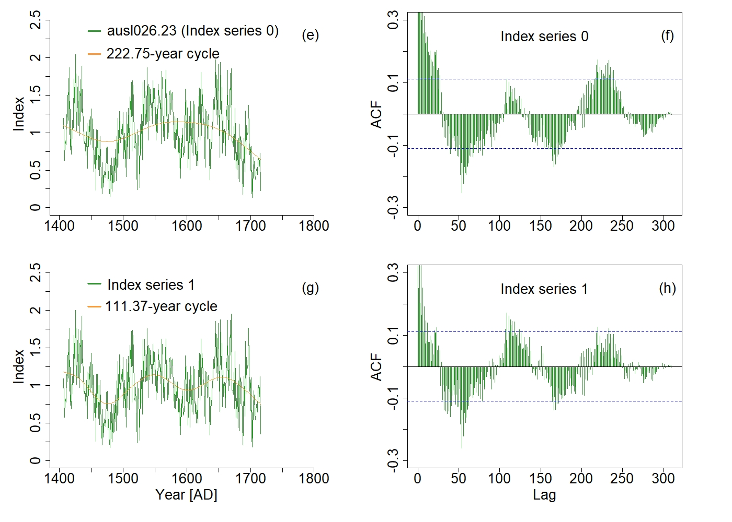
Supplementary Fig.9: Examples showing resonance 1.3 (a-d) of the 55.68-year solar cycle and resonance 1.2 (e-h) of the 111.37-year solar cycle. Left: different index series (green curves) and the extracted signals (orange curves) for two tree-species (a and c for Juniperus tibetica Kom., and e and g for Phyllocladus aspleniifolius (Labill.) Hook. F., 1845) located respectively a two different sites (chin045 series number 7 and ausl026 series number 23). Right: ACF corresponding to each index series and 90% significance level (blue dashed lines).

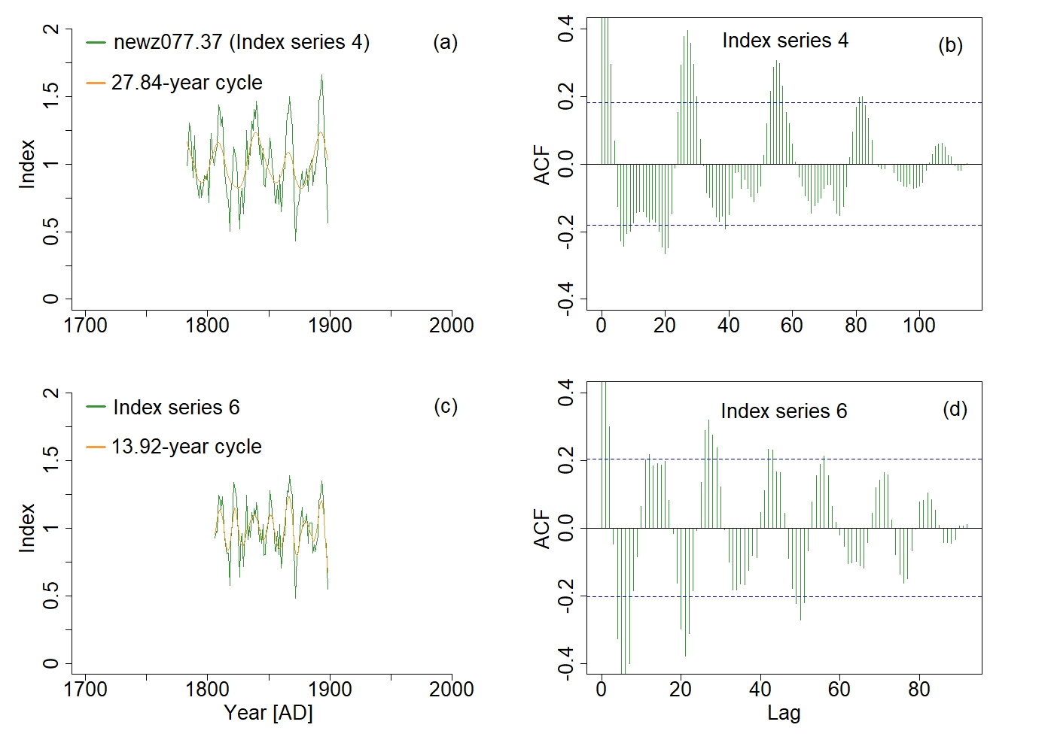
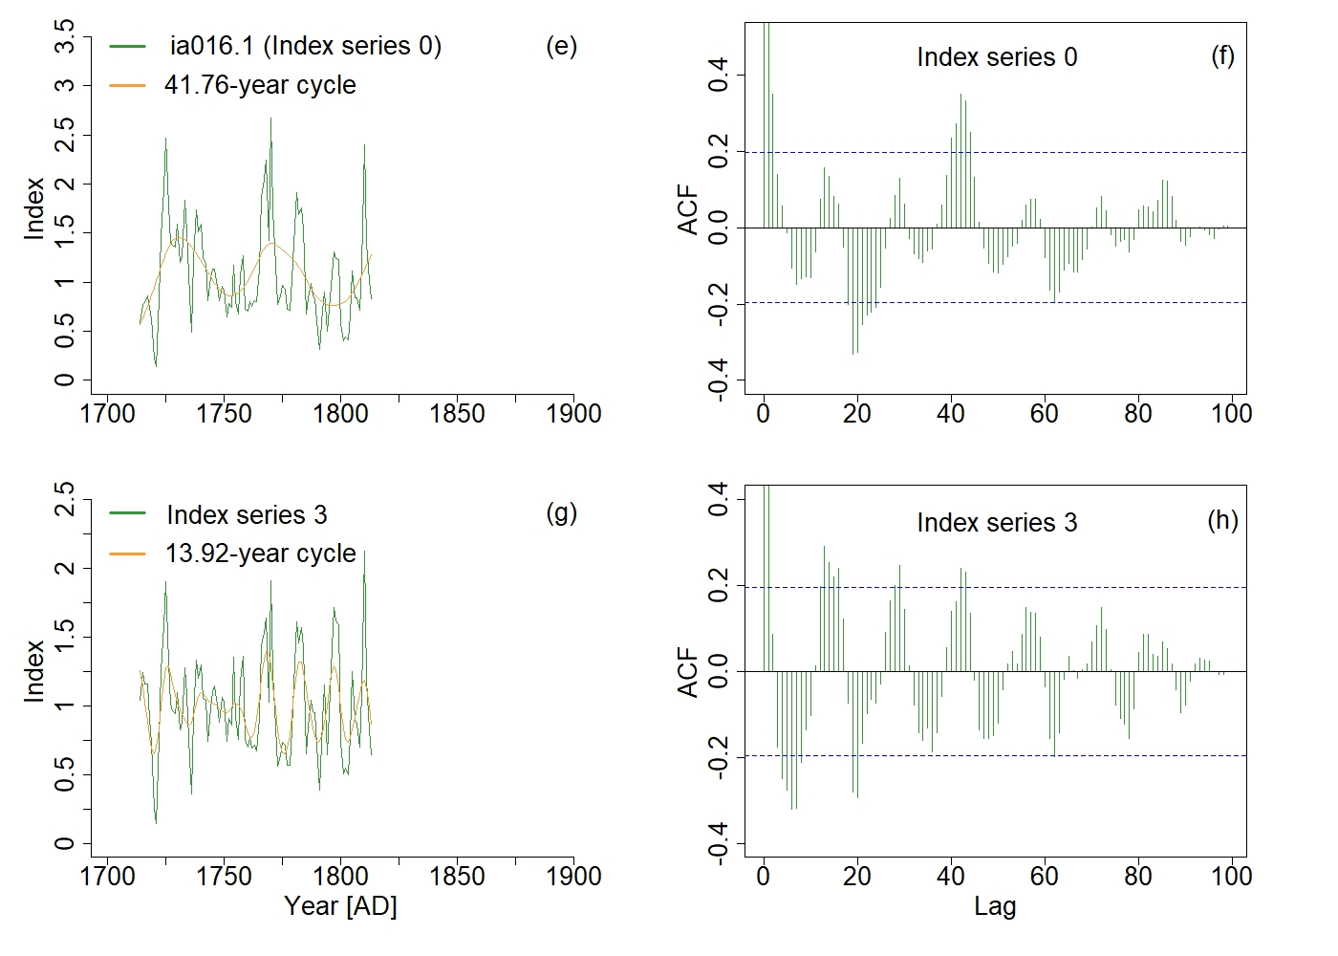
Supplementary Fig.10: Examples showing resonance 1.2 (a-d) and resonance 1.3 (e-h) of the 13.92-year solar cycle. Left: different index series (green curves) and the extracted signals (orange curves) for two tree-species (a and c for Holocarpus biformis (Hook.) C.J. Quinn and e and g for Quercus macrocarpa Michx.) located respectively a two different sites (newz077 series number 37 and ia016 series number 1). Right: ACF corresponding to each index series and 90% significance level (blue dashed lines).

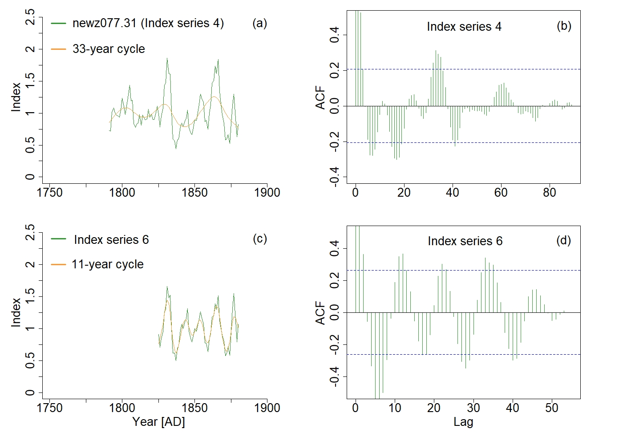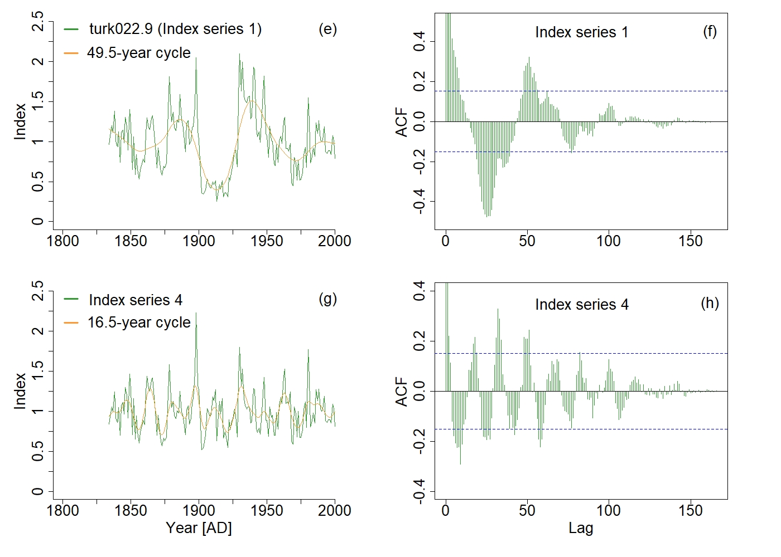
Supplementary Fig.11: Examples showing resonance 1.3 (a-d) of the 11-year solar cycle and resonance 1.3 (e-h) of the 16.5-year solar cycle. Left: different index series (green curves) and the extracted signals (orange curves) for two tree-species (a and c for Holocarpus biformis (Hook.) C.J. Quinn and e and g for Pinus sylvestris L) located respectively a two different sites (newz077 series number 31 and turk022 series number 9). Right: ACF corresponding to each index series and 90% significance level (blue dashed lines).
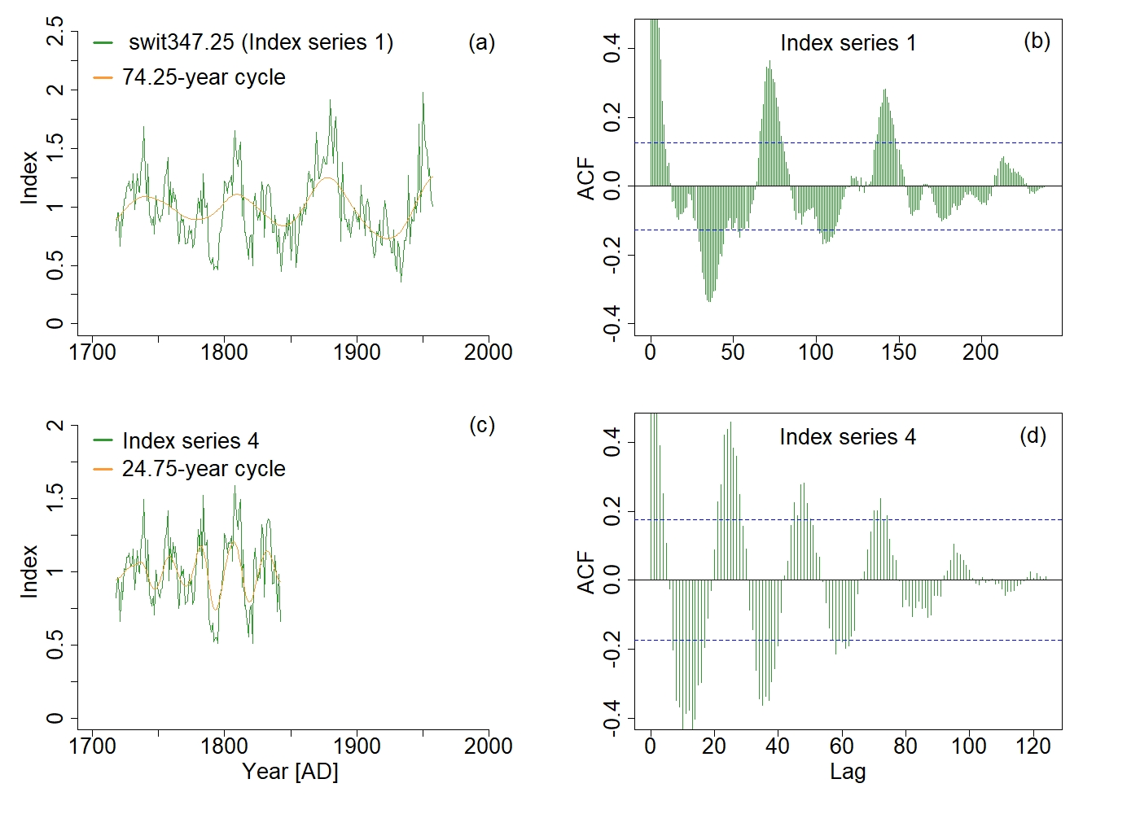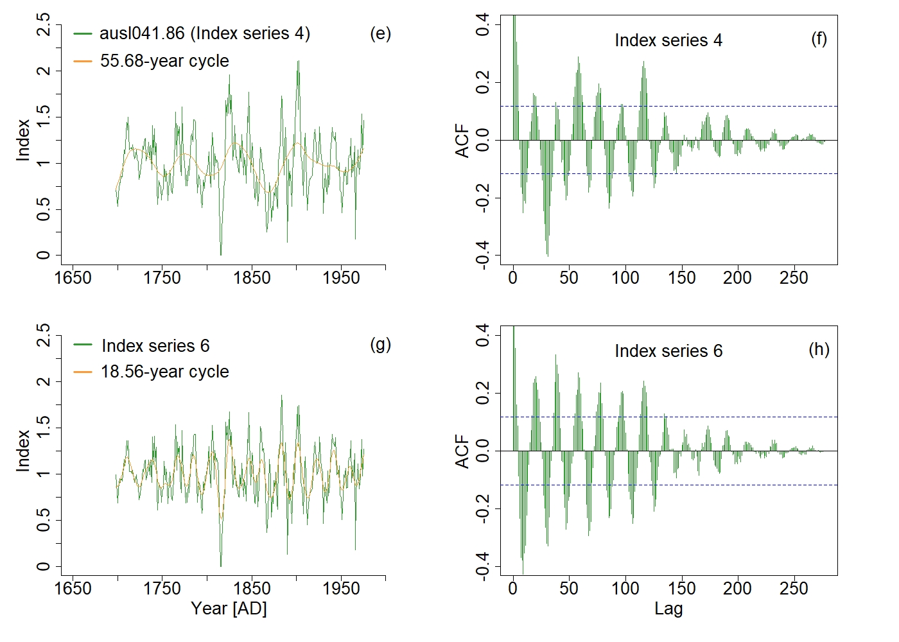
Supplementary Fig.12: Examples showing resonance 1.3 (a-d) of the 24.75-year solar cycle and resonance 1.3 (e-h) of the 18.56-year solar cycle. Left: different index series (green curves) and the extracted signals (orange curves) for two tree-species (a and c for Pinus cembra L. and e and g for Athrotaxis selaginoides D.Don) located respectively a two different sites (swit347 series number 25 and ausl041 series number 86). Right: ACF corresponding to each index series and 90% significance level (blue dashed lines).
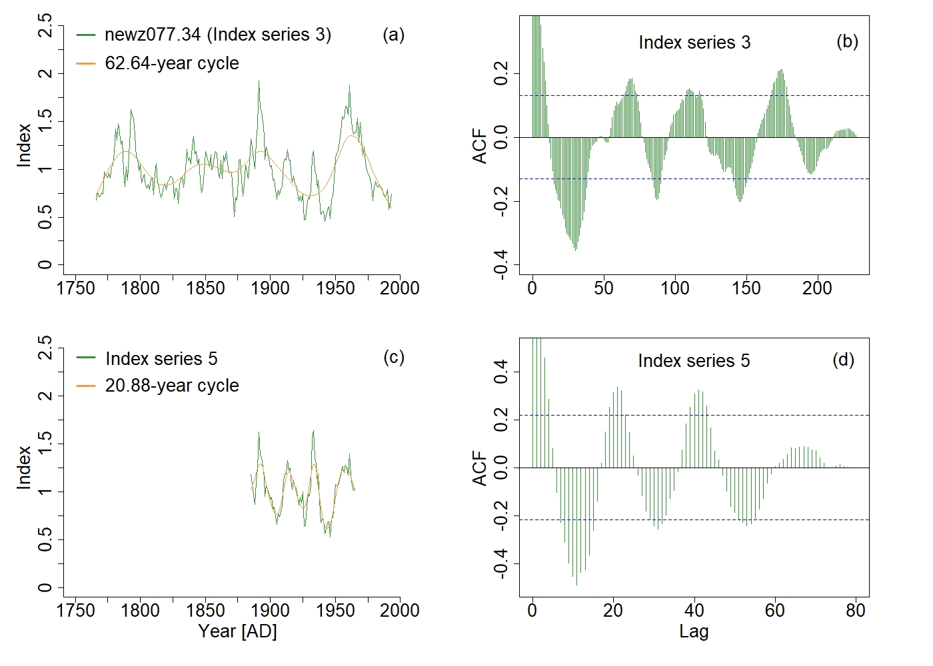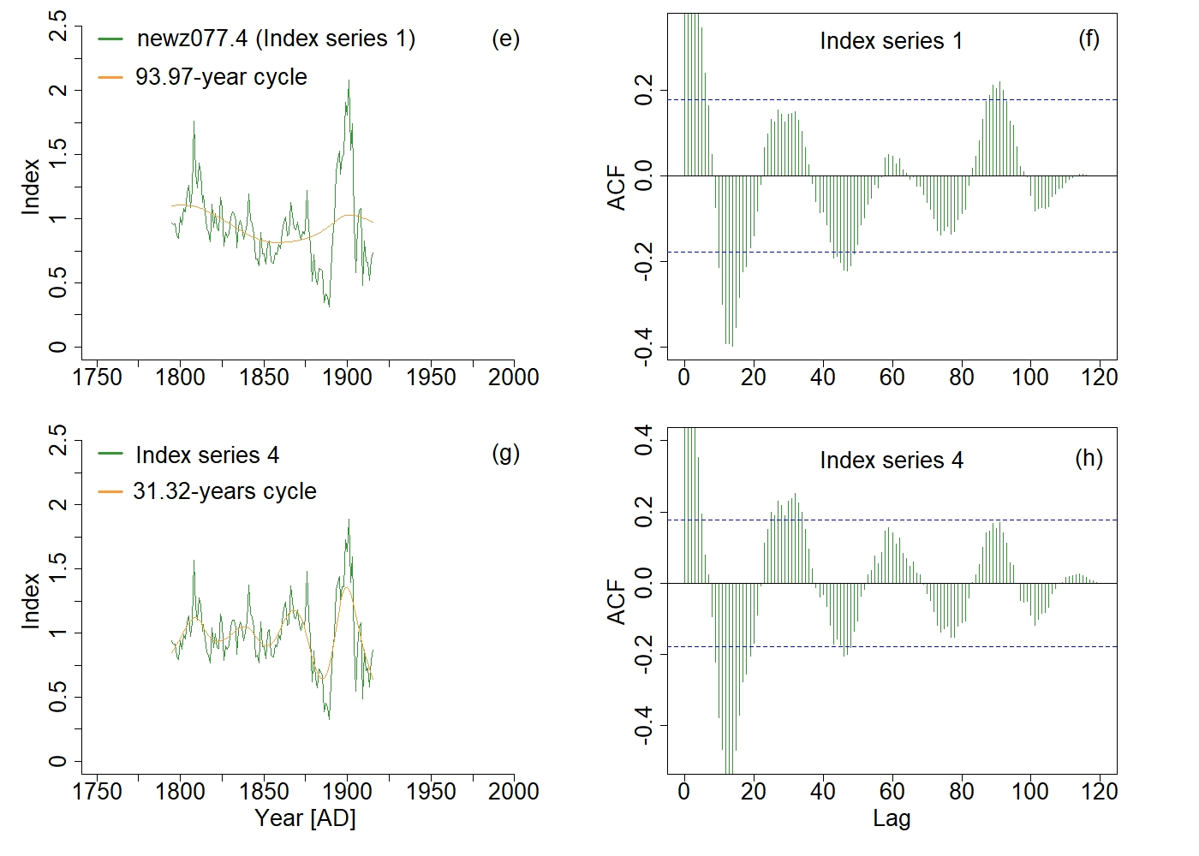
Supplementary Fig.13: Examples showing resonance 1.3 (a-d) of the 20.88-year solar cycle and resonance 1.3 (e-h) of the 31.32-year solar cycle. Left: different index series (green curves) and the extracted signals (orange curves) for two TRW series (34 and 4) for Holocarpus biformis (Hook.) C.J. Quinn tree-species located at the site newz077. Right: ACF corresponding to each index series and 90% significance level (blue dashed lines).

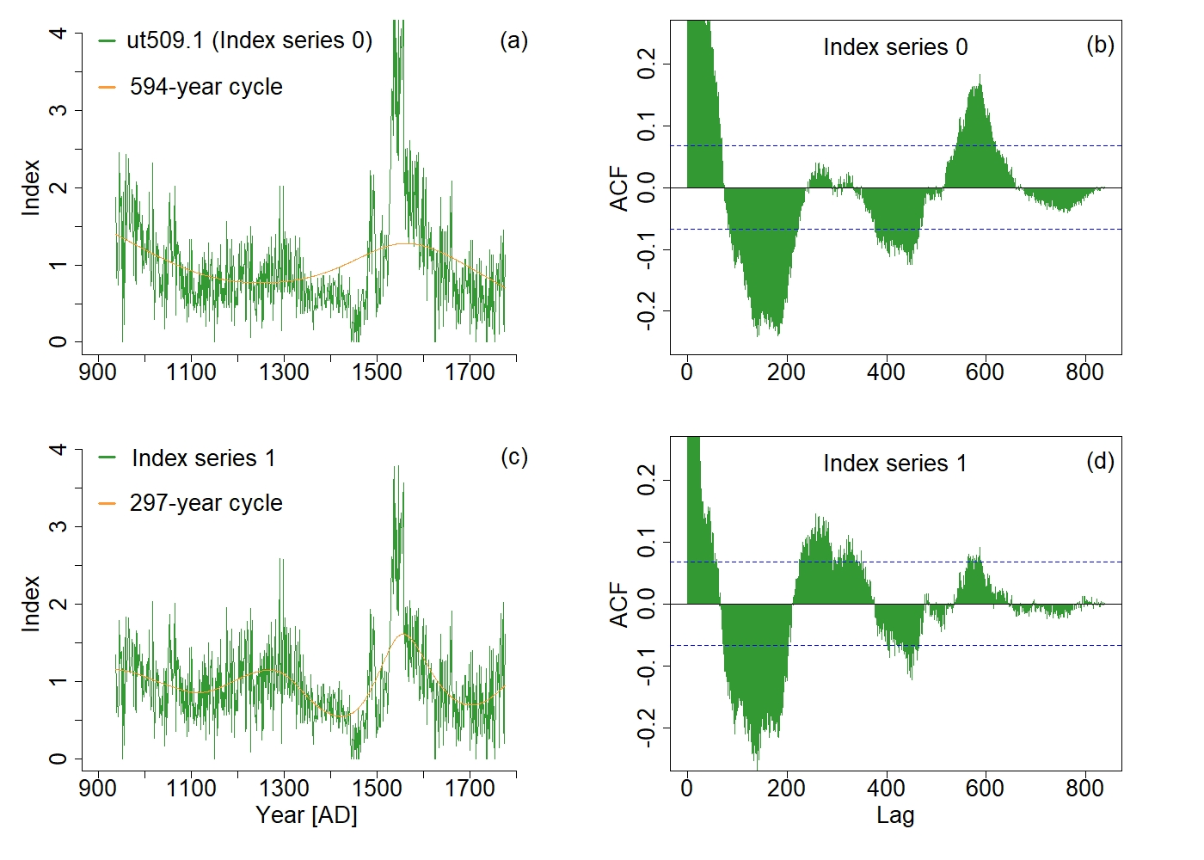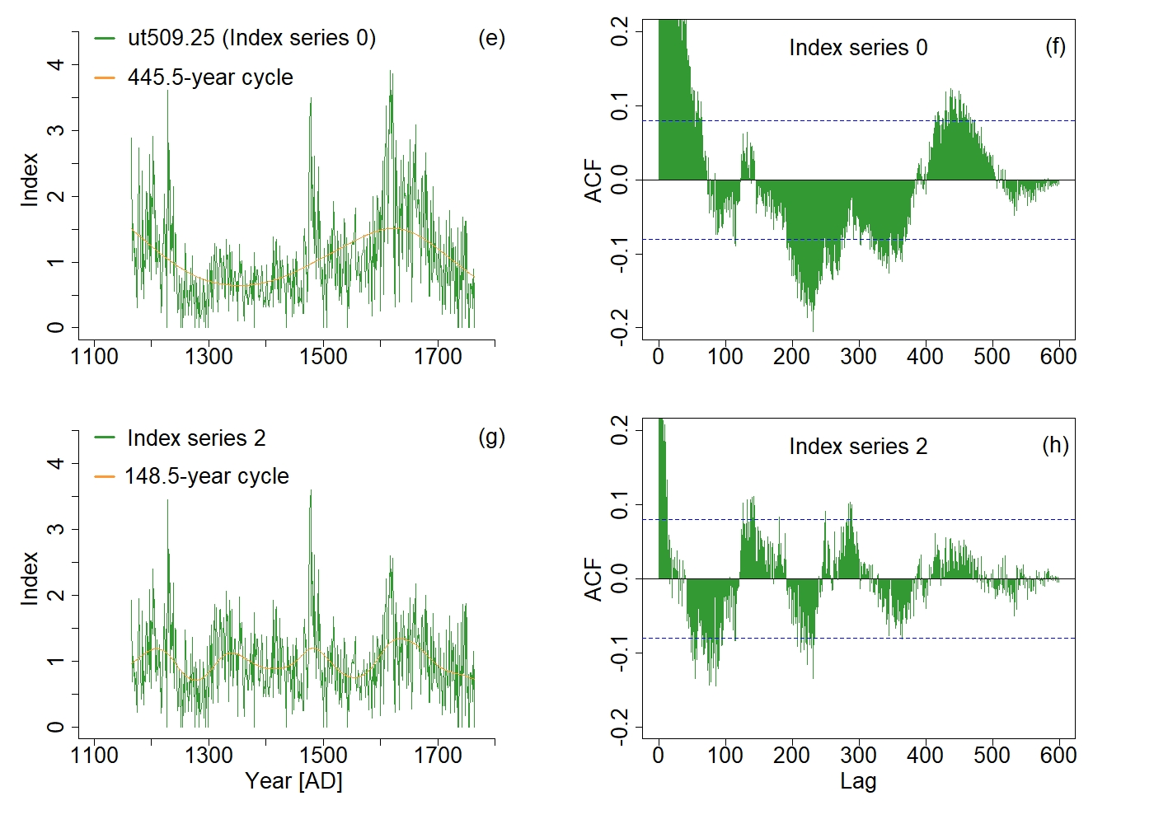
Supplementary Fig.14: Examples showing resonance 1.2 (a-d) of the 297-year solar cycle and resonance 1.3 (e-h) of the 148.5-year solar cycle. Left: different index series (green curves) and the extracted signals (orange curves) for two TRW series (1 and 25) for Bristlecone Pine tree-species located at the site ut509. Right: ACF corresponding to each index series and 90% significance level (blue dashed lines).

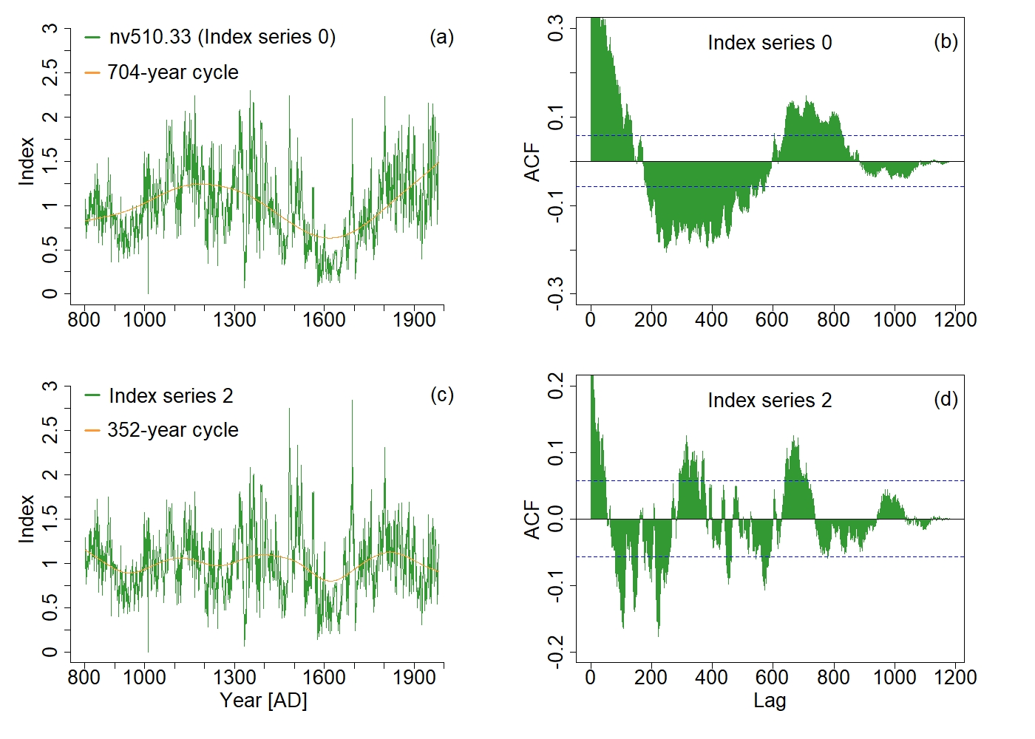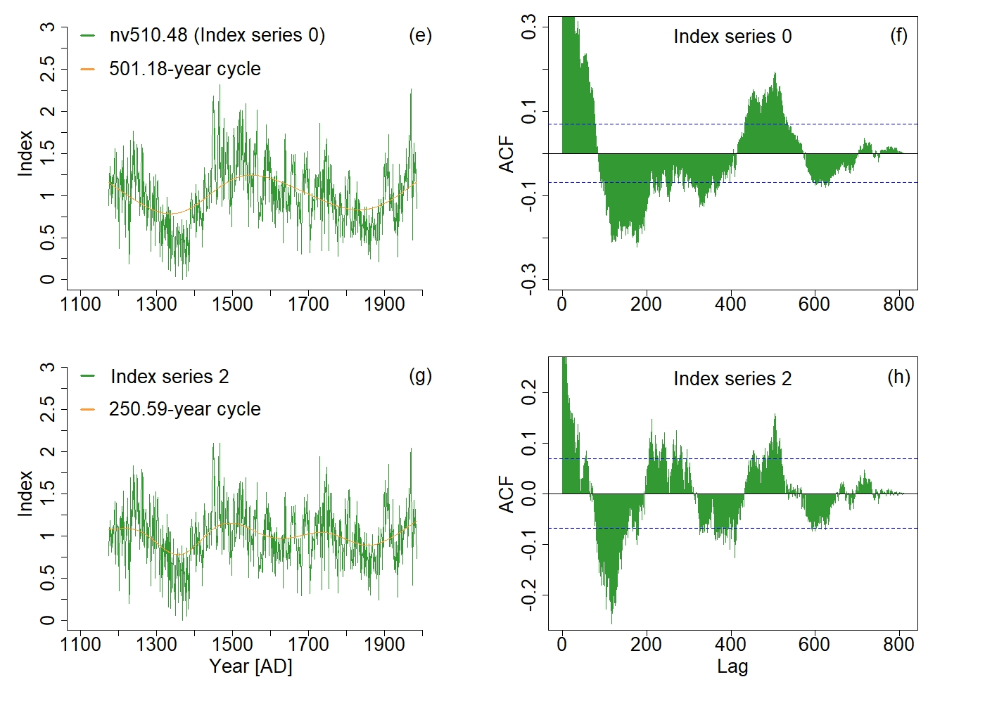
Supplementary Fig.15: Examples showing resonance 1.2 (a-d) of the 352-year solar cycle and resonance 1.2 (e-h) of the 250.59-year solar cycle. Left: different index series (green curves) and the extracted signals (orange curves) for two TRW series (33 and 48) for Bristlecone Pine tree-species located at the site nv510. Right: ACF corresponding to each index series and 90% significance level (blue dashed lines).

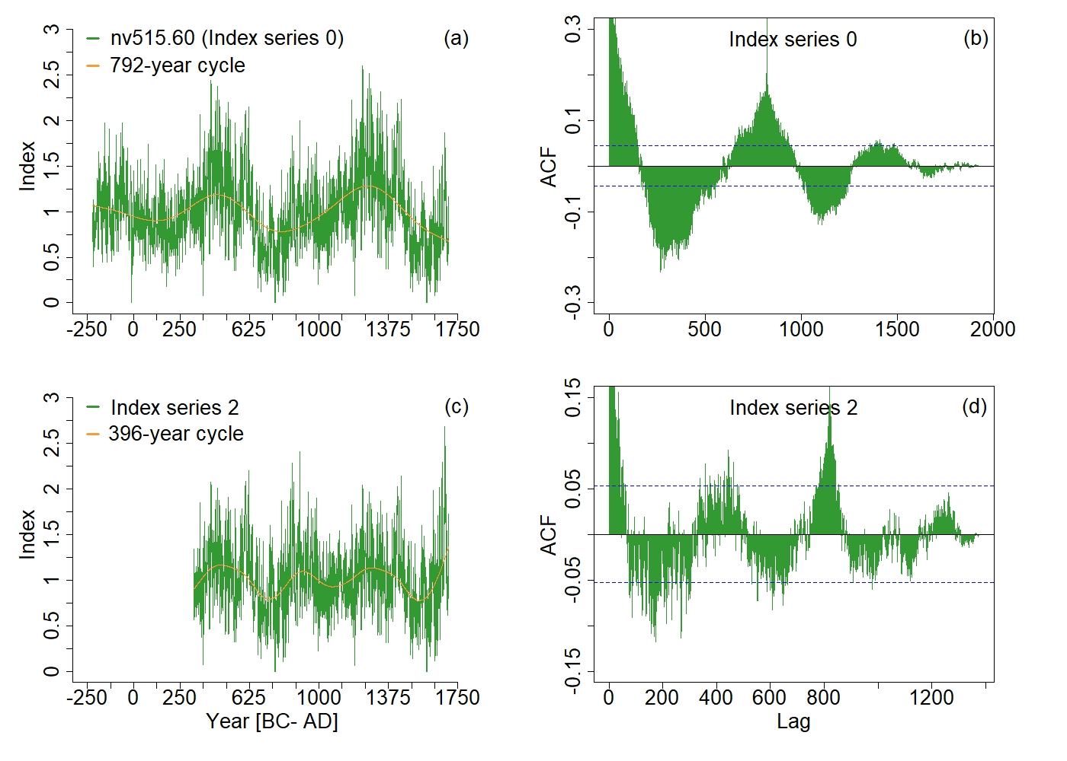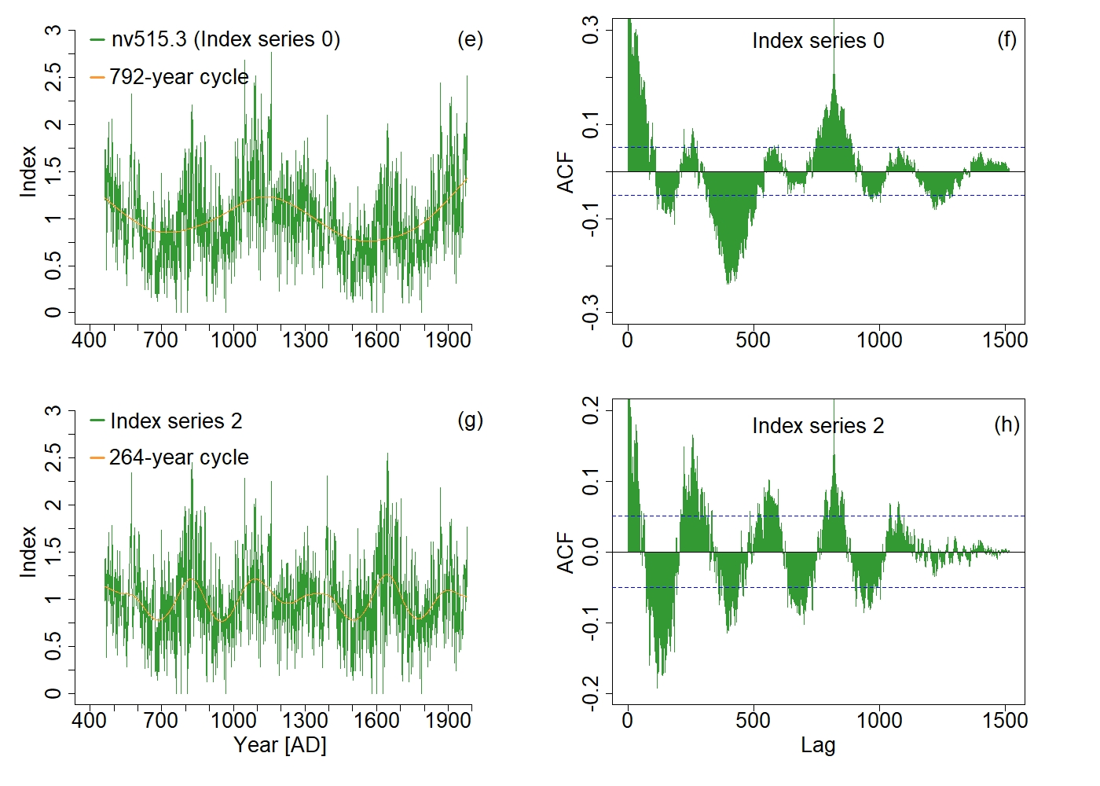
Supplementary Fig.16: Examples showing resonance 1.2 (a-d) of the 396-year solar cycle and resonance 1.3 (e-h) of the 264-year solar cycle. Left: different index series (green curves) and the extracted signals (orange curves) for two TRW series (60 and 3) for Bristlecone Pine tree-species located at the site nv515. Right: ACF corresponding to each index series and 90% significance level (blue dashed lines).
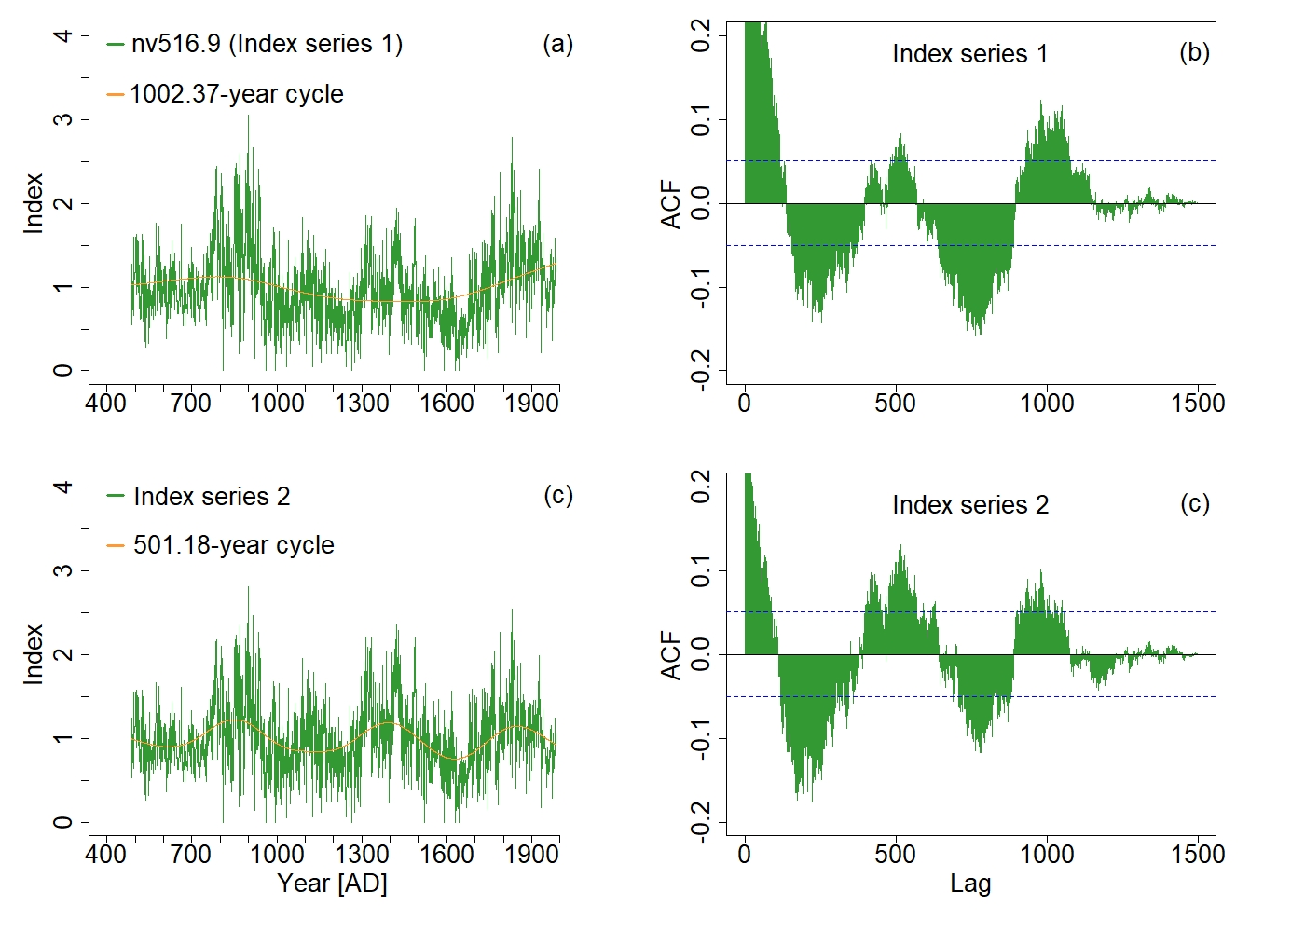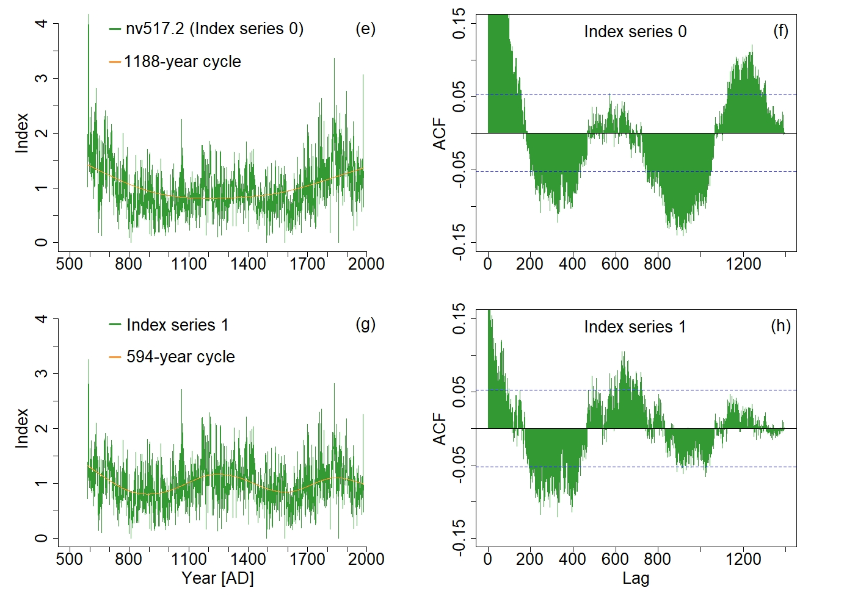
Supplementary Fig.17: Examples showing resonance 1.2 of the 501.18-year (a-d) and 594-year solar cycle (e-h). Left: different index series (green curves) and the extracted signals (orange curves) for two TRW series (9 and 2) for Bristlecone Pine tree-species located respectively at two sites (nv516 and nv517). Right: ACF corresponding to each index series and 90% significance level (blue dashed lines).

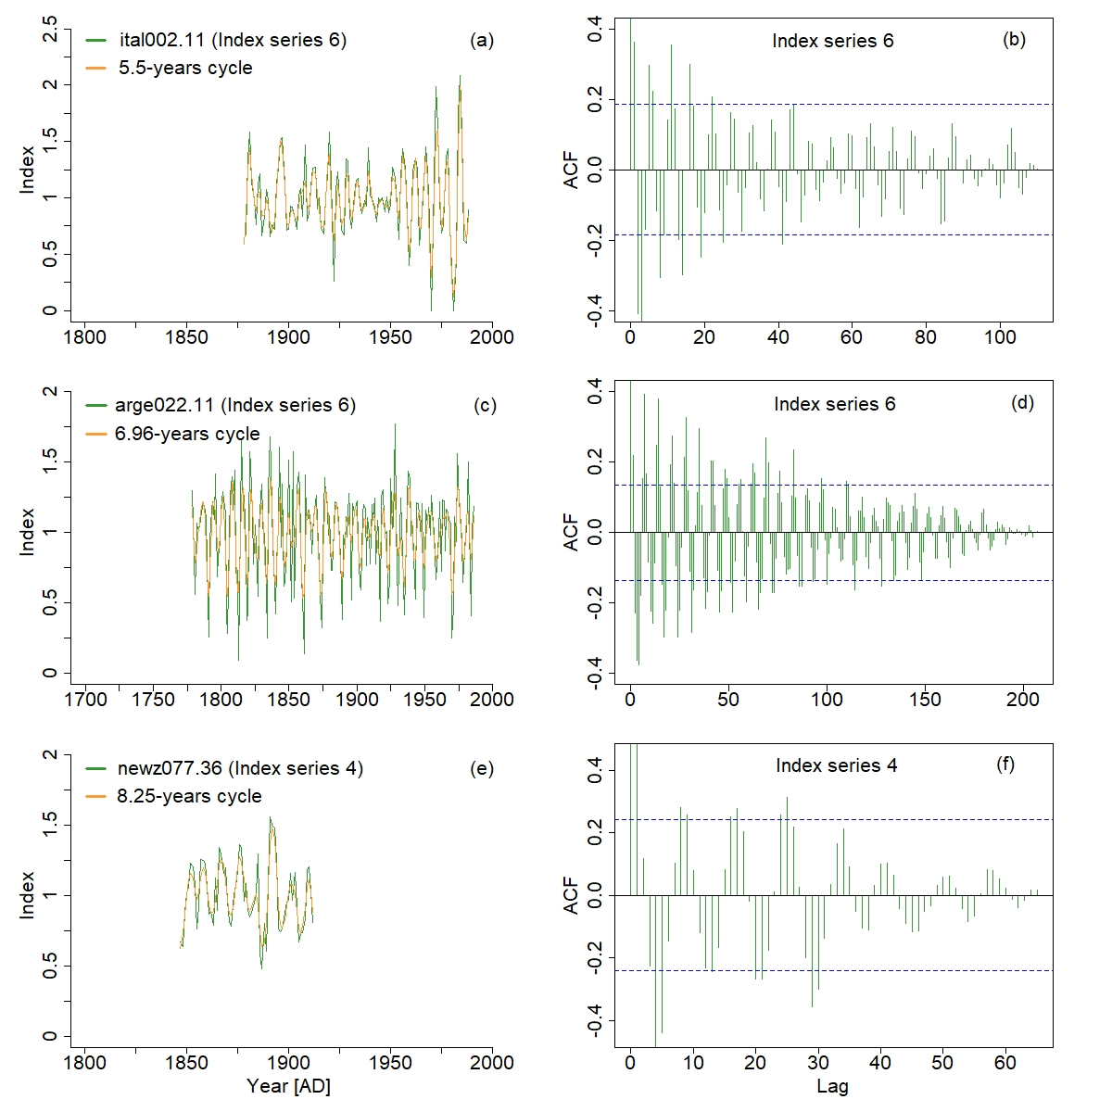
Supplementary Fig.18: Examples showing the three shortest cycles extracted from TRW series from different sites and tree-species. (a-b) for the 5.5-year solar cycle extracted from Pinus pinea L., (c-d) for the 6.96-year solar cycle extracted from Nothofagus pumilio (Poepp&Endl.) Reiche and (e-f) for the 8.25-year solar cycle extracted from Holocarpus biformis (Hook.) C.J. Quinn. Left: different index series (green curves) and the extracted signals (orange curves) for respectively the three sites ital002 (series number 11), arge022 (series number 11) and newz077 (series number 36). Right: ACF corresponding to each index series and 90% significance level (blue dashed lines).

Supplementary Table 1. Information about sites and species for the examples of TRW-time series showed in this study.
Site code | Série n° | Tree-species | Span of chronology (AD) | Coordinates  Lat. /Long. (°) | Elevation (m)
ca715 | 10 | Sequoiadendron gigantum (Lindl.) Buchholz | 1405-1991 | 36.45/-118.66 | 1935
nv510 | 38 | Pinus longaeva D.K. Bailey | 1239-1972 | 36.27/-115.7 | 3425
ca715 | 40 | Sequoiadendron gigantum (Lindl.) Buchholz | 1460-1991 | 36.45/-118.66 | 1935
fran021 | 15 | Pinus mughus Scop. | 1811-1977 | 42.97/0.73 | 1750
newz077 | 31 | Halocarpus biformis (Hook.) Quinn | 1782-1993 | -40.67/175.52 | 650
chil016 | 12 | Pilgerodendron uviferum (D. Don) Florin | 1781-1986 | -43/-72.5 | 540
newz077 | 37 | Halocarpus biformis (Hook.) Quinn | 1783-1993 | -40.67/175.52 | 650
ia016 | 1 | Quercus macrocarpa Michx. | 1714-1974 | 41.88/-95.92 | 396
turk022 | 9 | Pinus sylvestris L. | 1834-2001 | 40.55/41.98 | 2100
geor007 | 20 | Abies alba Mill. | 1784-2006 | 41.61/42.51 | 1930
cana388 | 53 | Pinus contorta Douglas ex Loidon | 1798-2002 | 53.76/-127.28 | 1220
ausl041 | 86 | Athrotaxis selaginoides D. Don | 1499-1975 | -41.63/145.93 | 1000
sem01 | 3 | Pinus halepensis Mill.
newz077 | 34 | Halocarpus biformis (Hook.) Quinn | 1727-1993 | -40.67/175.52 | 650
newz077 | 37 | Halocarpus biformis (Hook.) Quinn | 1783-1993 | -40.67/175.52 | 650
oh012 | 7 | Quercus macrocarpa Michx. | 1802-2015 | 41.55/-84.36 | 217
newz077 | 4 | Halocarpus biformis (Hook.) Quinn | 1776-1993 | -40.67/175.52 | 650
ausl030 | 7 | Phyllocladus aspleniifolius (Labill.) Hook. f. | 1610-1801 | -42.2/146.1 | 800
newz081 | 39 | Agathis australis (D. Don) Loudon | 1669-2002 | -35.37/173.28 | 468
russ058 | 2 | Pinus sylvestris L. | 1653-1758 | 66.88/51.95 | 35
geor008 | 1 | Pinus sylvestris L. | 1843-2006 | 41.76/43.51 | 1850
ausl026 | 54 | Phyllocladus aspleniifolius (Labill.) Hook. f. | 1489-1846 | -41.2/148 | 750
fran044 | 1 | Larix decidua Mill. | 1779-2007 | 44.08/7.46 | 2230
finl054 | 34 | Pinus sylvestris L. | 1562-1999 | 67.22/26.82 | 180
russ281 | 60 | Pinus sylvestris L. | 1739-2009 | 64.58/43.17 | 60
chin045 | 7 | Juniperus tibetica Kom. | 1643-1993 | 29.61/94.66 | n.a
finl055 | 28 | Pinus sylvestris L. | 1739-2000 | 67.08/27.02 | 190
cana113 | 21 | Tsuga mertensiana (Bong.) Carrière | 1660-1983 | 49.15/-125.23 | 1020
chin046 | 35 | Juniperus tibetica Kom. | 1139-1581 | 31.11/97.03 | n.a
ca703 | 5 | Sequoiadendron gigantum (Lindl.) Buchholz | 924-1774 | 38.24/-120.27 | 1380
swit347 | 25 | Pinus cembra L. | 1718-2002 | 46.68/10.36 | 2200
ca707 | 21 | Sequoiadendron gigantum (Lindl.) Buchholz | 1506-1989 | 36.76/-118.81 | 2075
ausl026 | 23 | Phyllocladus aspleniifolius (Labill.) Hook. f. | 1406-1716 | -41.2/148 | 750
nv515 | 3 | Pinus longaeva D.K. Bailey | 462-1980 | 39.08/-115.43 | 2900
ca709 | 16 | Sequoiadendron gigantum (Lindl.) Buchholz | 1563-1991 | 36.7/-118.88 | 2050
nv517 | 2 | Pinus longaeva D.K. Bailey | 589-1984 | 36.32/-115.7 | 3000
ut509 | 1 | Pinus longaeva D.K. Bailey | 937-1775 | 37.65/-112.67 | 2590
nv515 | 60 | Pinus longaeva D.K. Bailey | 224 (BC)-1701 | 39.08/-115.43 | 2900
finl054 | 20 | Pinus sylvestris L. | 1749-2000 | 67.22/26.82 | 180
fran036 | 12 | Pinus cembra L. | 1621-2000 | 44.63/6.83 | 2350
swit347 | 1 | Pinus cembra L. | 1659-2002 | 46.68/10.36 | 2200
ausl033 | 2 | Phyllocladus aspleniifolius (Labill.) Hook. f. | 1733-1988 | -43.25/146.7 | 575
spai068 | 10 | Pinus nigra J.F. Arnold | 1786-2008 | 40.66/-4.16 | 1350
chil015 | 25 | Fitzroya cupressoides (Molina) I.M. johnst. | 1679-1987 | -42.5/-73.83 | 750
swit347 | 28 | Pinus cembra L. | 1604-2002 | 46.68/10.36 | 2200
spai072 | 6 | Pinus sylvestris L. | 1658-2008 | 40.78/-4.04 | 1850
newz079 | 35 | Agathis australis (D. Don) Loudon | 1587-1964 | -35.27/173.73 | 305
ca533 | 19 | Pinus longaeva D.K. Bailey | 1471-1983 | 37.5/-118.22 | 3400
ausl041 | 1 | Athrotaxis selaginoides D. Don | 1158-1882 | -41.63/145.93 | 1000
ca710 | 35 | Sequoiadendron gigantum (Lindl.) Buchholz | 1578-1992 | 36.7/-118.91 | 1860
ca718 | 23 | Sequoiadendron gigantum (Lindl.) Buchholz | 1333-1991 | 36.13/-118.51 | 1890
nv037 | 3 | Pinus longaeva D.K. Bailey | 1083-1976 | 39.42/-114.65 | 3048
ca535 | 179 | Pinus longaeva D.K. Bailey | 214 (BC)-1978 | 37.43/-118.17 | 2805
mong007 | 22 | Larix gmelinii (Rupr.) Kuzen. | 1570-1964 | 49.7/91.55 | 2000
chil016 | 38 | Pilgerodendron uviferum (D. Don) Florin | 1810-1986 | -43/-72.5 | 540
chil016 | 50 | Pilgerodendron uviferum (D. Don) Florin | 1680-1939 | -43/-72.5 | 540
ca719 | 68 | Sequoiadendron gigantum (Lindl.) Buchholz | 300-1227 | 36.1/-118.65 | 1935
ut509 | 32 | Pinus longaeva D.K. Bailey | 1014-1980 | 37.65/-112.67 | 2590
russ099 | 1 | Pinus sylvestris L. | 1636-1992 | 60.57/59.55 | 720
swed019 | 5 | Pinus sylvestris L. | 1400-1977 | 68.23/19.67 | 400
nv500 | 12 | Pinus longaeva D.K. Bailey | 170-1964 | 38.95/-114.22 | 2926
brit039 | 44 | Pinus sylvestris L. | 1689 (BC)-1547 (BC) | 53.63/-0.88 | n.a.
russ058 | 13 | Pinus sylvestris L. | 1796-1990 | 66.88/51.95 | 35
newz077 | 26 | Halocarpus biformis (Hook.) Quinn | 1755-1993 | -40.67/175.52 | 650
ca709 | 60 | Sequoiadendron gigantum (Lindl.) Buchholz | 754-1634 | 36.7/-118.88 | 2050
alge001 | 8 | Cedrus atlantica (Endl.) Manetti ex Carrière | 1876-2005 | 36.45/4.1 | 1520
ca708 | 68 | Sequoiadendron gigantum (Lindl.) Buchholz | 894 (BC)-511 (BC) | 36.8/-118.96 | 1950
cana111 | 21 | Tsuga mertensiana (Bong.) Carrière | 1539-1983 | 49.42/-123.08 | 1110
ut509 | 25 | Pinus longaeva D.K. Bailey | 1165-1978 | 37.65/-112.67 | 2590
nv510 | 33 | Pinus longaeva D.K. Bailey | 800-1983 | 36.27/-115.7 | 3425
nv510 | 48 | Pinus longaeva D.K. Bailey | 1174-1984 | 36.27/-115.7 | 3425
nv516 | 9 | Pinus longaeva D.K. Bailey | 487-1984 | 38.93/-114.23 | 3050
ital002 | 11 | Pinus pinea L. | 1878-1988 | 41.33/13 | n.a.
arge022 | 11 | Nothofagus pumilio (Poepp. & Endl.) Reiche | 1779-1986 | -54.52/-67.42 | 200
newz077 | 36 | Halocarpus biformis (Hook.) Quinn | 1702-1993 | -40.67/175.52 | 650
fran027 | 10 | Pinus nigra J.F. Arnold | 1703-1830 | 42.07/9.20 | 1400
fran027 | 13 | Pinus nigra J.F. Arnold | 1767-1980 | 42.07/9.20 | 1400

