Figures
Fig. A1. Volcano plot of DEGs. (a)AP/MP. (b) HP/MP (c)HP/AP.
Fig. A2. KEGG pathway classification and enrichment of AP/MP DEGs. (a) KEGG pathway classification of AP/MP. (b) KEGG pathway functional enrichment of AP/MP. Rich factor indicates the ratio of DEGs to all genes in that pathway.
Fig. A3. Transcriptional regulation of “photosynthesis-antenna protein” KEGG pathway. The red and blue boxes indicate up-regulation and down-regulation respectively.
Fig. A4. Hierarchical cluster analysis of DEGs responding to preculture strategy in enriched KEGG pathways (AP/MP).

Fig. A1. Volcano plot of DEGs. (a)AP/MP. (b) HP/MP (c)HP/AP.
(a)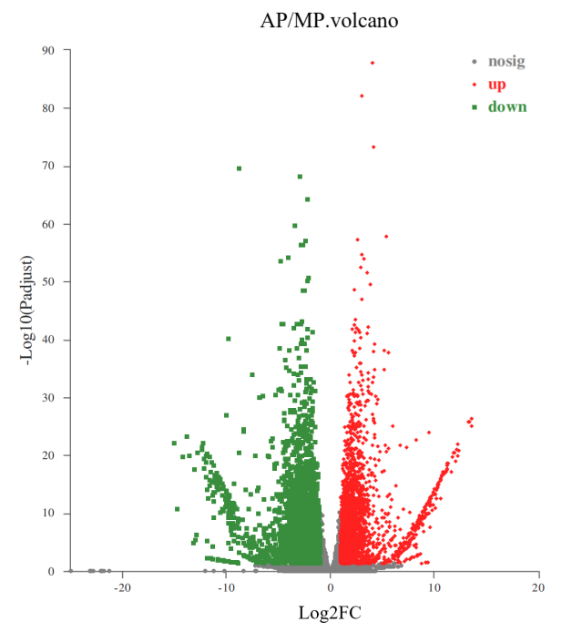(b)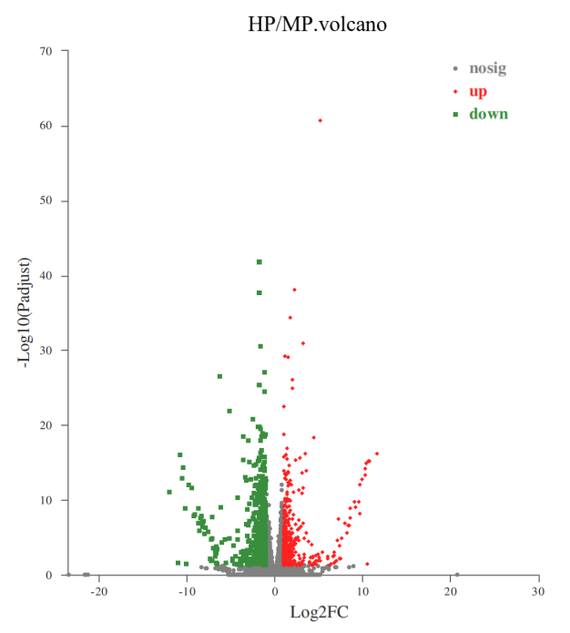
(c)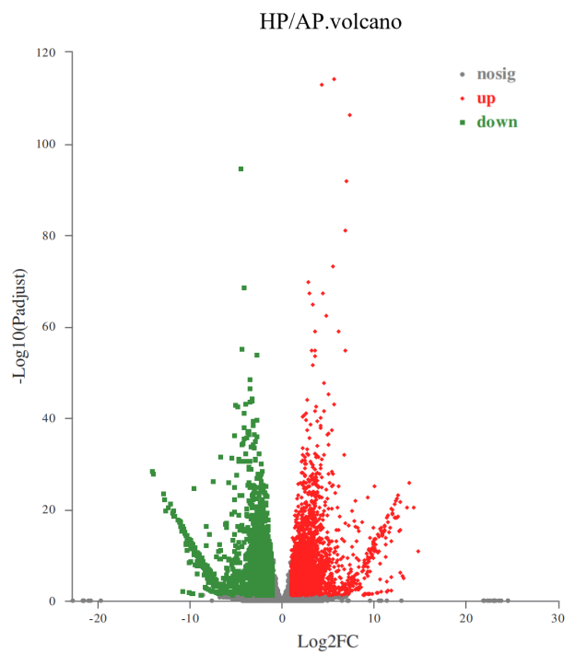

Fig. A2. KEGG pathway classification and enrichment of AP/MP DEGs. (a) KEGG pathway classification of AP/MP. (b) KEGG pathway functional enrichment of AP/MP. Rich factor indicates the ratio of DEGs to all genes in that pathway.
- 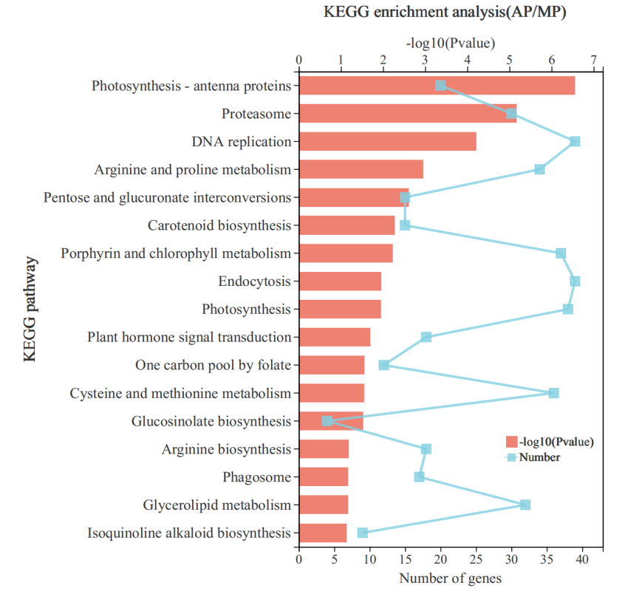
- 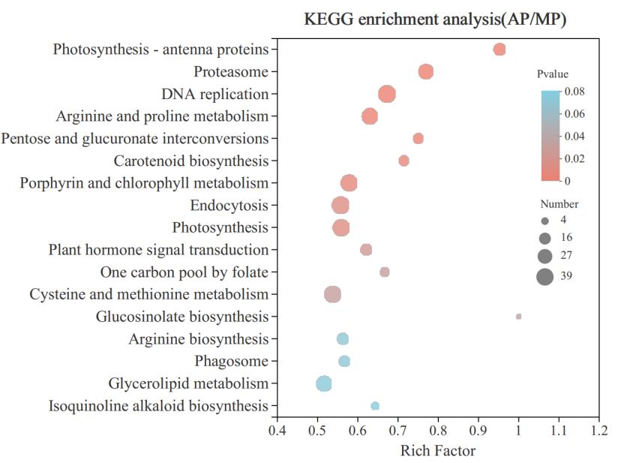
Fig. A3. Transcriptional regulation of “photosynthesis-antenna protein” KEGG pathway. The red and blue boxes indicate up-regulation and down-regulation respectively.
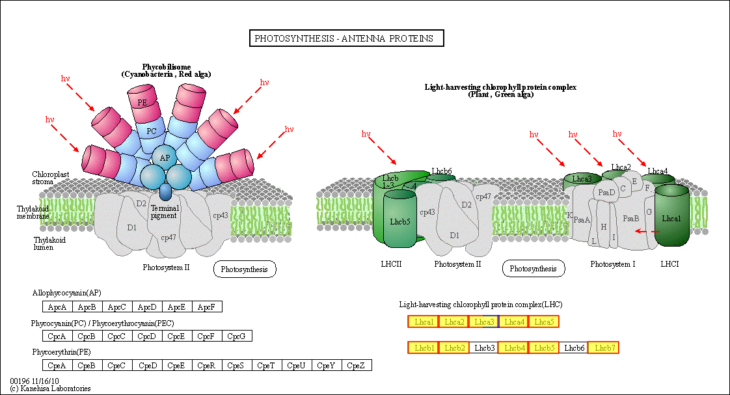

Fig. A4. Hierarchical cluster analysis of DEGs responding to preculture strategy in enriched KEGG pathways (AP/MP).
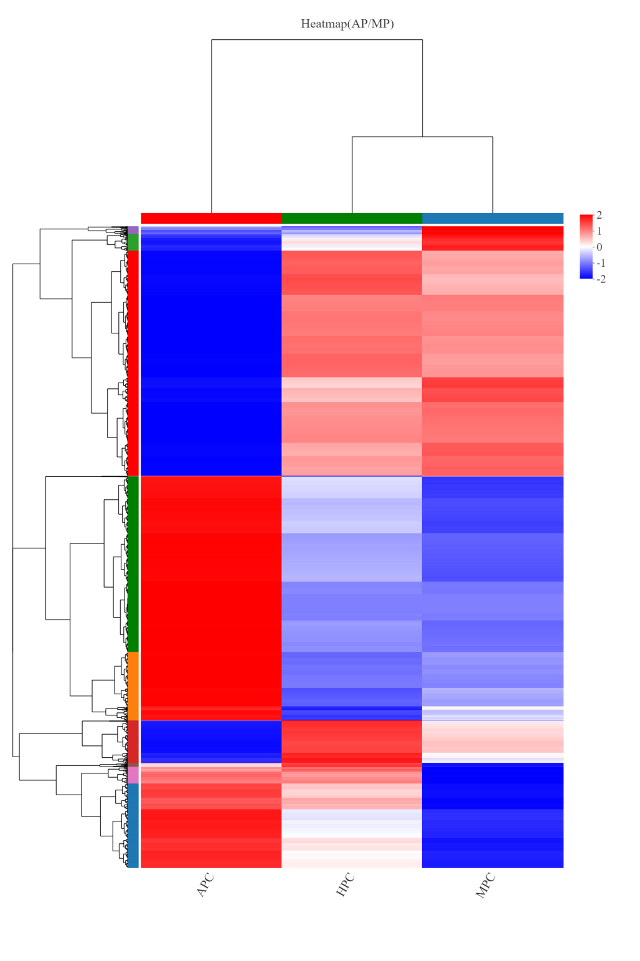

Tables
Table A1 Expression patterns of genes involved in TAG, astaxanthin biosynthesis and central carbon mechanism.
Table A2 Amino acid composition of heterotrophic cultured C. zofngiensis after MP.

Table A1 Expression patterns of genes involved in TAG, astaxanthin biosynthesis and central carbon mechanism
Gene ID | Annotation | Abbreviation | log 2 FC
Gene ID | Annotation | Abbreviation | AP/MP | HP/AP | HP/MP
FA biosynthesis
Cz02g12030 | carboxyltransferase subunit alpha  (ACCase complex) | α-CT | -0.45 | 0.73 | 0.29
Cz02g17060 | carboxyltransferase subunit beta  (ACCase complex) | β-CT | -0.05 | 0.55 | 0.51
Cz03g28270 | biotin carboxyl carrier protein  (ACCase complex) | BCCP1 | -0.83 | 0.80 | -0.02
Cz06g20040 | biotin carboxyl carrier protein  (ACCase complex) | BCCP2 | 0.74 | 0.09 | 0.83
Cz13g10110 | biotin carboxylase  (ACCase complex) | BC | -1.53 | 1.38 | -0.13
Cz19g10190 | acetyl-CoA carboxylase | ACCase | -0.59 | 0.79 | 0.22
Cz09g30220 | acyl carrier protein | ACP1 | -0.89 | 0.93 | 0.05
Cz07g17120 | acyl carrier protein | ACP2 | -1.11 | 0.98 | -0.11
Cz13g05150 | malonyl-CoA:Acyl carrier protein transacylase | MCT1 | -2.29 | 2.10 | -0.17
Cz04g37050 | malonyl-CoA:Acyl carrier protein transacylase | MCT2 | 0.99 | -2.29 | -1.27
UNPLg00257 | 3-oxoacyl-[acyl-carrier-protein] synthase, II  (C16:0 to C18:0) | KAS II | -1.54 | 1.25 | -0.27
Cz02g14160 | - oxoacyl-[acyl-carrier-protein] synthase, I  (C4:0 to up to C16:0) | KAS I | -3.17 | 2.78 | -0.37
Cz18g03070 | 3-oxoacyl-[acyl-carrier-protein] synthase, III  (C2:0 to C4:0) | KAS III | -1.00 | 1.05 | 0.07
Cz06g14030 | 3-oxoacyl-[acyl-carrier-protein] synthase, II | KAS II | -0.66 | 0.69 | 0.04
Cz01g34370 | 3-oxoacyl-[acyl-carrier protein] reductase | KAR1 | -2.48 | 2.53 | 0.06
Cz16g00050 | 3-oxoacyl-[acyl-carrier protein] reductase | KAR2 | -0.64 | 0.56 | -0.06
Cz10g18200 | 3-oxoacyl-[acyl-carrier protein] reductase | KAR3 | 1.55 | -1.10 | 0.47
Cz03g39140 | 3-oxoacyl-[acyl-carrier protein] reductase? | KAR4 | 1.48 | -2.06 | -0.57
Cz15g00050 | 3-oxoacyl-[acyl-carrier protein] reductase | KAR5 | -0.43 | -0.09 | -0.51
Cz04g17270 | 3-oxoacyl-[acyl-carrier protein] reductase | KAR6 | 1.82 | -1.20 | -0.60
Cz11g27250 | 3-oxoacyl-[acyl-carrier protein] reductase? | KAR7 | 0.56 | -1.33 | -0.75
Cz01g09160 | 3-hydroxyacyl-[acyl-carrier-protein] dehydratase | HAD | -2.87 | 1.79 | -1.06
Cz11g20040 | enoyl-[acyl-carrier protein] reductase | ENR | -2.69 | 1.54 | -1.14
FA desaturation
Cz04g09090 | acyl-[acyl-carrier-protein] desaturase | SAD1 | -4.16 | 3.35 | -0.79
Cz13g17200 | acyl-[acyl-carrier-protein] desaturase | SAD2 | 0.47 | -0.92 | -0.44
TAG synthesis
Cz11g03260 | glycerol-3-phosphate acyltransferase | GPAT1 | 8.96 | -9.90 | -0.91
Cz09g31330 | glycerol-3-phosphate acyltransferase | GPAT2 | -0.97 | 0.93 | -0.02
Cz16g02090 | 1-acyl-sn-glycerol-3-phosphate acyltransferase | LPAAT1 | 10.00 | -10.00 | 0.02
Cz10g20070 | 1-acyl-sn-glycerol-3-phosphate acyltransferase | LPAAT2 | 0.17 | -0.27 | -0.08
Cz05g23060 | phosphatidate phosphatase, Lipin | PAP1 | 0.70 | -0.19 | 0.53
Cz10g16040 | phosphatidate phosphatase | PAP2 | 5.24 | -4.97 | 0.29
Cz16g11240 | phosphatidate phosphatase | PAP3 | -1.78 | 3.69 | 1.91
Cz10g01120 | 2-acylglycerol O-acyltransferase | MGAT | 7.13 | -7.38 | -0.22
Cz06g05010 | Diacylglycerol O-acyltransferase, type I | DGAT1A | -2.15 | 2.05 | -0.08
Cz09g08290 | Diacylglycerol O-acyltransferase, type I | DGAT1B | 1.78 | -1.53 | 0.27
Cz06g35060 | Diacylglycerol O-acyltransferase, type II | DGTT1 | -0.88 | 1.76 | 0.91
Cz06g22030 | Diacylglycerol O-acyltransferase, type II | DGTT2 | -0.46 | -0.35 | -0.78
Cz09g23010 | Diacylglycerol O-acyltransferase, type II | DGTT3 | -0.56 | 3.49 | 2.95
Cz11g24150 | Diacylglycerol O-acyltransferase, type II | DGTT4 | 2.73 | -3.24 | -0.49
Cz09g27290 | Diacylglycerol O-acyltransferase, type II | DGTT5 | -3.16 | 2.56 | -0.59
Cz15g22140 | Diacylglycerol O-acyltransferase, type II | DGTT6 | -12.26 | 12.35 | 0.00
Cz11g21100 | Diacylglycerol O-acyltransferase, type II | DGTT7 | -1.89 | 0.52 | -1.35
Cz08g14220 | phospholipid:diacylglycerol acyltransferase | DGTT8 | -0.01 | 0.21 | 0.21
Carotenoids synthesis
Cz02g35280 | 1-deoxy-D-xylulose 5-phosphate synthase  (DOXP synthase) | DXS | 1.25 | -1.02 | 0.24
Cz07g19130 | 1-deoxy-D-xylulose 5-phosphate reductoisomerase | DXR | 0.60 | -1.01 | -0.40
Cz12g10090 | 2-C-methyl-D-erythritol 4-phosphate cytidylyltransferase | CMS | 9.12 | -8.48 | 0.67
Cz11g24270 | 4-diphosphocytidyl-2-C-methyl-D-erythritol kinase | CMK | -0.02 | -0.26 | -0.27
Cz02g10180 | 2-C-methyl-D-erythritol 2,4-cyclodiphosphate synthase | MCS | 5.23 | -5.92 | -0.68
Cz13g08020 | 4-hydroxy-3-methylbut-2-en-1-yl  diphosphate synthase | HDS | 0.36 | -0.60 | -0.23
Cz05g23010 | - hydroxy-3-methylbut-2-enyl  diphosphate reductase | HDR | 0.57 | -0.88 | -0.30
Cz04g25080 | Acetoacetyl-CoA thiolase | AACT | -0.70 | 0.28 | -0.40
Cz19g02060 | Hydroxymethylglutaryl-CoA synthase  (HMG-CoA synthase) | HCS | 1.12 | -1.67 | -0.54
Cz03g02150 | Isopentenyl-diphosphate Delta-isomerase | IPPI | 0.37 | 0.13 | 0.52
Cz02g31110 | geranyl diphosphate synthase | GPPS | 0.32 | -0.22 | 0.12
Cz01g03190 | farnesyl diphosphate synthase | FPPS | -0.82 | 0.63 | -0.18
Cz02g19200 | geranylgeranyl diphosphate synthase | GGPPS | 1.76 | -1.81 | -0.03
Cz05g32220 | phytoene synthase (chloroplastic) | PSY | 5.62 | -5.24 | 0.40
Cz02g32280 | phytoene desaturase | PDS | 3.47 | -2.64 | 0.86
Cz10g17010 | Zeta-carotene desaturase (chloroplastic) | ZDS | 2.22 | -1.68 | 0.55
Cz10g17130 | Zeta-carotene isomerase | ZISO | 2.38 | -1.74 | 0.65
Cz16g01210 | carotenoid isomerase | CRTISO1 | 3.33 | -3.53 | -0.17
Cz12g03260 | carotenoid isomerase | CRTISO2 | -1.19 | 1.19 | 0.02
Cz14g22040 | carotenoid isomerase | CRTISO3 | 1.61 | -1.33 | 0.29
Cz09g18310 | Lycopene epsilon cyclase | LCYe | 1.25 | -1.86 | -0.59
Cz12g10170 | Lycopene beta cyclase | LCYb | 0.70 | -0.18 | 0.54
Cz13g16110 | cytochrome P450 beta hydroxylase,CYP97A5(Cr) | CYP97A | 4.03 | -3.57 | 0.48
Cz09g07100 | cytochrome P450 epsilon hydroxylase, CYP97C3 | CYP97C | 2.44 | -2.76 | -0.30
Cz09g14130 | Cytochrome P450 CYP97B,  beta or seta-rings (At) | CYP97A | 0.74 | -0.64 | 0.12
Cz12g16080 | beta-carotene hydroxylase | CHYb | 0.45 | -0.18 | 0.28
Cz13g13100 | beta-carotene ketolase/oxygenase | BKT1 | 1.23 | -0.74 | 0.50
Cz04g11250 | beta-carotene ketolase/oxygenase | BKT2 | 0.95 | -0.46 | 0.50
Cz07g30060 | zeaxanthin epoxidase | ZEP | 2.18 | -1.83 | 0.37
Cz06g02070 | violaxanthin de-epoxidase | VDE | -0.10 | -0.28 | -0.36
Cz02g29020 | Long-chain-alcohol O-fatty-acyltransferase | AAT? | 1.38 | -1.04 | 0.36
OPP Pathway
Cz06g12080 | Glucose-6-phosphate 1-dehydrogenase | G6PD1 | 0.27 | -0.45 | -0.17
Cz03g12030 | Glucose-6-phosphate 1-dehydrogenase | G6PD2 | 1.45 | -1.46 | -3.71
Cz04g18010 | 6-phosphogluconolactonase | PGLS1 | 0.58 | -0.05 | 0.55
Cz11g03250 | 6-phosphogluconolactonase | PGLS2 | -1.38 | 2.43 | 1.05
Cz05g06160 | 6-phosphogluconate dehydrogenase | 6PGD | -2.32 | 1.77 | -0.53
Cz05g13260 | ribose 5-phosphate isomerase | RPI1 | -5.36 | 5.45 | 0
Cz09g17220 | ribose 5-phosphate isomerase | RPI2 | 0.23 | -0.57 | -0.32
Cz05g11190 | ribulose-phosphate 3-epimerase | RPE1 | 2.33 | -1.66 | 0.69
Cz04g31230 | ribulose-phosphate 3-epimerase | RPE2 | 1.15 | -0.88 | 0.29
Cz14g07140 | ribulose-phosphate 3-epimerase | RPE3 | 2.33 | -1.99 | 0.36
Cz03g04080 | transketolase | TRK | 1.94 | -2.01 | -0.05
Cz06g25040 | transaldolase | TAL1 | 0.20 | -0.82 | -0.61
Cz04g12210 | transaldolase | TAL2 | 0.37 | -0.15 | 0.24
Cz12g20290 | transaldolase | TAL3 | -2.29 | 2.41 | 0.13
Glycolysis and Glucogenesis
Cz13g07170 | hexokinase | HK | -0.73 | 1.32 | 0.60
Cz06g03010 | glucokinase | GK | -2.24 | 1.22 | -1.00
Cz01g30020 | glucose-6-phosphate isomerase | PGI | -0.00 | 0.04 | 0.05
Cz09g25120 | 6-phosphofructokinase | PFK1 | -1.08 | 0.58 | -0.48
Cz16g11260 | 6-phosphofructokinase | PFK2 | -1.36 | 2.49 | 1.14
Cz07g13120 | 6-phosphofructokinase | PFK3 | -1.54 | 0.93 | -0.58
Cz04g03070 | Fructose-1,6-bisphosphatase, class I | FBP1 | 2.52 | -2.49 | 0.04
Cz05g01180 | Fructose-1,6-bisphosphatase, class II | FBP2 | 0.71 | 0.91 | 1.63
Cz05g37140 | Fructose-bisphosphate aldolase | FBA1 | 0.89 | -1.05 | -0.15
Cz06g07090 | Fructose-bisphosphate aldolase | FBA2 | 0.11 | -0.72 | -0.59
Cz03g06050 | Fructose-bisphosphate aldolase | FBA3 | 0.63 | -0.46 | 0.19
Cz03g13070 | Fructose-bisphosphate aldolase | FBA4 | -2.42 | 1.66 | -0.76
Cz06g17270 | triosephosphate isomerase | TIM | -0.28 | 0.18 | -0.08
Cz05g34160 | glyceraldehyde 3-phosphate dehydrogenase (NAD) | GAPDH | -2.26 | 2.35 | 0.10
Cz16g19260 | phosphoglycerate kinase | PGK | 0.38 | -0.87 | -0.47
Cz06g01110 | phosphoglycerate mutase, 2,3-bisphosphoglycerate-dependent | PGAM1 | -2.81 | 2.28 | -0.51
Cz09g03220 | phosphoglycerate mutase, 2,3-bisphosphoglycerate-independent | PGAM2 | 0.15 | -0.29 | -0.12
Cz04g11130 | phosphoglycerate mutase, 2,3-bisphosphoglycerate-independent | PGAM3 | -3.66 | 3.38 | -0.26
Cz08g21030 | phosphoglycerate mutase, 2,3-bisphosphoglycerate-independent | PGAM4 | -0.86 | -0.23 | 1.08
Cz14g01200 | phosphoglycerate mutase | PGAM5 | 0.66 | -0.99 | -0.32
Cz14g08090 | phosphoglycerate mutase | PGAM6 | 0.56 | -0.50 | 0.07
Cz01g38050 | phosphoglycerate mutase | PGAM7 | -0.95 | 1.35 | 0.41
Cz05g10010 | enolase | ENO | -1.64 | 1.20 | -0.42
UNPLg00362 | pyruvate kinase | PK1 | 0.38 | -0.68 | -0.28
Cz08g12170 | pyruvate kinase | PK2 | 1.75 | -1.90 | -0.13
Cz16g00040 | pyruvate kinase | PK3 | -0.79 | 0.68 | -0.10
Cz14g14130 | pyruvate kinase | PK4 | 1.75 | -1.26 | 0.50
Cz04g17050 | pyruvate kinase | PK5 | -1.41 | 1.54 | 0.15
Cz01g21060 | pyruvate kinase | PK6 | -1.42 | 2.24 | 0.82
Cz15g09100 | pyruvate kinase | PK7 | -0.28 | 0.28 | 0.02
Cz10g06190 | pyruvate kinase | PK8 | 0.63 | -1.10 | -0.45
Cz01g05160 | phosphoenolpyruvate carboxykinase (ATP) | PEPCK | 0.30 | 1.83 | 2.15
Cz04g02090 | pyruvate carboxylase | PYC | 0.47 | -0.21 | 0.28
TCA
Cz02g27080 | citrate synthase | CIS1 | 0.08 | 0.94 | 1.03
Cz02g12210 | citrate synthase | CIS2 | -3.90 | 2.57 | -1.32
Cz13g00140 | aconitate hydratase | ACH | 0.34 | -0.31 | 0.05
Cz11g28180 | isocitrate dehydrogenase, NAD-dependent | IDH1 | -2.66 | 1.96 | -0.68
Cz11g08120 | isocitrate dehydrogenase, NAD-dependent | IDH2 | -1.57 | 0.86 | -0.70
Cz12g16160 | isocitrate dehydrogenase, NADP-dependent | IDH3 | 0.31 | -0.70 | -0.38
Cz05g03220 | 2-oxoglutarate dehydrogenase, E1 | OGDH1 | -1.08 | 0.37 | -0.69
Cz01g28100 | 2-oxoglutarate dehydrogenase, E1 | OGDH2 | 1.41 | -0.95 | 0.48
Cz02g11010 | 2-oxoglutarate dehydrogenase, E2 | OGDH3 | -1.84 | 0.75 | -1.07
Cz01g33150 | succinyl-CoA synthetase, alpha subunit | SCSa | -1.20 | 0.22 | -0.97
Cz03g31200 | succinyl-CoA synthetase, beta subunit | SCSb | -2.19 | 1.33 | -0.84
Cz15g13230 | succinate dehydrogenase (ubiquinone)  iron-sulfur subunit | SDH1 | -0.83 | 1.14 | 0.32
Cz07g14020 | succinate dehydrogenase (ubiquinone)  cytochrome b560 subunit | SDH2 | -1.79 | 1.76 | -0.01
Cz07g14015 | succinate dehydrogenase (ubiquinone)  membrane anchor subunit | SDH3 | -1.01 | 0.91 | -0.08
Cz07g04030 | fumarate hydratase, class I | FHD | 0.07 | 0.05 | 0.14
Cz02g21340 | malate dehydrogenase (NAD) | MDH | -2.45 | 1.25 | -1.18
Acetyl CoA source
Cz18g13050 | pyruvate dehydrogenase, E1 alpha | PDHC1 | -0.38 | 0.23 | -0.13
Cz07g25130 | pyruvate dehydrogenase, E1 beta | PDHC2 | -1.66 | 1.39 | -0.25
Cz03g08090 | pyruvate dehydrogenase, E1 alpha | PDHC3 | -0.72 | 0.72 | 0.02
Cz01g37230 | pyruvate dehydrogenase, E1 beta | PDHC4 | -1.57 | 1.76 | 0.21
Cz05g28130 | pyruvate dehydrogenase, E2  (dihydrolipoamide acetyltransferase) | PDHC5 | -3.26 | 2.97 | -0.27
Cz10g25060 | pyruvate dehydrogenase, E3  (dihydrolipoamide dehydrogenase) | PDHC6 | -0.48 | 0.25 | -0.21
Cz07g16120 | pyruvate dehydrogenase, E3  (dihydrolipoamide dehydrogenase) | PDHC7 | -0.35 | 0.45 | 0.11
Cz01g33100 | Pyruvate decarboxylase | PDC | -0.25 | -0.48 | -0.72
Cz11g04290 | aldehyde dehydrogenase (NAD+) | ALDH1 | -1.29 | 0.63 | -0.64
Cz03g20090 | aldehyde dehydrogenase (NAD+) | ALDH2 | -0.59 | -0.09 | -0.66
Cz05g18170 | aldehyde dehydrogenase | ALDH3 | 0.10 | -0.61 | -0.49
Cz09g15060 | acetyl-CoA synthetase | ACS1 | -1.05 | 0.50 | -0.53
Cz12g10100 | acetyl-CoA synthetase | ACS2 | 0.87 | -0.12 | 0.77

Table A2 Amino acid composition of heterotrophic cultured C. zofngiensis after MP.
Amino acid | Composition (%)
Asp | 9.97679
Ser | 2.90932
Glu | 14.18904
Gly | 5.90862
His | 2.96564
Arg | 10.89968
Thr | 2.01309
Ala | 9.25401
Pro | 6.02178
Cys | 0
Tyr | 0
Val | 9.6075
Met | 0
Lys | 6.31571
Ile | 5.60607
Leu | 8.79234
Phe | 5.54043

