APPENDIX FILES

Appendix-A:

Consent Form
Good Morning/Afternoon/Evening. My name is Sospeter Kibiru, from the Great Lakes University of Kisumu. I am collecting information on mother’s breastfeeding practices. I am requesting you
To volunteer to answer questions that will help us get your feedback on your attitudes and practices to exclusive breastfeeding. The County or Sub County Government will use this information to improve the health education, advice, and services in this facility.
Participation is voluntary. You can avoid any question you feel uncomfortable about. You can ask me to explain further anything you do not understand clearly from the interview. You are also free to stop me in the interview process if you do not feel like continuing with the interview. The information you give will be kept with utmost privacy and confidentiality; it will be used only for this study. Your name will not be attached to findings from this study. There will be no monetary compensation for participating in this study.

I hope it is okay if we proceed with the interview. Yes/No

Signature of the Respondent Signature of the interviewer
--------------------------------- -------------------------------

Appendix B:

Questionnaire
NB: This information will not be shared with anyone else outside the study group.
Please enter the details.
CODE-------------------------------------------------------------------
DATE OF INTERVIEW--------------------------------------------
NAME OF INTERVIEWER----------------------------------------
NAME OF HOSPITAL------------------------------------------------
Abbreviations: Strongly agree: SA Agree: A
Equivocal: E Disagree: D
Strongly Disagree: SD
- Infants age: in months:
- Infant’s sex:
Male
Female
- Birth order:
 | Information about the mother:
1. | Mother`s age in years
2. | Partner’s age in years:
3. | Parity
4. | Gravidity
5. | Level of education (completed) | - None  - Primary  - Secondary  - University  - Other (Specify)_______
6. | Occupation: | - Housewife  - Salaried Employee  - Self-employed  - Student  - Other (Specify)
7. | Marital status: | - Single  - Married  - Divorced  - Separated  - Widowed
8. | Religion | - Christian  - Muslim  - Other (specify)_____
9. | Home region
10. | ANC visits | - Yes  - No
11. | If yes in Q12 above, please specify the number of visits
12. | Mode of delivery: | - SVD  - CS  - Forceps  - Vacuum  - Others
13. | Place of delivery | - Hospital  - Health Centre  - Home  - Others (specify)
Practices of breastfeeding
14. | Did you initiate breastfeeding in the 1st hour of delivery? | - Yes  - No
15. | If No give, reasons (tick all that apply) | - Colostrum is not good  - No milk  - Mother was sick  - Baby was sick  - The baby was taken away from me
16. | Did you exclusively breastfeed for six months? | - Yes  - No
17. | If No give, reasons (tick all that apply) | - I don`t have enough milk  - I resumed work  - Water should be given as weather is hot our tradition says so  - Other (Specify)
18. | Has your child ever been sick? | - Yes  - No
19. | Did you continue to breastfeed even when the baby was sick? | - Yes  - No
20. | If No give reason(s)
21. | Do you express your milk for the baby to take when you are away? | - Yes  - No
22. | At what age did you start complementary food? | - ˂2 month  - 2-4 months  - 4-6 months’  - ˃6 months
23. | If you are not breastfeeding now, why did you stop breastfeeding? | - The child refused by himself  - I got pregnant  - The child is not feeding well  - I want to maintain my body shape  - Others (Specify)
Knowledge about breastfeeding:
24. | What advantages of breastfeeding do you know? (Tick all that apply)
25. | It is nutritious to the baby |  | SA A E D SD
26. | Protects the baby from infections |  | SA A E D SD
27. | Mother baby bonding |  | SA A E D SD
28. | Cheap and available |  | SA A E D SD
29. | Contraception method |  | SA A E D SD
30. | Maintains mothers body weight |  | SA A E D SD
31. | Prevents maternal breast cancer |  | SA A E D SD
32. | What are the disadvantages of breastfeeding?
33. | Transmission of diseases like HIV |  | SA A E D SD
34. | Other (Specify)
35. | Proper techniques of breastfeeding are :( Tick all that apply)
36. | To use both breasts at each feeding |  | SA A E D SD
37. | Breastfeed day and night |  | SA A E D SD
38. | Suitable attachment (baby close, facing mum with wide-opened mouth |  | SA A E D SD
39. | Use of EBM when the mother is away |  | SA A E D SD
40. | What is the definition of EBF?
41. | To give only breast milk and medicines if indicated |  | SA A E D SD
42. | To give breast milk and water |  | SA A E D SD
43. | What is the recommended duration of EBF? (Tick appropriately) |  | - One month  - Two months  - Three months  - Four months  - Five months  - Six months  - Eight months  - One year  - Others(specify)
44. | Have you ever expressed your milk? If yes, why?
45. | If a mum goes to work, should she express her milk and leave for the child? |  | Yes  No
46. | How would babies be fed?
47. | Cup and spoon |  | SA A E D SD
48. | Bottle |  | SA A E D SD
49. | What dangers of bottle-feeding do you know?
50. | Can cause diarrhea |  | SA A E D SD
51. | Nipple confusion |  | SA A E D SD

The Iowa Infant Feeding Attitude Scale
For each of the following statements, please indicate how much you agree or disagree by circling the number that most closely corresponds to your opinion
(1= strong disagreement, 2=disagreement, 3= neutral, 4=agreement, 5= strong agreement). You may choose any number from 1 to 5. Strongly disagree, Disagree, Neutral, Agree, strongly agree.
 | Strongly disagree | Disagree | Neutral, | agree | Strongly agree.
1. The nutritional benefits of breast milk last only until the baby is weaned from breast milk* | 1 | 2 | 3 | 4 | 5
2. Formula-feeding is more convenient than Breastfeeding. | 1 | 2 | 3 | 4 | 5
3. Breastfeeding increases mother-infant bonding. | 1 | 2 | 3 | 4 | 5
4. Breast milk is lacking in iron. * | 1 | 2 | 3 | 4 | 5
5. Formula-fed babies are more likely to be overfed than are breast-fed babies | 1 | 2 | 3 | 4 | 5
6. Formula-feeding is the better choice if a Mother plans to work outside the home. * | 1 | 2 | 3 | 4 | 5
7. Mothers who formula-fed are missed out on one of the great joys of motherhood | 1 | 2 | 3 | 4 | 5
8. Mothers should not breastfeed in public places such as restaurants. * | 1 | 2 | 3 | 4 | 5
9. Babies fed breast milk are healthier than babies who are fed formula. | 1 | 2 | 3 | 4 | 5
10. Breastfed babies are more likely to be Overfed than are formula-fed babies. * | 1` | 2 | 3 | 4 | 5
11. Fathers feel left out if a mother breastfeeds. * | 1 | 2 | 3 | 4 | 5
12. Breast milk is the ideal food for babies. | 1 | 2 | 3 | 4 | 5
13. Breast milk is more easily digested than formula. | 1 | 2 | 3 | 4 | 5
14. Formula is as healthy for an infant as breast milk. * | 1 | 2 | 3 | 4 | 5
15. Breast-feeding is more convenient than Formula feeding. | 1 | 2 | 3 | 4 | 5
16. Breast milk is less expensive than  Formula. | 1 | 2 | 3 | 4 | 5
17. A mother who occasionally drinks  Alcohol, should not breastfeed her baby. * | 1 | 2 | 3 | 4 | 5
THANK YOU.

Appendix C:

In-depth Interview Guide
- In your capacity as a community health worker, what would you say are the common breastfeeding practices among mothers in this area? Do they practice exclusive breastfeeding? Among those who practice exclusive breastfeeding, would you categorize them as the majority or the minority? Why would you say so?
- How would you characterize mothers who do not practice exclusive breastfeeding demographically? (Probe for employment status, age, marital status, religion, home area, gravidity, parity, level of education etc.)
- What are the essential components or areas of knowledge that mothers need to have regarding breastfeeding? Are mothers in this region knowledgeable on breastfeeding practices? What are the reasons for your answer? Does this knowledge affect their breastfeeding practices?
- What is the attitude of mothers in this area regarding breastfeeding? Why is this so? How does this attitude affect their breastfeeding practices?
- What message do you have for mothers concerning the topic of breastfeeding practices?
- Do you have any questions for me?
Thank You

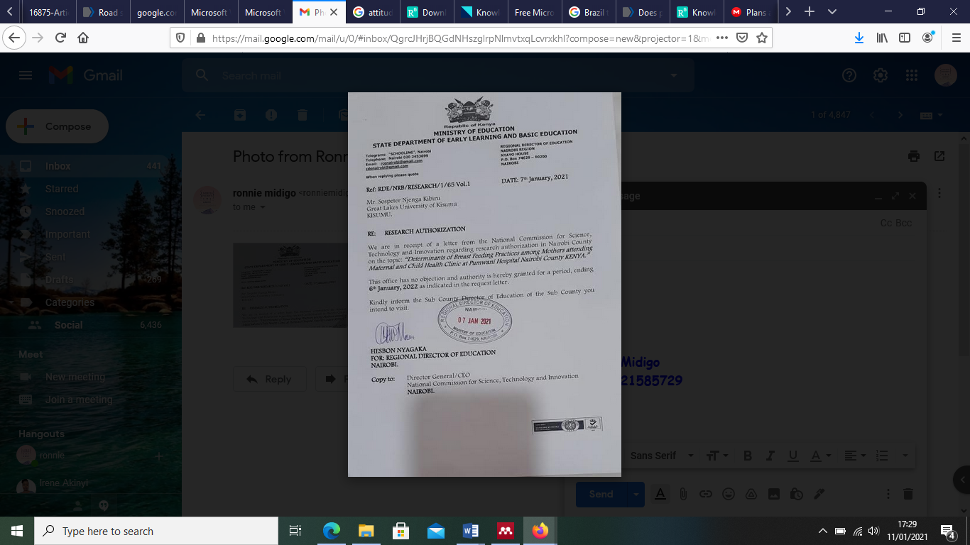
Appendix D: Letter from the Ministry of Education

Appendix E: NACOSTI Permit

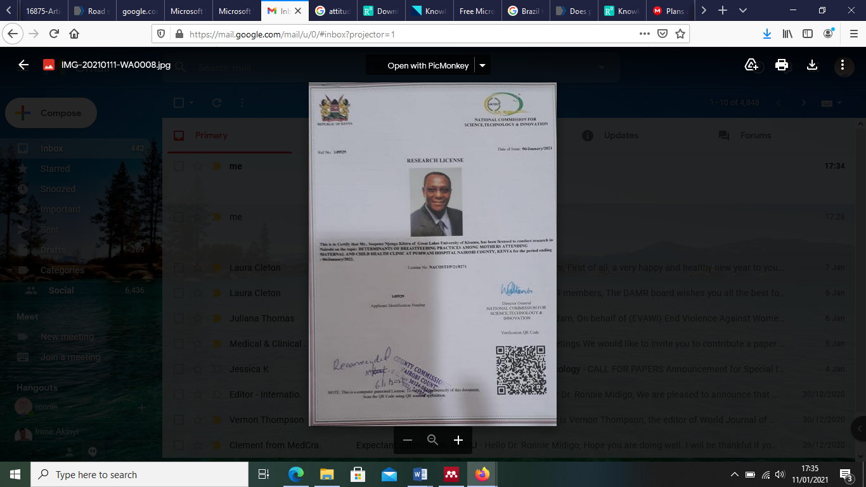

Appedix F: Nairobi Metropolitan Services approval letter
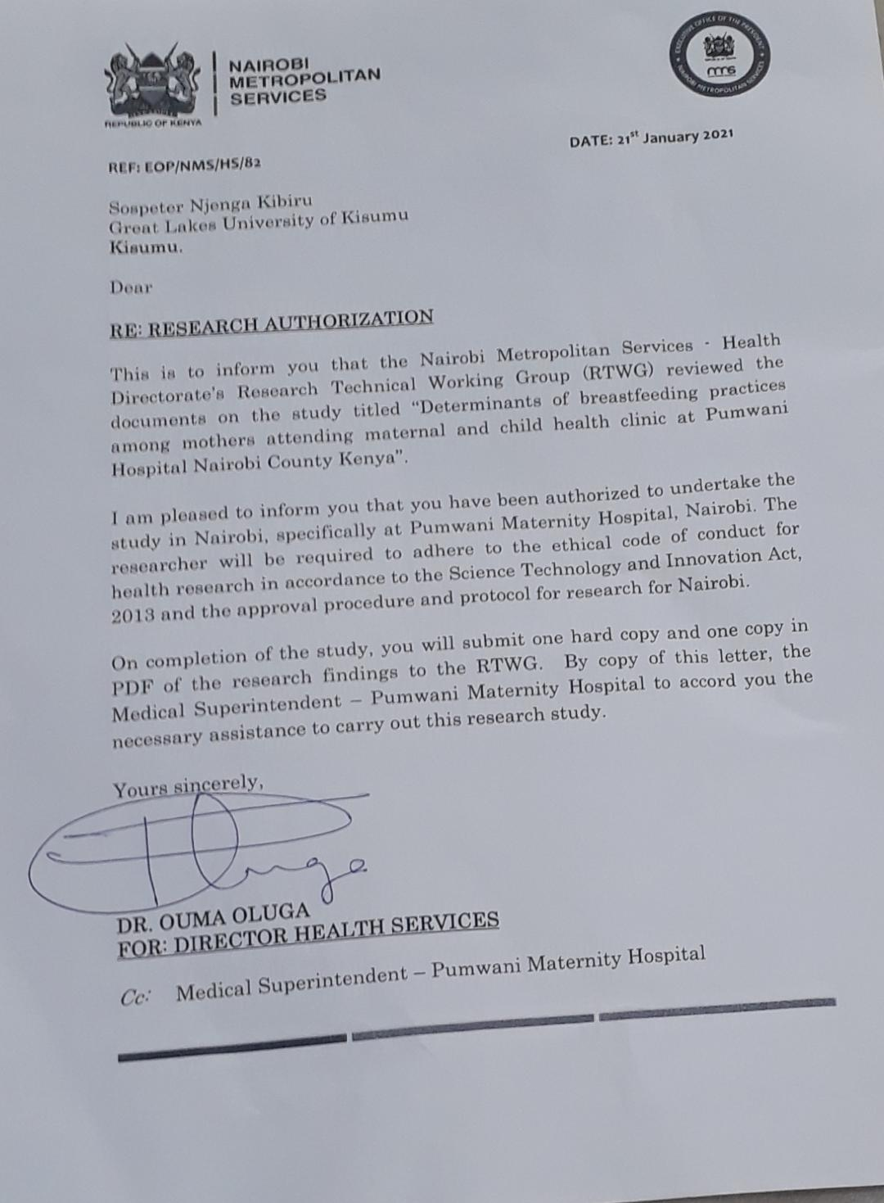

Appendix G: Ethical Approval Letter

