Supplementary Information for: Specific Codons Control Cellular Resources and Fitness
Aaron M. Love^{a,b}, Nikhil U. Nair^{b,}*
ª Manus Bio, Cambridge, MA 02138
^{b} Department of Chemical & Biological Engineering, Tufts University, Medford, MA 02155
* Corresponding author: nikhil.nair@tufts.edu; @nair_lab

Glossary of Terms
- RSCU: Relative synonymous codon usage
- W_{ij}: Relative adaptiveness
- CAI: Codon adaptation index
- ENC: Effective number of codons
- CUB: Codon usage bias
- TAI: tRNA adaptation index
- sTAI: Species specific tRNA adaptation index
- nTE: Normalized translational efficiency
- RFM: Ribosome flow model
- CFP: Cyan fluorescent protein
- YFP: Yellow fluorescent protein
- TxTL: Transcription/translation
- UTR: Untranslated region
- AUC: Area under the curve
- Fitness: Performance of induced culture/Performance from uninduced culture
- Growth Fitness: Cell density (OD600) from induced culture/cell density from uninduced culture
- Co-Expression Fitness: Chromosomal YFP signal in induced culture/YFP signal in uninduced culture
- Expression Level: Signal from induced over-expressed protein (CFP or mCherry)
- MFE: Mean free energy

Figure S1: Ribosome flow model (RFM) of CFP and YFP. a. Depiction of the RFM used to evaluate steady state ribosome occupancy probabilities and protein translation rates adapted from Reuveni et al.¹ For extensive details on the RFM, please refer to the original publication. In this model, ribosomes initiation translation according to the λ₀ rate, and then proceed to subsequent positions based on the sum of elongation times for 9 individual codons, which corresponds to the approximate footprint of a ribosome. b. Steady state ribosome occupancies are calculated numerically in Matlab® by solving a system of ODEs, which varies depending on the length of the gene. Protein translation rate is the rate of translation of the final position, which is simply the ribosome density (rho or ρ) multiplied by the elongation rate at the final position (λ_{n}). c. Calculated steady state ribosome occupancy values for codon optimized CFP (CAI = 1 with reference to highly expressed E. coli genes) vs. rare codon rich YFP (CAI = 0.16 with reference to highly expressed E. coli genes) using codon elongation times from Dana et al.² illustrates higher occupancy on the rare codon rich sequence. An initiation rate of 1s⁻¹ was used to generate all the ribosome density plots. d. Calculated translation rate vs. initiation rate for the optimal CFP vs. rare codon YFP indicates that poorly optimized sequences become elongation limited at lower translation initiation rates. e-f. Since exact elongation times have only been estimated and reported variations in elongation time are relatively small, the analysis was repeated using codon elongation times with more extreme variation. Here, the analysis was repeated using 1/codon frequency in highly expressed E. coli genes as an analog of codon elongation times (see Supplementary Data S1 for details on codon times). In this case, elongation times are more extreme for rare codons, and cause the YFP sequence to be largely insensitive to translation initiation rate due to severe elongation limitation.

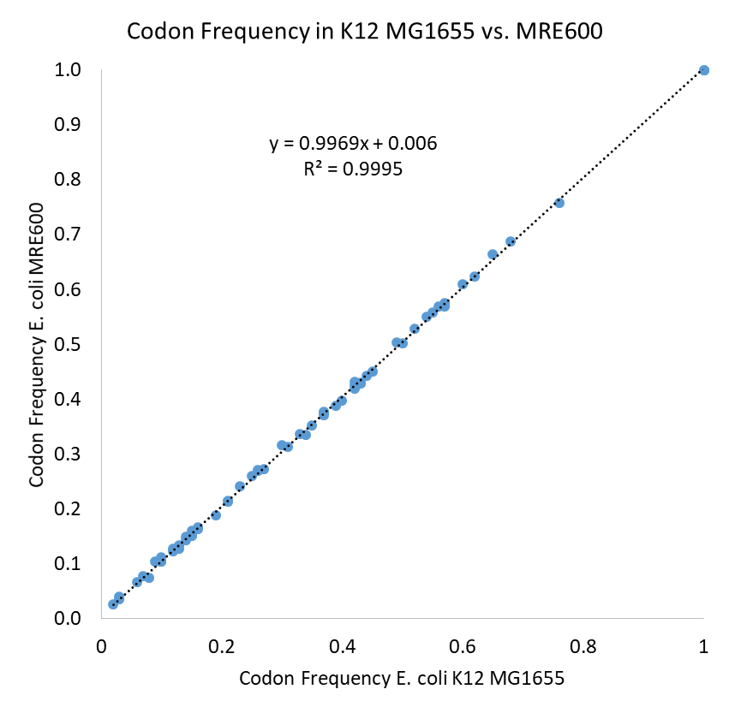
Figure S2: Codon usage data related to Figure 1 and the TxTL assay. Codon usage bias (CUB) for 64 codons in E. coli MRE600 vs. K12 MG1655 to analyze similarity. Codon use does not significantly differ between the two strains, indicating the tRNA profile in MRE600 is likely similar based on the same observed translational selection. Each point represents the frequency of an individual codon in either of the 2 strains. A full set of annotated protein coding sequences for MRE600 and MG1655 were downloaded from NCBI (CP014197.1 and NC_000913.3, respectively).

Figure S3: Data processing workflow for growth and fluorescent data related to Figure 2. Signals are gathered by taking the area under the curve (AUC) of growth (a. quantified by OD₆₀₀), or fluorescence (of b. YFP or c. CFP), using a numerical trapezoidal integrator in MATLAB. The timespan is generally defined by the maximum amount of time before any of the signals saturate in any of the samples being measured within an experiment. AUC values are represented here by bar plots (d – f). These are further processed (g) to calculate fitness values (i.e., AUC induced $÷$AUC uninduced for OD₆₀₀ or YFP signal yielding Growth Fitness or Co-Expression Fitness respectively). The absolute AUC for CFP of the induced culture is used to calculate Expression Level. Growth defects as well as a reduction in YFP expression are generally observed when CFP is induced.
Figure S4: Data related to Figure 3. a. Hierarchal clustering and analysis of RSCU values in 773 E. coli operons. Data were generated by arranging RSCU values for 773 E. coli operons with more than 1 protein coding sequence into an m x n matrix of 61 rows (one for each codon) and 773 columns (one for each operon). Hierarchal clustering was done in Matlab®, and a unique group of operons with distinct CUB is highlighted (colored green). RSCU values greater than 3 are displayed as the same color. b. List of operons/gene names present in the highlighted group. Many genes with distinct CUB are ribosomal proteins or involved in central carbon metabolism. c-d. Box and whisker plots of select operons from the highlighted group in green (56 operons) vs. the remainder (717 operons) for CAI values (c) or ENC values (d). An outlier is a value that is more than 1.5 times the interquartile range away from the bottom or top of the box. A lack of overlapping notches indicates >95% confidence in differences between medians. We observe a significantly higher CAI (median of 0.68 vs. 0.51) and lower ENC (median of 40.5 vs. 47.6) in select operons (green group) relative to the remainder, suggesting that this group has higher CUB overall, and generally uses distinct codons from the rest of the operons in E. coli.

Figure S5: Data related to Figure 3. Analysis of CUB in E. coli operons vs. individual gens within those operons shows that genes in the same operon tend to have similar CUB. Data above are from 773 annotated E. coli operons with at least 2 protein coding genes. CAI refers to codon adaptation index using highly expressed E. coli genes as a reference set (see methods).

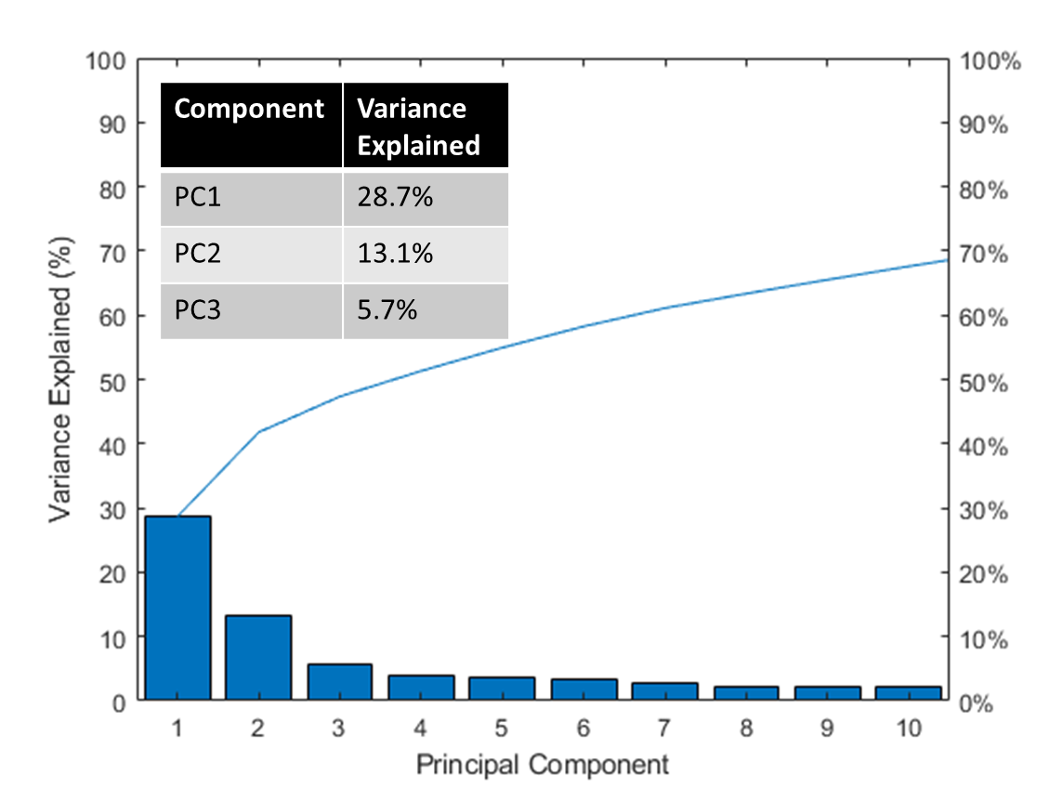
Figure S6: Data related to Figure 3 PCA analysis. Pareto plot showing variance explained by principal component analysis of 773 E. coli operons examined in Figure 3. PC1 with 28.7% of total variance was largely found to explain CAI (where CAI refers to codon adaptation index using highly expressed E. coli genes as a reference set).

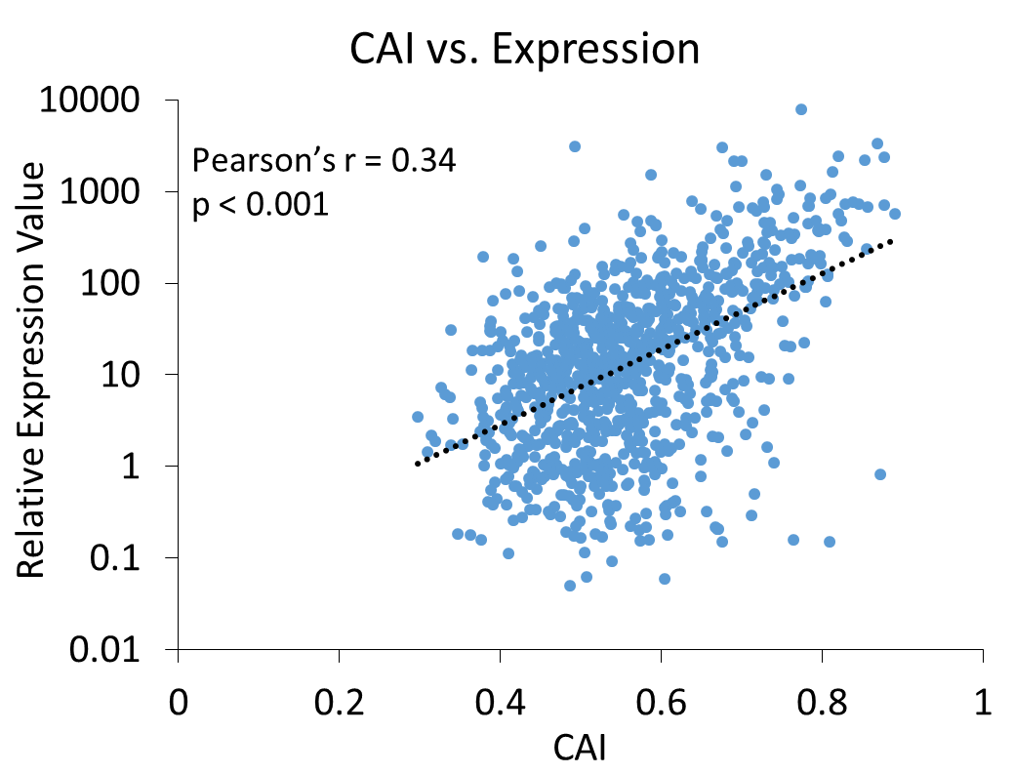
Figure S7: CAI vs. expression level correlation data related to figure 3. Expression data are from Taniguchi et al.³ Here we correlate calculated CAI value (where CAI refers to codon adaptation index using highly expressed E. coli genes as a reference set) with published expression data for genes where expression level was reported (total of 1014 genes represented here). Note that Pearson’s r is calculated based on raw protein level (as opposed to log values).

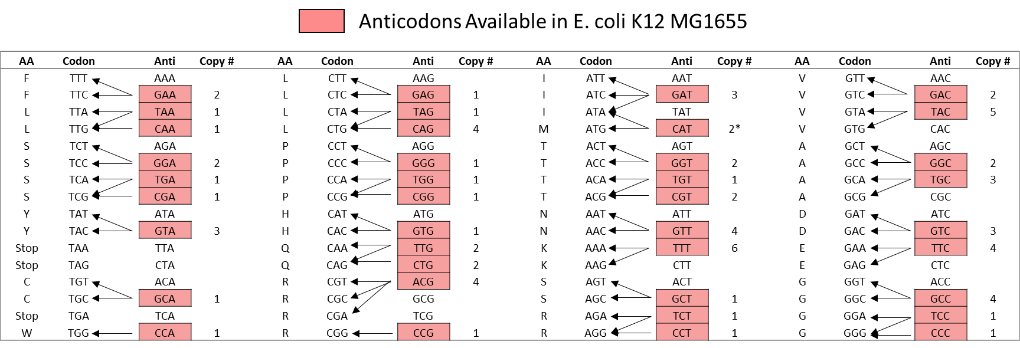
Figure S8: Available tRNA/anti-codons in E. coli K12 MG1655 and corresponding copy # for each. tRNA copy # data taken from the genomic tRNA database (http://gtrnadb.ucsc.edu/). Codon-anticodon interactions and figure adapted from Reis et al.⁴ Generally speaking, amino acids with more than 2 available codons also have more than a single tRNA available, while most amino acids with only 2 codons share a single tRNA anticodon. In the special case of the ATA codon for isoleucine, the anticodon is identical to the methionine tRNAs, and the copy # is shown only for the isoleucine CAT tRNA (denoted with *). Note that T is used in place of U for simplicity.

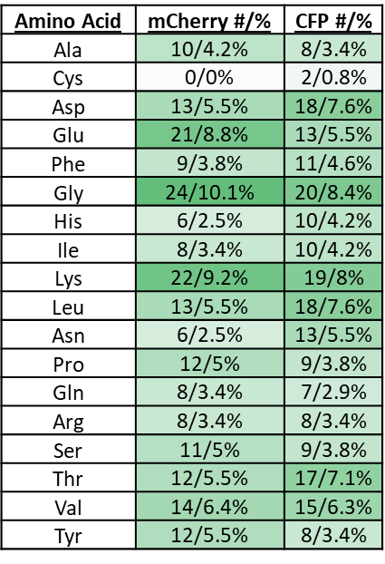
Figure S9: Amino acids re-coded for CFP and mCherry related to Figure 4. Differences in the number of amino acids between CFP and mCherry could contribute to noise in the codon sensitivity analysis dataset. Notably cysteine is underrepresented in CFP and absent in mCherry. The # refer to the total number re-coded, while the % refer to the number recoded as a percentage of all amino acids in the protein.

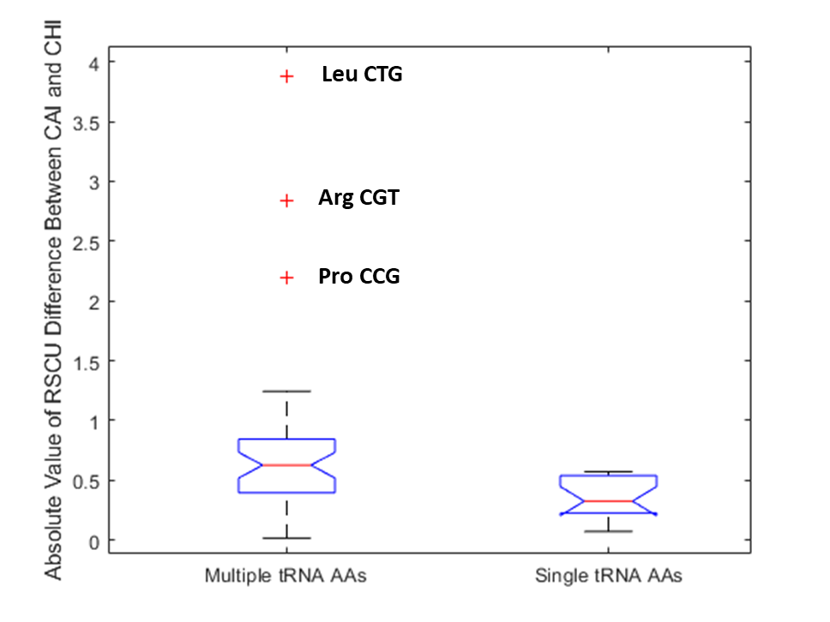
Figure S10: Data related to figure 5a. RSCU differences between CAI and χ indicates larger differences for amino acids with multiple available tRNAs. In this analysis, each amino acid is grouped based on whether there exists a single anticodon available or multiple (see Figure S9, there are 10 AAs with multiple tRNA anticodons in E. coli). The RSCU difference between CAI and χ is calculated based on the difference for each codon between expected RSCU values for a perfectly adapted sequence on either scale (i.e., the difference between the RSCU value on either scale represented in Figure 5a). An outlier is a value that is more than 1.5 times the interquartile range away from the bottom or top of the box. A lack of overlapping notches indicates >95% confidence in differences between medians.

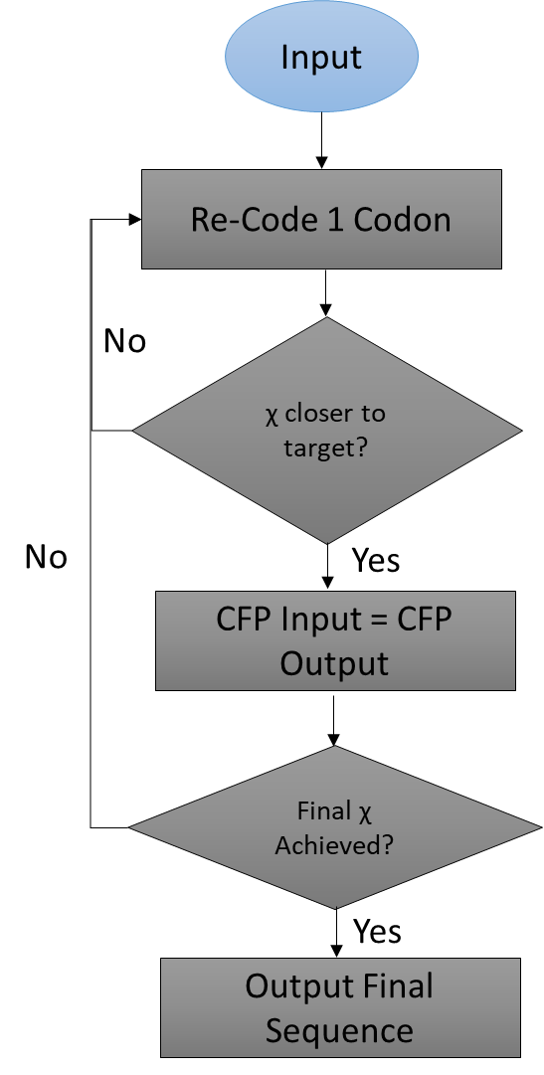
Figure S11: Algorithm used to create χ re-codes in Figure 5. A greedy algorithm implemented in Matlab® was used to create χ re-coded CFP and mCherry sequences. As pictured, the algorithm starts with any sequence (in this case we used a randomly re-coded version of CFP or mCherry as the input to avoid any initial bias), and randomly mutates a codon to a synonymous alternative. It then evaluates whether the new sequence is closer to the objective χ value. This is repeated until the final χ score is obtained. The same algorithm can be implemented with any objective function, e.g., for CAI, GC content, ENC, etc.

Figure S12: Correlation data from Figure 5 c–e demonstrating a strong relationship between Growth and Co-expression Fitness with χ. a–b: Strong correlation for CFP and mCherry χ re-codes with Co-Expression Fitness (as quantified by the chromosomally integrated YFP reporter (Figure 2). c–d: Strong correlation for CFP and mCherry χ re-codes with Growth Fitness (as quantified by OD₆₀₀).

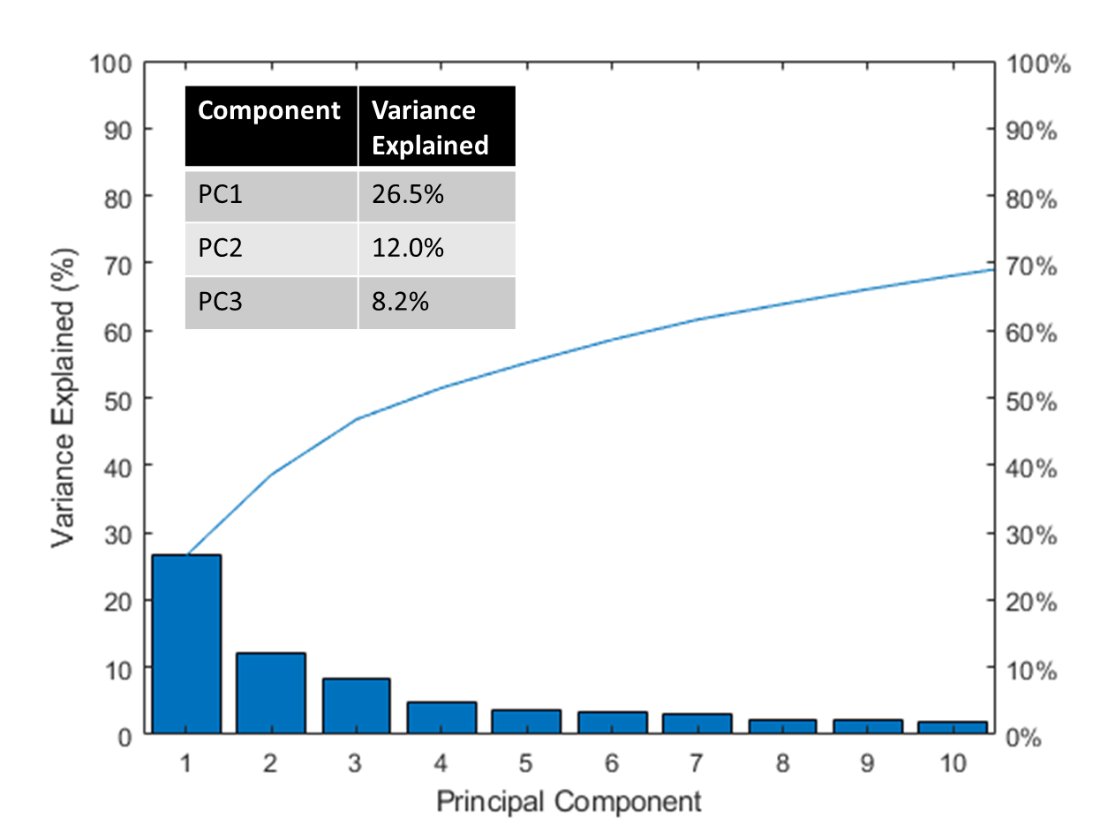
Figure S13: Data related to Figure 6 PCA analysis. Pareto plot showing variance explained by principal component analysis of 773 E. coli operons along with the χ re-coded sequences examined in Figure 6. PC1 with 26.5% of total variance was again largely found to explain CAI (where CAI refers to codon adaptation index using highly expressed E. coli genes as a reference set), while PC3 with 8.2% of total variance explained the χ sequences very well.

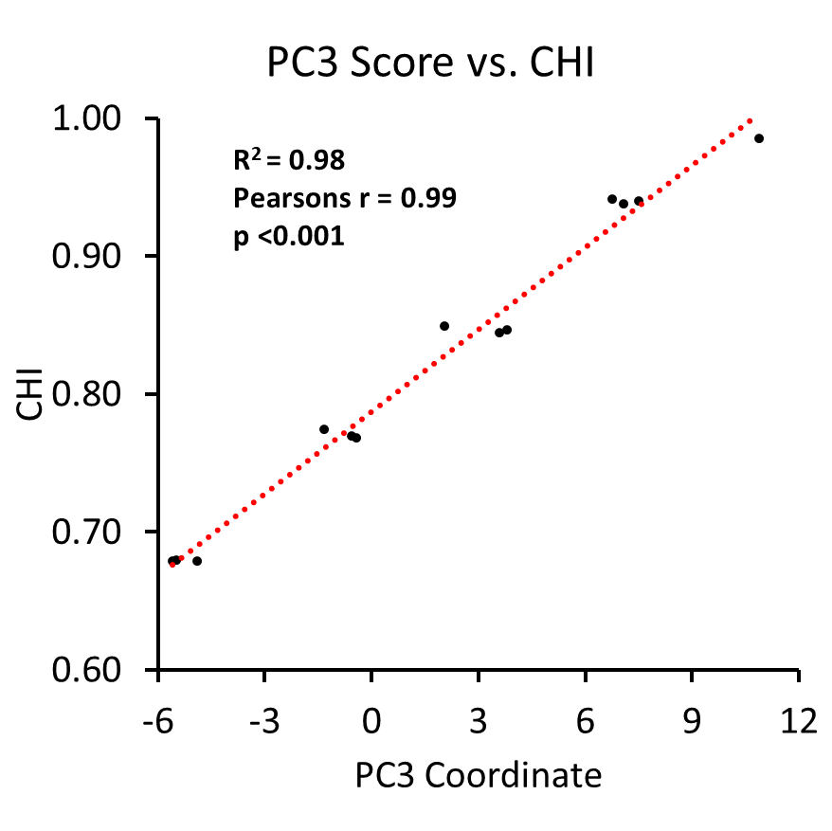
Figure S14: Data related to Figure 6 PCA analysis. Principal component 3 explains CHI (χ) re-coded sequence variation from Figure 6 very well, as there is a very strong correlation.

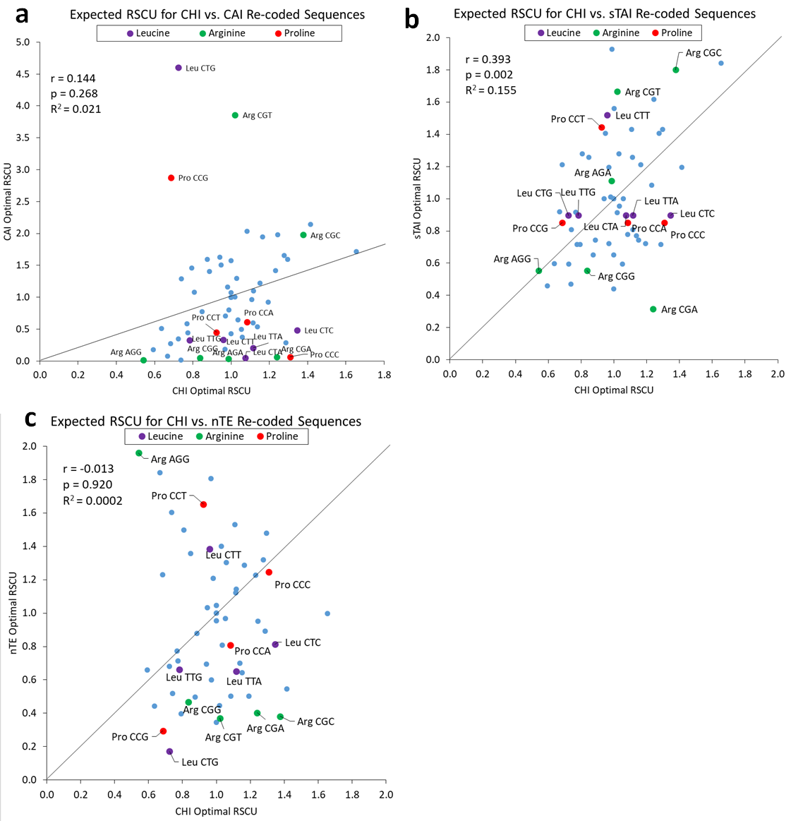
Figure S15: Comparison of CHI (χ) with other codon usage bias indices. Each correlation analysis is done using Pearson’s r between χ and another index based on predicted RSCU values for each codon in a perfectly adapted sequence. a. χ vs. CAI. The 3 outlier Arg, Leu, and Pro codons are clearly favored with CAI (where CAI is in reference to highly expressed E. coli genes). There is general a poor correlation between the two scales b. χ vs. sTAI. The correlation between χ and sTAI is better, but there is generally less differentiation between codons for sTAI (e.g., the sTAI derived RSCU for several Leu and Pro codons is the same). c. χ vs. nTE. χ and nTE are not well correlated. Despite considering supply vs. demand, nTE appears to exaggerate differences between codons resulting in the over-avoidance of some and over-favoring of others relative to χ.

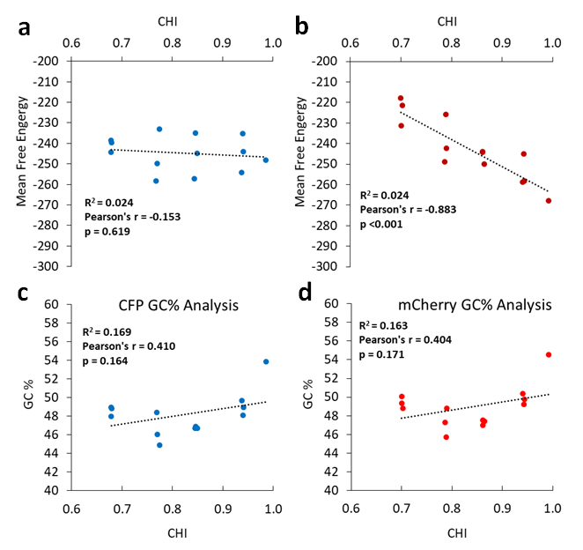
Figure S16: Correlations between MFE (mean free energy) or GC content of CHI (χ) re-coded sequences. a–b: Correlation between χ and MFE for CFP and mCherry re-coded sequences. There is no correlation for the CFP re-codes, but there is a negative correlation for mCherry recodes. This implies that for mCherry specifically there is likely additional structure forming due to the incorporation of χ favored codons, but the trend is not generalizable as it is not observed for CFP. c–d: Correlation between χ and GC content for CFP and mCherry re-coded sequences. In both cases there is no correlation, and GC content does not substantially vary as a function of χ value.
Figure S17: CHI (χ) sequences relative to commercial re-coding algorithms. a. Table of χ and CAI values (shown here using highly expressed E. coli genes or the entire genome as a reference set) for 10 genes re-coded using 3 different commercially available free codon optimization tools from IDT, Genewiz, or Genscript. The functional range of χ is between 0.6-1, so none of these sequences appear to explore the χ sequence space, falling at χ ∼ 0.8. IDT has the least bias towards either CAI scale. Genewiz appears to bias towards CUB very strongly with respect to all E. coli genes, while Genscript appears to adapt the sequence more moderately towards overall host codon usage. b. Pareto plot of PCA of RSCU values of 61 codons for all commercially re-coded genes (30 total) along with 13 χ re-coded sequences (from Figure 5) and 773 E. coli operons. 48.8% of total variance is represented by the 1st 3 components. c–d. PCA analysis showing PC1 vs. PC2 or PC1 vs. PC3, with categorically labeled points. We know from previous analysis (Figure 3) that PC1 largely represents CAI. It appears that Genscript re-codes most closely follow the natural sequence space of highly expressed genes. IDT re-codes align the closets with χ sequences, but do not explore the χ sequence space in any meaningful way.
Figure S18: CAI and CHI (χ) analysis of phage genes. a. Coliphages accessed from NCBI used in the analysis. b. Calculated CHI (χ) and CAI (with respect to highly expressed E. coli genes) for 4311 individual E. coli genes or 860 coliphage genes. Phages generally do not have CAI higher than 0.7 and appear to tend slightly more towards higher χ than E. coli genes. c–d: Calculated CAI (c) and χ (d) for 4311 E. coli genes and 860 coliphage genes. We observe a slightly higher median CAI for native E. coli genes, and a slightly higher median χ for coliphage genes. An outlier is a value that is more than 1.5 times the interquartile range away from the bottom or top of the box. A lack of overlapping notches indicates >95% confidence in differences between medians.

Figure S19: CHI (χ) and CAI values of random CFP sequence recodes. a. Calculated CAI (with respect to highly expressed E. coli genes) for 100,000 random sequences. The median CAI is 0.36, and even the highest outlier does not exceed 0.5. This illustrates why randomizing sequences is unlikely to affect global sequence bias towards specific codon use. b. Calculated CHI (χ) for the same random sequences. We see a median χ score of 0.80, and the highest outlier does not exceed 0.85, again illustrating a lack of global variation in specific codon use towards higher χ from randomized sequences.

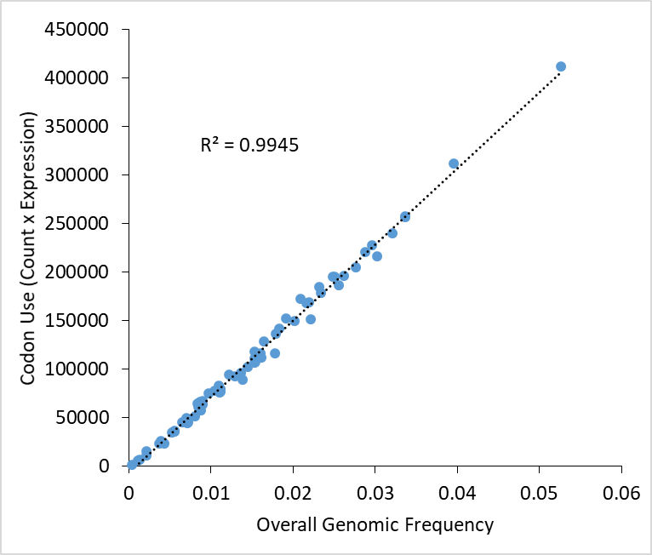
Figure S20: Codon use vs. codon frequency in E. coli K12 MG1655. Genomic frequency was used for nTE calculations in place of codon use (see methods) because they are very well correlated, or expression of genes in E. coli with different CUB does not appear to change codon demand in this case. Codon use was calculated as previously described⁵ by taking the total codon count across all E. coli genes multiplied by their corresponding transcript abundance from a publically available dataset (GEO accession GSE59377, “rpoB_wt_lb”),⁶ which correspond to an exponentially growing culture of E. coli in LB broth.

Figure S21: Vector maps for expression plasmids used in this study. Each vector consists of a unique origin/copy number control mechanism based on the origin of replication and in some cases accessory proteins. Copy numbers are approximated based on known values. a. pBAC (F1 origin, ~1 copy); b. p5 (pSC101 origin, ~5 copies); c. p10 (p15A origin, ~10 copies); d. p20 (pBR322 origin, ~20 copies). Full length vector sequences can be found in Data S4.

Figure S22: Chromosomal integration cassette for YFP reporter. The YFP cassette was integrated in the E. coli chromosome in between the genes rsmG and atpI. It consists of (from 5’ to 3’) a homology region of ∼500 bp, an insulator sequence, followed by the FAB46 strong constitutive promoter, BCD7 (a strong RBS), and the YFP CAI = 0.96 (∼1) sequence, and the rrnB T1/T2 terminator. Attached to the 3’ end is a kanamycin marker flanked by FRT sites for site specific marker excision with the FLP recombinase, and finally another ∼500 bases of homology on the 3’ end. The complete sequence can be found in Data S4.

Figure S23: In vitro transcription-translation (TxTL) assay design. a. Cloning vector used to generate the linear cassettes used in the TxTL assay. The vector includes a T7 promoter, which the NEB PURExpress® kit relies on for transcription. b. Representative Linear DNA cassettes used for TxTL for CFP and YFP, including an insulator, T7 promoter and lac operator (IPTG inducible), strong RBS (BCD7), gene of interest, and rrnB terminator. Genes were amplified from the insulator to the terminator for use in the TxTL assay. c–d. Expression of CFP and YFP in isolation or under competition in the TxTL assay and resulting reaction rates. DNA concentration refers to the concentration of each species of DNA added (i.e., there is 20 ng/µL total for individually expressed, or 40 ng/µL total for combined). Competition is effectively maximized around 20ng/µL of each gene.

Supplementary References:
1. Reuveni, S., Meilijson, I., Kupiec, M., Ruppin, E. & Tuller, T. Genome-Scale Analysis of Translation Elongation with a Ribosome Flow Model. PLoS Comput. Biol. 7, e1002127 (2011).
2. Dana, A. & Tuller, T. The effect of tRNA levels on decoding times of mRNA codons. Nucleic Acids Res. 42, 9171–9181 (2014).
3. Taniguchi, Y. et al. Quantifying E. coli Proteome and Transcriptome with Single-Molecule Sensitivity in Single Cells. Science (80-. ). 329, 533–538 (2010).
4. Reis, M. d., Savva, R. & Wernisch, L. Solving the riddle of codon usage preferences: a test for translational selection. Nucleic Acids Res. 32, 5036–5044 (2004).
5. Pechmann, S. & Frydman, J. Evolutionary conservation of codon optimality reveals hidden signatures of cotranslational folding. Nat. Struct. Mol. Biol. 20, 237–243 (2013).
6. Utrilla, J. et al. Global Rebalancing of Cellular Resources by Pleiotropic Point Mutations Illustrates a Multi-scale Mechanism of Adaptive Evolution. Cell Syst. 2, 260–271 (2016).

