Supplementary Figures

Supplementary Figure 1. Conditional QQ plots showing cross-phenotype polygenic enrichment between treatment resistant schizophrenia (TRS) and body-mass index (BMI) from an independent cohort. Plotted are the nominal vs empirical −log10 p values (corrected for inflation) for TRS, below the standard genome-wide association study threshold of p < 5.0 × 10−8, as a function of significance of association with BMI at the levels of p ≤ 0.10, p ≤ 0.01, and p ≤ 0.001. The dashed lines indicates the null hypothesis.
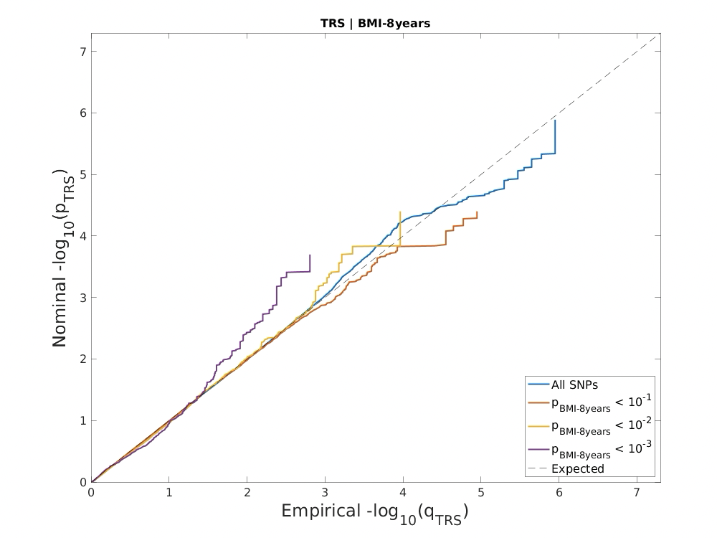

Supplementary Figure 2. Multi-tissue eQTL comparison for the effect of rs3087660 on the (A) MAP2K1, (B) SNAPC5 and (C) TIPIN genes in the GTEx database, respectively. The effects presented are relative to the rs3087660 A allele.

A
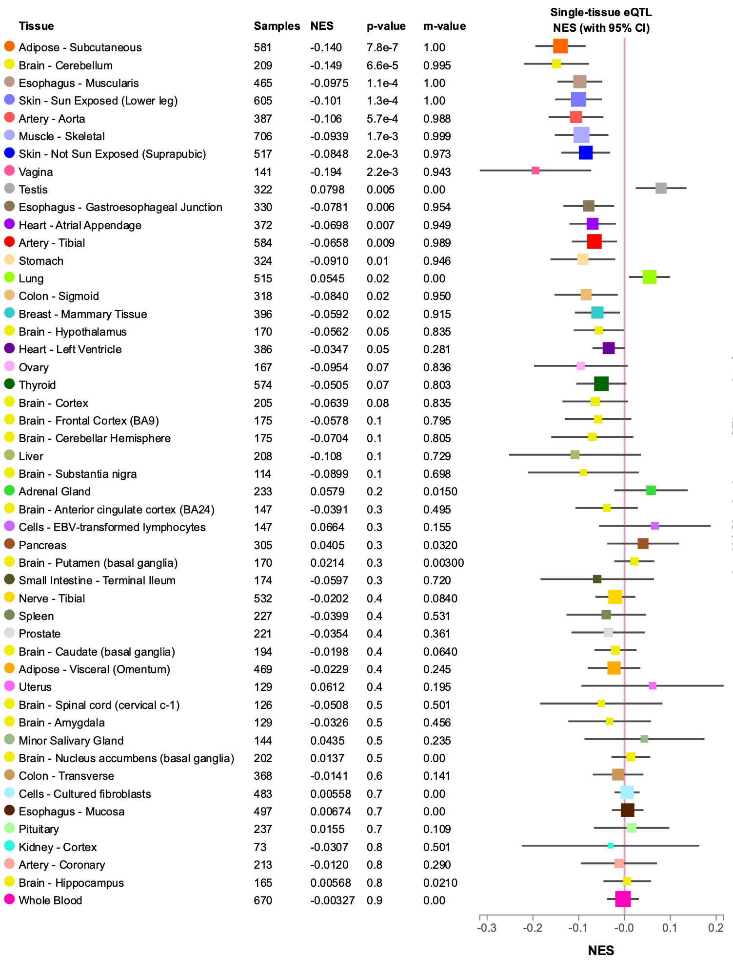

B
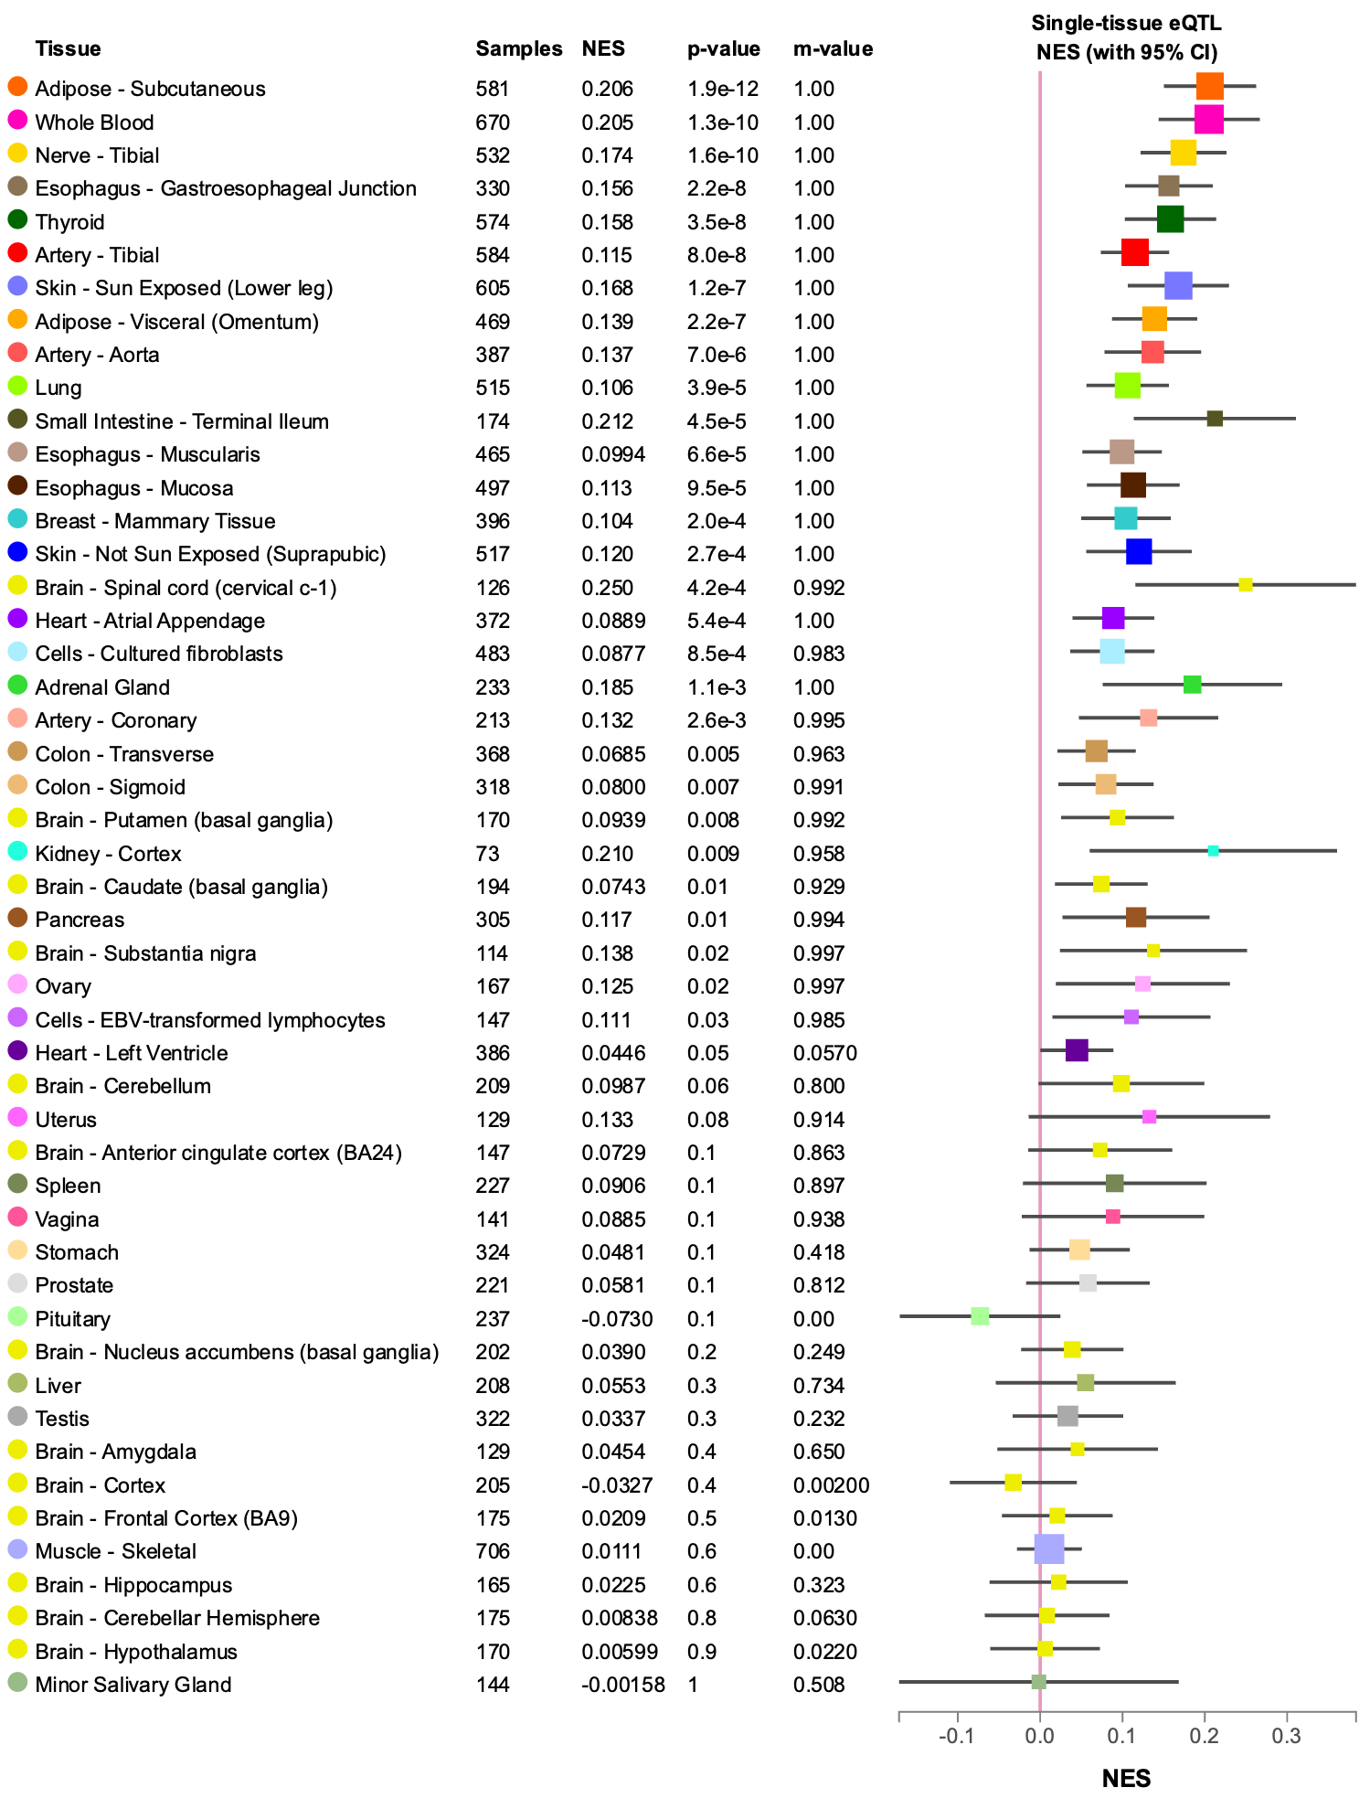

C
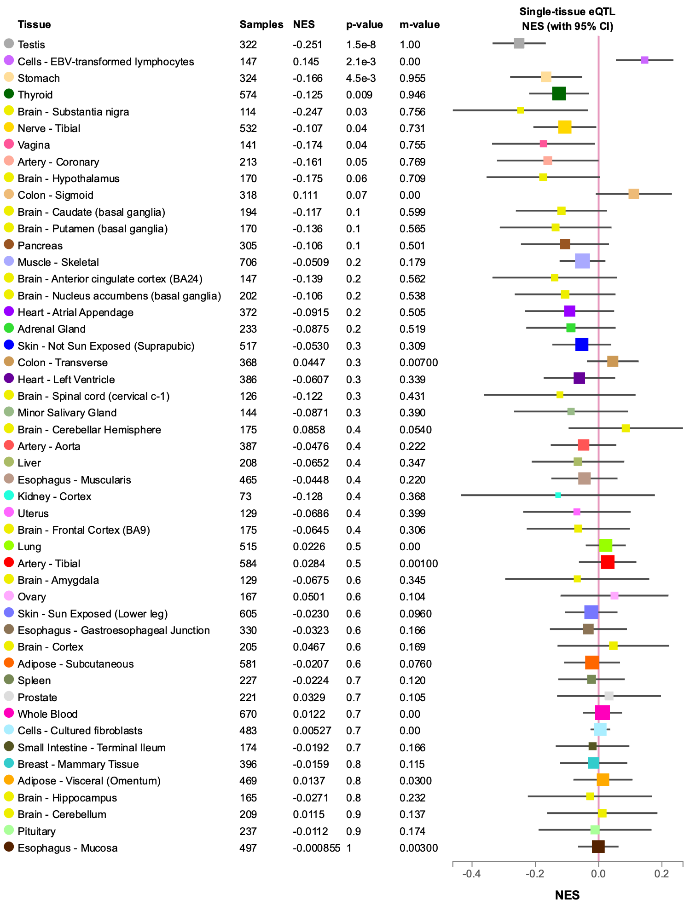

Supplementary Figure 3. Multi-tissue eQTL comparison for the effect of rs7560232 on the (A) ZDBF2, (B) ADAM23 and (C) CMKLR2 genes in the GTEx database, respectively. The effects presented are relative to the rs7560232 G allele.

A
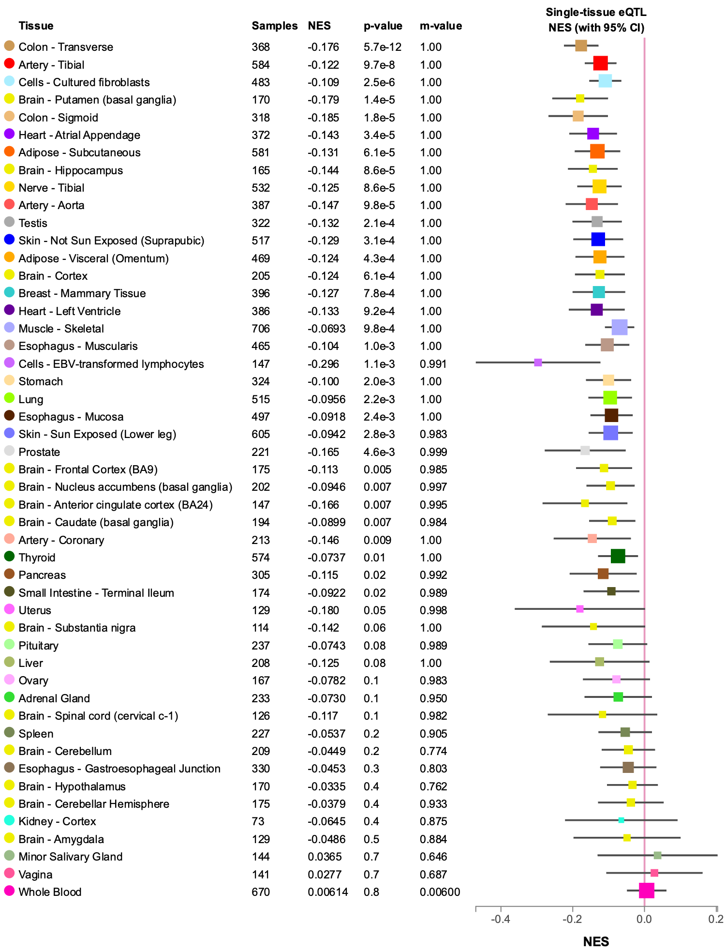

B
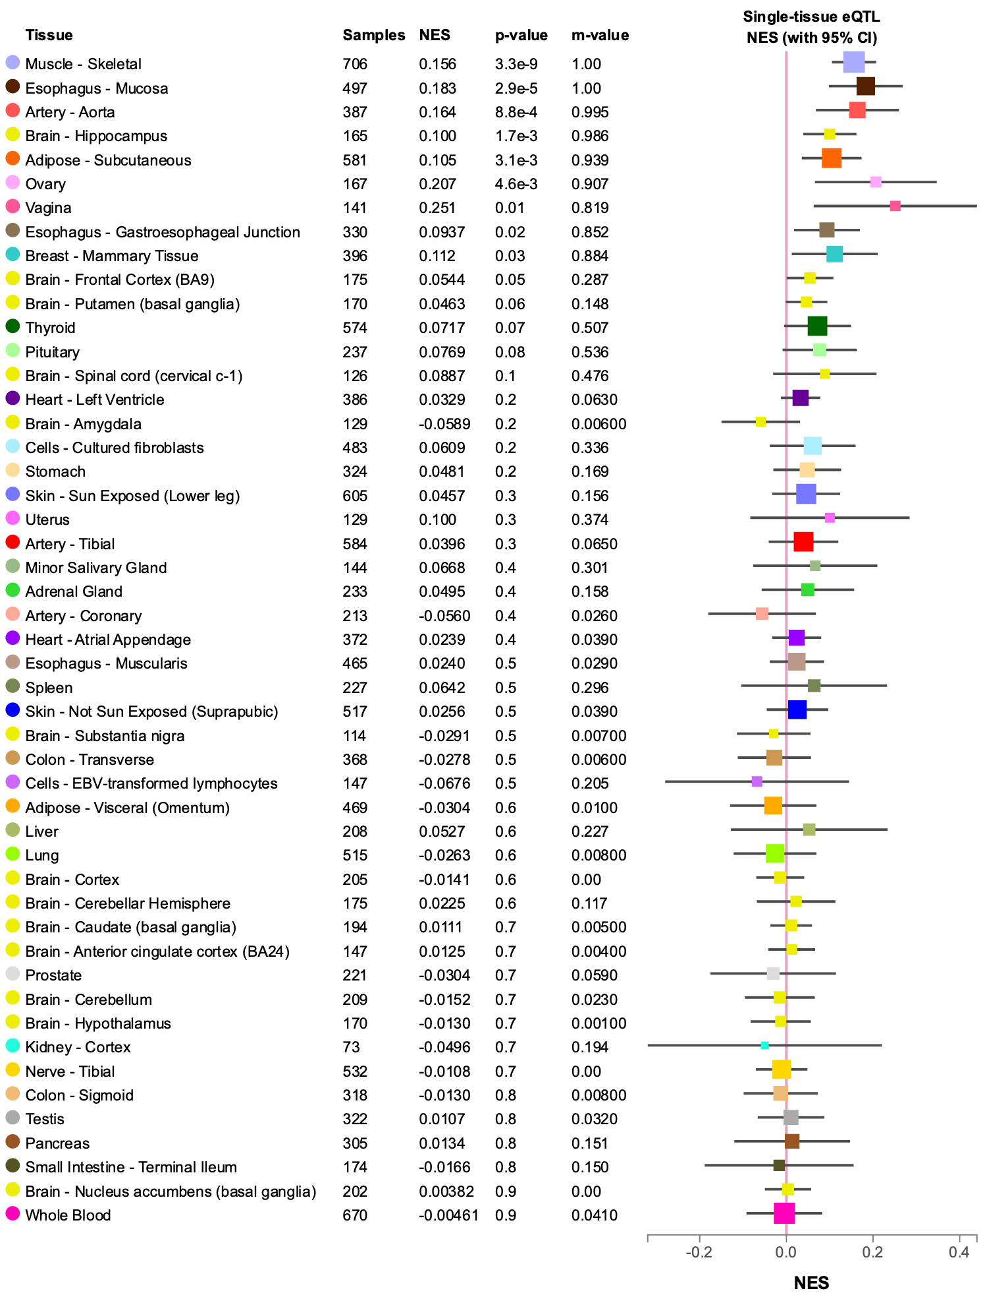

C
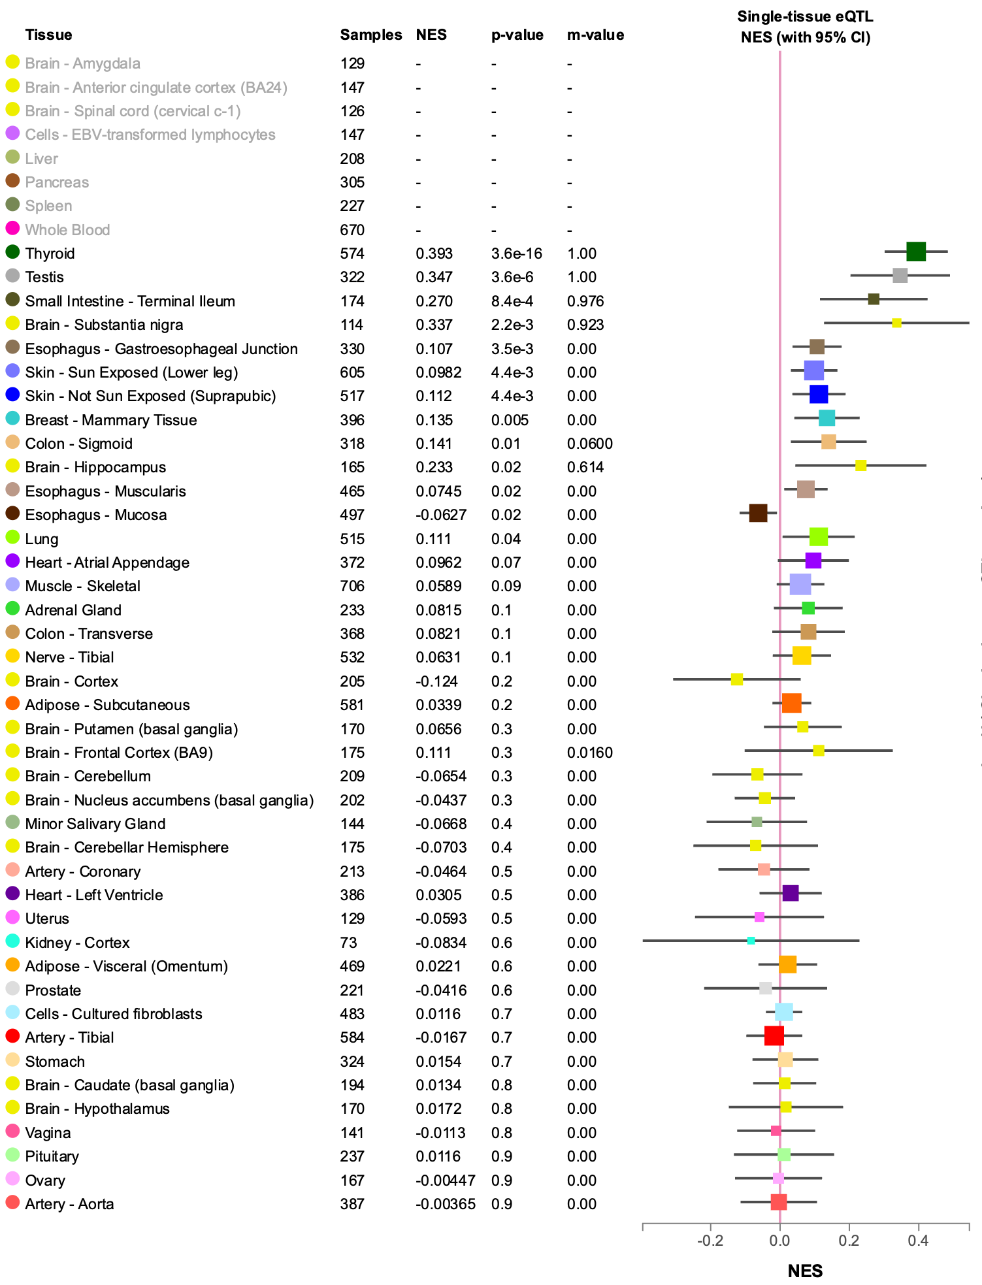

Supplementary Figure 4. Brain tissue eQTL comparison for the effect of rs3087660 on the MAP2K1 gene in the BRAINEAC database.

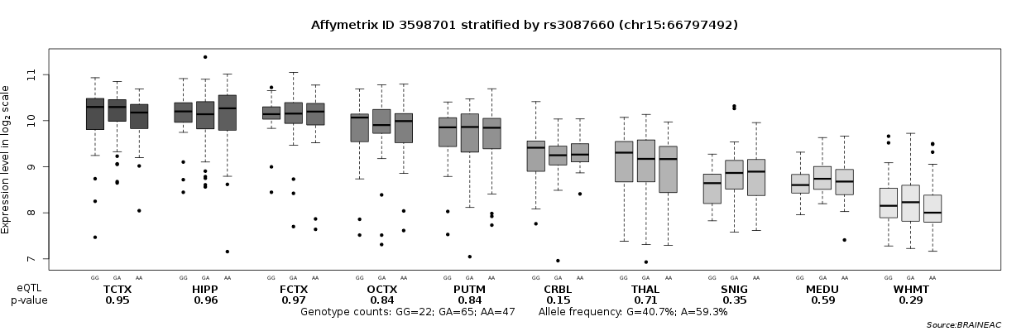

TCTX, temporal cortex
HIPP, hippocampus
FCTX, frontal cortex
OCTX, occipital cortex
PUTM, putamen
CRBL, cerebellar cortex
THAL, thalamus
SNIG, substantia nigra
MEDU, medulla
WHMT, intralobular white matter
Supplementary Figure 5. Differences in MAP2K1 gene expression between (A) TRS and non-TRS patient groups, (B) rs3087660 genotype groups, and (C) rs3087660 genotype groups within the TRS and non-TRS patient groups.
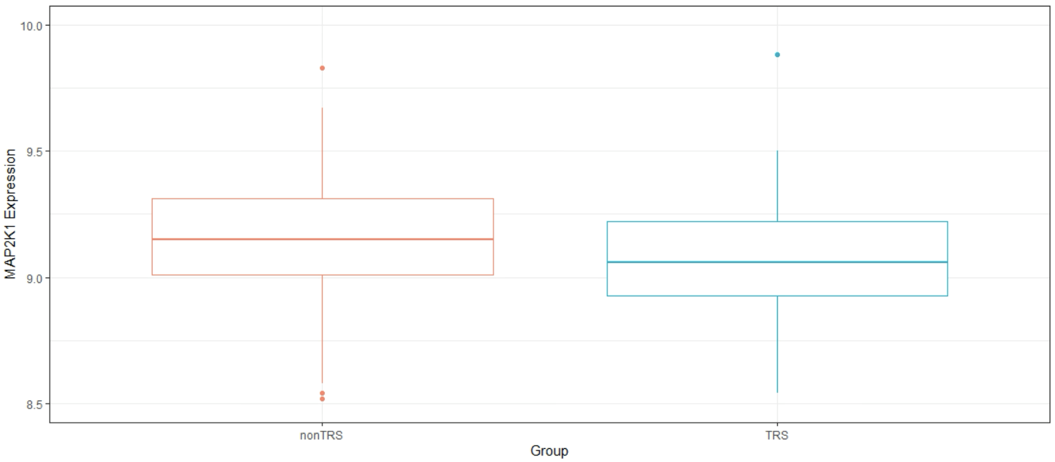
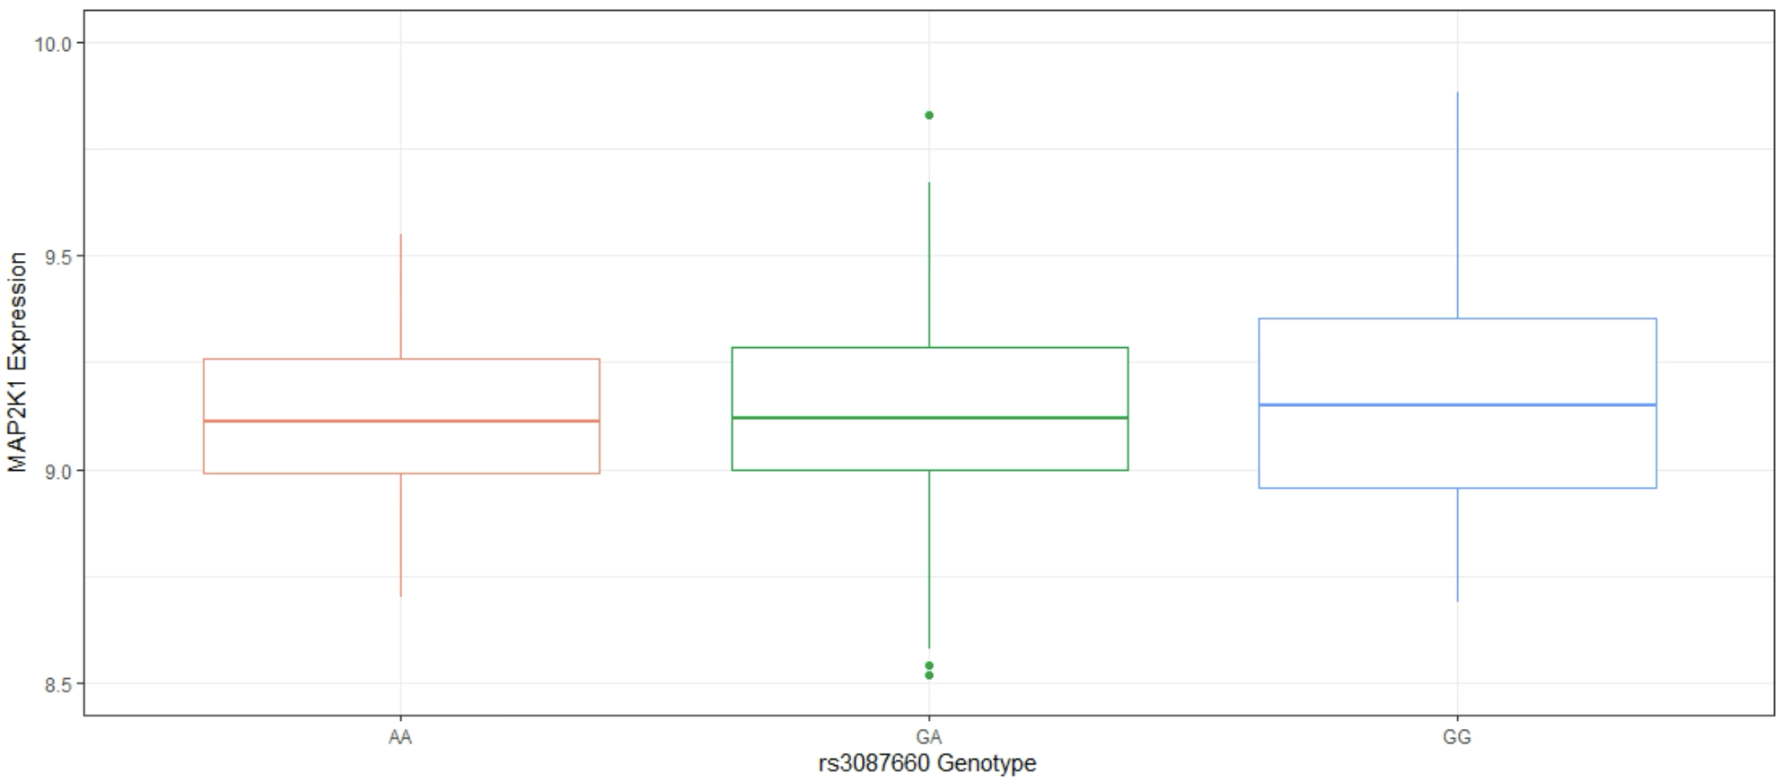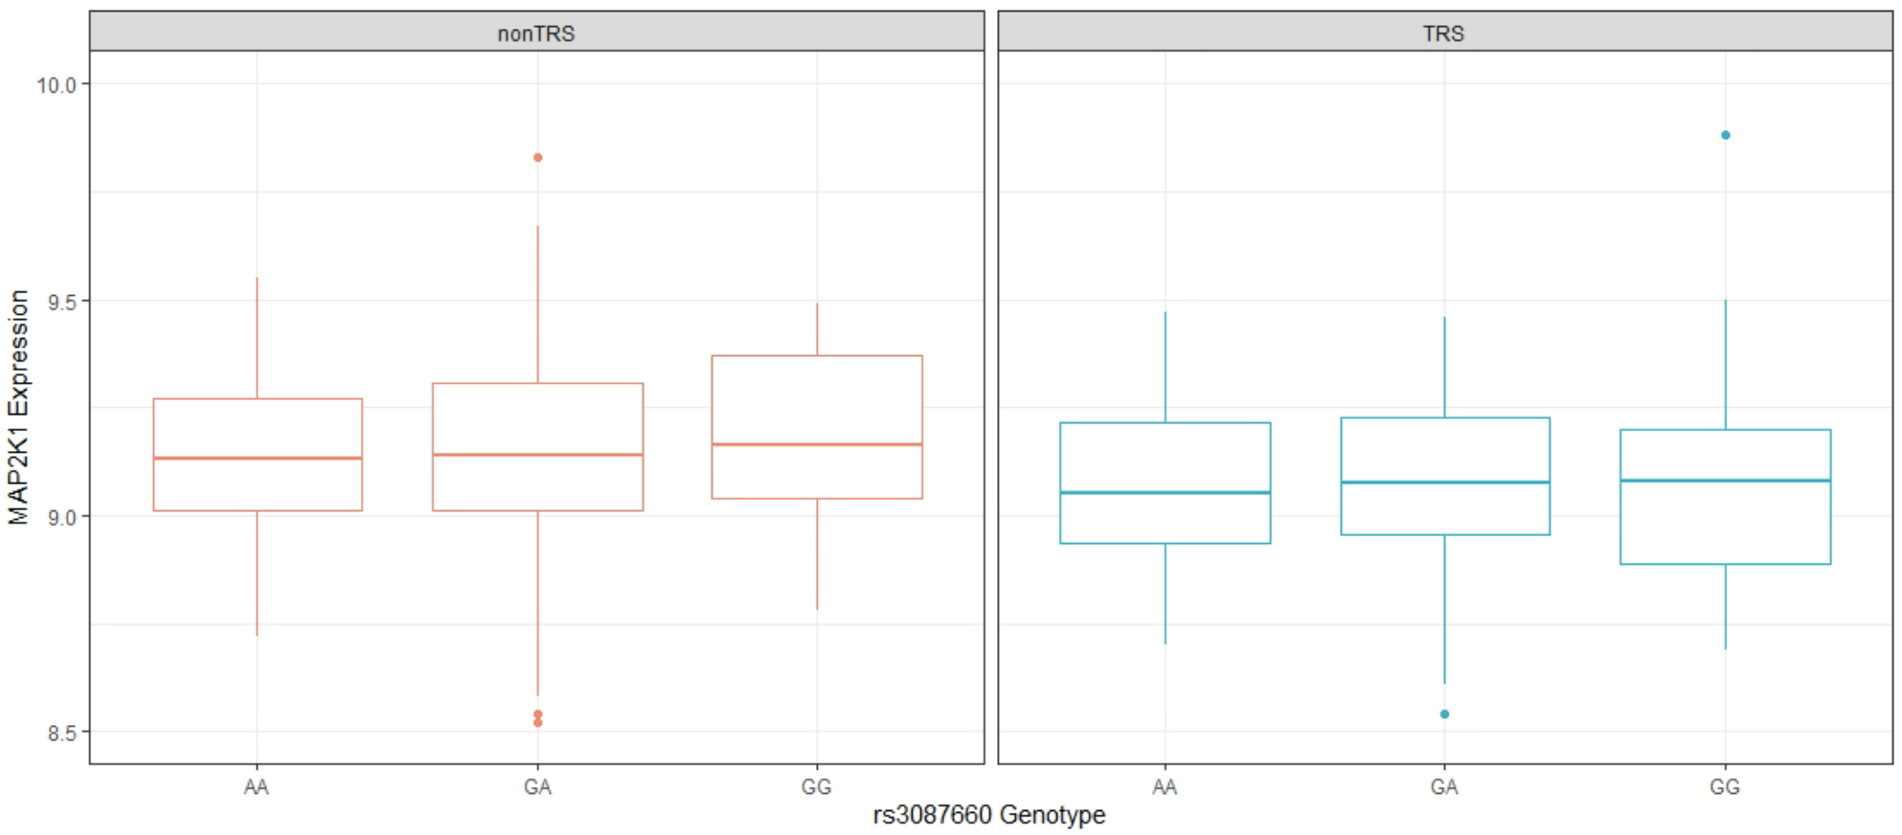

Supplementary Figure 6. Explained variance (on the liability scale) of treatment resistant schizophrenia (TRS, orange), body-mass index (BMI, purple), TRS after conditioning on BMI (cond TRS|BMI, green) and schizophrenia (SCZ, pink) polygenic scores (PGS) (Liability r2, y-axis) for top 100-105000 independent variants from the TRS GWAS summary statistics.

Supplementary Figure 7. Histograms showing the proportion of SNPs with corresponding functional annotations. (A) SNPs contributing to the PGS explaining the most variance in TRS after conditioning on BMI. (B) SNPs contributing to the PGS explaining the most variance in TRS using the original TRS GWAS. Bars are coloured by log2(enrichment) relative to all SNPs in the reference panel.

A
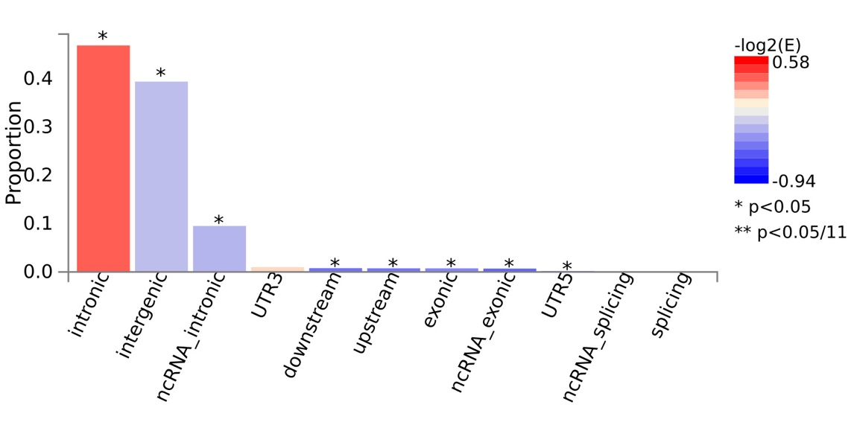
B
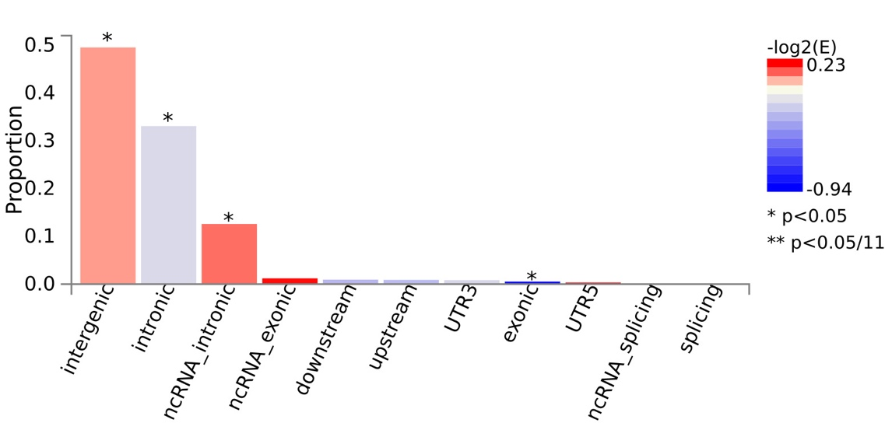

Supplementary Figure 8. Explained variance (on the liability scale) of treatment resistant schizophrenia (TRS, orange), and TRS after conditioning on BMI (cond TRS|BMI, green) polygenic scores (PGS) (Liability r2, y-axis) for top 100-1000 independent variants from the TRS GWAS summary statistics.

