Supplementary Figure S1 Farm Layout
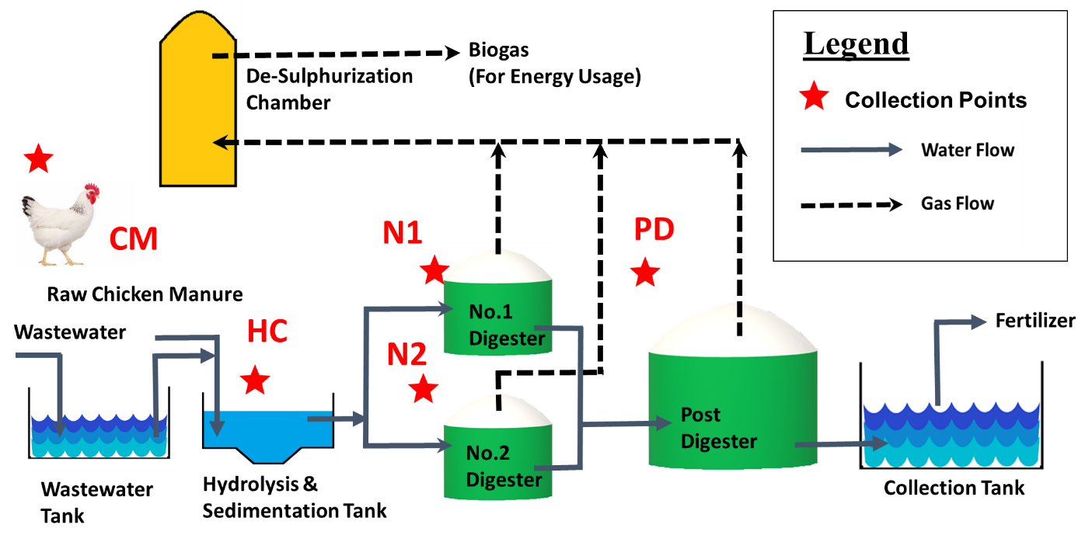
Farm layout as adopted from previous study by Lam et al. (2021). The asterisks represent the sample collection locations. Chicken Manure (CM); Hydrolysis Chamber (HC); No.1 digestion chamber (N1) and No.2 digestion chamber (N2) and Post-Digestion chambers (PD) are abbreviated respectively.

Reference
Lam, T.K., Yang, J.T., Lai, S.J., Liang, S.Y., Wu, S.H., 2021. Meta-proteomics analysis of microbial ecosystem during the anaerobic digestion of chicken manure in biogas production farm. Bioresour Technol Rep. 13, 100643. https://doi.org/10.1016/j.biteb.2021.100643.

