Supplementary Information

Phase diagrams of graphene-metal systems

Leilei Chen^{a, b}, Keke Chang^{a,} *, Zhenyu Zhang^{b,} *, Ruonan Zhouª, Kai Xuª, Ming Louª, Yujie Duª, Liping Wang^{a,} *

ª Key Laboratory of Marine Materials and Related Technologies, Zhejiang Key Laboratory of Marine Materials and Protective Technologies, Ningbo Institute of Materials Technology and Engineering, Chinese Academy of Sciences, Ningbo 315201, Zhejiang, China
^{b} Key Laboratory for Precision and Non-Traditional Machining Technology of Ministry of Education, Dalian University of Technology, Dalian 116024, China

* changkeke@nimte.ac.cn; zzy@dlut.edu.cn; wangliping@nimte.ac.cn

Table S1. Since the fitting results of 5-layer and 7-layer graphene are exceedingly similar to that of 6-layer and 8-layer graphene, we exclusively used the Gibbs energies of 5 and 8 layers of graphene to construct the thermodynamic database of graphene-metal systems.
Table S1. Fitting results of coefficient values of a to c from equation (S2).
 | 5 layers of graphene | 6 layers of graphene | 7 layers of graphene | 8 layers of graphene
a | 39888.2 | 40002.5 | 30805.5 | 30787.6
b | -444.2 | -445.4 | -340.5 | -340.5
c | 53.1 | 53.3 | 39.8 | 39.8

Figure S1-S6 show the phase diagrams of graphene-transitional metal systems, in which the secondary solid solutions exist. The phase diagrams are calculated based on the well accepted C-metal phase diagrams in literatures.¹⁻⁵ Solution phases with strong thermodynamic stability are shown in the middle composition range, which can merely be influenced by the graphene phase.
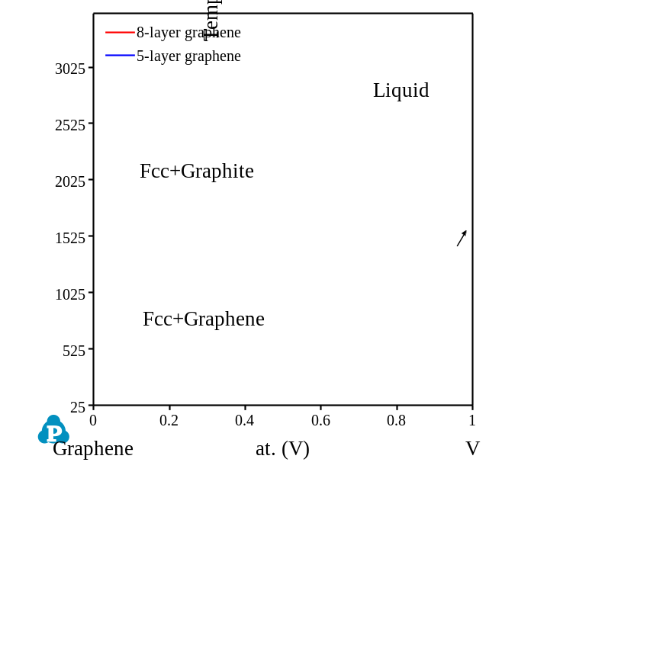
Figure S1. Calculated phase diagram of graphene-V system.
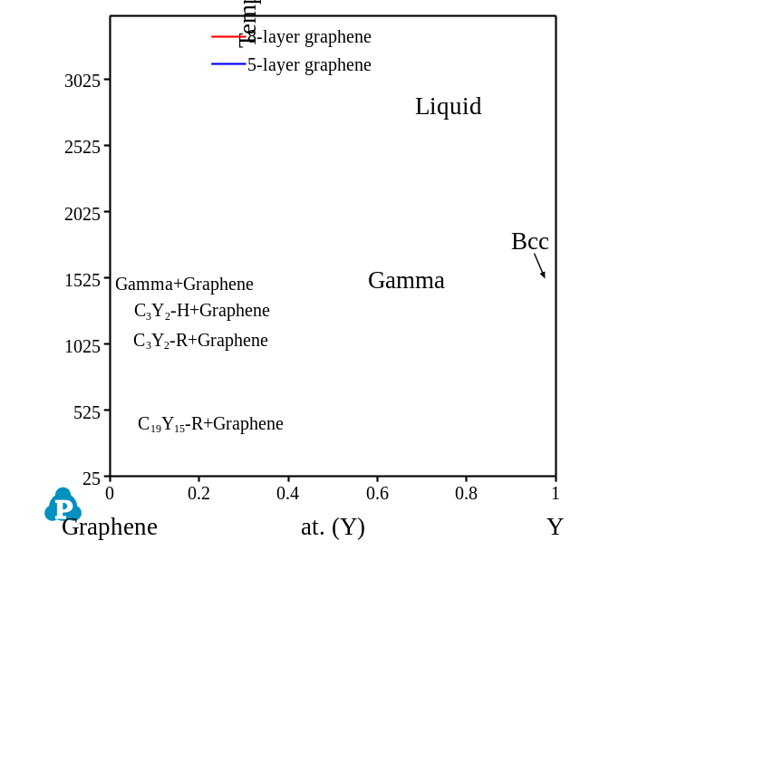
Figure S2. Calculated phase diagram of graphene-Y system.
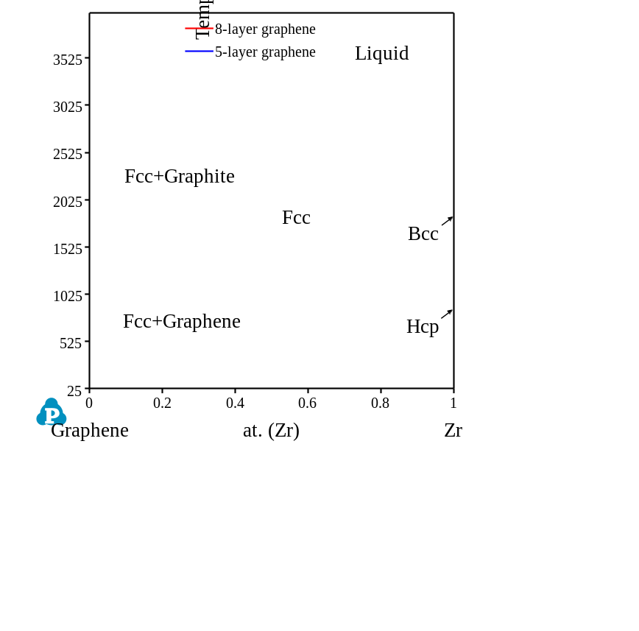
Figure S3. Calculated phase diagram of graphene-Zr system.
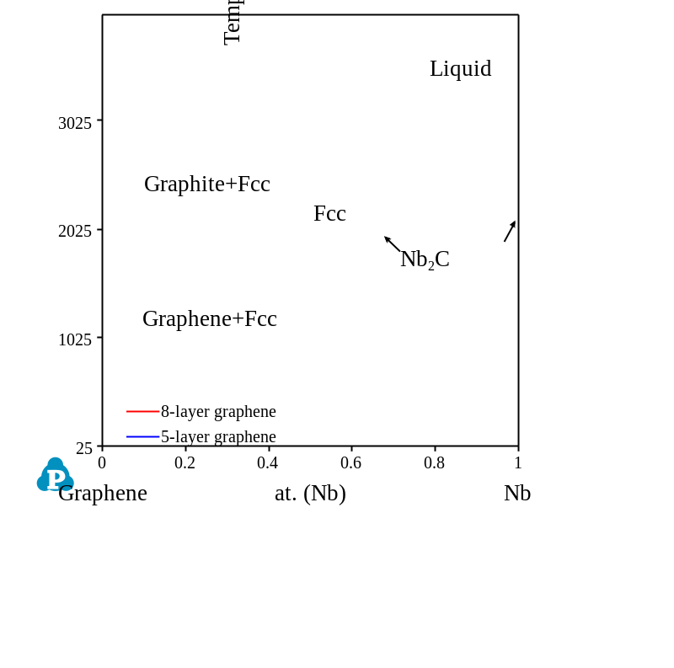
Figure S4. Calculated phase diagram of graphene-Nb system.

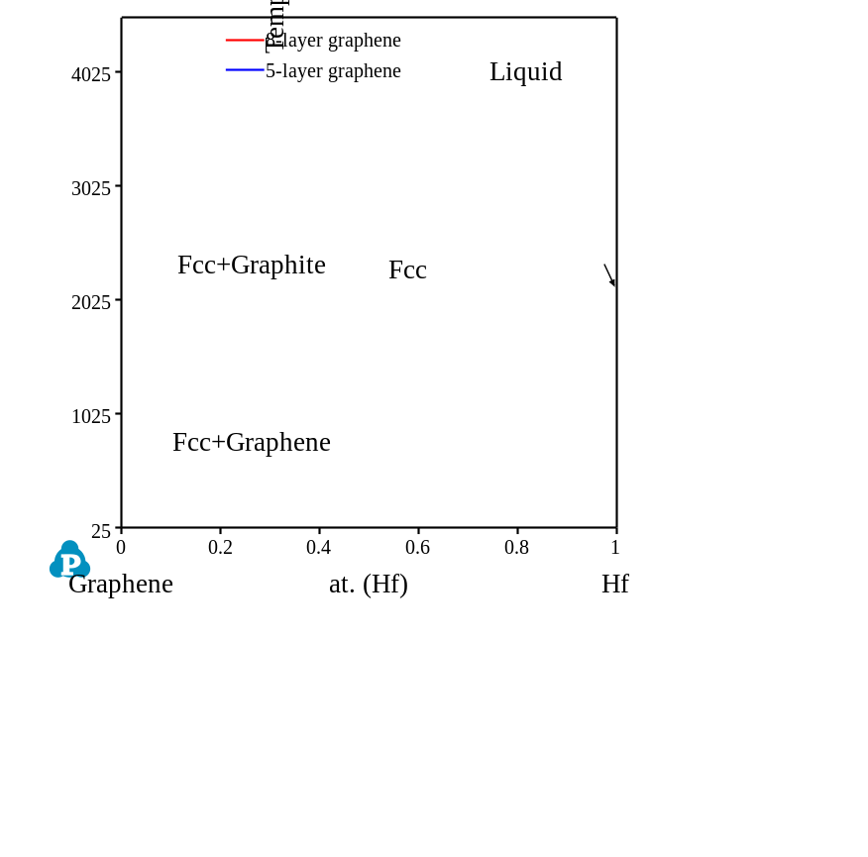
Figure S5. Calculated phase diagram of graphene-Hf system.
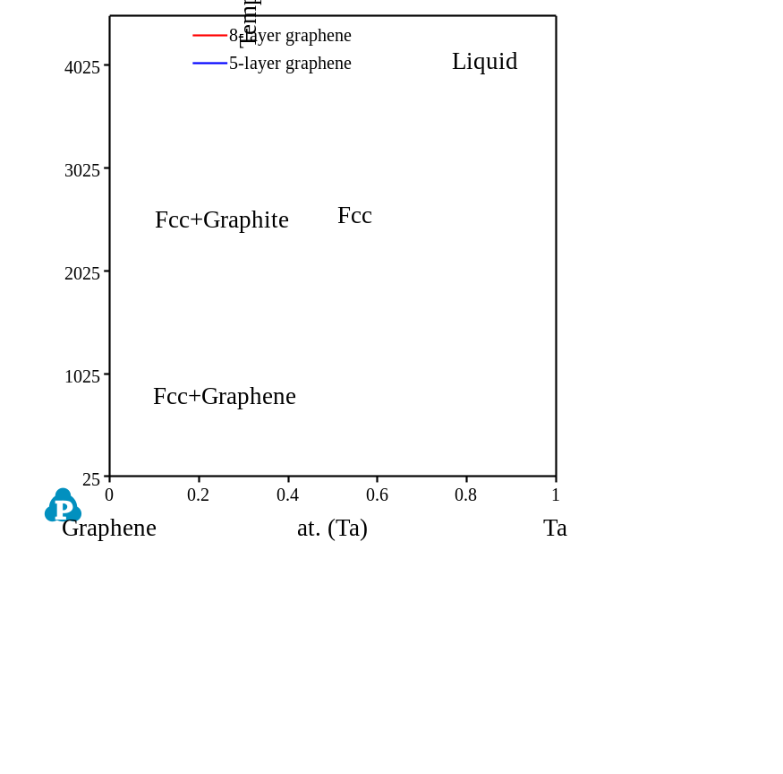
Figure S6. Calculated phase diagram of graphene-Ta system.
Note S4. Calculated graphene-metal phase diagrams with linear compounds.
Figure S7 and S10 show the calculated phase diagrams of graphene-Mo and graphene-W systems. The thermodynamic descriptions of their carbide counterparts were adopted from a literature.⁶ Figure S7 shows the calculated phase diagram of the graphene-Cr system. The addition of graphene has obviously affected the thermodynamic stability of the linear compound of Cr₃C₂. Thus, the Cr₃C₂ compound became unstable in the temperature range from 226.0 °C to 1297.4 °C for 5-layer graphene and from 254.2 °C to 1701.8 °C for 8-layer graphene, which was replaced by the “Graphene + Cr₇C₃” phase region. It was also demonstrated in Figure S7 that the layers of graphene can slightly change the phase diagram of the graphene-Cr system, especially the temperatures of invariant reactions on the graphene-rich side. The addition of graphene can also influence the thermodynamic stability of Mn₇C₃, Mn₅C₂, and Mn₃C compounds in the Graphene-Mn system as shown in Figure S8. The linear compound MoC in Figure S9 is unstable at medium temperature ranges (from ~180 ℃ to ~1600 ℃ depending on the number of graphene layers), while WC in Figure S10 keeps unchanged after graphene is added.
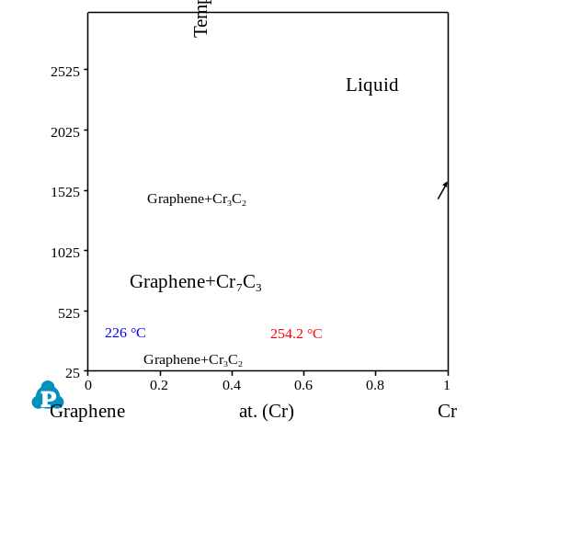
Figure S7. Calculated phase diagram of graphene-Cr system.
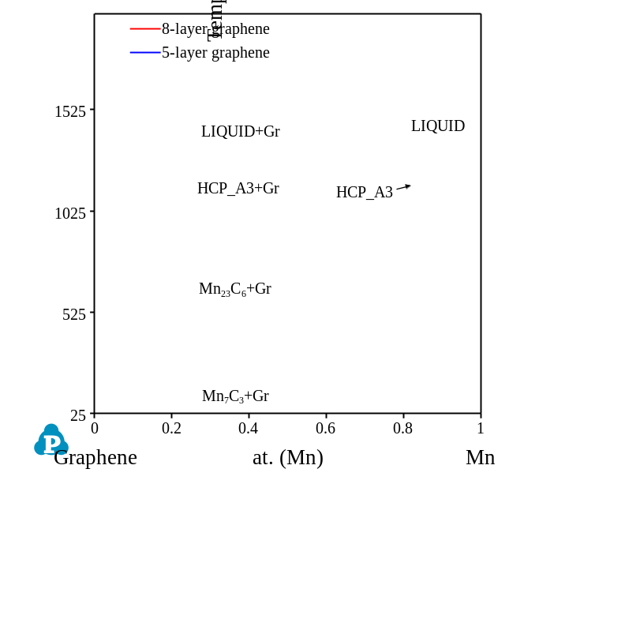
Figure S8. Calculated phase diagram of graphene-Mn system.
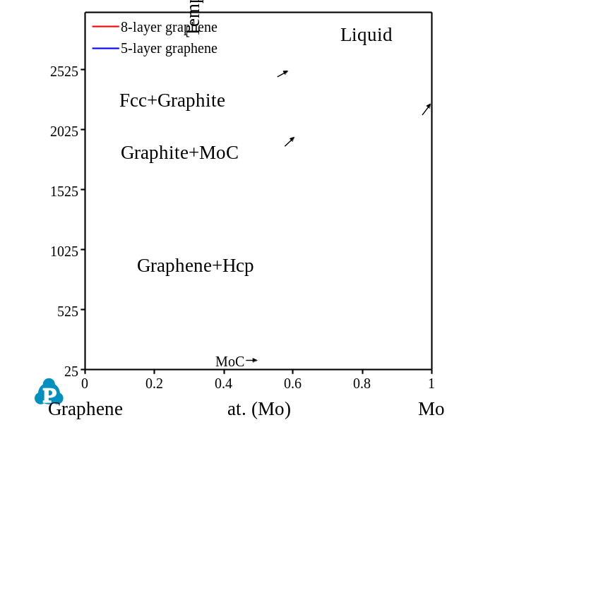
Figure S9. Calculated phase diagram of graphene-Mo system.
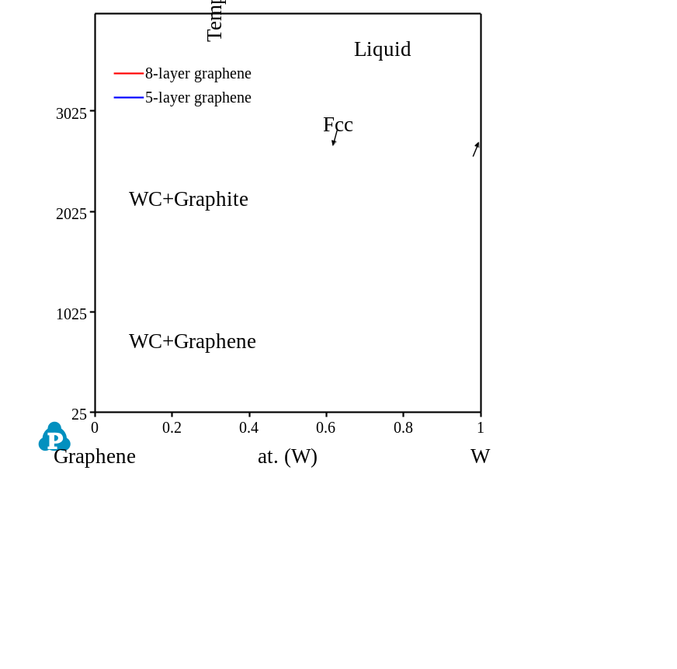
Figure S10. Calculated phase diagram of graphene-W system.
Note S5. Calculated graphene-metal phase diagrams with no compound.
Some of the transitional metals, such as Fe, Co, Ni, etc., could hardly react with graphene (or carbon) to form interphases or compounds. Thus, the phase diagrams of such metals and graphene contain no mesophase yet two-phase regions nearly cross the whole composition range. Figure S11 to S19 are the calculated phase diagrams of graphene-transitional metal systems with no compound, among which the thermodynamic descriptions of graphene-Fe, graphene-Co, graphene-Ni, graphene-Ru, graphene-Rh, and graphene-Pd, systems were developed based on literature reports,⁷⁻¹¹ and the systems of graphene-Ag, graphene-Re, graphene-Pt, and graphene-Au were simply assessed with the eutectic reaction temperatures under consideration. These phase diagrams possess similar phase relationships existed in the graphene-Cu phase diagram (Figure 3a), which contain no interphase or compound with hardly any solubility of end-members.
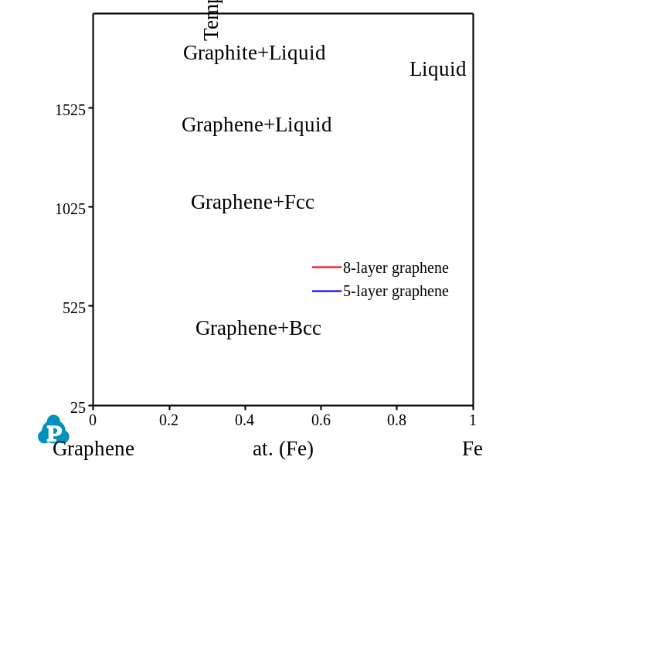
Figure S11. Calculated phase diagram of graphene-Fe system.
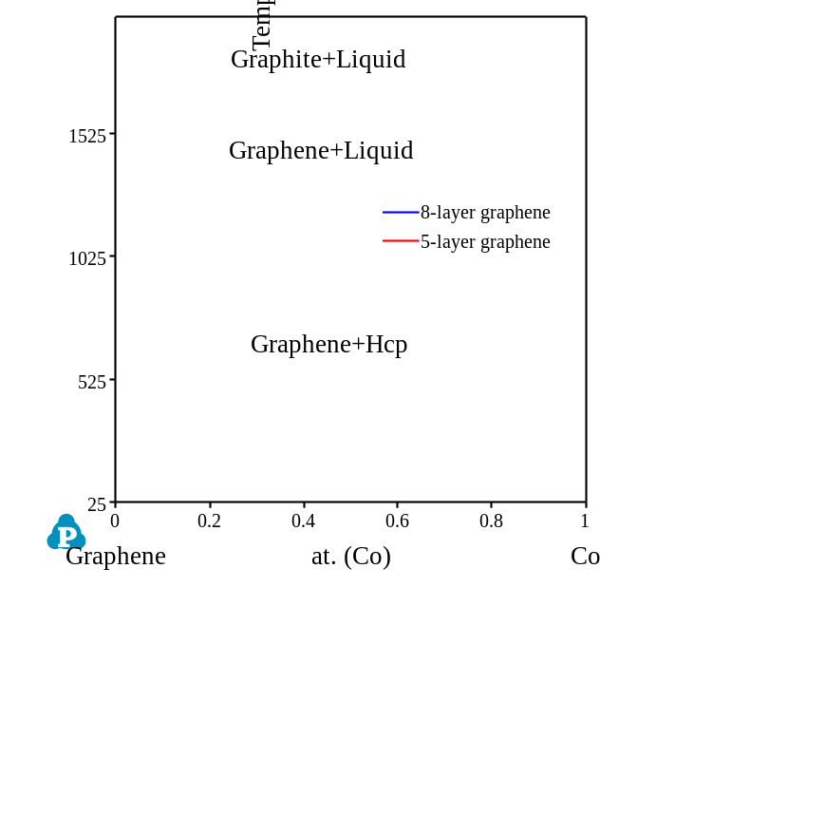
Figure S12. Calculated phase diagram of graphene-Co system.
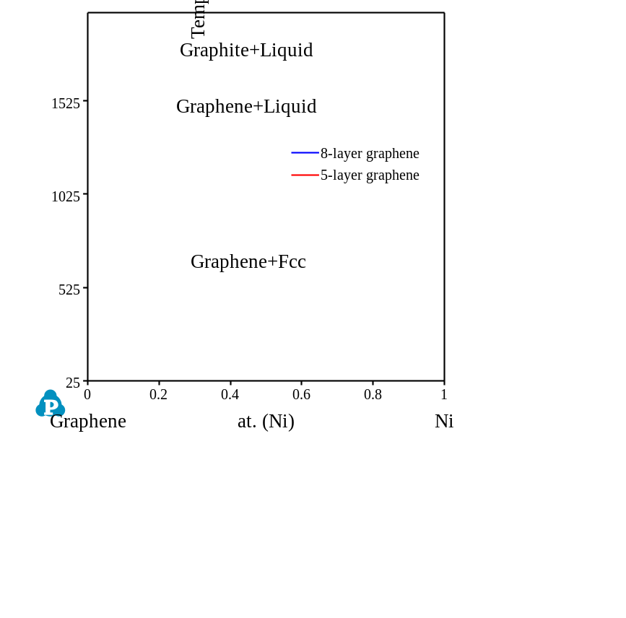
Figure S13. Calculated phase diagram of graphene-Ni system.
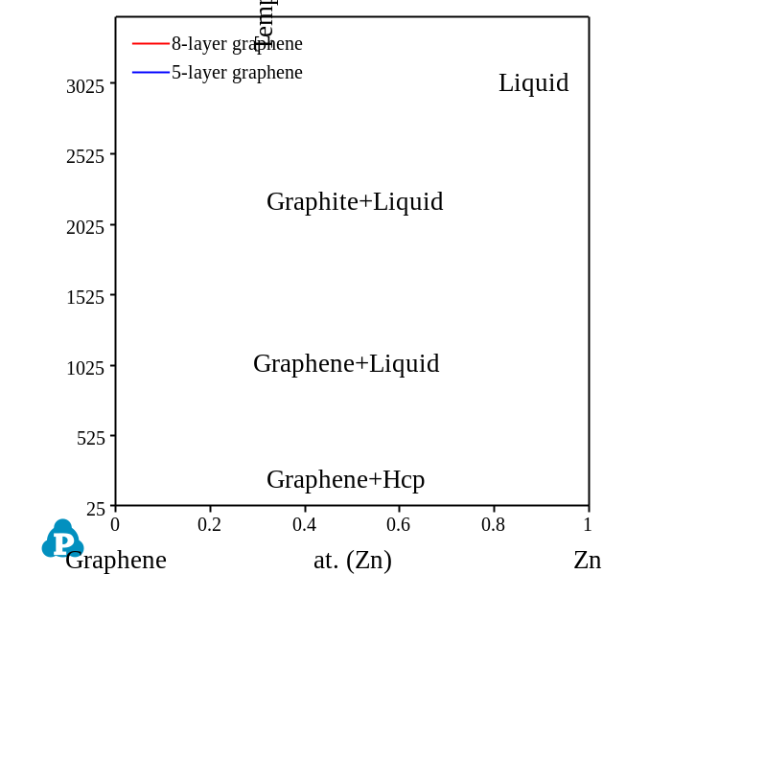
Figure S14. Calculated phase diagram of graphene-Ni system.

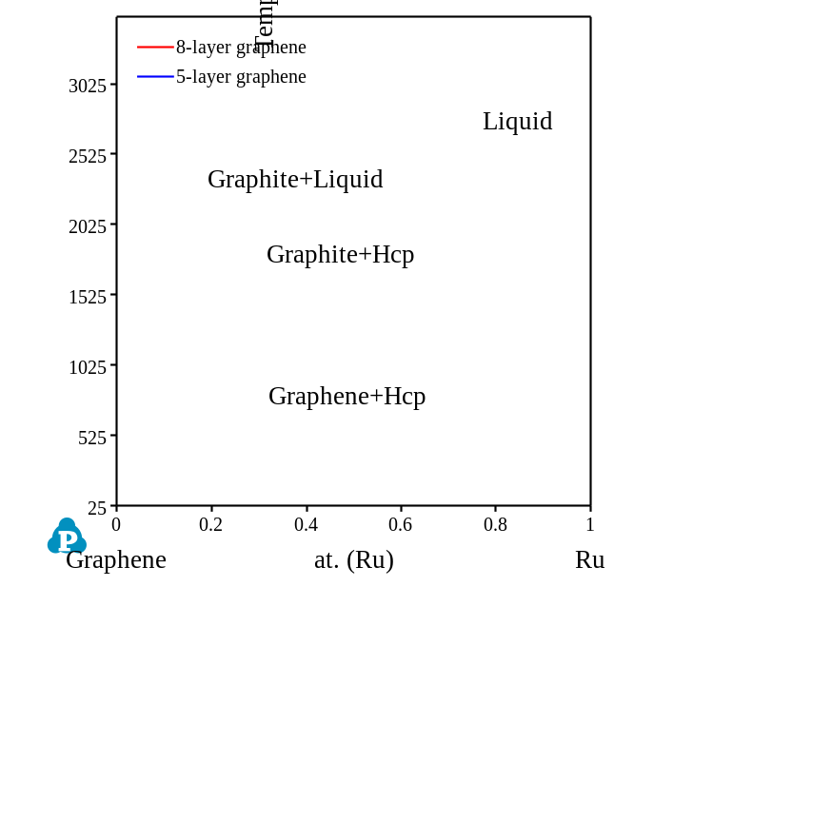
Figure S15. Calculated phase diagram of graphene-Ru system.
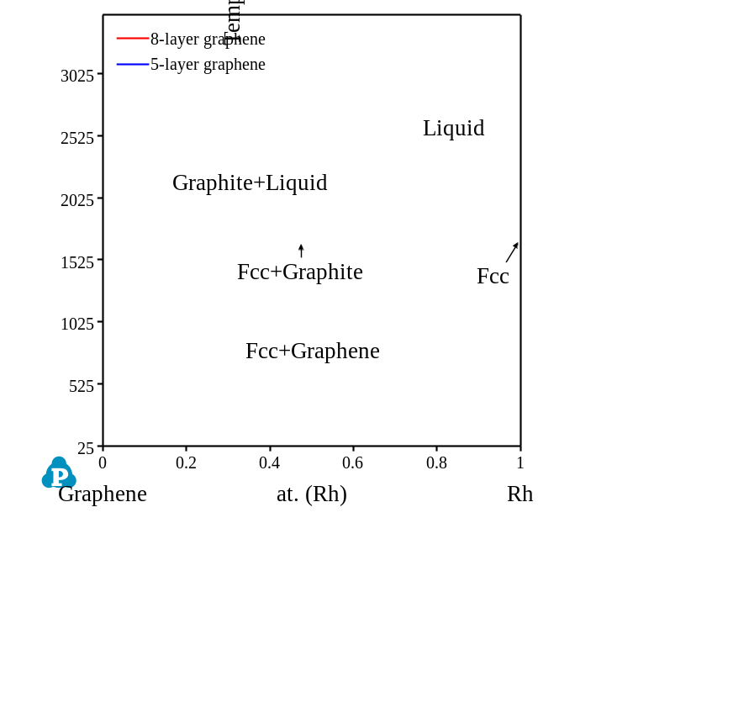
Figure S16. Calculated phase diagram of graphene-Ru system.
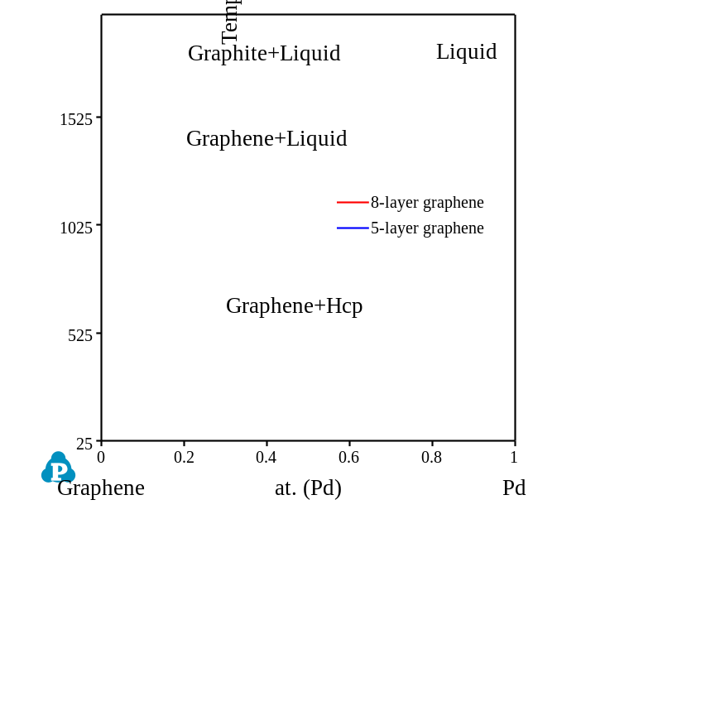
Figure S17. Calculated phase diagram of graphene-Pd system.
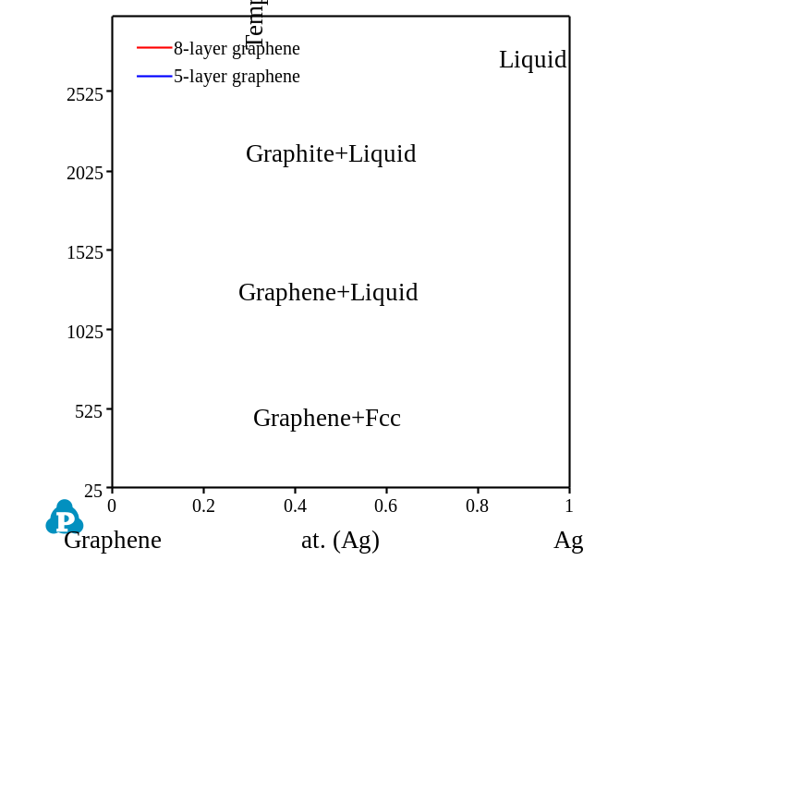
Figure S18. Calculated phase diagram of graphene-Ag system.
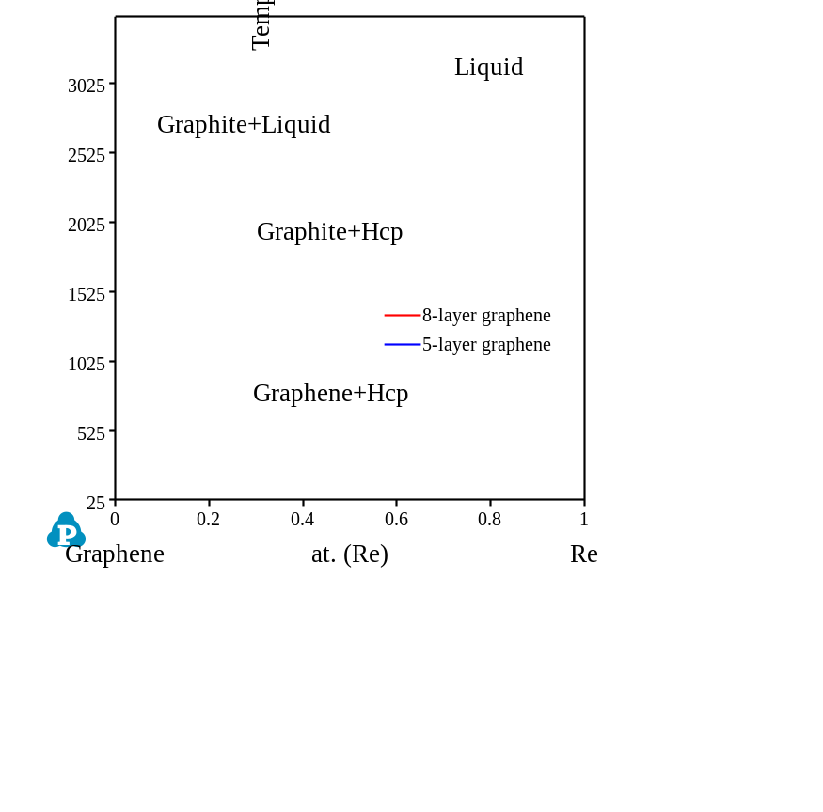
Figure S19. Calculated phase diagram of graphene-Re system.
Note S6. Calculated phase diagrams of graphene-La systems.
The reactions between graphene and La metals are relatively complex. They exhibit all the three types of phase diagrams shown in Note S3 to S5. The thermodynamic database of graphene-La, graphene-Ce, graphene-Pr, and graphene-Dy systems were established based on our previous works.^{12,13} Their phase diagrams are shown in Figure S20 to S23.
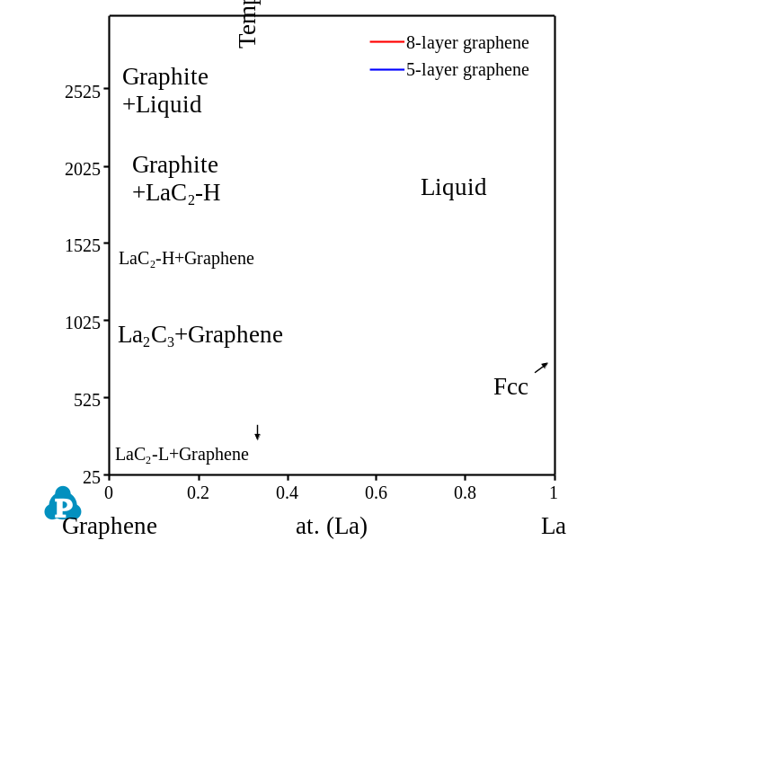
Figure S20. Calculated phase diagram of graphene-La system.
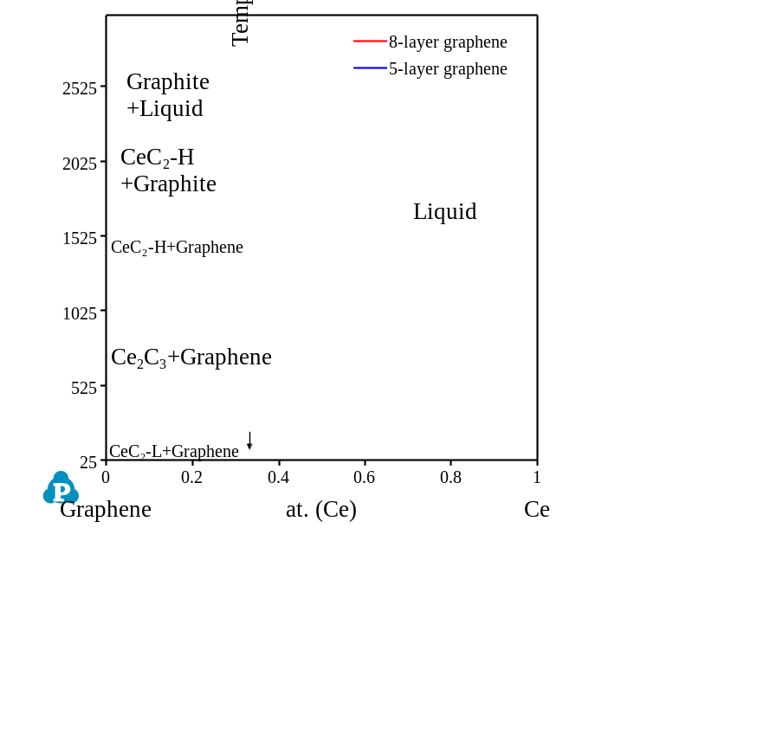
Figure S21. Calculated phase diagram of graphene-Ce system.
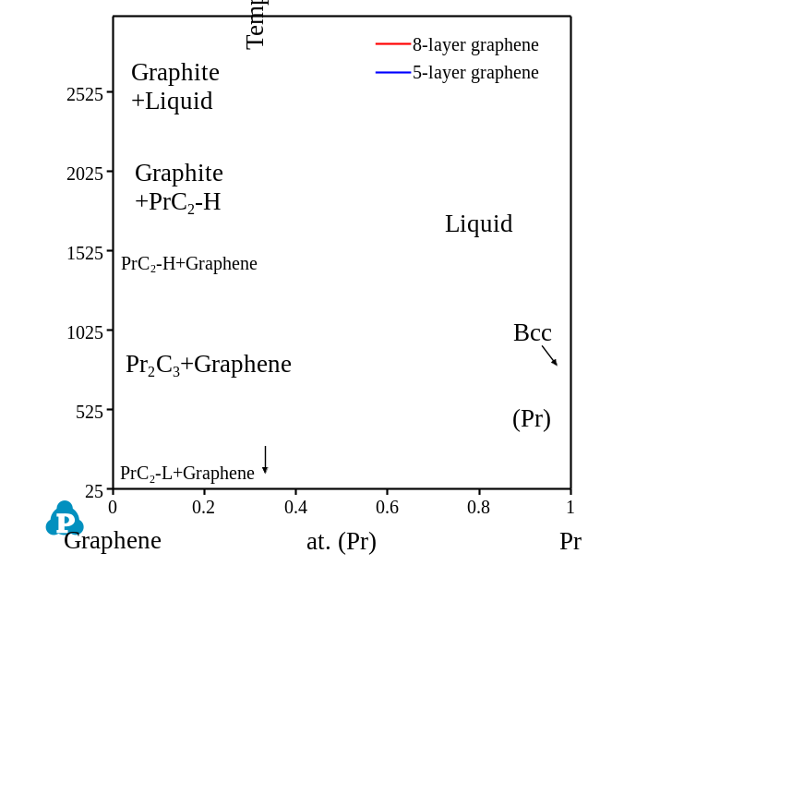
Figure S22. Calculated phase diagram of graphene-Pr system.
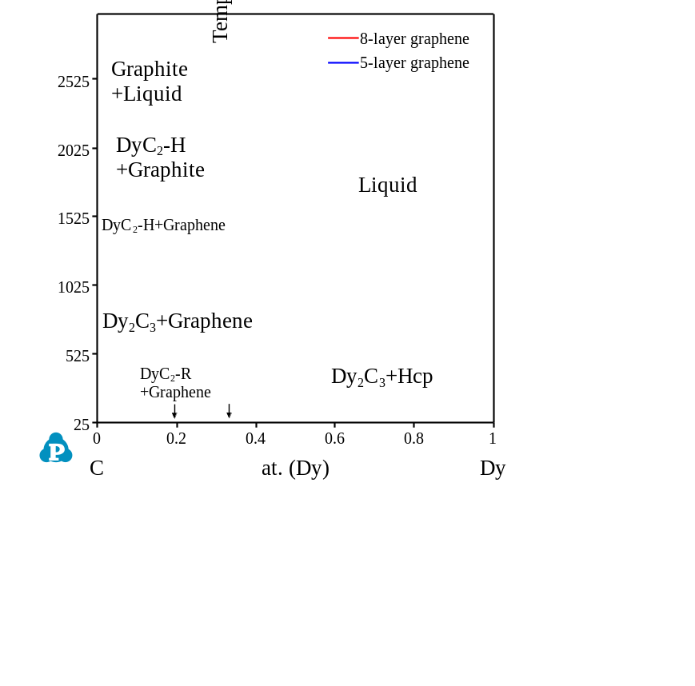
Figure S23. Calculated phase diagram of graphene-Dy system.
Note S7. Calculated phase diagrams of graphene-main group element systems.
We also predicted phase diagrams of some graphene-main group element systems. Figure S24 to S28 show the calculated phase diagrams of graphene-Be, graphene-Mg, graphene-Si, graphene-Ge, and graphene-Sn systems. The thermodynamic assessments of the corresponding carbide systems were adopted from literatures.¹⁴⁻¹⁷ In the graphene-Si phase diagram, the SiC compound exhibited high thermodynamical stability thus preventing the formation of “Graphene + Si” phase area. The “Graphene + SiC” phase area was shown in the graphene-rich side of the phase diagram at temperatures below 1619.7 °C for 5 layers of graphene (1701.8 °C for 8 layers of graphene). Such phase relationships demonstrated that the graphene and Si could be easy to react with each other and form the stable SiC compound, which was also testified by experimental observations.^{18,19}
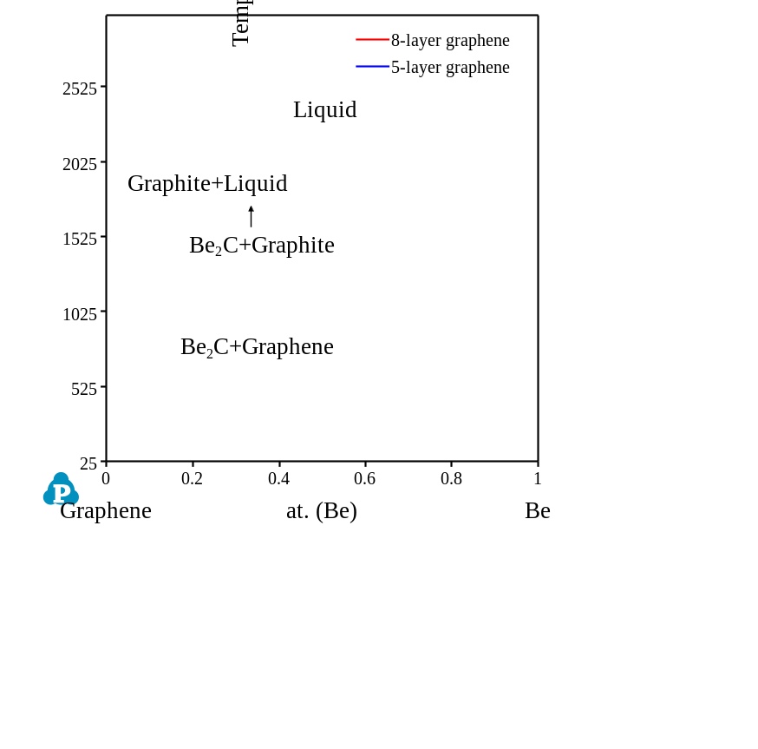
Figure S24. Calculated phase diagram of graphene-Be system.
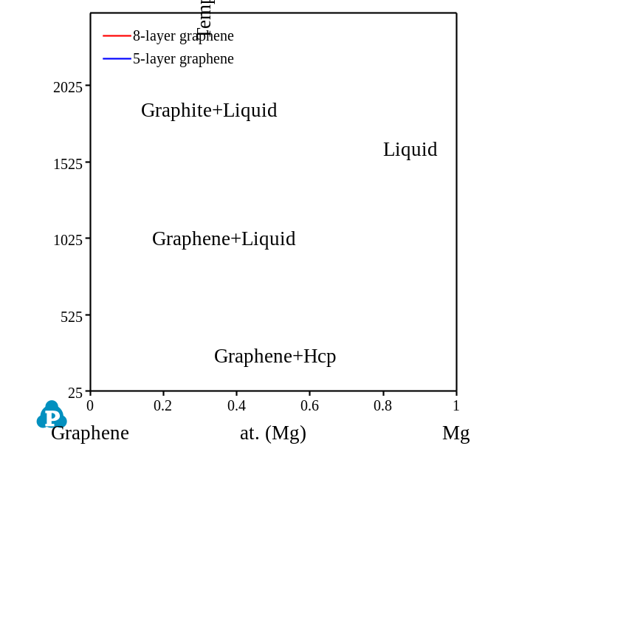
Figure S25. Calculated phase diagram of graphene-Mg system.
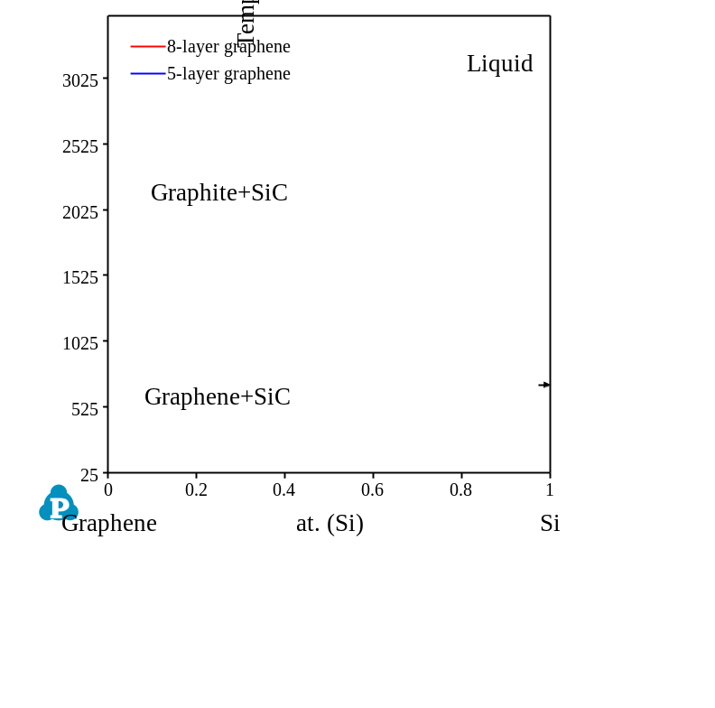
Figure S26. Calculated phase diagram of graphene-Si system.
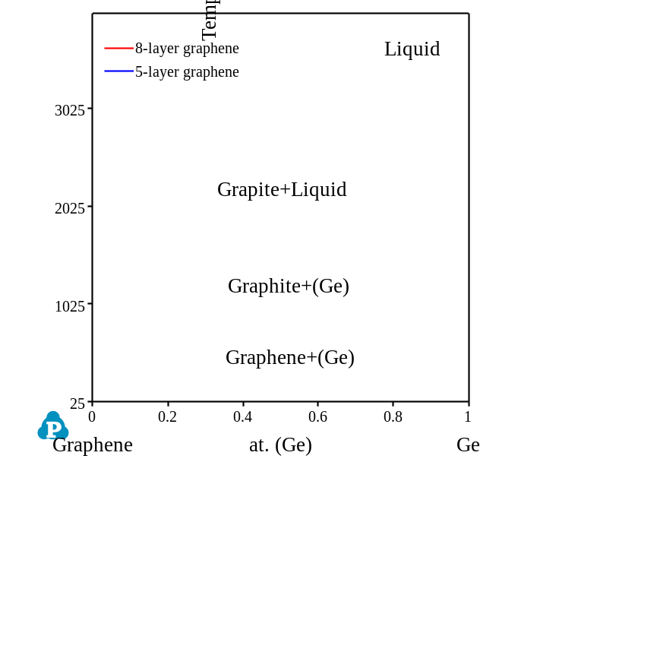
Figure S27. Calculated phase diagram of graphene-Ge system.
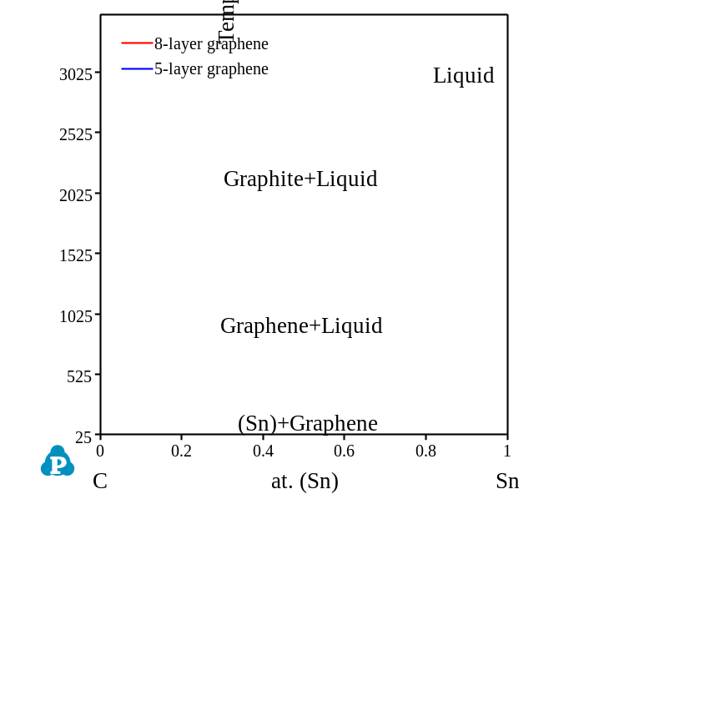
Figure S28. Calculated phase diagram of graphene-Sn system.

Note S8. Calculated formation enthalpies.
To further investigate the reason that transitional metals react with graphene in different ways: by forming secondary solid solutions, linear compounds, or no compound. We have estimated the formation enthalpies of the carbides using Miedema’s model:^{20,21} (taking Li_{x}C_{1-x} as an example)
$$\begin{aligned}∆H=f_{C}^{Li}×\frac{2xV_{A}^{\frac{2}{3}}\left\{-P{\left(∅_{Li}^{*}-∅_{C}^{*}\right)}^{2}+Q\left[{\left(n_{WS}^{\frac{1}{3}}\right)}_{A}-{\left(n_{WS}^{\frac{1}{3}}\right)}_{B}^{2}-R\right]\right\}}{{\left(n_{WS}^{\frac{1}{3}}\right)}_{A}+{\left(n_{WS}^{\frac{1}{3}}\right)}_{B}}\#\left(S5\right)\end{aligned}$$
where $f_{C}^{Li}$ indicates the degree to which a C atom is surrounded by dissimilar neighboring atoms (Li). P, Q, and R are proportionality constants determined empirically. Three basic parameters for Li and C of the LiC compound are required in this equation: the molar volume V, the electronic density at the Wigner-Seitz boundary n_{WS}, and the electronegativity $∅_{ }^{*}$. Such parameters were adopted directly from Chen’s work.²¹ All the calculated formation enthalpies of M_{x}C_{y} (in at.) compounds are listed in Table S2.
Table S2. Calculated formation enthalpies of M_{x}C_{y} compounds.
 | Formation enthalpy of M_{x}C_{y} compounds (kJ/mol)
 | M_{0.75}C_{0.25} | M_{0.5}C_{0.5} | M_{0.25}C_{0.75}
Li | -4.27 | 10.76 | 82.62
Be | 22.45 | 54.68 | 112.29
B | 16.21 | 20.92 | 85.67
Mg | -4.58 | 2.72 | 69.71
Al | -22.84 | -35.29 | 32.14
Si | 9.94 | -5.82 | 52.41
Ti | -48.02 | -84.52 | -13.89
V | -29.57 | -44.06 | 26.18
Cr | -13.46 | -14.98 | 53.65
Mn | 48.66 | -22.1 | 48.66
Fe | -3.05 | 3.29 | 67.17
Co | 2.94 | 14.57 | 76.69
Ni | 5.89 | 19.82 | 80.69
Cu | 9.79 | 27.41 | 87.37
Zn | -9.87 | -6.94 | 62.05
Ge | 7.93 | -1.65 | 53.65
Y | -42.76 | -83.93 | -47.4
Zr | -48.44 | -91.03 | -35.49
Nb | -41.03 | -72.85 | -7.3
Mo | -14.23 | -21.35 | 39.48
Ru | 10.64 | 25.57 | 80.11
Rh | 10.9 | 25.92 | 80.09
Pd | 13.99 | 31.08 | 82.98
Sn | -12.38 | -22.49 | 23.7
Hf | -54.47 | -101.77 | -42.48
Ta | -40.44 | -71.72 | -6.31
W | -8.29 | -10.78 | 47.16
Re | 5.6 | 15.6 | 70.44
Pt | 15.6 | 33.75 | 84.22
Au | 28.22 | 57.76 | 105.53
Hg | 3.39 | 9.44 | 59.36

REFERENCES
1 Huang, W. An assessment of the V-C system / Auswertung des systems V-C. Int. J. Mater. Res. 82, 174-181, (1991).
2 Xu, K. et al. Thermodynamic description of the sintering aid system in silicon carbide ceramics with the addition of yttrium. J. Eur. Ceram. Soc. 39, 4510-4519, (2019).
3 Zeng, Y., Zhou, P. & Du, Y. Thermodynamic assessment of the C–Zr–Nb ternary system. Calphad 61, 98-104, (2018).
4 Lee, B.-J. Thermodynamic assessment of the Fe-Nb-Ti-C-N system. Metallurgical and Materials Transactions A 32, 2423-2439, (2001).
5 Pan, Y., Zhou, P., Peng, Y., Du, Y. & Luo, F. A thermodynamic description of the C–Hf–Ta system over the whole composition and temperature ranges. Calphad 53, 1-9, (2016).
6 Zhang, C. et al. Thermodynamic investigation of phase equilibria on the (W,Mo)C-(Co,Ni) cemented carbides. Calphad 67, 101664, (2019).
7 Kaplan, B., Markström, A., Blomqvist, A., Norgren, S. & Selleby, M. Thermodynamic analysis of the Co–Cr–C system. Calphad 46, 226-236, (2014).
8 Chen, L. et al. Thermodynamic description of the Fe-Cu-C system. Calphad 64, 225-235, (2019).
9 Leonovich, B. I. Thermodynamic analysis and phase equilibria in the Ni-Cr-C system. Steel in Translation 41, 371-375, (2011).
10 https://www.sgte.net/en/thermochemical-databases.
11 Du, Z., Guo, C., Yang, X. & Liu, T. A thermodynamic description of the Pd–Si–C system. Intermetallics 14, 560-569, (2006).
12 Xu, K. et al. Thermodynamic descriptions of the light rare-earth elements in silicon carbide ceramics. J. Am. Ceram. Soc. 103, 3812-3825, (2020).
13 Xu, K. et al. Thermodynamic description of the Dy–Si–C system in silicon carbide ceramics. Calphad 68, 101738, (2020).
14 Hallstedt, B. Thermodynamic evaluation of the Al–V–C system. Calphad 41, 156-159, (2013).
15 Hu, B. et al. Thermodynamic description of the C-Ge and C-Mg systems. J. Min. Metall. B 46, 97-103, (2010).
16 Rogl, P. F., Vřešťál, J., Tanaka, T. & Takenouchi, S. The B-rich side of the B–C phase diagram. Calphad 44, 3-9, (2014).
17 Liu, K., Wang, P., Huang, X., Yang, H. & Du, Y. Experimental investigation and thermodynamic calculation of the Be-C-Si system. J. Phase Equilib. Diffus. 42, 515-523, (2021).
18 Belmonte, M. et al. Toughened and strengthened silicon carbide ceramics by adding graphene-based fillers. Scr. Mater. 113, 127-130, (2016).
19 Hanzel, O. et al. Anisotropy of functional properties of SiC composites with GNPs, GO and in-situ formed graphene. J. Eur. Ceram. Soc. 37, 3731-3739, (2017).
20 De Boer, F. R., Mattens, W., Boom, R., Miedema, A. & Niessen, A. Cohesion in metals. Transition metal alloys. (1988).
21 Chen, X.-Q. & Podloucky, R. Miedema’s model revisited: The parameter ϕ∗ for Ti, Zr, and Hf. Calphad 30, 266-269, (2006).

