Supplemental Materials

Sample Cohort and Collection Details

Sample Bank 1 (SB1) and Discovery life Sciences (DLS)
Samples were obtained under an IRB-approved protocol from pregnant women presenting at multiple sites across the United States.
Qualifying Condition subjects were those with one of the following conditions:
- Pre-existing or pre-gestational
  - Hypertension (systolic ≥ 140 mm Hg OR diastolic ≥ 90 mm Hg)
  - Diabetes mellitus (Type 1 or 2)
- New onset
  - Elevated blood pressure (systolic ≥ 140 mm Hg OR diastolic ≥ 90 mm Hg)
  - Proteinuria (≥ 300 mg per 24-hour urine collection OR protein/creatinine ratio ≥ 0.3 OR dipstick 1+ if other methods not available)
  - Worsening of pre-existing proteinuria
  - Gestational diabetes
  - Preeclampsia
Clinical data were collected from each subject at enrollment (baseline), follow-up visits, and post-delivery. Clinical samples were collected at the site, processed, and shipped according to the protocol. All samples were collected during routine clinical visits.
Subjects were designated into the following cohorts:
Healthy pregnancy (Normal) - Subjects with no signs and symptoms of preeclampsia enrolled between 20- and 39-weeks’ gestation on enrollment or anytime thereafter.
Symptomatic Non-Preeclampsia - Subjects with signs and symptoms of preeclampsia enrolled between 20- and 39-weeks’ gestation but were not diagnosed with preeclampsia on enrollment or anytime thereafter.
Positive Preeclampsia - Subjects that satisfied two conditions: (1) diagnosed with preeclampsia between 20- and 39-weeks’ gestation at the time of sample collection and (2) delivered before 37 weeks' gestation.

Sample Bank 2 (SB2)
Samples were obtained under an IRB-approved protocol from pregnant women presenting at multiple sites across the United States. Whole blood samples were collected from pregnant women with signs and symptoms of preeclampsia, including those who were being referred to a center for preeclampsia rule-out testing. Preeclampsia was diagnosed according to the ACOG 2013 and 2019 Diagnostic Guidelines. The subjects used in this protocol consisted of pregnant women 18 to 45 years of age and 28 0/7 to 36 6/7 weeks’ gestational age (GA) who presented with signs and symptoms of preeclampsia. Enrolled subjects were followed with samples collected through delivery by their Provider(s).
All clinical samples were collected in SSTs, spun, and stored frozen at the clinical sites. Bulk shipments of the frozen samples were received by the Progenity Biorepository in Ann Arbor, Michigan, processed further by thawing the contents of the SSTs and aliquoting the serum, followed by freezing at –80ºC and managed within the Progenity Biorepository. All clinical data were managed by Vision Clinical Research (VCR) data-management and transferred to Progenity data-management once final. All clinical data associated with usable clinical specimens were adjudicated in three cohorts, Negative Preeclampsia Controls, Cases, and Positive Preeclampsia Controls. Depending on the diagnosis and delivery, subjects were designated into the Study Cohort Positive Preeclampsia Controls if a diagnosis of preeclampsia occurred within 24 hours of testing.
Samples from SB1, SB2 and DLS were combined and classified as shown in supplementary figure 1.
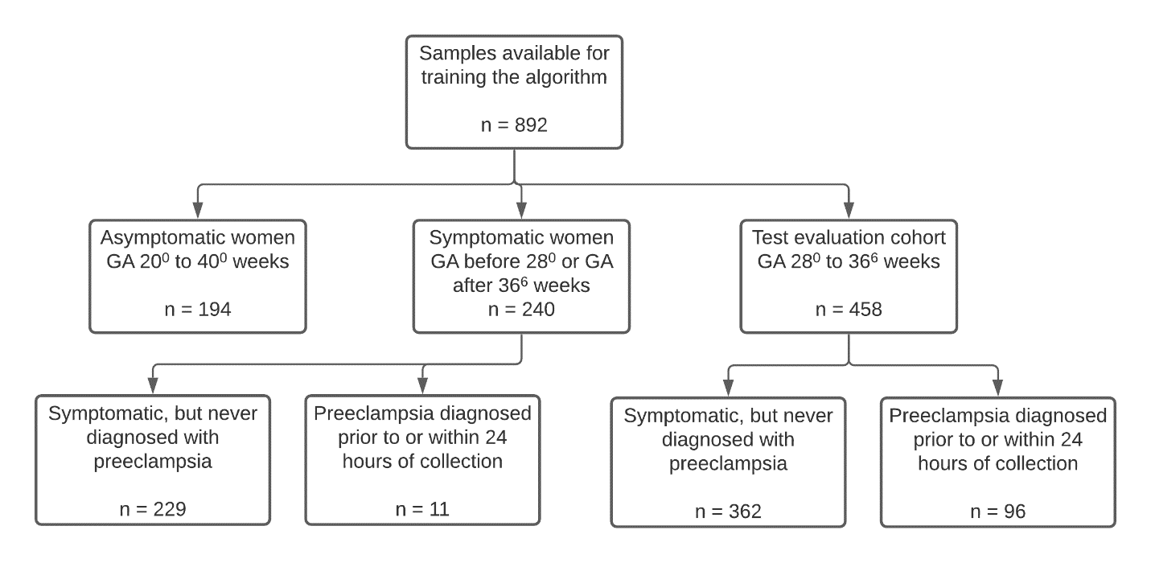
Supplementary figure 1. Flow chart describes the type of clinical sample used for preeclampsia classification algorithm Development. Total of 194 asymptomatic subjects, 591 symptomatic non-PE subjects, and 107 PE subjects were used during the algorithm development.

Supplementary Table 1 Clinical characteristics of 892 samples
Demographic and Clinical Variables | Symptomatic Non- PE (n=591) | Asymptomatic Non-PE (n=194) | PE (n=107) | All (n=892)
Blood Pressure
Systolic Median (IQR) | 123 (19) | 113 (15) | 160 (23.3) | 122 (25)
Diastolic Median (IQR) | 73 (14) | 65 (13) | 99 (14) | 73 (18)
Pregestational Diabetes
No | 358 (60.6%) | 194 (100%) | 51 (47.7%) | 603 (67.6%)
Yes | 233 (39.4%) |  | 21 (19.6%) | 254 (28.5%)
Missing |  |  | 35 (32.7%) | 35 (3.9%)
Diabetes
No | 269 (45.5%) | 193 (99.5%) | 79 (73.8%) | 541 (60.7%)
Yes | 322 (54.48%) |  | 28 (26.1%) | 350 (39.2%)
Missing |  | 1 (0.5%) |  | 1 (0.1%)
Chronic Hypertension
No | 349 (59.1%) | 194 (100%) | 63 (58.9) | 606 (67.9)
Yes | 242 (41%) |  | 44 (41.1) | 286 (32.1)
Gestation Age
GA Weeks at Enrollment Median (IQR) | 32 (7.5) | 31 (8) | 33 (3) | 32 (7)
GA Weeks at Delivery Median (IQR) | 38 (2) | 39 (1.8) | 34 (3) | 38 (2)
Age at enrollment
Age in years Median (IQR) | 30 (9) | 28 (10) | 29 (8) | 29 (9)
Race
WHITE | 332 (56.2%) | 148 (76.3%) | 56 (52.3%) | 536 (60.1%)
BLACK | 235 (39.8%) | 38 (19.6%) | 46 (43%) | 319 (35.8%)
ASIAN | 7 (1.2%) | 3 (1.6%) |  | 10 (1.1%)
NATIVE AMERICAN | 1 (0.2%) |  | 2 (1.2%) | 3 (0.3%)
PACIFIC ISLANDER |  | 1 (0.5%) |  | 1 (0.1%)
Missing | 16 (2.7%) | 4 (2.1%) | 3 (2.8%) | 23 (2.6%)
Ethnicity
HISPANIC OR LATINO | 12 (2%) | 7 (3.6%) | 10 (9.4%) | 29 (3.3%)
NOT HISPANIC OR LATINO | 399 (67.5%) | 162 (83.5%) | 94 (87.8%) | 655 (73.4%)
Missing | 180 (30.5%) | 25 (12.9%) | 3 (2.8) | 208 (23.3%)

Biomarker Assay Method
Supplementary table 2. Description of antibodies and assay protocol parameters
Assay | Capture Antibody | Detection Antibody | Sample Dilution  (fold) | Sample Volume  (µL) | Sample Incubation Time (min) | Conjugate Incubation Time (min) | TMB Incubation Time (min)
CD274 | mouse-anti-CD274 | goat-anti-CD274 | 4 | 25 | 120 | 120 | 20
Decorin | mouse-anti-Decorin | mouse-anti-Decorin | 50 | 2 | 120 | 120 | 20
Endoglin | mouse-anti-Endoglin | mouse-anti-Endoglin | 10 | 5 | 120 | 120 | 30
FGF21 | mouse-anti-FGF21 | goat-anti-FGF21 | No Dilution | 50 | 120 | 120 | 20
sFlt-1 | mouse-anti-sFlt-1 | goat-anti-sFlt-1 | 100 | 1 | 120 | 120 | 20
KIM-1 | mouse-anti-KIM-1 | goat-anti-KIM-1 | 2 | 25 | 120 | 45 | 20
Free PlGF | mouse-anti-PlGF | goat-anti-PlGF | 2 | 50 | 30 | 30 | 30
Total PlGF | mouse-anti-PlGF | goat-anti-PlGF | 4 | 25 | 120 | 120 | 20

Analytical Validation of the Assays
Precision was established according to CLSI EP05-A3 guidelines. The average intra-run precision for each assay was less than 10% for all assays. The inter-run %CV includes imprecision due to different operators and instruments.

Supplementary table 3. Intra- and inter-run precision

Assay | Sample Concentration Range (pg/mL) | Average Intra-run %CV | Average Inter-run %CV
Decorin | 3,962 - 5,280 | 4.4 | 5.3
FGF21 | 128 - 642 | 4.8 | 8.7
KIM-1 | 56.1 - 514 | 3.9 | 4.6
sFlt-1 | 8,724 - 54,252 | 4.3 | 4.6
CD274 | 296 - 2,248 | 3.4 | 3.7
Endoglin | 3,650 - 35,400 | 5.5 | 6.3
Free PlGF | 26.0 - 209 | 8.8 | 8.9
Total PlGF | 81.6 - 536 | 7.1 | 8.8

Supplementary table 4. Analytical and Concentration Ranges for each assay for Non-PE subjects
 | Analytical Range (pg/mL) |  |  | Sample Concentration Range (pg/mL)*
Assay | LOD | LLOQ | ULOQ | 5th | 25th | 50th | 75th | 95th
CD274 | 26.2 | 150 | 4,600 | 167 | 261 | 368 | 503 | 804
Decorin | 217 | 650 | 23,000 | 2,255 | 2,836 | 3,418 | 4,403 | 6,798
Endoglin | 206 | 2,000 | 70,000 | 4,975 | 7,646 | 11,632 | 20,724 | 85,735
FGF21 | 13.7 | 36 | 1,400 | 6.5 | 44.3 | 111 | 275 | 836
sFlt-1 | 1307 | 3,750 | 130,000 | 2,128 | 4,237 | 7,262 | 13,765 | 47,312
KIM-1 | 6.25 | 25 | 1,000 | 17.7 | 28.3 | 42.4 | 63.2 | 154.4
Free PlGF | 5 | 15 | 400 | 5.35 | 30.4 | 84.2 | 194 | 476
Total PlGF | 20 | 60 | 800 | 54.8 | 159 | 277 | 458 | 986
*Based on internal data

Test Subjects Stratified by Study Cohort and Group
Supplementary table 5. Test subjects stratified by study cohort across two groups.
 |  | Cohort
 |  | SB-1 | DLS | SB-2 | Total
Group | NON-PE | 163 | 199 | 0 | 362
Group | PE | 28 | 16 | 52 | 96
 | Total | 191 | 215 | 52 | 458

Association of Gestational Age and Biomarkers
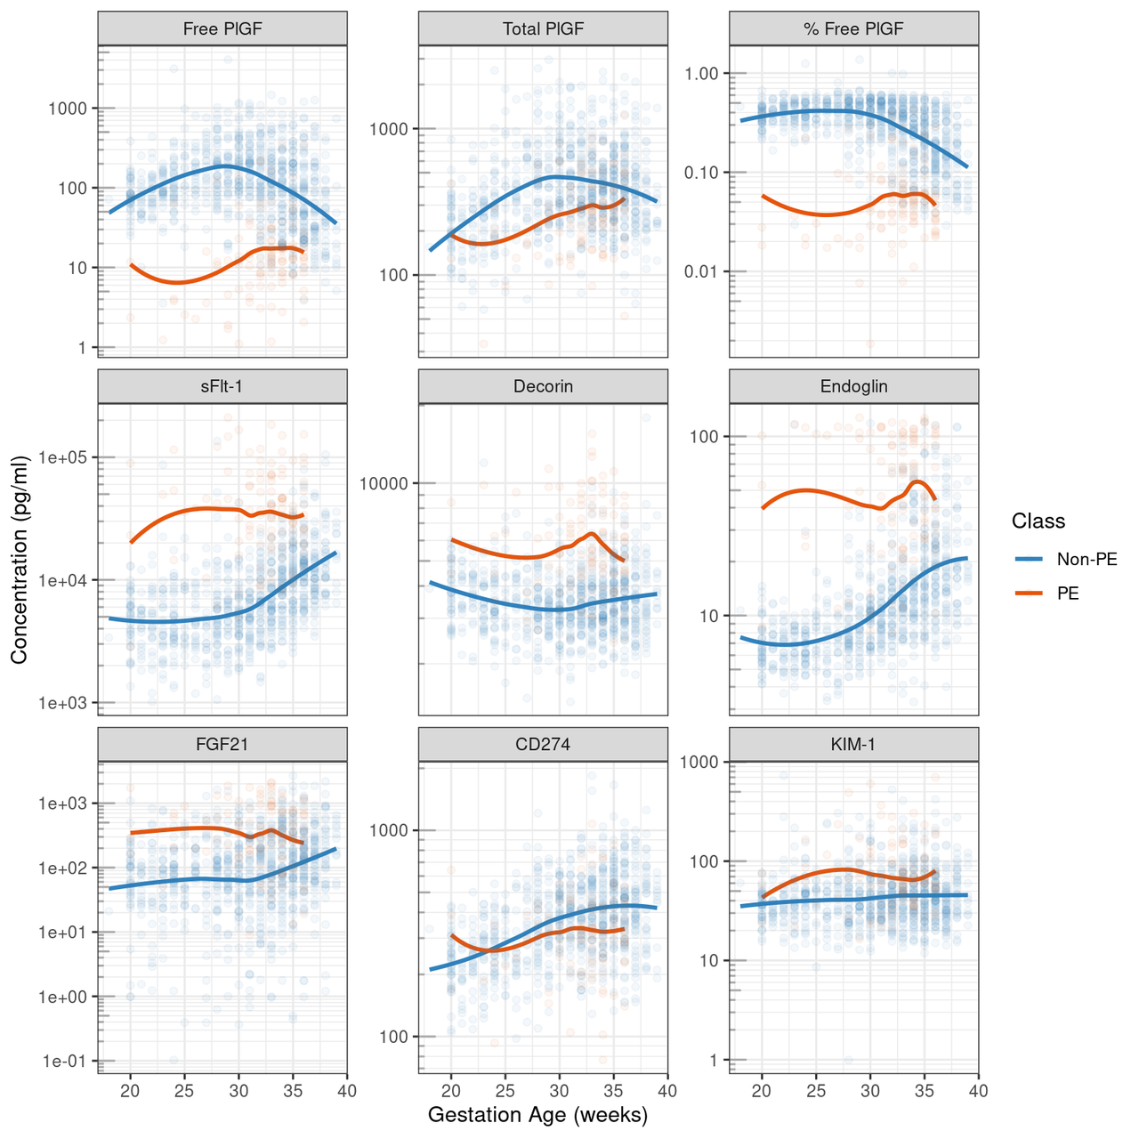
Supplementary figure 2. Scatterplot of serum protein biomarker concentration (pg/mL) compared to GA at blood draw for eight markers and % Free PlGF. Loess curves show how concentration differs by GA for PE- and non-PE-diagnosed subjects. In the panel, % Free PlGF is unitless as it is determined from the ratio of Free PlGF to Total PlGF

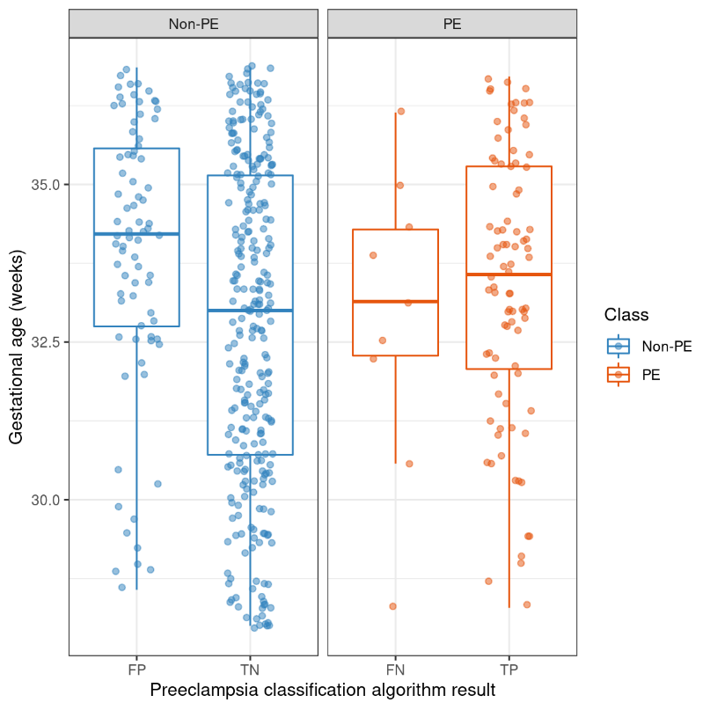
Supplementary figure 3. Comparison of gestational ages by preeclampsia classification result
- Supplementary table 6. CROSS-VALIDATED PERFORMANCE OF TEST DATA FOR THE PREECLAMPSIA CLASSIFICATION ALGORITHM, BROKEN DOWN BY EARLY (GA < 35 WEEKS) AND LATE (GA ≥ 35 WEEKS) PREGNANCIES. STATISTICS ARE SHOWN AS PERCENT WITH 95% CONFIDENCE INTERVALS.
GA | N | AUROC (%) | Sensitivity (%) | Specificity (%) | NPV  (%) | PPV  (%)
< 35 weeks | 327 | 94.6  [91.7-97.6] | 90.0  [80.8-95.1] | 80.5  [75.3-84.9] | 96.7  [93.4-98.4] | 55.8  [46.6-64.6]
≥ 35 weeks | 131 | 88.9  [80.5-97.3] | 92.3  [75.9-97.9] | 73.3  [64.2-80.9] | 97.5  [91.2-99.3] | 46.2  [33.3-59.5]

- Supplementary table 7. Confusion matrix of preeclampsia classification algorithm vs. clinical diagnosis gold-standard
 |  | Clinical Diagnosis
 |  | Preeclampsia | Non-Preeclampsia
Algorithm call | Positive | 87 | 78
Algorithm call | Negative | 9 | 284

Additional Statistical analysis

Systolic blood pressure
Systolic blood pressures were compared between FP and TN calls within non-PE-diagnosed subjects, and between FN and TP calls within PE-diagnosed subjects (Supplementary Figure 4) PE-diagnosed subjects had higher blood pressure than non-PE diagnosed subjects overall (Supplementary Figure 4) but FP subjects within non-PE-diagnosed subjects had significantly higher blood pressure than TN (Supplementary Figure 4; p < 0.0001, t-test). Conversely, FN were not significantly different than TP in PE-diagnosed subjects (Supplementary Figure 4; p = 0.318, t-test).
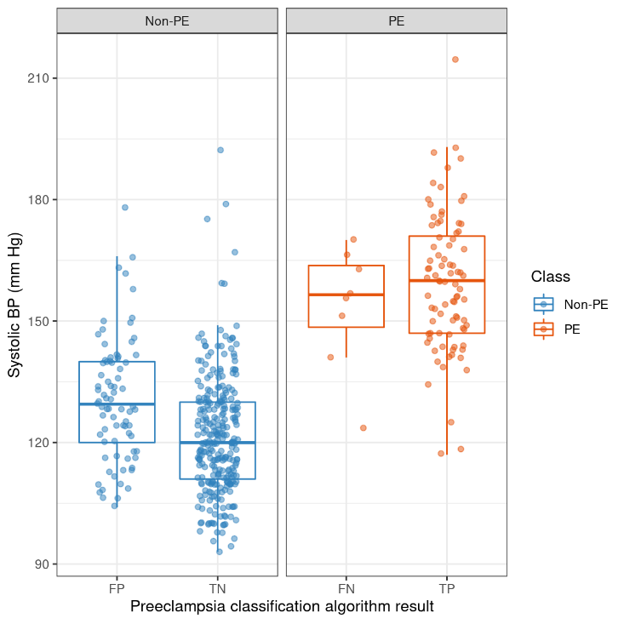
Supplementary figure 4. Comparison of systolic blood pressure by preeclampsia Classification result

Diastolic blood pressure
Diastolic blood pressures were compared between FP and TN calls within non-PE-diagnosed subjects, and between FN and TP calls within PE-diagnosed subjects (Supplementary Figure 5). PE-diagnosed subjects had higher blood pressure than non-PE diagnosed subjects overall (Supplementary Figure 5) but FP subjects within non-PE-diagnosed subjects had significantly higher blood pressure than TN (Supplementary Figure 5; p < 0.0001, t-test). Conversely, FN were not significantly different than TP in PE-diagnosed subjects (Supplementary Figure 5; p = 0.346, t-test).

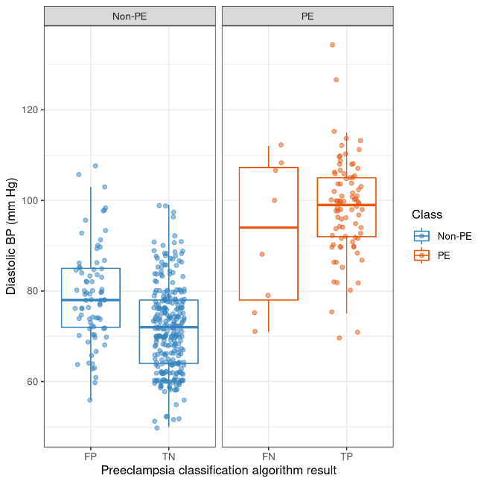
Supplementary figure 5. Comparison of diastolic blood pressure by preeclampsia Classification result

BMI
Across the three studies, 454 out of 458 subjects had height and weight data recorded. A comparison of Body Mass Index (BMI) by preeclampsia caller algorithm result showed that BMI was not significantly different among FP, TN, FN, or TP results (Supplementary Figure 6; p = 0.796, ANOVA).
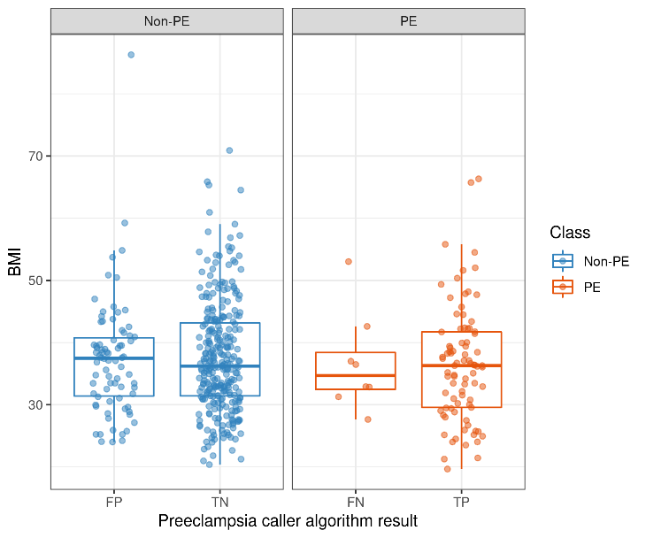
Supplementary figure 6. Comparison of BMI by preeclampsia caller result

Locking the Algorithm

To lock the design of the algorithm for future verification using an independent cohort, all training sets (eight biomarkers and GA; n = 892; Supplementary Table 1) were combined, transformed, standardized and fit to a single logistic regression model with a single classification threshold that was derived during the cross-validation. The naïve performance of the algorithm is shown in the Supplementary Table 8. The flowchart of the locked preeclampsia classification algorithm is shown in Supplementary Figure 7.
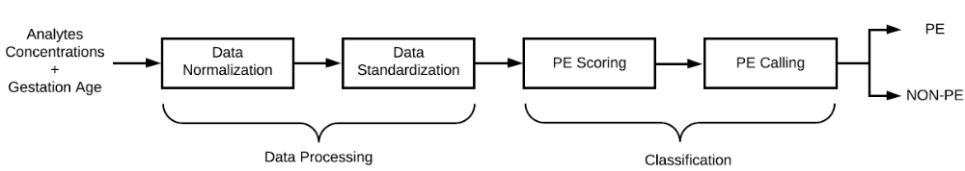
Supplementary figure 7. FLOW CHART OF THE ALGORITHM FOR PREECLAMPSIA BINARY CLASSIFICATION

Supplementary Table 8. Naïve Performance of Model E on the test data
N | Prevalence | AUROC (%) | Sensitivity (%) | Specificity (%) | NPV  (%) | PPV  (%)
458 | 21% | 93.6 | 90.6  [83.1-95.0] | 78.5  [73.9-82.4] | 96.9  [94.3-98.4] | 52.7  [45.1-60.2]

- Clinical Review of False Negatives
Supplementary table 9. Clinical Data for False Negative Samples
 | Age (years) | Gravida | Gestational Age at times of sample | Qualifying Condition per Intake | Proteinuria | P/C Ratio | BP at time of sample | BMI  (kg/m²⁾ | Severe Symptoms | Clinical Review | Interpretation
DLS1 | 35 | G6P3 | 34 2/7 | “preeclampsia” with proteinuria | 1995 g | Missing | 124/71 | 32 | None | This patient did not clinically meet the criteria for preeclampsia as hypertension was absent with normal BP and there were no severe features. There was no renal insufficiency noted. The examination of this patient with proteinuria has to question other etiologies such as IgA nephropathy / minimal change disease, etc.. Urinary tract infection is also in the possible reasons for proteinuria. The protein was recorded as 1995 grams but this is also likely in error. Analytes noted a reassuring PlGF level and low s-Flt1 level. | The biomolecular analysis is in alignment with the absence of hypertensive disease of pregnancy as well. The misclassification of this subject is most likely related to an absent diagnosis of preeclampsia which would correctly be identified as negative by the preeclampsia classifier.
DLS2 | 33 | G5P3A1 | 36 | Gestational Hypertension without proteinuria | N/A | 0.37 | 174/102 | 32.9 | None | This patient met criteria with the second sample drawn. | FALSE NEGATIVE
DLS3 | 36 | G5P4 | 36 1/7 | Preeclampsia with proteinuria | Trace | N/A | 170/100 | 54 | New onset headache; no other severe symptoms | There were no other measures of proteinuria and thus, this patient would not meet strict criteria for preeclampsia. There are also significant limitations in blood pressure assessment in patients with Class III obesity beyond 50 kg/m2 as is the case here | This patient is not proven to have preeclampsia by data presented and may represent a TRUE NEGATIVE in the classifier.
SB2-1 | 20 | G1P0 | 35 0/7 | Preeclampsia by 24 hour urine protein > 300 mg with mild range blood pressure and persistent headache | 300 mg | 0.2 | 151/79 | 42.6 | None | There is some uncertainty with the presence of proteinuria. Generally, the 24 hour urine is more accurate than the P/C ratio and the ratio will not always encapsulate the total proteinuria | Based upon presentation this is a TRUE POSITIVE that is misclassified near the limits of the testing classifier with some uncertainty as to the amount of protein.
SB2-2 | 27 | G1P0 | 33 1/7 | Preeclampsia by 24 hour urine protein > 300 mg with both mild and severe range blood pressure | 410.4 mg | 0.26 | 166/107 | 36.5 |  | There is some uncertainty with the presence of preexisting hypertension. Given that a cohort of patients with chronic hypertension will have proteinuria, a baseline is necessary to understand if this is truly preeclampsia. This patient may not have had preeclampsia but only worsening chronic hypertension given lack of other signs. | This is possibly a TRUE NEGATIVE or a FALSE NEGATIVE. There is not enough information provided to allow for discernment of prior hypertension.
SB2-3 | 39 | G590222 | 33 6/7 | with severe preeclampsia by urinary P/C and severe blood pressure | 3+ | 0.45 | 163/112 | 31.3 |  | The patient has superimposed preeclampsia on chronic hypertension most likely. However, there was no magnesium sulfate administered for severe range blood pressures or antihypertensive therapy per report. Thus, this may have been misclassified. The patient would meet criteria for preeclampsia by the urine dip and the P/C ratio with blood pressure criteria | Based upon those findings, this would be a patient that is a FALSE NEGATIVE. However, the rendered treatment would have suggested otherwise with the lack of magnesium sulfate or antihypertensives.
SB2-4 | 28 | G4P0303 | 32 4/7 | Preeclampsia by worsening blood pressure | 1+ | 0.3 | 143/92 | 27.6 |  | The patient has chronic hypertension and is not certain to have preeclampsia based upon lack of protein to support this diagnosis. | This may be a TRUE NEGATIVE or TRUE POSITIVE case
SB2-5 | 26 | G6P1223 | 32 2/7 | Preeclampsia by known baseline hypertension with worsening blood pressure (superimposed preeclampsia | 369 mg | N/A | 152/78 | 32.8 |  | The patient has chronic hypertension and was given a diagnosis of superimposed preeclampsia based upon proteinuria that was worsening and hypertension | This is a FALSE NEGATIVE case by the classifier.
SB2-6 | 31 | G3P2 | 30 4/7 | By known baseline chronic hypertension with worsening blood pressure | 2+ | 0.48 | 141/88 | 37 |  | This is a very complex case as HIV may result in proteinuria and the course of this disease would also need to be understood. Based upon the proteinuria and hypertension reported, the patient may have qualified for superimposed preeclampsia. However, a baseline was not known and HIV causes proteinuria in many subjects. The blood pressure was at goal for a patient with hypertension | This may represent a TRUE NEGATIVE in the classifier. A full understanding of the clinical case would be needed to render additional insight.

