Appendix A
Consent Form
Welcome to this study. The study is being conducted by Matthew Arnold of Northwest University to meet the requirements of his doctorate dissertation. The study has been approved by the Northwest University Institutional Review Board. No deception is involved, and the study involves no more than minimal risk to participants (i.e., the level of risk encountered in daily life). The risks encountered may cause uncomfortable feelings such as emotional distress due to answering questions of a personal nature. If any questions or content of this questionnaire bring up personal questions, confusion, or anxiety, you may seek help by contacting the Crisis Text Hotline by texting 741741. In addition, Psychology Today at www.psychologytoday.com is a resource to find a referral for a counselor in your area.
Participation in the study is expected to take 5-10 minutes and is strictly anonymous. You begin by answering a series of demographic questions, followed by questions regarding your experiences over the last two weeks. Your responses will be treated confidentially and will not be linked to any identifying information about you. You may discontinue the questionnaire at any time if you wish. The results from this study will be presented within research papers and may be shared at a professional conference or presented in academic settings. All data forms will be destroyed on or before December 31, 2024. Electronic data with no identifying information will be kept indefinitely.
You will have the opportunity to enter to win 1 of 4 $25 Amazon gift cards in a raffle. Participation in the raffle requires completion of the entire survey, as well as a valid email address. If you chose to participate the in raffle, your email will be stored separately from the questionnaire as to not identify your email with your responses. Only 1 entry per participant. Winning in the raffle is not guaranteed. Winners will be notified within 30 days of the closing of the survey and notified via email. Gift cards will be distributed digitally via the email provided.
If you have further questions about this study or their rights, or if you wish to lodge a complaint or concern, you may contact the principal investigator, Matthew Arnold, Email: matthew.arnold13@northwestu.edu; Dr. Leihua Edstrom, Northwest University College of Social and Behavioral Sciences, at (425) 889-5367, Email: leihua.edstrom@northwestu.edu; or the Chair of the Northwest University Institutional Review Board, Dr. Cheri Seese, at cherri.seese@northwestu.edu or (425) 285-2413.
Before taking part in this study, please read the consent form below and click on the "I Agree" button at the bottom of the page if you understand the statements and freely consent to participate in the study. You may exit the survey at any time.
Thank you for considering participation in this study.
Matthew Arnold
Doctoral Student in Counseling Psychology
College of Social & Behavioral Sciences
matthew.arnold13@northwestu.edu
Leihua Edstrom, PhD, ABSNP
Professor of Psychology
College of Social & Behavioral Sciences
leihua.edstrom@northwestu.edu
Please print a copy of this consent form for future reference
If you are 18 years of age or older, understand the statements above, and freely consent to participate in the study, click on the “I Agree” button to begin the survey
- I Agree
- I Disagree and Wish to Exit

Appendix B

Qualtrics Survey

What is the year you were born? Please enter in numeric form (example: "1985").
________________________________________________________________

Do you have a sibling who has been professionally diagnosed with Autism Spectrum Disorder (ASD)?
- Yes
- No

What is the year of birth for your sibling with Autism (ASD). Please enter in numeric form (example: "1985").
________________________________________________________________

What is your sex?
- Male
- Female
- Prefer not to answer

Choose one or more races/ethnicity that you consider yourself to be:
- White
- Black or African American
- American Indian or Alaska Native
- Asian
- Native Hawaiian or Pacific Islander
- Latina/o
- Other ________________________________________________

What is the highest level of school you have completed or the highest degree you have received?
- Less than high school diploma
- High school graduate (high school diploma or equivalent including GED)
- Some college but no degree
- Associate degree in college (2-year)
- Bachelor's degree in college (4-year)
- Master's degree
- Doctoral degree
- Professional degree (JD, MD)

Information about income is very important to understand. Would you please give your best guess? Please indicate the answer that includes your entire household income in (previous year) before taxes.
- Less than $10,000
- $10,000 to $29,999
- $30,000 to $59,999
- $60,000 to $89,999
- $90,000 to $99,999
- $100,000 to $149,999
- $150,000 or more

What State do you live in? (If outside the US, please specify)
________________________________________________________________

Are you now married, widowed, divorced, separated or never married?
- Married
- Widowed
- Divorced
- Separated
- Never Married

Please indicate your occupation:
- Management, professional, and related
- Service
- Sales and office
- Farming, fishing, and forestry
- Construction, extraction, and maintenance
- Production, transportation, and material moving
- Government
- Retired
- Unemployed
- Full-time student

Please enter the number of siblings you were raised with (biological or adopted) as it pertains to you.
- Biological Siblings ________________________________________________
- Adoptive Siblings ________________________________________________
- Stepsiblings ________________________________________________
- Foster Siblings ________________________________________________
- Extended Family (Such as Cousins) __________________________________

What is your birth order among your siblings?
Example: If you are born first, you would enter "1." If you are born fourth, you would enter "4."
________________________________________________________________

How many siblings are between you and your sibling with ASD in birth order (biological or adopted) in your family of origin?
Example 1: If you are 2nd born, and your sibling with ASD was 5th born, you would enter "1."
Example 2: If your sibling with ASD with 1st born and you were 2nd born, you would enter "0."
________________________________________________________________

Over the last 2 weeks, how often have you been bothered by the following problems?

 | Not at all sure | Several days | Over half the days | Nearly every day
Feeling nervous, anxiety, or on edge
Not being able to stop or control worrying
Worrying too much about different things
Trouble Relaxing
Being so restless that it's hard to sit still
Becoming easily annoyed or irritable
Feeling afraid as if something awful might happen

If you checked off any problems, how difficult have these made it for you to do your work, take care of things at home, or get along with other people?
- Not difficult at all
- Somewhat difficult
- Very difficult
- Extremely difficult

Please each question carefully, then mark one of the numbers to the right to indicate how you have felt or behaved during the past week, including today.
 | RARELY OR NONE OF THE TIME (LESS THAN 1 DAY) | SOME OR A LITTLE OF THE TIME (1-2 DAYS) | OCCASIONALLY OR A MODERATE AMOUNT OF TIME (3-4 DAYS) | MOST OR ALL OF THE TIME (5-7 DAYS)
I was bothered by things that usually don't bother me.
I did not feel like eating; my appetite was poor.
I felt that I could not shake off the blues even with help from my family or friends.
I had trouble keeping my mind on what I was doing.
I felt depressed.
I had trouble keeping my mind on what I was doing.
I felt that everything I did was an effort.
I felt hopeful about the future.
I thought my life had been a failure.
I felt fearful.
My sleep was restless.
I was happy.
I talked less than usual.
I felt lonely.
People were unfriendly.
I enjoyed life.
I had crying spells.
I felt sad.
I felt that people dislike me.
I could not get "going."

Would you like to be entered to win a $25 Amazon gift card?
- Yes
- No

Please select the link below to enter your email for a chance to win one of four $25 Amazon gift card in a raffle. The winners will be notified no later than 11/1/2022. If selecting the link does not activate it, please copy/paste the link into your browser.
https://northwestupsych.az1.qualtrics.com/jfe/form/SV_bNvK0JGT5lJfyFo

Thank you for participating in this survey.
If you have questions about this study, how your information will be used, please contact the investigator at Matthew.Arnold13@NorthwestU.edu. If you have concerns about this study, you may contact the investigator's faculty advisor at Leihua.Edstrom@NorthwestU.edu.
If this survey brought about any discomfort, emotional or psychological distress, you are encouraged to contact a professional for support.
For the King County 24-Hour Crisis Line, call 1-866-427-4747.
For the American Psychological Association Psychology Help Center, visit https://www.apa.org/helpcenter/.
To locate a counselor near you, visit www.psychologytoday.com and click the "Find a Therapist" link on the top menu bar.
Thank you!
TO END THE SURVEY, PLEASE SELECT THE BUTTON BELOW
Appendix C

Generalized Anxiety Disorder 7-Item (GAD-7)
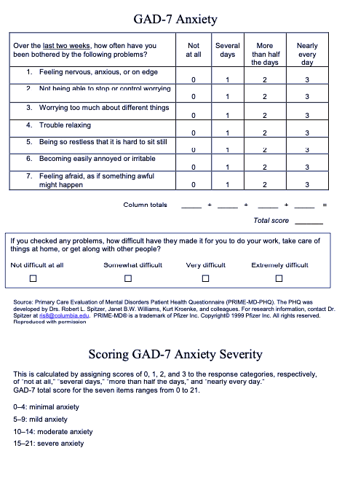

Appendix D
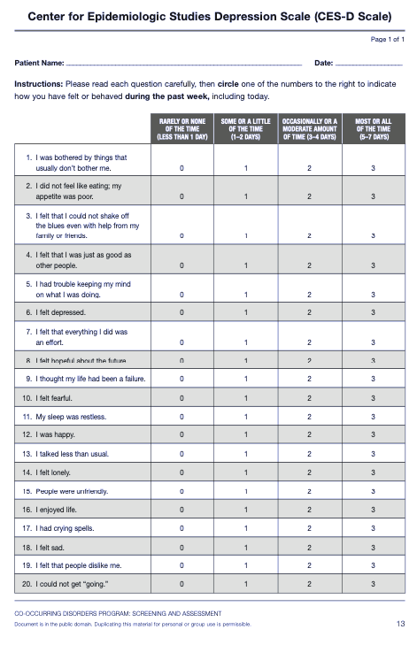
Appendix E

Survey Respondent Qualtrics Raffle

Please enter a valid email to be entered to win 1 of 4 $25 Amazon gift cards. (Example: "name@example.com").
Winners will be notified by 11/1/2021 and will receive the digital Amazon gift card via the email provided.
________________________________________________________________

