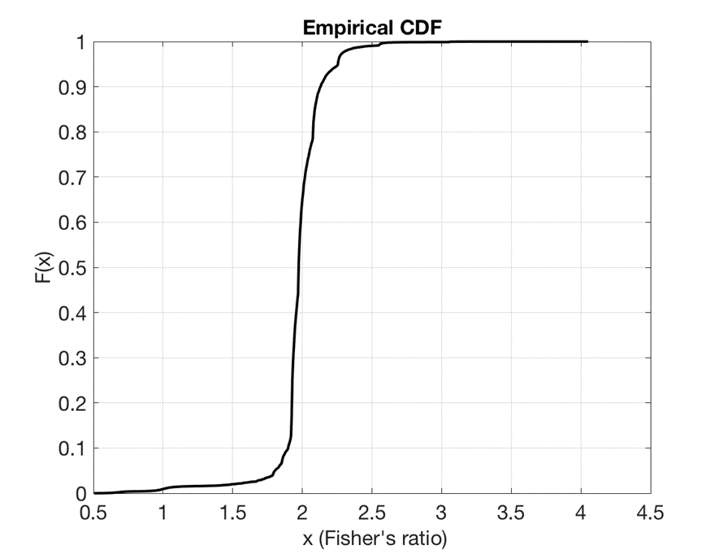
Figure S1: HOE Dataset. Cumulative probability distribution function (cdf) of the Fisher’s ratio in the set of discriminatory SNPs.

Table S1: HOE Dataset. List of the most discriminatory SNPs (C1: No CIPN; C2 CIPN). The minimum scale signature contains 30 SNPs to achieve 100% LOOCV accuracy.
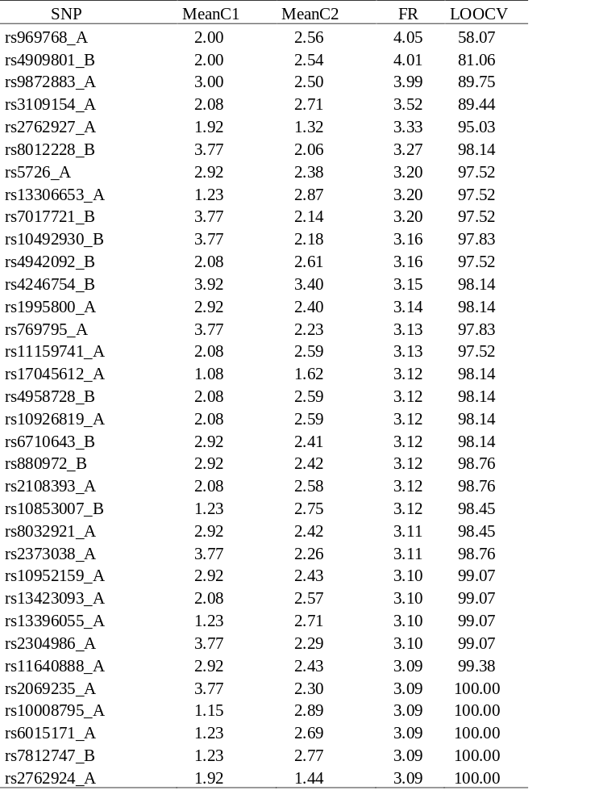

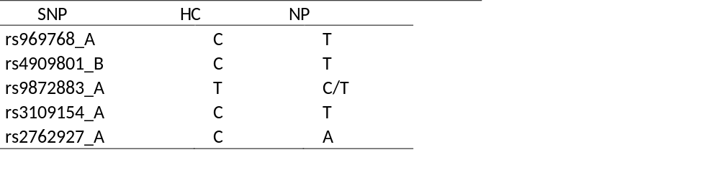
Table S2: Nucleotide substitutions in the five most discriminating SNPs.

Table S3: HOE Dataset. Most frequently samples SNPs with frequency > 49% (C1: No CIPN; C2 CIPN).
SNP | MeanC1 | MeanC2 | FR | Frequency
rs10492930_B | 3.77 | 2.18 | 3.16 | 50.76
rs11159741_A | 2.08 | 2.59 | 3.13 | 50.76
rs10926819_A | 2.08 | 2.59 | 3.12 | 50.76
rs10853007_B | 1.23 | 2.75 | 3.12 | 50.76
rs10952159_A | 2.92 | 2.43 | 3.10 | 50.76
rs11640888_A | 2.92 | 2.43 | 3.09 | 50.76
rs10008795_A | 1.15 | 2.89 | 3.09 | 50.76
rs10803066_B | 2.92 | 2.44 | 3.08 | 50.76
rs10247883_B | 3.77 | 2.34 | 3.08 | 50.76
rs10489637_A | 1.23 | 2.65 | 3.07 | 50.76
rs10048253_B | 2.08 | 2.61 | 2.99 | 50.76
rs1122109_A | 3.92 | 3.43 | 2.77 | 50.76
rs10220974_A | 2.85 | 2.33 | 2.75 | 50.76
rs10125252_B | 3.54 | 2.04 | 2.69 | 50.76
rs10877867_A | 1.46 | 2.90 | 2.66 | 50.76
rs11650988_A | 2.85 | 2.38 | 2.65 | 50.76
rs11003476_B | 1.23 | 1.75 | 2.64 | 50.76
rs10872455_B | 1.46 | 2.85 | 2.63 | 50.76
rs10754474_B | 3.54 | 2.20 | 2.62 | 50.76
rs10976050_A | 2.85 | 2.40 | 2.62 | 50.76
rs1040347_B | 3.15 | 3.59 | 2.61 | 50.76
rs10272334_A | 1.46 | 2.76 | 2.60 | 50.76
rs10952234_A | 2.23 | 2.74 | 2.60 | 50.76
rs1009671_A | 3.15 | 3.58 | 2.60 | 50.76
rs10945538_A | 2.15 | 2.57 | 2.58 | 50.76
rs1155974_A | 2.15 | 2.57 | 2.58 | 50.76
rs11085743_B | 1.46 | 2.71 | 2.58 | 50.76
rs11159273_B | 2.15 | 2.57 | 2.58 | 50.76
rs10001417_B | 3.54 | 2.30 | 2.58 | 50.76
rs10895277_B | 1.46 | 2.70 | 2.58 | 50.76
rs10068684_B | 2.69 | 2.19 | 2.58 | 50.76
rs10241261_B | 2.15 | 2.56 | 2.58 | 50.76
rs10791372_B | 3.15 | 3.56 | 2.58 | 50.76
rs10961346_B | 3.54 | 2.31 | 2.58 | 50.76
rs1152500_A | 1.46 | 2.69 | 2.58 | 50.76

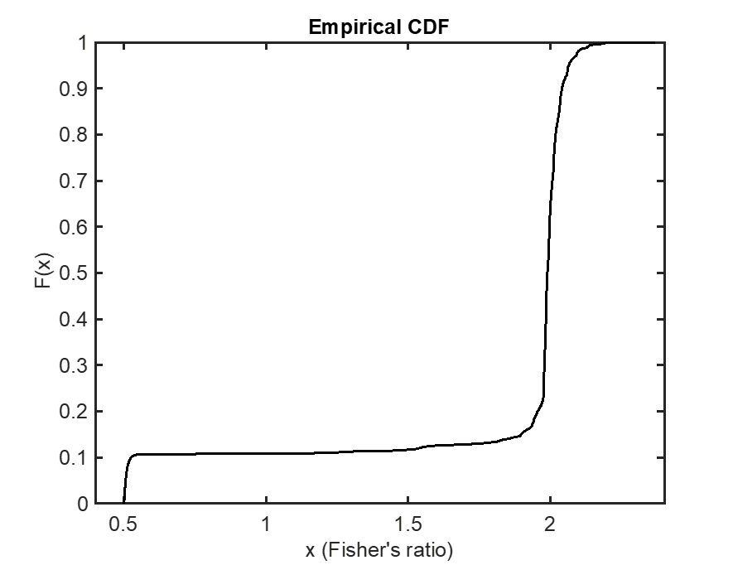
Figure S2: HOQ1: cdf (cumulative probability) of the Fisher’s ratio in the set of discriminatory P1 SNPs. The median, lower and upper quartiles are close to a FR=2.

Table S4: HOQ1 Dataset. List of the most discriminating SNPs (C1 no CIPN; C2 CIPN). The signature with the first 15 SNPs provides an LOOCV accuracy of 92.08%. The incremental gain with the addition of each SNP to the signature is small, but achieves an overall accuracy of 95.1% when the 96 most discriminatory SNPs are included. All the SNPs are in the allele A.
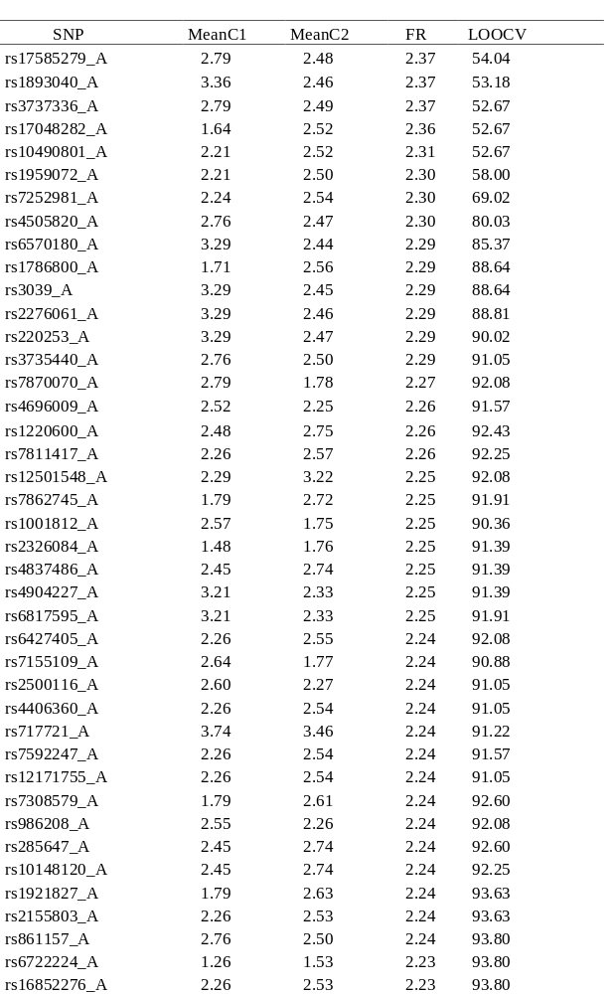
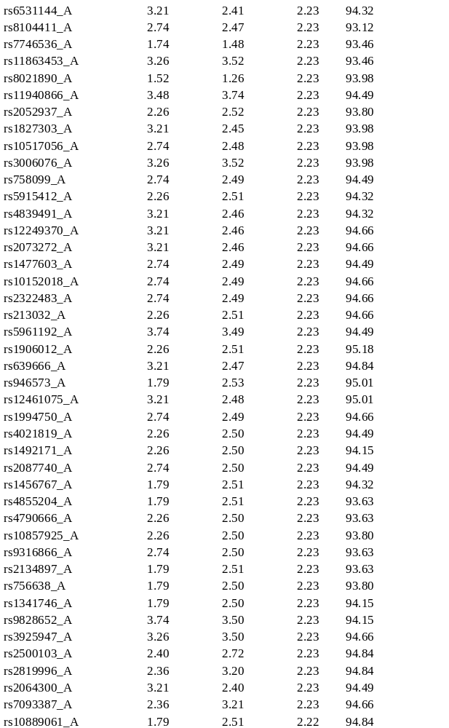

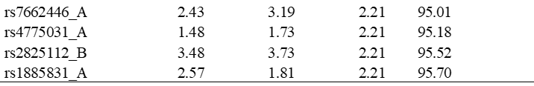

Table S5. List of the most frequently sampled SNPs in the HOQ1 dataset with a frequency > 3%.
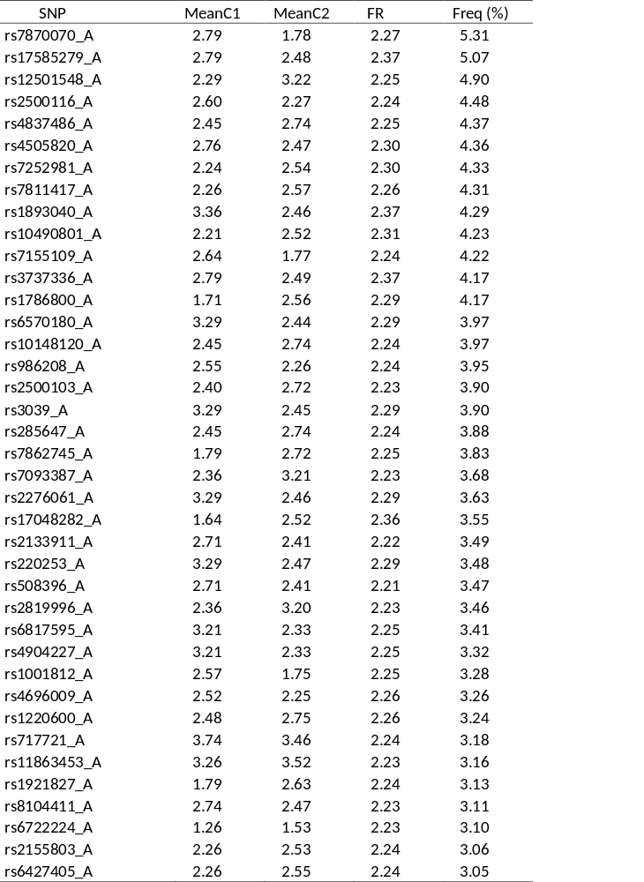

Table S6: List of the most discriminatory SNPs in the merged dataset. Incremental gains in accuracy are noted in the far right column. (C1 – no CIPN; C2 CIPN).
SNP | MeanC1 |  | MeanC2 |  | FR |  | Freq (%)
rs1000141_A |  | 2.69 |  | 1.98 |  | 2.13 |  | 66.78
rs10021207_A |  | 2.47 |  | 2.63 |  | 2.05 |  | 66.78
rs1003842_A |  | 2.64 |  | 2.48 |  | 2.06 |  | 66.78
rs10059285_A |  | 1.36 |  | 1.59 |  | 2.09 |  | 66.78
rs10097465_A |  | 1.58 |  | 1.40 |  | 2.05 |  | 68.88
rs10112358_A |  | 2.36 |  | 2.54 |  | 2.06 |  | 70.43
rs10115055_A |  | 2.64 |  | 2.49 |  | 2.06 |  | 80.62
rs10119678_A |  | 1.47 |  | 1.66 |  | 2.09 |  | 84.05
rs10122334_A |  | 2.53 |  | 2.09 |  | 2.06 |  | 85.60
rs10136547_A |  | 2.91 |  | 2.43 |  | 2.06 |  | 87.71
rs10141966_A |  | 2.51 |  | 2.33 |  | 2.08 |  | 88.70
rs10150720_A |  | 2.62 |  | 2.44 |  | 2.05 |  | 88.15
rs10163625_A |  | 1.36 |  | 1.50 |  | 2.06 |  | 87.49
rs10178369_A |  | 1.64 |  | 1.46 |  | 2.05 |  | 89.26
rs10187354_A |  | 3.51 |  | 3.35 |  | 2.08 |  | 89.92
rs1019153_A |  | 3.02 |  | 2.39 |  | 2.11 |  | 89.92
rs10198541_A |  | 2.65 |  | 2.47 |  | 2.05 |  | 89.81
rs10225065_A |  | 2.91 |  | 2.40 |  | 2.06 |  | 90.14
rs10228048_A |  | 3.35 |  | 3.53 |  | 2.09 |  | 90.37
rs1023025_A |  | 2.35 |  | 2.53 |  | 2.08 |  | 91.03
rs10232337_A |  | 1.64 |  | 1.46 |  | 2.07 |  | 91.47
rs10235144_A |  | 2.58 |  | 2.03 |  | 2.08 |  | 89.92
rs10261439_A |  | 2.20 |  | 2.94 |  | 2.11 |  | 89.59
rs10266867_A |  | 2.64 |  | 2.48 |  | 2.06 |  | 90.03
rs1031676_A |  | 2.53 |  | 2.03 |  | 2.08 |  | 90.03
rs1033975_A |  | 2.25 |  | 2.82 |  | 2.05 |  | 90.25
rs10428343_A |  | 3.29 |  | 3.56 |  | 2.12 |  | 90.59
rs10439973_A |  | 3.36 |  | 3.53 |  | 2.06 |  | 90.92
rs10474157_A |  | 2.53 |  | 2.36 |  | 2.07 |  | 91.14
rs10474543_A |  | 2.58 |  | 2.39 |  | 2.06 |  | 91.25
rs10484804_A |  | 2.60 |  | 2.41 |  | 2.06 |  | 91.92
rs10498633_A |  | 3.47 |  | 3.65 |  | 2.07 |  | 92.25
rs10499319_A |  | 2.36 |  | 2.51 |  | 2.06 |  | 91.25
rs10504551_A |  | 2.36 |  | 2.51 |  | 2.06 |  | 91.36
rs10509145_A |  | 2.53 |  | 2.05 |  | 2.07 |  | 91.47
rs10511205_A |  | 2.96 |  | 2.38 |  | 2.09 |  | 91.25
rs10519347_A |  | 2.36 |  | 2.52 |  | 2.06 |  | 92.25
rs1059778_A |  | 2.49 |  | 2.63 |  | 2.05 |  | 91.81
rs10734091_A |  | 2.62 |  | 2.44 |  | 2.06 |  | 91.81
rs10735794_A |  | 2.36 |  | 2.93 |  | 2.07 |  | 91.58
rs10738389_A |  | 2.15 |  | 2.69 |  | 2.05 |  | 92.47
rs10749134_A |  | 1.98 |  | 2.61 |  | 2.11 |  | 91.81
rs10758513_A |  | 2.44 |  | 2.63 |  | 2.07 |  | 92.03
rs10761507_A |  | 1.33 |  | 1.56 |  | 2.12 |  | 92.14
rs10784791_A |  | 2.53 |  | 1.99 |  | 2.10 |  | 92.03
rs10788615_A |  | 2.64 |  | 2.49 |  | 2.06 |  | 92.36
rs10799862_A |  | 2.64 |  | 2.48 |  | 2.06 |  | 92.03
rs10804401_A |  | 2.91 |  | 2.43 |  | 2.06 |  | 92.69
rs10806918_A |  | 3.60 |  | 3.41 |  | 2.05 |  | 93.13
rs10823243_A |  | 1.53 |  | 1.34 |  | 2.09 |  | 93.24
rs10826176_A |  | 2.91 |  | 2.42 |  | 2.05 |  | 93.47
rs10834385_A |  | 2.49 |  | 2.67 |  | 2.10 |  | 93.47
rs10836020_A |  | 2.65 |  | 2.48 |  | 2.05 |  | 93.24
rs10857618_A |  | 3.36 |  | 3.54 |  | 2.07 |  | 92.80
rs10857881_A |  | 3.02 |  | 2.43 |  | 2.11 |  | 91.81
rs10864910_A |  | 2.53 |  | 2.33 |  | 2.11 |  | 92.47
rs10880730_A |  | 2.58 |  | 2.00 |  | 2.10 |  | 92.69
rs10882267_A |  | 1.40 |  | 1.62 |  | 2.08 |  | 92.58
rs10893634_A |  | 2.09 |  | 2.67 |  | 2.07 |  | 92.14
rs10927083_A |  | 1.47 |  | 1.66 |  | 2.09 |  | 92.69
rs10934163_A |  | 2.91 |  | 2.35 |  | 2.05 |  | 92.80
rs10935336_A |  | 2.64 |  | 2.49 |  | 2.06 |  | 91.92
rs10945682_A |  | 2.53 |  | 2.10 |  | 2.05 |  | 92.80
rs10978078_A |  | 2.51 |  | 2.26 |  | 2.23 |  | 92.69
rs10982370_A |  | 2.53 |  | 2.04 |  | 2.07 |  | 92.80
rs11007851_A |  | 2.49 |  | 2.67 |  | 2.10 |  | 93.02
rs11020171_A |  | 1.36 |  | 1.54 |  | 2.05 |  | 93.24
rs11043499_A |  | 2.53 |  | 2.03 |  | 2.08 |  | 93.36
rs11066523_A |  | 2.35 |  | 2.52 |  | 2.08 |  | 93.24
rs11066591_A |  | 2.96 |  | 2.42 |  | 2.08 |  | 92.80
rs11072610_A |  | 1.69 |  | 1.48 |  | 2.14 |  | 92.91
rs11073015_A |  | 2.75 |  | 2.10 |  | 2.08 |  | 92.91
rs11079983_A |  | 2.31 |  | 2.52 |  | 2.14 |  | 93.13
rs11080007_A |  | 2.36 |  | 2.53 |  | 2.06 |  | 93.13
rs11112542_A |  | 2.25 |  | 2.85 |  | 2.06 |  | 93.13
rs11119426_A |  | 2.20 |  | 2.76 |  | 2.05 |  | 93.02
rs11149788_A |  | 2.64 |  | 2.45 |  | 2.07 |  | 92.91
rs11155530_A |  | 2.91 |  | 2.37 |  | 2.07 |  | 92.47
rs11159741_A |  | 2.35 |  | 2.58 |  | 2.11 |  | 92.80
rs11162463_A |  | 2.20 |  | 3.03 |  | 2.15 |  | 92.58
rs11178229_A |  | 2.42 |  | 2.94 |  | 2.07 |  | 92.47
rs11195188_A |  | 2.42 |  | 2.92 |  | 2.06 |  | 92.58
rs11202849_A |  | 2.09 |  | 2.65 |  | 2.06 |  | 92.58
rs11219821_A |  | 2.47 |  | 2.66 |  | 2.08 |  | 92.47
rs11238132_A |  | 2.96 |  | 2.40 |  | 2.08 |  | 92.58
rs11251294_A |  | 2.36 |  | 2.52 |  | 2.06 |  | 92.69
rs11251954_A |  | 2.09 |  | 2.51 |  | 2.06 |  | 93.91
rs11263806_A |  | 1.98 |  | 2.59 |  | 2.11 |  | 94.13
rs11593916_A |  | 2.09 |  | 2.58 |  | 2.06 |  | 94.02
rs11596260_A |  | 2.35 |  | 2.56 |  | 2.10 |  | 94.02
rs11604662_A |  | 2.15 |  | 2.67 |  | 2.05 |  | 93.69
rs11627891_A |  | 3.69 |  | 3.47 |  | 2.14 |  | 93.80
rs11634913_A |  | 2.53 |  | 2.10 |  | 2.05 |  | 93.69
rs11637817_A |  | 2.35 |  | 2.54 |  | 2.09 |  | 93.80
rs11640888_A |  | 2.65 |  | 2.43 |  | 2.10 |  | 93.80
rs11664621_A |  | 2.35 |  | 2.57 |  | 2.10 |  | 93.58
rs11669808_A |  | 2.65 |  | 2.46 |  | 2.09 |  | 93.58
rs11672660_A |  | 2.53 |  | 2.36 |  | 2.06 |  | 93.36
rs11678646_A |  | 2.64 |  | 2.48 |  | 2.06 |  | 93.58
rs11691815_A |  | 2.35 |  | 2.58 |  | 2.11 |  | 93.58
rs11709061_A |  | 2.38 |  | 2.56 |  | 2.05 |  | 93.58
rs11710870_A |  | 2.25 |  | 2.98 |  | 2.11 |  | 93.36
rs11721813_A |  | 2.67 |  | 2.48 |  | 2.08 |  | 93.58
rs11772758_A |  | 2.47 |  | 2.95 |  | 2.07 |  | 93.24
rs11805036_A |  | 2.42 |  | 3.03 |  | 2.11 |  | 94.13
rs1181775_A |  | 2.15 |  | 2.71 |  | 2.06 |  | 94.13
rs11851004_A |  | 2.65 |  | 2.48 |  | 2.05 |  | 94.02
rs11880298_A |  | 2.58 |  | 1.79 |  | 2.23 |  | 94.02
rs11907737_A |  | 2.69 |  | 2.00 |  | 2.11 |  | 93.80
rs11968290_A |  | 1.93 |  | 2.56 |  | 2.14 |  | 94.13
rs12082061_A |  | 2.64 |  | 2.47 |  | 2.06 |  | 94.35
rs12119876_A |  | 1.47 |  | 1.67 |  | 2.07 |  | 94.46
rs12131032_A |  | 1.56 |  | 1.38 |  | 2.06 |  | 94.02
rs12149317_A |  | 1.38 |  | 1.56 |  | 2.05 |  | 94.02
rs1216481_A |  | 2.56 |  | 2.38 |  | 2.06 |  | 93.91
rs12193635_A |  | 3.36 |  | 3.51 |  | 2.06 |  | 93.69
rs12215647_A |  | 1.93 |  | 2.62 |  | 2.15 |  | 93.24
rs12254876_A |  | 2.64 |  | 2.11 |  | 2.06 |  | 93.69
rs12357206_A |  | 2.64 |  | 2.09 |  | 2.07 |  | 93.36
rs12373744_A |  | 3.47 |  | 3.66 |  | 2.09 |  | 93.47
rs12377344_A |  | 2.65 |  | 2.48 |  | 2.08 |  | 93.69
rs12420868_A |  | 2.55 |  | 2.35 |  | 2.08 |  | 94.02
rs12429505_A |  | 2.67 |  | 2.49 |  | 2.11 |  | 94.02
rs12441544_A |  | 1.93 |  | 2.64 |  | 2.15 |  | 93.47
rs12452084_A |  | 2.38 |  | 2.56 |  | 2.05 |  | 93.47
rs12479_A |  | 2.09 |  | 2.77 |  | 2.09 |  | 93.36
rs12525228_A |  | 2.56 |  | 2.34 |  | 2.11 |  | 93.24
rs12537364_A |  | 2.62 |  | 2.40 |  | 2.08 |  | 93.36
rs12542460_A |  | 2.58 |  | 1.96 |  | 2.12 |  | 93.69
rs12545322_A |  | 2.04 |  | 2.63 |  | 2.09 |  | 93.58
rs12557877_A |  | 2.35 |  | 2.54 |  | 2.06 |  | 93.69
rs1257273_A |  | 2.56 |  | 2.38 |  | 2.06 |  | 93.36
rs12589478_A |  | 2.20 |  | 2.84 |  | 2.07 |  | 93.91
rs12598602_A |  | 2.36 |  | 2.53 |  | 2.06 |  | 93.69
rs12612219_A |  | 3.45 |  | 3.65 |  | 2.08 |  | 93.69
rs12631841_A |  | 2.53 |  | 2.35 |  | 2.08 |  | 93.80
rs12640588_A |  | 2.36 |  | 2.55 |  | 2.07 |  | 93.91
rs12641839_A |  | 2.51 |  | 2.31 |  | 2.10 |  | 94.13
rs12644269_A |  | 2.45 |  | 2.63 |  | 2.05 |  | 94.02
rs12678799_A |  | 2.58 |  | 2.35 |  | 2.11 |  | 94.46
rs12681574_A |  | 2.53 |  | 2.36 |  | 2.06 |  | 94.46
rs12731636_A |  | 3.58 |  | 3.39 |  | 2.06 |  | 94.24
rs1275161_A |  | 2.91 |  | 2.43 |  | 2.06 |  | 93.47
rs12758891_A |  | 2.91 |  | 2.43 |  | 2.06 |  | 93.47
rs12778761_A |  | 3.49 |  | 3.63 |  | 2.05 |  | 93.36
rs12786825_A |  | 2.64 |  | 2.12 |  | 2.05 |  | 93.36
rs12832515_A |  | 1.98 |  | 2.54 |  | 2.11 |  | 93.69
rs12876742_A |  | 1.38 |  | 1.56 |  | 2.05 |  | 93.69
rs12894377_A |  | 2.64 |  | 2.13 |  | 2.05 |  | 93.36
rs12896969_A |  | 2.36 |  | 2.52 |  | 2.06 |  | 93.24
rs12904751_A |  | 3.35 |  | 3.51 |  | 2.08 |  | 93.13
rs12917822_A |  | 2.04 |  | 2.57 |  | 2.08 |  | 94.13
rs12926696_A |  | 2.75 |  | 2.12 |  | 2.08 |  | 93.91
rs12936834_A |  | 2.09 |  | 2.77 |  | 2.09 |  | 93.80
rs12985603_A |  | 2.45 |  | 2.62 |  | 2.05 |  | 93.58
rs13006698_A |  | 3.47 |  | 3.70 |  | 2.09 |  | 93.58
rs13011842_A |  | 2.53 |  | 2.36 |  | 2.07 |  | 93.58
rs13069443_A |  | 2.36 |  | 2.54 |  | 2.06 |  | 93.69
rs13097605_A |  | 2.65 |  | 2.47 |  | 2.09 |  | 93.80
rs13118630_A |  | 2.20 |  | 2.79 |  | 2.06 |  | 94.24
rs13133342_A |  | 2.91 |  | 2.46 |  | 2.06 |  | 93.69
rs13141291_A |  | 2.47 |  | 2.64 |  | 2.06 |  | 93.69
rs1316479_A |  | 2.51 |  | 2.29 |  | 2.18 |  | 94.02
rs131715_A |  | 2.36 |  | 2.60 |  | 2.10 |  | 93.80
rs13208297_A |  | 2.04 |  | 2.59 |  | 2.08 |  | 94.24
rs13216090_A |  | 3.35 |  | 3.60 |  | 2.12 |  | 94.13
rs13220178_A |  | 2.96 |  | 2.44 |  | 2.08 |  | 94.35
rs1323881_A |  | 1.98 |  | 2.54 |  | 2.11 |  | 94.35
rs13257428_A |  | 2.96 |  | 2.48 |  | 2.07 |  | 93.91
rs1328452_A |  | 2.60 |  | 2.32 |  | 2.16 |  | 93.91
rs1333217_A |  | 2.62 |  | 2.44 |  | 2.05 |  | 93.91
rs1333914_A |  | 1.60 |  | 1.41 |  | 2.05 |  | 94.02
rs13394706_A |  | 2.55 |  | 2.35 |  | 2.08 |  | 94.02
rs1341416_A |  | 2.60 |  | 2.41 |  | 2.05 |  | 94.02
rs1343900_A |  | 2.65 |  | 2.45 |  | 2.09 |  | 94.02
rs1354365_A |  | 2.58 |  | 2.01 |  | 2.09 |  | 94.57
rs1355255_A |  | 2.15 |  | 2.77 |  | 2.07 |  | 94.35
rs1367211_A |  | 3.02 |  | 2.42 |  | 2.11 |  | 94.13
rs138170_A |  | 2.36 |  | 3.01 |  | 2.11 |  | 94.13
rs139778_A |  | 1.62 |  | 1.44 |  | 2.05 |  | 94.13
rs1413005_A |  | 3.36 |  | 3.51 |  | 2.06 |  | 94.24
rs1416560_A |  | 2.36 |  | 2.53 |  | 2.06 |  | 93.91
rs1419956_A |  | 2.85 |  | 2.29 |  | 2.06 |  | 94.13
rs144173_A |  | 2.47 |  | 2.64 |  | 2.06 |  | 94.13
rs1470121_A |  | 3.02 |  | 2.41 |  | 2.11 |  | 94.57
rs1493101_A |  | 2.36 |  | 2.87 |  | 2.05 |  | 94.80
rs1495003_A |  | 2.85 |  | 2.28 |  | 2.06 |  | 94.91
rs1495042_A |  | 2.42 |  | 2.62 |  | 2.07 |  | 94.91
rs1509339_A |  | 2.85 |  | 2.29 |  | 2.06 |  | 94.57
rs1520934_A |  | 2.51 |  | 2.29 |  | 2.16 |  | 94.35
rs1533366_A |  | 3.65 |  | 3.48 |  | 2.08 |  | 94.91
rs1537626_A |  | 2.58 |  | 2.38 |  | 2.06 |  | 94.57
rs1543083_A |  | 1.55 |  | 1.37 |  | 2.06 |  | 94.57
rs1545632_A |  | 2.36 |  | 2.98 |  | 2.10 |  | 94.02
rs1547402_A |  | 2.33 |  | 2.54 |  | 2.08 |  | 94.02
rs1552186_A |  | 1.51 |  | 1.29 |  | 2.18 |  | 93.91
rs1554131_A |  | 1.44 |  | 1.62 |  | 2.05 |  | 94.24
rs1555906_A |  | 2.04 |  | 2.55 |  | 2.08 |  | 94.13
rs1556879_A |  | 2.96 |  | 2.40 |  | 2.09 |  | 94.35
rs1563005_A |  | 2.53 |  | 2.36 |  | 2.07 |  | 94.46
rs1565650_A |  | 1.45 |  | 1.64 |  | 2.07 |  | 94.46
rs156969_A |  | 1.64 |  | 1.44 |  | 2.06 |  | 94.24
rs1577635_A |  | 2.53 |  | 1.94 |  | 2.13 |  | 94.80
rs1592968_A |  | 2.85 |  | 2.32 |  | 2.05 |  | 94.80
rs1596659_A |  | 1.98 |  | 2.60 |  | 2.11 |  | 94.57
rs15993_A |  | 2.53 |  | 2.36 |  | 2.06 |  | 94.46
rs1620111_A |  | 2.42 |  | 2.62 |  | 2.07 |  | 94.68
rs1668839_A |  | 2.96 |  | 2.45 |  | 2.08 |  | 94.68
rs167461_A |  | 2.55 |  | 2.38 |  | 2.05 |  | 94.68
rs1678622_A |  | 2.49 |  | 2.65 |  | 2.07 |  | 94.80
rs1679029_A |  | 2.85 |  | 2.28 |  | 2.06 |  | 94.57
rs1680083_A |  | 2.96 |  | 2.38 |  | 2.09 |  | 94.91
rs16827937_A |  | 3.02 |  | 2.35 |  | 2.12 |  | 94.80
rs16829656_A |  | 2.47 |  | 3.04 |  | 2.12 |  | 94.80
rs16859250_A |  | 3.38 |  | 3.59 |  | 2.07 |  | 94.68
rs16871149_A |  | 2.64 |  | 2.45 |  | 2.07 |  | 94.80
rs16912792_A |  | 2.80 |  | 2.20 |  | 2.06 |  | 94.80
rs16921295_A |  | 2.09 |  | 2.63 |  | 2.07 |  | 94.57
rs1697143_A |  | 1.47 |  | 1.63 |  | 2.05 |  | 94.57
rs16984496_A |  | 2.15 |  | 2.76 |  | 2.07 |  | 94.35
rs17013665_A |  | 2.33 |  | 2.51 |  | 2.11 |  | 94.35
rs17015701_A |  | 2.04 |  | 2.59 |  | 2.08 |  | 94.46
rs17060351_A |  | 2.09 |  | 2.65 |  | 2.07 |  | 94.57
rs17113829_A |  | 2.47 |  | 2.95 |  | 2.07 |  | 94.46
rs17132286_A |  | 2.42 |  | 2.89 |  | 2.05 |  | 94.80
rs17148121_A |  | 2.51 |  | 2.32 |  | 2.12 |  | 94.80
rs17347156_A |  | 2.91 |  | 2.43 |  | 2.06 |  | 94.91
rs17411983_A |  | 2.91 |  | 2.39 |  | 2.06 |  | 95.35
rs174414_A |  | 2.69 |  | 2.09 |  | 2.08 |  | 94.91
rs17442753_A |  | 2.42 |  | 2.91 |  | 2.06 |  | 94.80
rs17446744_A |  | 2.96 |  | 2.32 |  | 2.10 |  | 94.80
rs17514650_A |  | 2.64 |  | 2.44 |  | 2.08 |  | 95.24
rs17617904_A |  | 2.56 |  | 2.33 |  | 2.08 |  | 95.24
rs17633749_A |  | 3.02 |  | 2.32 |  | 2.12 |  | 95.35
rs17669929_A |  | 2.36 |  | 2.56 |  | 2.07 |  | 95.57
rs17807525_A |  | 2.36 |  | 2.52 |  | 2.06 |  | 95.57
rs1788656_A |  | 2.62 |  | 2.39 |  | 2.09 |  | 95.57
rs1792738_A |  | 2.67 |  | 2.49 |  | 2.11 |  | 95.57
rs1793426_A |  | 1.98 |  | 2.52 |  | 2.11 |  | 95.46
rs1799025_A |  | 2.91 |  | 2.44 |  | 2.05 |  | 95.79
rs1810839_A |  | 2.53 |  | 2.32 |  | 2.08 |  | 95.79
rs1826712_A |  | 2.36 |  | 2.89 |  | 2.06 |  | 95.57
rs1856784_A |  | 2.53 |  | 2.35 |  | 2.07 |  | 95.79
rs1862499_A |  | 2.53 |  | 1.95 |  | 2.12 |  | 95.79
rs1869641_A |  | 2.75 |  | 2.14 |  | 2.07 |  | 95.68
rs1873530_A |  | 2.51 |  | 2.36 |  | 2.07 |  | 95.68
rs1882328_A |  | 2.44 |  | 2.62 |  | 2.05 |  | 95.68
rs1882345_A |  | 2.91 |  | 2.43 |  | 2.06 |  | 95.68
rs1890627_A |  | 2.40 |  | 2.58 |  | 2.05 |  | 95.57
rs1891659_A |  | 1.98 |  | 2.55 |  | 2.11 |  | 95.57
rs1893650_A |  | 2.31 |  | 2.56 |  | 2.15 |  | 95.46
rs1918690_A |  | 2.64 |  | 2.45 |  | 2.07 |  | 95.46
rs1951966_A |  | 2.36 |  | 3.04 |  | 2.13 |  | 95.90
rs1958431_A |  | 2.42 |  | 2.95 |  | 2.08 |  | 95.90
rs195852_A |  | 2.36 |  | 2.58 |  | 2.09 |  | 96.01
rs1958601_A |  | 2.33 |  | 2.57 |  | 2.10 |  | 96.01
rs196583_A |  | 2.60 |  | 2.39 |  | 2.07 |  | 95.90
rs1984791_A |  | 2.69 |  | 2.47 |  | 2.14 |  | 96.01
rs1995065_A |  | 2.80 |  | 2.23 |  | 2.05 |  | 95.90
rs2000697_A |  | 1.53 |  | 1.36 |  | 2.06 |  | 95.90
rs2010511_A |  | 2.38 |  | 2.56 |  | 2.05 |  | 95.68
rs2021852_A |  | 2.15 |  | 2.68 |  | 2.05 |  | 95.68
rs2041861_A |  | 2.60 |  | 2.36 |  | 2.07 |  | 95.79
rs2042752_A |  | 2.91 |  | 2.50 |  | 2.06 |  | 96.01
rs2043071_A |  | 2.91 |  | 2.37 |  | 2.07 |  | 96.01
rs2056367_A |  | 2.38 |  | 2.56 |  | 2.05 |  | 96.12

