 | Isolates from Farm 1
Antibiotics | Vibrio alginolyticus | V. cholerae | V. mimicus | V.fluvialis | Shewanella algae
 | Minimum inhibitory concentration of resistant antibiotics (mcg/ml)
Ampicillin (0.016-256mcg/ml) | >256 | >256 | >256 | >256 | >256
Amoxicillin (0.016-256mcg/ml) | >256
Amoxicillin clavulanic acid (0.016-256mcg/ml) |  |  |  | >256
Azithromycin (0.016-256mcg/ml) | >256
Aztreonam (0.016-256mcg/ml) | >256 |  | >256 | >256
Cefipime  (0.016-256mcg/ml) | >256 |  | >256
Cefixime/Clavulanic acid (0.016-256mcg/ml) | >256 |  | >256 | >256 | >256
Cefoperazone (0.016-256mcg/ml) | >256 | >256 | >256 | >256
Cefotaxime (0.016-256mcg/ml) | >256 |  | >256 | >256
Cefoxitin (0.016-256mcg/ml) | >256
Ceftriaxone (0.016-256mcg/ml) | >256 |  | >256 | >256 | >256
Ceftazidime  (0.016-256mcg/ml) | >256 | >256 | >256 | >256
Cefuroxime (0.016-256mcg/ml) | >256 | >256 | >256 |  | >256
Cephalothin (0.016-256mcg/ml) | >256 |  |  | >256 | >256
Chloramphenicol (0.016-256mcg/ml) |  | >256 | >256 | >256 | >256
Co-trimoxazole (0.016-256mcg/ml) | >256 |  |  |  | >256
Doripenem(0.002-32mcg/ml) |  | >32 |  | >32
Enrofloxacin (0.002-32mcg/ml) | >32 | >32 |  |  | >32
Gentamycin (0.064-1024mcg/ml) |  | >1024 | >256
Imipenem (0.002-32mcg/ml) |  |  | >32
Levofloxacin (0.016-256mcg/ml) | >256 |  |  | >256
Norfloxacin (0.016-256mcg/ml) | >256 |  |  |  | >256
Nitrofurantoin (0.032-512 mcg/ml) | >512 |  | >512
Piperacillin (0.016-256mcg/ml) | >256 |  | >256 | >256 | >256
Polymyxin (0.016-256mcg/ml) | >256 |  | >256
Rifampicin (0.002-32mcg/ml) |  |  | >32 | >32
Streptomycin (0.016-256mcg/ml) |  |  | >256 |  | >256
Tetracycline (0.016-256mcg/ml) | >256 | >256 | >256 | >256 | >256
Vancomycin (0.016-256mcg/ml) |  |  | >256
Table.1. Minimum inhibitory concentration (MIC) of antibiotics for resistant shrimp isolates from farm1.
 | Isolates from Farm 2
Antibiotics | Vibrio parahaemolyticus | Vibrio cholerae | Aeromonas hydrophila | A.salmonicida | Citrobacter freundii | Shewanella algae
 | Minimum inhibitory concentration of resistant antibiotics (mcg/ml)
Amikacin (0.016-256mcg/ml) |  | >256 |  | >256
Amoxicillin (0.016-256mcg/ml) |  | >256 |  | >256
Ampicillin (0.016-256mcg/ml) | >256 | >256 | >256 | >256 | >256 | >256
Azithromycin (0.016-256mcg/ml) | >256 |  |  | >256
Aztreonam (0.016-256mcg/ml) | >256 |  |  |  | >256 | >256
Cefazolin (0.016-256mcg/ml) | >256
Cefipime  (0.016-256mcg/ml) | >256 |  |  |  | >256
Cefixime/Clavulanic acid (0.016-256mcg/ml) |  | >256 |  |  | >256
Cefoperazone (0.016-256mcg/ml) | >256 |  |  |  | >256
Cefotaxime (0.016-256mcg/ml) | >256
Cefoxitin (0.016-256mcg/ml) |  |  | >256 |  | >256
Ceftazidime  (0.016-256mcg/ml) | >256 |  | >256 |  | >256
Cefuroxime (0.016-256mcg/ml) |  |  | >256 | >256 | >256 | >256
Ceftriaxone (0.016-256mcg/ml) | >256 |  |  |  | >256
Cephalothin (0.016-256mcg/ml) |  | >256 | >256
Chloramphenicol (0.016-256mcg/ml) |  | >256 | >256 | >256 |  | >256
Co-trimoxazole (0.016-256mcg/ml) | >256 |  |  | >256 |  | >256
Doripenem(0.002-32mcg/ml) |  | >32 | >32 | >32
Gentamycin (0.064-1024mcg/ml) |  | >1024 |  |  |  | >1024
Imipenem (0.002-32mcg/ml) |  | >32
Meropenem (0.002-32mcg/ml) |  |  |  | >32
Nitrofurantoin (0.032-512 mcg/ml) | >512 |  |  |  | >512
Polymyxin (0.016-256mcg/ml) | >256 |  |  |  | >256
Piperacillin (0.016-256mcg/ml) |  |  | >256
Rifampicin (0.002-32mcg/ml) | >32 |  | >32 |  |  | >32
Streptomycin (0.016-256mcg/ml) |  | >256 | >256 |  | >256 | >256
Tetracycline (0.016-256mcg/ml) | >256 | >256 | >256 | >256 | >256 | >256
Tobramycin (0.016-256mcg/ml) | >256 | >256
Table.2. Minimum inhibitory concentration (MIC) of antibiotics for resistant shrimp isolates from farm 2
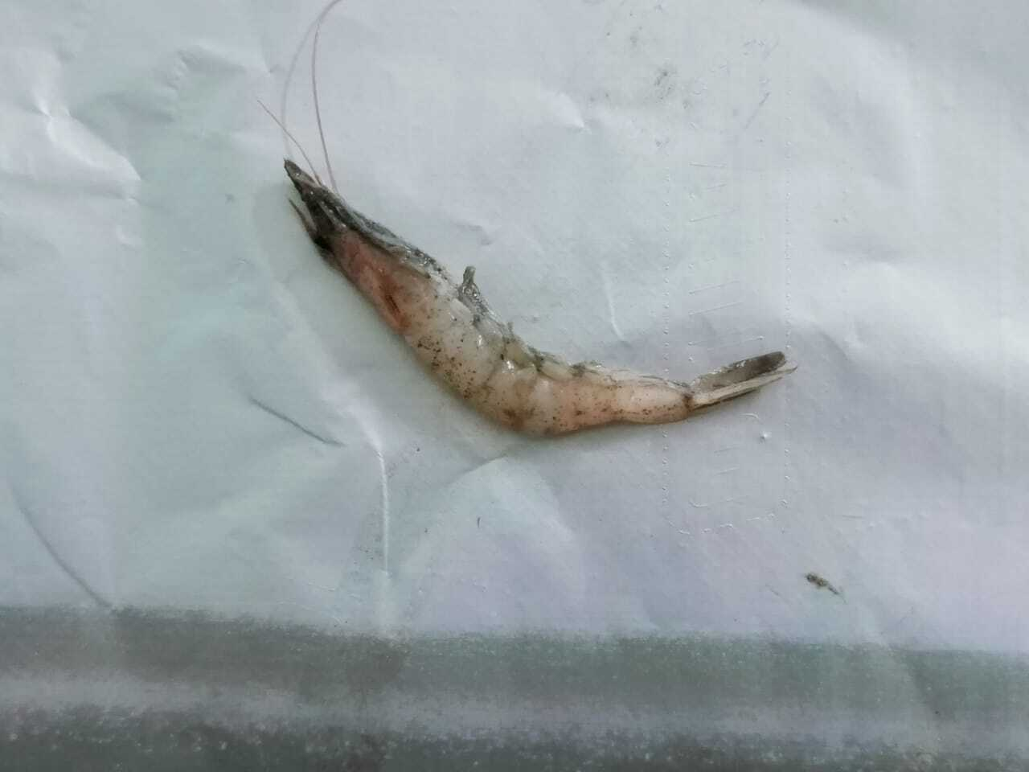
ESM Fig.1 Infected shrimp showing clinical signs.

ESM Fig.2. Dendrogram of shrimp isolates from farm 1 based on biochemical tests constructed using NtSys software

ESM Fig.3 Dendrogram of shrimp isolates from farm 2 based on biochemical tests constructed using NtSys software

