Supporting information

Titanium (IV) μ-Oxo Complex Supported by Phenoxyimine Ligand: Synthesis, Crystal Structure Characterization, DFT and Molecular Docking Studies

Vinodkumar P. Sajjan (0000-0001-8339-0072),ª Prabhuodeyara M Gurubasavaraj(0000-0002-5281-129X),^{a *} Vikram Pujari(0000-0001-6548-5748),^{b} Sanjeev R Inamdar(0000-0003-3398-4897),^{b} and Nobendu Mukerjee(0000-0002-7129-7003)^{c}
ªDepartment of chemistry, Rani Channamma University, Vidyasangama, PBNH-4, Belagavi, Karnataka, 591156, India.
^{b}Laser Spectroscopy Programme, Department of Physics, Karnatak University Dharwad, Dharwad, Karnataka, 580003, India.
.
^{c}Department of Microbiology, Ramakrishna Mission Vivekananda Centenary College, Kolkata, West Bengal, 700118, India.
Corresponding address: Prabhuodeyara M Gurubasavaraj (pmg@rcub.ac.in)

Content:
Experimental Section
Figure S1: ¹H NMR Spectra of ligand La.
Figure S2: Molecular structure of complex [Ti{La}] and its asymmetric unit. thermal ellipsoid plot, hydrogen atoms have been omitted for clarity.
Table S1: Crystal data for complex [Ti{La}].
Figure S3: Perspective view of packing of complex [Ti{La}].
Figure S4: DFT Optimized structure of Complex[Ti{La}].
Table S2: Selected bond length of the complex [Ti{La}].
Table S3: Selected bond angle of the complex [Ti{La}].
Experimental Section:
- Synthesis of 2-(((2,6-diisopropylphenyl)imino)methyl)-6-methylphenol (La).
A solution of 2,6-diisopropylaniline (1.7 g, 10 mmol) in ethanol (40 mL) was prepared, and to it was added 2 hydroxy,3-dimethylbenzaldehyde (1.34g, 10 mmol). TLC was employed to monitor the reactions progress. It was carried out at room temperature using a conventional TLC plate. A 8:2 combination of the solvents N-hexane and methanol was utilized. The resultant mixture was refluxed for 18 h with stirring. The resultant solution was concentrated under vacuum to 50 mL and stored at −20 °C for a night to give a yellow crystal. Yield: 0.234g, 79%. FT-IR data, (υ_{max} cm⁻¹ KBr pellet): 3446 υ(OH), 1619 υ(C=N), 1081 υ(C-N), 1269 υ(C-O), 1553, 1464, 1407 υ(C=C). ¹H-NMR (400 MHz, CHLOROFORM-D) δ 11.43 (s, 1H, OH), 9.89 (s, 1H, C=N), 7.47-6.77(m, 6H Ar-H), 3.36-3.50 (m, 2H, CH(CH₃)₂), 2.41 (m, 3H, CH₃), 1.31 (m, 12H, (CH₃)₄). Elemental Analysis for C₂₀H₂₅NO: Cacld: C 81.31; H 8.53; N 4.74. Found: C 80.98; H 8.43; N 4.71.
- Complex preparation [Ti{La}].
A solution of La (0.228 g, 1.00 mmol) and titanium butoxide (0.394 g, 1.00 mmol) were dissolved separately in toluene (15 mL and 15mL, respectively), and cooled to -30 °C. The solutions were then mixed and allowed to stir for 12 hours turning to pale yellow. The resulting solution was removed under vacuum and the crude product was washed with n-hexane, to give a pale-yellow powder. Yield: 0.526g, 84%. ¹H-NMR (400 MHz, CDCl₃): δ 8.88 (s, 1H, HC=N), δ 6.67-7.18 (m, 25H), 4.92 (s, 1H), 4.30 (s, 1H), 3.56 (d, J = 6.6 Hz, 1H), 1.93-2.56 (m, 30H), 1.35-1.49 (m, 21H), 0.78-1.01 (m, 5H). Elemental Analysis for C₈₀H₉₆N₄O₆Ti₂: Cacld: C 73.61; H 7.41; N 4.29. Found: C 73.48; H 7.39; N 4.21.
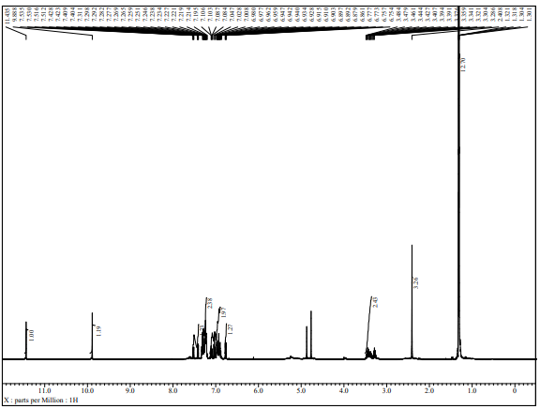
Figure S1: ¹H NMR Spectra of ligand La.
Figure S2: Molecular structure of complex [Ti{La}] and its asymmetric unit. thermal ellipsoid plot, hydrogen atoms have been omitted for clarity.
Table S1: Crystal data for complex [Ti{La}].
Empirical formula | C₈₀ H₉₆ N₄ O₆ Ti₂
Formula weight | 1305.46
Temperature | 100(2) K
Color | yellow
Wavelength (Å) | 1.54178
Crystal System | monoclinic
Space group | C 1 2/c 1
a [Å] | 19.939 (3)
b [Å] | 17.808 (2)
c [Å] | 23.871 (3)
α [deg] | 90.00
β [deg] | 103.795(3)
γ [deg] | 90.00
V [Å³] | 8231.3 (17)
Z | 4
Density (calculated) Mg m⁻³ | 1.053
Absorption coefficient (mm⁻¹) | 0.242
F (000) | 2784.00
θ range for data collection (deg) | 3.04 to 24.32
Index ranges | -23 ≤ h ≤ 23, -20 ≤ k ≤ 20, -27 ≤ l ≤25
No. of reflections collected / unique | Total: 30111 Unique: 2966 (Rint = 0.2034)
Goodness-of-fit on F² | 1.024
Final R indices (I > 2σ(I)) | R1 = 0.1081, wR2 = 0.2697
R indices (all data) | R1 = 0.2181, wR2 = 0.3252
Largest diff peak / hole [e Å⁻³] | -0.331/ +0.389

Figure S3: Perspective view of packing of complex [Ti{La}].
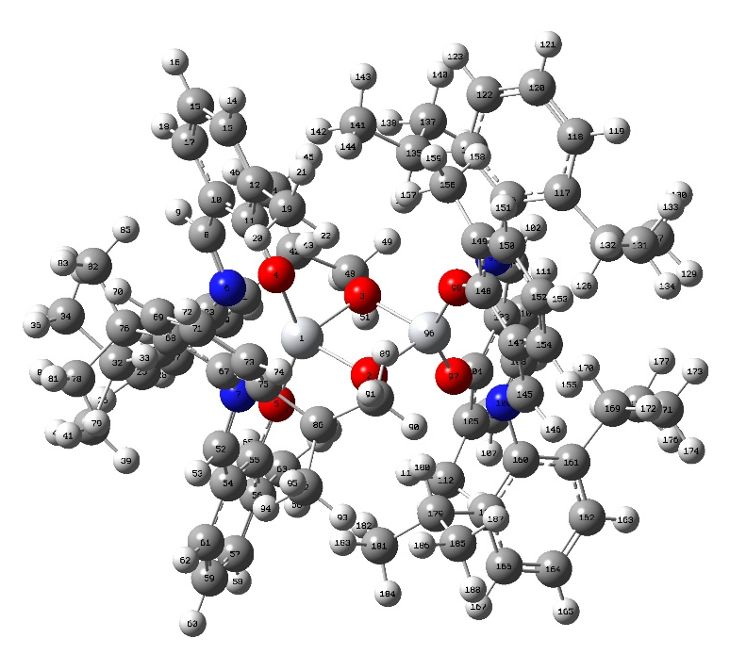
Figure S4: DFT Optimized structure of Complex [Ti{La}].

Table S2: Bond length of the complex[Ti{La}].
Ti1 O2 1.853(4)
Ti1 O1 1.857(4)
Ti1 O3 1.881(5)
Ti1 O4 1.896(5)
Ti1 N1 2.373(6)
Ti1 N2 2.391(6)
Ti1 Ti1 2.786(3)
O1 Ti1 1.857(4)
O2 Ti1 1.853(4)
O3 C3 1.341(8)
O4 C23 1.319(9)
N1 C1 1.306(9)
N1 C9 1.465(9)
N2 C21 1.272(9)
N2 C29 1.471(9)
C1 C2 1.455(11)
C1 H1 0.9500
C2 C3 1.379(10)
C2 C7 1.409(10)
C3 C4 1.401(10)
C4 C5 1.348(10)
C4 C8 1.499(10)
C5 C6 1.401(11)
C5 H5 0.9500
C6 C7 1.354(11)
C6 H6 0.9500
C7 H7 0.9500
C8 H8A 0.9800
C8 H8B 0.9800
C8 H8C 0.9800
C9 C14 1.392(10)
C9 C10 1.426(10)
C10 C11 1.377(11)
C10 C15 1.509(11)
C11 C12 1.424(12)
C11 H11 0.9500
C12 C13 1.371(11)
C12 H12 0.9500
C13 C14 1.363(10)
C13 H13 0.9500
C14 C18 1.521(11)
C15 C17 1.528(11)
C15 C16 1.563(10)
C15 H15 1.0000
C16 H16A 0.9800
C16 H16B 0.9800
C16 H16C 0.9800
C17 H17A 0.9800
C17 H17B 0.9800
C17 H17C 0.9800
C18 C20 1.524(11)
C18 C19 1.552(11)
C18 H18 1.0000
C19 H19A 0.9800
C19 H19B 0.9800
C19 H19C 0.9800
C20 H20A 0.9800
C20 H20B 0.9800
C20 H20C 0.9800
C21 C22 1.439(10)
C21 H21 0.9500
C22 C23 1.404(10)
C22 C27 1.451(11)
C23 C24 1.393(11)
C24 C25 1.383(11)
C24 C28 1.492(10)
C25 C26 1.366(11)
C25 H25 0.9500
C26 C27 1.362(11)
C26 H26 0.9500
C27 H27 0.9500
C28 H28A 0.9800
C28 H28B 0.9800
C28 H28C 0.9800
C29 C34 1.397(10)
C29 C30 1.406(10)
C30 C31 1.411(11)
C30 C35 1.494(10)
C31 C32 1.401(11)
C31 H31 0.9500
C32 C33 1.378(11)
C32 H32 0.9500
C33 C34 1.393(11)
C33 H33 0.9500
C34 C38 1.552(11)
C35 C37 1.539(11)
C35 C36 1.549(11)
C35 H35 1.0000
C36 H36A 0.9800
C36 H36B 0.9800
C36 H36C 0.9800
C37 H37A 0.9800
C37 H37B 0.9800
C37 H37C 0.9800
C38 C39 1.472(11)
C38 C40 1.543(11)

Table S3: Selected bond angle of the complex [Ti{La}].

O2 Ti1 O1 82.7(2)
O2 Ti1 O3 97.56(17)
O1 Ti1 O3 106.06(16)
O2 Ti1 O4 108.27(17)
O1 Ti1 O4 99.12(17)
O3 Ti1 O4 145.9(2)
O2 Ti1 N1 87.7(2)
O1 Ti1 N1 168.8(2)
O3 Ti1 N1 80.8(2)
O4 Ti1 N1 78.4(2)
O2 Ti1 N2 168.0(2)
O1 Ti1 N2 87.6(2)
O3 Ti1 N2 78.4(2)
O4 Ti1 N2 80.1(2)
N1 Ti1 N2 102.6(2)
O2 Ti1 Ti1 41.26(14)
O1 Ti1 Ti1 41.42(15)
O3 Ti1 Ti1 105.76(17)
O4 Ti1 Ti1 108.33(17)
N1 Ti1 Ti1 128.72(14)
N2 Ti1 Ti1 128.66(14)
Ti1 O1 Ti1 97.2(3)
Ti1 O2 Ti1 97.5(3)
C3 O3 Ti1 143.4(5)
C23 O4 Ti1 143.3(5)
C1 N1 C9 113.9(7)
C1 N1 Ti1 121.4(5)
C9 N1 Ti1 124.2(5)
C21 N2 C29 114.5(6)
C21 N2 Ti1 122.3(5)
C29 N2 Ti1 122.3(5)
N1 C1 C2 127.9(8)
N1 C1 H1 116.1
C2 C1 H1 116.1
C3 C2 C7 119.3(8)
C3 C2 C1 124.3(7)
C7 C2 C1 116.3(8)
O3 C3 C2 119.9(7)
O3 C3 C4 118.4(7)
C2 C3 C4 121.7(7)
C5 C4 C3 117.0(8)
C5 C4 C8 124.0(8)
C3 C4 C8 119.0(7)
C4 C5 C6 122.9(8)
C4 C5 H5 118.6
C6 C5 H5 118.6
C7 C6 C5 119.8(8)
C7 C6 H6 120.1
C5 C6 H6 120.1
C6 C7 C2 119.2(8)
C6 C7 H7 120.4
C2 C7 H7 120.4
C4 C8 H8A 109.5
C4 C8 H8B 109.5
H8A C8 H8B 109.5
C4 C8 H8C 109.5
H8A C8 H8C 109.5
H8B C8 H8C 109.5
C14 C9 C10 120.8(8)
C14 C9 N1 122.1(7)
C10 C9 N1 116.9(7)
C11 C10 C9 117.7(8)
C11 C10 C15 119.8(8)
C9 C10 C15 122.4(8)
C10 C11 C12 120.3(8)
C10 C11 H11 119.8
C12 C11 H11 119.8
C13 C12 C11 120.1(8)
C13 C12 H12 119.9
C11 C12 H12 119.9
C14 C13 C12 120.5(9)
C14 C13 H13 119.8
C12 C13 H13 119.8
C13 C14 C9 120.3(7)
C13 C14 C18 118.0(7)
C9 C14 C18 121.6(7)
C10 C15 C17 113.9(7)
C10 C15 C16 107.3(6)
C17 C15 C16 110.0(7)
C10 C15 H15 108.5
C17 C15 H15 108.5
C16 C15 H15 108.5
C15 C16 H16A 109.5
C15 C16 H16B 109.5
H16A C16 H16B 109.5
C15 C16 H16C 109.5
H16A C16 H16C 109.5
H16B C16 H16C 109.5
C15 C17 H17A 109.5
C15 C17 H17B 109.5
H17A C17 H17B 109.5
C15 C17 H17C 109.5
H17A C17 H17C 109.5
H17B C17 H17C 109.5
C14 C18 C20 110.7(7)
C14 C18 C19 110.9(7)
C20 C18 C19 108.6(8)
C14 C18 H18 108.9
C20 C18 H18 108.9
C19 C18 H18 108.9
C18 C19 H19A 109.5
C18 C19 H19B 109.5
H19A C19 H19B 109.5
C18 C19 H19C 109.5
H19A C19 H19C 109.5
H19B C19 H19C 109.5
C18 C20 H20A 109.5
C18 C20 H20B 109.5
H20A C20 H20B 109.5
C18 C20 H20C 109.5
H20A C20 H20C 109.5
H20B C20 H20C 109.5
N2 C21 C22 126.5(7)
N2 C21 H21 116.7
C22 C21 H21 116.7
C23 C22 C21 125.9(7)
C23 C22 C27 115.9(8)
C21 C22 C27 118.1(7)
O4 C23 C24 119.0(7)
O4 C23 C22 118.8(8)
C24 C23 C22 122.1(7)
C25 C24 C23 118.7(8)
C25 C24 C28 121.2(8)
C23 C24 C28 120.0(7)
C26 C25 C24 121.3(9)
C26 C25 H25 119.3
C24 C25 H25 119.3
C27 C26 C25 120.8(8)
C27 C26 H26 119.6
C25 C26 H26 119.6
C26 C27 C22 120.8(8)
C26 C27 H27 119.6
C22 C27 H27 119.6
C24 C28 H28A 109.5
C24 C28 H28B 109.5
H28A C28 H28B 109.5
C24 C28 H28C 109.5
H28A C28 H28C 109.5
H28B C28 H28C 109.5
C34 C29 C30 121.6(8)
C34 C29 N2 120.1(7)
C30 C29 N2 118.3(7)
C29 C30 C31 116.4(7)
C29 C30 C35 123.9(8)
C31 C30 C35 119.3(8)
C32 C31 C30 123.4(8)
C32 C31 H31 118.3
C30 C31 H31 118.3
C33 C32 C31 117.1(8)
C33 C32 H32 121.5
C31 C32 H32 121.5
C32 C33 C34 122.5(9)
C32 C33 H33 118.7
C34 C33 H33 118.7
C33 C34 C29 118.9(8)
C33 C34 C38 117.1(7)
C29 C34 C38 123.8(7)
C30 C35 C37 114.3(8)
C30 C35 C36 109.7(7)
C37 C35 C36 108.8(7)
C30 C35 H35 107.9
C37 C35 H35 107.9
C36 C35 H35 107.9
C35 C36 H36A 109.5
C35 C36 H36B 109.5
H36A C36 H36B 109.5
C35 C36 H36C 109.5
H36A C36 H36C 109.5
H36B C36 H36C 109.5
C35 C37 H37A 109.5
C35 C37 H37B 109.5
H37A C37 H37B 109.5
C35 C37 H37C 109.5
H37A C37 H37C 109.5
H37B C37 H37C 109.5
C39 C38 C40 113.2(8)
C39 C38 C34 112.0(7)
C40 C38 C34 107.2(6)
C39 C38 H38 108.1
C40 C38 H38 108.1
C34 C38 H38 108.1
C38 C39 H39A 109.5
C38 C39 H39B 109.5
H39A C39 H39B 109.5
C38 C39 H39C 109.5
H39A C39 H39C 109.5
H39B C39 H39C 109.5
C38 C40 H40A 109.5
C38 C40 H40B 109.5
H40A C40 H40B 109.5
C38 C40 H40C 109.5
H40A C40 H40C 109.5
H40B C40 H40C 109.5

