Supplementary materials

Figure S1. The morphology of BMMs and EPCs under optical microscope. (A) Representative the morphology of the mature macrophages. Scale bar: 20μm. (B)
Representative colony morphology of early EPCs. Scale bar: 200μm.

Supplementary Table 1. qRT-PCR primer sequences in this study
Gene | Primer sequence 5’- 3’
Gene | Forward | Reverse
iNOS | GTTCTCAGCCCAACAATACAAGA | GTGGACGGGTCGATGTCAC
TNF-α | CAGGCGGTGCCTATGTCTC | CGATCACCCCGAAGTTCAGTAG
CD86 | TCAATGGGACTGCATATCTGCC | GCCAAAATACTACCAGCTCACT
Arginase-1 | CTCCAAGCCAAAGTCCTTAGAG | GGAGCTGTCATTAGGGACATCA
IL-10 | CTTACTGACTGGCATGAGGATCA | GCAGCTCTAGGAGCATGTGG
CD206 | CTCTGTTCAGCTATTGGACGC | TGGCACTCCCAAACATAATTTGA
SOCS3 | ATGGTCACCCACAGCAAGTTT | TCCAGTAGAATCCGCTCTCCT
GAPDH | AGGTCGGTGTGAACGGATTTG | GGGGTCGTTGATGGCAACA

Supplementary WB images
Figure 2B
iNOS
Arg-1
β-actin

Figure 3C
SCI 7D
Arg-1

iNOS
β-actin

SCI 14D
Arg-1
iNOS

β-actin

Figure 5F
iNOS Arg-1

Figure 5O
SCI 7D
iNOS Arg-1
β-actin
SCI 14D
iNOS Arg-1

β-actin

Figure 6C
SOCS3

Figure 6F
SOCS3

iNOS

Arg-1

Figure 6J
JAK2 p-JAK2
STAT3 p-STAT3

Figure 7A
JAK2 p-JAK2
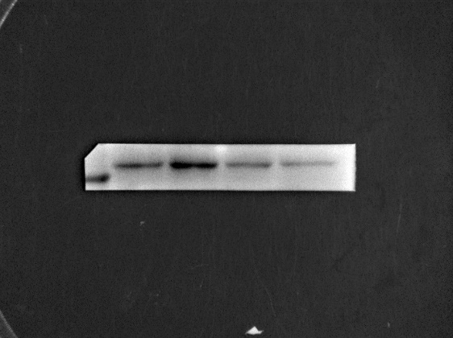
STAT3 p-STAT3
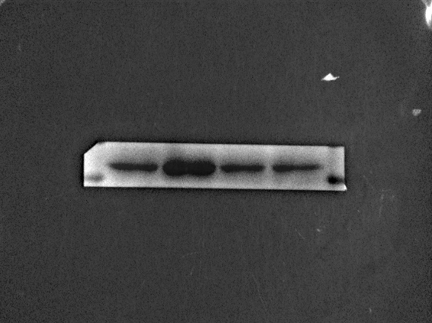
SOCS3

Figure 7D
Arg-1 iNOS
Figure 7P
Arg-1 iNOS
β-actin

Figure 7S
Arg-1 iNOS
β-actin

